BizTrack360 — Noor Fatima Branch Artifacts
Branch: testing-docs | Responsibility: Testing & Documentation

Purpose of This File
This file contains all supporting diagrams from the SRS as a consolidated testing/documentation reference. It can be used to derive test cases, integration scenarios, acceptance criteria and traceability.

Source
This file is derived from the submitted BizTrack360 Software Requirements Specification (SRS). The artifact descriptions and diagrams below preserve the SRS terminology and content.

Branch Artifact List
- 1. Use Case Diagram
- 2. Class Diagram
- 3. Sequence Diagram
- 4. Contextual Level DFD
- 5. Level 1 DFD
- 6. Level 2 DFD — Task Management
- 7. Activity Diagram — Task Workflow
- 8. State Chart Diagram — Task Lifecycle
- 9. State Transition Diagram — System-Level Behavior

1. Use Case Diagram

Purpose / Description
Testing and documentation reference for identifying actors, user permissions and functional coverage.

Detailed Artifact Content from the SRS
- Actors: Business Owner, Administrator, Manager, Employee, Investors.
- Use cases: managing user accounts and permissions; assigning/tracking tasks; monitoring performance matrix; reviewing financial summaries; accessing reports and analysis.
- Useful for deriving acceptance tests and role-based test scenarios.

Related SRS Requirements
- Users must be authenticated before accessing the system.
- Access must be restricted according to user roles/permissions.
- Task information, progress and status must be stored and tracked.
- System activities must be traceable through activity logs.
- Sensitive data and files must be securely stored.

Original Diagram from SRS (Page 15)
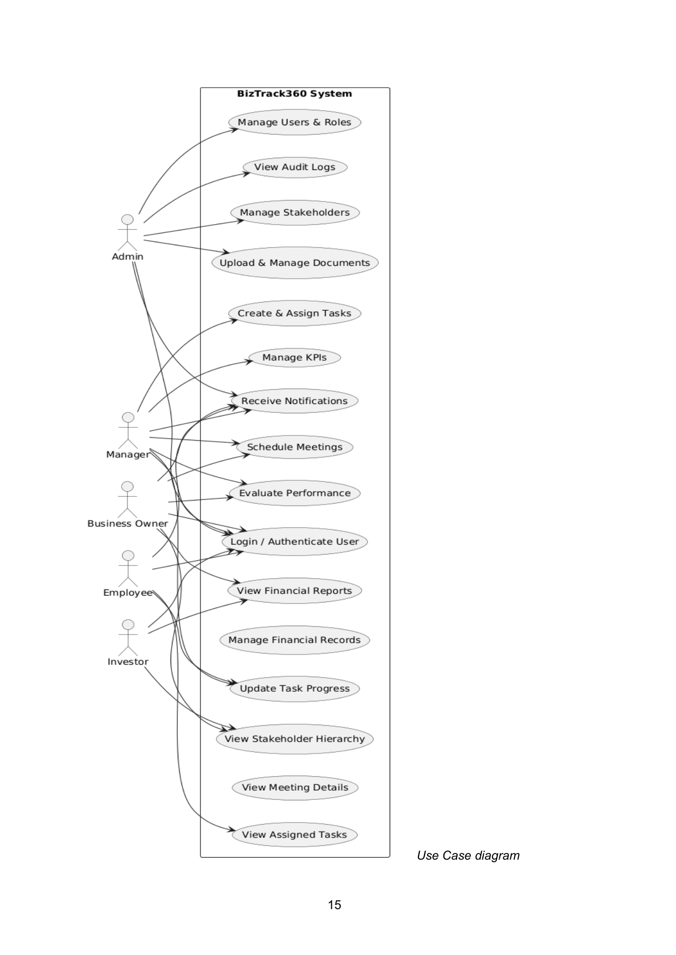

2. Class Diagram

Purpose / Description
Testing/documentation reference for identifying entities, relationships and data-oriented test coverage.

Detailed Artifact Content from the SRS
- Core entities/classes include User, Stakeholder, Business, Department, Task, KPI, Financial Record, Document and Meeting.
- Important relationships: Business contains stakeholders; users belong to departments; tasks are assigned to users; KPIs evaluate tasks.
- Useful for checking data integrity and relationship-related test cases.

Related SRS Requirements
- Users must be authenticated before accessing the system.
- Access must be restricted according to user roles/permissions.
- Task information, progress and status must be stored and tracked.
- System activities must be traceable through activity logs.
- Sensitive data and files must be securely stored.

Original Diagram from SRS (Page 17)
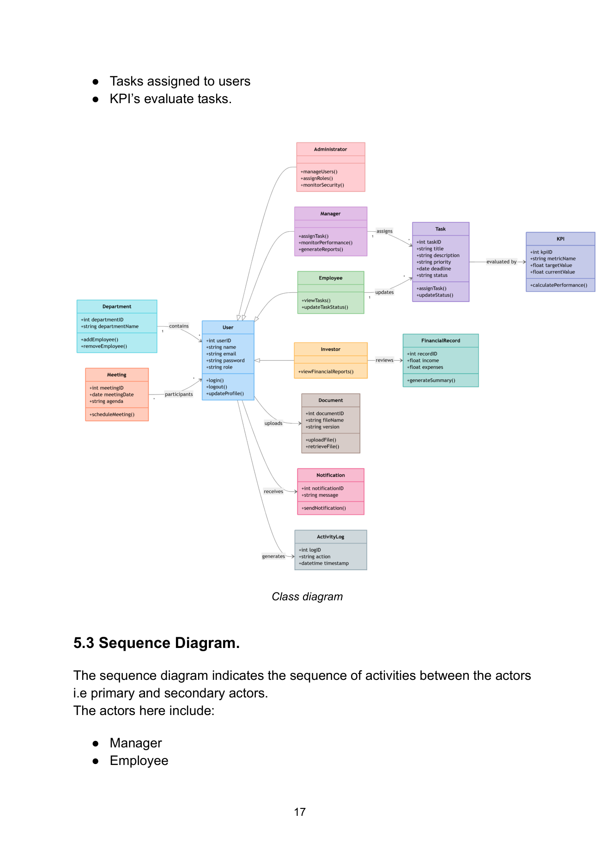

3. Sequence Diagram

Purpose / Description
Testing reference for verifying the expected order of task-related interactions.

Detailed Artifact Content from the SRS
- Manager creates task.
- System stores task.
- System notifies employee.
- Employee views task.
- Employee updates progress.
- System receives progress update.
- System updates task status.
- Useful for integration/system test scenarios.

Related SRS Requirements
- Users must be authenticated before accessing the system.
- Access must be restricted according to user roles/permissions.
- Task information, progress and status must be stored and tracked.
- System activities must be traceable through activity logs.
- Sensitive data and files must be securely stored.

Original Diagram from SRS (Page 18)
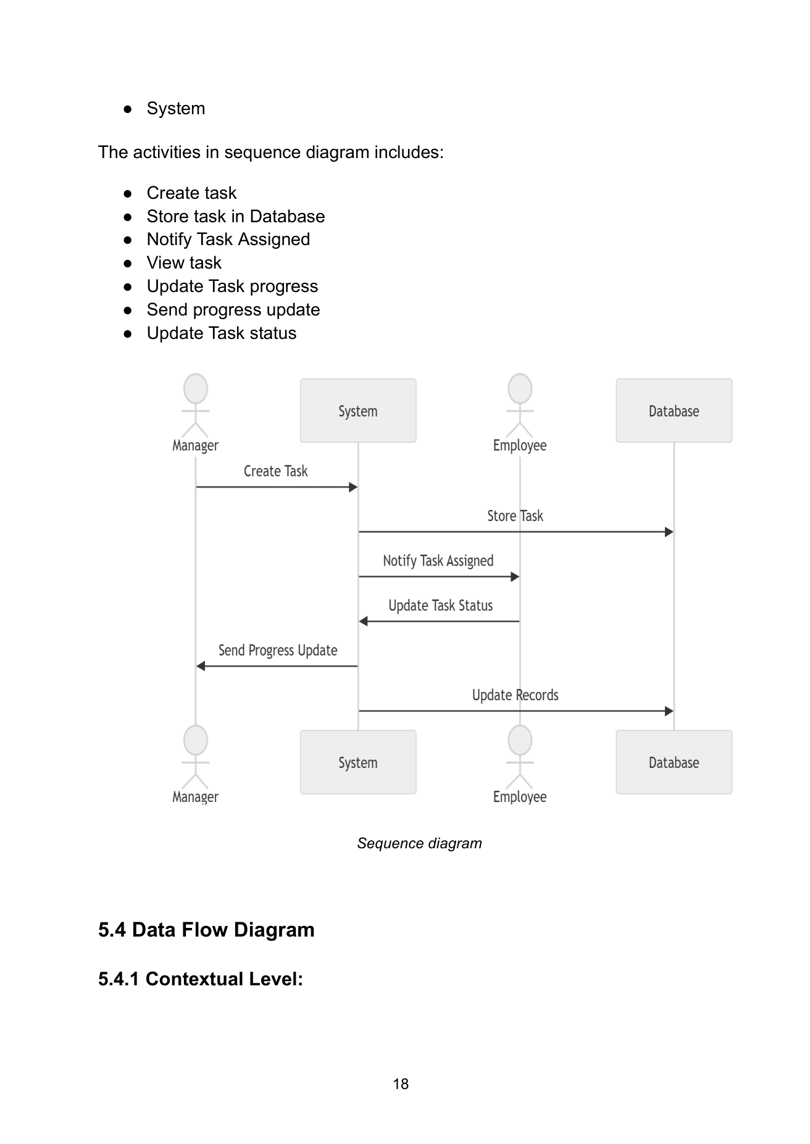

4. Contextual Level DFD

Purpose / Description
Documentation and test-boundary reference for external actors and major information exchanges.

Detailed Artifact Content from the SRS
- Administrator manages users/permissions/security.
- Business Owner monitors performance and reviews financial information.
- Managers allocate tasks and supervise workflow.
- Employees access tasks, update progress and retrieve documents.
- Investors receive limited business insights and financial summaries.

Related SRS Requirements
- Users must be authenticated before accessing the system.
- Access must be restricted according to user roles/permissions.
- Task information, progress and status must be stored and tracked.
- System activities must be traceable through activity logs.
- Sensitive data and files must be securely stored.

Original Diagram from SRS (Page 19)
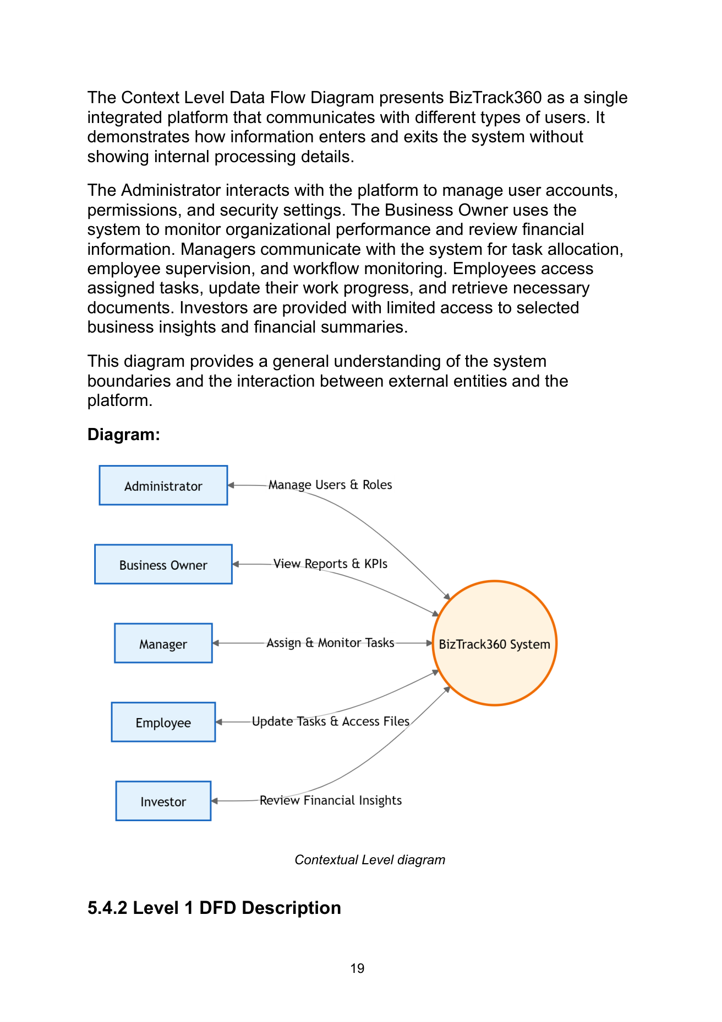

5. Level 1 DFD

Purpose / Description
Testing reference for validating coverage of major system modules.

Detailed Artifact Content from the SRS
- User and Role Management.
- Task Management.
- Performance Monitoring.
- Financial Overview.
- Document Management.
- Meeting Management.
- Notification Service.
- Activity Logging.

Related SRS Requirements
- Users must be authenticated before accessing the system.
- Access must be restricted according to user roles/permissions.
- Task information, progress and status must be stored and tracked.
- System activities must be traceable through activity logs.
- Sensitive data and files must be securely stored.

Original Diagram from SRS (Page 20)
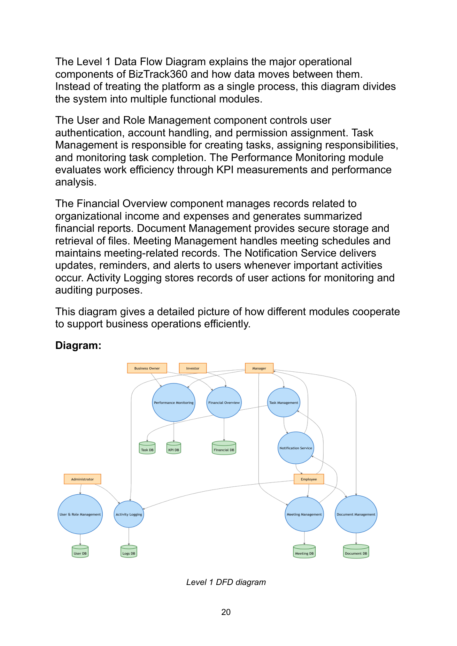

6. Level 2 DFD — Task Management

Purpose / Description
Test-flow reference for detailed task creation, assignment, notification, progress and monitoring.

Detailed Artifact Content from the SRS
- Manager creates task with priority, deadline and description.
- Task is saved in the task database.
- Employee is notified.
- Employee views task and submits progress.
- Updates are stored.
- Manager monitors and reviews completion.

Related SRS Requirements
- Users must be authenticated before accessing the system.
- Access must be restricted according to user roles/permissions.
- Task information, progress and status must be stored and tracked.
- System activities must be traceable through activity logs.
- Sensitive data and files must be securely stored.

Original Diagram from SRS (Page 21)
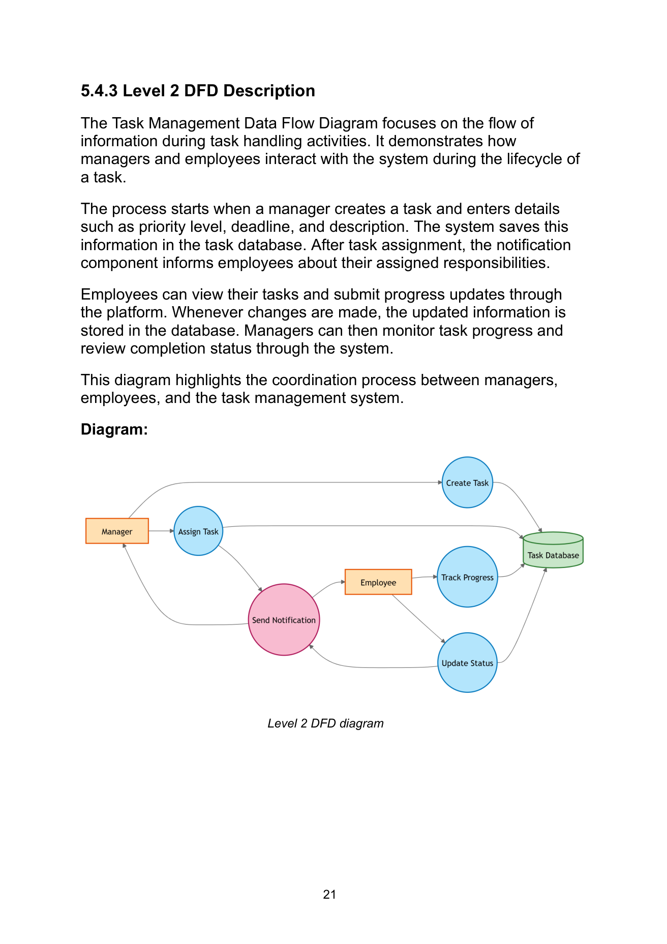

7. Activity Diagram — Task Workflow

Purpose / Description
Testing reference for normal, failed-authentication and repeated-progress paths.

Detailed Artifact Content from the SRS
- Login → authentication.
- Authentication failure → access denied/end.
- Successful authentication → dashboard.
- Create/assign task → database storage → notification.
- Employee works and repeatedly updates progress.
- Completion → KPI/report updates → stakeholder notification → end.

Related SRS Requirements
- Users must be authenticated before accessing the system.
- Access must be restricted according to user roles/permissions.
- Task information, progress and status must be stored and tracked.
- System activities must be traceable through activity logs.
- Sensitive data and files must be securely stored.

Original Diagram from SRS (Page 23)
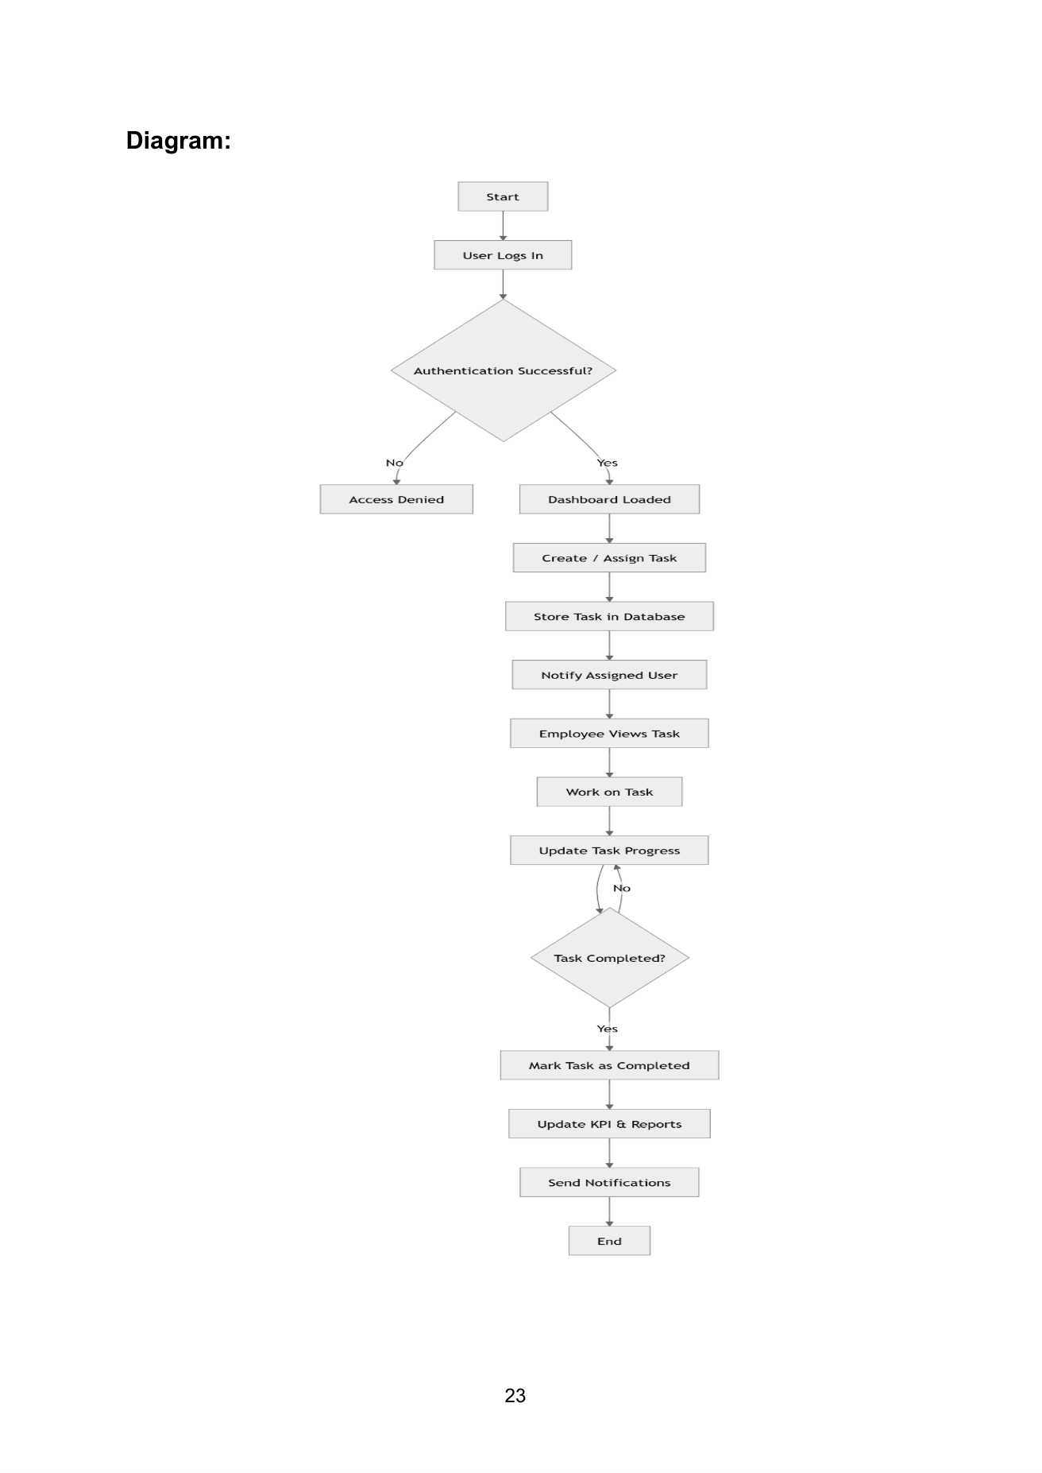

8. State Chart Diagram — Task Lifecycle

Purpose / Description
Testing reference for verifying valid task state transitions.

Detailed Artifact Content from the SRS
- Created → Assigned → In Progress.
- In Progress may move to On Hold.
- Work proceeds to Under Review.
- Under Review returns to In Progress if changes are required.
- Approved work becomes Completed.
- Completed → Archived.

Related SRS Requirements
- Users must be authenticated before accessing the system.
- Access must be restricted according to user roles/permissions.
- Task information, progress and status must be stored and tracked.
- System activities must be traceable through activity logs.
- Sensitive data and files must be securely stored.

Original Diagram from SRS (Page 24)
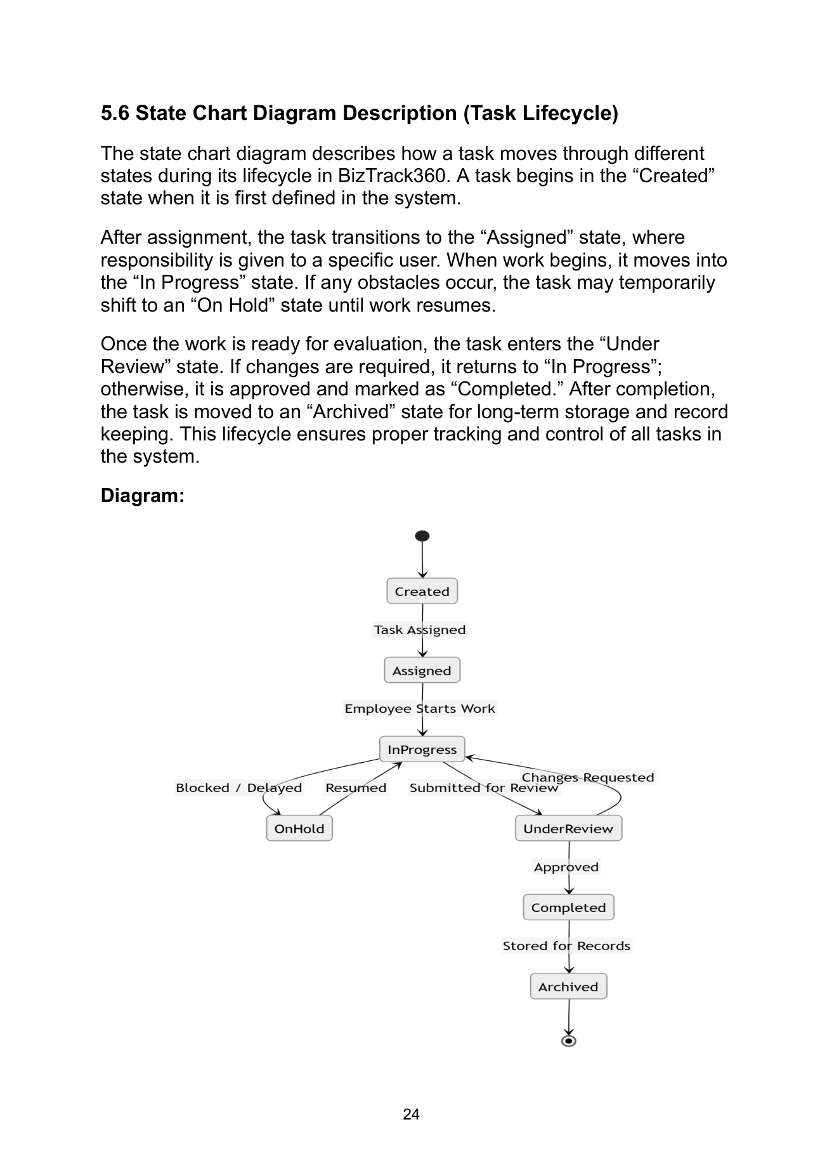

9. State Transition Diagram — System-Level Behavior

Purpose / Description
Testing reference for validating automated events, state updates, KPI/report updates and archival.

Detailed Artifact Content from the SRS
- Task created → stored in database.
- Stored task → automatic notification.
- User accesses task → Viewed.
- Work begins → In Progress.
- Progress updates are recorded.
- Completion → KPI/report updates.
- Completed task → archived for reference and auditing.

Related SRS Requirements
- Users must be authenticated before accessing the system.
- Access must be restricted according to user roles/permissions.
- Task information, progress and status must be stored and tracked.
- System activities must be traceable through activity logs.
- Sensitive data and files must be securely stored.

Original Diagram from SRS (Page 26)
