BizTrack360
Branch: testing-docs | Responsibility: Testing & Documentation
Sequence and Activity Diagrams

Purpose of This File
This file combines the sequence diagram and task-workflow activity diagram to support testing of interaction order, authentication paths, task assignment, progress updates, completion, reporting, and notifications.

Source
Derived from the supplied BizTrack360 Software Requirements Specification (SRS) and the attached testing/documentation artifact document. Original diagram page images are retained from the supplied document; diagram images are not redrawn.

Part A — Sequence Diagram

Purpose / Description
Testing reference for verifying the expected order of task-related interactions and for developing integration/system test scenarios.

Detailed Artifact Content from the SRS
- Manager creates a task.
- System stores the task.
- System notifies the employee.
- Employee views the task.
- Employee updates progress.
- System receives the progress update.
- System updates task status.

Related SRS Requirements
- Users must be authenticated before accessing the system.
- Access must be restricted according to user roles/permissions.
- Task information, progress and status must be stored and tracked.
- System activities must be traceable through activity logs.
- Sensitive data and files must be securely stored.

Original Sequence Diagram — SRS Page 18
Original SRS page reference: Page 18. The image below is preserved from the supplied source document.
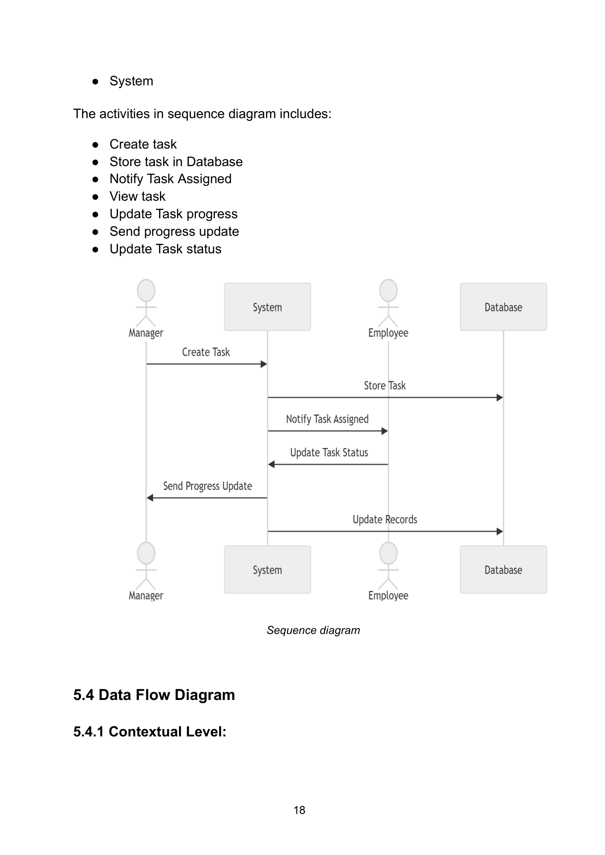

Part B — Activity Diagram — Task Workflow

Purpose / Description
Testing reference for normal, failed-authentication, and repeated-progress paths in the task workflow.

Detailed Artifact Content from the SRS
- Login leads to authentication.
- Authentication failure leads to access denied and end.
- Successful authentication opens the dashboard.
- Create and assign task; store it in the database; send notification.
- Employee works on the task and repeatedly updates progress.
- Completion leads to KPI/report updates, stakeholder notification, and end.

Related SRS Requirements
- Users must be authenticated before accessing the system.
- Access must be restricted according to user roles/permissions.
- Task information, progress and status must be stored and tracked.
- System activities must be traceable through activity logs.
- Sensitive data and files must be securely stored.

Original Activity Diagram — SRS Page 23
Original SRS page reference: Page 23. The image below is preserved from the supplied source document.
