BizTrack360
Branch: testing-docs | Responsibility: Testing & Documentation
Contextual Level, Level 1, and Level 2 DFDs

Purpose of This File
This file consolidates the three data-flow diagrams for testing and documentation: the system boundary and external information exchanges, the major system modules, and the detailed task-management flow.

Source
Derived from the supplied BizTrack360 Software Requirements Specification (SRS) and the attached testing/documentation artifact document. Original diagram page images are retained from the supplied document; diagram images are not redrawn.

Part A — Contextual Level DFD

Purpose / Description
Documentation and test-boundary reference for external actors and major information exchanges.

Detailed Artifact Content from the SRS
- Administrator manages users, permissions, and security.
- Business Owner monitors performance and reviews financial information.
- Managers allocate tasks and supervise workflow.
- Employees access tasks, update progress, and retrieve documents.
- Investors receive limited business insights and financial summaries.

Related SRS Requirements
- Users must be authenticated before accessing the system.
- Access must be restricted according to user roles/permissions.
- Task information, progress and status must be stored and tracked.
- System activities must be traceable through activity logs.
- Sensitive data and files must be securely stored.

Original Contextual Level DFD — SRS Page 19
Original SRS page reference: Page 19. The image below is preserved from the supplied source document.
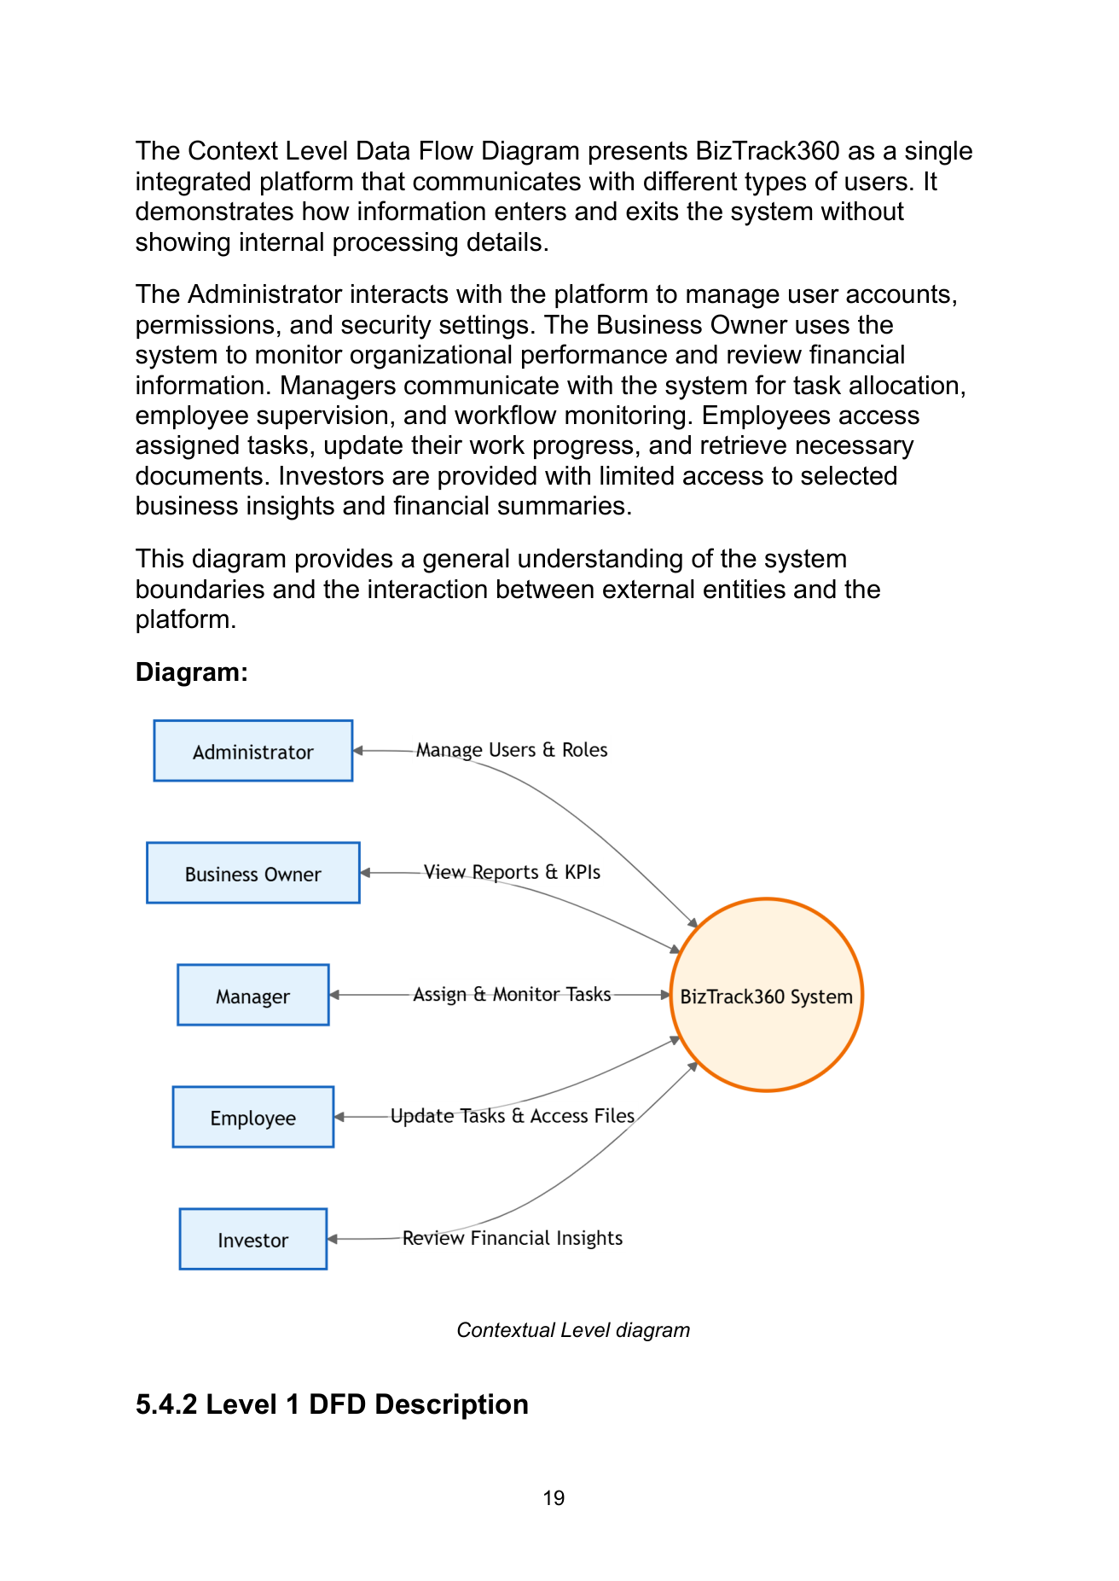

Part B — Level 1 DFD

Purpose / Description
Testing reference for validating coverage of the major system modules and their cooperative information flows.

Detailed Artifact Content from the SRS
- User and Role Management
- Task Management
- Performance Monitoring
- Financial Overview
- Document Management
- Meeting Management
- Notification Service
- Activity Logging

Related SRS Requirements
- Users must be authenticated before accessing the system.
- Access must be restricted according to user roles/permissions.
- Task information, progress and status must be stored and tracked.
- System activities must be traceable through activity logs.
- Sensitive data and files must be securely stored.

Original Level 1 DFD — SRS Page 20
Original SRS page reference: Page 20. The image below is preserved from the supplied source document.
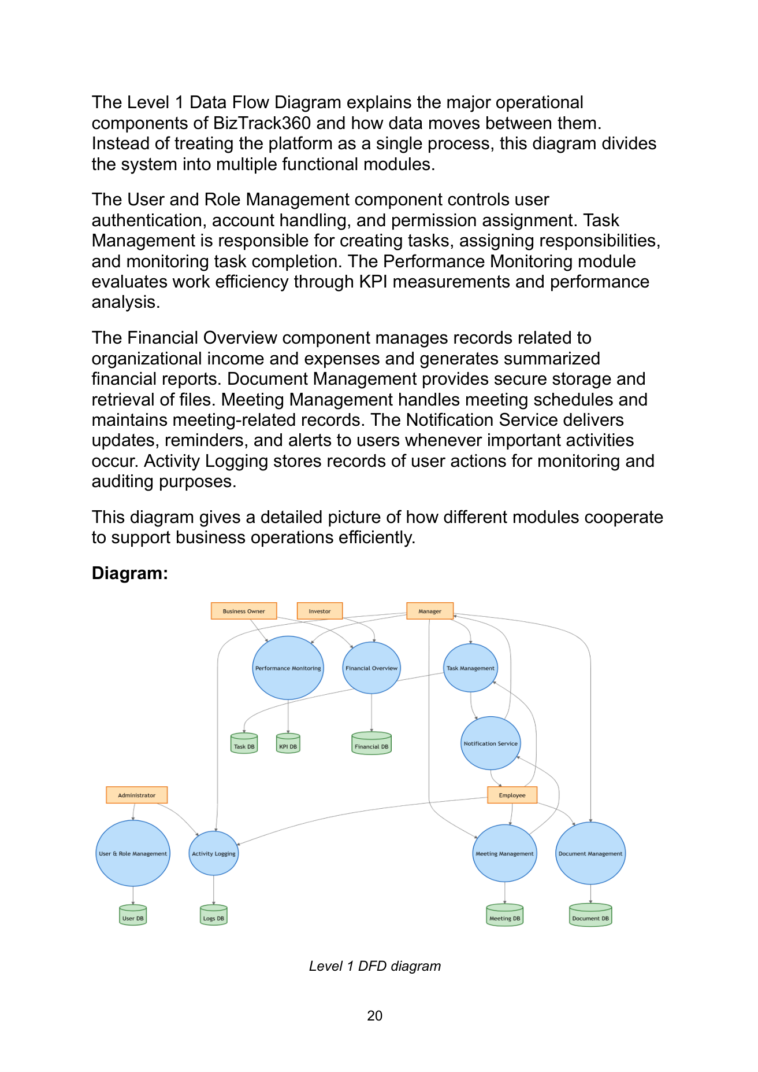

Part C — Level 2 DFD — Task Management

Purpose / Description
Test-flow reference for detailed task creation, assignment, notification, progress, and monitoring.

Detailed Artifact Content from the SRS
- Manager creates a task with priority, deadline, and description.
- Task is saved in the task database.
- Employee is notified.
- Employee views the task and submits progress.
- Updates are stored.
- Manager monitors and reviews completion.

Related SRS Requirements
- Users must be authenticated before accessing the system.
- Access must be restricted according to user roles/permissions.
- Task information, progress and status must be stored and tracked.
- System activities must be traceable through activity logs.
- Sensitive data and files must be securely stored.

Original Level 2 DFD — Task Management — SRS Page 21
Original SRS page reference: Page 21. The image below is preserved from the supplied source document.
