**Your Name** <your-ju-id@student.ju.se>

A Project Work in *Web Development Fundamentals*

Jönköping University 2019

Your title here...

*In this template, all italic text should be removed and replaced with your own text (which should not be italic); the italic text is just a placeholder letting you know what to write there.*

*On the cover page, change to your own project name, your own name and your own JU email address.*

*You have a lot of freedom when it comes to writing this report. You do not have to use any part of this template, but the report you write should in the end somehow (in a good way) provide the same information as indicated in this template. Most students trying to do it in their own way usually fail, so if you try that, be sure to know what you are doing!*

*Use proper sentences, paragraphs, lists, tables, figures, etc. The more figures you use, the less text you need to write, so use many of them.*

*This page should be removed.*

Table of Contents

Introduction 3

Architecture 4

Database 5

Graphical User Interface 6

Web Application 7

# Introduction

*Introduce your project work. Write text that* ***indirectly*** *(look up what indirectly means if you don't know it) answers questions like:*

* *Why does the project exist?*
* *What is the project about?*
* *Who are involved in the project?*
* *What will the project result in?*
* *Who are interested in the outcome of the project?*
* *How will the outcome of the project be used?*
* *...*

*It is good if you can add a UML use case diagrams that visualizes how the end users will use the website, such as the one at* [*https://www.conceptdraw.com/resources/images/solutions-screens/diagramming/UML_Use_Case_Diagram.png*](https://www.conceptdraw.com/resources/images/solutions-screens/diagramming/UML_Use_Case_Diagram.png)*.*

*After having read this chapter, those that have never heard of the project before should a have a good understanding of what it is about. If they would like to learn how it has been implemented, they just need to continue reading the rest of the report.*

# Architecture

*Give an overview of the components the website consists of (web application, database, web browsers, end-users, etc.)? Visualize this in a figure and show how the different components make use of each other.*

*After having read this chapter, the reader should have a broad (but shallow) understanding of the website's internal structure.*

# Database

*Describe the database and the resources on the website in detail. What attributes do they consist of? How are they related? Where are they stored (in files on the hard-drive? In a relational database? Etc.). Visualize the resource in an ER diagram, such as the one found at* [*https://www.lucidchart.com/pages/templates/er-diagram/er-diagram-example-template*](https://www.lucidchart.com/pages/templates/er-diagram/er-diagram-example-template)*.*

*After having read this chapter, the reader should understand how the data (the resources) in the website is stored. If the reader is a new programmer that should start working on the website, she should now know what she needs to do if she wants to change the resources or add more type of resources (e.g. know how to add a new table to the database with a relation to an existing table in the database).*

# Graphical User Interface

*Describe the graphical user interface. Initially this can simply be low-detailed pictures as the ones shown in Figure 1 below (Note: the click at the top is on the "Contact" link, and not the "Home" link (optical illusion)).*

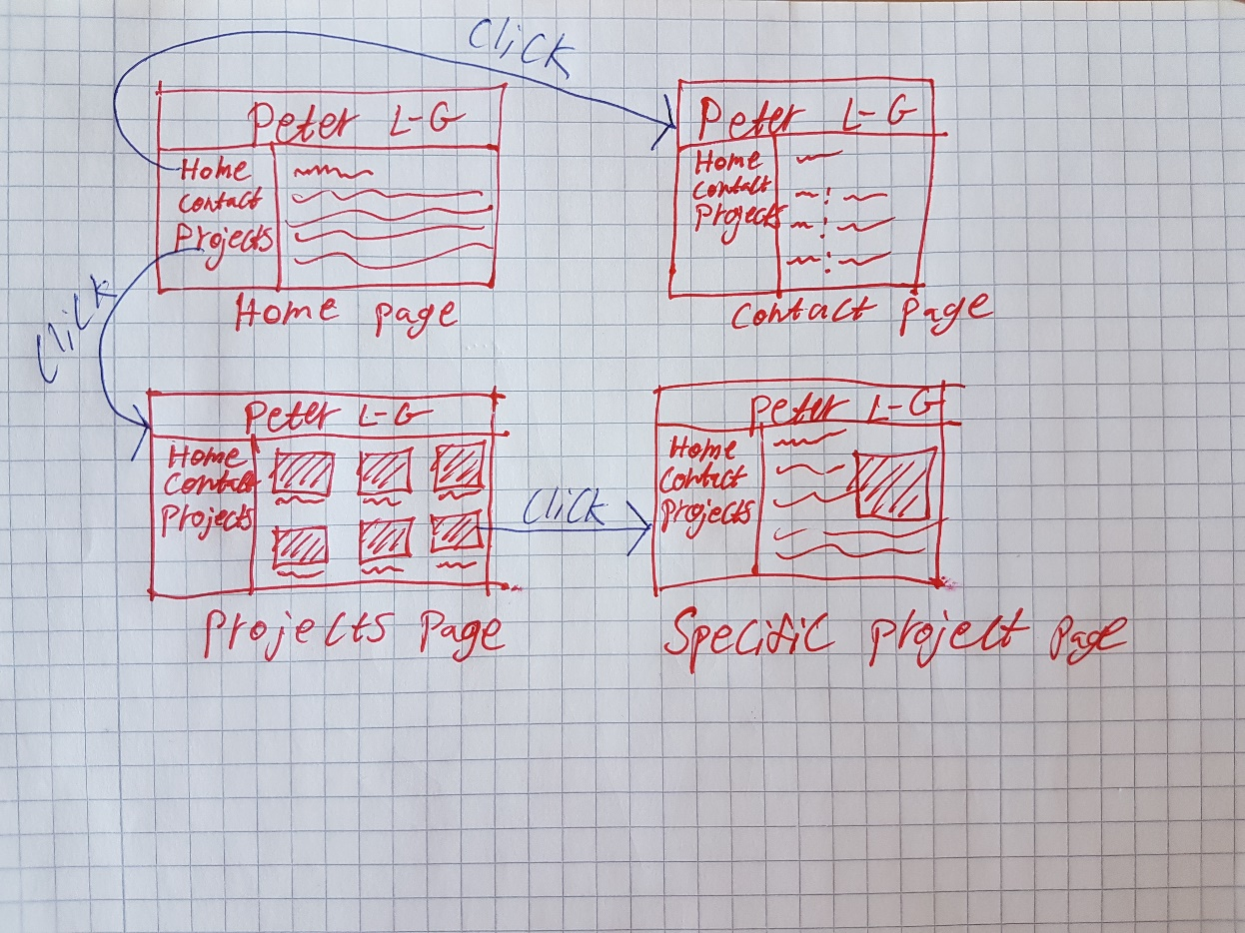

Figure 1, Low-detailed picture of a graphical user interface.

*When you have implemented the website, showing some screenshots of it here is a very good idea. Keep your low-detailed pictures even when you have real screenshots; they give a good/quick overview of the GUI.*

*After having read this chapter, the reader should understand how the end users will be able to accomplish their goals through the graphical user interface.*

# Web Application

*Describe implementation details of the web application. Which language have you used? Which framework have you used? Which libraries/packages have you used, and for what purpose? Has all code been written in one file? Or have you somehow structured it in multiple files? Are you using some design patterns (e.g. MVC)? Are you using middlewares? Etc...*

*You do not necessarily need to show any code to describe the implementation, but if you feel that improves the quality of the report, feel free to do that.*

*Security is a very important topic when it comes to web applications. Having a sub-chapter here that describes all security vulnerabilities you have thought of (e.g. using HTTPS (and why), hashing passwords (and why), XSS, cookies, session ids, ...) is probably a good idea. It's probably a good idea to have some more sub-chapters as well, but you can figure out them on your own.*

*Try to use many figures.*

*After having read this chapter, the reader should have a very good understanding of how the web application has been implemented. If the reader is a programmer who should start working on the web application, she should now know where to start when she should implement new features to the web application.*