Your Name 1 <your-ju-id1@student.ju.se>,  
Your Name 2 <your-ju-id2@student.ju.se>,  
Your Name 3 <your-ju-id3@student.ju.se>

Project Work in Android Development

Jönköping University 2020

Your App title here

*In this template, all italic text should be removed and replaced with your own text (which should not be italic); the italic text is just a placeholder letting you know what to write there.*

*On the cover page, change to your own title (name of application or platform), your own names and your own JU email addresses.*

*Figures are a great way to explain things (use many of them!), but make sure that each one is given a caption and a figure number and refer to them from the main text.*

*This page should of course be removed.*

*Common mistakes students do when writing reports (try to avoid them!):*

* *Writing things like "we did", "I think", etcetera. Avoid words such as "we" and "I"; what is written in a report should be true no matter who has done the work/written it.*
* *Dividing the report into parts, and let different students write the different parts, making you lose the red thread in the report. Dividing the work is great, but when the different parts has been written, be sure to rework the texts so the red thread is maintained throughout the report, e.g. optimally, a reader should be able to read the report from start to end and understand everything as it reads the report, without being forced to jump back and forth between different sections.*

*You have a lot of freedom when it comes to writing this report. You do not have to use any part of this template, but the report you write should in the end somehow provide the same information as indicated in this template.*

*This document is a living document throughout the course. Try to fill in as much as possible. What you write in the beginning may be changed later. Specifying how your application will work is especially important if you are two working on it, so you first agree on and specify how the application should work.*

Table of Contents

Introduction 3

Overview 4

Application 5

# Introduction

*Describe your application idea here. Write text that indirectly answers questions like:*

* *What is the problem the application solves (why anyone would use it)?*
  + *Describing the problem is usually a good way to start this chapter.*
* *Who would be interested in using the application (who are having the problem?)?*
* *How will users use the application to solve the problem?*

*After reading this section, the reader should have been convinced that the application solves the problem in a good way, and that it is a good idea to build the application. You are recommended to use use-case diagrams.*

*Think of this chapter as a text you write to a billionaire, who will give you the money you need to build the application only if you convince him that the application is good. But, of course, do not tell any lies.*

*If you have taken the course Internet & Cloud Services, and choose to implement an Android application as the frontend application for the platform you created in that course, you should more or less be able to copy-paste your entire Introduction chapter from the report in that course and use it as the Introduction chapter in the report in this course.*

# Overview

*Imagine the billionaire liked your application idea and has given you the money you need to realize it. Now you need to build it, but how? This chapter should provide an overview of all the external components your application makes use of, such as Facebook Login, Google APIs, Firebase, etcetera.*

*If a new programmer starts to work on the application, this chapter should be a really good way for that programmer to get a good understanding of how the solution is structured.*

*If you have taken the course Internet & Cloud Services and choose in this course to implement a frontend application for the platform you created in that course, you should more or less be able to use your entire Overview chapter from the report in that course as the Overview chapter in the report in this course.*

# Application

*Describe how you have implemented the application, e.g. explain that it has been implemented in Java using the Android SDK, etc. Write which versions of Android your application supports, and motivate why you choose to support these versions, which screen sizes you are supporting, how it works differently depending on the screen size of the device the application runs on, which third party libraries you are using, if you support multiple natural languages, etc. Motivate all your decisions.*

*Especially, provide a link/reference to your mockups, so the reader easily can see what the GUI looks like. Providing real screenshots is probably helpful as well. Providing an overview of the GUI as shown in the figure below might be helpful as well.*

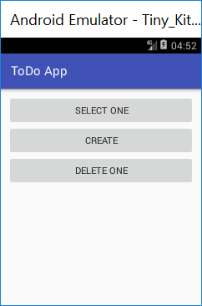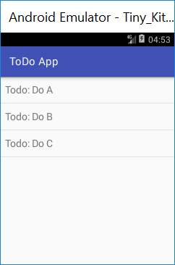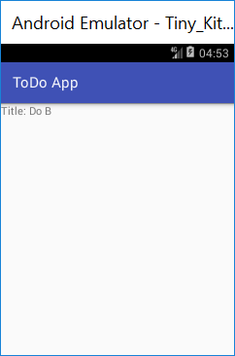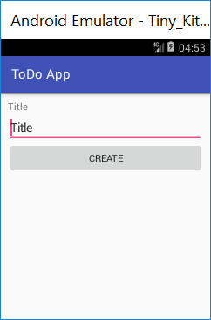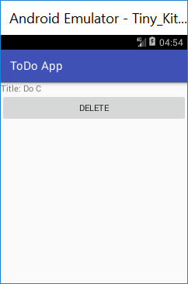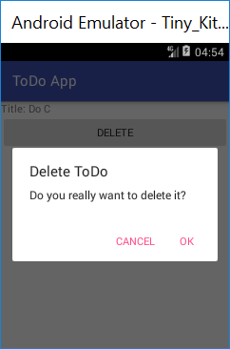

*If not obvious, describe what each screen is used for.*

*Also describe particular design patterns you are using, and how your code is organized. For example, if you implement a frontend application for the platform you created in the course Internet and Cloud Services, it might be a good idea to create an SDK, which can be used to communicate with the backend application. Implemented in Java, the SDK would also be reusable in ordinary Java applications, and not only Android applications. And what about caching? Sending the same GET request to a server over and over again is not optimal.*

*Explain how you store data. In a database? Which tables is inside of it? Or in files? How do you organize those files? Etc. Maybe it makes sense to show an ER diagram?*

*What is your strategy when it comes to asking the user for permissions to use different features on the device (e.g. the camera, or accessing contacts, etc.)? When/how do you do that?*

*If a new programmer starts to work on the application, this section should provide a really good introduction to how it works and how it has been implemented.*