Software Design Document

Automatic Attendance System Using Face Recognition



Submitted by
MARYAM KHURSHID (S23BINFT1M01094)

Submitted to
Sr. Abdul Kareem Nawaz

Department of Information Technology
Faculty of Computing
The Islamia University of Bahawalpur

Meeting Details
Sr No | Details | Date | Supervisor Signature
01. | Presented the initial concept for the final year project.

Summary
This Software Design Document (SDD) presents the architectural and technical design of the Automatic Attendance System Using Face Recognition. The document serves as a blueprint for translating the system requirements into a structured implementation plan by defining the application's architecture, database schema, user interface, and overall system design considerations.
Traditional attendance management systems often rely on manual processes such as paper registers, ID cards, or manual data entry, which are time-consuming, prone to human error, and susceptible to fraudulent attendance marking. To address these limitations, the proposed system leverages Face Recognition technology to automate the attendance process, providing a secure, accurate, and efficient solution for educational institutions and organizations.
Several design considerations were taken into account during the development of this system. Accuracy and reliability are critical factors, requiring the integration of facial recognition algorithms capable of identifying individuals under varying environmental conditions. Security and privacy considerations are also emphasized to ensure that biometric data is stored and processed securely. Furthermore, scalability and performance are important to support a large number of registered users while maintaining fast recognition and attendance processing.
The application follows a layered architecture consisting of a user interface layer, an application processing layer, a face recognition module, and a database layer. The face recognition component captures facial images, extracts unique facial features, compares them against stored biometric records, and automatically records attendance upon successful identification. The backend manages user information, attendance records, and administrative operations, while the database ensures secure storage and retrieval of system data.
The data model is designed to maintain consistency between student records, attendance logs, facial datasets, and system users. In addition, the user interface is developed to provide a simple and intuitive experience for students, instructors, and administrators, enabling efficient management of attendance activities and reports.
Overall, this document describes the design framework required to implement a reliable, secure, and intelligent attendance management system that improves efficiency, reduces administrative workload, and enhances the accuracy of attendance tracking through facial recognition technology.

Table of Contents
1. Application Architecture 5
1.1. Architecture Overview 5
1.2. MVT Components 7
1.3. Controllers and Function 8
1.4. APIs and Libraries 10
1.5. UML Diagram 12
1.6. Codding Conventon 12
2. Data Model Schema 13
2.1. User Entity 13
2.2 Student Entity 14
2.3 FaceData Entity 15
2.4 Course Entity 16
2.5 Attendance Entity 16
2.6 Attendance Report Entity 17
2.7 Entity Relationship Diagram 18
ER Diagram Structure: 19
2.8 Database Design Consideration 20
3. Use Interface 21
3.1. Design Philosphy 21
3.2 Screen List 22
3.3 Login Page 22
3.4 Registration Page 23
3.5 Administration Dashboard 24
3.6 Student Management Page 24
3.7 Face Enrillment Page 25
3.8 Attendance Capture Page 26
3.9 Attendance Record Page 27
3.10 Course Management Page 28
3.11 Attendance Report Page 28
3.12 User Profile Page 29
3.13 Use Interface Desgin Consideration 30
4. References 30

- Application Architecture
The Automatic Attendance System Using Face Recognition is designed as a modern web-based application that integrates facial recognition technology with attendance management functionalities. The system follows a client-server architecture that separates the user interface, business logic, facial recognition processing, and database management into independent layers. This architectural approach improves maintainability, scalability, security, and system performance while ensuring accurate attendance tracking.
The system utilizes the Model-View-Template (MVT) architectural pattern provided by the Django framework. Similar to the Model-View-Controller (MVC) pattern, MVT separates data management, application processing, and user interface components to facilitate efficient development and maintenance.

1.1 Architectural Overview
The application architecture consists of the following major components:

Presentation Layer (Frontend)
The presentation layer serves as the interface through which students, teachers, and administrators interact with the system.
Technologies Used:
- HTML5
- CSS3
- JavaScript
- Bootstrap
Responsibilities:
- User registration and login interfaces
- Student enrollment forms
- Attendance monitoring dashboard
- Attendance reports and statistics
- Administrative controls

Business Logic Layer (Backend)
The backend layer is developed using Django and contains the core functionality of the system.
Responsibilities:
- User authentication and authorization
- Student management
- Attendance management
- Face recognition coordination
- Attendance report generation
- System validation and security enforcement
This layer acts as the communication bridge between the frontend interface and the database.

Face Recognition Layer
The Face Recognition Layer is the intelligent component of the system responsible for identifying registered students.
Responsibilities:
- Image capture through webcam
- Face detection
- Face encoding generation
- Face matching and recognition
- Attendance verification
The module compares captured facial features with previously stored facial encodings and automatically marks attendance when a match is detected.

Database Layer
The database layer stores all persistent system information.
Technologies Used:
- MySQL Database
Stored Information:
- Student records
- User accounts
- Attendance logs
- Course information
- Facial recognition data
- System configurations

1.2 MVT Components

Proposed Models
The following models are proposed for the system:
- User
- Student
- Course
- Attendance
- FaceData
- AttendanceReport
These models represent the core entities required for attendance management and facial recognition operations.

Proposed Views
The system includes the following views:
- Login View
- Registration View
- Student Enrollment View
- Face Registration View
- Attendance Capture View
- Attendance Report View
- Admin Dashboard View
- Course Management View

Proposed Templates
The user interface will consist of:
- Login Page
- Registration Page
- Dashboard Page
- Student Management Page
- Face Enrollment Page
- Attendance Monitoring Page
- Attendance Report Page
- Administrator Panel

1.3 Controllers and Functions
The system functionality is divided among several controllers.

Authentication Controller
Purpose:
Handles authentication and user access control.
Functions:
- registerUser()
- loginUser()
- logoutUser()
- changePassword()
- resetPassword()

Student Controller
Purpose:
Manages student-related operations.
Functions:
- addStudent()
- updateStudent()
- deleteStudent()
- viewStudent()
- searchStudent()

Face Recognition Controller
Purpose:
Processes facial recognition activities.
Functions:
- captureImage()
- detectFace()
- generateFaceEncoding()
- compareFaceEncoding()
- recognizeStudent()

Attendance Controller
Purpose:
Manages attendance operations.
Functions:
- markAttendance()
- validateAttendance()
- updateAttendance()
- viewAttendance()
- generateAttendanceReport()

Course Controller
Purpose:
Handles course management activities.
Functions:
- createCourse()
- updateCourse()
- deleteCourse()
- assignStudents()
- viewCourse()

1.4 APIs and Libraries
The system utilizes several libraries and APIs to support attendance processing and face recognition.

Internal APIs
The following internal APIs facilitate communication between system modules:
- Authentication API
- Student Management API
- Face Recognition API
- Attendance Management API
- Reporting API

External Libraries

Django Framework
Provides:
- Authentication mechanisms
- URL routing
- ORM functionality
- Session management
- Security features

OpenCV
Provides:
- Camera access
- Image processing
- Face detection functionality
- Real-time video frame handling

Face Recognition Library
Provides:
- Facial feature extraction
- Face encoding generation
- Face matching algorithms
- Recognition confidence calculations

NumPy
Provides:
- Numerical computation support
- Matrix operations
- Facial feature vector processing

Bootstrap
Provides:
- Responsive user interfaces
- UI components
- Cross-device compatibility

1.5 UML Diagrams
The following UML diagrams will be used to represent the architecture and workflow of the system:
- Use Case Diagram
- Class Diagram
- Sequence Diagram
- Activity Diagram
- Entity Relationship Diagram (ERD)
- Component Diagram
These diagrams provide visual representations of system behavior, object interactions, and data relationships.

1.6 Coding Conventions
To maintain code quality and consistency throughout development, the following standards will be followed:

Python (Django)
- Follow PEP-8 coding standards
- Use meaningful variable and function names
- Maintain 4-space indentation
- Implement modular and reusable code
- Document critical functions using comments

HTML/CSS
- Use semantic HTML tags
- Maintain consistent styling conventions
- Follow responsive design principles

JavaScript
- Use camelCase naming convention
- Create reusable functions
- Avoid redundant code

Database Design
- Apply normalization principles
- Use meaningful table names
- Implement Primary Key and Foreign Key constraints
- Maintain referential integrity
The proposed architecture provides a robust foundation for developing a secure, accurate, and scalable attendance management solution that automates attendance recording through facial recognition technology.

- Data Model Schema
The Automatic Attendance System Using Face Recognition utilizes a relational database structure to efficiently manage student information, facial recognition data, attendance records, courses, and system users. The database is designed to ensure data consistency, security, and scalability while supporting automated attendance marking through facial recognition technology.
The conceptual schema consists of several interconnected entities that work together to facilitate student identification, attendance recording, report generation, and administrative management. The relationships among these entities ensure accurate attendance tracking and prevent duplicate or unauthorized attendance entries.

2.1 User Entity
The User entity stores information about all authorized users who can access the system.

Attributes
Attribute | Data Type | Description
user_id | Integer (PK) | Unique user identifier
username | Varchar(50) | Login username
email | Varchar(100) | User email address
password | Varchar(255) | Encrypted password
role | Varchar(20) | Admin, Teacher
created_at | DateTime | Account creation date

Purpose
This entity manages authentication and authorization within the system.

Relationships
- One User can manage multiple Courses.
- One User can generate multiple Attendance Reports.

2.2 Student Entity
The Student entity stores personal and academic information about registered students.

Attributes
Attribute | Data Type | Description
student_id | Integer (PK) | Unique student identifier
registration_no | Varchar(30) | Student registration number
full_name | Varchar(100) | Student name
email | Varchar(100) | Student email
department | Varchar(100) | Department name
semester | Integer | Current semester
image_path | Varchar(255) | Student image location

Purpose
Stores student information required for attendance management and facial recognition.

Relationships
- One Student can have one FaceData record.
- One Student can have multiple Attendance records.
- One Student can enroll in multiple Courses.

2.3 FaceData Entity
The FaceData entity stores facial recognition information associated with registered students.

Attributes
Attribute | Data Type | Description
face_id | Integer (PK) | Face record identifier
student_id | Integer (FK) | Associated student
face_encoding | Text | Encoded facial features
enrollment_date | DateTime | Registration date

Purpose
Stores facial feature vectors used for face recognition and identity verification.

Relationships
- One FaceData record belongs to one Student.
- One Student has one FaceData profile.

2.4 Course Entity
The Course entity stores academic course information.

Attributes
Attribute | Data Type | Description
course_id | Integer (PK) | Course identifier
course_name | Varchar(100) | Course title
course_code | Varchar(20) | Unique course code
instructor_name | Varchar(100) | Assigned instructor

Purpose
Stores course details for attendance tracking.

Relationships
- One Course contains multiple Students.
- One Course generates multiple Attendance records.

2.5 Attendance Entity
The Attendance entity stores attendance records generated by the facial recognition system.

Attributes
Attribute | Data Type | Description
attendance_id | Integer (PK) | Attendance identifier
student_id | Integer (FK) | Student reference
course_id | Integer (FK) | Course reference
attendance_date | Date | Attendance date
attendance_time | Time | Attendance time
status | Varchar(20) | Present, Absent

Purpose
Records attendance automatically after successful facial recognition.

Relationships
- One Attendance record belongs to one Student.
- One Attendance record belongs to one Course.

Business Rule
A student can only be marked present once per course session.

2.6 Attendance Report Entity
The Attendance Report entity stores summarized attendance information.

Attributes
Attribute | Data Type | Description
report_id | Integer (PK) | Report identifier
course_id | Integer (FK) | Course reference
generated_by | Integer (FK) | User reference
report_date | DateTime | Report generation date
attendance_percentage | Decimal | Attendance statistics

Purpose
Generates and stores attendance summaries and analytical reports.

Relationships
- One Report belongs to one Course.
- One User can generate multiple Reports.

2.7 Entity Relationship Diagram (ERD)
The Entity Relationship Diagram illustrates the relationships among the system entities.

Relationship Summary
- User (1) ---- (M) Attendance Report
- Student (1) ---- (1) FaceData
- Student (1) ---- (M) Attendance
- Course (1) ---- (M) Attendance
- Course (1) ---- (M) Attendance Report

ER Diagram Structure
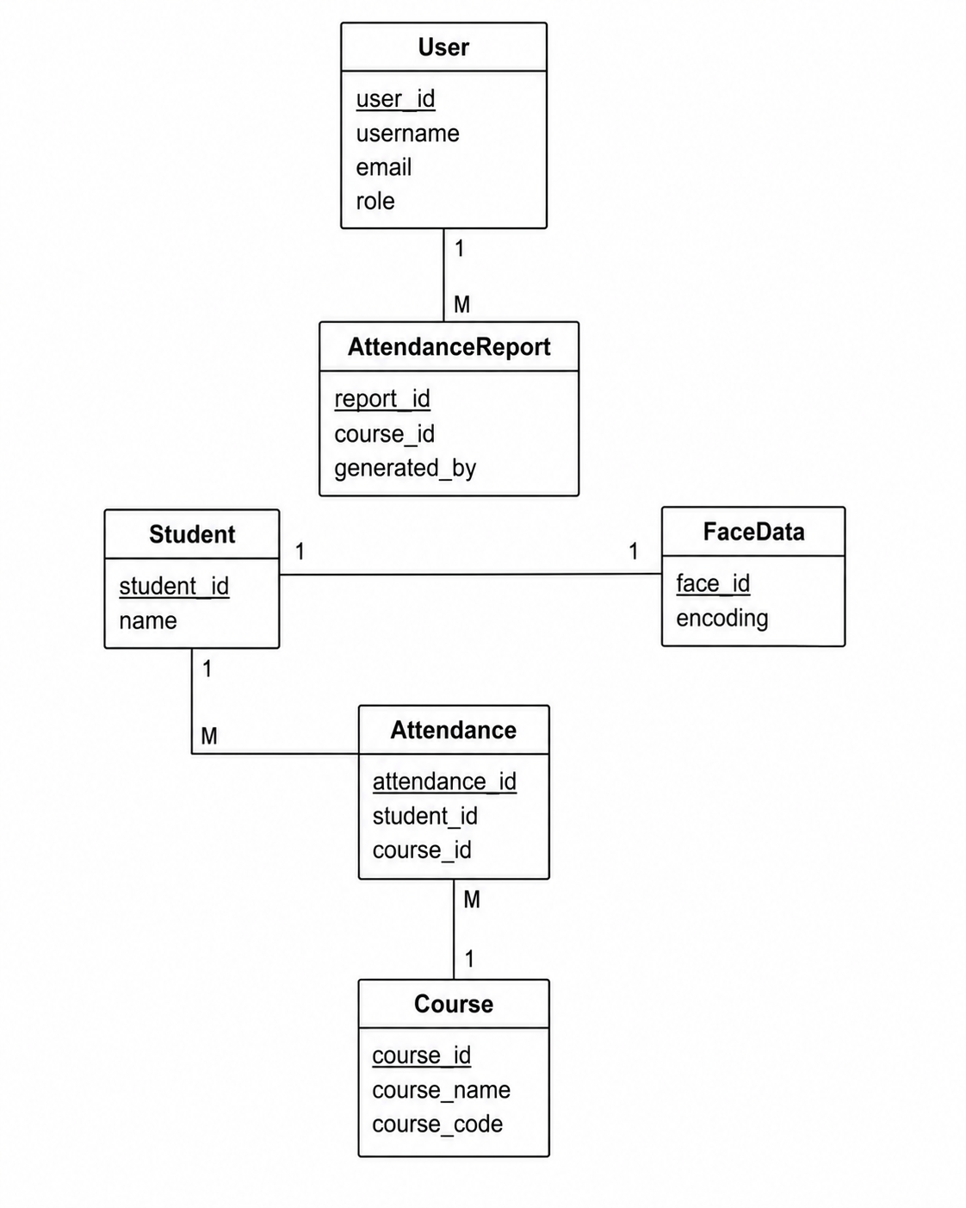

2.8 Database Design Considerations
The database schema has been designed according to relational database principles and normalization standards.
The design incorporates:
- Primary Key constraints for unique identification.
- Foreign Key constraints for referential integrity.
- One-to-One relationship between Student and FaceData.
- One-to-Many relationships between Student and Attendance.
- One-to-Many relationships between Course and Attendance.
- Secure storage of authentication credentials.
- Efficient querying for attendance reports and analytics.
- Prevention of duplicate attendance records.
This database design provides a reliable foundation for accurate facial recognition, automated attendance management, and future system scalability.

The Secure Web-Based Online Voting System relies on a relational database structure designed to ensure data integrity, consistency, and efficient retrieval of election-related information. The database schema consists of several interconnected entities that collectively support user authentication, election management, candidate administration, vote processing, and result generation.
The conceptual data model establishes relationships between users, elections, candidates, and votes while enforcing business rules such as one-vote-per-user and secure vote storage. The following entities form the core of the database design.

- User Interface
The user interface of the Automatic Attendance System Using Face Recognition is designed to provide a simple, efficient, and user-friendly experience for students, teachers, and administrators. The interface emphasizes ease of navigation, quick access to attendance information, and seamless interaction with the facial recognition module. The design focuses on minimizing user effort while ensuring that attendance-related operations can be performed accurately and efficiently.

3.1 Design Philosophy
The system follows a modern and professional design approach that prioritizes usability, accessibility, and responsiveness. Since the application may be used frequently by academic staff and students, the interface is designed to be clean, intuitive, and visually organized.

Color Scheme
The proposed color palette includes:
- Primary Color: Dark Blue (#1E3A8A)
- Secondary Color: Sky Blue (#3B82F6)
- Background Color: White (#FFFFFF)
- Success Color: Green (#22C55E)
- Warning/Error Color: Red (#EF4444)
The selected colors promote professionalism, trust, and readability while providing clear visual feedback to users.

Typography
The system will utilize modern web fonts such as:
- Poppins
- Roboto
- Arial (Fallback)
These fonts provide excellent readability across different devices and screen sizes.

Responsiveness
The system will support:
- Desktop Computers
- Laptops
- Tablets
- Mobile Devices
Bootstrap's responsive grid system will be utilized to ensure consistent user experience across different screen resolutions.

3.2 Screen List
The application consists of the following screens:
- Login Page
- Registration Page
- Administrator Dashboard
- Student Management Page
- Face Enrollment Page
- Attendance Capture Page
- Attendance Records Page
- Course Management Page
- Attendance Report Page
- User Profile Page

3.3 Login Page

Purpose
Allows authorized users to access the system.

Data Displayed
- System Logo
- Login Form
- Error Messages

Controls
Control | Type | Purpose
Email Address | Textbox | User email
Password | Password Field | User password
Login | Button | Authenticate user
Forgot Password | Hyperlink | Password recovery

Input Constraints
- Email must follow valid email format.
- Password cannot be empty.
- User credentials must exist in the system.

3.4 Registration Page

Purpose
Allows administrators to create user accounts.

Data Displayed
- User Registration Form

Controls
Control | Type | Purpose
Full Name | Textbox | User name
Email | Textbox | User email
Password | Password Field | User password
Confirm Password | Password Field | Password verification
Role | Drop Down | Admin or Teacher
Register | Button | Submit registration

Input Constraints
- All fields are mandatory.
- Password must contain at least 8 characters.
- Password and Confirm Password must match.

3.5 Administrator Dashboard

Purpose
Provides administrators with an overview of the system.

Data Displayed
- Total Students
- Total Courses
- Today's Attendance
- Attendance Statistics

Controls
Control | Type | Purpose
Manage Students | Button | Student management
Manage Courses | Button | Course management
Attendance Reports | Button | View reports
Logout | Button | End session

Input Constraints
- Accessible only to authenticated administrators.

3.6 Student Management Page

Purpose
Allows administrators to manage student information.

Data Displayed
- Student List
- Registration Information

Controls
Control | Type | Purpose
Registration Number | Textbox | Student ID
Full Name | Textbox | Student name
Department | Textbox | Department
Semester | Drop Down | Current semester
Save Student | Button | Store information
Update Student | Button | Modify student data
Delete Student | Button | Remove student

Input Constraints
- Registration number must be unique.
- Name field cannot be empty.
- Semester value must be valid.

3.7 Face Enrollment Page

Purpose
Registers student facial data for recognition.

Data Displayed
- Live Camera Feed
- Student Information

Controls
Control | Type | Purpose
Start Camera | Button | Activate webcam
Capture Face | Button | Capture facial image
Save Face Data | Button | Store face encoding
Retake Image | Button | Capture new image

Input Constraints
- Student record must exist before enrollment.
- Face must be clearly visible.
- Adequate lighting conditions required.

3.8 Attendance Capture Page

Purpose
Automatically records attendance using facial recognition.

Data Displayed
- Live Video Feed
- Recognized Student Information
- Attendance Status

Controls
Control | Type | Purpose
Start Attendance | Button | Activate recognition system
Stop Attendance | Button | End attendance session
Refresh | Button | Reload recognition module

Input Constraints
- Camera device must be available.
- Student must be previously enrolled.
- Attendance can only be marked once per session.

3.9 Attendance Records Page

Purpose
Displays attendance history of students.

Data Displayed
- Student Name
- Course Name
- Attendance Date
- Attendance Status

Controls
Control | Type | Purpose
Search | Textbox | Search records
Filter Course | Drop Down | Course selection
Filter Date | Date Picker | Date filtering
Export Data | Button | Download records

Input Constraints
- Date range must be valid.
- Course must exist in the system.

3.10 Course Management Page

Purpose
Allows administrators to manage courses.

Data Displayed
- Course List
- Instructor Information

Controls
Control | Type | Purpose
Course Name | Textbox | Course title
Course Code | Textbox | Unique course code
Instructor Name | Textbox | Assigned instructor
Save Course | Button | Store course
Update Course | Button | Modify course
Delete Course | Button | Remove course

Input Constraints
- Course code must be unique.
- Course name cannot be empty.

3.11 Attendance Report Page

Purpose
Generates attendance summaries and analytical reports.

Data Displayed
- Attendance Statistics
- Student Attendance Percentage
- Course Attendance Summary

Controls
Control | Type | Purpose
Select Course | Drop Down | Course selection
Select Date Range | Date Picker | Report duration
Generate Report | Button | Create report
Export PDF | Button | Download PDF report
Export Excel | Button | Download Excel report

Input Constraints
- Date range must be valid.
- Course selection is required.

3.12 User Profile Page

Purpose
Allows users to view and update personal information.

Data Displayed
- User Details
- Account Information

Controls
Control | Type | Purpose
Name | Textbox | Update name
Email | Textbox | Update email
Change Password | Button | Update password
Save Changes | Button | Store modifications

Input Constraints
- Email must be unique.
- Password must satisfy security requirements.

3.13 User Interface Design Considerations
The user interface is designed according to the following principles:
- Simplicity and ease of use.
- Consistent navigation across all pages.
- Responsive design for multiple devices.
- Real-time feedback during attendance processing.
- Clear validation and error messages.
- Accessibility and readability.
- Secure user interactions.
- Minimal training requirements for end users.
These design considerations ensure that administrators, teachers, and students can effectively interact with the system while maintaining accuracy, usability, and security throughout the attendance management process.

4. References
[1] Django Software Foundation. "Django: The Web Framework for Perfectionists with Deadlines." Django Project. https://www.djangoproject.com/ (accessed Apr. 30, 2026).
[2] Oracle Corporation. "MySQL: The World's Most Popular Open Source Database." MySQL. https://www.mysql.com/ (accessed Apr. 30, 2026).
[3] OpenCV Team. "OpenCV: Open Source Computer Vision Library." OpenCV.org. https://opencv.org/ (accessed Apr. 30, 2026).
[4] Adam Geitgey. "Face Recognition Library for Python." GitHub Repository. https://github.com/ageitgey/face_recognition (accessed Apr. 30, 2026).
[5] NumPy Developers. "NumPy: Fundamental Package for Scientific Computing in Python." NumPy.org. https://numpy.org/ (accessed Apr. 30, 2026).
[6] Bootstrap Team. "Bootstrap: Powerful, Extensible, and Feature-Packed Frontend Toolkit." https://getbootstrap.com/ (accessed Apr. 30, 2026).
[7] Mozilla Foundation. "JavaScript Guide." MDN Web Docs. https://developer.mozilla.org/en-US/docs/Web/JavaScript (accessed Apr. 30, 2026).
[8] W3C. "HTML Standard." World Wide Web Consortium. https://html.spec.whatwg.org/ (accessed Apr. 30, 2026).
[9] W3C. "CSS Cascading Style Sheets." World Wide Web Consortium. https://www.w3.org/Style/CSS/ (accessed Apr. 30, 2026).
[10] Object Management Group (OMG). "Unified Modeling Language (UML)." https://www.uml.org/ (accessed Apr. 30, 2026).
[11] IEEE Computer Society. "IEEE Recommended Practice for Architectural Description of Software-Intensive Systems." IEEE Standards Association. https://ieeexplore.ieee.org/ (accessed Apr. 30, 2026).
[12] Richard Szeliski. Computer Vision: Algorithms and Applications, 2nd Edition. Springer, 2022.
[13] Ian Sommerville. Software Engineering, 10th Edition. Pearson Education, 2015.
[14] Elmasri, R., & Navathe, S. B. Fundamentals of Database Systems, 7th Edition. Pearson Education, 2016.
[15] Pressman, R. S., & Maxim, B. R. Software Engineering: A Practitioner's Approach, 9th Edition. McGraw-Hill Education, 2019.
[16] Nielsen, J. Usability Engineering. Morgan Kaufmann Publishers, 1993.
[17] Krug, S. Don't Make Me Think: A Common Sense Approach to Web Usability, 3rd Edition. New Riders Publishing, 2014.

