AI LAB
MINIMAX ALGORITHM AND ALPHA-BETA PRUNING
Submitted By
Maryam
Roll Number: SU-92-BSAIM-F-25-350
Subject: AI Lab
Document Name: Minimax_AI_Lab_Maryam_Final.docx

Lab Title: Comparing Minimax with Alpha-Beta Pruning on a Binary Game Tree

1. Problem Statement
This lab examines how a binary game tree is evaluated using the Minimax method. MAX chooses the larger score, while MIN chooses the smaller one. Alpha-Beta Pruning should produce the same final value as Minimax, but it can avoid checking branches that cannot affect the result.

2. Minimax Algorithm
Minimax works upward from the leaf nodes to the root. At a MAX node, the larger child score is selected. At a MIN node, the smaller child score is selected. Repeating these choices gives the best result for the player at the root.

2.1 Tree Diagram and Value Calculation
The diagram below presents the game tree digitally. The leaf scores are grouped in pairs, and their values are passed upward through the MAX and MIN levels.
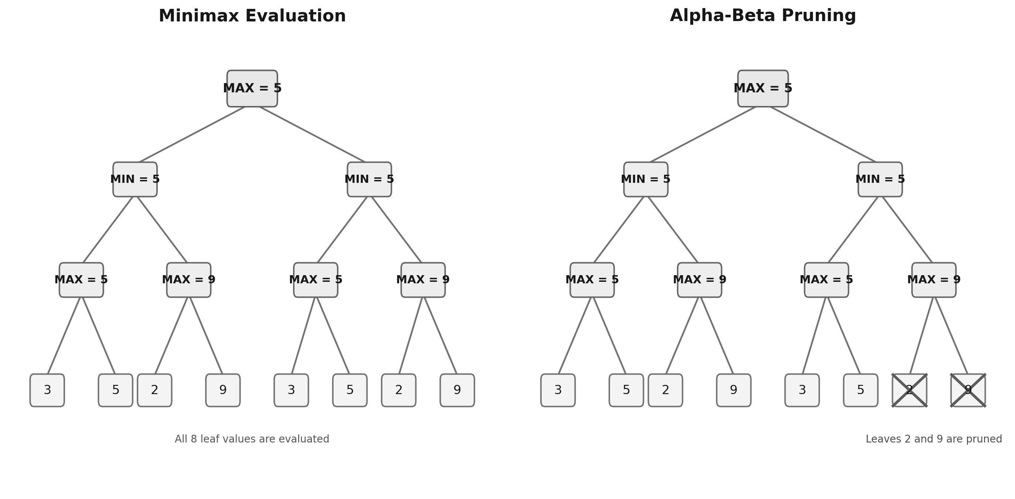
Figure 1. Clean digital representation of the Minimax tree and Alpha-Beta pruning.

2.2 Minimax Code
The code uses a recursive Minimax function to examine the tree. A counter is increased whenever a leaf is reached, allowing the program to report how many leaf nodes were checked.
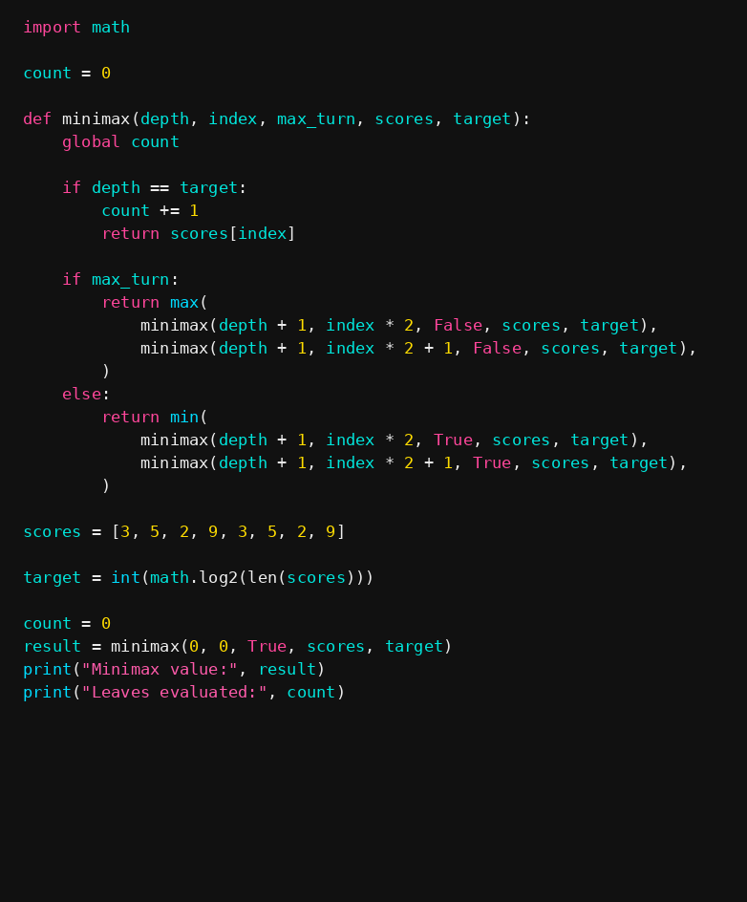
Figure 2. Minimax function and the test data used for evaluation.

2.3 Minimax Result
For the original ordering, the program gives a Minimax value of 5 after evaluating all 8 leaf nodes. The console result is shown below.
Figure 3. Minimax output from the program.

3. Alpha-Beta Pruning
Alpha-Beta Pruning makes Minimax more efficient by skipping parts of the tree when their values cannot change the final choice. Alpha stores MAX’s best lower bound so far, while beta stores MIN’s best upper bound.

3.1 Reading the Pruning Diagram
In the right-hand tree of Figure 1, the crossed-out leaves are not evaluated. Once the current bounds show that exploring a branch cannot improve the decision, the algorithm stops checking that branch. This reduces work without changing the root value.

3.2 Alpha-Beta Code
At MAX nodes, the algorithm updates alpha; at MIN nodes, it updates beta. If alpha becomes equal to or greater than beta, the remaining children of that branch are skipped.
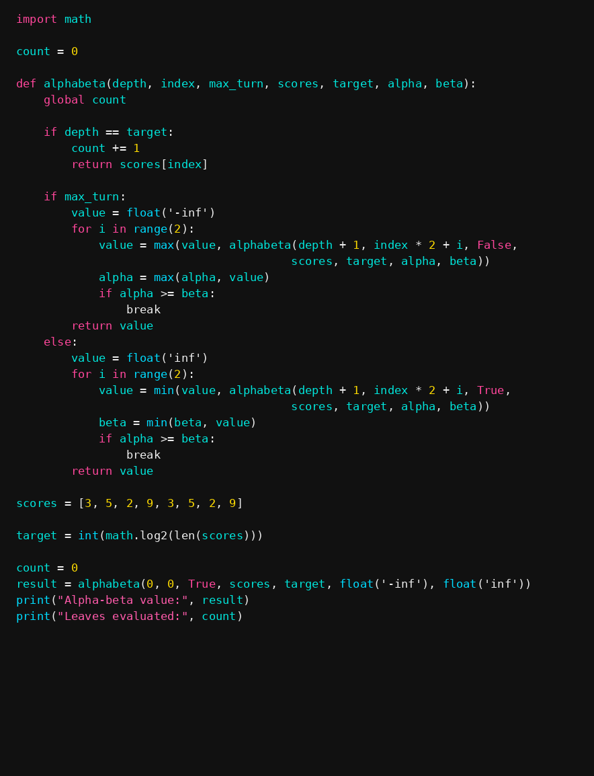
Figure 4. Alpha-Beta function and test cases.

3.3 Alpha-Beta Result
With the original leaf ordering, Alpha-Beta also returns 5. It checks only 6 leaves, so it reaches the same answer with fewer evaluations than standard Minimax.
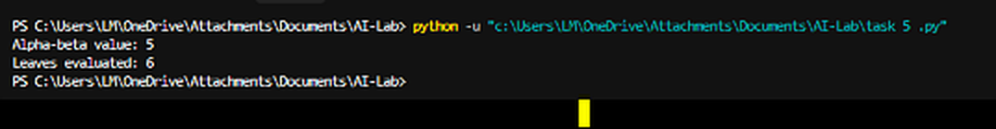
Figure 5. Alpha-Beta output from the program.

4. Comparison Table
The results below compare three leaf orderings. The reported Minimax value remains 5, while the number of leaves visited by Alpha-Beta depends on the order in which values are examined.
Test | Leaf Values | Minimax Value | Minimax Leaves | Alpha-Beta Leaves
Original | [3, 5, 2, 9, 3, 5, 2, 9] | 5 | 8 | 6
Reorder 1 | [9, 2, 5, 3, 3, 5, 3, 3] | 5 | 8 | 8
Reorder 2 | [2, 9, 3, 5, 2, 9, 3, 5] | 5 | 8 | 8

5. Edge Case Test
An additional test gives every leaf the same score: [5, 5, 5, 5, 5, 5, 5, 5]. Since all possible outcomes are equal, both algorithms should return 5.
Test Case | Expected Value | Observed Alpha-Beta Output
All leaf values equal | 5 | 5 (5 leaves evaluated, as recorded)

6. Interpretation
Both methods produce the same final value, 5, for the tests shown. Minimax evaluates all 8 leaves, whereas Alpha-Beta can skip leaves when alpha and beta prove that they are unnecessary. In the original ordering, Alpha-Beta checks 6 leaves; in the two reordered examples, it checks 8. Therefore, leaf order affects how much pruning occurs, but it does not change the reported Minimax result.

