Lab-3.R

Usuario

2024-08-30

#Laboratorio semana 3  
#María Fernanda González Rodríguez   
#2093400  
#30/08/2024  
  
Cuadro_1 <- read.csv ("C:\\Repositorios\\Met_Est_2024\\Laboratorios\\Cuadro_1.csv")  
  
#Selección de datos  
H.media <- which(Cuadro_1$Altura<=mean(Cuadro_1$Altura))  
H.media

## [1] 4 5 14 15 16 20 21 22 26 27 30 31 32 35 38 39 40 41 43 44 45 46 47 48

H.16 <- which(Cuadro_1$Altura<= mean(Cuadro_1$Altura))  
H.16

## [1] 4 5 14 15 16 20 21 22 26 27 30 31 32 35 38 39 40 41 43 44 45 46 47 48

#Vecinos  
Vecinos.3 <- which(Cuadro_1$Vecinos<=mean(Cuadro_1$Vecinos))  
Vecinos.3

## [1] 2 6 7 8 11 13 14 16 17 18 20 23 25 27 28 29 30 31 36 37 38 41 42 46 49  
## [26] 50

vecinos.4 <- which(Cuadro_1$Vecinos<=mean(Cuadro_1$Vecinos))  
vecinos.4

## [1] 2 6 7 8 11 13 14 16 17 18 20 23 25 27 28 29 30 31 36 37 38 41 42 46 49  
## [26] 50

#Diametro  
mean(Cuadro_1$Diametro)

## [1] 15.794

DBH.media <- which(Cuadro_1$Diametro<mean(Cuadro_1$Diametro))  
DBH.media

## [1] 1 4 5 6 11 12 16 19 21 24 28 31 32 33 34 35 39 40 41 42 44 45 46 47 48

DBH.16 <- which(Cuadro_1$Diametro>16)  
DBH.16

## [1] 2 3 7 8 9 10 13 14 15 17 18 20 22 23 25 27 29 30 36 37 38 43 49 50

DBH.16 <- which(Cuadro_1$Diametro>16)  
DBH.16

## [1] 2 3 7 8 9 10 13 14 15 17 18 20 22 23 25 27 29 30 36 37 38 43 49 50

#Histogramas  
hist(Cuadro_1$Altura, col = "lightpink")

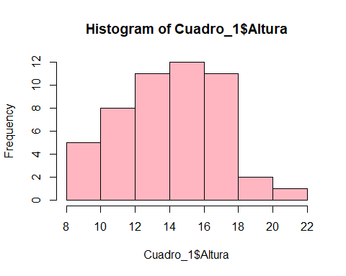

hist(H.media, col = "lightyellow")

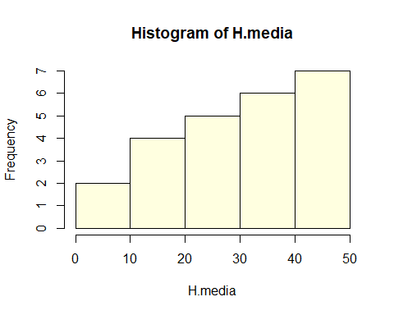

hist(H.16, col = "gray")

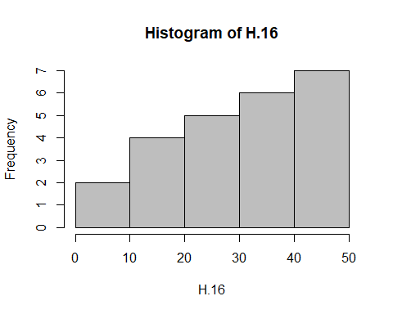

hist(Cuadro_1$Vecinos, col = "lightblue")

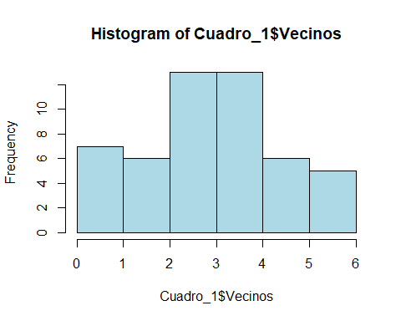

hist(Vecinos.3, col = "lightgreen")

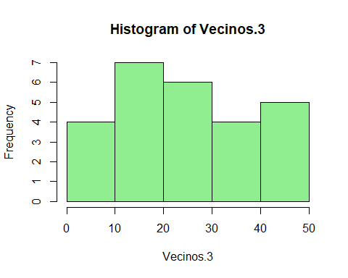

hist(vecinos.4, col = "purple")

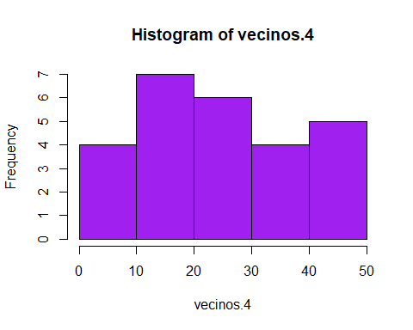

hist(Cuadro_1$Diametro, col = "red")

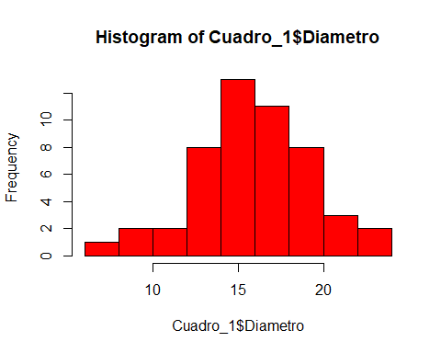

hist(DBH.media, col = "blue")

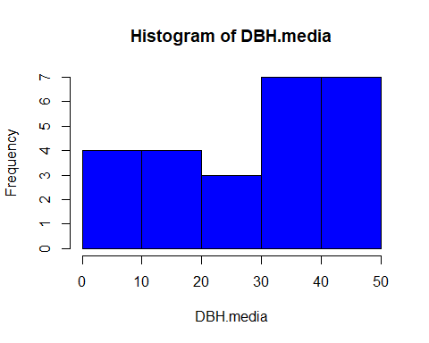

hist(DBH.16, col = "orange")

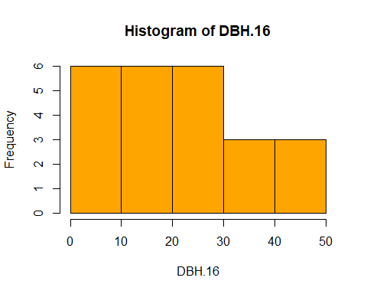

#Determinar la media  
mean(Cuadro_1$Altura)

## [1] 13.9432

mean(H.media)

## [1] 30.375

mean(H.16)

## [1] 30.375

mean(Cuadro_1$Vecinos)

## [1] 3.34

mean(Vecinos.3)

## [1] 25.53846

mean(vecinos.4)

## [1] 25.53846

mean(Cuadro_1$Diametro)

## [1] 15.794

mean(DBH.media)

## [1] 28.16

mean(DBH.16)

## [1] 22.70833