TCP/IP COMMUNICATION IN ACTION
Tracing a Secure HTTPS Website Request Across the TCP/IP Model
Project Report
TEAM-02 · FCDF-COHORT-11 · Level 1, Semester 1
Team Members
Maryjudith Chidinma Ogunaka — C11/26/FCDF/17151
Abdul Fatawu Umar — 2026/FCDF/16899
Selected Scenario: Opening a Secure Website (HTTPS)

1. Introduction
This report explains how information travels across a network using the TCP/IP model, using the scenario of a user opening a secure website (HTTPS). As junior network analysts, our task is to trace this communication end to end — from the moment a user types a web address to the moment the encrypted page is rendered in their browser — and to explain what happens at each of the four TCP/IP layers.
We selected this scenario because it touches every layer of the TCP/IP model in a single, everyday action: it involves name resolution (DNS), connection setup and reliability (TCP), logical addressing and routing (IP), and physical transmission (Ethernet/Wi-Fi). It also naturally introduces core cybersecurity concepts such as TLS encryption, certificates, and port-based filtering, making it a strong vehicle for both networking and security learning outcomes.
This report covers the function of each TCP/IP layer, the mapping between TCP/IP and the OSI model, the encapsulation and decapsulation process, addressing and port numbers, a protocol analysis table, a comparison of TCP and UDP, an original packet journey diagram, and a worked troubleshooting example for a realistic communication failure.

2. The TCP/IP Model
TCP/IP (Transmission Control Protocol / Internet Protocol) is the set of rules that governs how devices communicate over the internet. It organises communication into four layers, each with a distinct responsibility. Data moves down through these layers on the sending device, across the network, and back up through the same four layers on the receiving device.
Layer | Role
Application | Generates the user-facing request and interprets the response. The only layer users directly interact with.
Transport | Breaks data into segments, attaches port numbers, and governs reliable or best-effort delivery.
Internet | Attaches logical (IP) addresses and routes packets across networks toward their destination.
Network Access | Attaches physical (MAC) addresses and transmits bits across the physical medium (Wi-Fi, Ethernet, fibre).

3. Selected Scenario: Opening a Secure Website
Scenario: a user types https://www.amazon.com into a browser and presses Enter. The browser resolves the domain name, opens a secure (encrypted) connection to the web server, requests the page, and renders the response — all while using all four TCP/IP layers on both the client and the server.
High-level path: User → Browser → Home Router → ISP Network → Web Server, and back again along the same path for the response. This single request exercises addressing (IP), delivery and ports (TCP), routing (routers), and physical transmission (Wi-Fi/Ethernet) — which is why it is well suited to demonstrating the complete TCP/IP model.

4. Layer-by-Layer Analysis

4.1 Application Layer — Starting the Request
The Application Layer is where the user-facing request is generated and where the response is ultimately interpreted. In our scenario, the browser first uses DNS (Domain Name System) to resolve www.amazon.com to an IP address. It then builds an HTTPS request, using TLS to encrypt the request before it is handed to the Transport Layer. The destination port for this request is 443, the well-known port reserved for secure web traffic (HTTPS).
- Key protocols: HTTPS, HTTP, DNS, TLS
- Example request: GET / HTTP/1.1, Host: www.amazon.com, Destination Port: 443
- HTTPS (rather than plain HTTP) matters because TLS encrypts the request before it leaves this layer, protecting it from eavesdropping further down the stack.

4.2 Transport Layer — TCP Segmentation & Handshake
The Transport Layer breaks the application data into segments, attaches source and destination port numbers, and — because TCP is used — guarantees reliable, ordered, error-checked delivery. The source port is a randomly chosen ephemeral port on the client (for example 51322); the destination port is the server's well-known port 443.
Before any application data is sent, TCP performs a three-way handshake to establish the connection:
- 1. SYN — the client proposes a connection (source port 51322 → destination port 443).
- 2. SYN-ACK — the server acknowledges and proposes its own sequence number (443 → 51322).
- 3. ACK — the client confirms, and the connection is established.
Once the handshake completes, the client's HTTPS request is sent as one or more TCP segments.

4.3 Internet Layer — IP Addressing & Routing
The Internet Layer wraps each segment in an IP packet and attaches source and destination IP addresses — for example, source 192.168.1.10 (client) and destination 54.239.28.85 (server). Routers examine only the destination IP address and forward the packet hop by hop — from the client, to the home router, to the ISP's routers, and finally to the web server — along the best available path. The same source/destination IP pair is used for the reply, so the response can find its way back to the client.

4.4 Network Access Layer — Physical Transmission
The Network Access Layer wraps the IP packet in a frame and physically transmits it as bits across a medium such as Wi-Fi, Ethernet cable, or fibre. It uses MAC addresses — physical hardware addresses — to move the frame to the next device on the local network. Devices involved include the client's network interface card (NIC), the Wi-Fi access point, and the router or switch. This is the only layer that touches the physical medium; every layer above it is purely logical.

5. Encapsulation and Decapsulation
As data descends the sender's stack, each layer adds its own header — a process called encapsulation. The receiving device reverses this process on arrival, called decapsulation.
Layer | Encapsulation step (sender) | PDU
Application | Browser + TLS build the HTTPS request | Data
Transport | TCP adds a header with source/destination ports | Segment
Internet | IP adds a header with source/destination addresses | Packet
Network Access | Ethernet/Wi-Fi adds a header with source/destination MAC addresses, then transmits as bits | Frame → Bits
On the server side (decapsulation), the process happens in reverse: the frame is received and its MAC header is stripped; the packet is passed up and its IP header is stripped; the TCP segments are reassembled and the TCP header is stripped; and finally the raw HTTPS request is handed to the web application, where TLS decrypts it.

6. Protocol Analysis Table
Layer | Protocol | PDU | Addressing | Purpose
Application | HTTPS / DNS / TLS | Data | URL / domain name | Build and encrypt the request
Transport | TCP | Segment | Port 443 / ephemeral port | Reliable, ordered delivery
Internet | IP | Packet | Source / destination IP | Logical addressing and routing
Network Access | Ethernet / Wi-Fi | Frame | Source / destination MAC | Physical transmission

7. Mapping TCP/IP to the OSI Model
The four-layer TCP/IP model is a practical, condensed version of the seven-layer OSI reference model. OSI is a conceptual model used for teaching and vendor documentation; TCP/IP is the model actually implemented on the internet.
TCP/IP Layer | Corresponding OSI Layer(s) | Example in Our Scenario
Application | Application, Presentation, Session | Browser builds the HTTPS request; TLS session is negotiated
Transport | Transport | TCP segments the data; ports 443 and an ephemeral port are used
Internet | Network | IP addresses are attached; the router forwards the packet
Network Access | Data Link, Physical | A frame is built with a MAC address; bits are sent over Wi-Fi

8. TCP vs UDP — Choosing the Right Transport Protocol
TCP and UDP are the two transport-layer protocols used on the internet. The choice between them depends on whether an application needs guaranteed, ordered delivery or low-latency, best-effort delivery.
Criterion | TCP (Transmission Control Protocol) | UDP (User Datagram Protocol)
Connection type | Connection-oriented (three-way handshake) | Connectionless (no handshake)
Reliability | Guaranteed delivery, with retransmission | Best-effort — no delivery guarantee
Ordering | Data arrives in the order it was sent | No guaranteed order
Speed | Slower — overhead from reliability checks | Faster — minimal overhead
Header size | 20 bytes (larger) | 8 bytes (smaller)
Used in our scenario for | The HTTPS web request, on port 443 | Not used — HTTPS needs guaranteed, ordered delivery
Typical application examples | Email (SMTP), file transfer (FTP) | Video streaming, VoIP calls, online gaming, DNS queries

9. Original Diagram: The Complete Packet Journey
The diagram below (originally designed for the slide presentation) illustrates the full request/response journey. Data travels down the client's four-layer stack, across the internet, and up the server's stack for the request — then the reverse path returns the response.
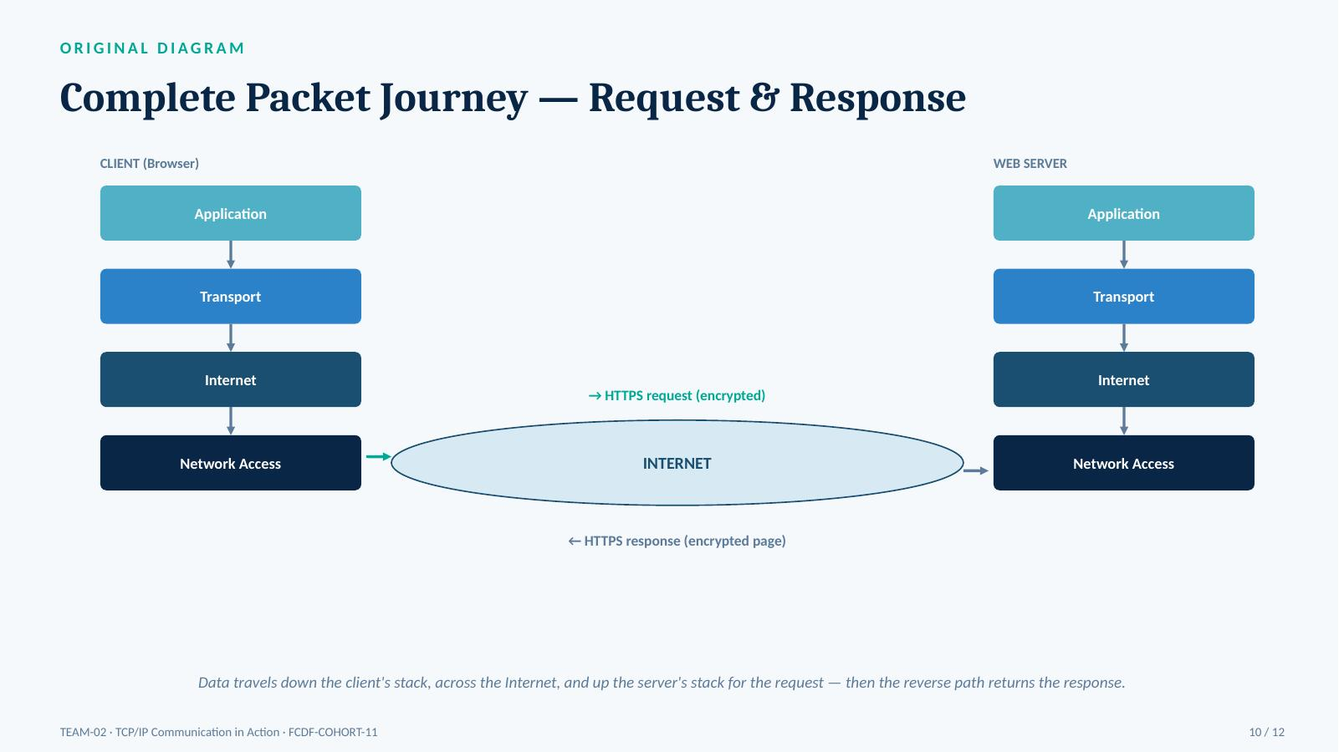
Figure 1. Complete packet journey — request and response across the TCP/IP stack.

10. Troubleshooting a Communication Failure
Failure scenario: the user's browser shows “This site can’t be reached” when opening https://www.amazon.com. The following layer-by-layer approach isolates the fault quickly rather than guessing.
Step | Layer | Check | What it tells us
1 | Network Access | Confirm physical connectivity — check the Wi-Fi/Ethernet link and adapter status; retry on another network if needed. | Confirms local connectivity is working
2 | Internet | Verify IP configuration — run ipconfig/ifconfig and ping the default gateway. | Confirms the device has a valid IP address
3 | Application (DNS) | Test DNS resolution — run nslookup www.amazon.com. | Rules out a domain-name resolution problem
4 | Transport | Check port and firewall — confirm port 443 is not blocked locally or by the ISP (telnet / Test-NetConnection). | Reveals a blocked TCP handshake
5 | Transport | Inspect the TCP handshake — capture traffic (e.g., Wireshark) to see if SYN/SYN-ACK/ACK completes. | Confirms whether the connection can be established
6 | Application (TLS) | Validate the TLS certificate — check for an expired or invalid certificate on the server. | Confirms encryption can be negotiated
In a realistic case for this scenario, the most likely root cause is an outbound firewall rule blocking port 443. Updating the rule to permit port 443 and retesting the connection resolves the failure.

11. Conclusion
- TCP/IP's four layers each add a specific header, enabling reliable end-to-end communication.
- Ports (443/ephemeral) and IP/MAC addresses together get data to the right application on the right device.
- TCP trades speed for reliability — the right choice for HTTPS; UDP trades reliability for speed — right for streaming, VoIP, gaming and DNS.
- The OSI model maps cleanly onto TCP/IP and gives a more detailed vocabulary for the same process.
- A layer-by-layer troubleshooting approach (physical → IP → DNS → port → handshake → TLS) isolates failures quickly.

References
- IETF. RFC 9293 — Transmission Control Protocol (TCP). Official Internet standard. https://www.rfc-editor.org/rfc/rfc9293
- Cisco Networking Academy. Introduction to Networks — The OSI and TCP/IP Models. https://www.netacad.com
- Cloudflare Learning Center. What Happens When You Type a URL Into Your Browser? https://www.cloudflare.com/learning
- MDN Web Docs (Mozilla). An Overview of HTTP. https://developer.mozilla.org

Team Contribution Record
Member | Slides / Sections | Contribution
Maryjudith Chidinma Ogunaka  (C11/26/FCDF/17151) | Slides 1 - 7 | Researched and wrote the introduction, TCP/IP model overview, scenario, and the Application, Transport, Internet and Network Access layer sections.
Abdul Fatawu Umar  (2026/FCDF/16899) | Slides 8 - 13 | Researched and wrote the encapsulation/decapsulation section, OSI mapping, protocol analysis table, TCP vs UDP comparison, packet journey diagram, troubleshooting, and conclusion.
Note: each member also submits an individual contribution declaration separately through the portal, as required by the project brief.

