Base R Graphics Cheat Sheet

David Gerard

August 8, 2017

# Abstract:

I reproduce some of the plots from Rstudio’s [ggplot2](https://www.rstudio.com/wp-content/uploads/2015/03/ggplot2-cheatsheet.pdf) cheat sheet using Base R graphics. I didn’t try to pretty up these plots, but **you should**.

I use this dataset

data(mpg, package = "ggplot2")

# General Considerations

The main functions that I generally use for plotting are

* Plotting Functions
  + plot: Makes scatterplots, line plots, among other plots.
  + lines: Adds lines to an already-made plot.
  + par: Change plotting options.
  + hist: Makes a histogram.
  + boxplot: Makes a boxplot.
  + text: Adds text to an already-made plot.
  + legend: Adds a legend to an already-made plot.
  + mosaicplot: Makes a mosaic plot.
  + barplot: Makes a bar plot.
  + jitter: Adds a small value to data (so points don’t overlap on a plot).
  + rug: Adds a rugplot to an already-made plot.
  + polygon: Adds a shape to an already-made plot.
  + points: Adds a scatterplot to an already-made plot.
  + mtext: Adds text on the edges of an already-made plot.
* Sometimes needed to transform data (or make new data) to make appropriate plots:
  + table: Builds frequency and two-way tables.
  + density: Calculates the density.
  + loess: Calculates a smooth line.
  + predict: Predicts new values based on a model.

All of the plotting functions have arguments that control the way the plot looks. You should read about these arguments. In particular, read carefully the help page ?plot.default. Useful ones are:

* main: This controls the title.
* xlab, ylab: These control the x and y axis labels.
* col: This will control the color of the lines/points/areas.
* cex: This will control the size of points.
* pch: The type of point (circle, dot, triangle, etc…)
* lwd: Line width.
* lty: Line type (solid, dashed, dotted, etc…).

# One Variable

## Continuous

Density plot

density_object <- density(mpg$hwy)  
plot(density_object)

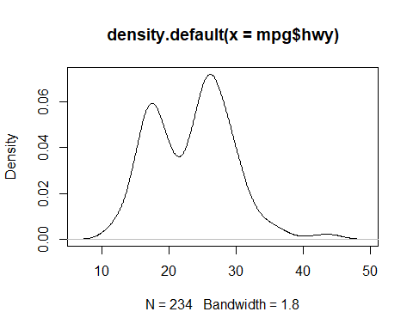

Histogram

hist(mpg$hwy, breaks = 10)

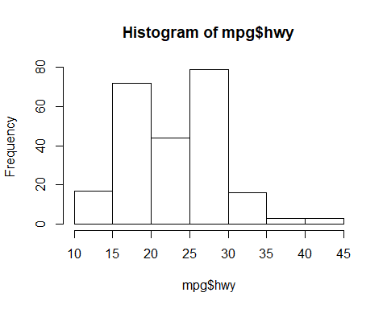

## Discrete

Barplot

tabdat <- table(mpg$drv)  
barplot(tabdat)

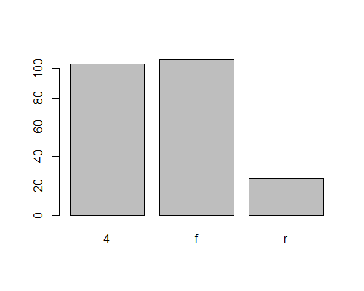

Different type of bar plot

plot(tabdat)

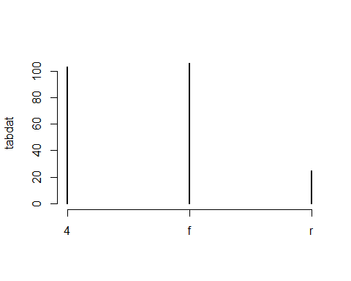

# Two Variables

## Continuous X, Continuous Y

Scatterplot

plot(mpg$cty, mpg$hwy)

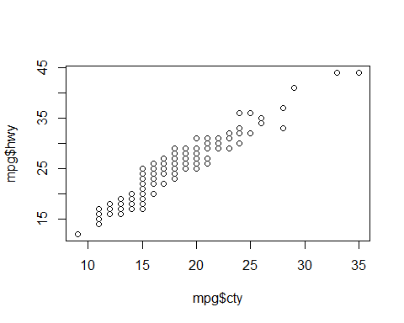

Jitter points to account for overlaying points.

x <- jitter(mpg$cty)  
y <- jitter(mpg$hwy)  
plot(x, y)

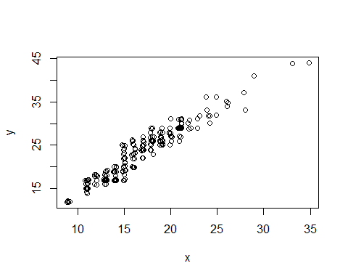

Add a rug plot

plot(x, y)  
rug(x, side = 1)  
rug(y, side = 2)

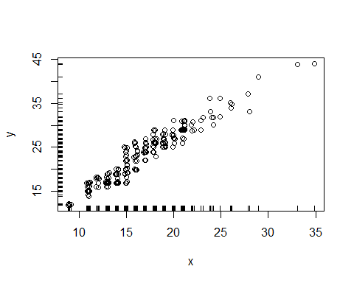

Add a Loess Smoother

loess_fit <- loess(hwy ~ cty, data = mpg)  
xnew <- seq(min(x), max(x), length = 100)  
ynew <- predict(object = loess_fit, newdata = data.frame(cty = xnew))  
plot(x, y)  
lines(xnew, ynew, col = 2, lty = 2)

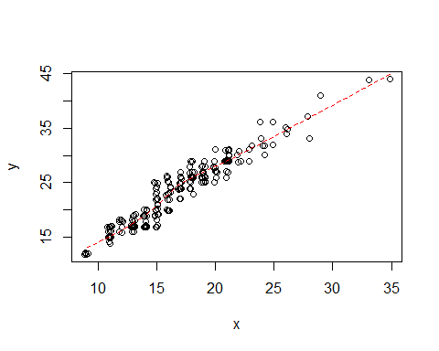

Loess smoother with upper and lower 95% confidence bands

loess_fit <- loess(hwy ~ cty, data = mpg)  
xnew <- seq(min(x), max(x), length = 100)  
pfit <- predict(object = loess_fit, newdata = data.frame(cty = xnew), se = TRUE)  
ynew <- pfit$fit  
upper_bound <- pfit$fit + qnorm(0.975) * pfit$se.fit  
lower_bound <- pfit$fit - qnorm(0.975) * pfit$se.fit  
plot(x, y)  
lines(xnew, ynew, col = 2, lty = 2)  
lines(xnew, upper_bound, col = 4, lty = 2)  
lines(xnew, lower_bound, col = 4, lty = 2)

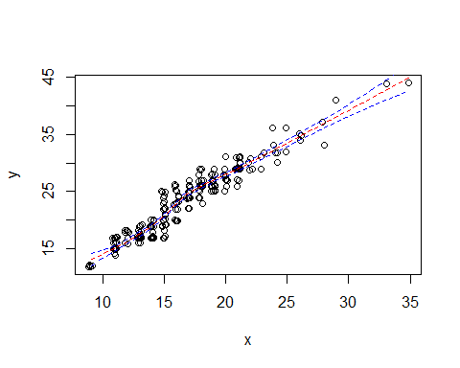

Loess smoother with upper and lower 95% confidence bands and that fancy shading from ggplot2.

loess_fit <- loess(hwy ~ cty, data = mpg)  
xnew <- seq(min(x), max(x), length = 100)  
pfit <- predict(object = loess_fit, newdata = data.frame(cty = xnew), se = TRUE)  
ynew <- pfit$fit  
upper_bound <- pfit$fit + qnorm(0.975) * pfit$se.fit  
lower_bound <- pfit$fit - qnorm(0.975) * pfit$se.fit  
xshade <- c(xnew, xnew[length(xnew):1])  
yshade <- c(upper_bound, lower_bound[length(lower_bound):1])  
plot(x, y)  
lines(xnew, ynew, col = 2, lty = 2)  
polygon(xshade, yshade, col = "#0000FF33", border = FALSE)

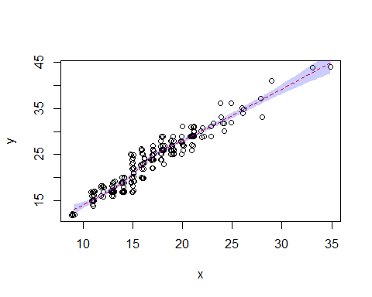

Add text to a plot

plot(x, y)  
text(15, 40, "some text")

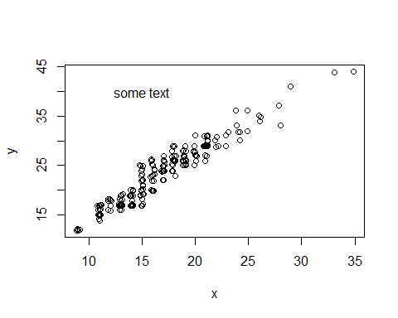

## Discrete X, Continuous Y

Boxplot

boxplot(hwy ~ class, data = mpg)

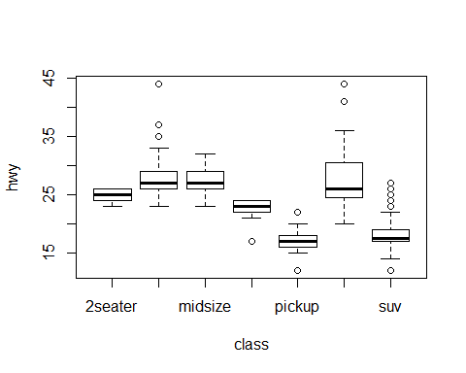

## Discrete X, Discrete Y

Mosaic Plot

tabdat <- table(mpg$fl, mpg$drv)  
mosaicplot(tabdat, color = TRUE)

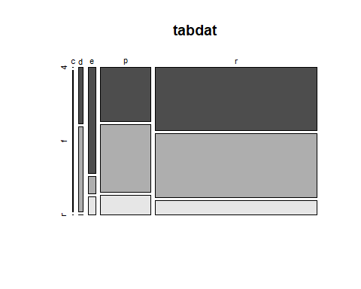

## Continuous Function

Line plot

f <- function(x) {  
 return(x ^ 2)  
}  
  
x <- seq(-2, 2, length = 100)  
y <- f(x)  
plot(x, y, type = "l")

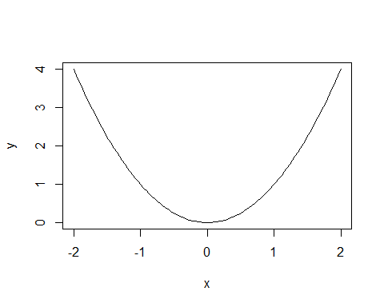

# Color Coding and Legends

Color code a scatterplot by a categorical variable and add a legend.

x <- jitter(mpg$hwy)  
y <- jitter(mpg$cty)  
z <- factor(mpg$drv)  
plot(x, y, col = z)  
legend("topleft", legend = levels(z), col = 1:nlevels(z), pch = 1, title = "Drive")

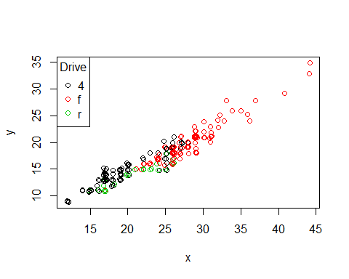

# Faceting

par sets the graphics options, where mfrow is the parameter controling the facets.

old_options <- par(mfrow = c(2, 3))  
plot(mpg$cty, mpg$hwy)  
hist(mpg$cty)  
plot(density(mpg$cty))  
plot(table(mpg$fl))  
barplot(table(mpg$fl))  
plot(table(mpg$fl, mpg$drv))

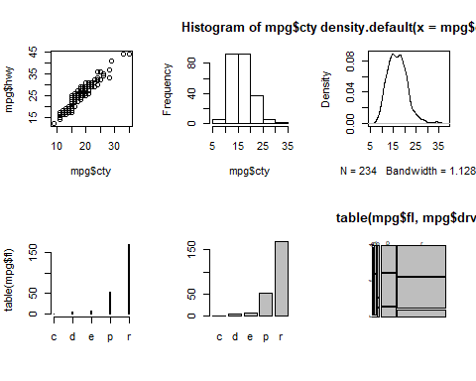

par(old_options)

The first line sets the new options and saves the old options in the list old_options. The last line reinstates the old options.