test_flextable

Marylene Henry

23 mars 2019

## R Markdown

This is an R Markdown document. Markdown is a simple formatting syntax for authoring HTML, PDF, and MS Word documents. For more details on using R Markdown see <http://rmarkdown.rstudio.com>.

When you click the **Knit** button a document will be generated that includes both content as well as the output of any embedded R code chunks within the document. You can embed an R code chunk like this:

summary(cars)

## speed dist   
## Min. : 4.0 Min. : 2.00   
## 1st Qu.:12.0 1st Qu.: 26.00   
## Median :15.0 Median : 36.00   
## Mean :15.4 Mean : 42.98   
## 3rd Qu.:19.0 3rd Qu.: 56.00   
## Max. :25.0 Max. :120.00

## Including Plots

You can also embed plots, for example:

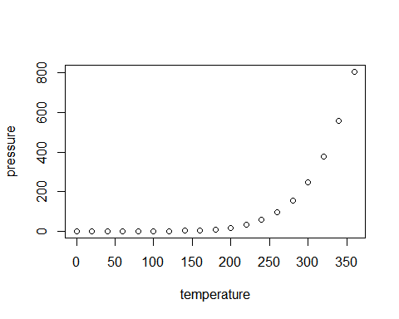

Note that the echo = FALSE parameter was added to the code chunk to prevent printing of the R code that generated the plot.

## Test

Entete 1

Entete 2

Cellule 1 de la ligne 2

Cellule 2 de la ligne 2

library(flextable)

## Warning: package 'flextable' was built under R version 3.5.3

library(officer)  
  
ft <- flextable(head(mtcars))  
ft <- theme_booktabs(ft)  
ft <- autofit(ft)  
doc <- read_docx()  
doc <- body_add_flextable(doc, value = ft)  
print(doc, target = "example.docx")

## [1] "C:/Users/maryl/Urfist/dataviz_avancee/example.docx"

library(kableExtra)  
library(flextable)  
library(officer)  
  
# a <- kable(mtcars[1:5, ], "html") %>%  
# kable_styling("striped") %>%  
# row_spec(1, color = "red")  
a <- flextable(head(mtcars))  
a <- theme_booktabs(ft)  
a <- autofit(ft)  
aa <- read_docx()  
aa <- body_add_flextable(aa, value = a)  
print(aa, target = "test_flextable.docx")  
  
#   
# kable(mtcars, "latex") %>%  
# kable_styling(latex_options = "striped") %>%  
# save_kable("test.png")

| mpg | cyl | disp | hp | drat | wt | qsec | vs | am | gear | carb |
| --- | --- | --- | --- | --- | --- | --- | --- | --- | --- | --- |
| 21.000 | 6.000 | 160.000 | 110.000 | 3.900 | 2.620 | 16.460 | 0.000 | 1.000 | 4.000 | 4.000 |
| 21.000 | 6.000 | 160.000 | 110.000 | 3.900 | 2.875 | 17.020 | 0.000 | 1.000 | 4.000 | 4.000 |
| 22.800 | 4.000 | 108.000 | 93.000 | 3.850 | 2.320 | 18.610 | 1.000 | 1.000 | 4.000 | 1.000 |
| 21.400 | 6.000 | 258.000 | 110.000 | 3.080 | 3.215 | 19.440 | 1.000 | 0.000 | 3.000 | 1.000 |
| 18.700 | 8.000 | 360.000 | 175.000 | 3.150 | 3.440 | 17.020 | 0.000 | 0.000 | 3.000 | 2.000 |
| 18.100 | 6.000 | 225.000 | 105.000 | 2.760 | 3.460 | 20.220 | 1.000 | 0.000 | 3.000 | 1.000 |