Course work
By Maryna Maksimava

0 The topic is Specialty food items or gourmet treats.
1.1
Inventory.StockLevel is the number of items on a date when this information was recorded.
Order.TotalAmount is the total cost of the items ordered. Order_details table represents a list of items in an order. All the other things on a scheme are self-explanatory.

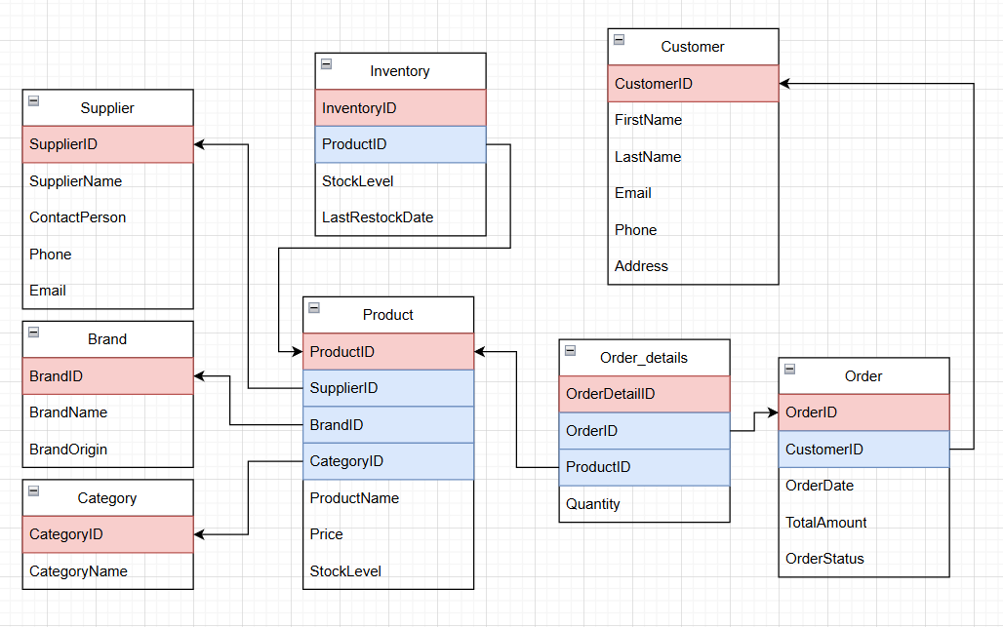
OLTP schema

OLTP_creation file shows the script for creating the database.
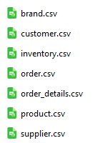

1.2 The Data_Files folder should be located at C:\\Program Files\\PostgreSQL\\16\\data\\Data_Files’.

These are the data files prepared --->

1.3 In ETL1 folder You can find the folder with data files and the script for filling the OLTP database with this data.
When doing the ETL1 process for the first time run Staging_Tables script and then ETL1 script. On every next ETL1 process just use ETL1 script alone.

2.1
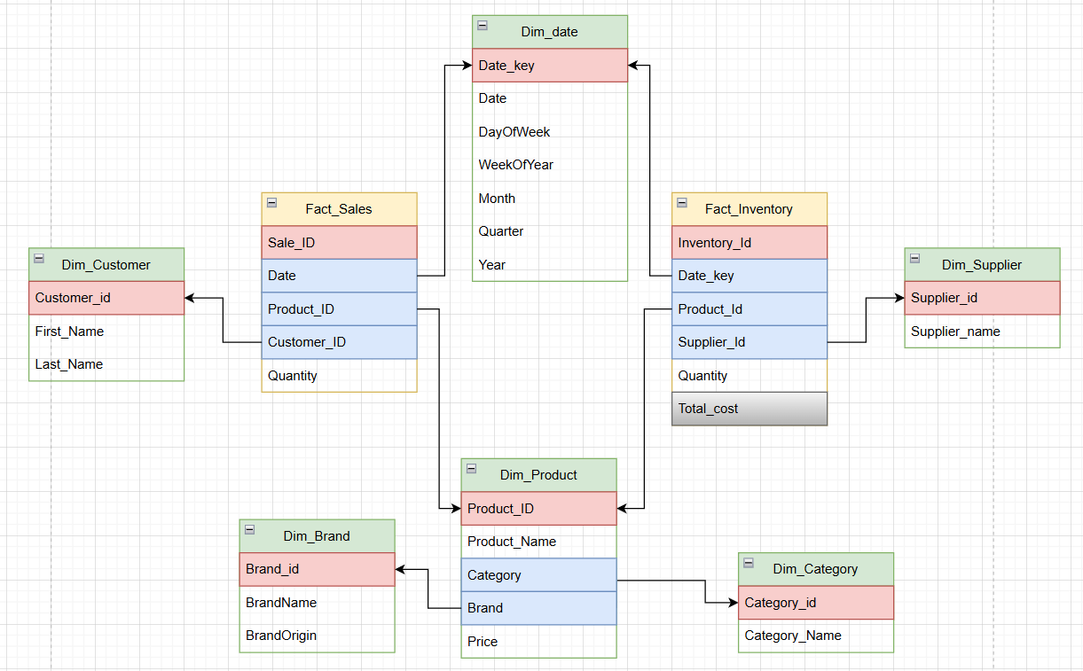
OLAP scheme

2 facts ✓
Fact_Inventory is SCD 2 ✓
Total_cost is an aggregation. Fact_Sales is an aggregation on Order and Order_Details ✓

All the details from OLTP that are not needed for analysis are omitted (like supplier contact person etc.).

In OLAP folder there is OLAP_creation script.

2.2 After that ETL2 process from ETL2 folder should be executed. It is able to get data from oltp_db without storing the same information twice. Fact_inventory stores both the old and the new row if the information was changed.

2.3 olap_export from OLAP folder can be executed to get OLAP tables in csv format. I use this way to add the data to PowerBI.

The Visuals are in OLAP_Stats
Measures:
- Full name
- Total cost of sold products

Visuals:
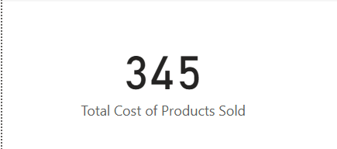
- Title

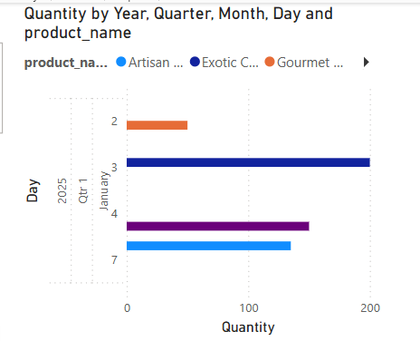
2 Line chart of amount stored by product

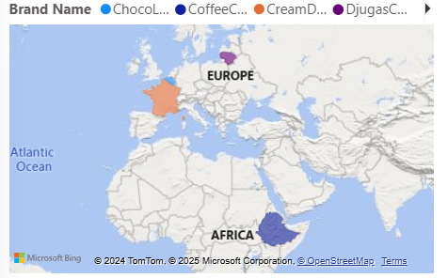
3 Brand origins are shown on map

4 Donut chart of money earned on each category
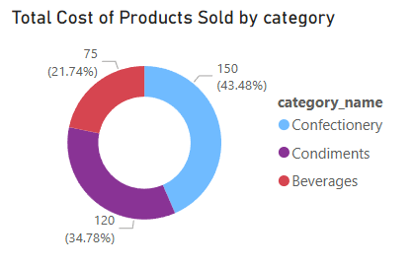

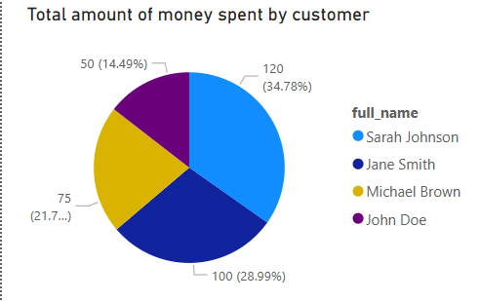
5 Pie that shows who is the best customer

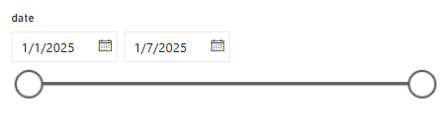
6

Date slicer

7 Brand tile slicer

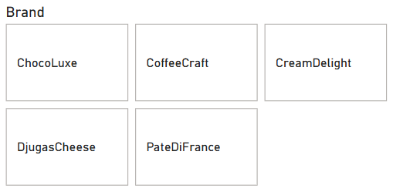

3.1 The queries for the OLTP are in OLTP folder
3.2 The queries for the OLAP are in OLAP folder

