1:

import json

def lambda_handler(event, context):

if "body" in event:
payload = json.loads(event["body"])
else:
payload = event

print(" Parsed JSON keys and values:")
for key, value in payload.items():
print(f"Value for the key {key} : {value}")

return {
"statusCode": 200,
"body": json.dumps(payload)
}

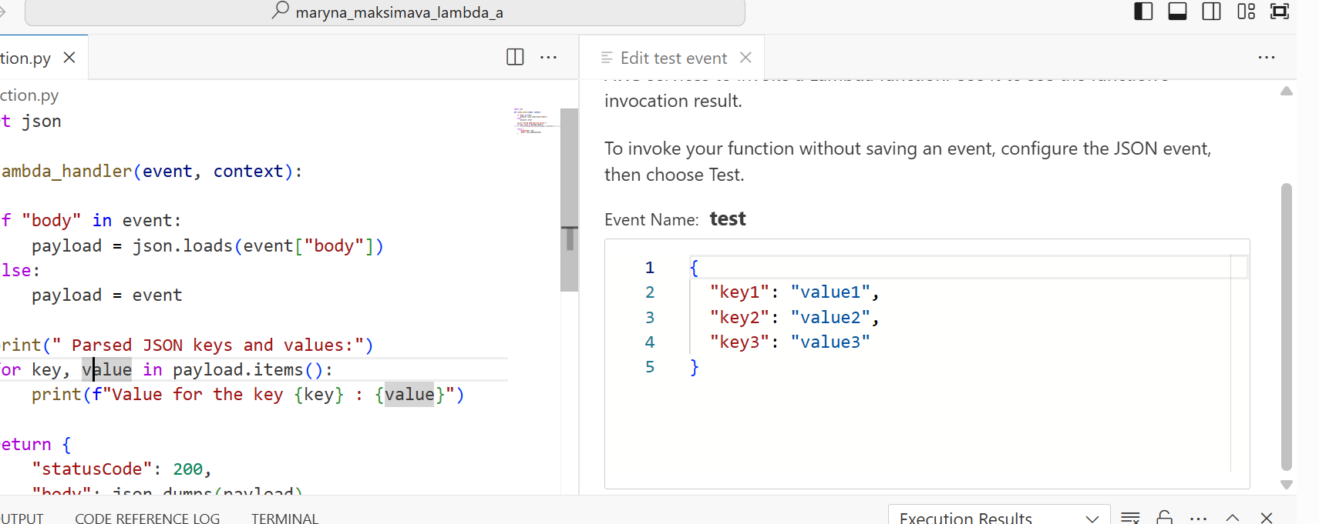
https://eu-central-1.console.aws.amazon.com/lambda/home?region=eu-central-1#/functions/maryna_maksimava_lambda_a?tab=code

deployed function 1 and the test.

Configured setting for step functions
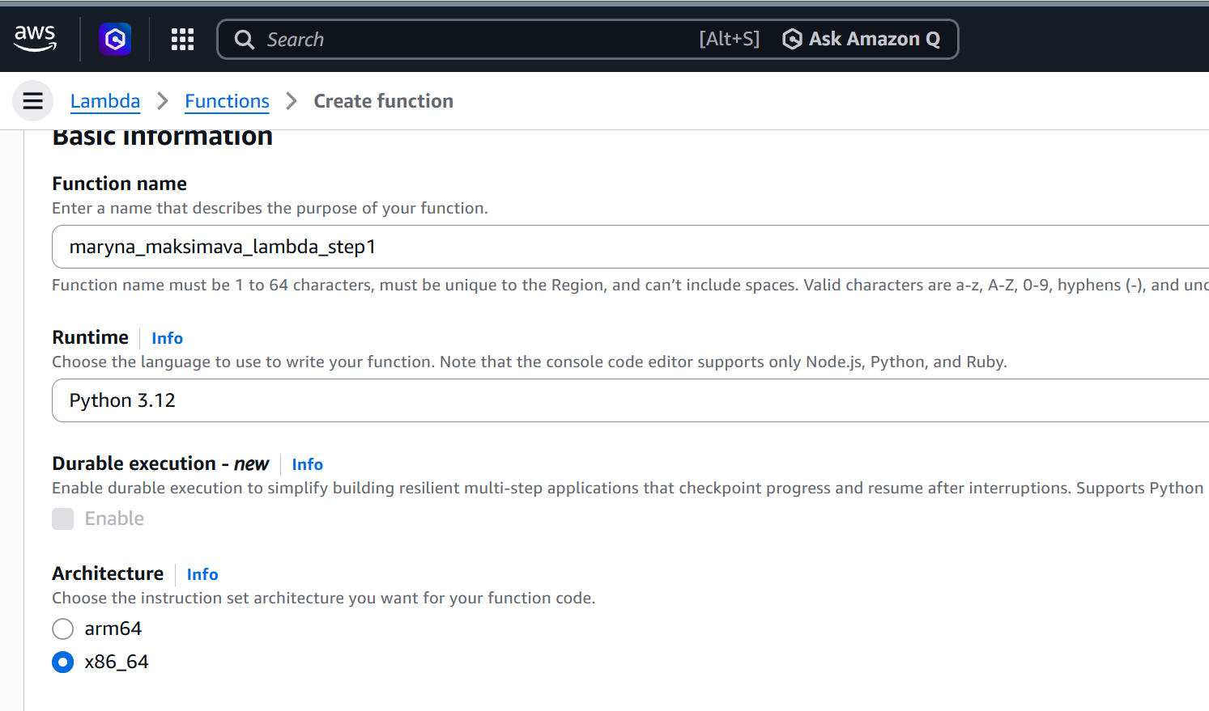

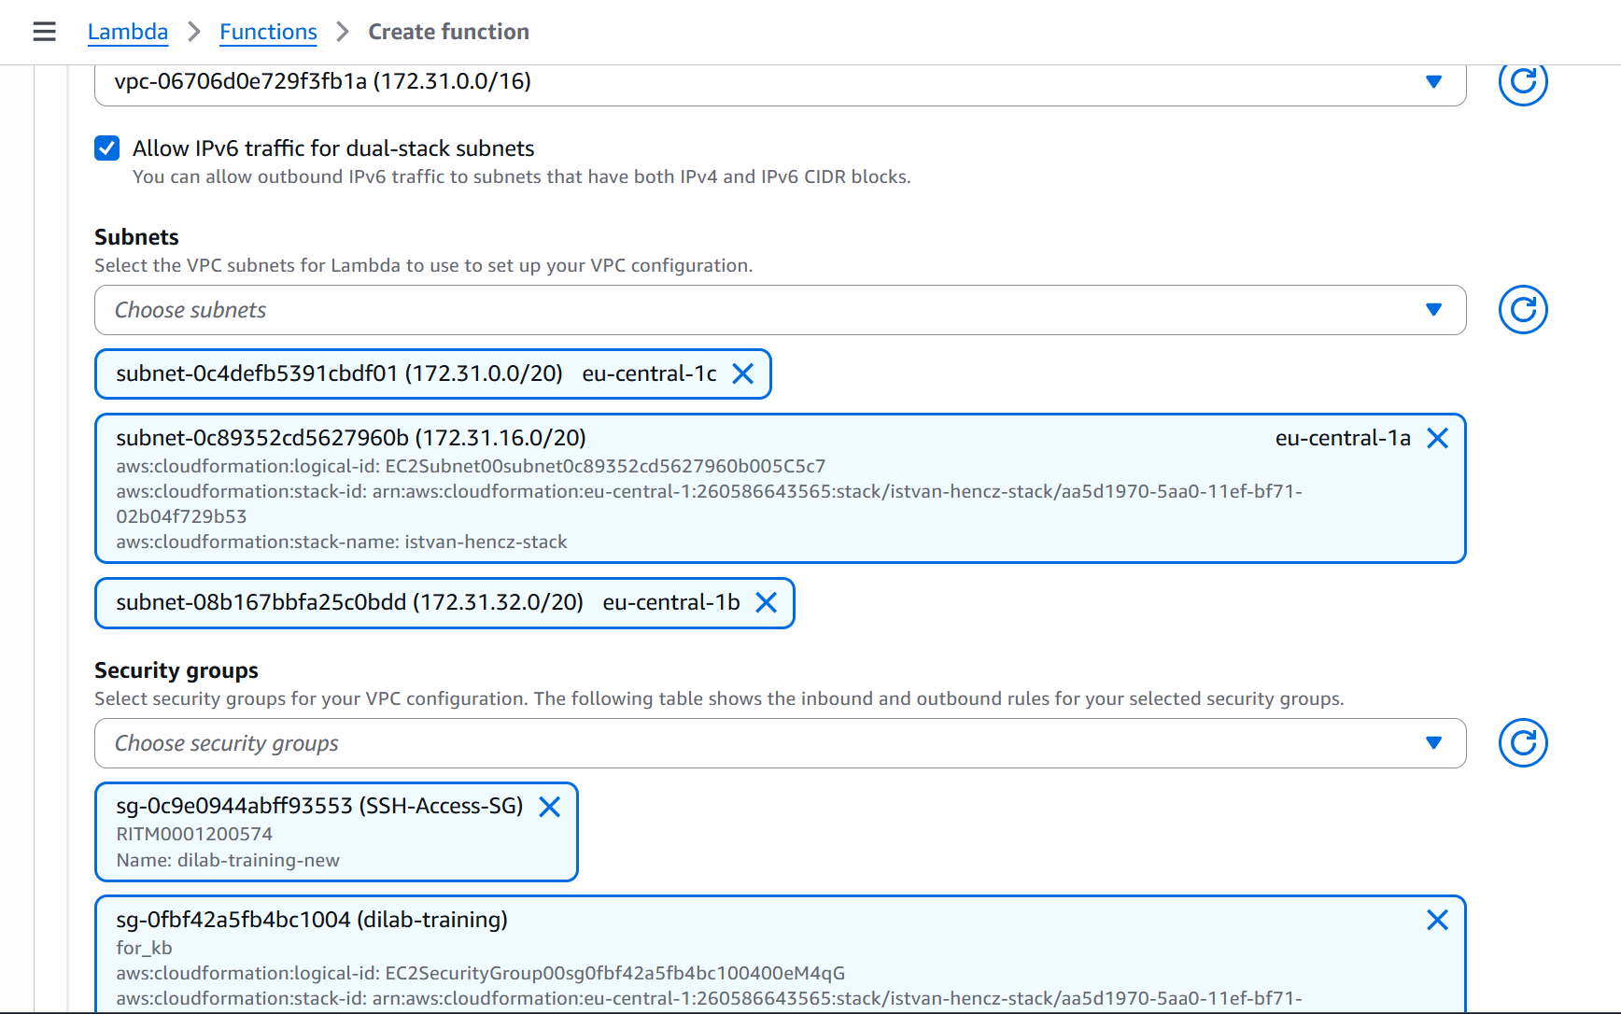

func1:

import json
import boto3
import time

def lambda_handler(event, context):
client = boto3.client('athena')

response = client.start_query_execution(
QueryString='SELECT COUNT(*) FROM maryna_test_iceberg;',
QueryExecutionContext={
'Database': 'maryna_maksimava_bl_dm_db'
},
ResultConfiguration={
'OutputLocation': 's3://maryna-maksimava-bl-dm-dwh-bucket/athena-results/'
}
)

queryExecutionId = response['QueryExecutionId']
status_response = client.get_query_execution(QueryExecutionId=queryExecutionId)

while status_response['QueryExecution']['Status']['State'].lower() not in ('succeeded', 'failed'):
time.sleep(15)
status_response = client.get_query_execution(QueryExecutionId=queryExecutionId)
print(status_response['QueryExecution']['Status']['State'])

results = client.get_query_results(QueryExecutionId=queryExecutionId)

# Row 0 is header, row 1 is the actual count
row_count = int(results['ResultSet']['Rows'][1]['Data'][0]['VarCharValue'])
print(f'Row count: {row_count}')

test1_passed = row_count > 0
print(f'Test 1 passed: {test1_passed}')

return {
'test1_passed': test1_passed,
'row_count': row_count
}

---------
func 2:
import json
import boto3
import time

def lambda_handler(event, context):
client = boto3.client('athena')

response = client.start_query_execution(
QueryString="""
UPDATE maryna_test_iceberg
SET name = 'updated_by_lambda'
WHERE id = 1;
""",
QueryExecutionContext={
'Database': 'maryna_maksimava_bl_dm_db'
},
ResultConfiguration={
'OutputLocation': 's3://maryna-maksimava-bl-dm-dwh-bucket/athena-results/'
}
)

queryExecutionId = response['QueryExecutionId']
status_response = client.get_query_execution(QueryExecutionId=queryExecutionId)

while status_response['QueryExecution']['Status']['State'].lower() not in ('succeeded', 'failed'):
time.sleep(15)
status_response = client.get_query_execution(QueryExecutionId=queryExecutionId)
print(status_response['QueryExecution']['Status']['State'])

final_state = status_response['QueryExecution']['Status']['State']
print(f'UPDATE query state: {final_state}')

return {
'test1_passed': event.get('test1_passed', False),
'update_done': final_state.lower() == 'succeeded'
}

-------------------
func3:

import json
import boto3
import time

def lambda_handler(event, context):
client = boto3.client('athena')

response = client.start_query_execution(
QueryString="""
SELECT name
FROM maryna_test_iceberg
WHERE id = 1
LIMIT 1;
""",
QueryExecutionContext={
'Database': 'maryna_maksimava_bl_dm_db'
},
ResultConfiguration={
'OutputLocation': 's3://maryna-maksimava-bl-dm-dwh-bucket/athena-results/'
}
)

queryExecutionId = response['QueryExecutionId']
status_response = client.get_query_execution(QueryExecutionId=queryExecutionId)

while status_response['QueryExecution']['Status']['State'].lower() not in ('succeeded', 'failed'):
time.sleep(15)
status_response = client.get_query_execution(QueryExecutionId=queryExecutionId)
print(status_response['QueryExecution']['Status']['State'])

results = client.get_query_results(QueryExecutionId=queryExecutionId)

# Row 0 is header, row 1 is data
actual_value = results['ResultSet']['Rows'][1]['Data'][0]['VarCharValue']
print(f'name after update: {actual_value}')

test2_passed = (actual_value == 'updated_by_lambda')
print(f'Test 2 passed: {test2_passed}')

both_passed = event.get('test1_passed', False) and test2_passed

return {
'test1_passed': event.get('test1_passed', False),
'test2_passed': test2_passed,
'both_passed': both_passed
}

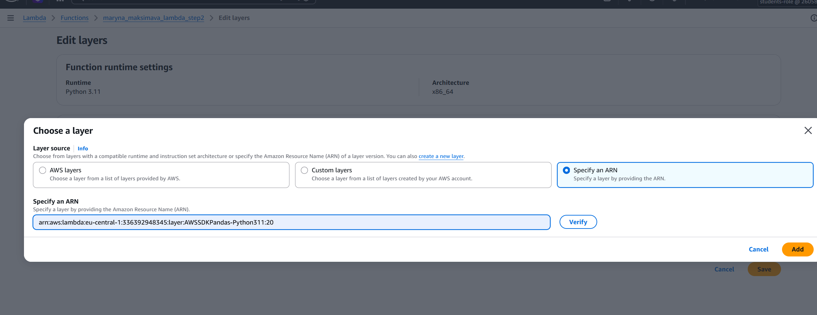
Adding layer.

https://eu-central-1.console.aws.amazon.com/lambda/home?region=eu-central-1#/functions/maryna_maksimava_lambda_step1?tab=configure

https://eu-central-1.console.aws.amazon.com/lambda/home?region=eu-central-1#/functions/maryna_maksimava_lambda_step3?tab=configure

https://eu-central-1.console.aws.amazon.com/lambda/home?region=eu-central-1#/functions/maryna_maksimava_lambda_step2?subtab=general&tab=configure
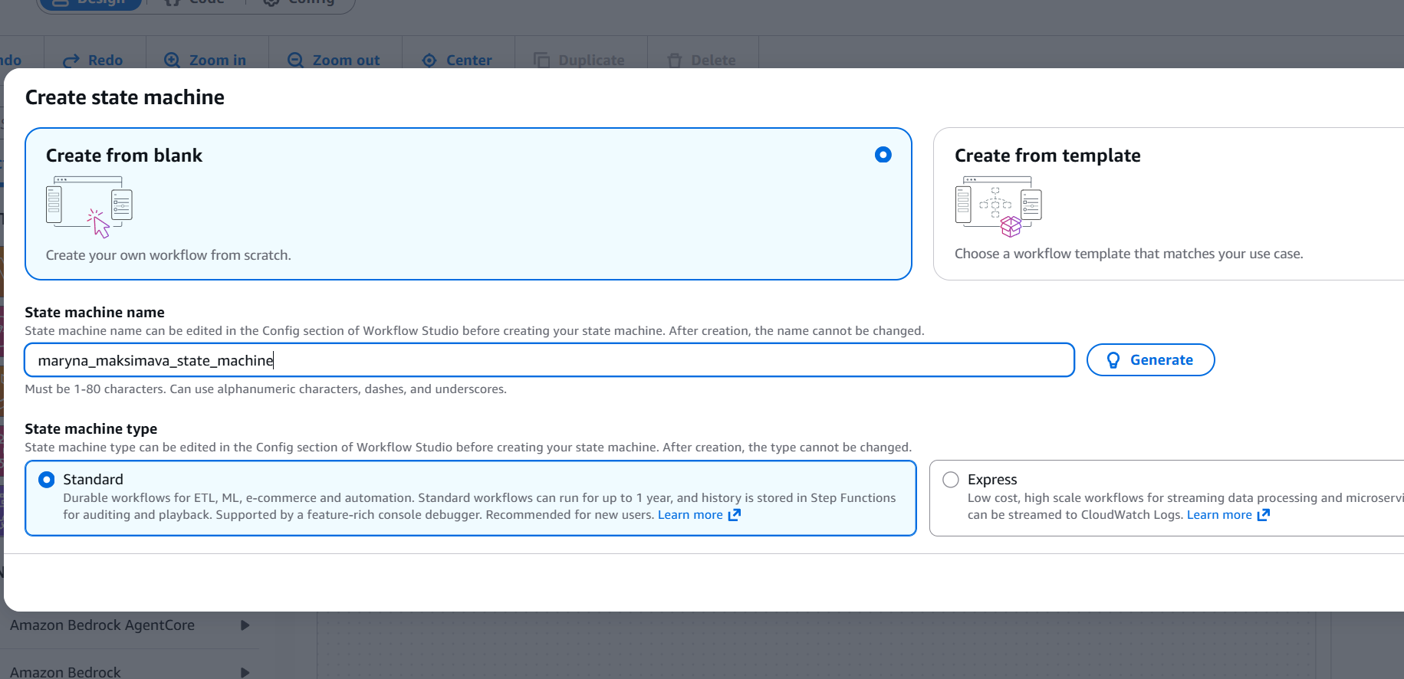
Created a state machine

https://eu-central-1.console.aws.amazon.com/states/home?region=eu-central-1#/v2/executions/details/arn:aws:states:eu-central-1:260586643565:execution:maryna_maksimava_state_machine:d5df33be-223a-45b8-a80d-f17300b0f794

{
"Comment": "First Redshift test → update → second test → check both",
"StartAt": "FirstRedshiftTest",
"States": {
"FirstRedshiftTest": {
"Type": "Task",
"Resource": "arn:aws:lambda:eu-central-1:260586643565:function:maryna_maksimava_lambda_step1",
"Next": "UpdateRedshiftData",
"Catch": [
{
"ErrorEquals": [
"States.ALL"
],
"Next": "SomeTestsFailed"
}
]
},
"UpdateRedshiftData": {
"Type": "Task",
"Resource": "arn:aws:lambda:eu-central-1:260586643565:function:maryna_maksimava_lambda_step2",
"Next": "SecondRedshiftTest",
"Catch": [
{
"ErrorEquals": [
"States.ALL"
],
"Next": "SomeTestsFailed"
}
]
},
"SecondRedshiftTest": {
"Type": "Task",
"Resource": "arn:aws:lambda:eu-central-1:260586643565:function:maryna_maksimava_lambda_step3",
"Next": "CheckBothTests",
"Catch": [
{
"ErrorEquals": [
"States.ALL"
],
"Next": "SomeTestsFailed"
}
]
},
"CheckBothTests": {
"Type": "Choice",
"Choices": [
{
"Variable": "$.both_passed",
"BooleanEquals": true,
"Next": "BothTestsPassed"
}
],
"Default": "SomeTestsFailed"
},
"BothTestsPassed": {
"Type": "Succeed"
},
"SomeTestsFailed": {
"Type": "Fail",
"Error": "TestsFailed",
"Cause": "One or more Athena/Iceberg tests did not pass."
}
}
}

