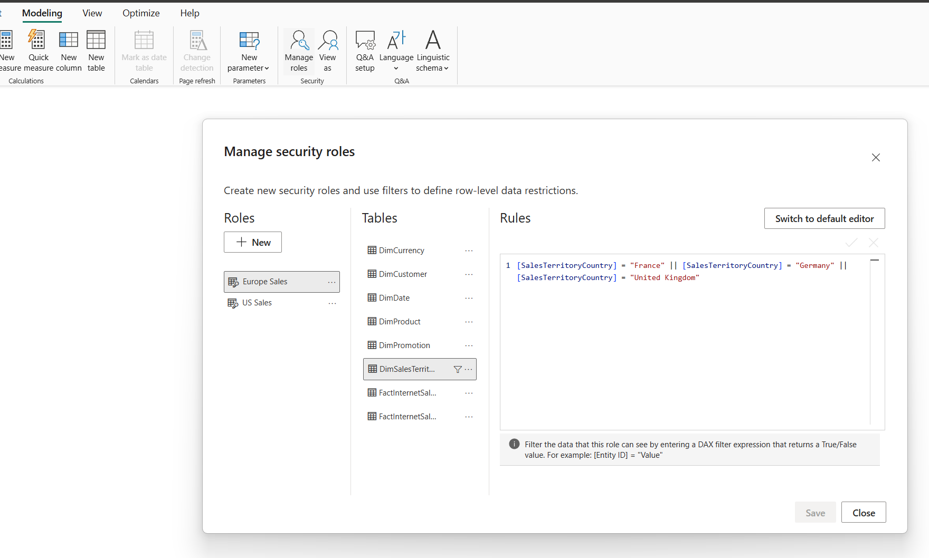
1
In the modeling I clicked on Manage roles and created roles for US and European analysts.

When viewing as Europe Sales the report shows 8M total sales instead of 29M without the role and other visuals show only Europe data too.
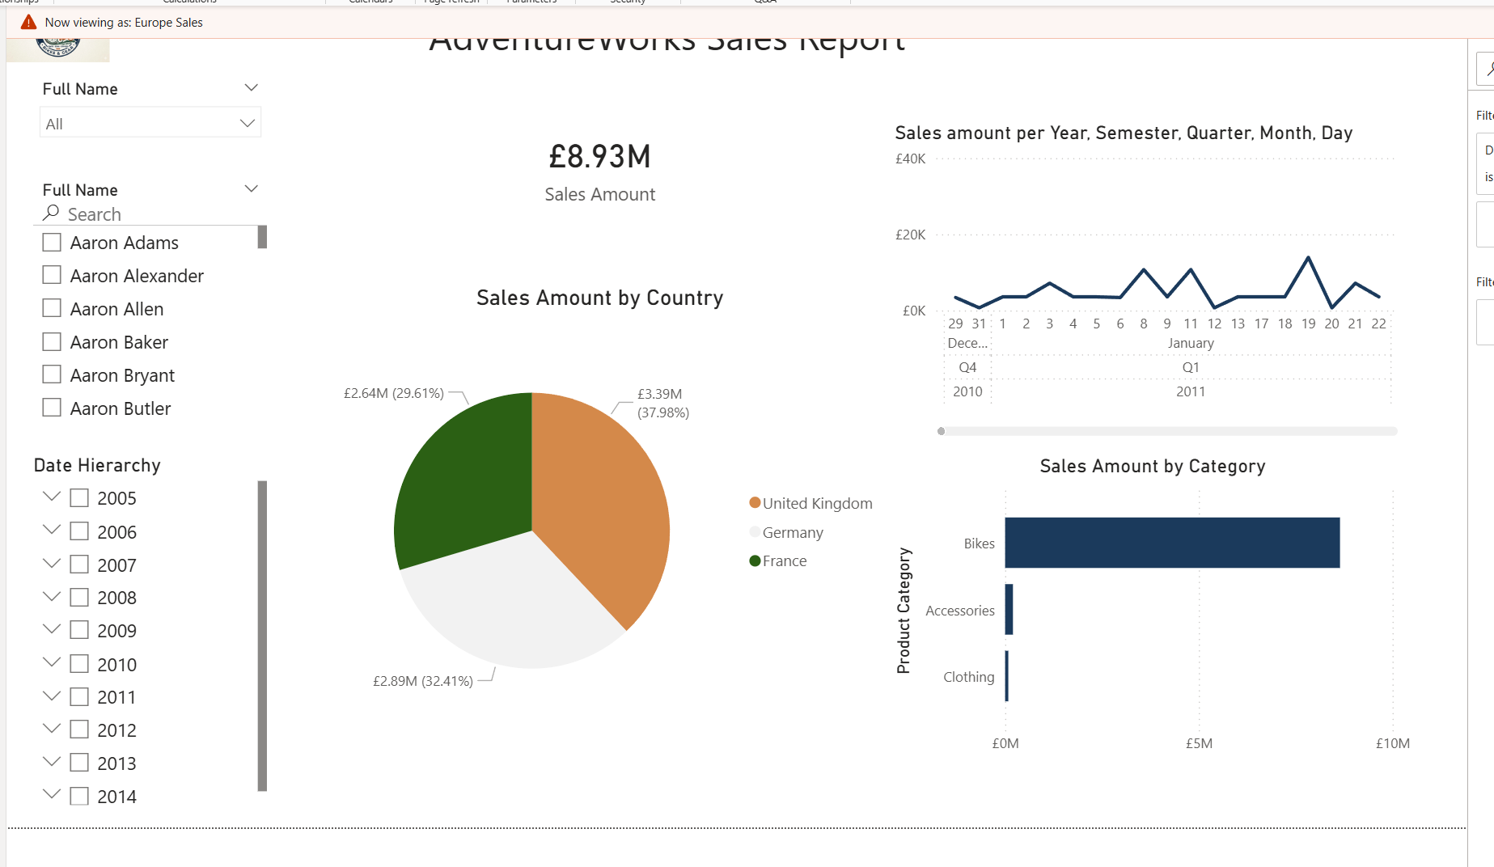

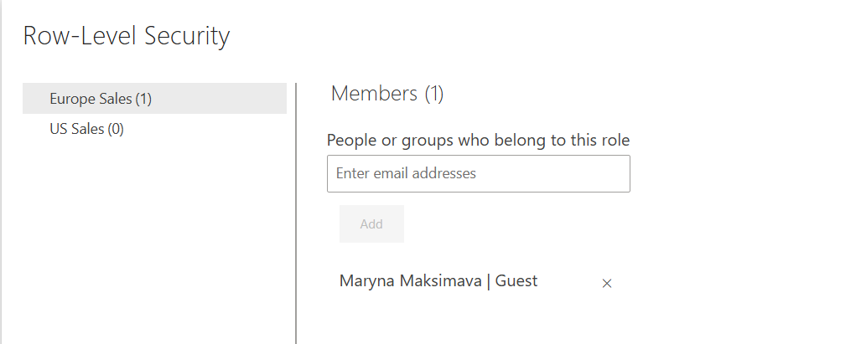

Added my other account.

-----------
2
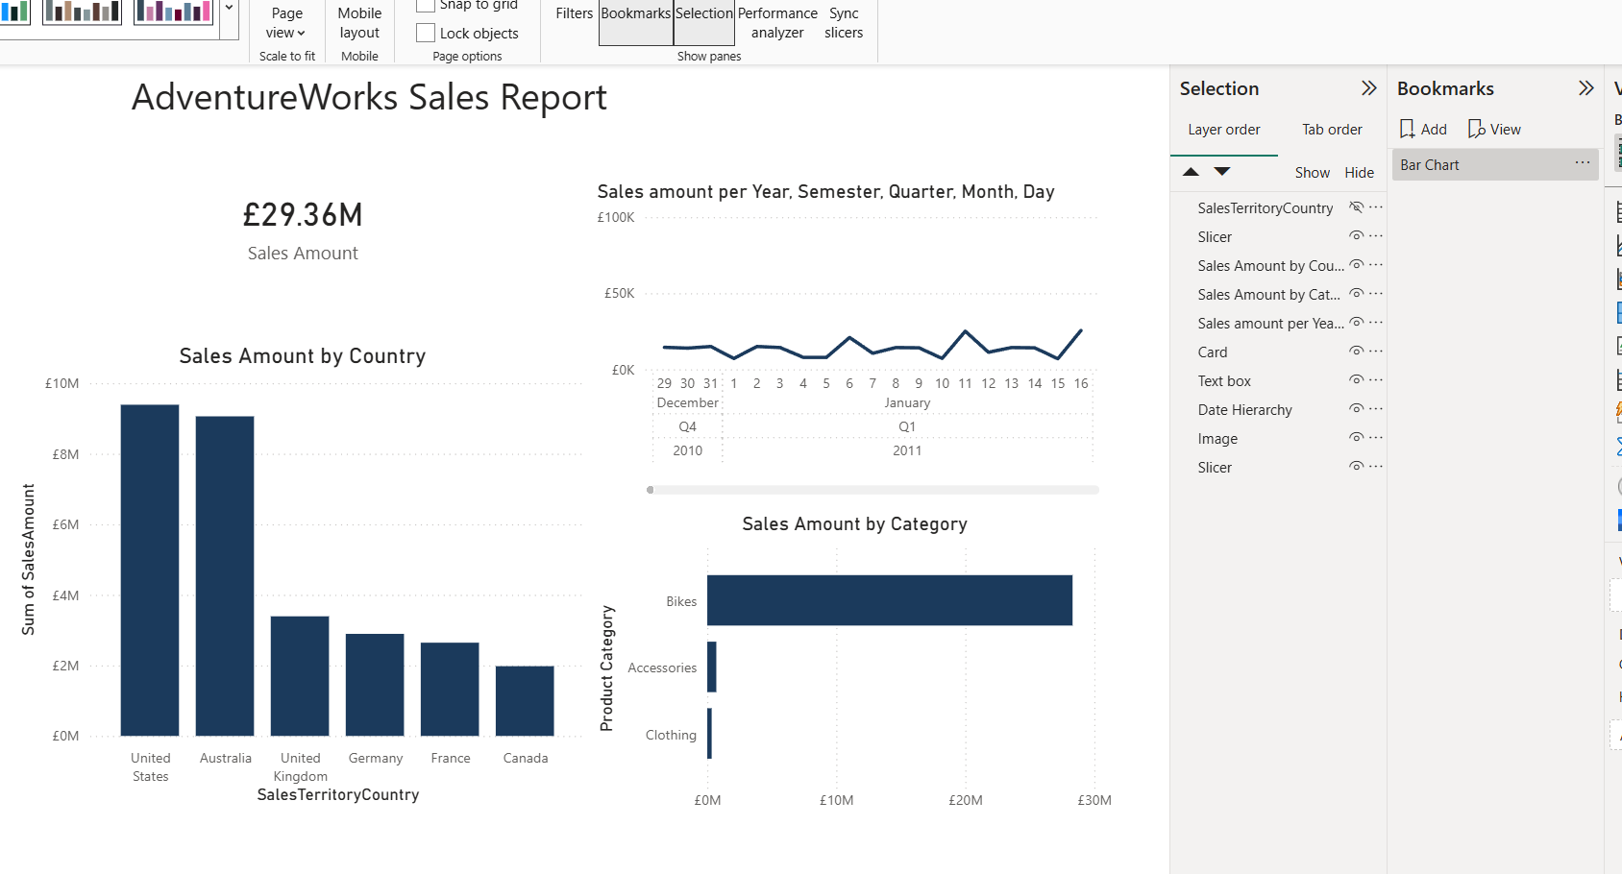
Creating bookmarks
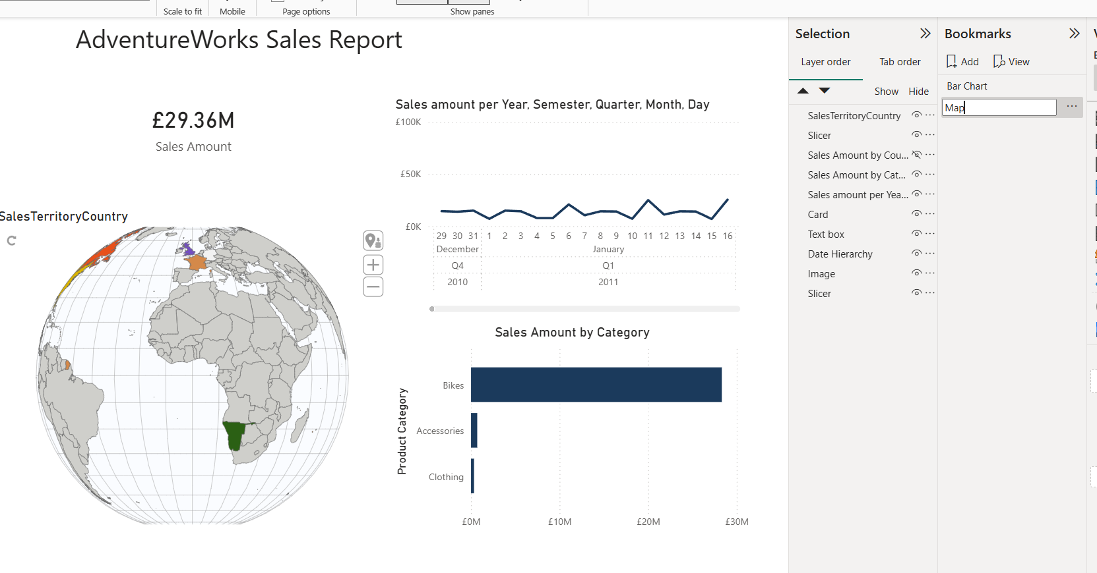
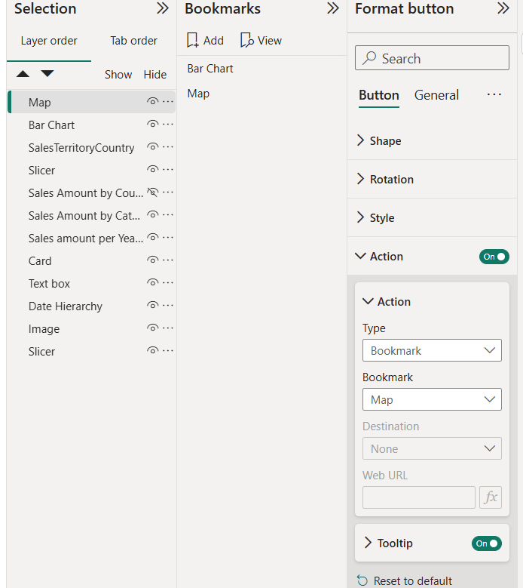
--

Configuring button settings.

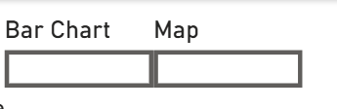
Buttons change the view between a bar chart and a map
-----

3
Sales Amount MTD = CALCULATE([Sales Amount], DATESMTD('DimDate'[FullDateAlternateKey]))
Sales Amount QTD = CALCULATE([Sales Amount], DATESQTD('DimDate'[FullDateAlternateKey]))

Order Quantity QTD = CALCULATE([Order Quantity], DATESQTD('DimDate'[FullDateAlternateKey]))
Order Quantity MTD = CALCULATE([Order Quantity], DATESMTD('DimDate'[FullDateAlternateKey]))

TimePeriodQuantity = {
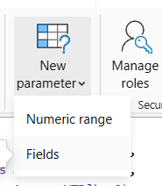
("Order Quantity MTD", NAMEOF('FactInternetSales'[Order Quantity MTD]), 0),
("Order Quantity QTD", NAMEOF('FactInternetSales'[Order Quantity QTD]), 1),
("Order Quantity YTD", NAMEOF('FactInternetSales'[Order Quantity YTD]), 2)
}

TimePeriodAmount = {
("Sales Amount MTD", NAMEOF('FactInternetSales'[Sales Amount MTD]), 0),
("Sales Amount QTD", NAMEOF('FactInternetSales'[Sales Amount QTD]), 1),
("Sales Amount YTD", NAMEOF('FactInternetSales'[Sales Amount YTD]), 2)
}

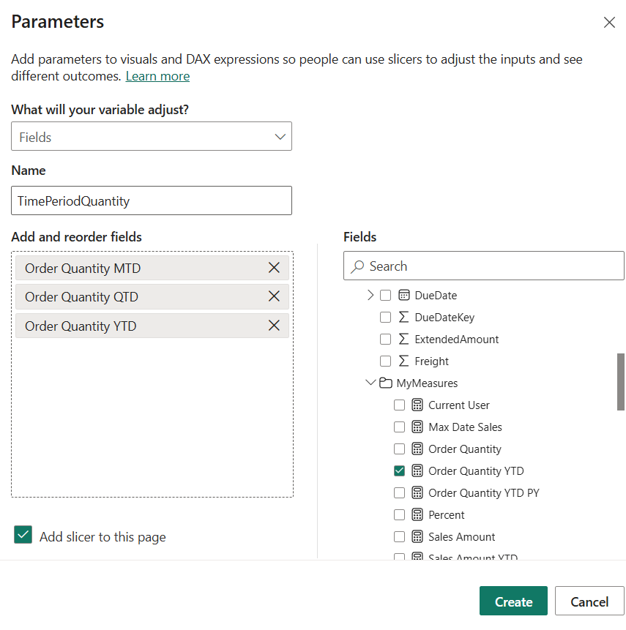

Created a parameter and applied it on the visual
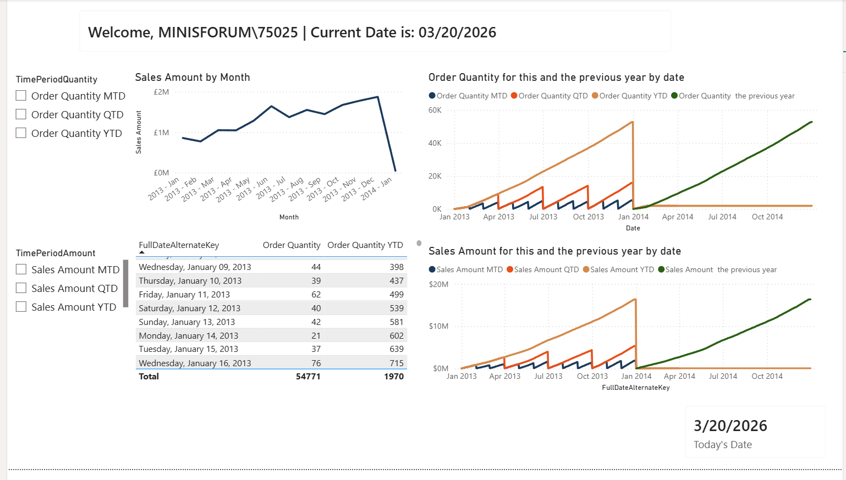
--
4

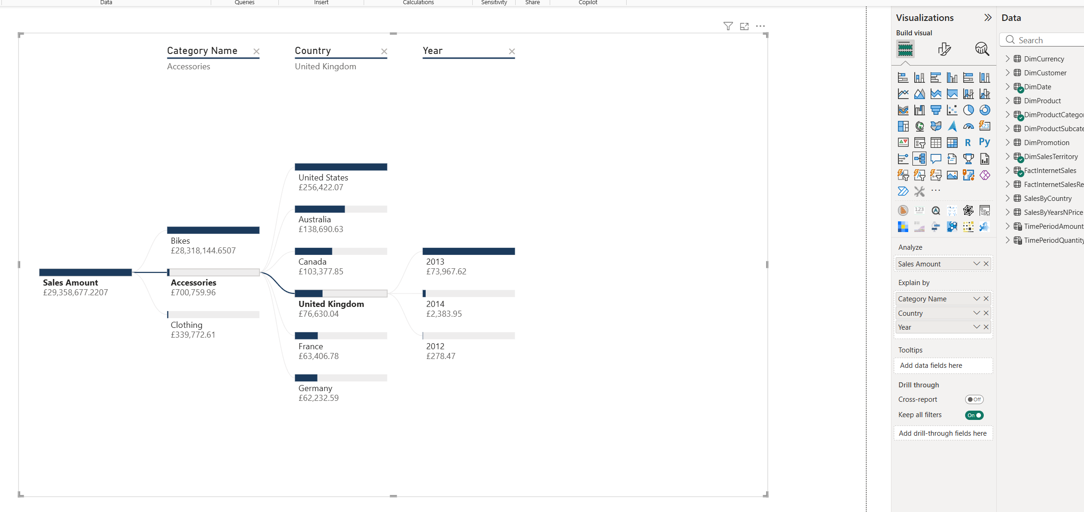
Created a decomposition tree that breaks down the sale amount by Country, year, product category.

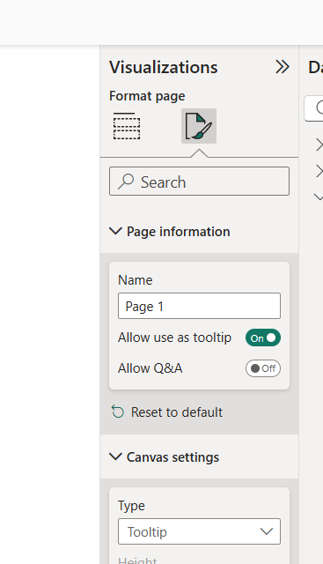
5
Created a tooltip page.

I added the card visual to the tooltip.

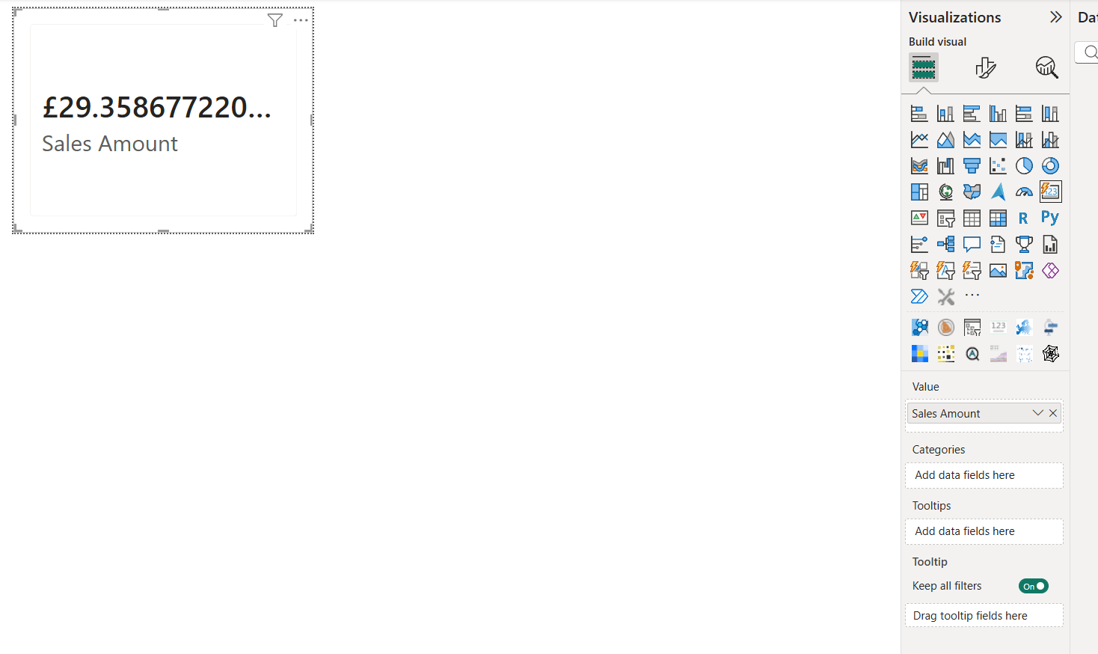

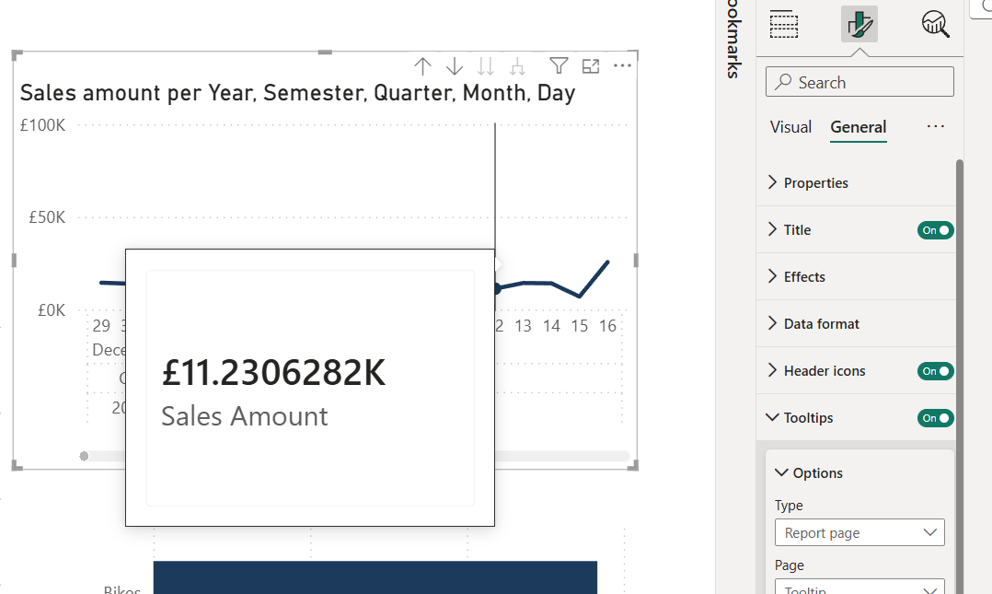

I turned on the tooltip for the line chart and now it shows the sales amount for a specific point in time (for a day or month etc. depending on the drill-down level on the chart).

