--1.1 TASK 1: USE INHERITANCE
--1

CREATE TABLE sales_info_2022 (
CHECK (eventdate >= DATE '2022-01-01' AND eventdate < DATE '2023-01-01')
) INHERITS (sales_info);

CREATE TABLE sales_info_2023 (
CHECK (eventdate >= DATE '2023-01-01' AND eventdate < DATE '2024-01-01')
) INHERITS (sales_info);

CREATE TABLE sales_info_2024 (
CHECK (eventdate >= DATE '2024-01-01' AND eventdate < DATE '2025-01-01')
) INHERITS (sales_info);

CREATE TABLE sales_info_2025 (
CHECK (eventdate >= DATE '2025-01-01' AND eventdate < DATE '2026-01-01')
) INHERITS (sales_info);

CREATE TABLE sales_info_2026 (
CHECK (eventdate >= DATE '2026-01-01' AND eventdate < DATE '2027-01-01')
) INHERITS (sales_info);

-----------------------------------------------
--2
CREATE OR REPLACE FUNCTION partition_sales_info()
RETURNS trigger
LANGUAGE plpgsql
AS $$
BEGIN
IF (NEW.eventdate >= DATE '2026-01-01' AND NEW.eventdate < DATE '2027-01-01') THEN
INSERT INTO sales_info_2026 VALUES (NEW.*);

ELSIF (NEW.eventdate >= DATE '2025-01-01' AND NEW.eventdate < DATE '2026-01-01') THEN
INSERT INTO sales_info_2025 VALUES (NEW.*);

ELSIF (NEW.eventdate >= DATE '2024-01-01' AND NEW.eventdate < DATE '2025-01-01') THEN
INSERT INTO sales_info_2024 VALUES (NEW.*);

ELSIF (NEW.eventdate >= DATE '2023-01-01' AND NEW.eventdate < DATE '2024-01-01') THEN
INSERT INTO sales_info_2023 VALUES (NEW.*);

ELSIF (NEW.eventdate >= DATE '2022-01-01' AND NEW.eventdate < DATE '2023-01-01') THEN
INSERT INTO sales_info_2022 VALUES (NEW.*);

ELSE
RAISE EXCEPTION 'Out of range: %', NEW.eventdate;
END IF;

RETURN NULL;
END;
$$;
----------------------------------------------------------------------------------
--3

DROP TRIGGER IF EXISTS partition_sales_info_trigger ON sales_info;

CREATE TRIGGER partition_sales_info_trigger
BEFORE INSERT ON sales_info
FOR EACH ROW
EXECUTE PROCEDURE partition_sales_info();
----------------------------------------------------------------------------------------
--4
INSERT INTO sales_info(id, category, ischeck, eventdate)
SELECT
id,
('{"A","B","C","D","E","F","G","H","I","J","K"}'::text[])[(random()*10)::int + 1]::varchar(1) AS category,
(random() < 0.5) AS ischeck,
(DATE '2022-01-01' + floor(random() * (DATE '2027-01-01' - DATE '2022-01-01'))::int) AS eventdate
FROM generate_series(1,10000000) AS id;

----------------------------------------------------------------------------------------------------
--5
WITH moved_rows AS ( DELETE FROM sales_info
WHERE id BETWEEN 1 AND 1000
RETURNING id, category, ischeck
)
INSERT INTO sales_info (id, category, ischeck, eventdate)
SELECT
id,
category,
ischeck,
DATE '2026-06-01'
FROM moved_rows;
-------------------------------------------------------------------------------
--6
DROP TABLE IF EXISTS sales_info_simple;

CREATE TABLE sales_info_simple (
id integer,
category varchar(1),
ischeck boolean,
eventdate date
);

INSERT INTO sales_info_simple (id, category, ischeck, eventdate)
SELECT id, category, ischeck, eventdate
FROM sales_info;
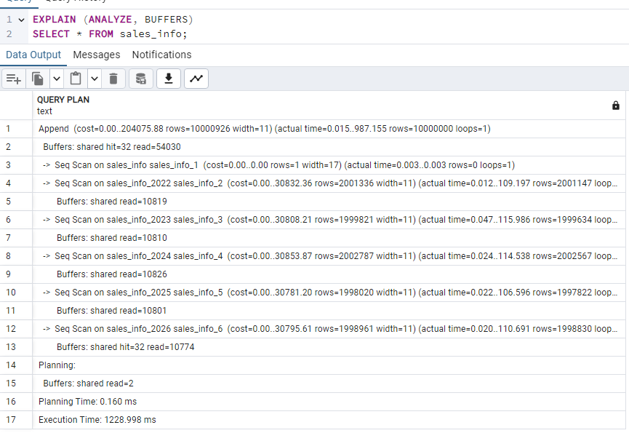

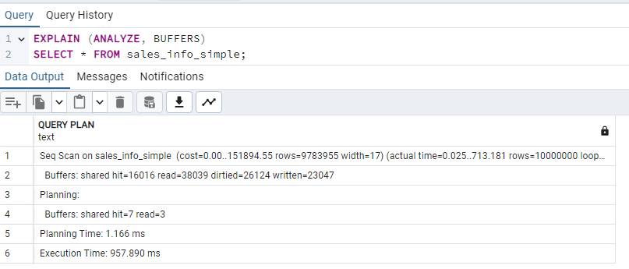

Reading from sales_info_simple is much simpler. In case of sales_info postgresql needs to collect the data from all the partitions.
-------------------------------------------------------------------------
--7
DROP TABLE sales_info_2022;

DROP TABLE IF EXISTS sales_info_3000;
CREATE TABLE sales_info_3000 (
CHECK (eventdate < DATE '2023-01-01' or eventdate >= DATE '2027-01-01')
) INHERITS (sales_info);

-----------------------------------------------------------------------------------------------------------
--1.2 TASK2: USE DECLARATIVE PARTITIONING
--2
CREATE TABLE sales_info_dp_2022
PARTITION OF sales_info_dp
FOR VALUES FROM ('2022-01-01') TO ('2023-01-01')
PARTITION BY LIST (category);
CREATE TABLE sales_info_dp_2023
PARTITION OF sales_info_dp
FOR VALUES FROM ('2023-01-01') TO ('2024-01-01')
PARTITION BY LIST (category);
CREATE TABLE sales_info_dp_2024
PARTITION OF sales_info_dp
FOR VALUES FROM ('2024-01-01') TO ('2025-01-01')
PARTITION BY LIST (category);
CREATE TABLE sales_info_dp_2025
PARTITION OF sales_info_dp
FOR VALUES FROM ('2025-01-01') TO ('2026-01-01')
PARTITION BY LIST (category);
CREATE TABLE sales_info_dp_2026
PARTITION OF sales_info_dp
FOR VALUES FROM ('2026-01-01') TO ('2027-01-01')
PARTITION BY LIST (category);
-----------------------------------------------------------------
-- 2022
CREATE TABLE sales_info_dp_2022_g1 PARTITION OF sales_info_dp_2022
FOR VALUES IN ('A','B','C','D','E');

CREATE TABLE sales_info_dp_2022_g2 PARTITION OF sales_info_dp_2022
FOR VALUES IN ('F','G','H','I','J','K');

CREATE TABLE sales_info_dp_2022_def PARTITION OF sales_info_dp_2022 DEFAULT;

-- 2023
CREATE TABLE sales_info_dp_2023_g1 PARTITION OF sales_info_dp_2023
FOR VALUES IN ('A','B','C','D','E');

CREATE TABLE sales_info_dp_2023_g2 PARTITION OF sales_info_dp_2023
FOR VALUES IN ('F','G','H','I','J','K');

CREATE TABLE sales_info_dp_2023_def PARTITION OF sales_info_dp_2023 DEFAULT;

-- 2024
CREATE TABLE sales_info_dp_2024_g1 PARTITION OF sales_info_dp_2024
FOR VALUES IN ('A','B','C','D','E');

CREATE TABLE sales_info_dp_2024_g2 PARTITION OF sales_info_dp_2024
FOR VALUES IN ('F','G','H','I','J','K');

CREATE TABLE sales_info_dp_2024_def PARTITION OF sales_info_dp_2024 DEFAULT;

-- 2025
CREATE TABLE sales_info_dp_2025_g1 PARTITION OF sales_info_dp_2025
FOR VALUES IN ('A','B','C','D','E');

CREATE TABLE sales_info_dp_2025_g2 PARTITION OF sales_info_dp_2025
FOR VALUES IN ('F','G','H','I','J','K');

CREATE TABLE sales_info_dp_2025_def PARTITION OF sales_info_dp_2025 DEFAULT;

-- 2026
CREATE TABLE sales_info_dp_2026_g1 PARTITION OF sales_info_dp_2026
FOR VALUES IN ('A','B','C','D','E');

CREATE TABLE sales_info_dp_2026_g2 PARTITION OF sales_info_dp_2026
FOR VALUES IN ('F','G','H','I','J','K');

CREATE TABLE sales_info_dp_2026_def PARTITION OF sales_info_dp_2026 DEFAULT;
------------------------------------
--3
INSERT INTO sales_info_dp(id, category, ischeck, eventdate)
SELECT
id,
('{"A","B","C","D","E","F","G","H","I","J","K"}'::text[])[(random()*10)::int + 1]::varchar(1) AS category,
(random() < 0.5) AS ischeck,
(DATE '2022-01-01' + floor(random() * (DATE '2027-01-01' - DATE '2022-01-01'))::int) AS eventdate
FROM generate_series(1,10000000) AS id;
-------------------------------------
--4

UPDATE sales_info_dp
SET category = 'A'
WHERE id BETWEEN 1 AND 1000;
-----------------------------------------------
5

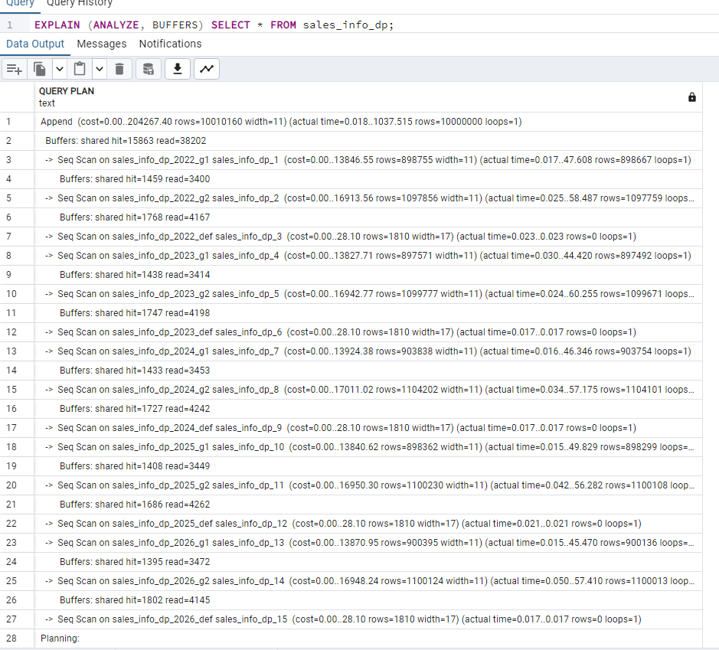

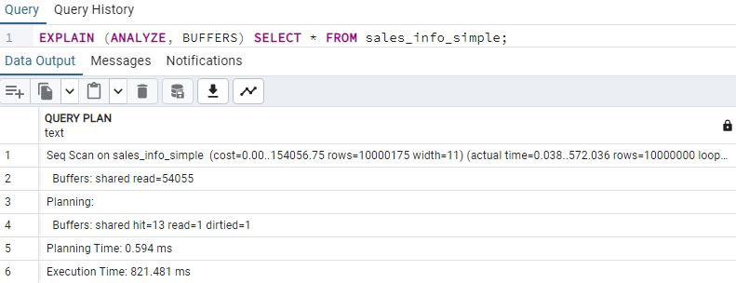
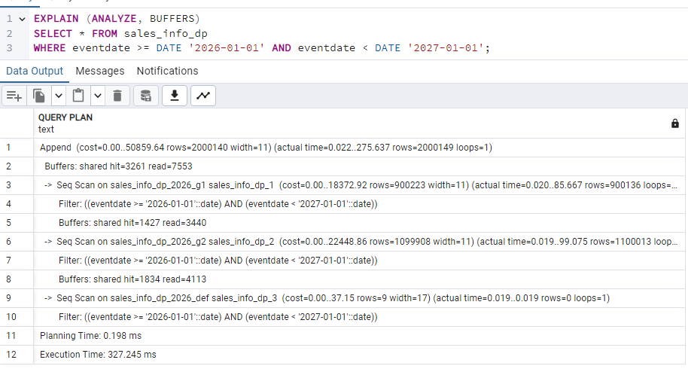
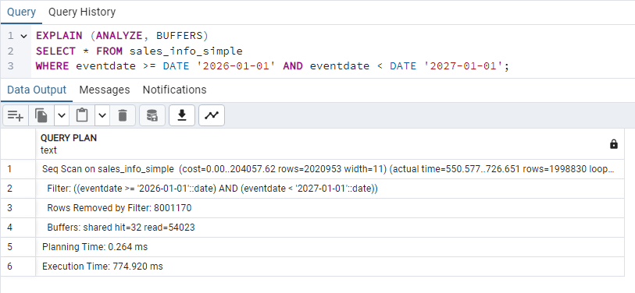
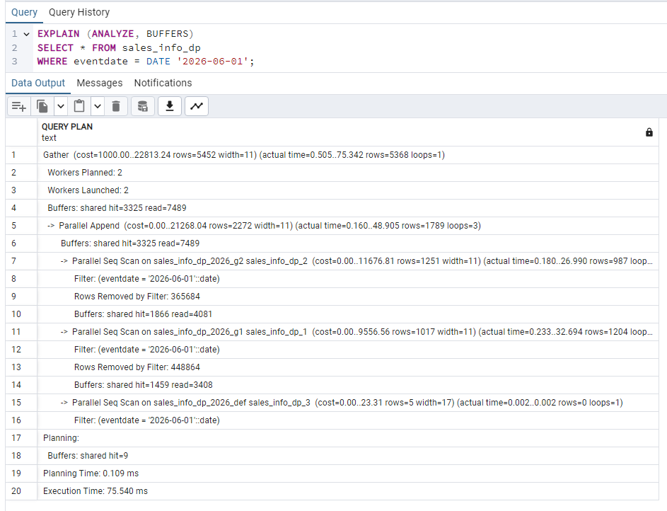
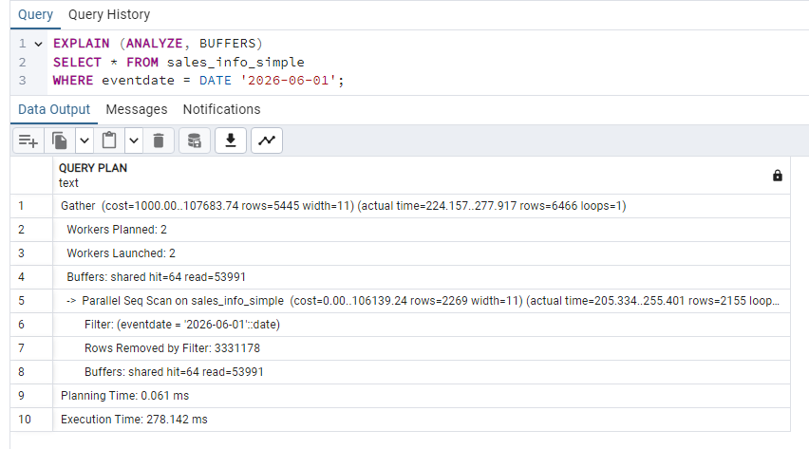
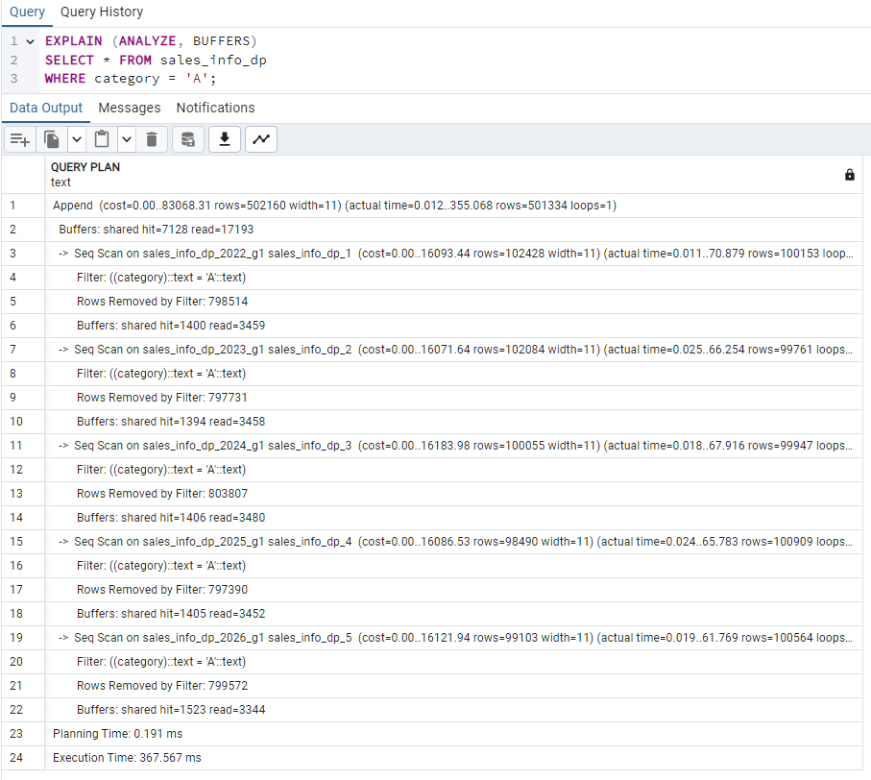
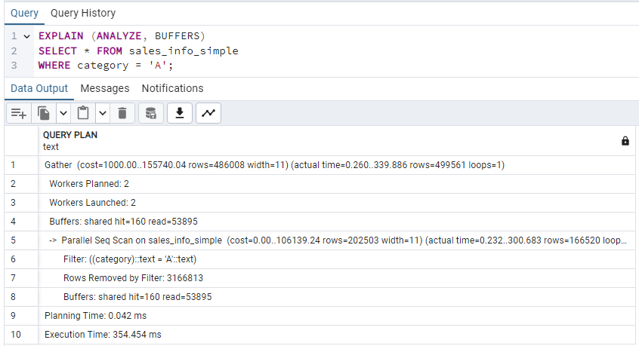

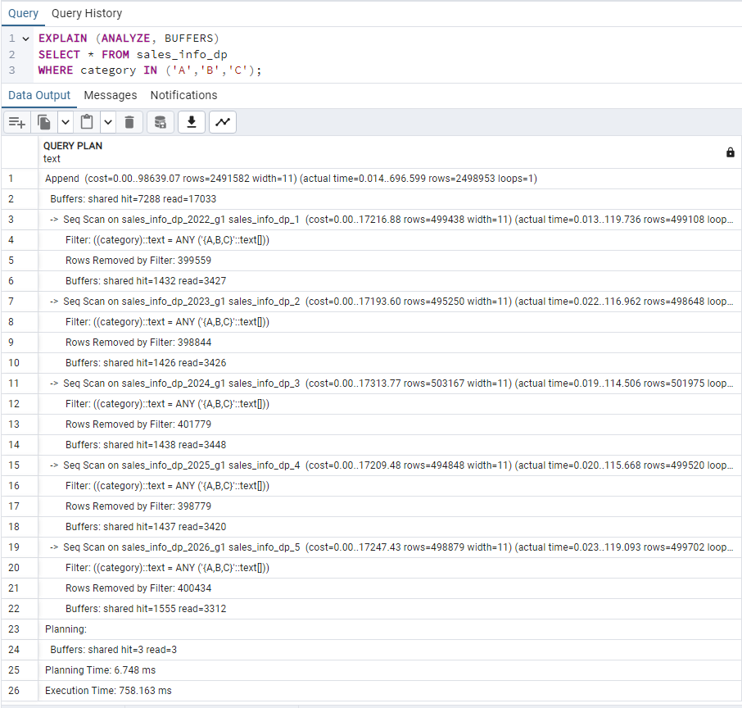
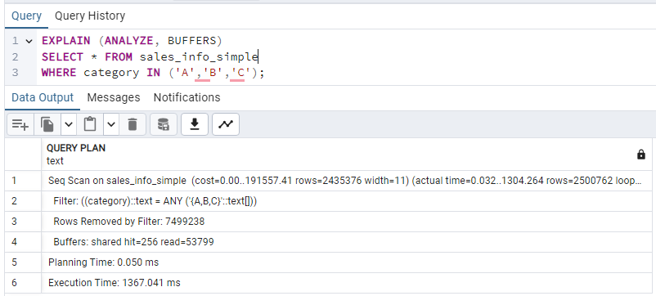
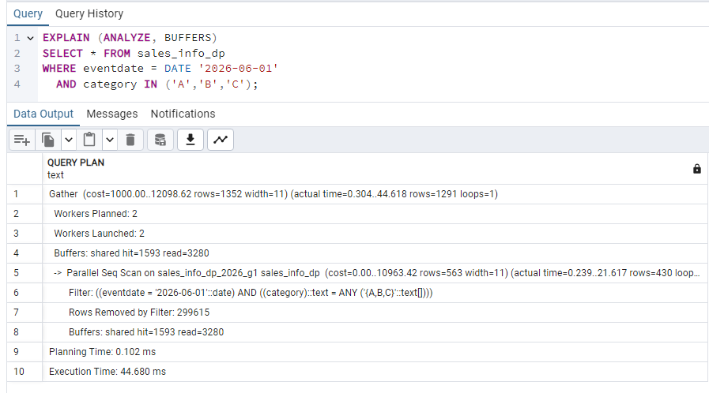
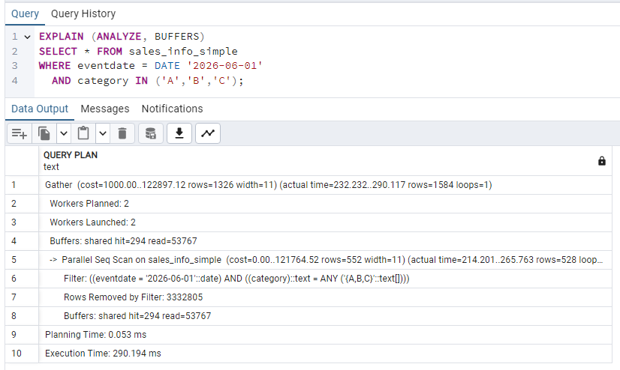
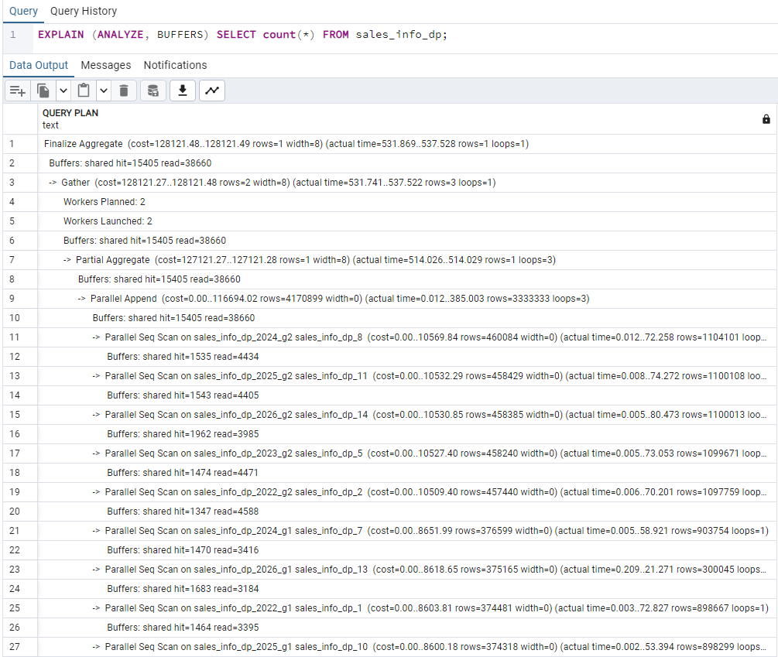
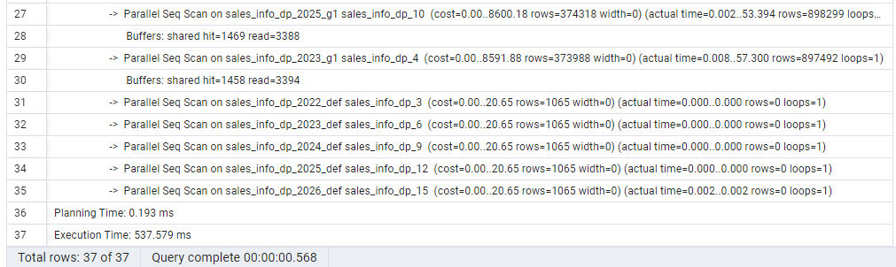

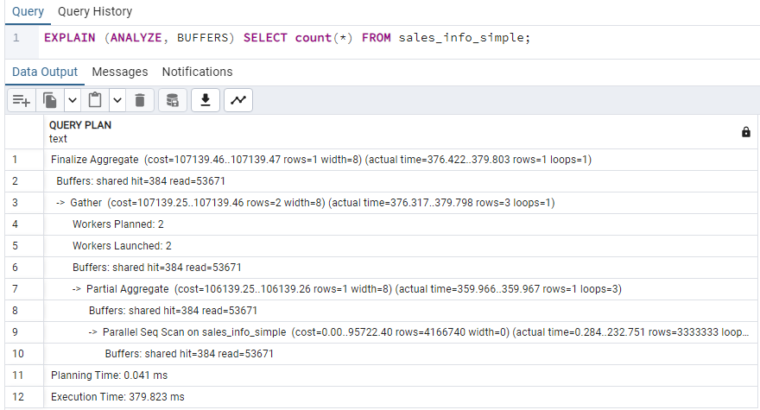
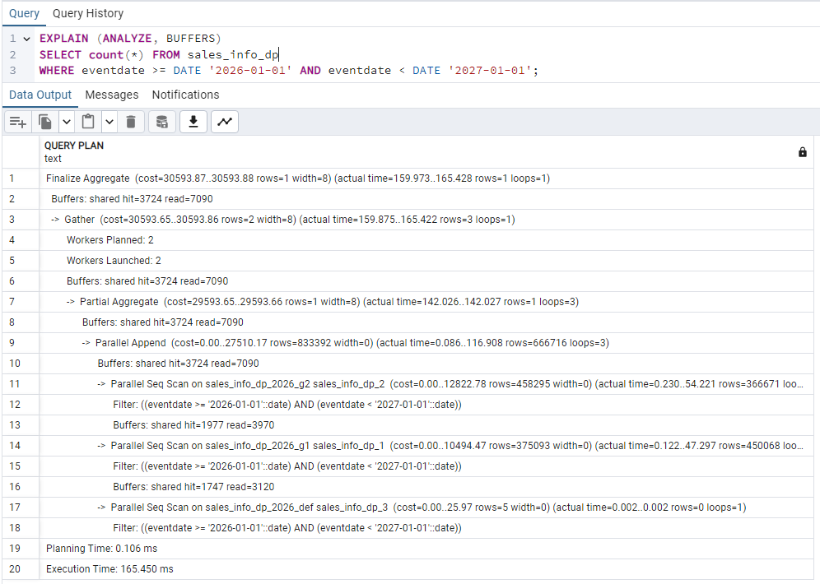

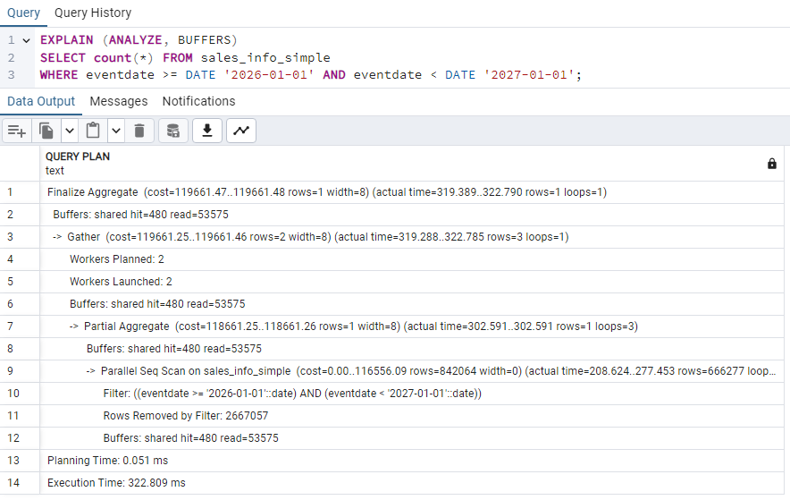
---------------------------------------------------------------------
--6
ALTER TABLE sales_info_dp_2026 DETACH PARTITION sales_info_dp_2026_g1;

CREATE TABLE sales_info_dp_2026_g1_abc
PARTITION OF sales_info_dp_2026
FOR VALUES IN ('A','B','C');

CREATE TABLE sales_info_dp_2026_g1_de
PARTITION OF sales_info_dp_2026
FOR VALUES IN ('D','E');

------ return it back

ALTER TABLE sales_info_dp_2026 DETACH PARTITION sales_info_dp_2026_g1_abc;
ALTER TABLE sales_info_dp_2026 DETACH PARTITION sales_info_dp_2026_g1_de;

ALTER TABLE sales_info_dp_2026 ATTACH PARTITION sales_info_dp_2026_g1
FOR VALUES IN ('A','B','C','D','E');

DROP TABLE sales_info_dp_2026_g1_abc;
DROP TABLE sales_info_dp_2026_g1_de;
--------------------------------------------------------------------------------------------------------------------

--2.1
--2.1 TASK 3: USE PARALLEL QUERING
-----------------------------------------------------------
SET max_parallel_workers_per_gather = 4;

-------------I’ll attach only the screenshots where paralel work occurred.

--a. Select all from tables - no
--b. Add order by eventadate - some
--c. Select count of all rows - all
--d. Add range of dates - no
--e. Add grouping by category - all
--f. Join SALES_INFO and SALES_INFO_DP on id and count rows on exact date. - yes
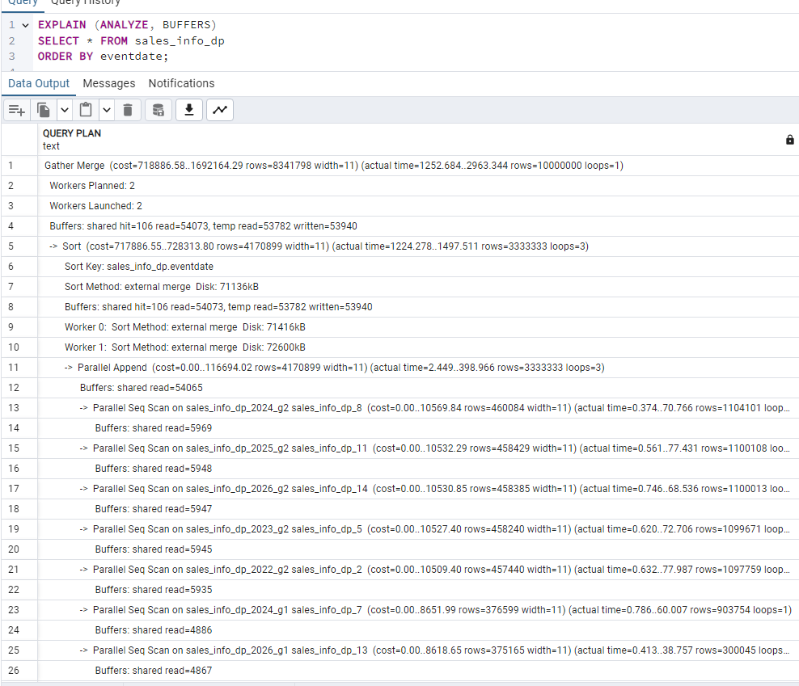

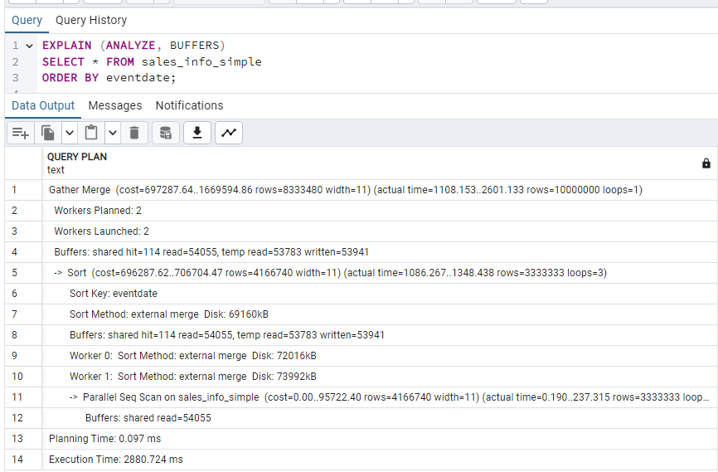

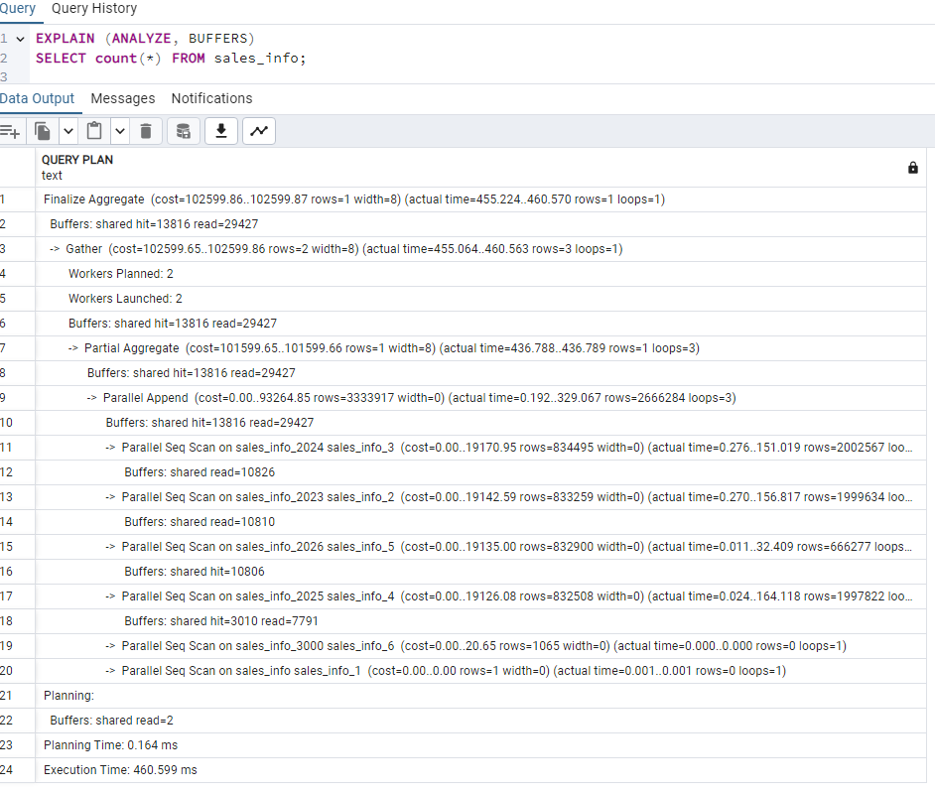

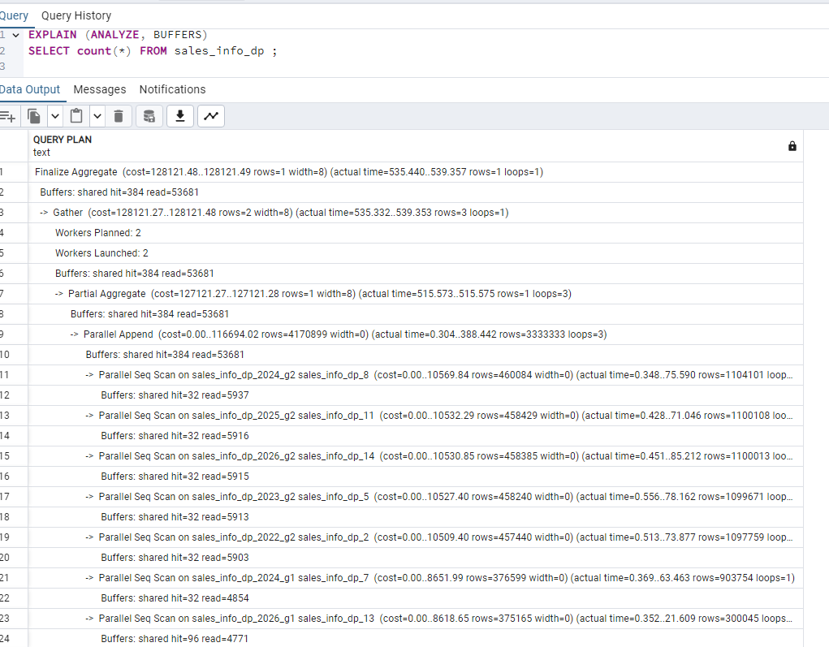

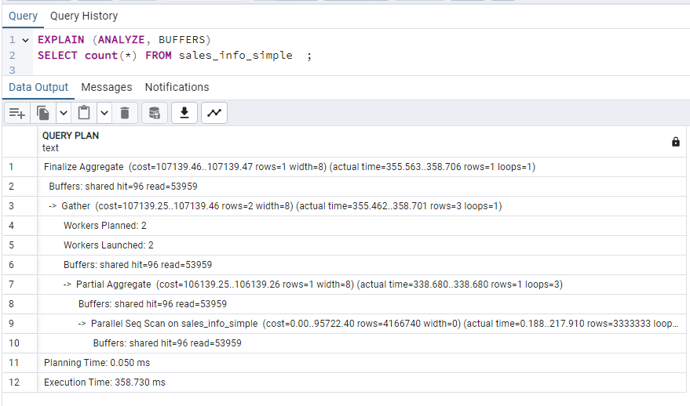

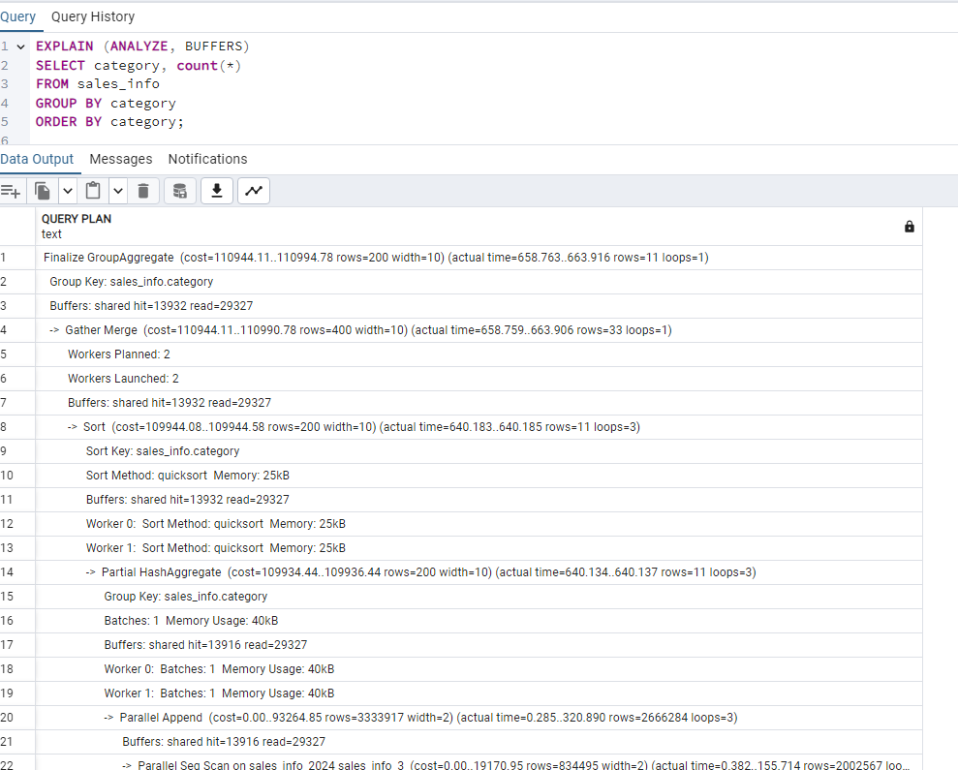

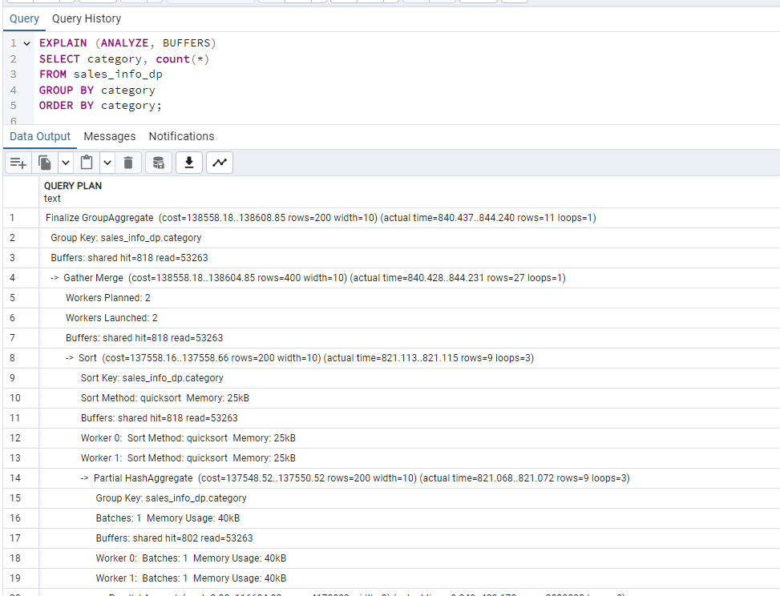

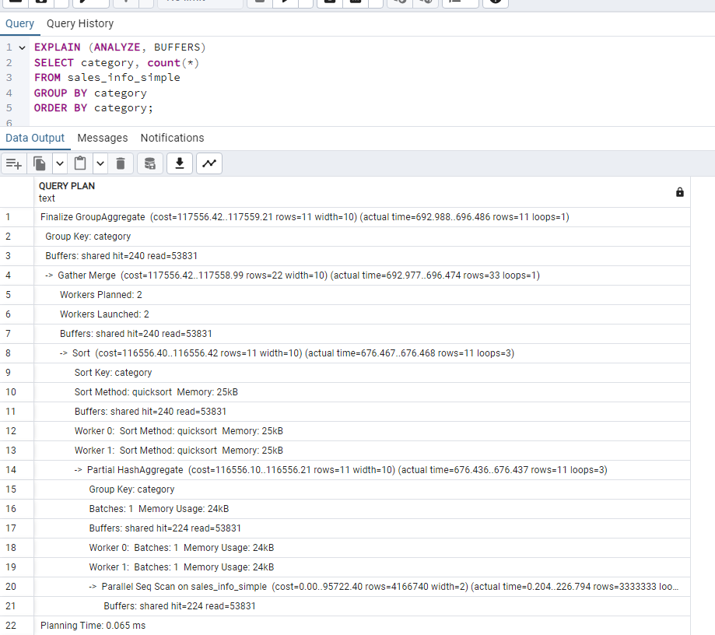
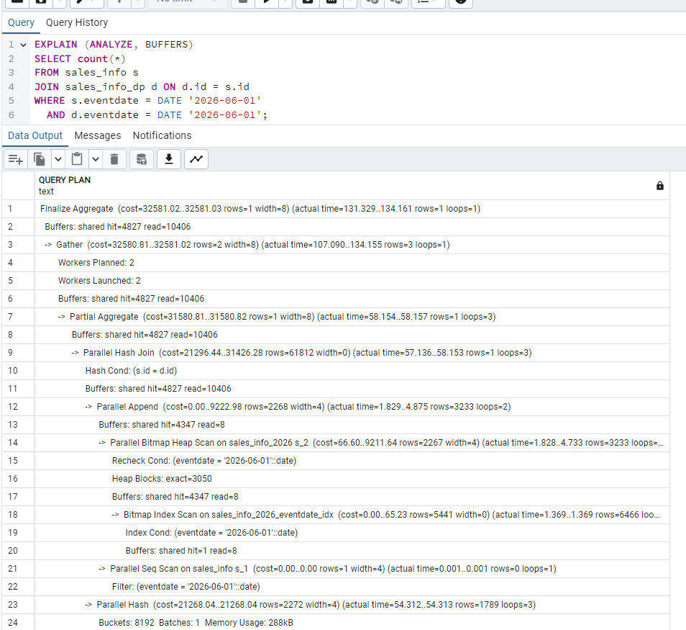

---------------------------------------------------------------------------------------
---indexes
-----------------------------
--For the sales_info table I received exactly the same results as without indexes.

--And for sales_info_dp too

