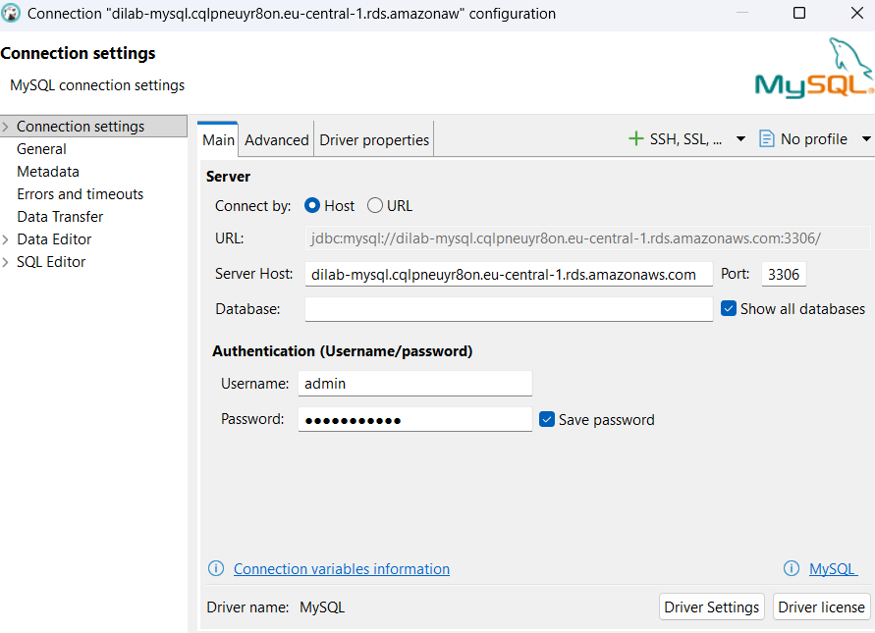

CREATE USER IF NOT EXISTS 'maryna_maksimava'@'%' IDENTIFIED BY 'Maryna2026!';
GRANT ALL PRIVILEGES ON maryna_maksimava_db.* TO 'maryna_maksimava'@'%';
FLUSH PRIVILEGES;

CREATE DATABASE IF NOT EXISTS maryna_maksimava_db;

USE maryna_maksimava_db;

DROP TABLE IF EXISTS employees;
CREATE TABLE employees (
id INT AUTO_INCREMENT PRIMARY KEY,
first_name VARCHAR(50) NOT NULL,
last_name VARCHAR(50) NOT NULL,
department VARCHAR(100),
salary DECIMAL(10,2),
hire_date DATE DEFAULT (CURRENT_DATE)
);

INSERT INTO employees (first_name, last_name, department, salary)
VALUES
('Alice', 'Johnson', 'Engineering', 85000),
('Bob', 'Smith', 'Marketing', 72000),
('Carol', 'White', 'Engineering', 91000);

DROP VIEW IF EXISTS active_employees;
CREATE VIEW active_employees AS
SELECT id, CONCAT(first_name, ' ', last_name) AS full_name, department, salary
FROM employees;

USE maryna_maksimava_db;

DROP PROCEDURE IF EXISTS give_raise;

DELIMITER //

CREATE PROCEDURE give_raise(IN p_dept VARCHAR(100), IN p_percent DECIMAL(5,2))
BEGIN
UPDATE employees
SET salary = salary * (1 + p_percent/100)
WHERE department = p_dept;
END //

DELIMITER ;

----2---
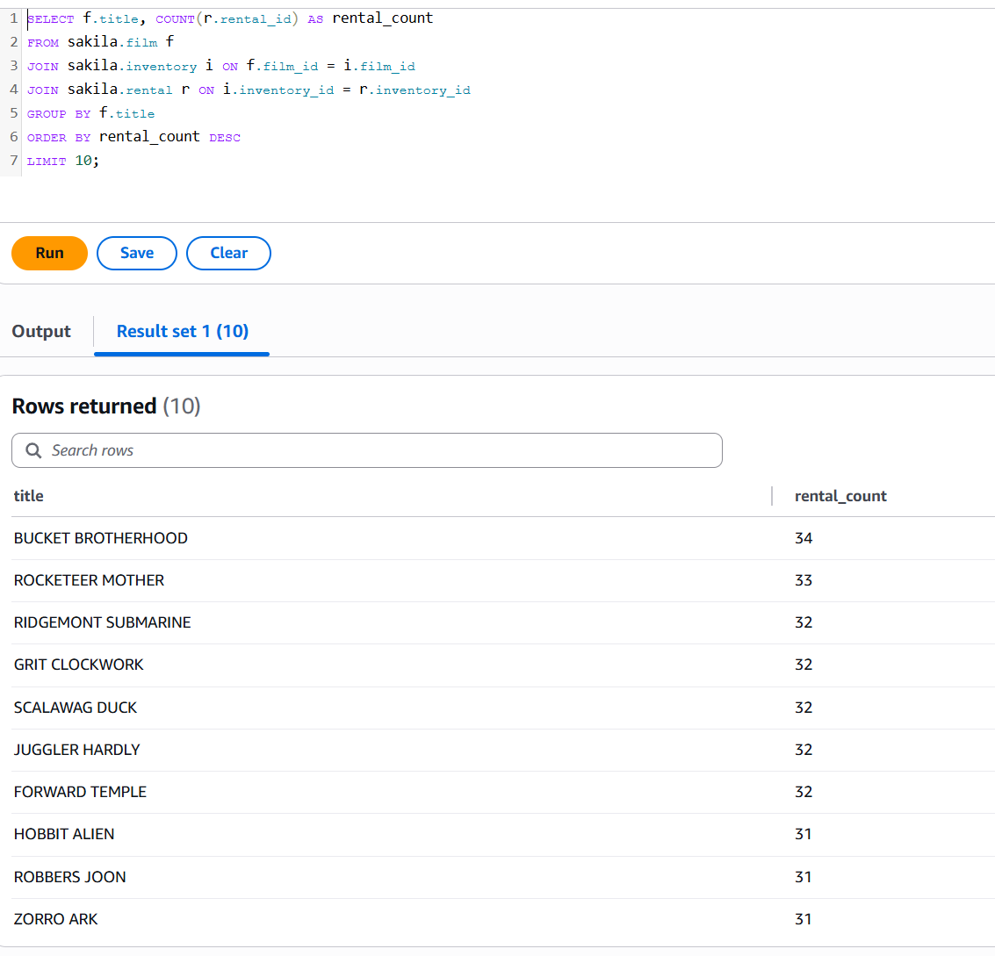
most rented movies

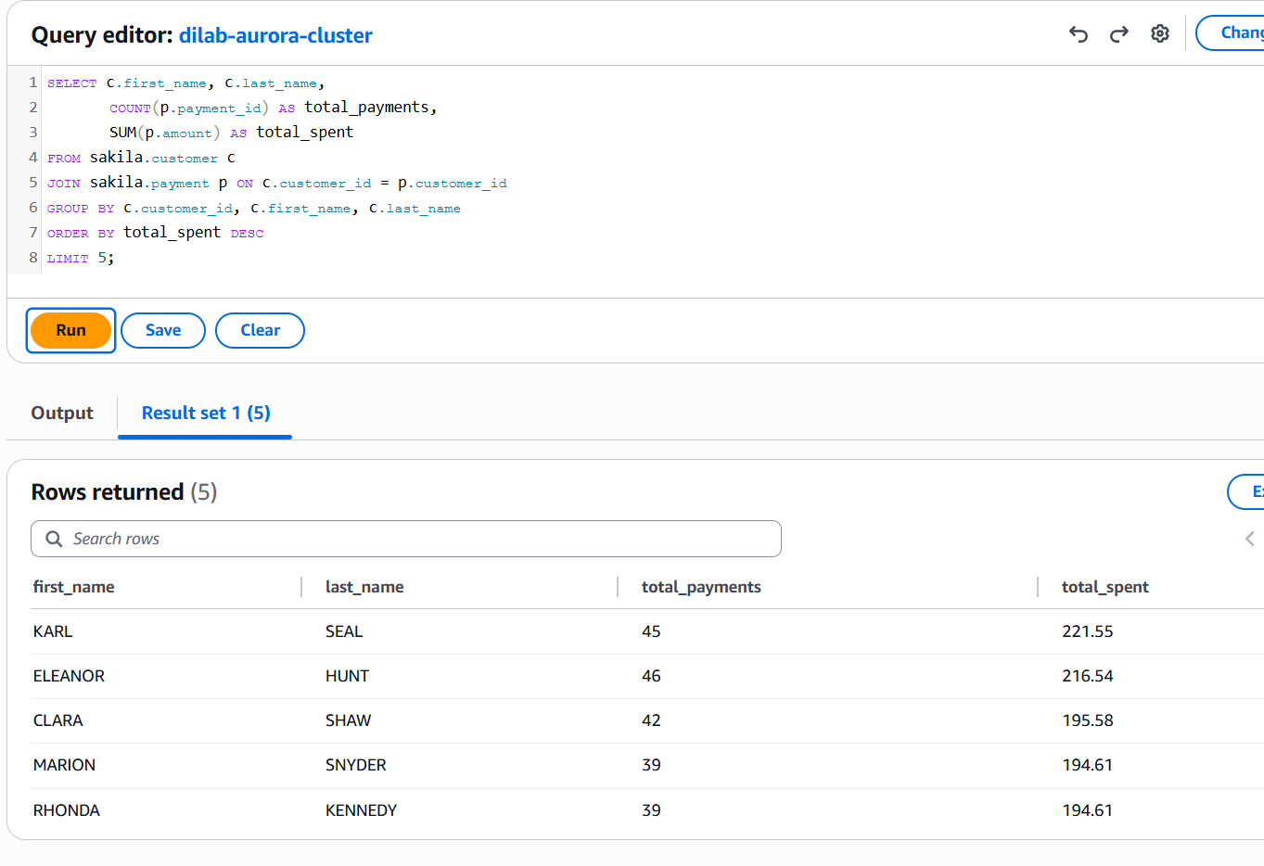
customers who spent the most
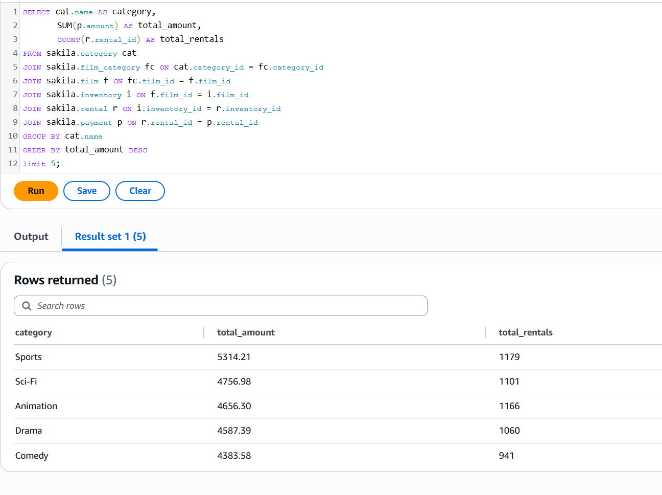
best selling categories by amount earned

Describe why it is the only way to connect to Aurora from local PC oppose to Amazon RDS MySQL.
Aurora is always deployed in a private vpc-subnet with no public endpoint for security reasons.
RDS MySQL can be set to be publicly accessible while Aurora can’t.

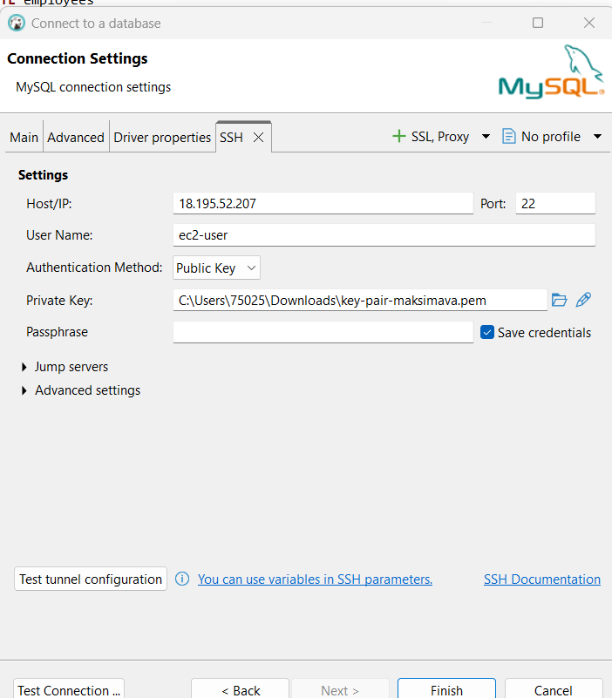

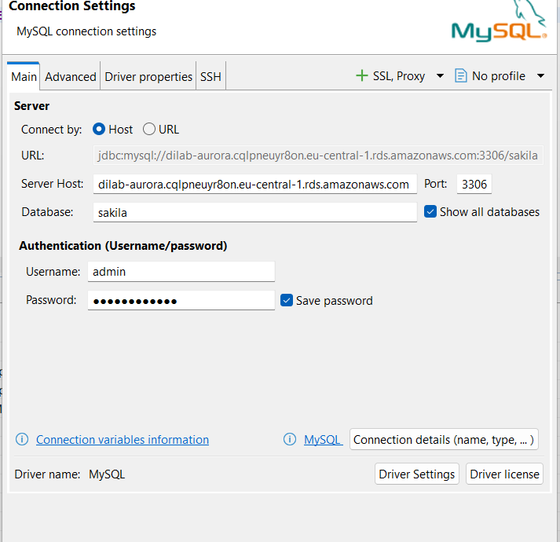

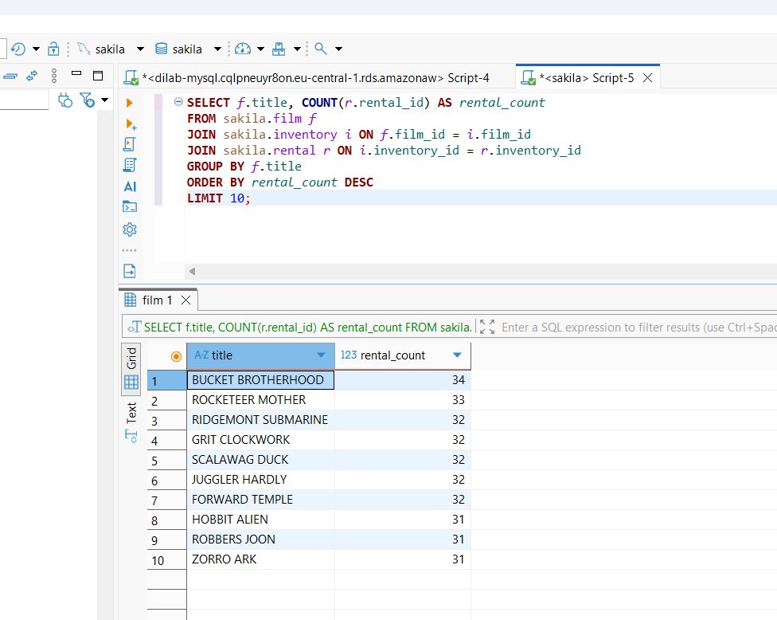

--DynamoDB
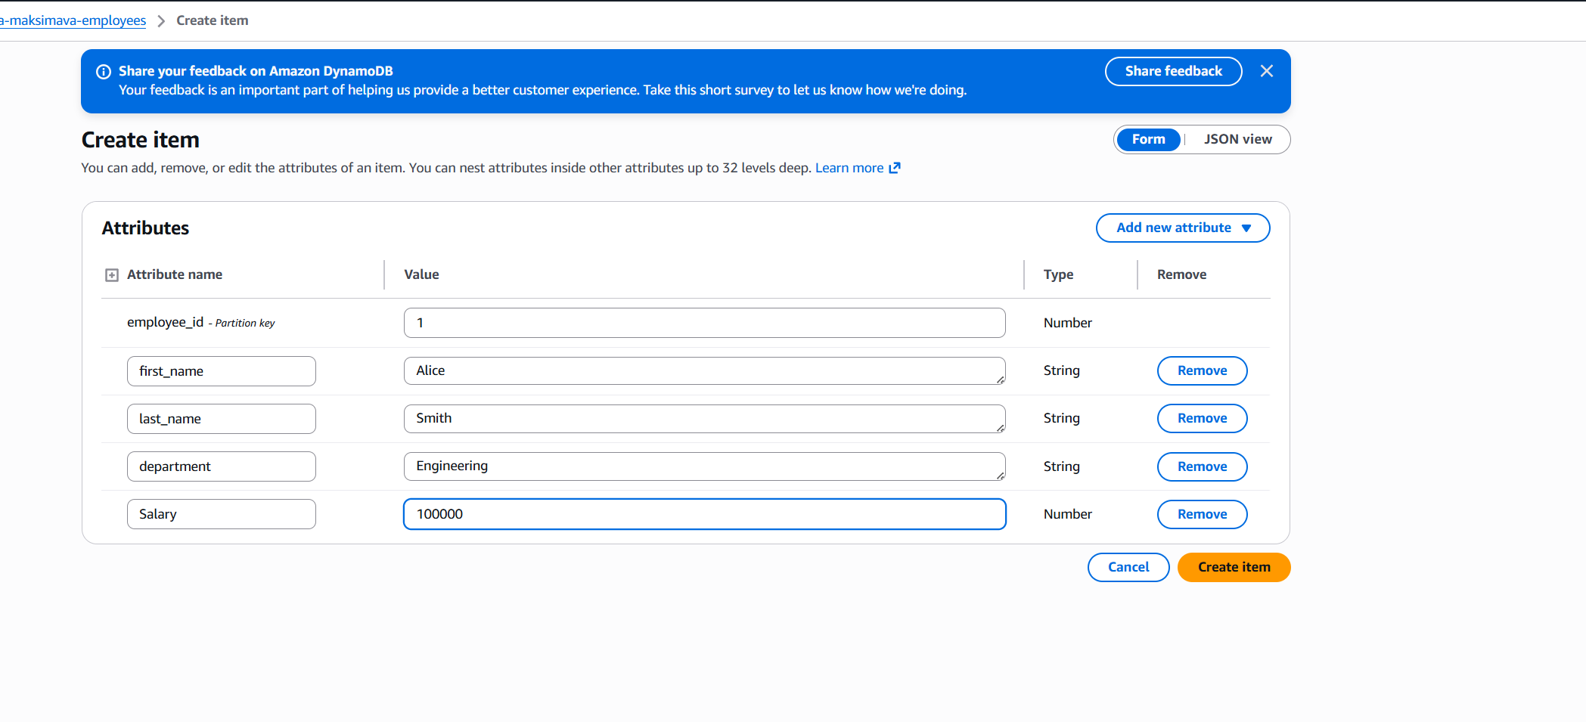

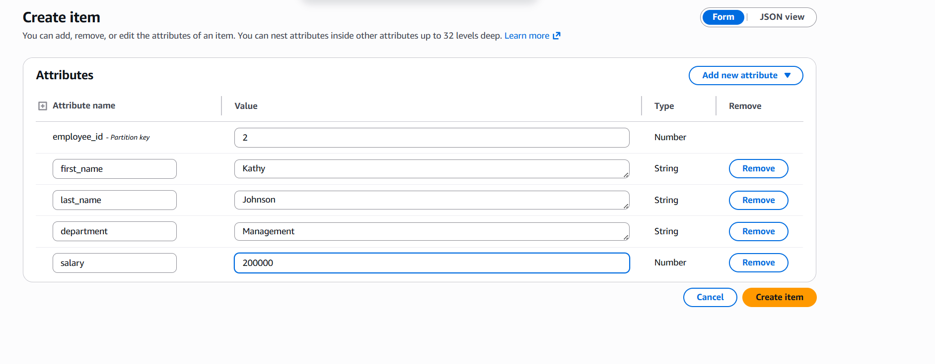
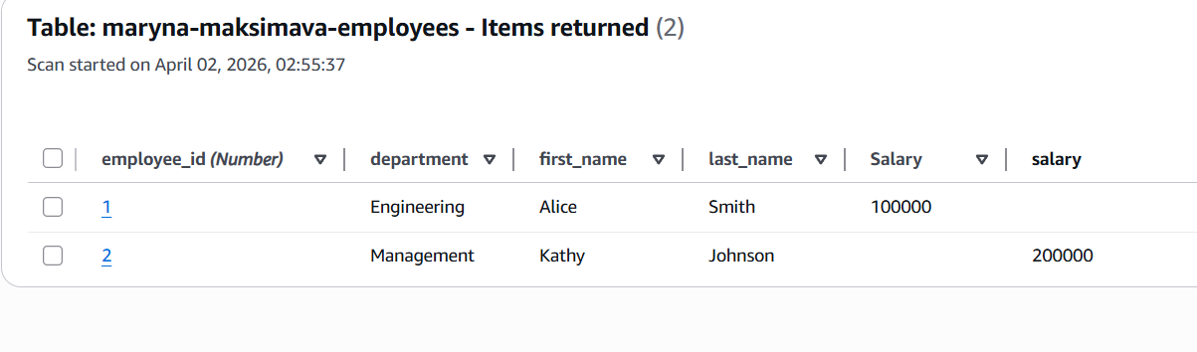
Easy to make a mistake when filling it out manually.
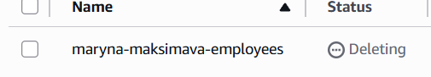

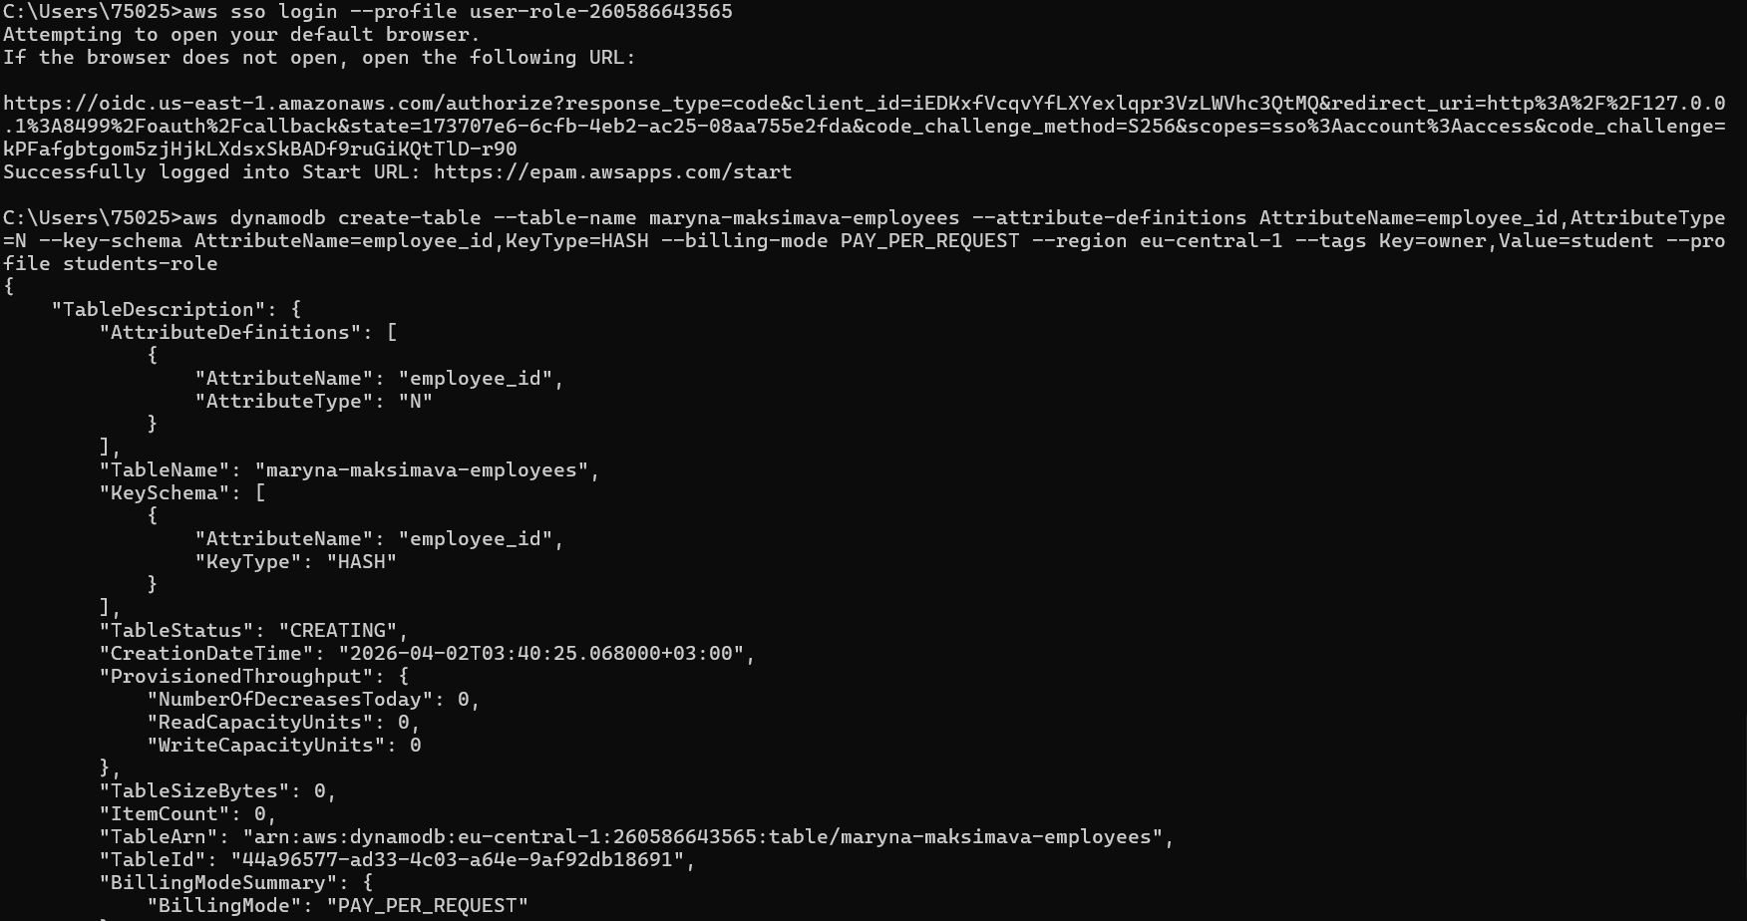

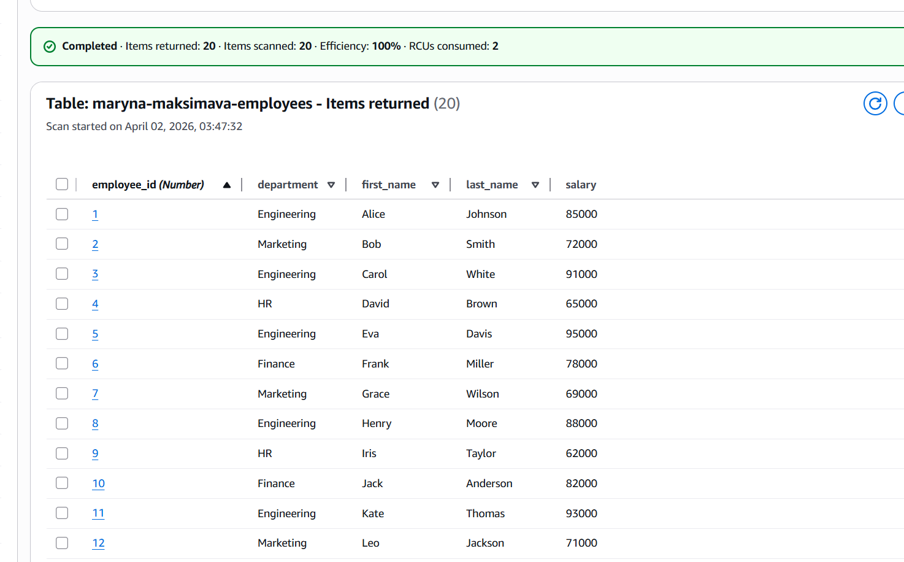

--connect

aws sso login --profile user-role-260586643565

--create

aws dynamodb create-table --table-name maryna-maksimava-employees --attribute-definitions AttributeName=employee_id,AttributeType=N --key-schema AttributeName=employee_id,KeyType=HASH --billing-mode PAY_PER_REQUEST --region eu-central-1 --tags Key=owner,Value=student --profile students-role

--write

aws dynamodb put-item --table-name maryna-maksimava-employees --item "{\"employee_id\": {\"N\": \"1\"}, \"first_name\": {\"S\": \"Alice\"}, \"last_name\": {\"S\": \"Johnson\"}, \"department\": {\"S\": \"Engineering\"}, \"salary\": {\"N\": \"85000\"}}" --region eu-central-1 --profile students-role

aws dynamodb put-item --table-name maryna-maksimava-employees --item "{\"employee_id\": {\"N\": \"2\"}, \"first_name\": {\"S\": \"Bob\"}, \"last_name\": {\"S\": \"Smith\"}, \"department\": {\"S\": \"Marketing\"}, \"salary\": {\"N\": \"72000\"}}" --region eu-central-1 --profile students-role

aws dynamodb put-item --table-name maryna-maksimava-employees --item "{\"employee_id\": {\"N\": \"1\"}, \"first_name\": {\"S\": \"Alice\"}, \"last_name\": {\"S\": \"Johnson\"}, \"department\": {\"S\": \"Engineering\"}, \"salary\": {\"N\": \"85000\"}}" --region eu-central-1 --profile students-role

aws dynamodb put-item --table-name maryna-maksimava-employees --item "{\"employee_id\": {\"N\": \"2\"}, \"first_name\": {\"S\": \"Bob\"}, \"last_name\": {\"S\": \"Smith\"}, \"department\": {\"S\": \"Marketing\"}, \"salary\": {\"N\": \"72000\"}}" --region eu-central-1 --profile students-role

aws dynamodb put-item --table-name maryna-maksimava-employees --item "{\"employee_id\": {\"N\": \"3\"}, \"first_name\": {\"S\": \"Carol\"}, \"last_name\": {\"S\": \"White\"}, \"department\": {\"S\": \"Engineering\"}, \"salary\": {\"N\": \"91000\"}}" --region eu-central-1 --profile students-role

aws dynamodb put-item --table-name maryna-maksimava-employees --item "{\"employee_id\": {\"N\": \"4\"}, \"first_name\": {\"S\": \"David\"}, \"last_name\": {\"S\": \"Brown\"}, \"department\": {\"S\": \"HR\"}, \"salary\": {\"N\": \"65000\"}}" --region eu-central-1 --profile students-role

aws dynamodb put-item --table-name maryna-maksimava-employees --item "{\"employee_id\": {\"N\": \"5\"}, \"first_name\": {\"S\": \"Eva\"}, \"last_name\": {\"S\": \"Davis\"}, \"department\": {\"S\": \"Engineering\"}, \"salary\": {\"N\": \"95000\"}}" --region eu-central-1 --profile students-role

aws dynamodb put-item --table-name maryna-maksimava-employees --item "{\"employee_id\": {\"N\": \"6\"}, \"first_name\": {\"S\": \"Frank\"}, \"last_name\": {\"S\": \"Miller\"}, \"department\": {\"S\": \"Finance\"}, \"salary\": {\"N\": \"78000\"}}" --region eu-central-1 --profile students-role

aws dynamodb put-item --table-name maryna-maksimava-employees --item "{\"employee_id\": {\"N\": \"7\"}, \"first_name\": {\"S\": \"Grace\"}, \"last_name\": {\"S\": \"Wilson\"}, \"department\": {\"S\": \"Marketing\"}, \"salary\": {\"N\": \"69000\"}}" --region eu-central-1 --profile students-role

aws dynamodb put-item --table-name maryna-maksimava-employees --item "{\"employee_id\": {\"N\": \"8\"}, \"first_name\": {\"S\": \"Henry\"}, \"last_name\": {\"S\": \"Moore\"}, \"department\": {\"S\": \"Engineering\"}, \"salary\": {\"N\": \"88000\"}}" --region eu-central-1 --profile students-role

aws dynamodb put-item --table-name maryna-maksimava-employees --item "{\"employee_id\": {\"N\": \"9\"}, \"first_name\": {\"S\": \"Iris\"}, \"last_name\": {\"S\": \"Taylor\"}, \"department\": {\"S\": \"HR\"}, \"salary\": {\"N\": \"62000\"}}" --region eu-central-1 --profile students-role

aws dynamodb put-item --table-name maryna-maksimava-employees --item "{\"employee_id\": {\"N\": \"10\"}, \"first_name\": {\"S\": \"Jack\"}, \"last_name\": {\"S\": \"Anderson\"}, \"department\": {\"S\": \"Finance\"}, \"salary\": {\"N\": \"82000\"}}" --region eu-central-1 --profile students-role

aws dynamodb put-item --table-name maryna-maksimava-employees --item "{\"employee_id\": {\"N\": \"11\"}, \"first_name\": {\"S\": \"Kate\"}, \"last_name\": {\"S\": \"Thomas\"}, \"department\": {\"S\": \"Engineering\"}, \"salary\": {\"N\": \"93000\"}}" --region eu-central-1 --profile students-role

aws dynamodb put-item --table-name maryna-maksimava-employees --item "{\"employee_id\": {\"N\": \"12\"}, \"first_name\": {\"S\": \"Leo\"}, \"last_name\": {\"S\": \"Jackson\"}, \"department\": {\"S\": \"Marketing\"}, \"salary\": {\"N\": \"71000\"}}" --region eu-central-1 --profile students-role

aws dynamodb put-item --table-name maryna-maksimava-employees --item "{\"employee_id\": {\"N\": \"13\"}, \"first_name\": {\"S\": \"Mia\"}, \"last_name\": {\"S\": \"Harris\"}, \"department\": {\"S\": \"HR\"}, \"salary\": {\"N\": \"67000\"}}" --region eu-central-1 --profile students-role

aws dynamodb put-item --table-name maryna-maksimava-employees --item "{\"employee_id\": {\"N\": \"14\"}, \"first_name\": {\"S\": \"Nick\"}, \"last_name\": {\"S\": \"Martin\"}, \"department\": {\"S\": \"Finance\"}, \"salary\": {\"N\": \"79000\"}}" --region eu-central-1 --profile students-role

aws dynamodb put-item --table-name maryna-maksimava-employees --item "{\"employee_id\": {\"N\": \"15\"}, \"first_name\": {\"S\": \"Olivia\"}, \"last_name\": {\"S\": \"Garcia\"}, \"department\": {\"S\": \"Engineering\"}, \"salary\": {\"N\": \"97000\"}}" --region eu-central-1 --profile students-role

aws dynamodb put-item --table-name maryna-maksimava-employees --item "{\"employee_id\": {\"N\": \"16\"}, \"first_name\": {\"S\": \"Paul\"}, \"last_name\": {\"S\": \"Martinez\"}, \"department\": {\"S\": \"Marketing\"}, \"salary\": {\"N\": \"74000\"}}" --region eu-central-1 --profile students-role

aws dynamodb put-item --table-name maryna-maksimava-employees --item "{\"employee_id\": {\"N\": \"17\"}, \"first_name\": {\"S\": \"Quinn\"}, \"last_name\": {\"S\": \"Robinson\"}, \"department\": {\"S\": \"HR\"}, \"salary\": {\"N\": \"63000\"}}" --region eu-central-1 --profile students-role

aws dynamodb put-item --table-name maryna-maksimava-employees --item "{\"employee_id\": {\"N\": \"18\"}, \"first_name\": {\"S\": \"Rose\"}, \"last_name\": {\"S\": \"Clark\"}, \"department\": {\"S\": \"Finance\"}, \"salary\": {\"N\": \"81000\"}}" --region eu-central-1 --profile students-role

aws dynamodb put-item --table-name maryna-maksimava-employees --item "{\"employee_id\": {\"N\": \"19\"}, \"first_name\": {\"S\": \"Sam\"}, \"last_name\": {\"S\": \"Rodriguez\"}, \"department\": {\"S\": \"Engineering\"}, \"salary\": {\"N\": \"89000\"}}" --region eu-central-1 --profile students-role

aws dynamodb put-item --table-name maryna-maksimava-employees --item "{\"employee_id\": {\"N\": \"20\"}, \"first_name\": {\"S\": \"Tina\"}, \"last_name\": {\"S\": \"Lewis\"}, \"department\": {\"S\": \"Marketing\"}, \"salary\": {\"N\": \"76000\"}}" --region eu-central-1 --profile students-role

---read

aws dynamodb get-item --table-name maryna-maksimava-employees --key "{\"employee_id\": {\"N\": \"1\"}}" --region eu-central-1 --profile students-role
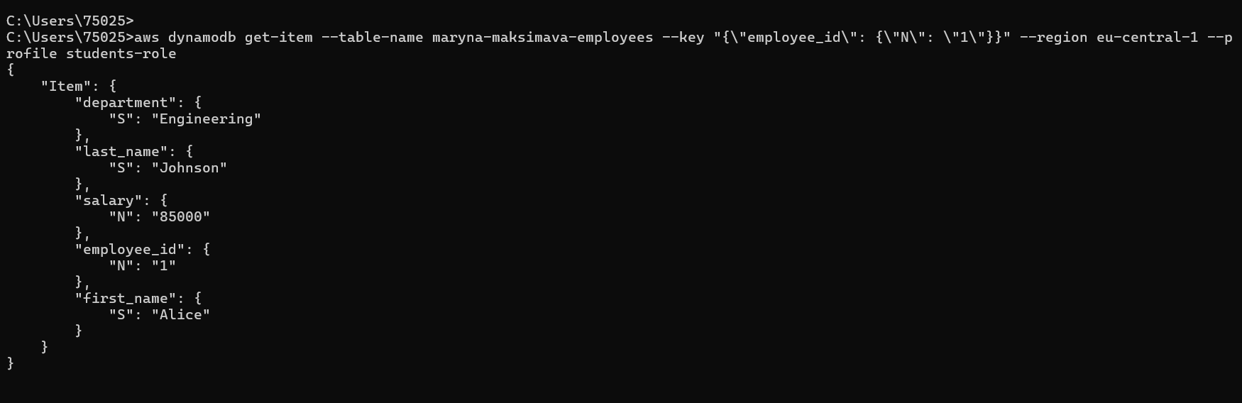
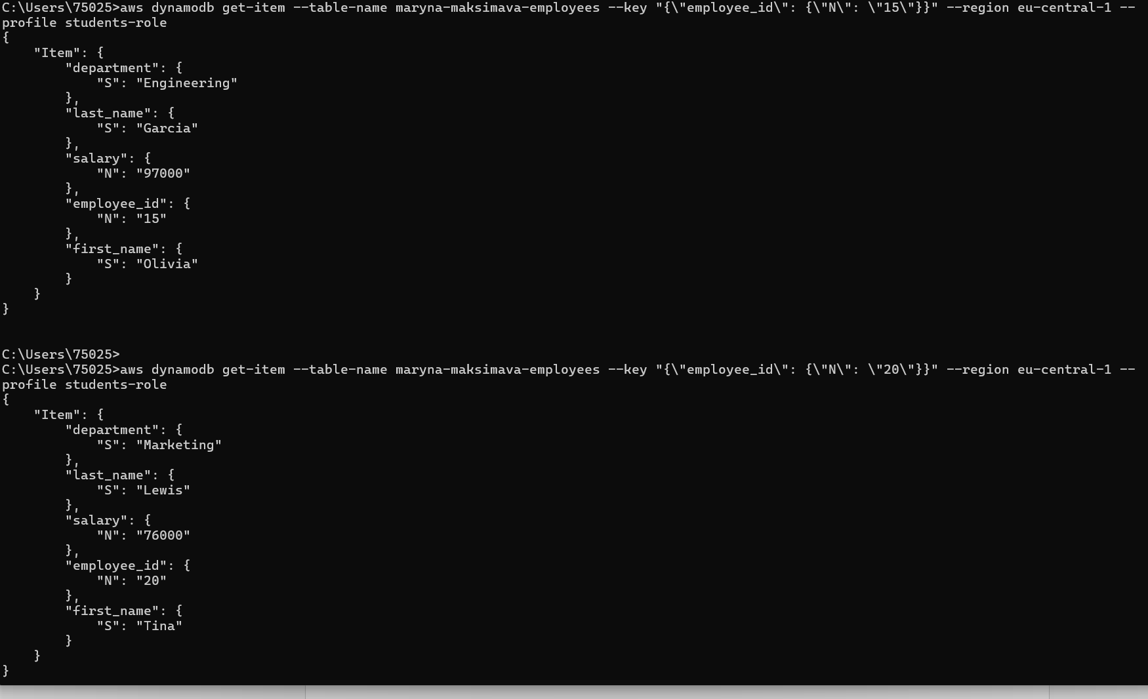

aws dynamodb scan --table-name maryna-maksimava-employees --filter-expression "department = :dept" --expression-attribute-values "{\":dept\": {\"S\": \"Engineering\"}}" --region eu-central-1 --profile students-role

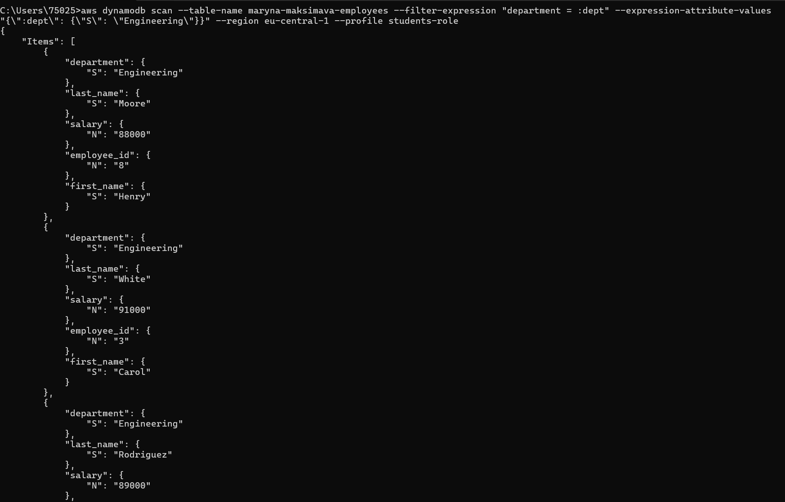

aws dynamodb scan --table-name maryna-maksimava-employees --filter-expression "department = :dept AND salary > :sal" --expression-attribute-values "{\":dept\": {\"S\": \"Engineering\"}, \":sal\": {\"N\": \"85000\"}}" --region eu-central-1 --profile students-role

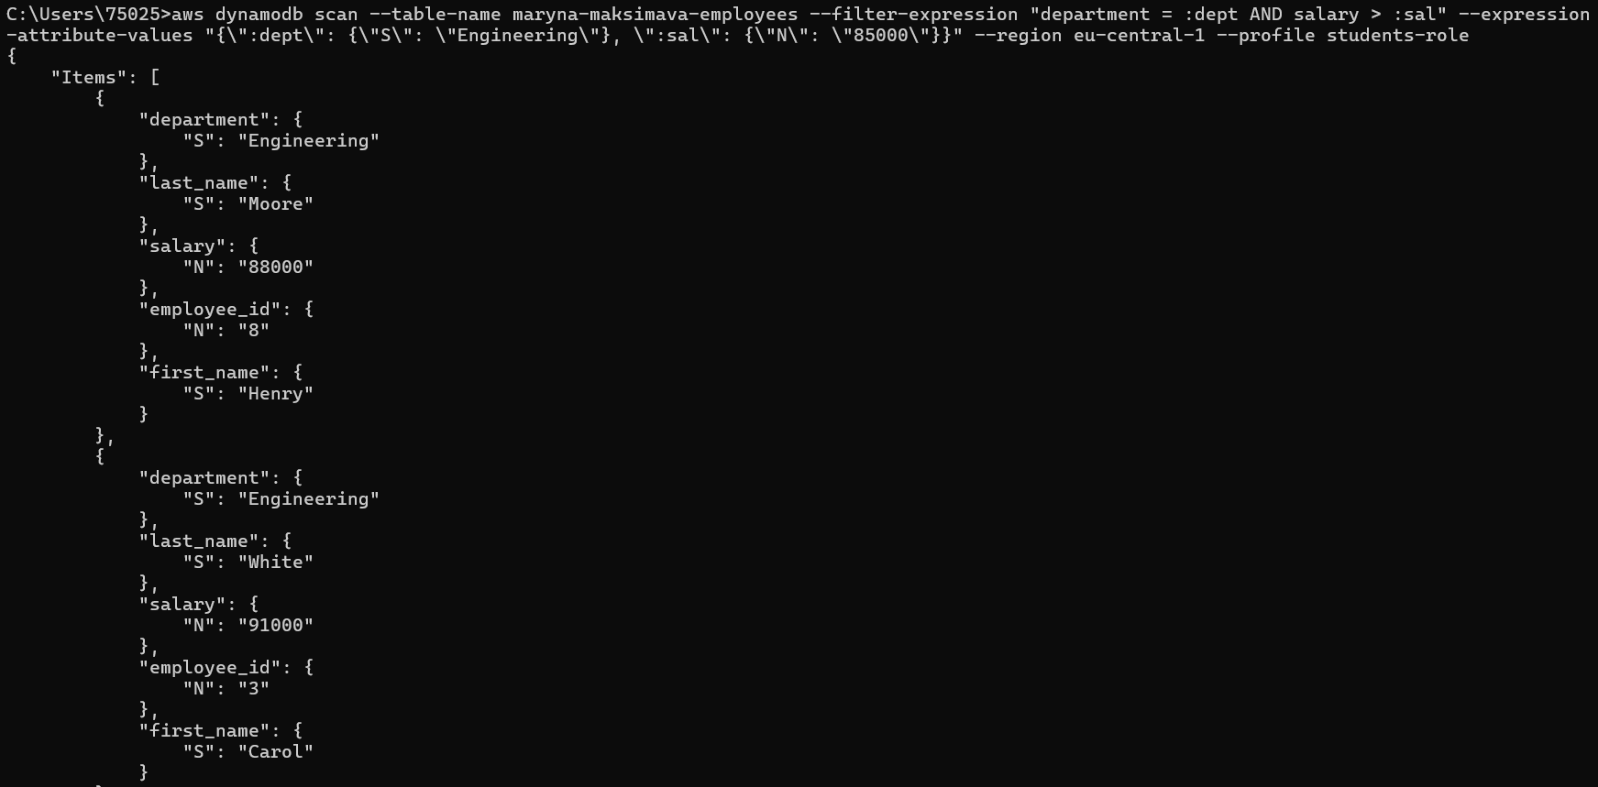
aws dynamodb scan --table-name maryna-maksimava-employees --filter-expression "department = :dept AND salary > :sal" --expression-attribute-values "{\":dept\": {\"S\": \"Engineering\"}, \":sal\": {\"N\": \"85000\"}}" --region eu-central-1 --profile students-role

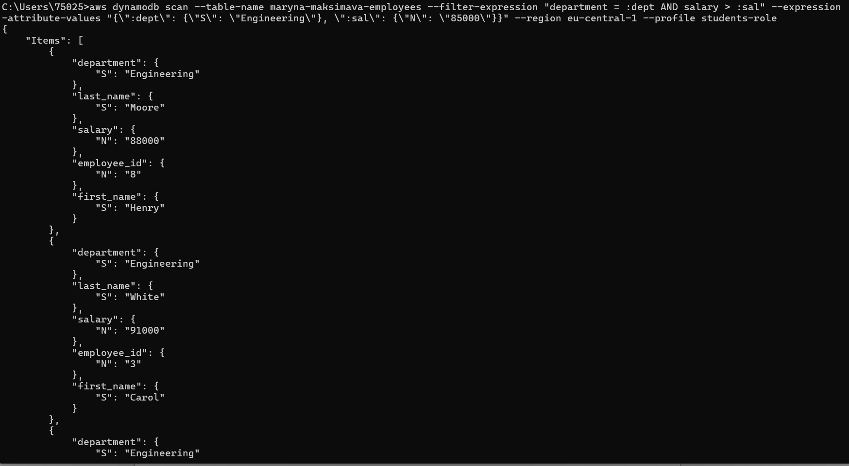

--delete
aws dynamodb delete-item --table-name maryna-maksimava-employees --key "{\"employee_id\": {\"N\": \"19\"}}" --region eu-central-1 --profile students-role

aws dynamodb delete-item --table-name maryna-maksimava-employees --key "{\"employee_id\": {\"N\": \"20\"}}" --region eu-central-1 --profile students-role

--check
aws dynamodb scan --table-name maryna-maksimava-employees --select "COUNT" --region eu-central-1 --profile students-role

