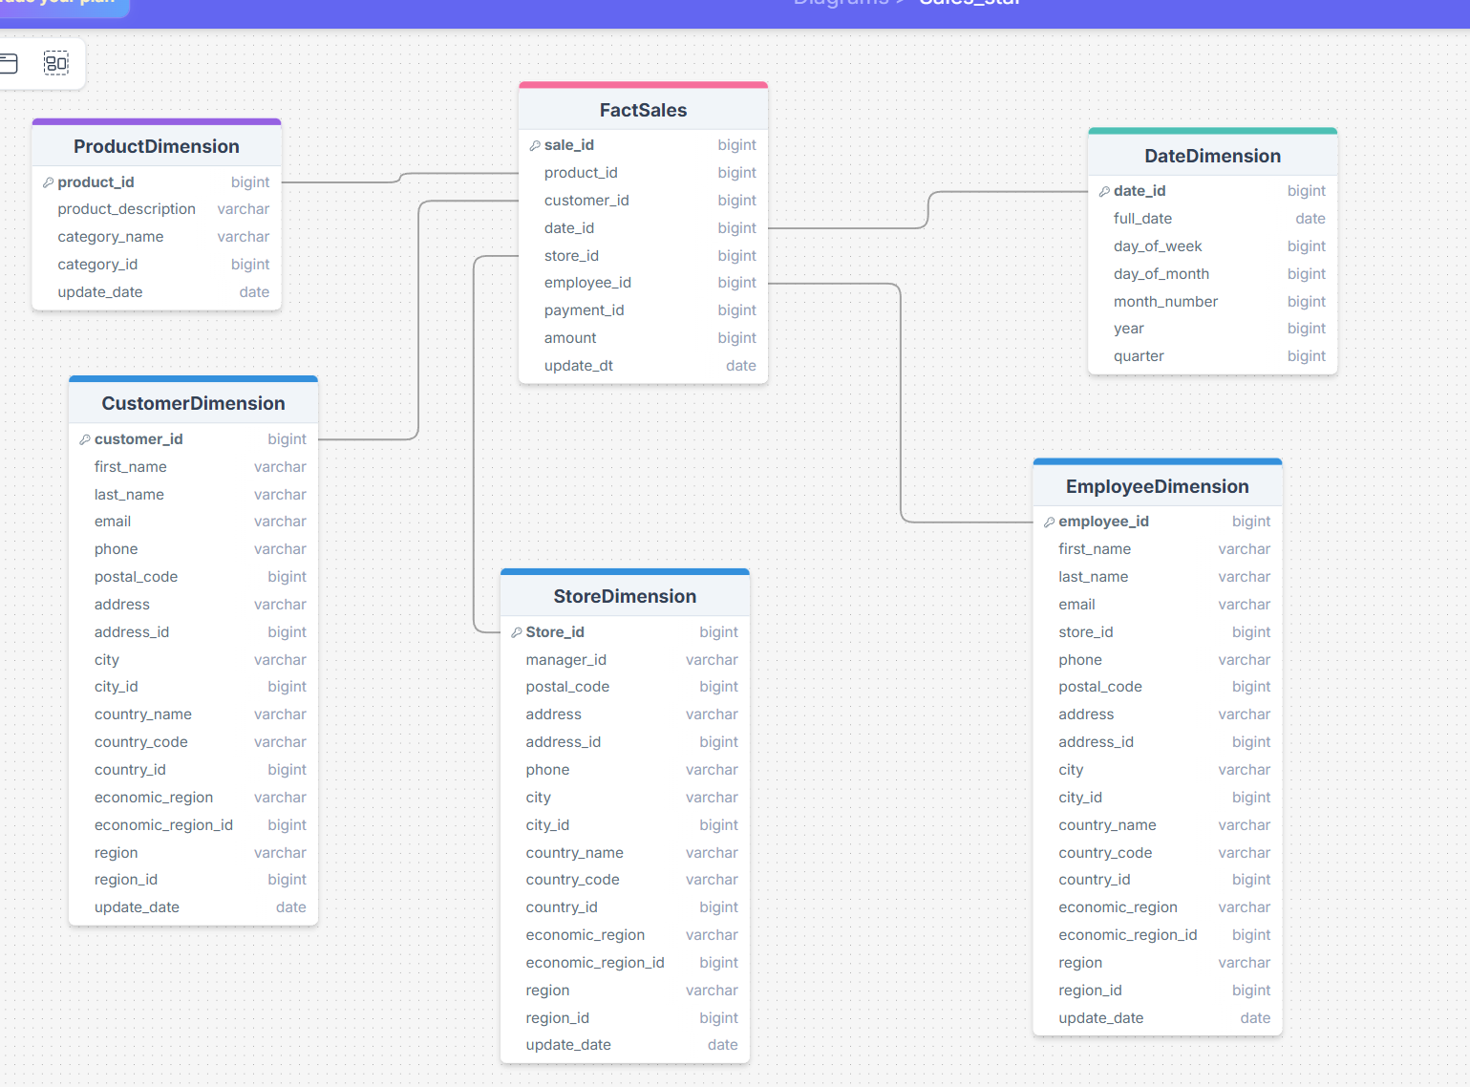
1 Sales are the central activity connecting customers, products, stores, employees, and time. Sale table was merged with the payment entity since they share most fields and basically describe the same thing; keeping payment as a dimension would have introduced too many interdimetional relations.

2 Each row corresponds to a single sale. Since the initial schema states that one sale corresponds to one product this grain is the optimal one.

3 Dimensions:
CustomerDimension – who made the purchase
ProductDimension – what was sold
StoreDimension – where it was sold
EmployeeDimension – who arranged the sale
DateDimension – when it occurred

4 FactSales table contains numeric measures (amount) and foreign keys linking it to dimensions. Also payment_id is saved there so that no initial data is lost as per the task.

Commentary:
Metadata (update_dt) is reduced to only describe the main tables’ update date.
Fields like city_id, country_id, etc. are redundant in the star schema but were preserved in order to not lose any initial data.

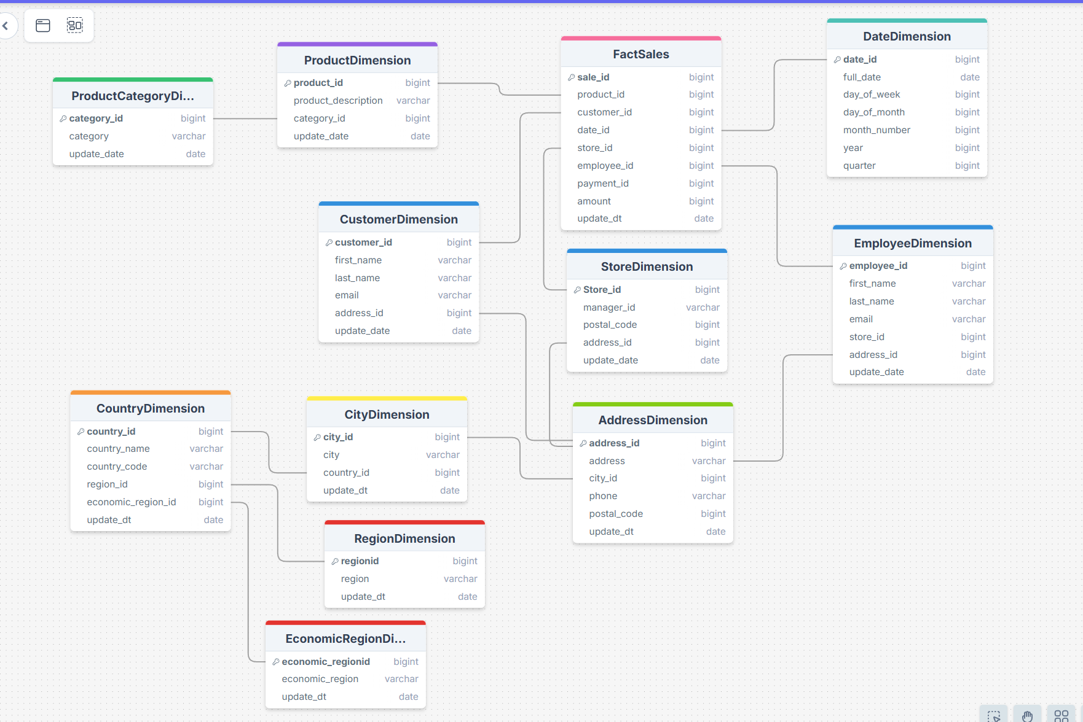

In the normalization process some natural hierarchies were discovered:
Address → City → Country → Region
Address → City → Country→ Economic Region
Product → Product Category
They were leading to redundancies across multiple dimension rows.
In the final snowflake schema these relations between tables were preserved through foreign keys.

The grain remains one row per sale. No new attributes were introduced into the fact table.

