1.1 TASK 1 – TABLE WITHOUT INDEX

2 runs of explain
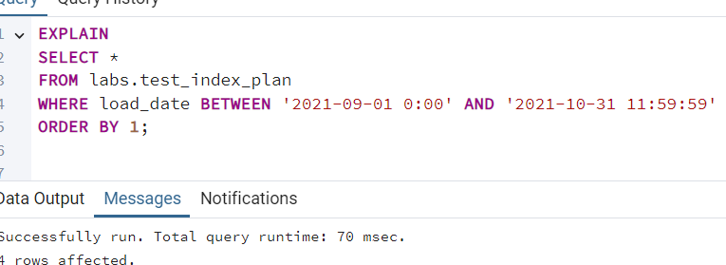

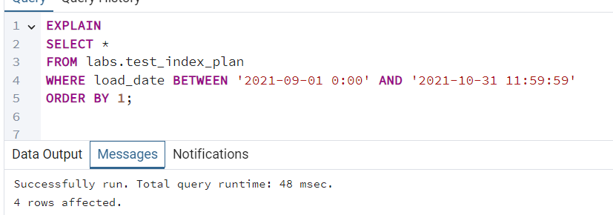

-----------------------------------------------
EXPLAIN ANALYZE 2 runs
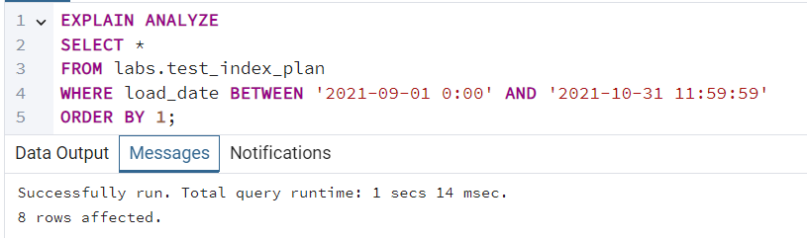

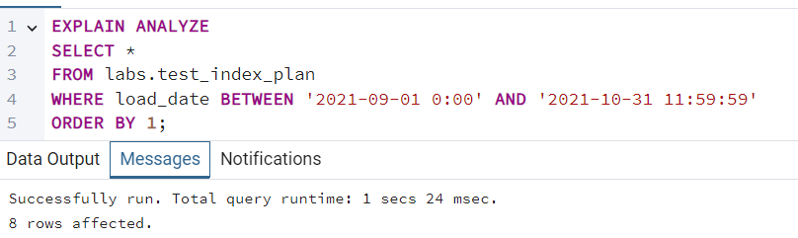

---------------------------------------
EXPLAIN (ANALYZE, BUFFERS)
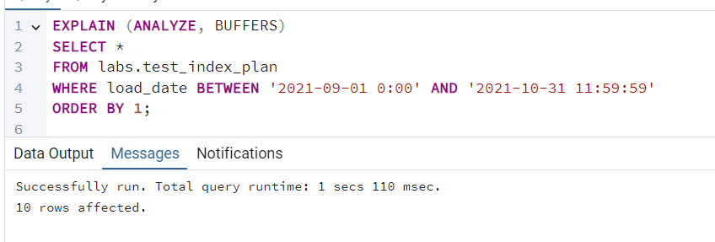

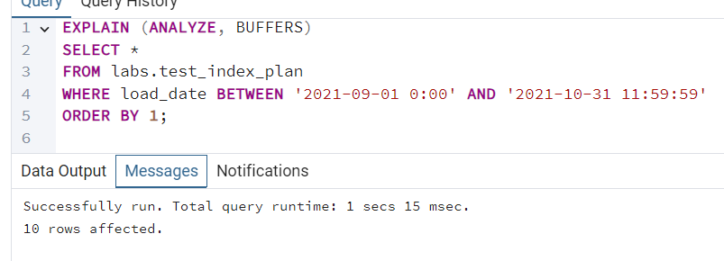

Explain analyze and explain (analyze, buffers) are both running way longer than explain.
1.2 TASK 2 – ADDING INDEX

Explain analyze and explain
dsdd
Explain:
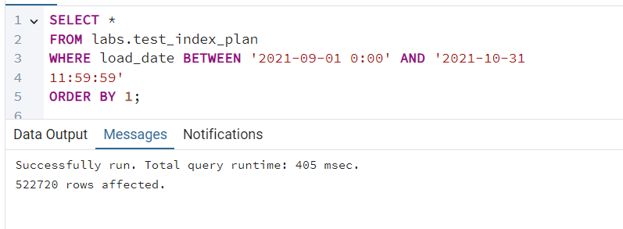

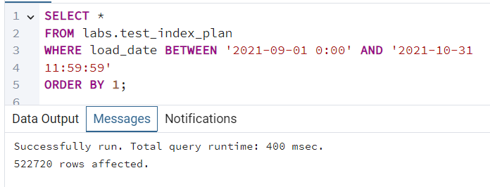

---------------------------------------------------------
Explain analyze

Successfully run. Total query runtime: 248 msec.
Successfully run. Total query runtime: 255 msec.
-------------------------------------------------
EXPLAIN (ANALYZE, BUFFERS)
Successfully run. Total query runtime: 254 msec.
Successfully run. Total query runtime: 256 msec.

With the index these operations run 4-8 times faster.
------------------------------------
3
Index Only scan is possible when all the columns are in the index or when only the indexed columns are selected.
---------------------------------

BRIN index
Explain
Successfully run. Total query runtime: 48 msec.
Successfully run. Total query runtime: 58 msec.
EXPLAIN ANALYZE
Successfully run. Total query runtime: 245 msec.
Successfully run. Total query runtime: 235 msec.
EXPLAIN (ANALYZE, BUFFERS)
Successfully run. Total query runtime: 226 msec.
Successfully run. Total query runtime: 253 msec.

Brin index shows approximately the same results as B-Tree Index on this select.

2.1 TASK 3 BULK INSERT
CREATE INDEX idx_test_inserts_load_date
ON labs.test_inserts (load_date);
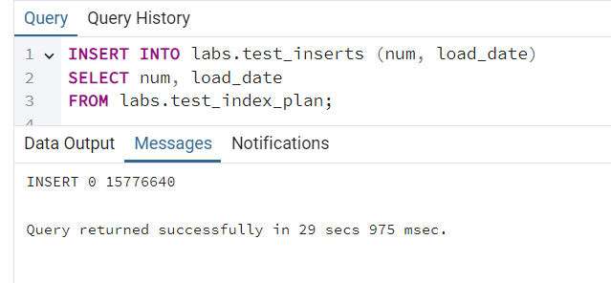

Bulk insert from select is much faster than inserting row-by-row.
Since index was created the system needs to update the index for every row which makes the slower
-------------------
It’s more efficient to have one insert statement with multiple value rows than to have multiple insert statements.

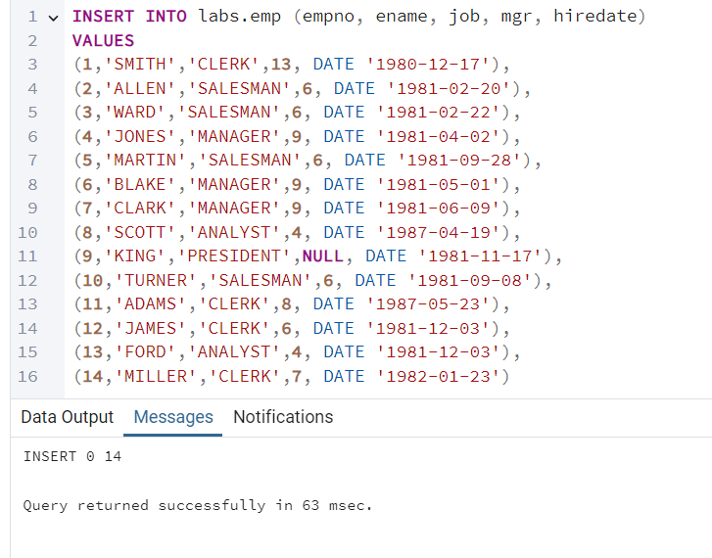

2.2 TASK 4 COPY COMMAND
COPY labs.test_index_plan TO 'C:\postgres_files\test_index_plan.csv'
WITH (FORMAT csv, HEADER true, DELIMITER ',');
------------------------------------------------
COPY labs.test_index_plan (num, load_date)
TO 'C:\postgres_files\test_index_plan_quotes.csv'
WITH (
FORMAT csv,
HEADER true,
DELIMITER ',',
FORCE_QUOTE (load_date)
);
----------------------
COPY (
SELECT num, load_date
FROM labs.test_index_plan
WHERE load_date BETWEEN '2021-09-01 0:00' AND '2021-09-01 11:59:59'
ORDER BY load_date
)
TO 'C:\postgres_files\test_index_plan_short.csv'
WITH (FORMAT csv, HEADER true, DELIMITER ',');
-------------------------------------
COPY labs.test_copy (num, load_date)
FROM 'C:\postgres_files\test_index_plan.csv'
WITH (FORMAT csv, HEADER true, DELIMITER ',');
----
I used COPY command to export the table contents to csv files. To control quoting, I used FORCE_QUOTE(load_date).

2.3 TASK 5 UPSERT

INSERT INTO labs.emp (empno, ename, job, mgr, hiredate)
VALUES
(1, 'SMITH', 'MANAGER', 13, DATE '2021-12-01'),
(14, 'KELLY', 'CLERK', 1, DATE '2021-12-01'),
(15, 'HANNAH', 'CLERK', 1, DATE '2021-12-01'),
(11, 'ADAMS', 'SALESMAN', 8, DATE '2021-12-01'),
(4, 'JONES', 'ANALYST', 9, DATE '2021-12-01')
ON CONFLICT (empno)
DO UPDATE
SET
ename = EXCLUDED.ename,
job = EXCLUDED.job,
mgr = EXCLUDED.mgr,
hiredate = EXCLUDED.hiredate;

If an employee number already existed, the row was updated. If it did not exist, it was inserted.

