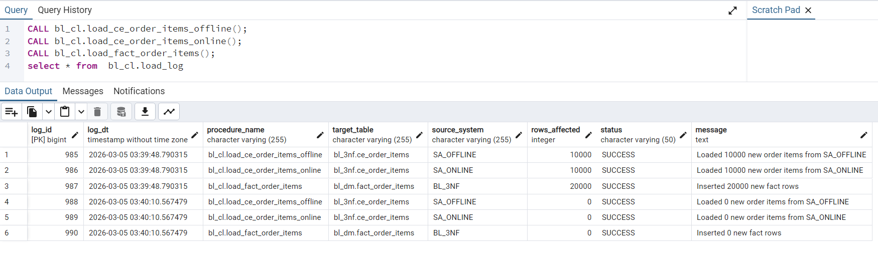

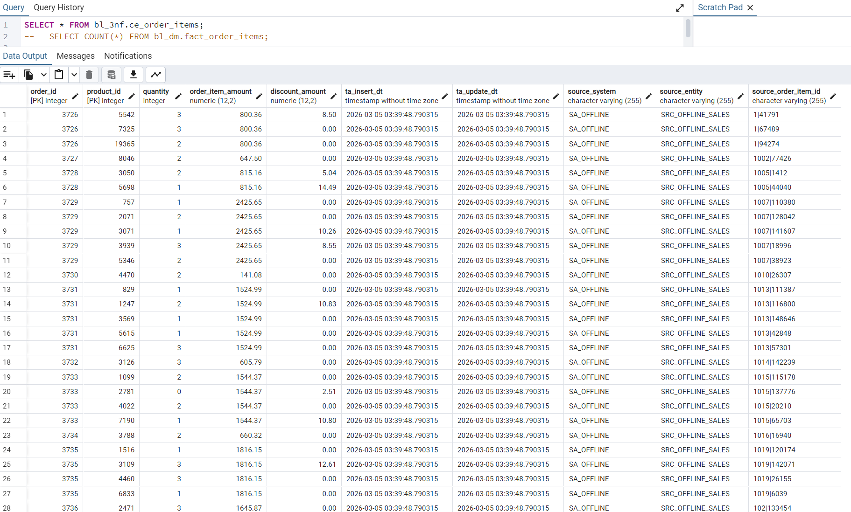

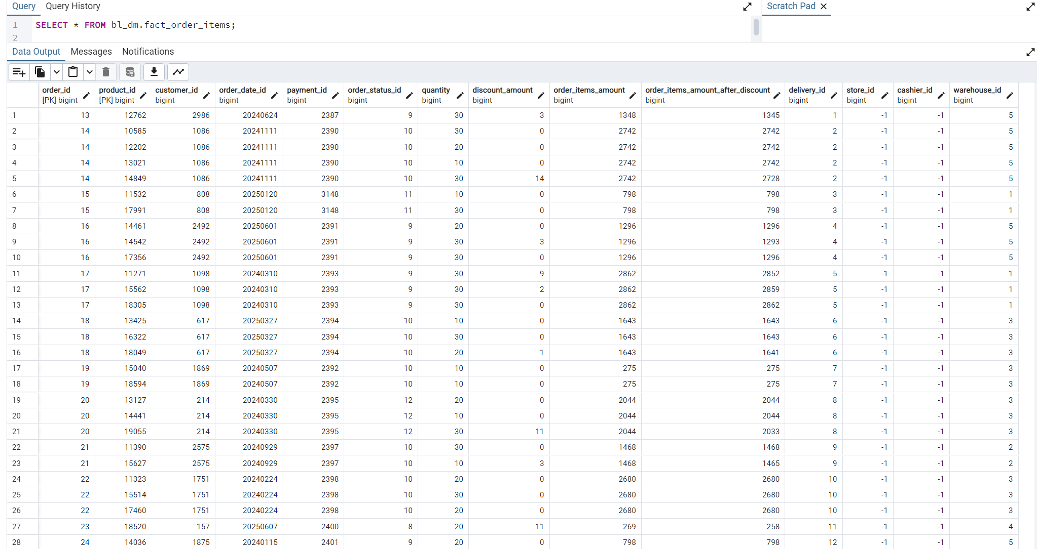

SELECT order_id, product_id, COUNT(*) AS cnt
FROM bl_3nf.ce_order_items
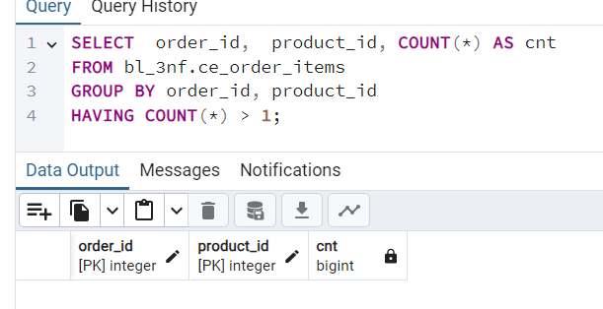
GROUP BY order_id, product_id
HAVING COUNT(*) > 1;

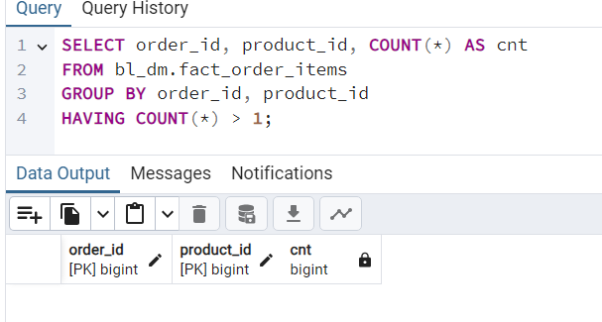
SELECT order_id, product_id, COUNT(*) AS cnt
FROM bl_dm.fact_order_items
GROUP BY order_id, product_id
HAVING COUNT(*) > 1;

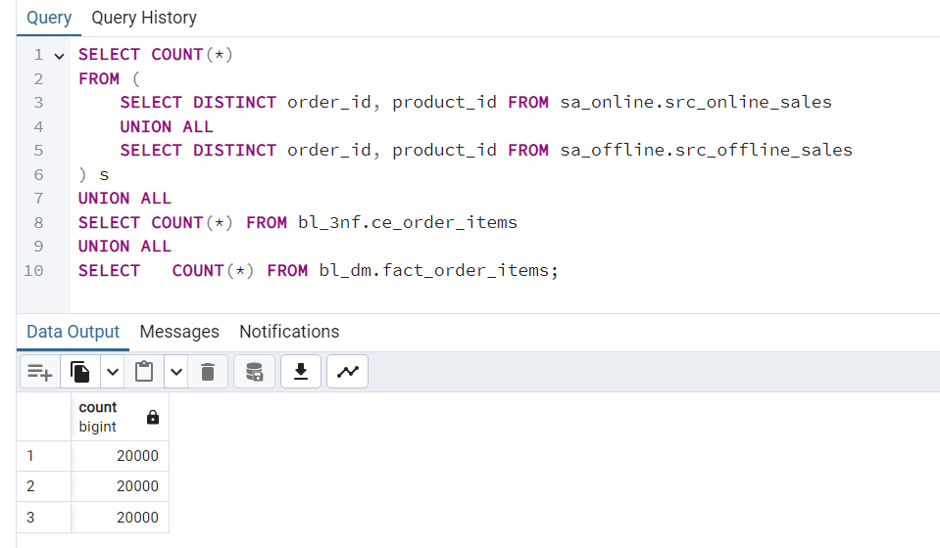

SELECT COUNT(*)
FROM (
SELECT DISTINCT order_id, product_id FROM sa_online.src_online_sales
UNION ALL
SELECT DISTINCT order_id, product_id FROM sa_offline.src_offline_sales
) s
UNION ALL
SELECT COUNT(*) FROM bl_3nf.ce_order_items
UNION ALL
SELECT COUNT(*) FROM bl_dm.fact_order_items;

