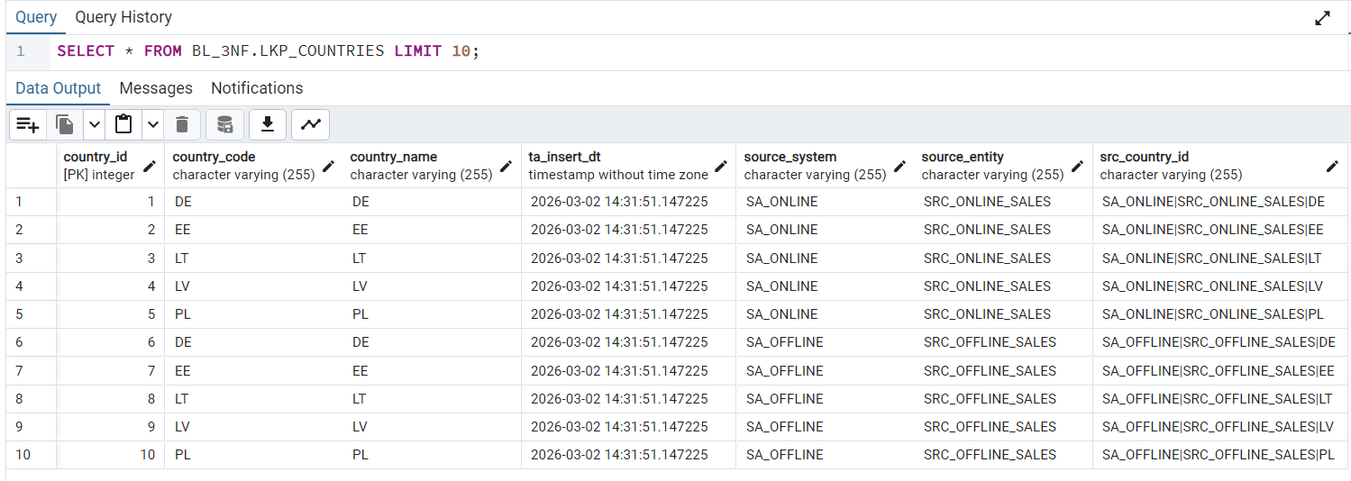
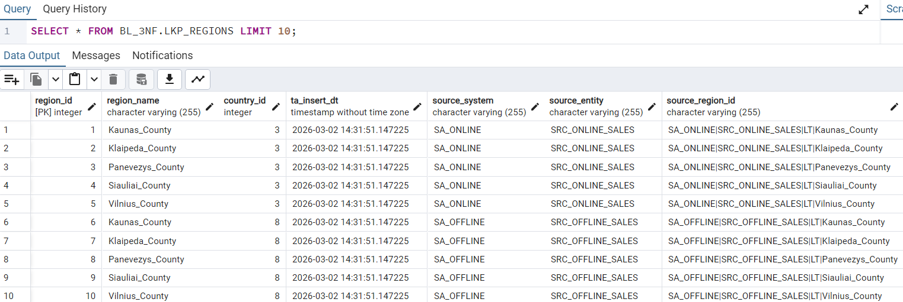
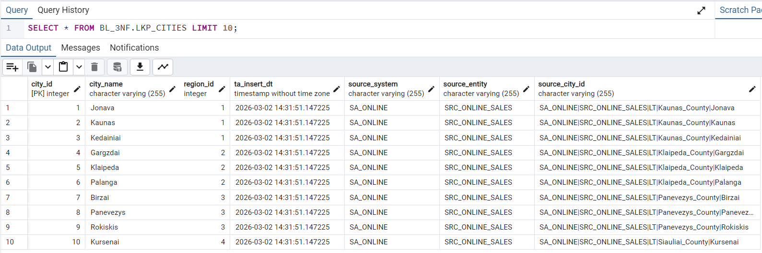
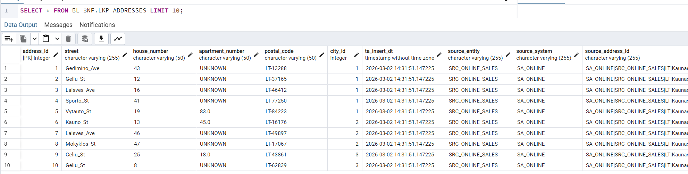
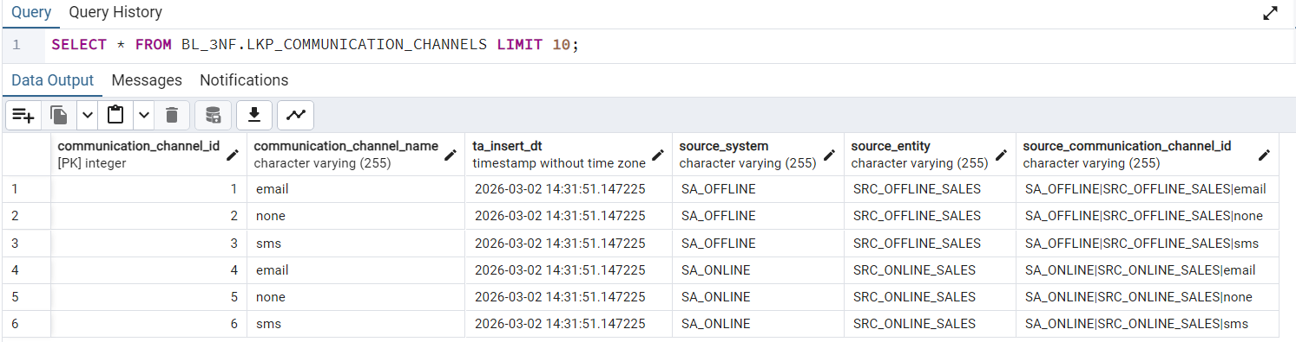
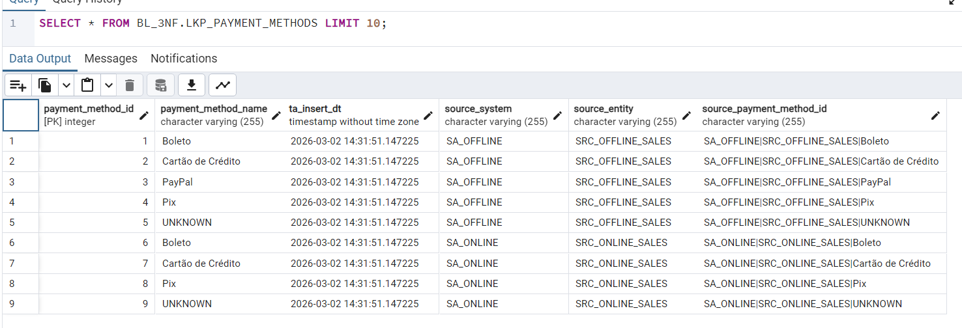
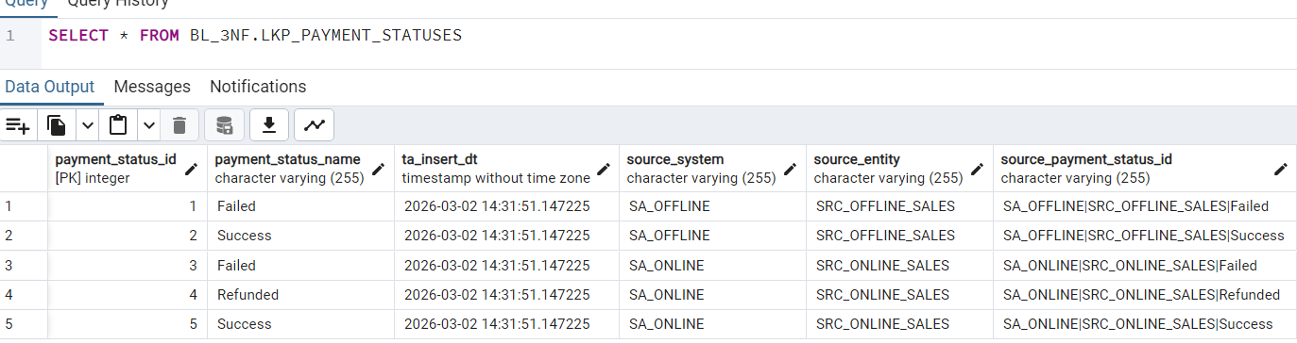

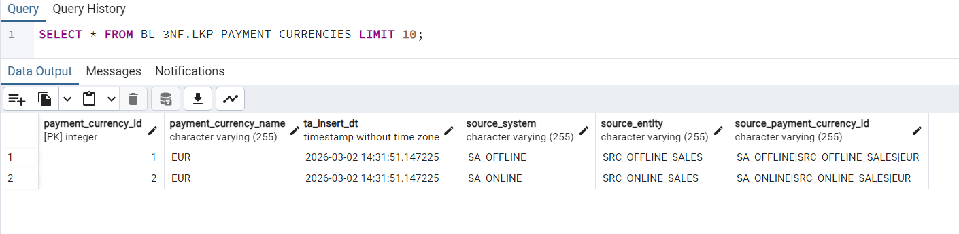
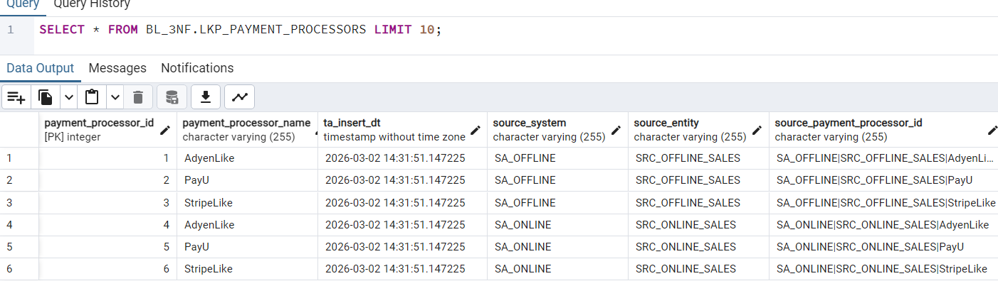

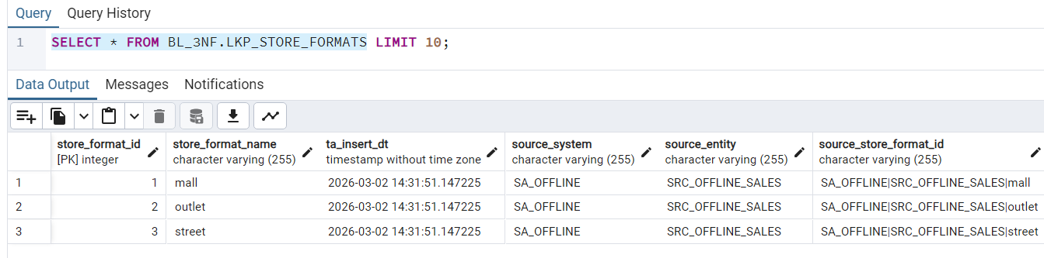

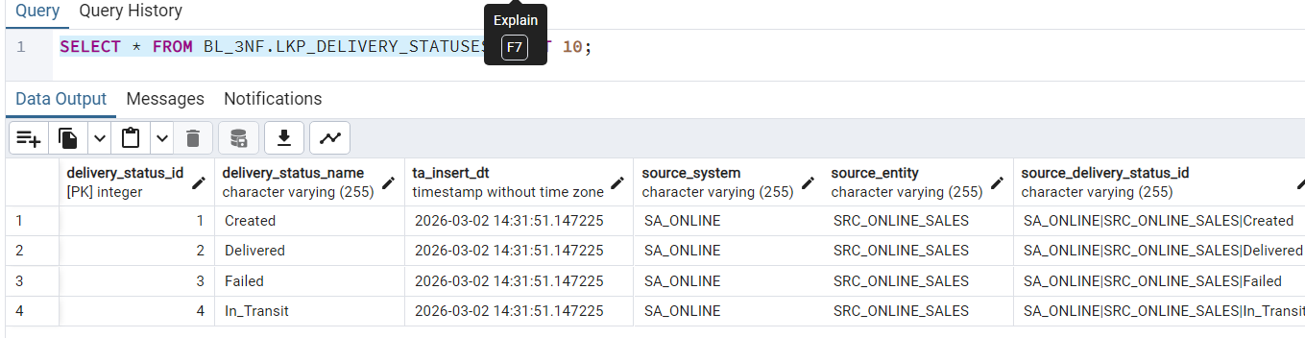

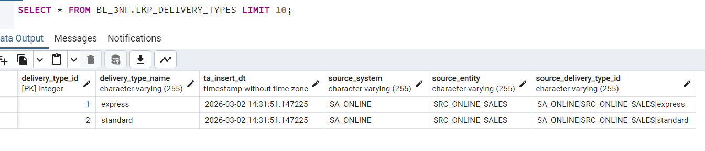
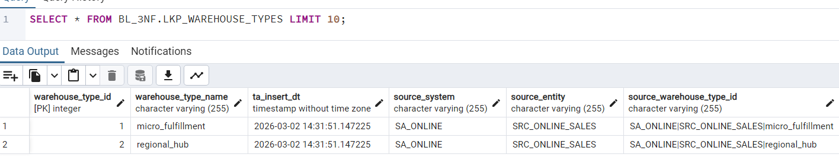
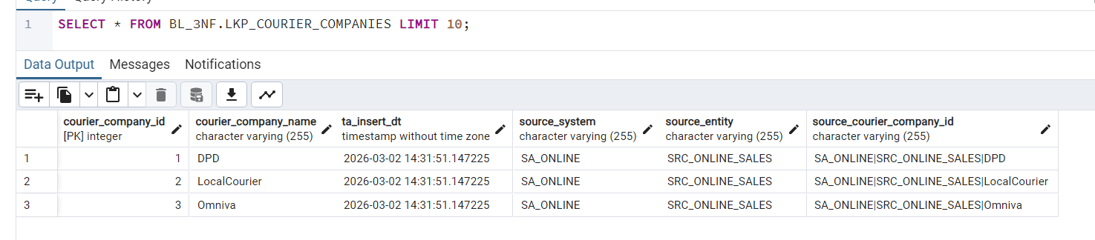
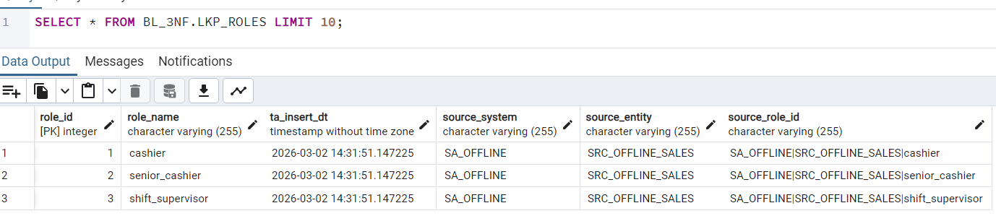

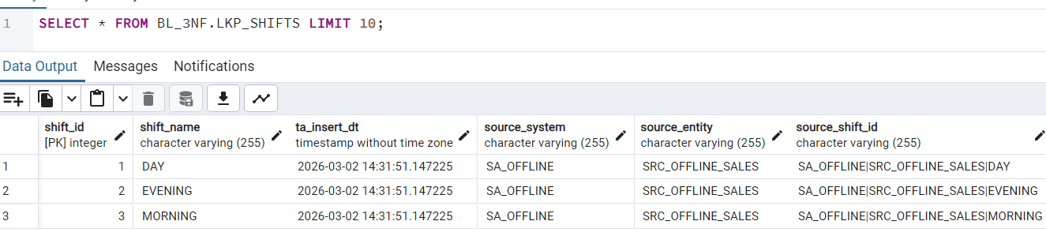

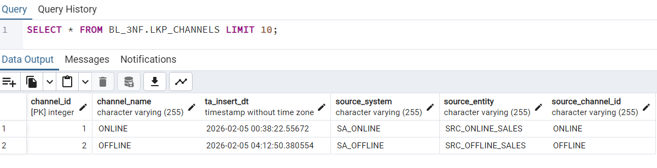

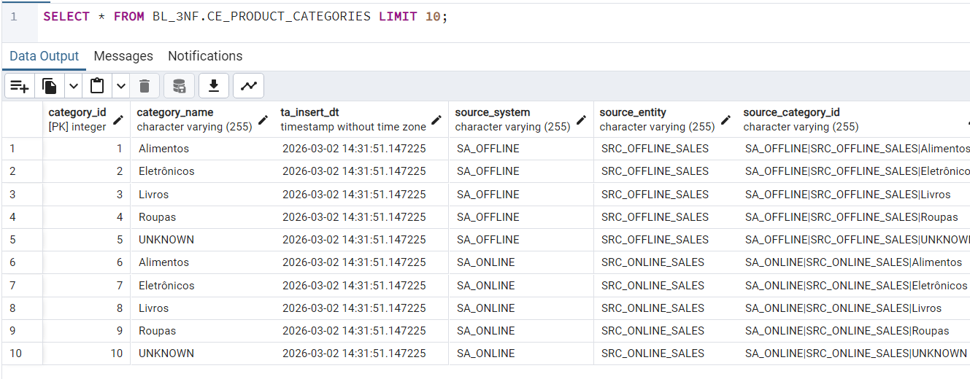
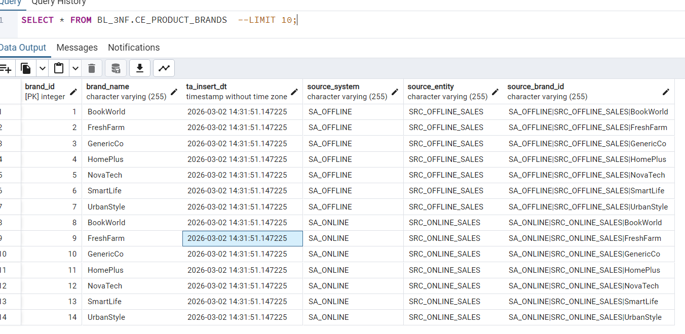

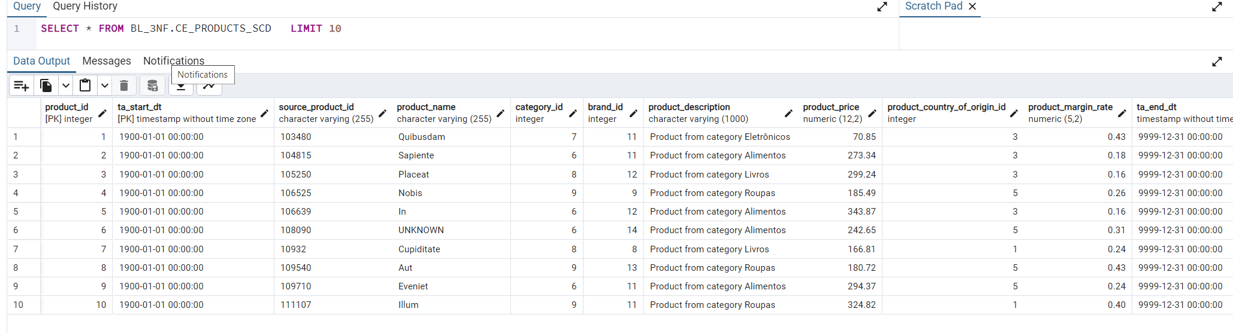

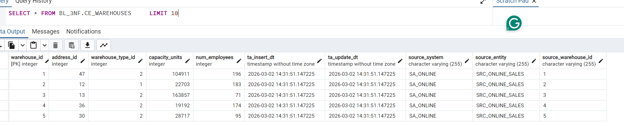
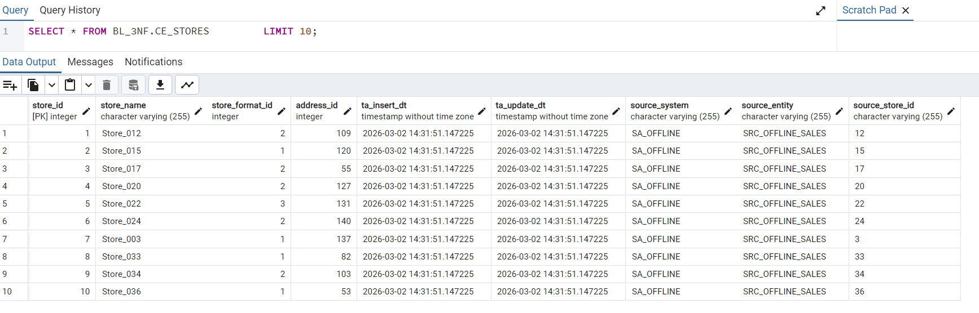

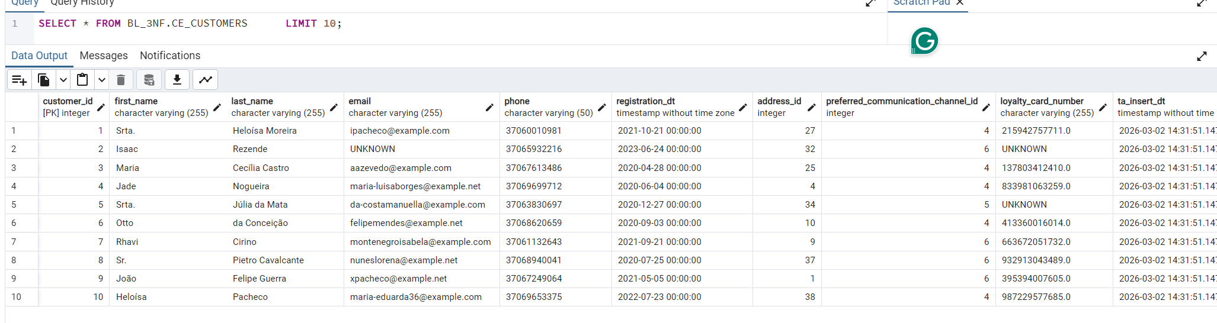

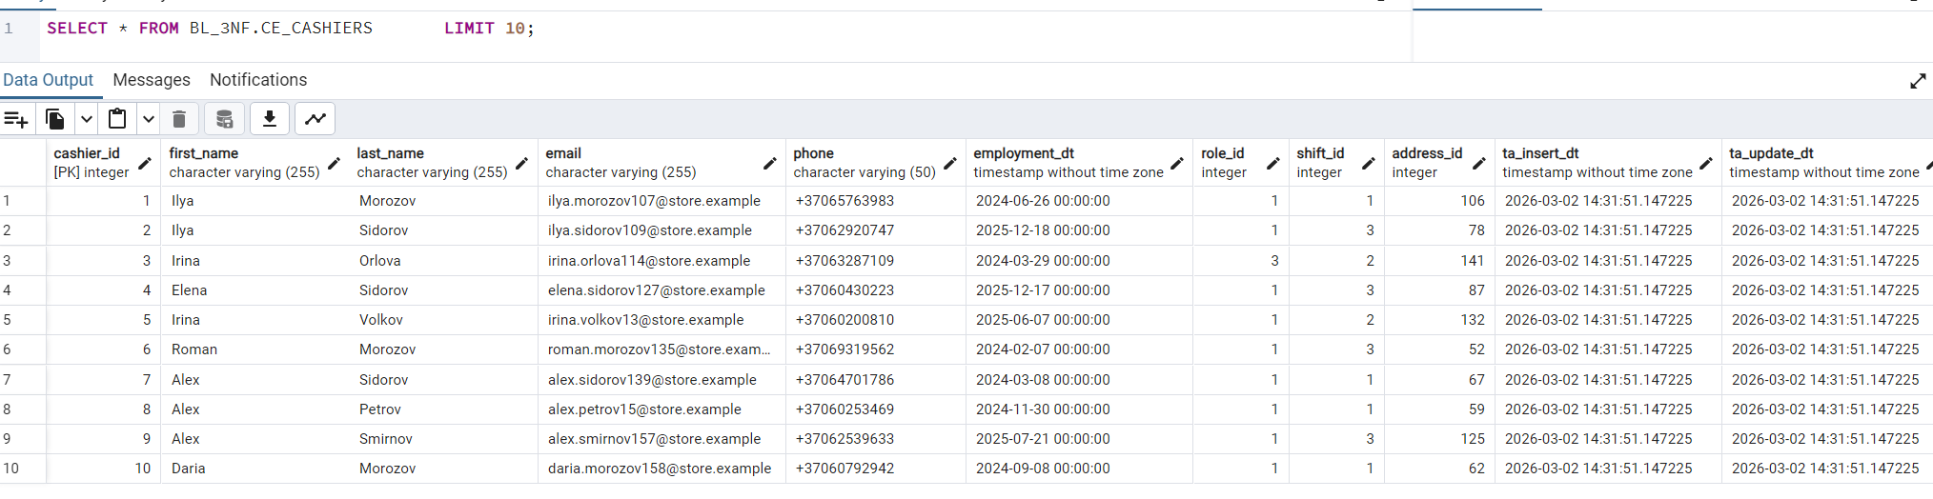

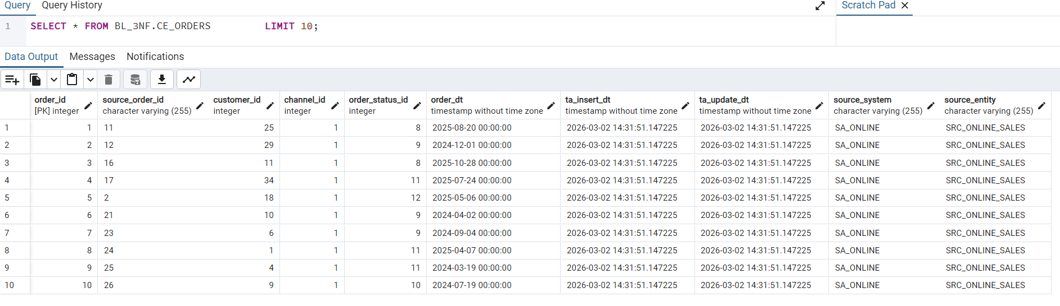
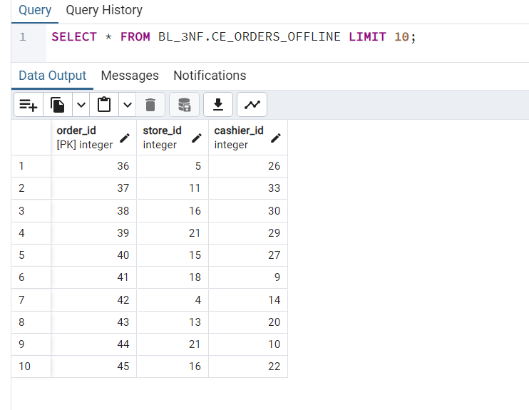
--procedures rerunnability summary
WITH runs AS (
SELECT
procedure_name,
rows_affected,
status,
ROW_NUMBER() OVER (PARTITION BY procedure_name ORDER BY log_dt ASC) AS run_num
FROM BL_CL.LOAD_LOG
WHERE status != 'INFO'
)
SELECT
procedure_name,
MAX(CASE WHEN run_num = 1 THEN rows_affected END) AS first_run_rows,
MAX(CASE WHEN run_num = 2 THEN rows_affected END) AS second_run_rows,
MAX(CASE WHEN run_num = 2 THEN status END) AS second_run_status
FROM runs
GROUP BY procedure_name
ORDER BY procedure_name;
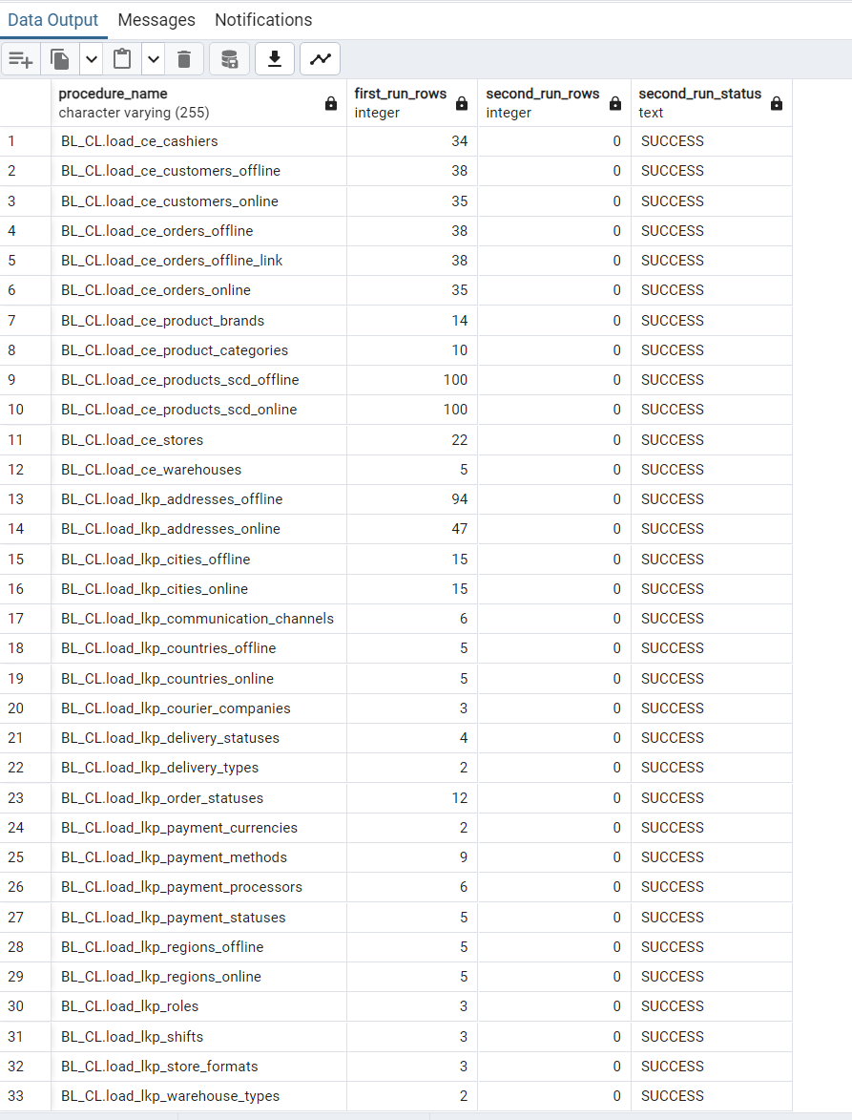

Each procedure loads one target table at a time. There is the load_all_3nf to load all the tables in the correct order: lookup tables first and CE tables later.
Rerunnability is achieved by using WHERE NOT EXISTS in DML and CREATE OR REPLACE in DDL.

Logging captures the procedure name, target table, source system, timestamp, number of rows affected, and status (SUCCESS / ERROR / INFO) for every execution.

