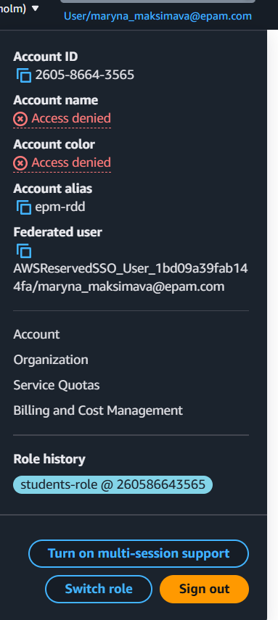

I switched the role.

I did aws configure sso.

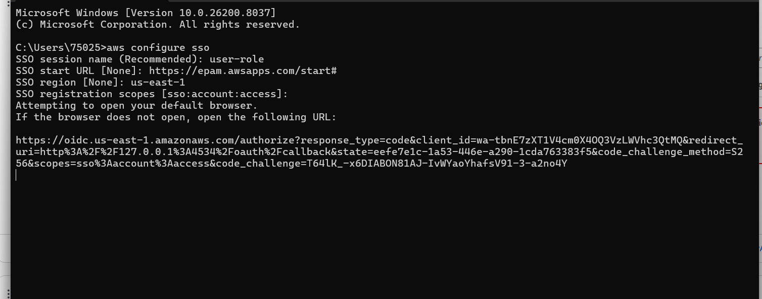

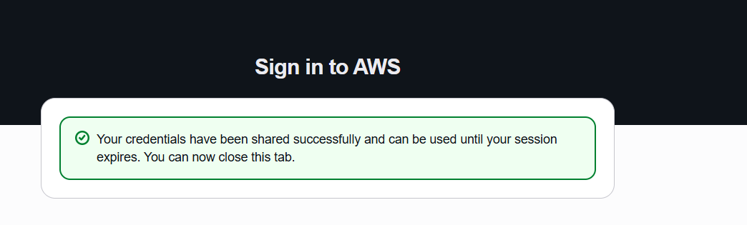
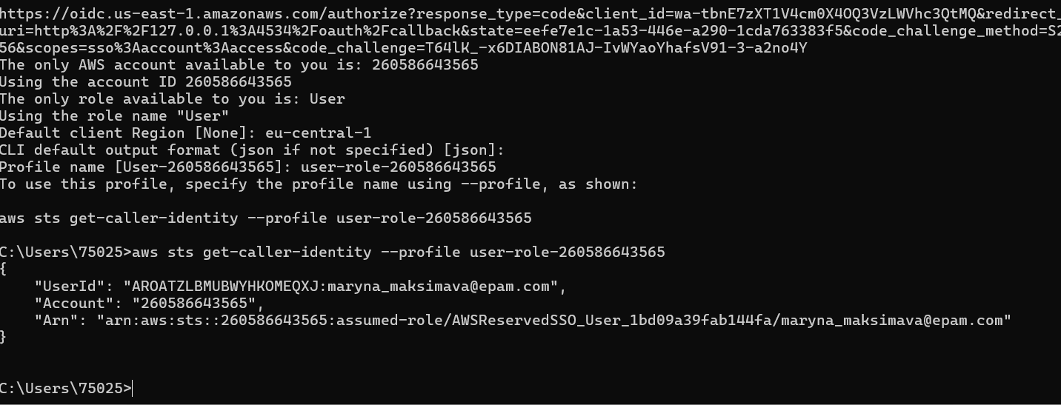

{
"UserId": "AROATZLBMUBWYHKOMEQXJ:maryna_maksimava@epam.com",
"Account": "260586643565",
"Arn": "arn:aws:sts::260586643565:assumed-role/AWSReservedSSO_User_1bd09a39fab144fa/maryna_maksimava@epam.com"
}
The config file:
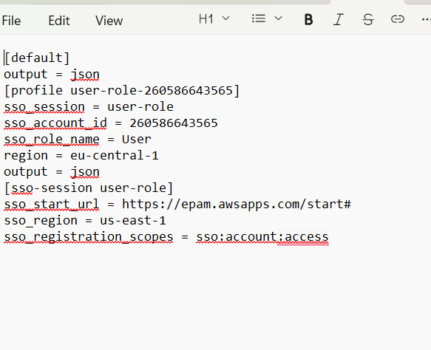
I assumed the role

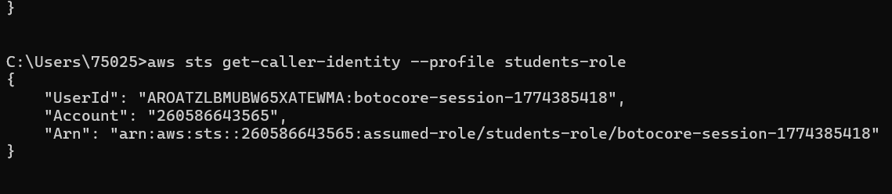

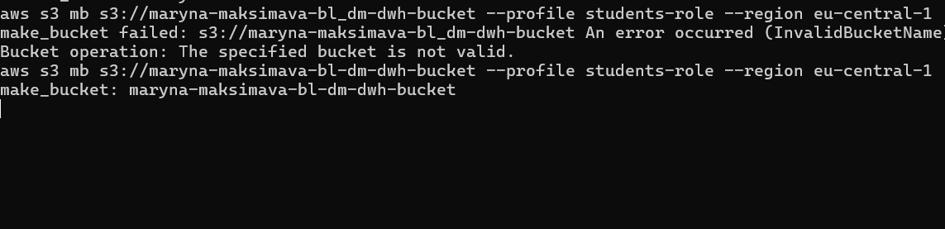

I made the bucket.

I uploaded the files to the bucket.
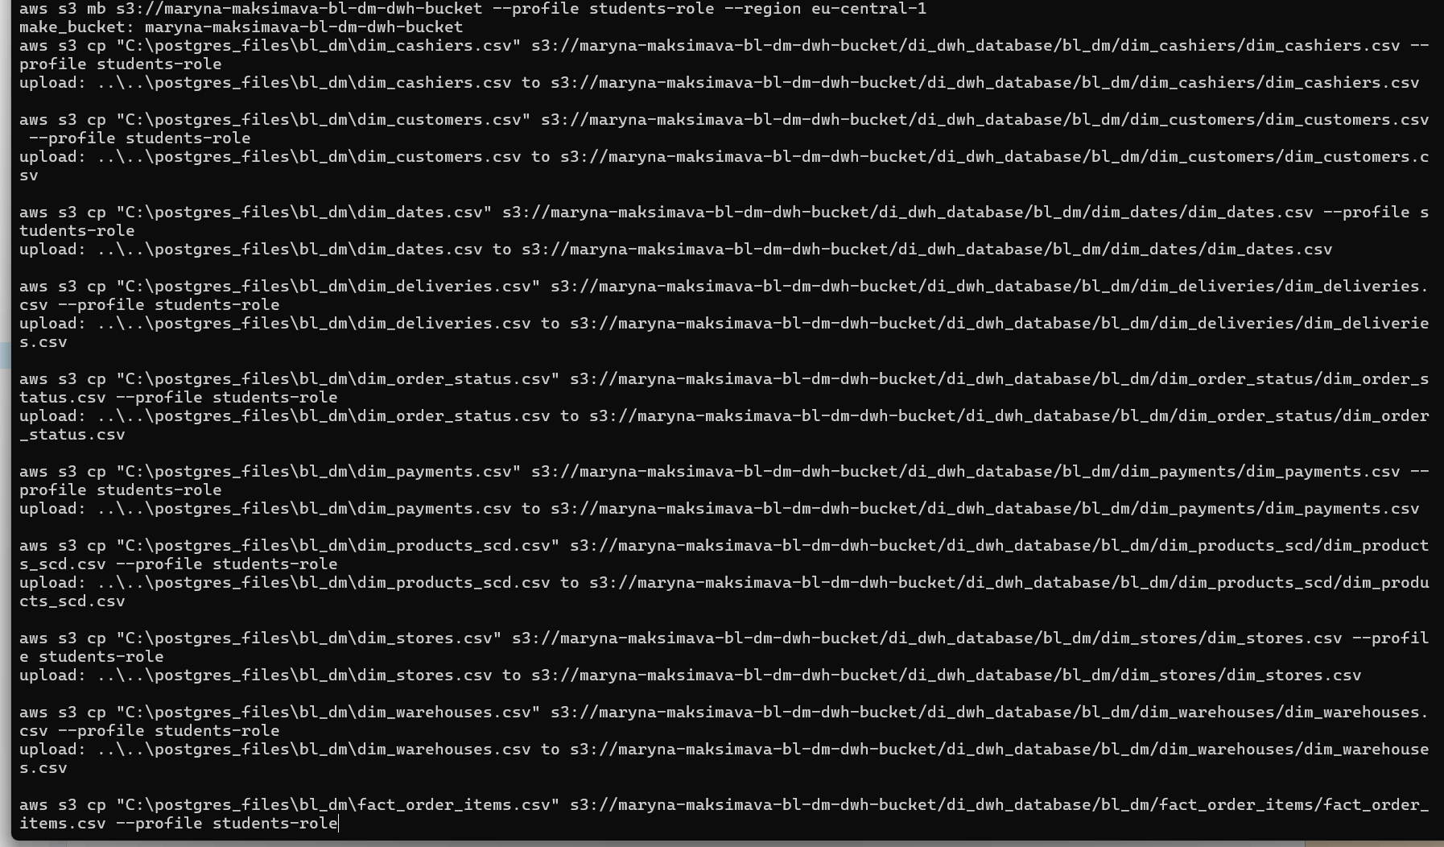

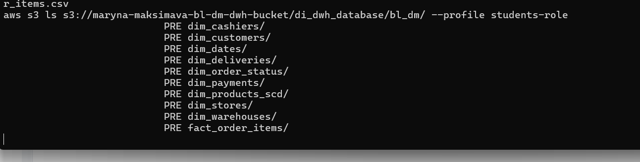

I created a crawler.

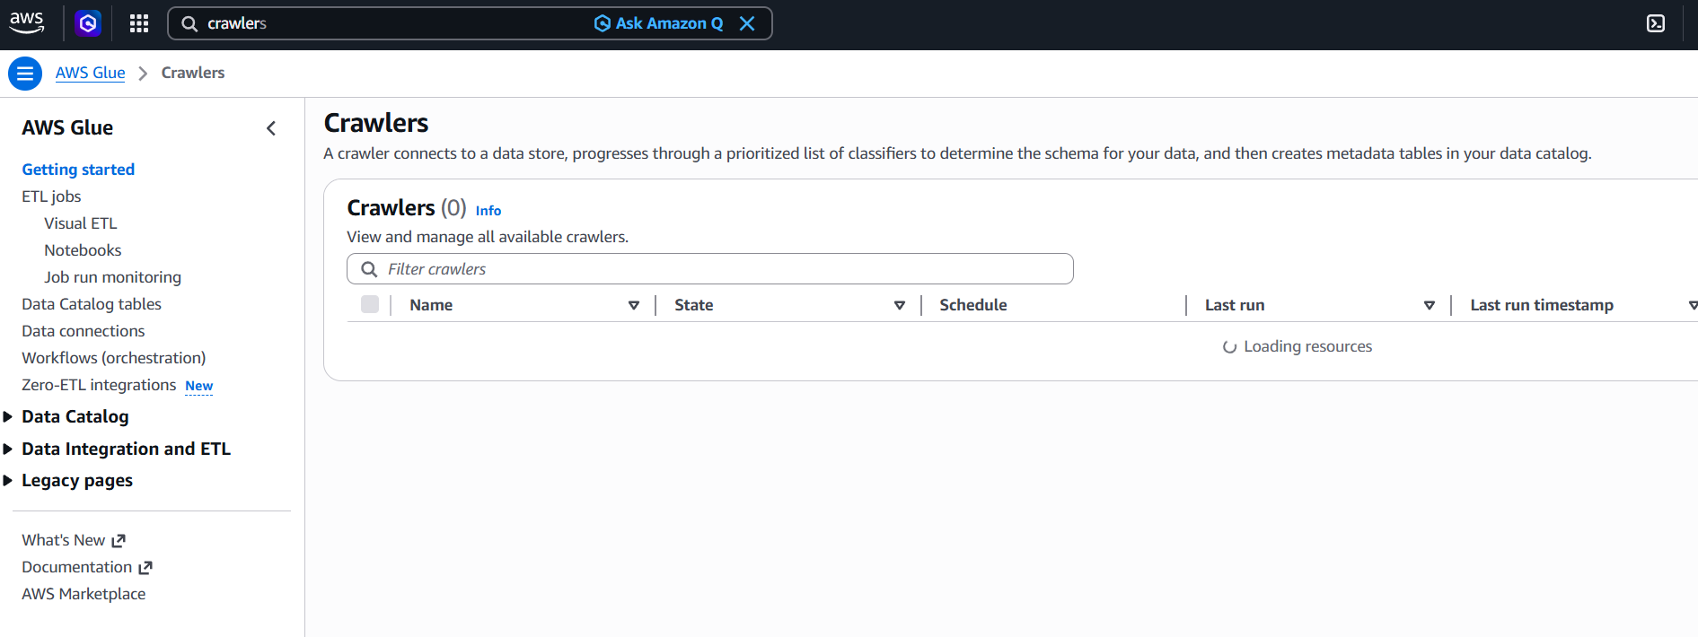

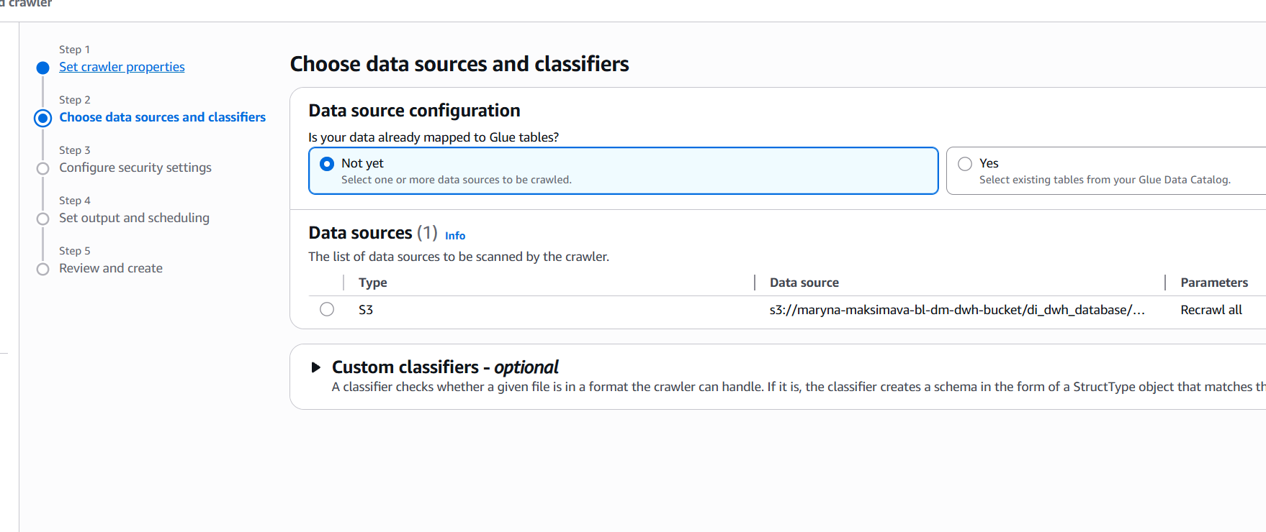
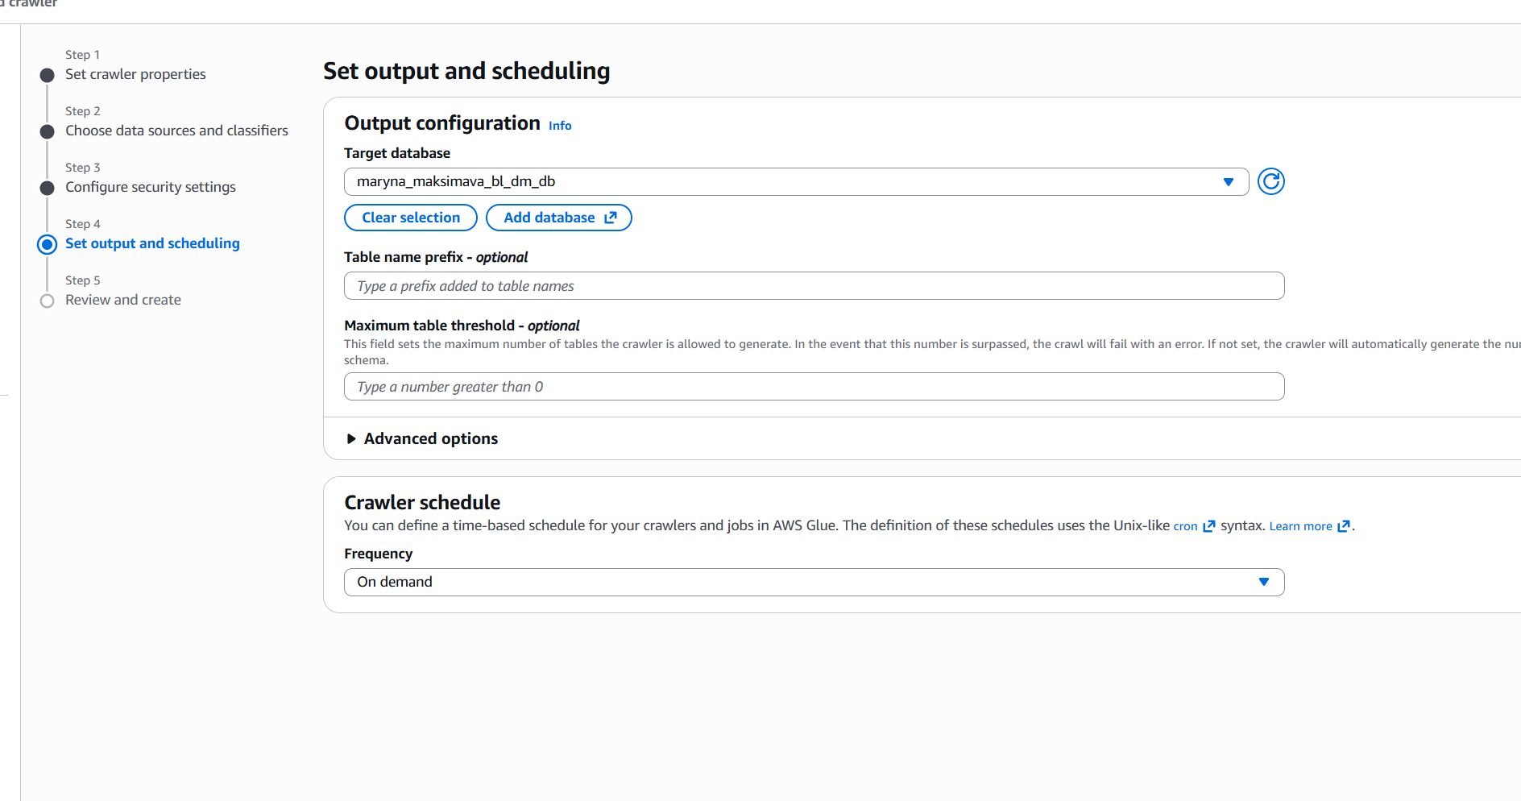

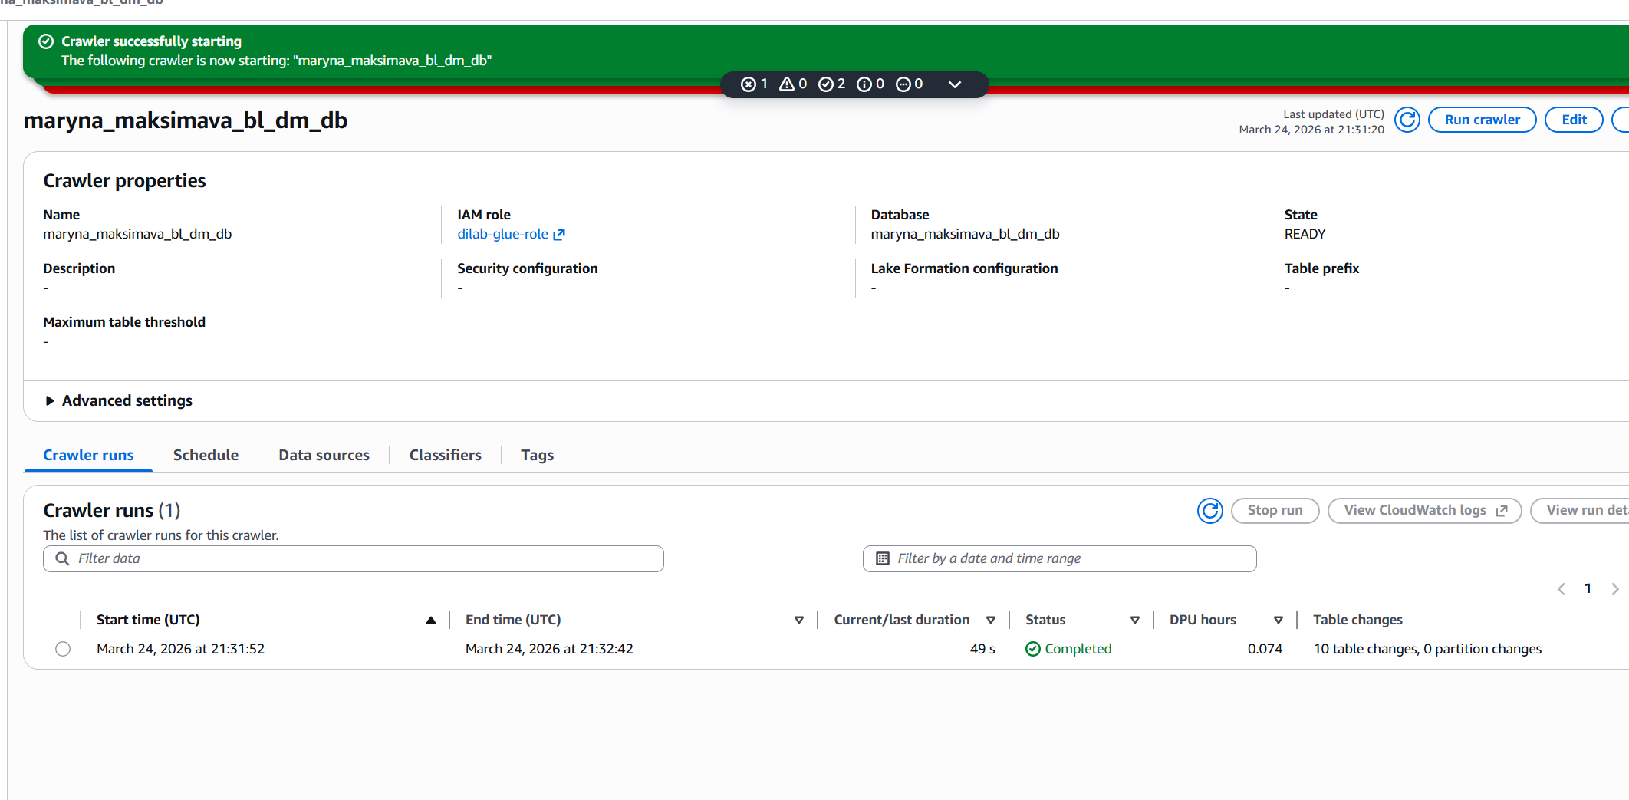
I queried the database via Athena.

SELECT *
FROM maryna_maksimava_bl_dm_db.fact_order_items
LIMIT 10000;

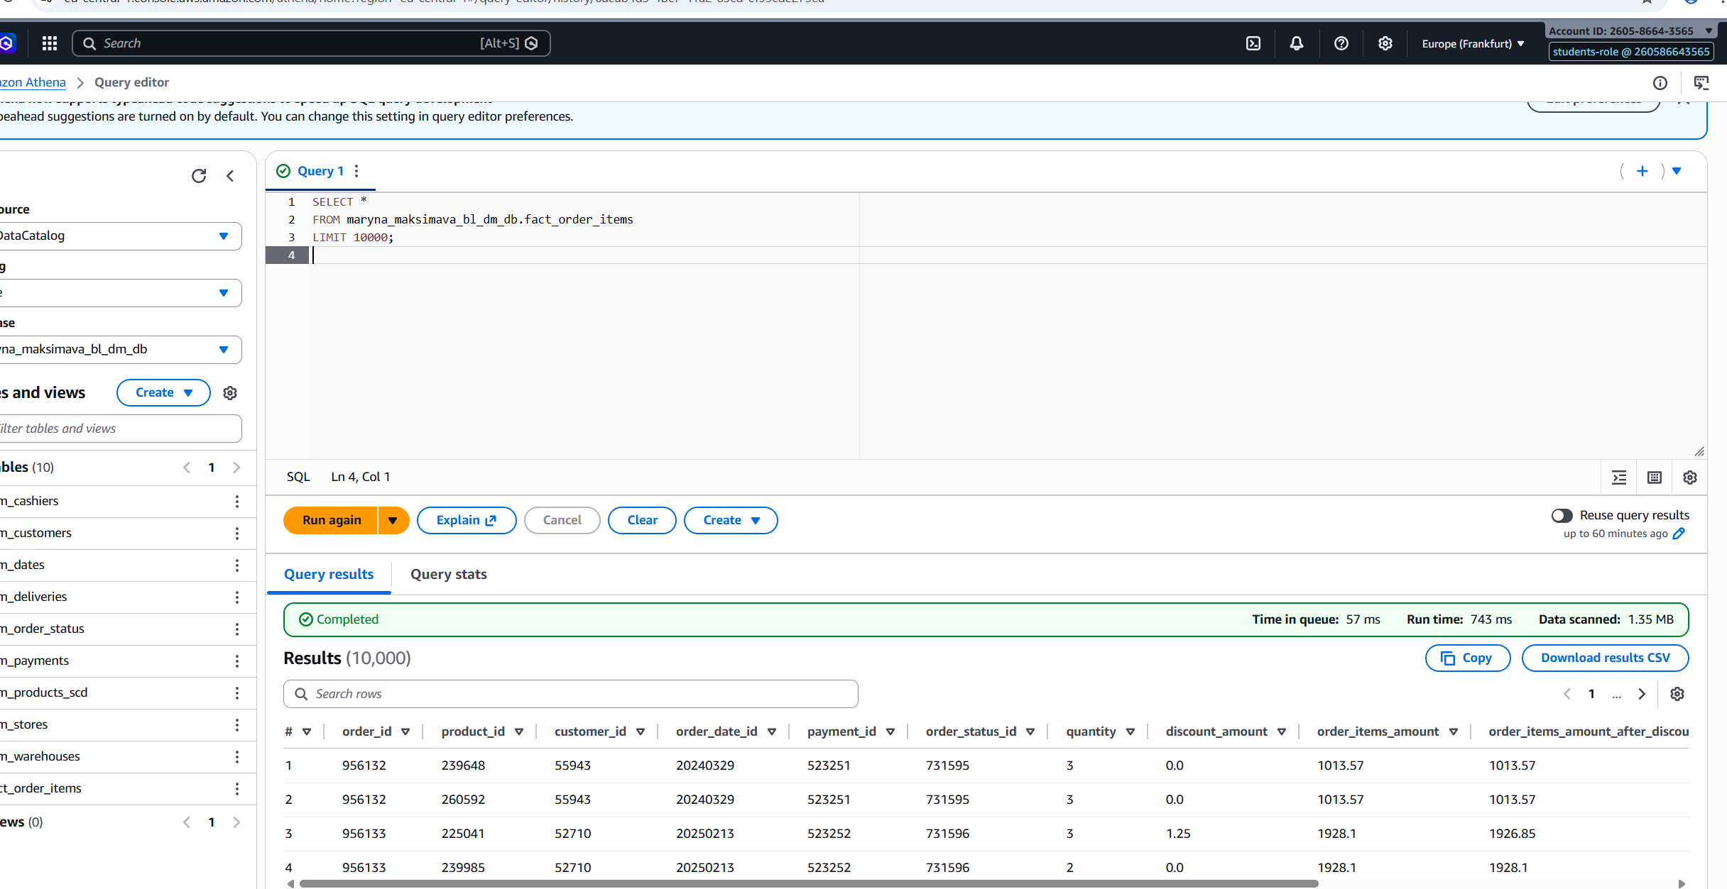

SELECT
c.first_name || ' ' || c.last_name AS customer_name,
c.country_name,
COUNT(f.order_id) AS total_orders,
SUM(f.order_items_amount_after_discount) AS total_spent
FROM fact_order_items f
JOIN dim_customers c ON f.customer_id = c.customer_id
GROUP BY c.first_name, c.last_name, c.country_name
ORDER BY total_spent DESC
LIMIT 10000;

