Business Template

Logo / Image

Contents
1 Business Description 3
1.1 Business background 3
1.2 Problems because of poor data management 3
1.3 Benefits from implementing a Data Warehouse 3
1.4 DATASETS DESCRIPTION 3
1.5 GRAIN / DIM / FACT 4
2 Business Layer 3NF 4
3 Business Layer Dimensional Model 4
4 Logical Scheme 4
5 Data Flow 4
6 Fact Table Partitioning Strategy 4

Business Description

Business background
E-Commerce Data Sd is a retail company operating in both online and offline sales channels. The company sells a wide range of consumer products through its e-commerce platform as well as through physical retail stores. Online sales include home delivery fulfilled via warehouses and courier services, while offline sales are conducted in brick-and-mortar stores with in-store cashiers.
The company operates across multiple regions in Lithuania and serves a large customer base with diverse purchasing behavior. Due to the increasing volume of transactions and the coexistence of different sales channels, the company requires a structured and reliable way to store, integrate, and analyze sales data. Collecting and analyzing historical sales, customer, product, payment, delivery, and store data is critical for understanding customer behavior, improving operational efficiency, and supporting strategic business decisions.

Problems because of poor data management
Without proper data management, E-Commerce Data Sd faces several challenges. Sales data is stored in multiple separate files and systems, making it difficult to combine information about customers, products, orders, and payments. Missing values, inconsistent identifiers, and lack of standardization lead to unreliable reporting and incomplete analysis.
Poor data integration prevents the company from easily answering important business questions such as comparing online and offline performance, analyzing customer loyalty, evaluating delivery efficiency, or understanding regional sales trends. Manual data processing is time-consuming, error-prone, and does not scale as the business grows. As a result, decision-making is based on fragmented information rather than a unified and trusted data source.

Benefits from implementing a Data Warehouse
Implementing a Data Warehouse allows E-Commerce Data Sd to centralize and organize its data into a single, consistent structure. A Data Warehouse enables historical analysis, improves data quality, and supports advanced analytics and reporting.
With a Data Warehouse, the company can:
- Compare online and offline sales performance.
- Analyze customer behavior and loyalty across channels.
- Monitor product performance, pricing, and discounts.
- Evaluate payment methods, order statuses, and refund patterns.
- Assess delivery efficiency and warehouse operations.
- Support management decisions with reliable, up-to-date analytical data.
Overall, a Data Warehouse provides a solid foundation for business intelligence, forecasting, and strategic planning.

DATASETS DESCRIPTION
The project uses two fully denormalized datasets, representing different source systems.

Online Sales Dataset
The online dataset contains detailed information about e-commerce transactions, including:
- Customer information: personal details, contact information, registration date, loyalty card, and full customer address.
- Product information: product name, category, brand, price, stock quantity, margin, and country of origin.
- Order information: order date, order status, quantities, discounts, and total order amount.
- Payment information: payment method, payment amount, payment date, payment status, currency, and payment processor.
- Delivery information: courier, delivery status, delivery type, shipping fee, delivery date, and delivery address.
- Warehouse information: warehouse identifiers, capacity, number of employees, type, and warehouse address.

Offline Sales Dataset
The offline dataset represents in-store purchases and includes:
- Customer information: customer details, contact information, registration date, loyalty card, and customer address.
- Product information: same product attributes as in the online dataset.
- Order information: order date, order status, quantities, discounts, and total order amount.
- Payment information: payment method, payment amount, payment date, payment status, currency, and processor.
- Store information: store identifiers, store name, format, region, and store address.
- Cashier information: cashier personal details, role, shift, employment date, and cashier address.
Together, the datasets contain approximately 1 million rows, with around 55% online sales and 45% offline sales, providing a comprehensive view of company operations.
Dataset was originally taken from https://www.kaggle.com/datasets/danttis/e-commerce-data-sd were it is represented as 5 files: customers.csv, order_items.csv, orders.csv, payments.csv, products.csv. Warehouse, Store, Cashier and Delivery data were generated using python. Then the entities were merged into Online and Offline datasets.

GRAIN / DIM / FACT

1 The selected business process is sales transactions across both online and offline sales channels.

2 The grain of the fact table is defined as one row per order item, uniquely identified by the combination of order_id and product_id. Each row represents a single product sold within a specific order, with the quantity attribute indicating cases where multiple units of the same product are purchased. Defining the grain at the order-item level provides the highest level of detail required for analytical reporting while still allowing aggregation at higher levels such as order, customer, or product.
3 The dimensions describe the context of each sales transaction. The key dimensions include:
Customer – identifies who made the purchase
Product – describes the product that was sold
Date – indicates when the order was placed
Payment – describes how the order was paid for
Order Status – represents the current state of the order
Additional channel-specific dimensions include:
Delivery (online only) – describes how the order is delivered
Warehouse (online only) – identifies where the order is fulfilled from
Store and Cashier (offline only) – identify where and by whom the sale was processed
An additional Address dimension is used for normalization and contains location-related data shared across customers, stores, warehouses, and deliveries. The schema is semi-normalized: the address is separated due to its large number of attributes, while other dimensions remain denormalized to preserve analytical convenience.
4 The FactSaleItem table represents the sale of an individual item within an order. Each fact row is characterized by the quantity of items sold, the discount amount applied, the line amount, representing the monetary value of the sold quantity after discount, and foreign key references to the dimensions that describe the transaction context.
DimAddress
Column name | Description | Data Type
address_id | Surrogate key for the address | Int
country | Country code/name | Text
region | Region/county | Text
city | City name | Text
street | Street name | Text
house_number | House number | Int
apartment_number | Apartment number (nullable) | Int
postal_code | Postal code | Text

address_id | country | region | city | street | house_number | apartment_number | postal_code
90001 | LT | Vilnius_County | Vilnius | Gedimino_Ave | 12 | 34 | LT-01103

DimCustomer
Column name | Description | Data Type
customer_id | Surrogate key identifying the customer | Int
first_name | Customer first name | Text
last_name | Customer last name | Text
email | Customer email | Text
phone | Customer phone number | Text
registration_date_id | FK to DimDate for registration date | Int
loyalty_card_number | Loyalty card identifier (nullable) | Text
preferred_communication_channel | Email/SMS/Phone etc. | Text
address_id | FK to DimAddress | Int

customer_id | first_name | last_name | email | phone | registration_date_id | loyalty_card_number | preferred_communication_channel | address_id
101 | Anna | Novak | anna.novak@email.com | +37061234567 | 20240315 | LC-900123 | Email | 90001

DimStore
Column name | Description | Data Type
store_id | Surrogate key identifying the store | Int
store_name | Store name | Text
store_format | mall/street/outlet | Text
store_region | Region label for reporting | Text
address_id | FK to DimAddress | Int

store_id | store_name | store_format | store_region | address_id
12 | Store_012 | mall | Vilnius_County | 90110

DimWarehouse
Column name | Description | Data Type
warehouse_id | Surrogate key identifying the warehouse | Int
warehouse_type | regional_hub/micro_fulfillment | Text
warehouse_capacity_units | Max capacity in units | Int
warehouse_num_employees | Number of employees | Int
address_id | FK to DimAddress | Int

warehouse_id | warehouse_type | warehouse_capacity_units | warehouse_num_employees | address_id
3 | regional_hub | 150000 | 85 | 90205

DimCashier
Column name | Description | Data Type
cashier_id | Surrogate key identifying the cashier | Int
first_name | Cashier first name | Text
last_name | Cashier last name | Text
email | Cashier email | Text
phone | Cashier phone | Text
employment_date_id | FK to DimDate for employment start | Int
role | cashier/senior_cashier/supervisor | Text
shift_code | MORNING/DAY/EVENING | Text
address_id | FK to DimAddress | Int

cashier_id | first_name | last_name | email | phone | employment_date_id | role | shift_code | address_id
77 | Marta | Ivanova | marta.ivanova77@store.example | +37061299811 | 20240201 | cashier | EVENING | 90333

DimDate

Column name | Description | Data Type
date_id | Surrogate date key (e.g., YYYYMMDD) | Int
date_value | Full date | Date
year | Year number | Int
quarter | Quarter number (1–4) | Int
month | Month number (1–12) | Int
month_name | Month name | Text
day_of_month | Day of month (1–31) | Int
day_of_year | Day of year (1–366) | Int
week_of_year | week number | Int
day_name | Day name | Text
is_weekend | Weekend flag | Boolean
is_holiday | Holiday flag | Boolean

date_id | date_value |  | year |  | quarter | month | month_name | day_of_month | week_of_year | day_name | is_weekend | is_holiday
20240315 |  | 2024-03-15 |  | 2024 | 1 | 3 | March | 15 | 11 | Friday | False | False

DimProduct

Column name | Description | Data Type
product_id | Surrogate key identifying the product | Int
product_name | Product name | Text
product_category | Product category (e.g., Electronics, Clothing) | Text
product_brand | Brand name | Text
product_description | Textual product description | Text
product_country_of_origin | Country where the product was produced | Text
product_margin_rate | Margin rate for the product | Decimal
product_price | The price of the product | Decimal

product_id | product_name | product_category | product_brand | product_country_of_origin | product_margin_rate | product_price
501 | Wireless Mouse | Electronics | TechBrand | China | 0.32 | 3.55
DimDelivery

Column name | Description | Data Type
delivery_id | Surrogate key identifying the delivery | Int
delivery_status | Delivery state (Created, In_Transit, Delivered, Failed) | Text
delivery_type | Delivery service type (standard/express) | Text
shipping_fee | Shipping fee charged to customer | Decimal
delivery_date_id | FK to DimDate for delivery date | Int
courier_id | Courier identifier | Int
courier_company | Courier company name | Text
delivery_address_id | FK to DimAddress (delivery destination) | Int

delivery_id | delivery_status | delivery_type | shipping_fee | delivery_date_id | courier_id | courier_company | delivery_address_id
700120 | Delivered | standard | 2.99 | 20240618 | 155 | Omniva | 90555
DimPayment

Column name | Description | Data Type
payment_dim_id | Surrogate key for the payment dimension record | Int
payment_method | Payment method (Credit Card, Boleto, Pix, PayPal) | Text
payment_status | Payment status (Success, Failed, Refunded) | Text
payment_currency | Currency code (e.g., EUR) | Text
payment_processor | Payment processor/provider | Text

payment_dim_id | payment_method | payment_status | payment_currency | payment_processor
301 | Credit Card | Success | EUR | StripeLike

FactSaleItem
Column name | Description | Data Type
order_id | Degenerate order identifier | Int
customer_id | FK to DimCustomer | Int
product_id | FK to DimProduct | Int
order_date_id | FK to DimDate (order date) | Int
payment_id | FK to DimPayment | Int
order_status_id | FK to DimOrderStatus | Int
quantity | Quantity of product in the order line | Int
discount_amount | Discount amount applied to the order item | Decimal
line_amount | Net revenue for the order item of this quantity | Decimal
delivery_id | FK to DimDelivery (online only, nullable) | Int
store_id | FK to DimStore (offline only, nullable) | Int
cashier_id | FK to DimCashier (offline only, nullable) | Int
order_status | (Completed/ In Progress / Cancelled) | Text
Example online
order_id | customer_id | product_id | order_date_id | payment_dim_id | order_status_id | quantity | discount_amount | line_amount | delivery_id | store_id | cashier_id
4500123 | 101 | 501 | 20240610 | 301 | 4 | 2 | 3.00 | 56.98 | 700120 | NULL | NULL
Example offline
order_id | customer_id | product_id | order_date_id | payment_dim_id | order_status_id | quantity | discount_amount | line_amount | delivery_id | store_id | cashier_id
4500123 | 101 | 501 | 20240610 | 301 | 4 | 2 | 3.00 | 56.98 | 700120 | NULL | NULL

Business Layer 3NF
Slowly changing dimensions is a technique in DWH design for managing changes in data.
SDC 0 is used in tables where the data doesn’t change.
SDC 1 overwrites existing data with the new value.
SDC 2 tables store the full history by creating a new row for the updated values and keeping the old row. There are attributes start_dt, end_dt, is_active to separate outdated data from the current.
Design process of the 3NF model
For tables that describe real-world objects like customers, stores, or warehouses, changes can happen, but old values are not important, so they are simply updated. Tables that store events, such as orders, order items, and payments, represent business events and therefore don’t need to store old versions, so for the case where corrections are needed we store update_dt along with insert_dt. Products are different because their attributes can change over time and affect analysis, so product changes are stored by creating a new version of the product with start and end dates (SDC2).The primary key of the SCD Type 2 product table is defined as a composite key consisting of the business identifier and the record start date, ensuring uniqueness of each historical version.Tables that only store small lists of values, such as statuses or types, were treated as data that never changes (SCD 0).

Offline-specific attributes (store and cashier) are separated into a dedicated extension table to preserve normalization and avoid nullable, channel-dependent attributes in the core Orders entity.

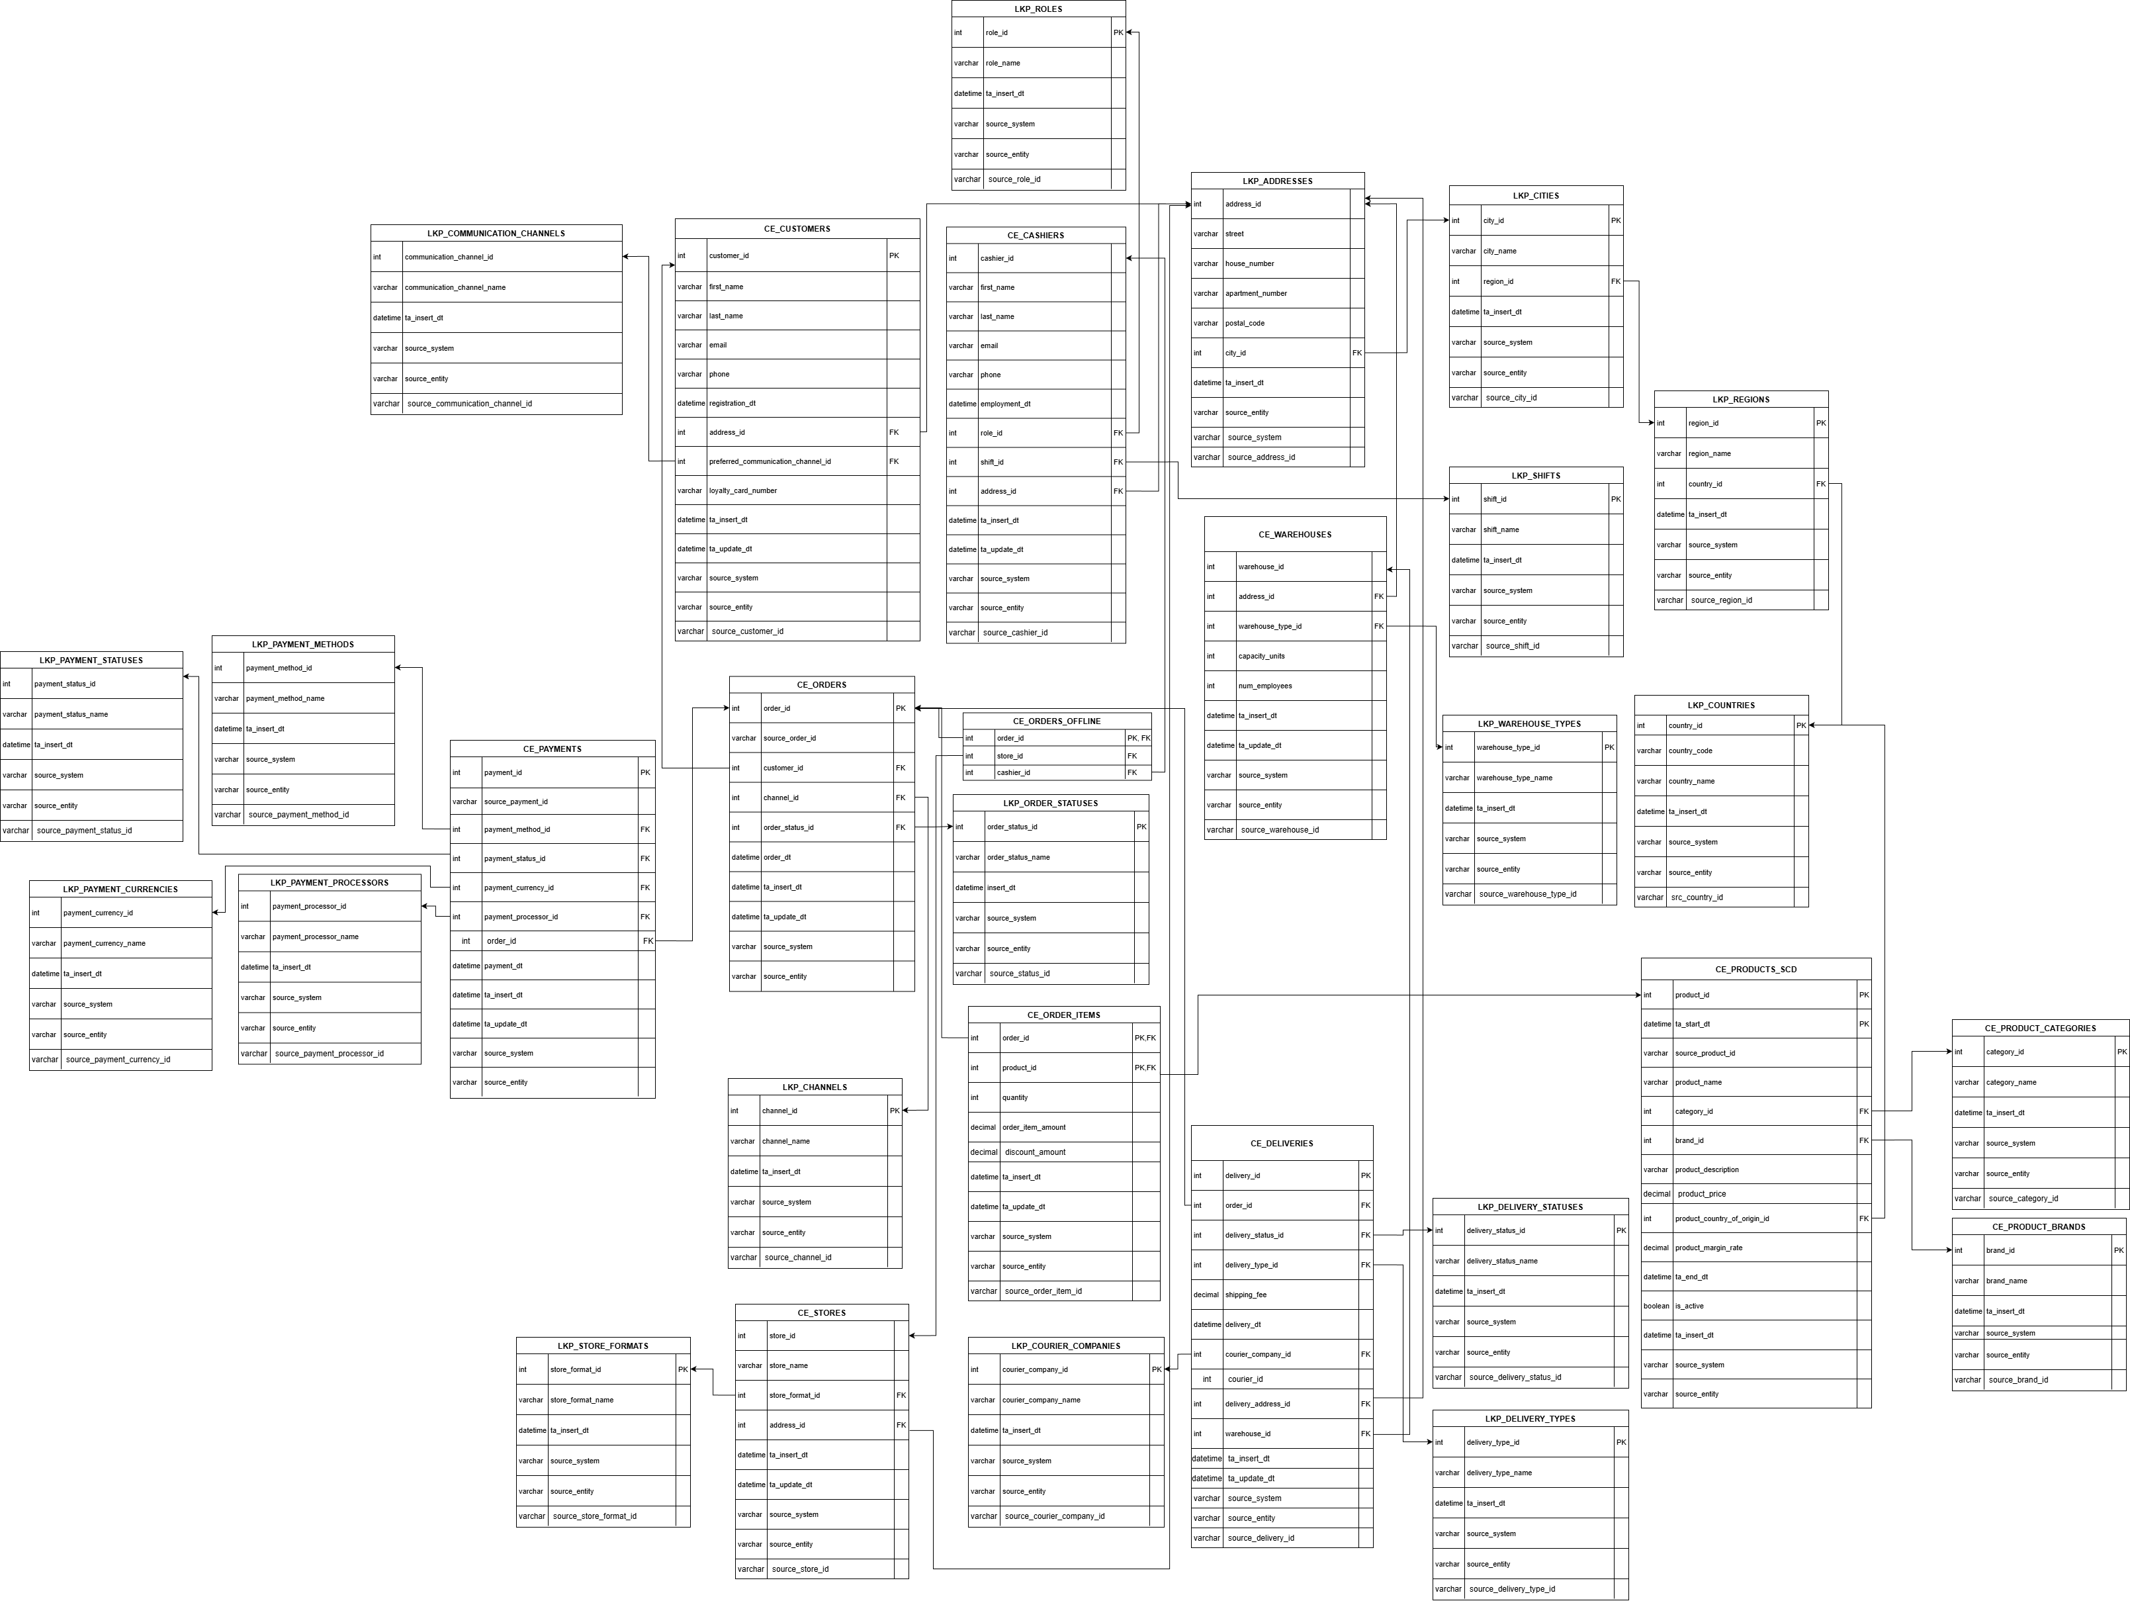

Business Layer Dimensional Model

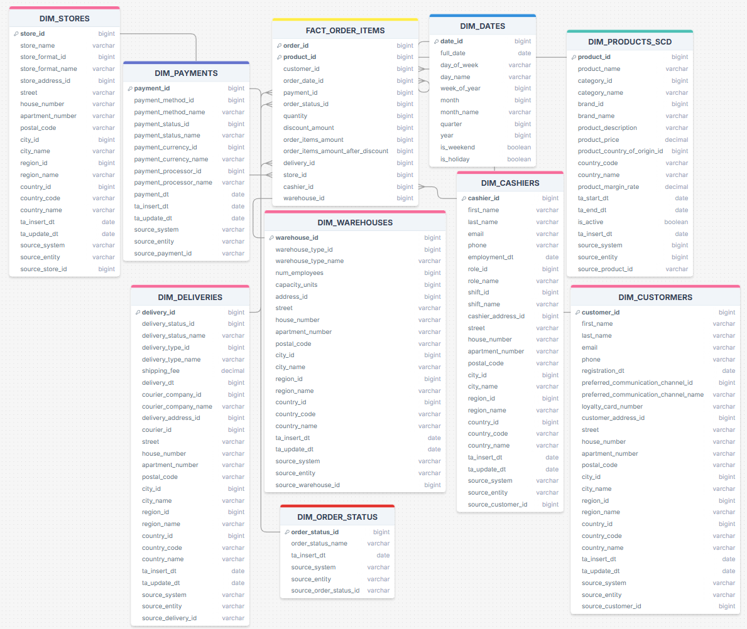
order_items_amount_after_discount is a metric calculated as (order_items_amount - discount) and expresses the amount of money the customer pays for the items after the discount is applied.

Logical Scheme
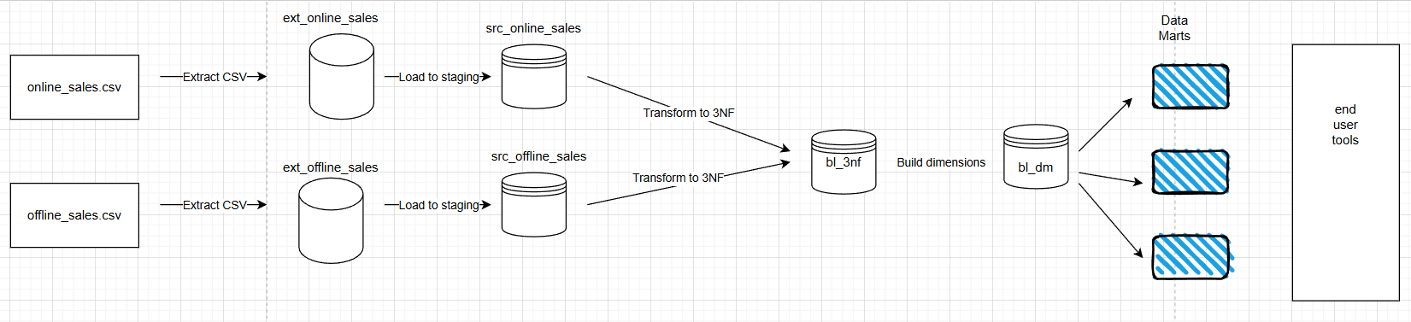

Data Flow
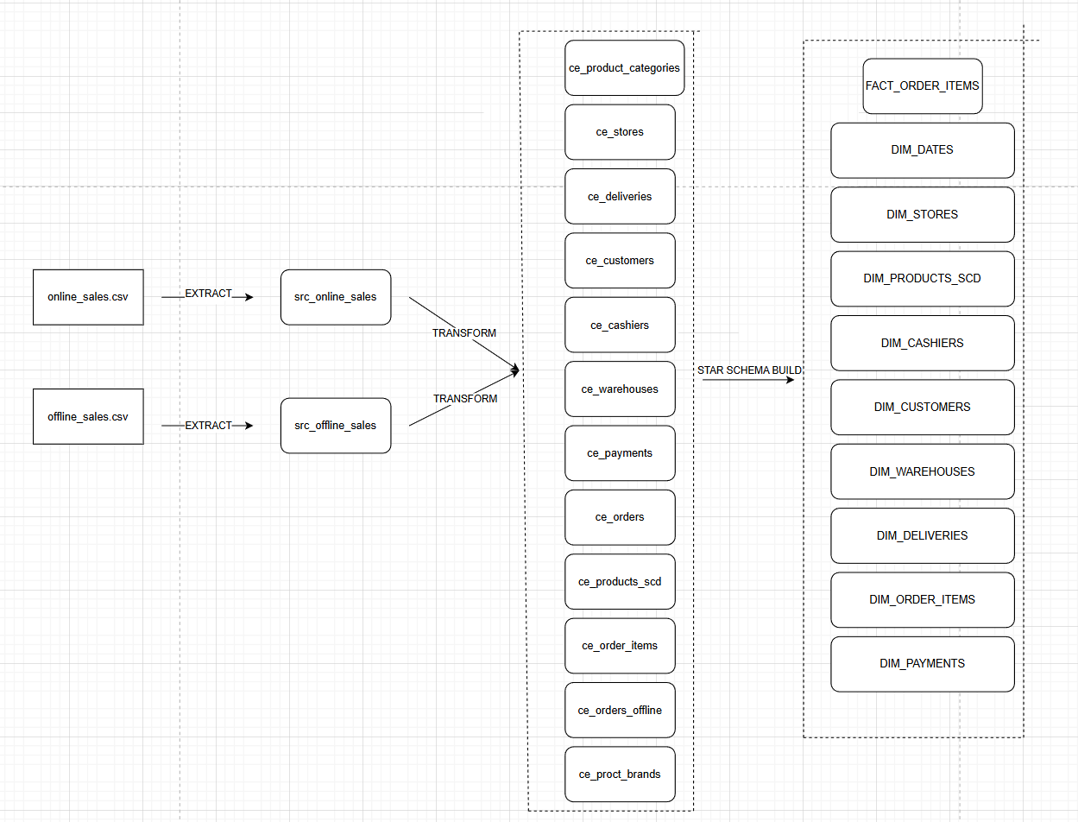

Fact Table Partitioning Strategy

