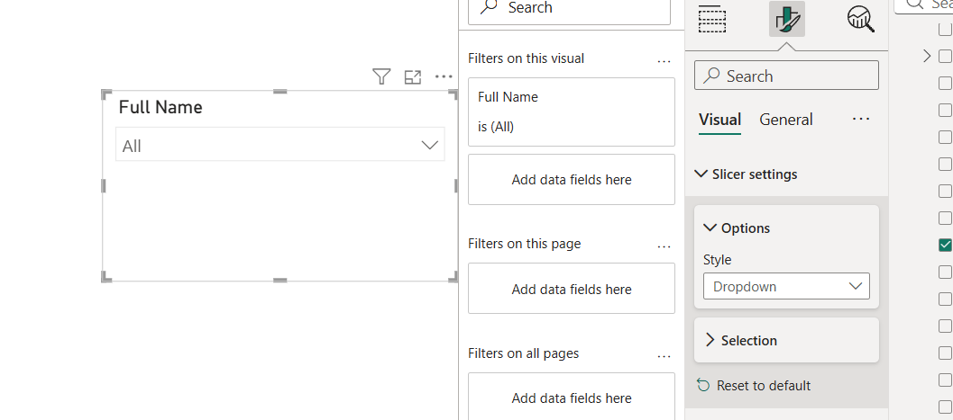
Configuring slicers

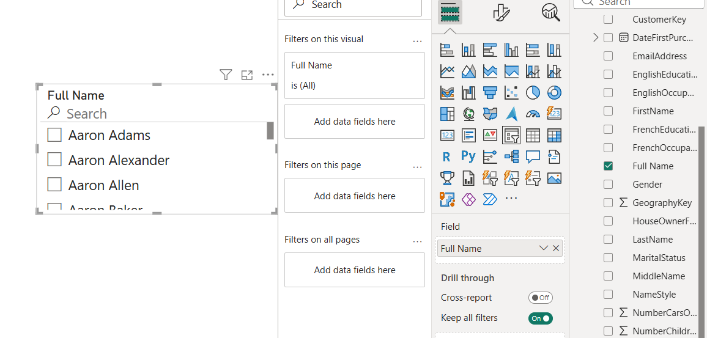

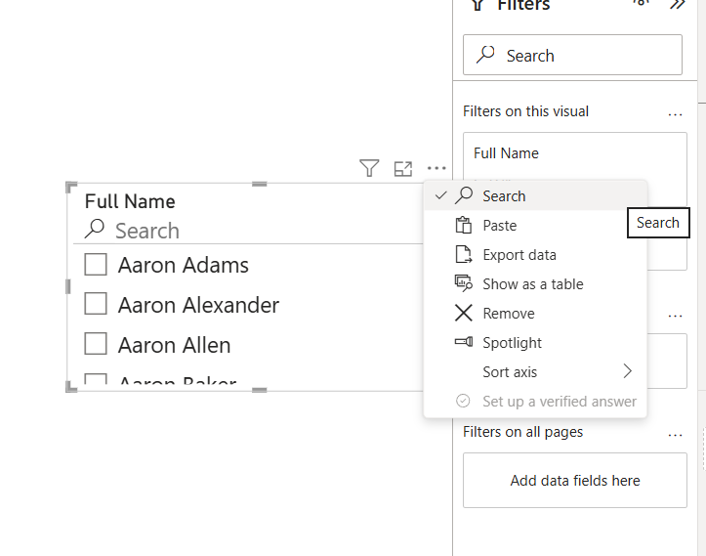

A date hierarchy created for use in various visuals.

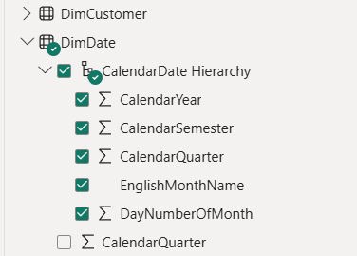

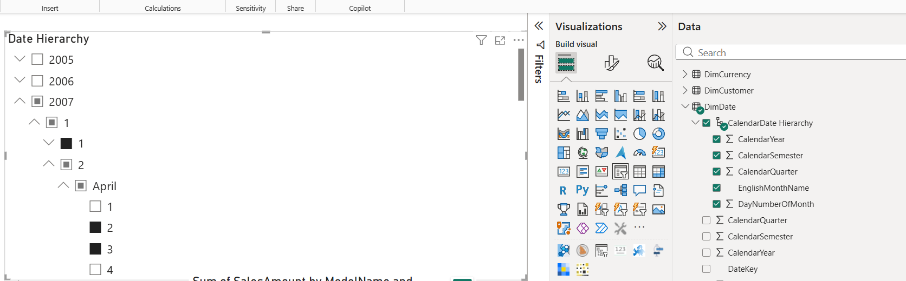
Date slicer allows the user to select some specific year, or a month, or a day, several values too.

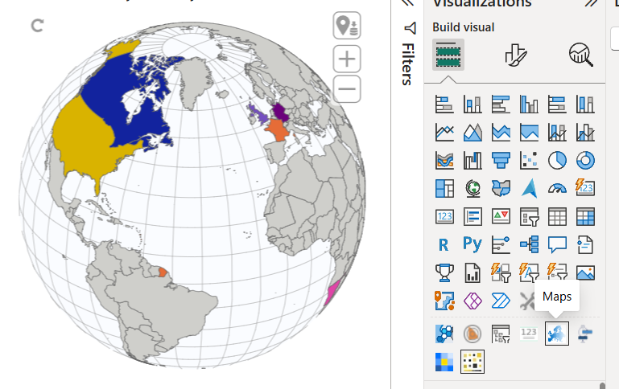
Custom visual used to represent the areas where the company operates.
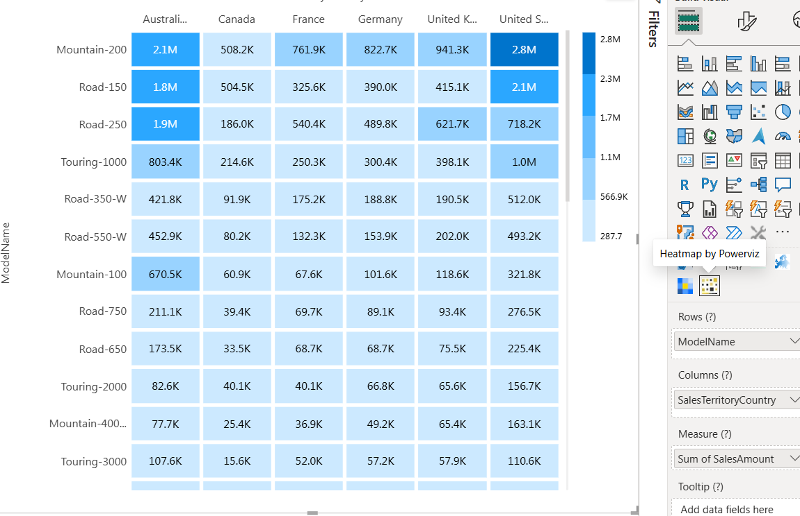

Custom visual Heatmap is used to show which models are most popular in specific countries and produce most profit.

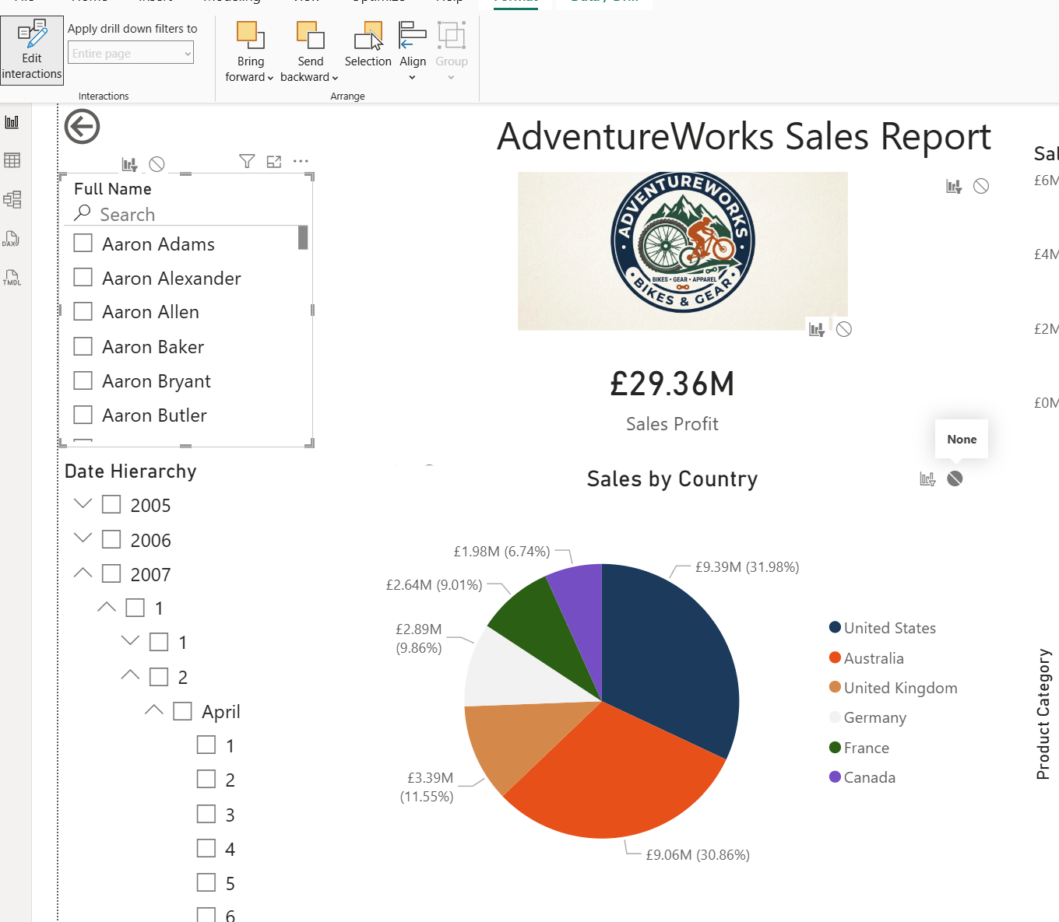
Interaction between the vertical list slicer and the pie chart is disabled.

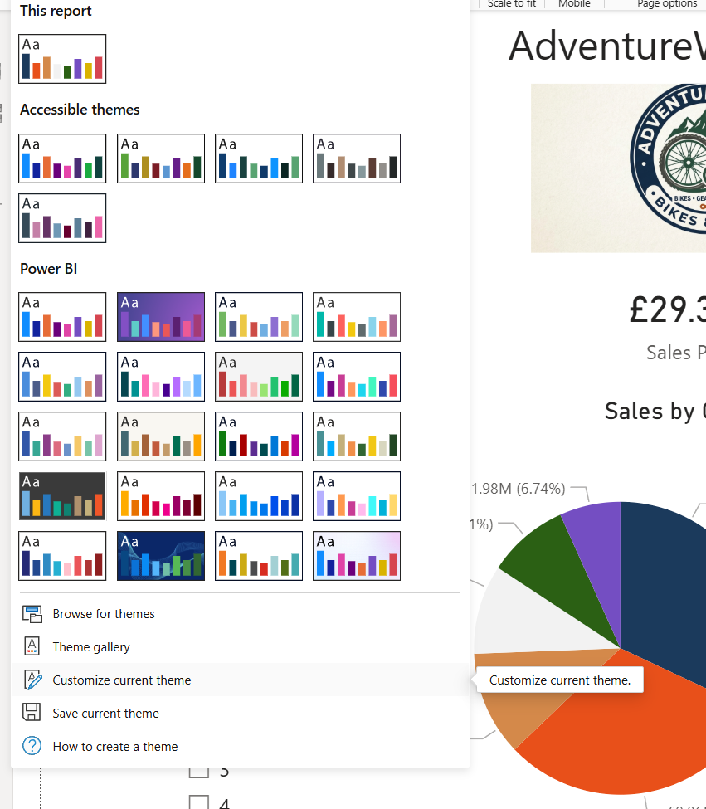
The custom theme was used with the colors set to the logo colors.

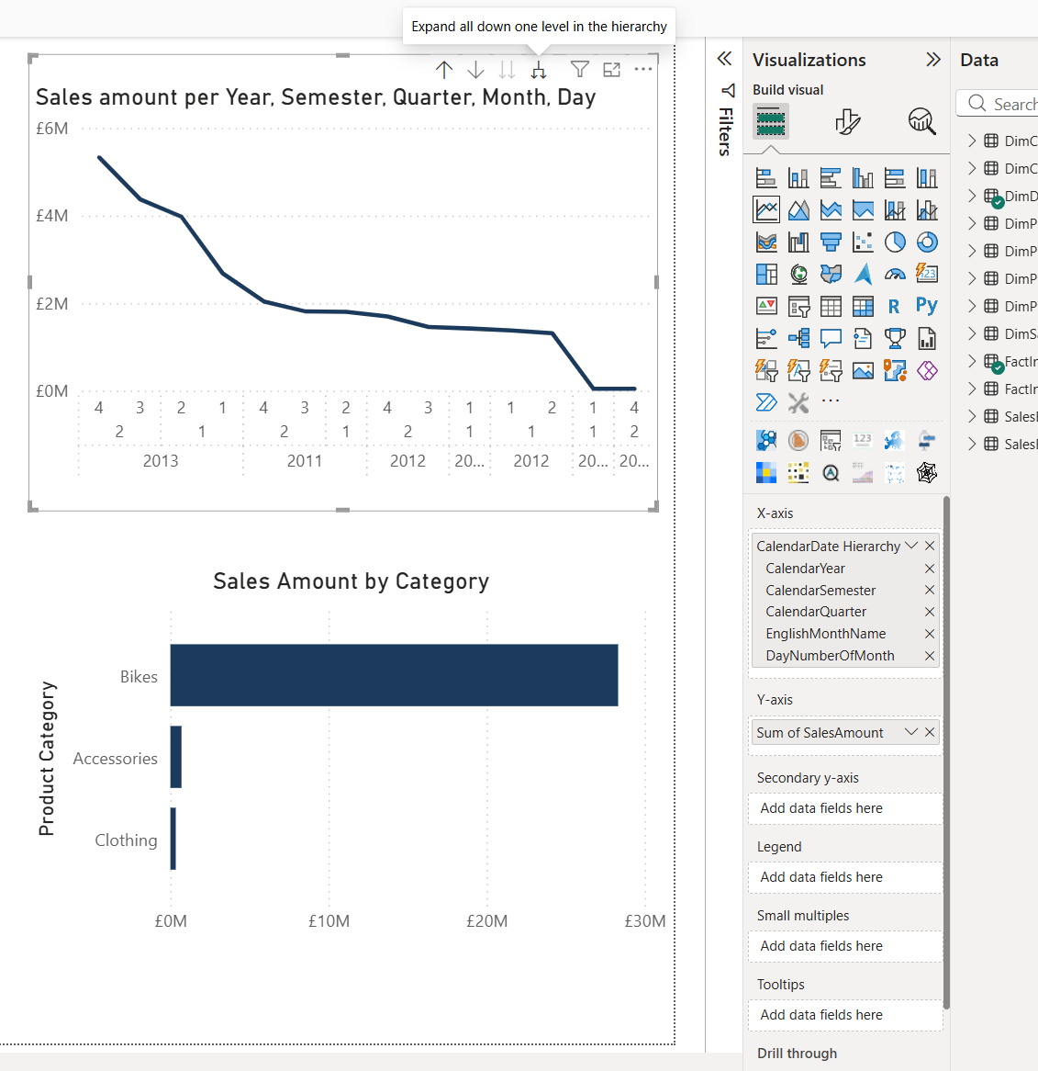
The line chart shows how the profits were changing with time, the user can drill down from the year view to the day view in steps.
Bar chart shows what categories bring the most profit.

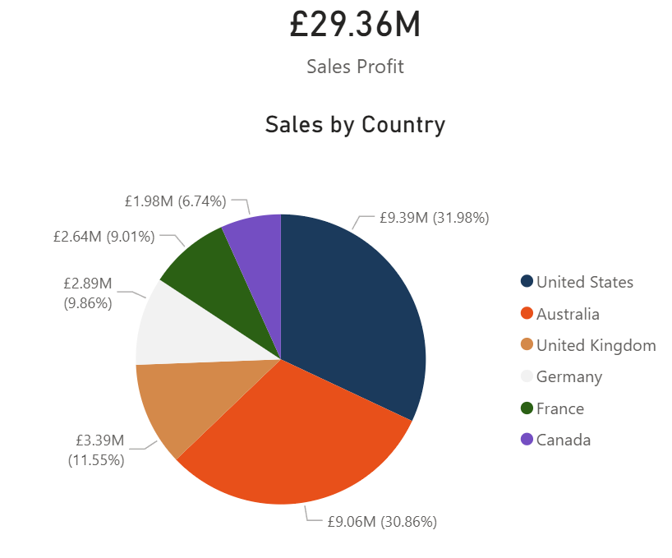
The card visual shows the overall sales and changes according to the slicers used (like selecting some country on the pie chart will change the card to show the overall sales in this specific country)
Pie chart shows the ratio between the sales in different countries.

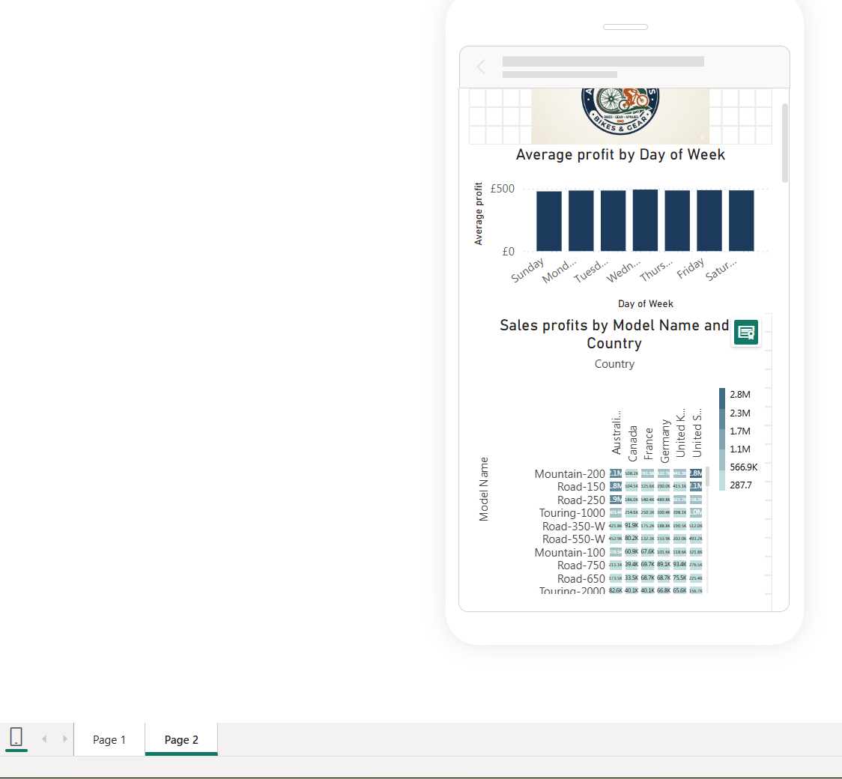

Mobile layouts were created and fitted accordingly.

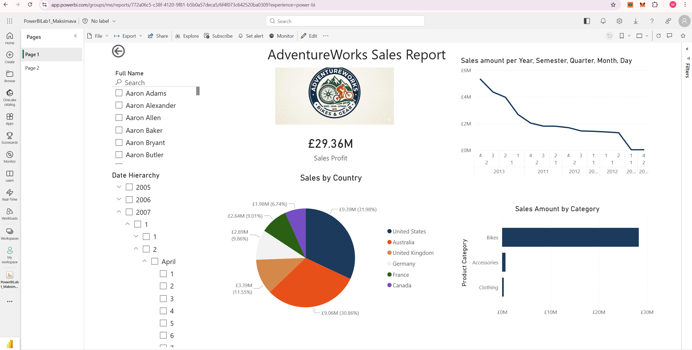

The report was published.

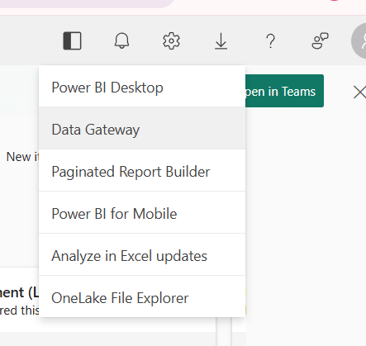

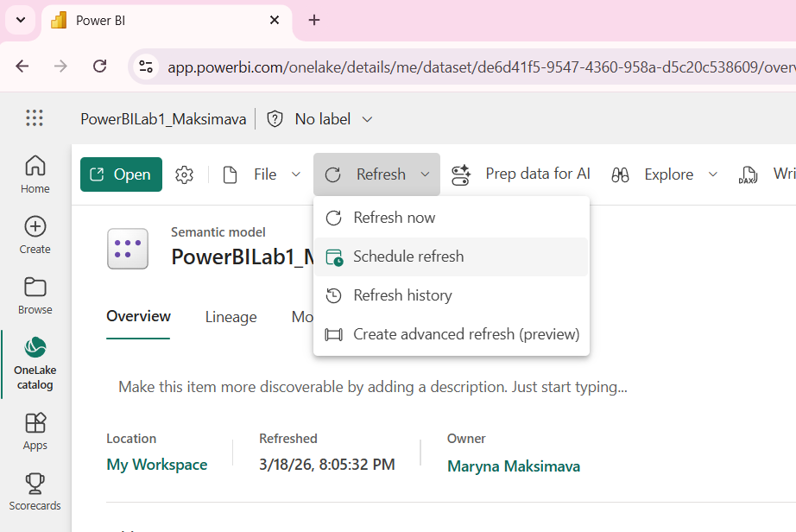

Configuring refresh

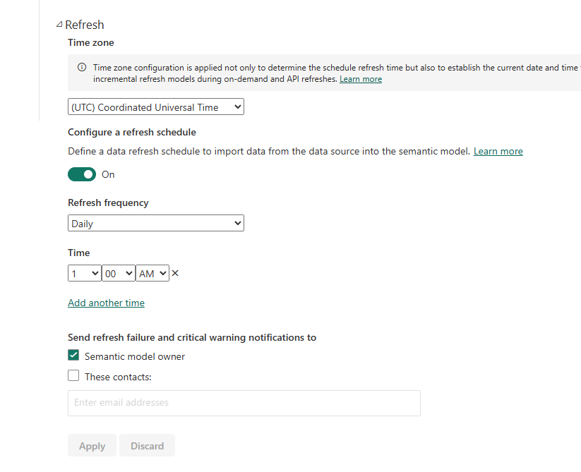

https://app.powerbi.com/links/9XLeSHlkAo?ctid=b41b72d0-4e9f-4c26-8a69-f949f367c91d&pbi_source=linkShare&bookmarkGuid=ccf45d61-e111-4703-a436-9394dd496c94

Sorted by Australia

