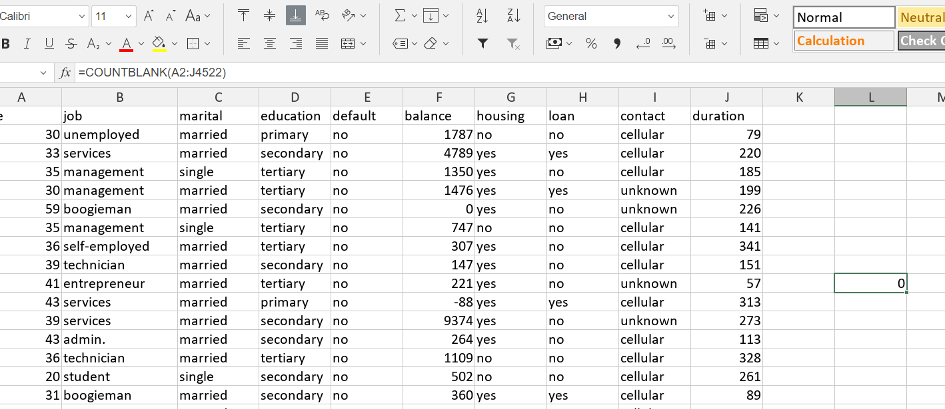
1 Check for blanks - there are no blanks.
-------------------------------------------
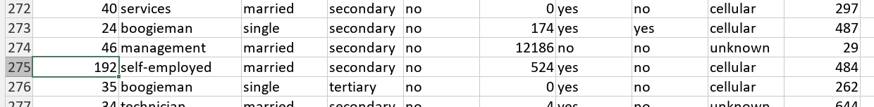
2 There are incorrect values like “192” for age.
-----

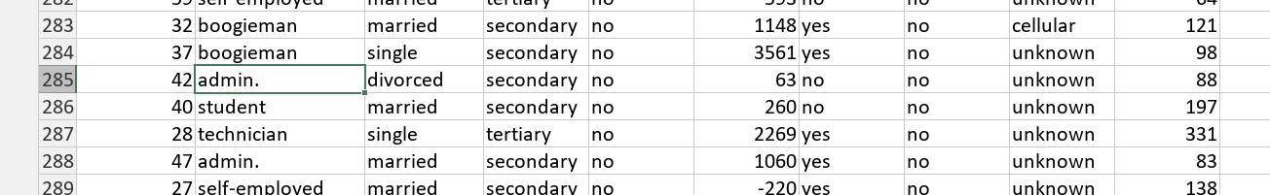
3 Values’ input form is inconsistent – most professions are without the dot in the end and “admin.” has a dot.
-----------------

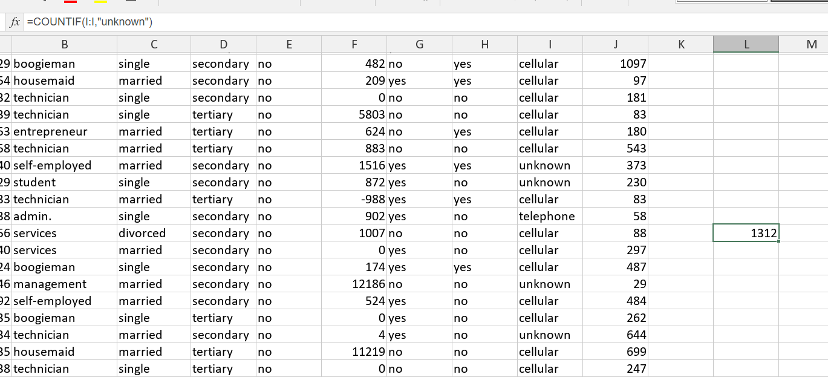
4 There are 1312/4521 unknowns in “contact”
----------------------------------

5 It’s likely that “boogieman” isn’t a correct value for “job”

---------------------------------
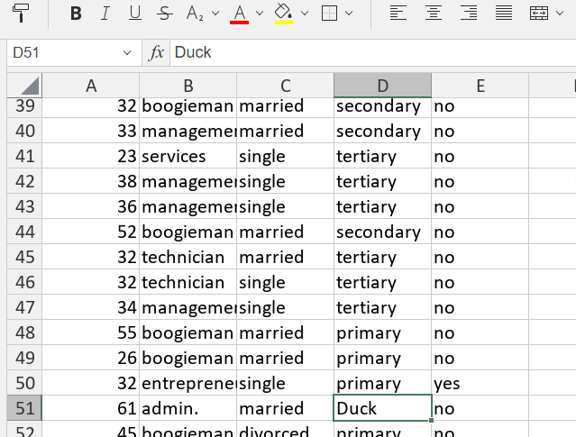

6 “Duck” isn’t a correct value for “education”.

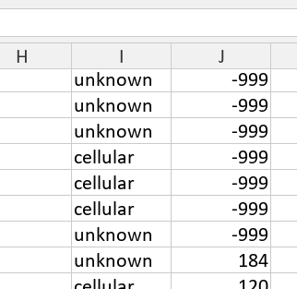
----------------

7 Several “-999” in “duration”.

-------------

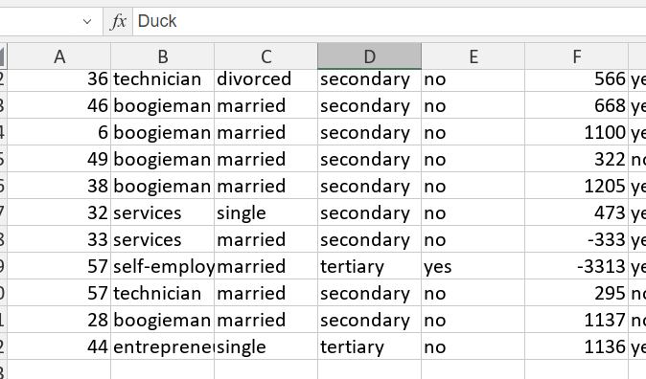
8

Several values below 0 in “balance” (might be okay depending on domain).

6 in “age” might be off for a loan dataset.

----------------------------------------------2---------------------------------------

For the car_prices file analysis I used python ydata-profiling library.
The code:

pip install pandas ydata-profiling

import pandas as pd
import os
from ydata_profiling import ProfileReport

df_car = pd.read_parquet("car_prices.parquet")
df_car.to_csv("car_prices.csv", index=False)

print(f"Parquet size: {os.path.getsize('car_prices.parquet'):,} bytes")
print(f"CSV size: {os.path.getsize('car_prices.csv'):,} bytes")

profile_car = ProfileReport(df_car, title="Car Prices Profile", explorative=True, interactions={"continuous": True})
profile_car.to_file("car_prices_report.html")

------------------------
Findings:
-----------

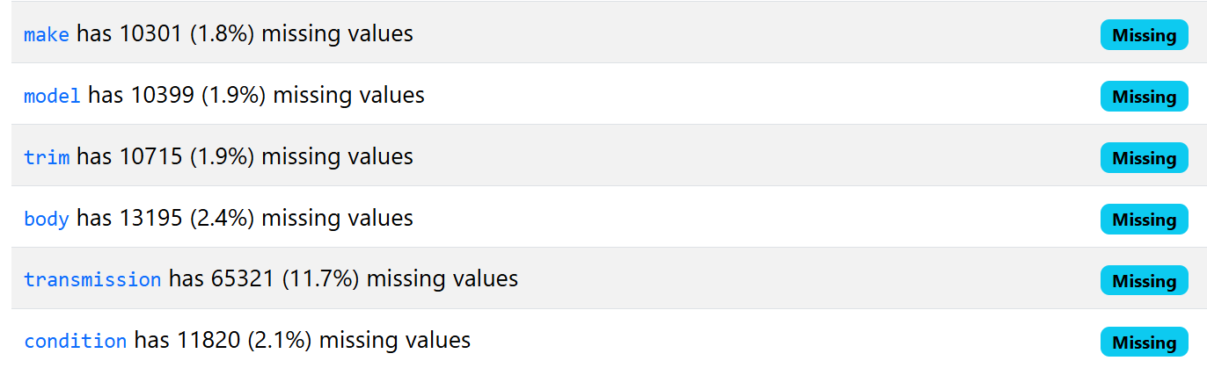

1 A lot of missing values.
--------------------------------
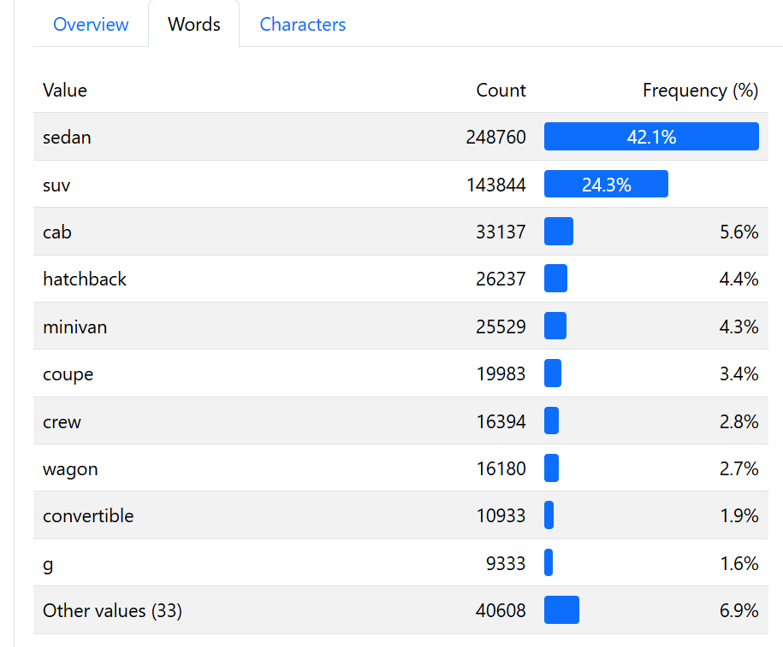

2 A single letter “g” as “body” value is likely to be incorrect.

-------------------------------------------------------------------
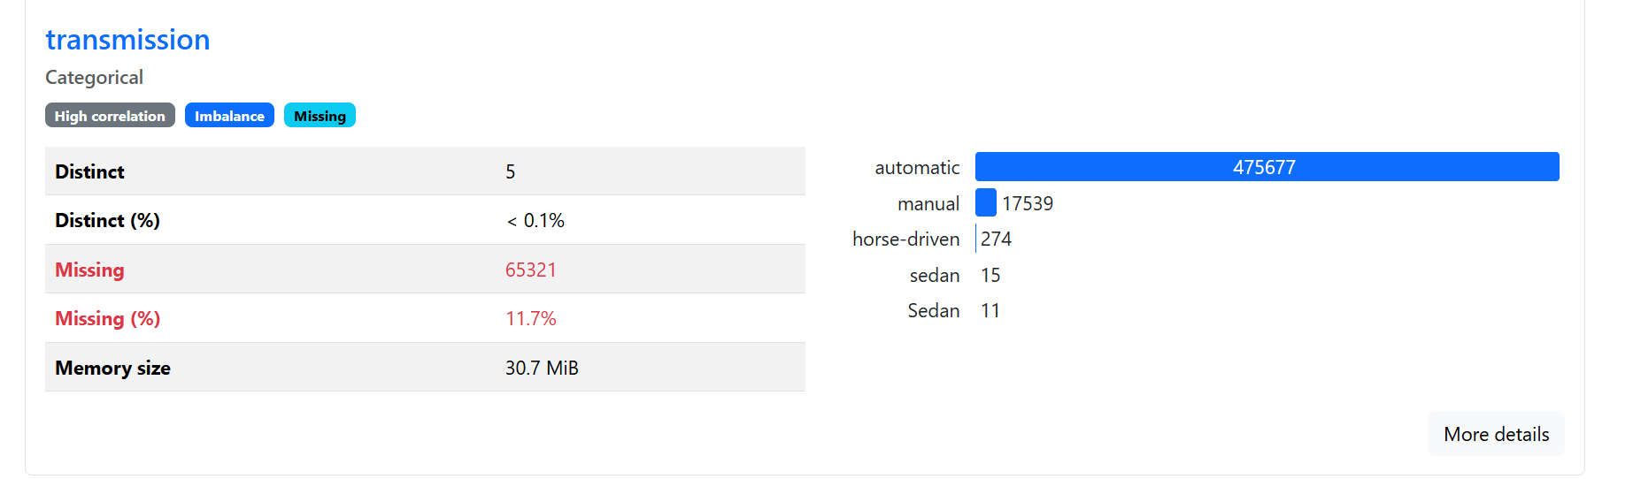
3 “Horse-driven” and “sedan” and “Sedan” aren’t valid types of car transmission.

-------------------------------------------------------
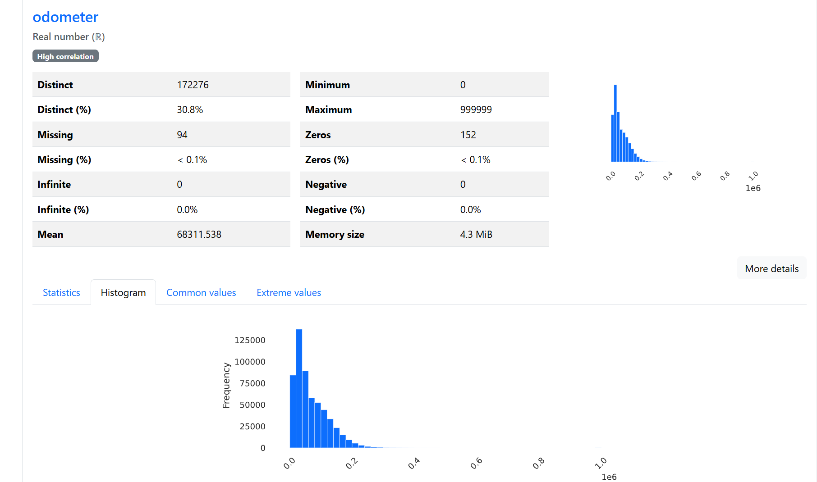

4 Odometer values are highly skewed, but driving 999999 miles isn’t impossible, so the values may be valid.

-------------------------------------
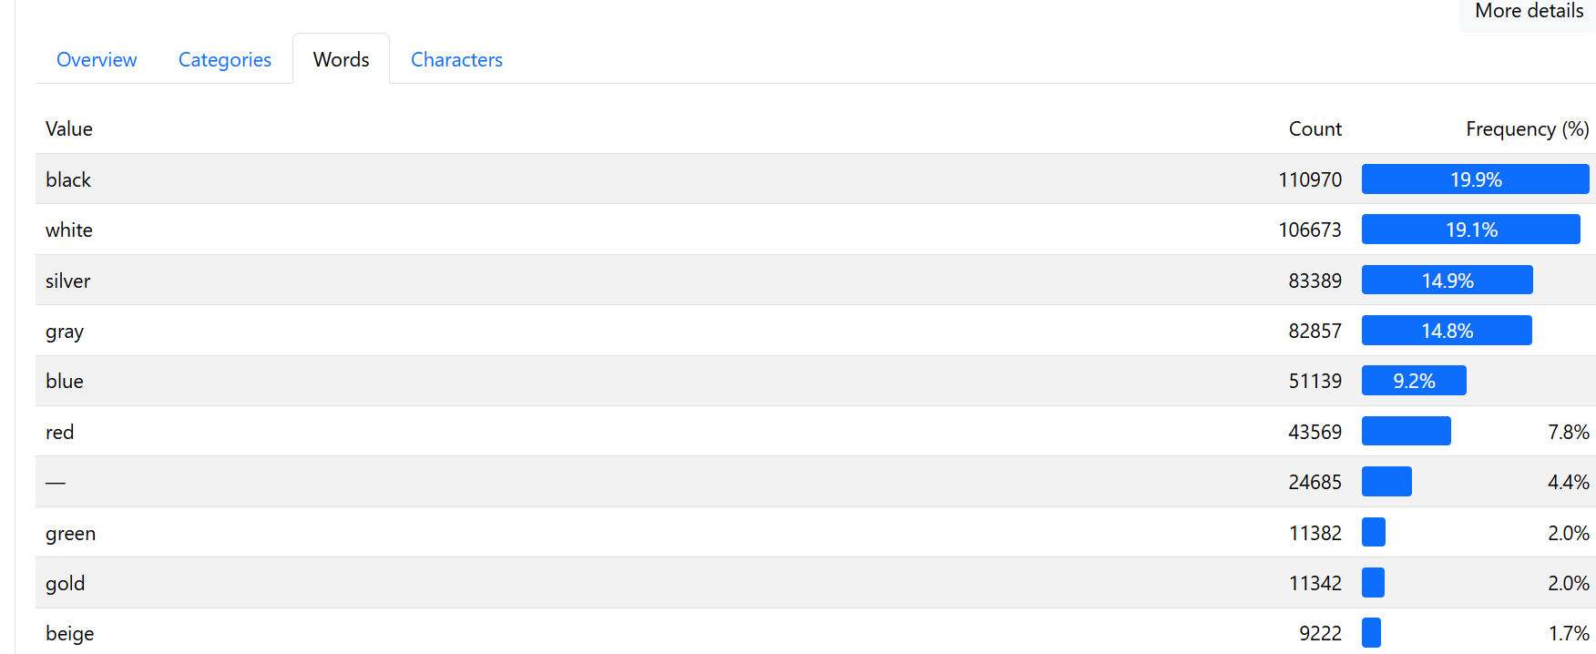

5
4.4% of “-” color – missing values.
------------------------------

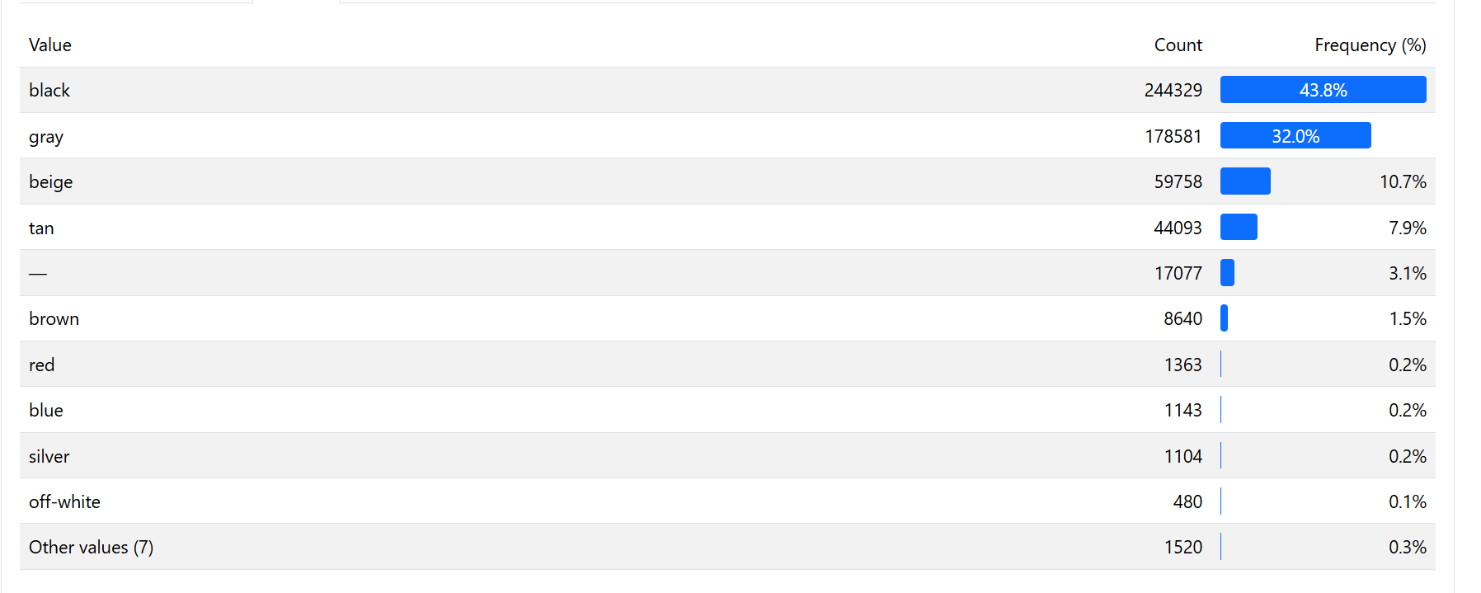
6 Similar picture for “interior”.
---------------------------------------------------
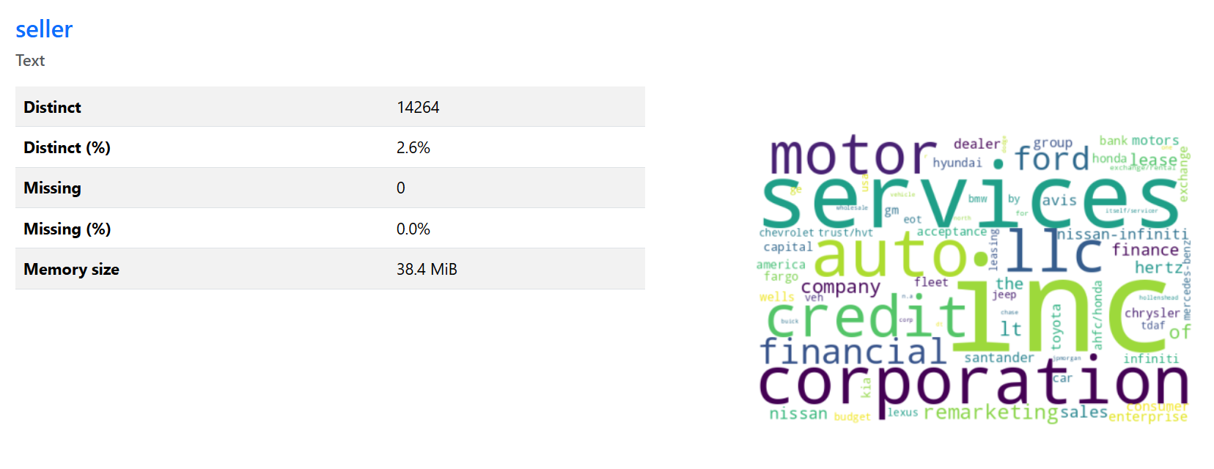
7 There are several suspicious values like “dealer”, “sales”, “company”, “finance” – that are unlikely to be a seller’s name.
------------------------------------

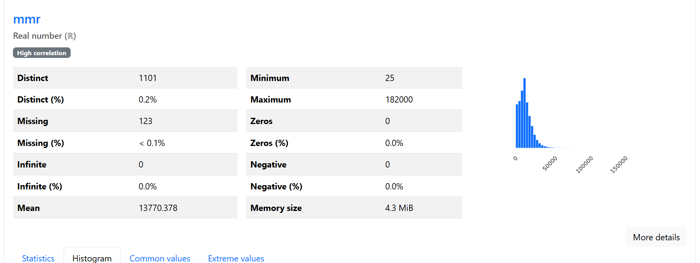
8 mmr is skewed.
---------------------------------
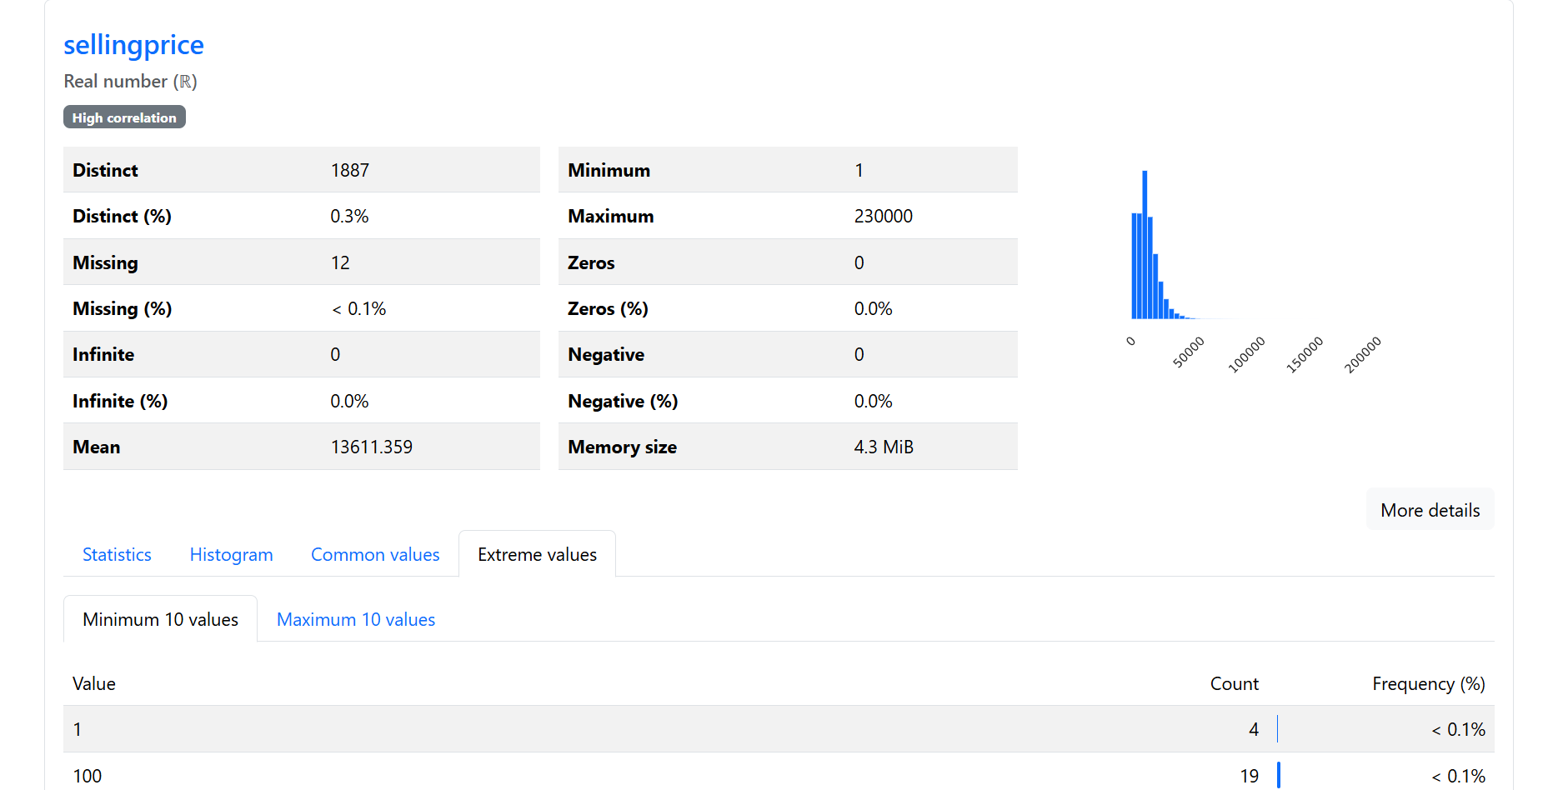
9 Selling a car for 1 dollar/euro doesn’t make sense, some values here must be wrong.
-----------------------------------------
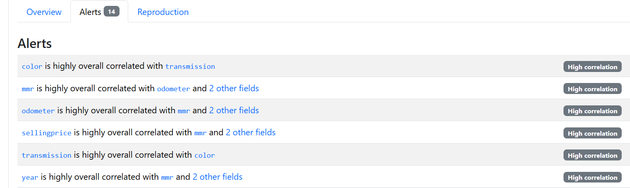
10 There is a correlation alert but its analysis requires a lot more domain knowledge than I posses.
----------------
Using this library allows for some quick analysis like evaluating ranges, extreme values, categorical values distribution, most common values, etc.

