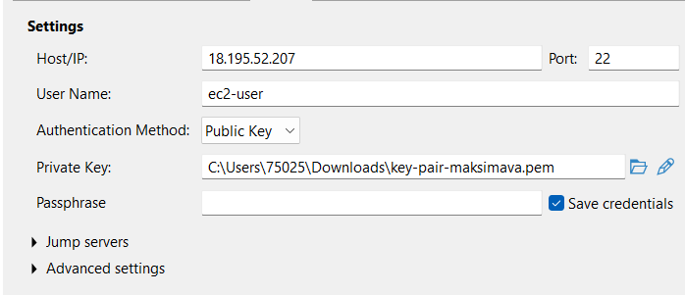

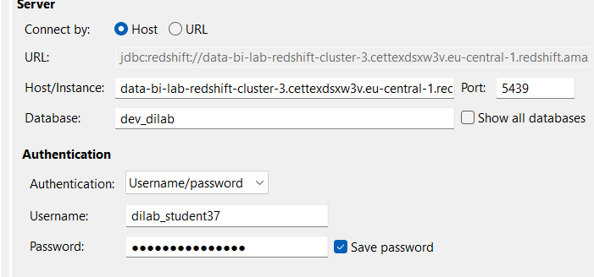

Host data-bi-lab-redshift-cluster-3.cettexdsxw3v.eu-central-1.redshift.amazonaws.com
Port 5439
Database dev_dilab
Username dilab_student37
Password epam_AE2026!_37
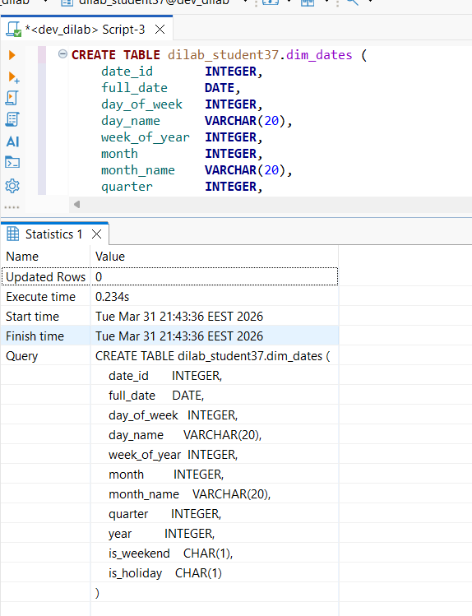

---

CREATE TABLE dilab_student37.dim_dates ( date_id INTEGER, full_date DATE, day_of_week VARCHAR(10), day_name VARCHAR(20), week_of_year VARCHAR(10), month VARCHAR(10), month_name VARCHAR(20), quarter VARCHAR(10), year VARCHAR(10), is_weekend CHAR(1), is_holiday CHAR(1) );

--created and loaded the tables

COPY dilab_student37.dim_dates
FROM 's3://maryna-maksimava-bl-dm-dwh-bucket/di_dwh_database/bl_dm/dim_dates/dim_dates.csv'
IAM_ROLE 'arn:aws:iam::260586643565:role/dilab-redshift-role'
region 'eu-central-1'
delimiter ','
csv
IGNOREHEADER 1;
----

CREATE TABLE dilab_student37.dim_customers (
customer_id INTEGER,
first_name VARCHAR(100),
last_name VARCHAR(100),
email VARCHAR(100),
phone VARCHAR(50),
registration_dt DATE,
preferred_communication_channel_id INTEGER,
preferred_communication_channel_name VARCHAR(50),
loyalty_card_number VARCHAR(50),
customer_address_id INTEGER,
street VARCHAR(100),
house_number VARCHAR(20),
apartment_number VARCHAR(20),
postal_code VARCHAR(20),
city_id INTEGER,
city_name VARCHAR(100),
region_id INTEGER,
region_name VARCHAR(100),
country_id INTEGER,
country_code VARCHAR(10),
country_name VARCHAR(100),
ta_insert_dt DATE,
ta_update_dt DATE,
source_system VARCHAR(50),
source_entity VARCHAR(50),
source_customer_id VARCHAR(50)
);

COPY dilab_student37.dim_customers
FROM 's3://maryna-maksimava-bl-dm-dwh-bucket/di_dwh_database/bl_dm/dim_customers/dim_customers.csv'
IAM_ROLE 'arn:aws:iam::260586643565:role/dilab-redshift-role'
region 'eu-central-1'
delimiter ','
csv
IGNOREHEADER 1
ACCEPTINVCHARS;
--
CREATE TABLE dilab_student37.fct_order_items (
order_id INTEGER,
product_id INTEGER,
customer_id INTEGER,
order_date_id INTEGER,
payment_id INTEGER,
order_status_id INTEGER,
quantity INTEGER,
discount_amount DECIMAL(10,2),
order_items_amount DECIMAL(10,2),
order_items_amount_after_discount DECIMAL(10,2),
delivery_id INTEGER,
store_id INTEGER,
cashier_id INTEGER,
warehouse_id INTEGER
);

COPY dilab_student37.fct_order_items
FROM 's3://maryna-maksimava-bl-dm-dwh-bucket/di_dwh_database/bl_dm/fact_order_items/fact_order_items.csv'
IAM_ROLE 'arn:aws:iam::260586643565:role/dilab-redshift-role'
region 'eu-central-1'
delimiter ','
csv
IGNOREHEADER 1;

--
SELECT tablename, "column", type, encoding, distkey, sortkey
FROM pg_table_def
WHERE schemaname = 'dilab_student37'
ORDER BY tablename, sortkey;

--looking at encoding and keys
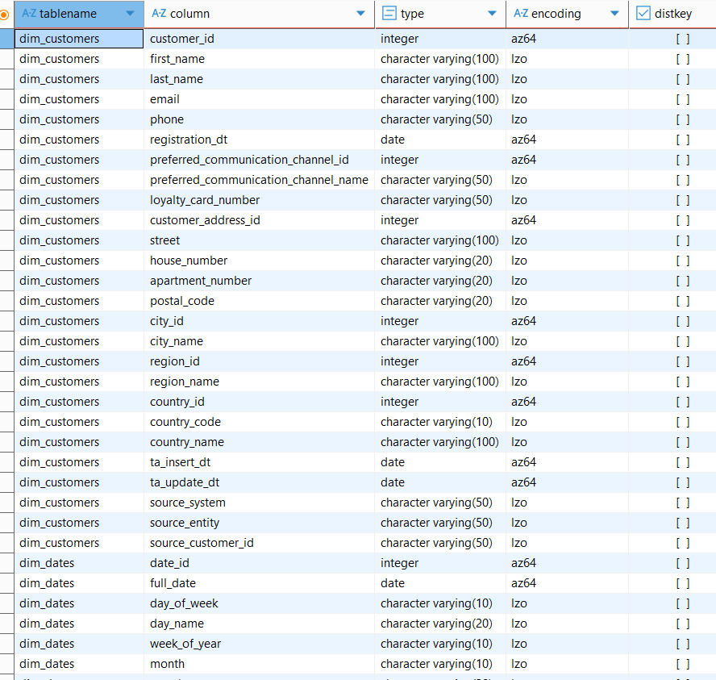

-- trying a table without compression
CREATE TABLE dilab_student37.fct_order_items_withoutcomp (
order_id INTEGER ENCODE RAW,
product_id INTEGER ENCODE RAW,
customer_id INTEGER ENCODE RAW,
order_date_id INTEGER ENCODE RAW,
payment_id INTEGER ENCODE RAW,
order_status_id INTEGER ENCODE RAW,
quantity INTEGER ENCODE RAW,
discount_amount DECIMAL(10,2) ENCODE RAW,
order_items_amount DECIMAL(10,2) ENCODE RAW,
order_items_amount_after_discount DECIMAL(10,2) ENCODE RAW,
delivery_id INTEGER ENCODE RAW,
store_id INTEGER ENCODE RAW,
cashier_id INTEGER ENCODE RAW,
warehouse_id INTEGER ENCODE RAW
);

INSERT INTO dilab_student37.fct_order_items_withoutcomp
SELECT * FROM dilab_student37.fct_order_items;

ALTER TABLE dilab_student37.fct_order_items
RENAME TO fct_order_items_defaultcomp;

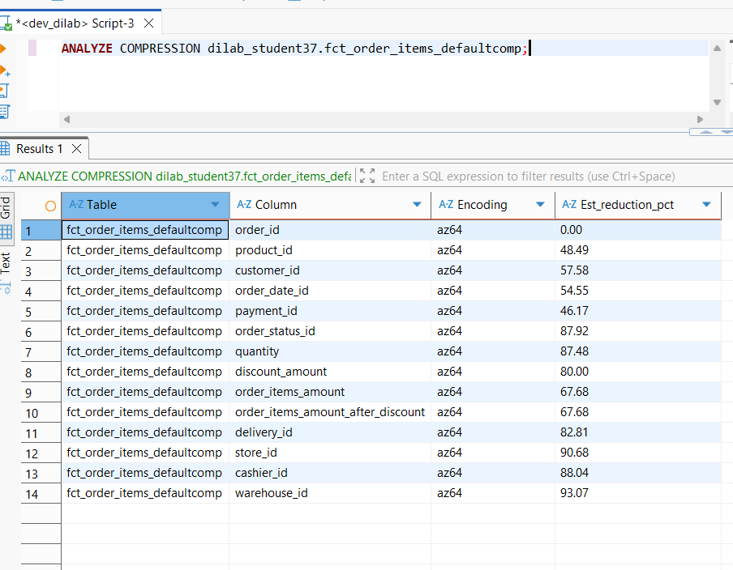
CREATE TABLE dilab_student37.fct_order_items_analyzedcomp (
order_id INTEGER ENCODE az64,
product_id INTEGER ENCODE az64,
customer_id INTEGER ENCODE az64,
order_date_id INTEGER ENCODE az64,
payment_id INTEGER ENCODE az64,
order_status_id INTEGER ENCODE az64,
quantity INTEGER ENCODE az64,
discount_amount DECIMAL(10,2) ENCODE az64,
order_items_amount DECIMAL(10,2) ENCODE az64,
order_items_amount_after_discount DECIMAL(10,2) ENCODE az64,
delivery_id INTEGER ENCODE az64,
store_id INTEGER ENCODE az64,
cashier_id INTEGER ENCODE az64,
warehouse_id INTEGER ENCODE az64
);

INSERT INTO dilab_student37.fct_order_items_analyzedcomp
SELECT * FROM dilab_student37.fct_order_items_defaultcomp;

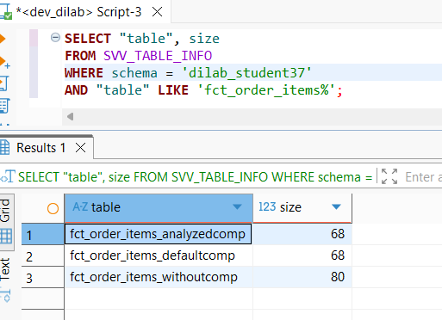

SELECT "table", size
FROM SVV_TABLE_INFO
WHERE schema = 'dilab_student37'
AND "table" LIKE 'fct_order_items%';

--4

--stored procedure

CREATE OR REPLACE PROCEDURE dilab_student37.sp_customer_orders_report()
AS $$
BEGIN
DROP TABLE IF EXISTS dilab_student37.report_customer_orders;

CREATE TABLE dilab_student37.report_customer_orders AS
SELECT
c.customer_id,
c.first_name || ' ' || c.last_name AS full_name,
c.country_name,
c.city_name,
d.year,
d.month_name,
d.quarter,
COUNT(f.order_id) AS total_orders,
SUM(f.quantity) AS total_quantity,
SUM(f.order_items_amount) AS total_amount,
SUM(f.order_items_amount_after_discount) AS total_amount_after_discount,
SUM(f.discount_amount) AS total_discount
FROM dilab_student37.fct_order_items_defaultcomp f
JOIN dilab_student37.dim_customers c
ON f.customer_id = c.customer_id
JOIN dilab_student37.dim_dates d
ON f.order_date_id = d.date_id
GROUP BY
c.customer_id, c.first_name, c.last_name,
c.country_name, c.city_name,
d.year, d.month_name, d.quarter;
END;
$$ LANGUAGE plpgsql;

--optimized dimensions
-- customers
CREATE TABLE dilab_student37.dim_customers_opt (
customer_id INTEGER ENCODE az64 DISTKEY,
first_name VARCHAR(100) ENCODE lzo,
last_name VARCHAR(100) ENCODE lzo,
email VARCHAR(100) ENCODE lzo,
phone VARCHAR(50) ENCODE lzo,
registration_dt DATE ENCODE az64,
preferred_communication_channel_id INTEGER ENCODE az64,
preferred_communication_channel_name VARCHAR(50) ENCODE lzo,
loyalty_card_number VARCHAR(50) ENCODE lzo,
customer_address_id INTEGER ENCODE az64,
street VARCHAR(100) ENCODE lzo,
house_number VARCHAR(20) ENCODE lzo,
apartment_number VARCHAR(20) ENCODE lzo,
postal_code VARCHAR(20) ENCODE lzo,
city_id INTEGER ENCODE az64,
city_name VARCHAR(100) ENCODE lzo,
region_id INTEGER ENCODE az64,
region_name VARCHAR(100) ENCODE lzo,
country_id INTEGER ENCODE az64,
country_code VARCHAR(10) ENCODE lzo,
country_name VARCHAR(100) ENCODE lzo,
ta_insert_dt DATE ENCODE az64,
ta_update_dt DATE ENCODE az64,
source_system VARCHAR(50) ENCODE lzo,
source_entity VARCHAR(50) ENCODE lzo,
source_customer_id VARCHAR(50) ENCODE lzo
);

INSERT INTO dilab_student37.dim_customers_opt
SELECT * FROM dilab_student37.dim_customers;

-- dates
CREATE TABLE dilab_student37.dim_dates_opt (
date_id INTEGER ENCODE az64 SORTKEY,
full_date DATE ENCODE az64,
day_of_week VARCHAR(10) ENCODE lzo,
day_name VARCHAR(20) ENCODE lzo,
week_of_year VARCHAR(10) ENCODE lzo,
month VARCHAR(10) ENCODE lzo,
month_name VARCHAR(20) ENCODE lzo,
quarter VARCHAR(10) ENCODE lzo,
year VARCHAR(10) ENCODE lzo,
is_weekend CHAR(1) ENCODE lzo,
is_holiday CHAR(1) ENCODE lzo
);

INSERT INTO dilab_student37.dim_dates_opt
SELECT * FROM dilab_student37.dim_dates;
--
--complex join to test the execution time
SET enable_result_cache_for_session TO OFF;
EXPLAIN
SELECT
c.customer_id,
c.first_name || ' ' || c.last_name AS full_name,
c.country_name,
c.city_name,
d.year,
d.month_name,
d.quarter,
COUNT(f.order_id) AS total_orders,
SUM(f.quantity) AS total_quantity,
SUM(f.order_items_amount) AS total_amount,
SUM(f.order_items_amount_after_discount) AS total_amount_after_discount,
SUM(f.discount_amount) AS total_discount
FROM dilab_student37.fct_order_items_defaultcomp f
JOIN dilab_student37.dim_customers c
ON f.customer_id = c.customer_id
JOIN dilab_student37.dim_dates d
ON f.order_date_id = d.date_id
GROUP BY
c.customer_id, c.first_name, c.last_name,
c.country_name, c.city_name,
d.year, d.month_name, d.quarter;

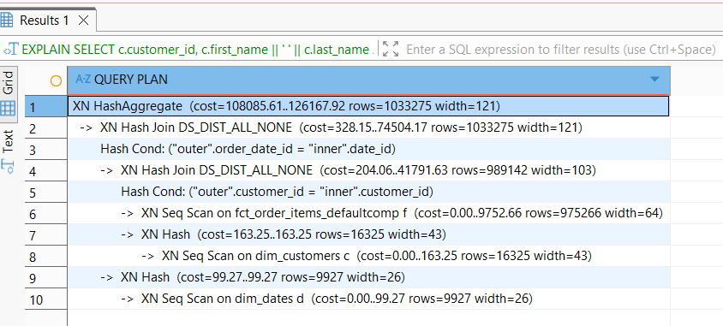
-non-optimized plan
It scans fact table, scans and hashes customers, joins them, DS_DIST_ALL_NONE means data redestribution is happening because there is no matching distkey. Then it scans dates, joins. DS_DIST_ALL_NONE means redestribution is happening again Then the group by is performed.

--non-optimized time is about 3.7s
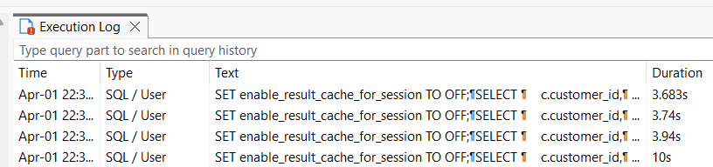

SET enable_result_cache_for_session TO OFF;
--optimised script
EXPLAIN
SELECT
c.customer_id,
c.first_name || ' ' || c.last_name AS full_name,
c.country_name,
c.city_name,
d.year,
d.month_name,
d.quarter,
COUNT(f.order_id) AS total_orders,
SUM(f.quantity) AS total_quantity,
SUM(f.order_items_amount) AS total_amount,
SUM(f.order_items_amount_after_discount) AS total_amount_after_discount,
SUM(f.discount_amount) AS total_discount
FROM dilab_student37.fct_order_items_opt f
JOIN dilab_student37.dim_customers_opt c
ON f.customer_id = c.customer_id
JOIN dilab_student37.dim_dates_opt d
ON f.order_date_id = d.date_id
GROUP BY
c.customer_id, c.first_name, c.last_name,
c.country_name, c.city_name,
d.year, d.month_name, d.quarter;

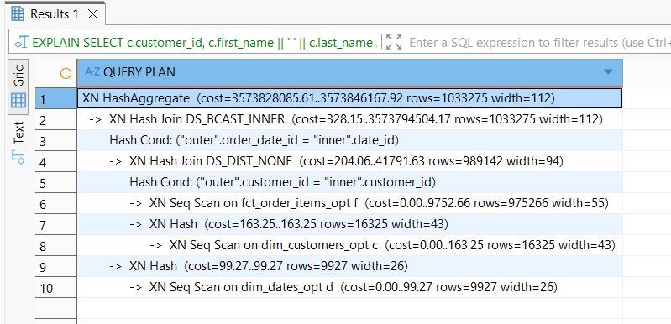

--optimized plan
It scans the fact table, scans and hashes customers, joins them, DS_DIST_NONE means no data redestribution is needed. Then it scans dates, joins. DS_BCAST_INNER means dates table is broadcast to all nodes (it can be done because it’s small). Then the group by is performed.
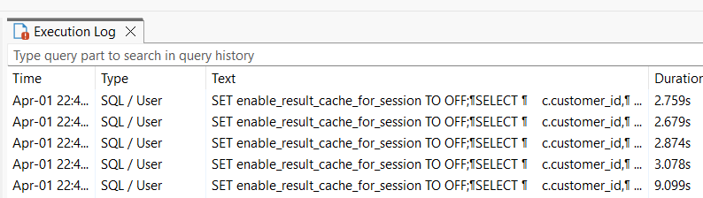
--optimized query ran for ~2.8s which is better than non-optimized

The first run isn’t good for comparing the execution time because the first run loads the data from disk and compiles the query, while subsequent don’t do it and only executes the query.

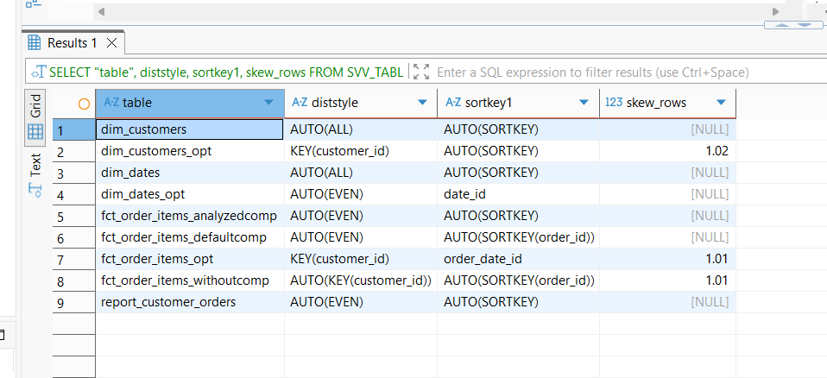

AUTO means Redshift chose keys automatically: small dimension tables got ALL (copied to every node), fact table got EVEN (distributed evenly across nodes). No explicit sort keys were defined.

Distkey on customer_id was chosen because it is the primary join column between the fact and dimension tables, reducing data movement between nodes. Sortkey on order_date_id was chosen because date-based filtering is the most common access pattern in reporting queries, enabling Redshift to skip irrelevant data blocks.

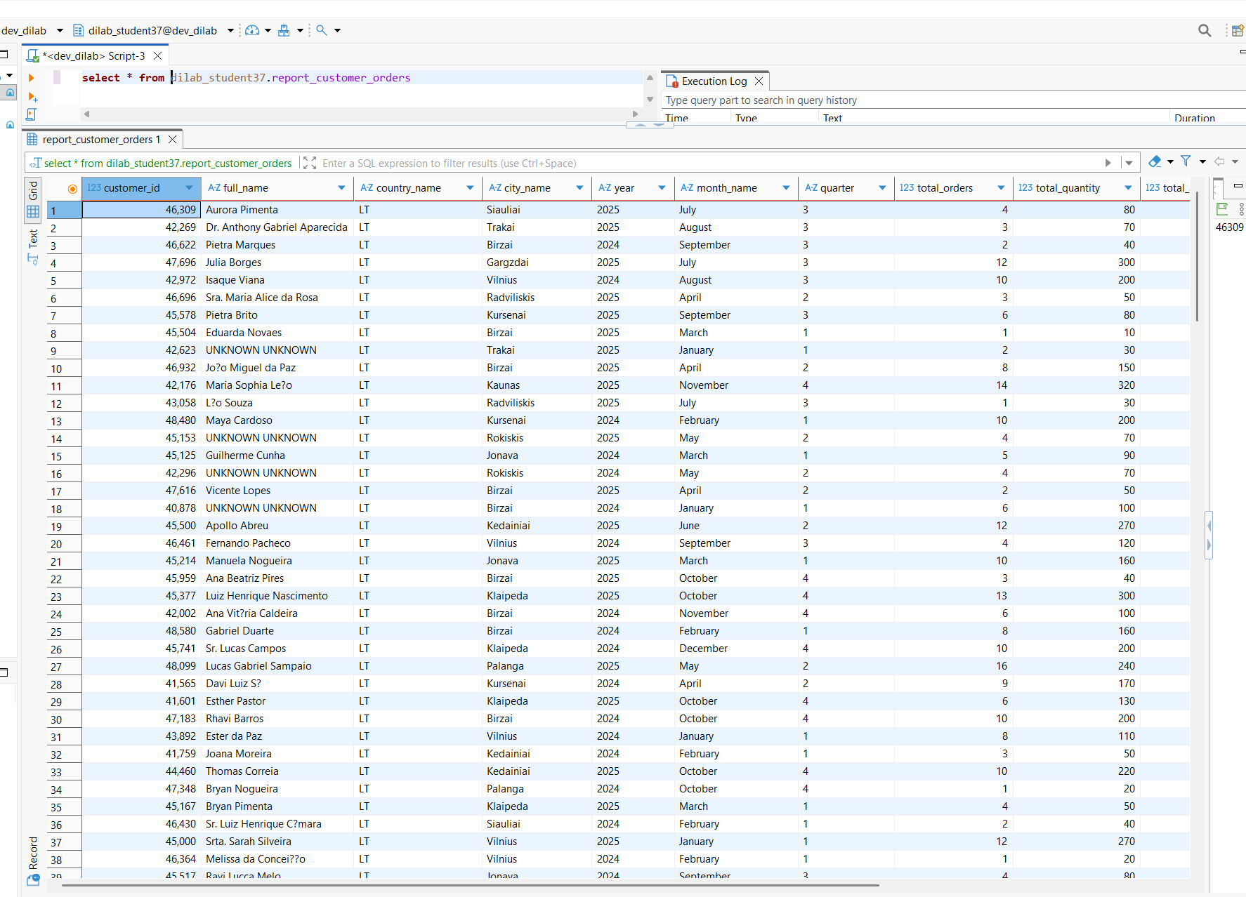
--report

-----------------------------------------------------------------------
--copy
------------------
There is a huge difference (6min ad 0.6sec) and loading several smaller files is faster than loading one bigger file because redshift loads files in parallel.

COPY dilab_student37.lineorder_1
FROM 's3://dilabbucket/files/lineorder_file/lineorder_00.gz'
IAM_ROLE 'arn:aws:iam::260586643565:role/dilab-redshift-role'
region 'eu-central-1'
delimiter ','
csv
gzip
IGNOREHEADER 1;

COPY dilab_student37.lineorder_2
FROM 's3://dilabbucket/files/lineorder_files/'
IAM_ROLE 'arn:aws:iam::260586643565:role/dilab-redshift-role'

FORMAT AS PARQUET;
-------------------------------------
Redshift Spectrum allows querying data directly in S3 without loading it into Redshift

CREATE EXTERNAL SCHEMA IF NOT EXISTS dilab_student37_ext
FROM DATA CATALOG
DATABASE 'maryna_maksimava_bl_dm_db'
IAM_ROLE 'arn:aws:iam::260586643565:role/dilab-redshift-role';

UNLOAD ('SELECT * FROM dilab_student37.fct_order_items_defaultcomp
WHERE order_date_id >= 20240101 AND order_date_id <= 20240131')
TO 's3://maryna-maksimava-bl-dm-dwh-bucket/spectrum/fact_order_items/order_month=2024-01-01/'
IAM_ROLE 'arn:aws:iam::260586643565:role/dilab-redshift-role'
FORMAT AS PARQUET
ALLOWOVERWRITE;
ALTER TABLE dilab_student37_ext.ext_student37_partitioned
ADD PARTITION (order_month='2024-02-01')
LOCATION 's3://maryna-maksimava-bl-dm-dwh-bucket/spectrum/fact_order_items/order_month=2024-02-01/';
ALTER TABLE dilab_student37_ext.ext_student37_partitioned
ADD PARTITION (order_month='2024-03-01')
LOCATION 's3://maryna-maksimava-bl-dm-dwh-bucket/spectrum/fact_order_items/order_month=2024-03-01/';

CREATE EXTERNAL TABLE dilab_student37_ext.ext_student37_partitioned (
order_id INTEGER,
product_id INTEGER,
customer_id INTEGER,
order_date_id INTEGER,
payment_id INTEGER,
order_status_id INTEGER,
quantity INTEGER,
discount_amount DECIMAL(10,2),
order_items_amount DECIMAL(10,2),
order_items_amount_after_discount DECIMAL(10,2),
delivery_id INTEGER,
store_id INTEGER,
cashier_id INTEGER,
warehouse_id INTEGER
)
PARTITIONED BY (order_month DATE)
STORED AS PARQUET
LOCATION 's3://maryna-maksimava-bl-dm-dwh-bucket/spectrum/fact_order_items/';

ALTER TABLE dilab_student37_ext.ext_student37_partitioned
ADD PARTITION (order_month='2024-01-01')
LOCATION 's3://maryna-maksimava-bl-dm-dwh-bucket/spectrum/fact_order_items/order_month=2024-01-01/';

-- verification
SELECT 'external' AS source, COUNT(*) AS row_count
FROM dilab_student37_ext.ext_student37_partitioned
WHERE order_month = '2024-01-01'
UNION ALL
SELECT 'original' AS source, COUNT(*) AS row_count
FROM dilab_student37.fct_order_items_defaultcomp
WHERE order_date_id >= 20240101 AND order_date_id <= 20240131;

EXPLAIN
SELECT * FROM dilab_student37_ext.ext_student37_partitioned
WHERE order_month = '2024-01-01';

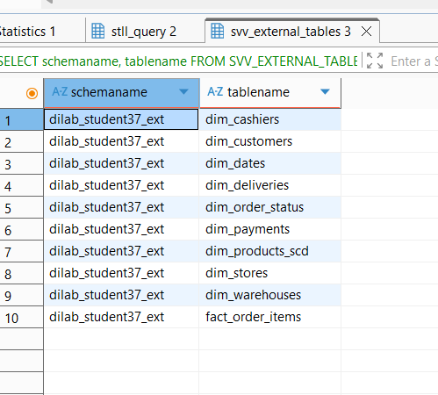

Partitioned tables are displayed in s3 spectrum folder.

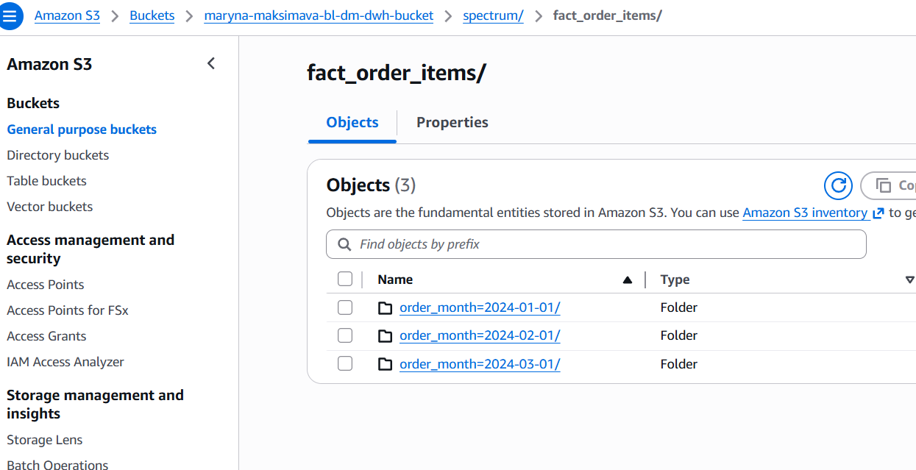

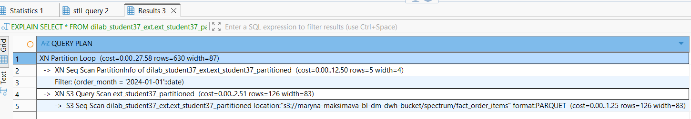

S3 Seq Scan reads the parquet files from s3://maryna-maksimava-bl-dm-dwh-bucket/spectrum/fact_order_items.
XN S3 Query Scan reads only the data from the matching partition folder in S3.
XN Seq Scan PartitionInfo scans only 5 partition metadata rows to find matching partitions, then applies Filter. Then Redshift loops through partitions (only the ones we need).

