TASK 1 – PERFOMANCE WITH UNLLOGED TABLES

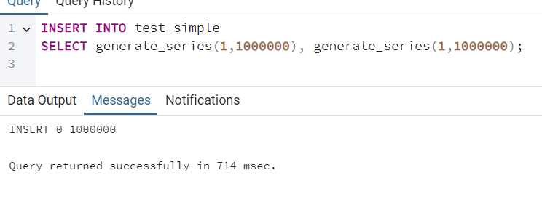

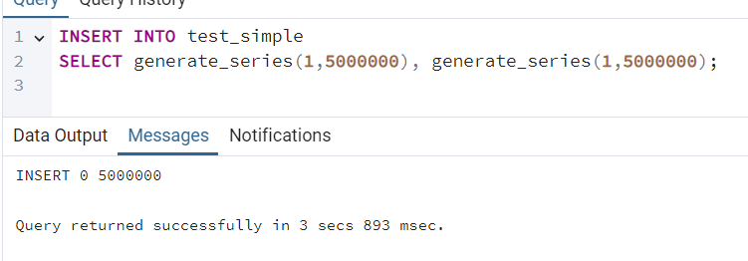

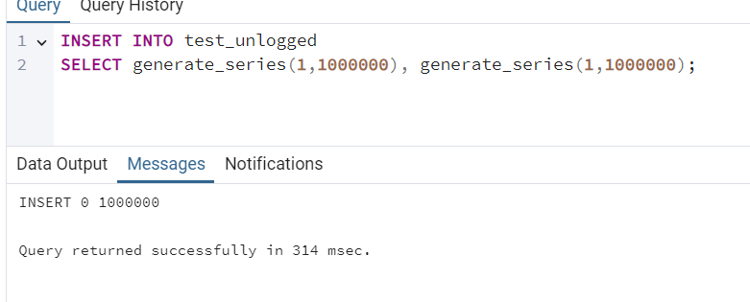

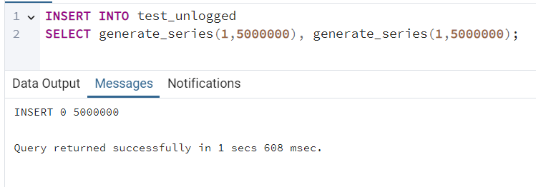

Unlogged tables perform inserts more than twice faster.

TASK 2 – UNDERSTANDING INHERITED TABLES

SELECT * FROM users; - shows the 2 new inserted to users values
SELECT * FROM person; - shows old values + new values (only id and name from new values)
SELECT * FROM ONLY person; - shows the initial 3 values inserted directly to person

After update

UPDATE person
SET name = 'not Bob'
where id = 1

SELECT * FROM users; - name changed

SELECT * FROM person;

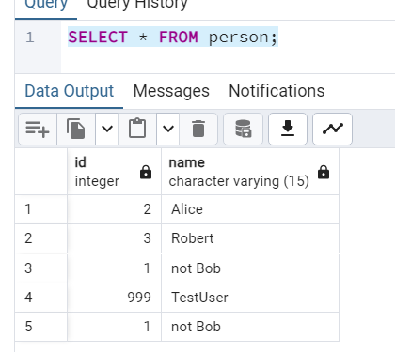

name changes in both places where id is 1

SELECT * FROM ONLY person; - name changed in 1 place

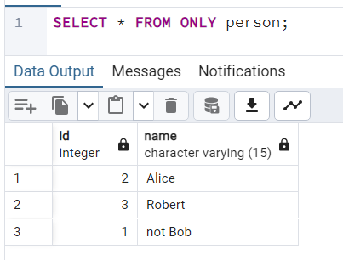

-----------------------------------
UPDATE ONLY person
SET name = 'Bob person only'
WHERE id = 1;
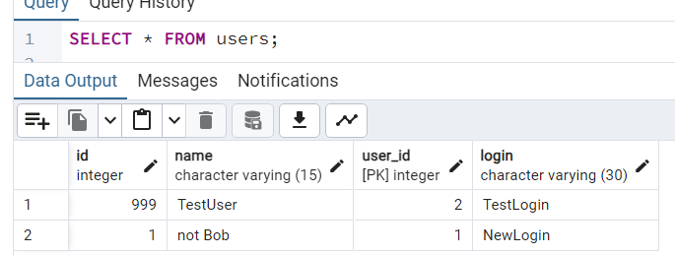

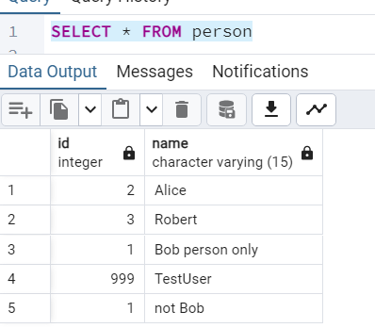

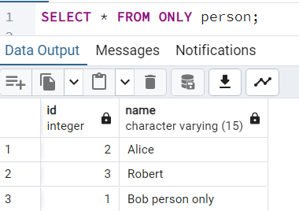

Now the value changes only in the row that was inserted into person table initially and not the child table.

---------------------------
ALTER TABLE person ADD COLUMN status integer DEFAULT 0;

SELECT * FROM users; - column appeared
SELECT * FROM person; - column appeared
SELECT * FROM ONLY person; - column appeared

Inheritance propagates structure.

---------------------------
ALTER TABLE person ADD CONSTRAINT status CHECK (status in (0,1)) NO INHERIT;

I’ll check it by trying to insert bad values
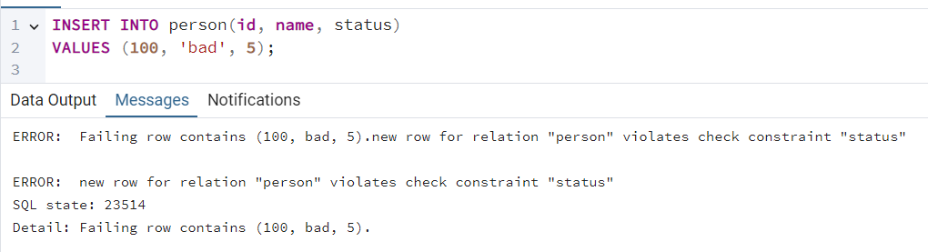
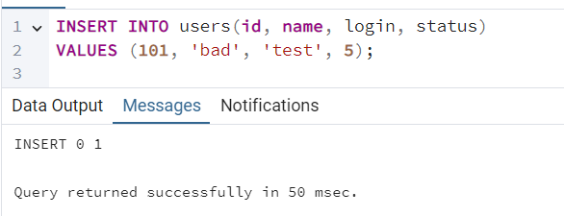

Insert into person fails but insert into users works.
-----------------------------------------
ALTER TABLE person ADD CONSTRAINT id UNIQUE (id, name);
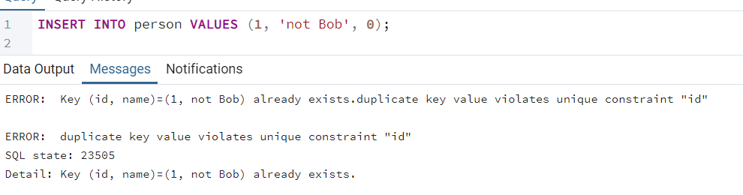

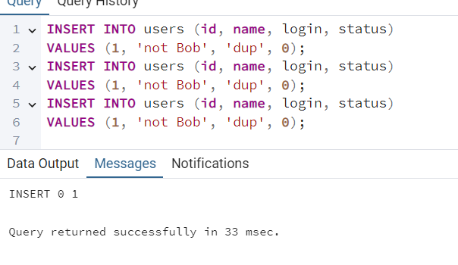

Person table prohibits duplicate (id, name) while users table allows it.
“Notably, primary key constraints, foreign key constraints, uniqueness constraints, and indexes are never inherited. Check constraints are inherited, but children can have their own check constraints in addition to the ones they inherit from their parents. “
-----------------------------------------------------------
3.1 TASK 3 - BRIN VS B-TREE

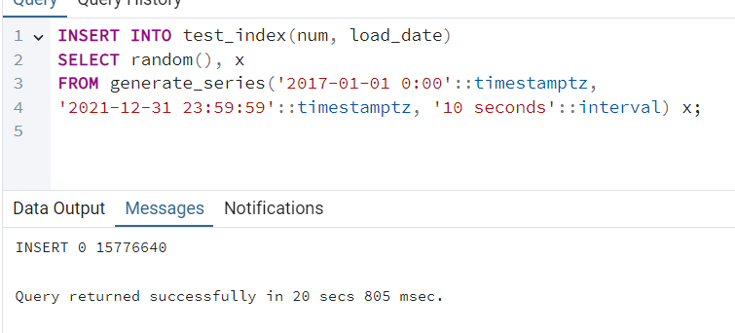

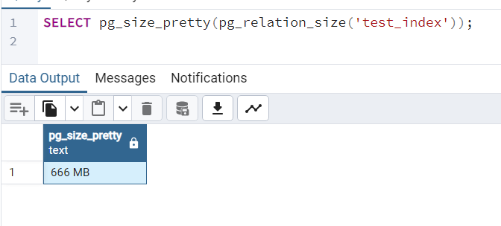
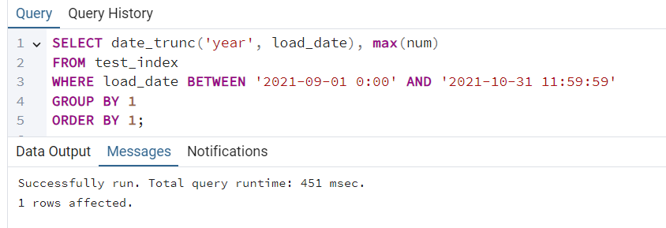
-----------------------------------------------------------------------------

CREATE INDEX idx_btree_load_date
ON test_index USING btree(load_date);

--Query returned successfully in 6 secs 561 msec.
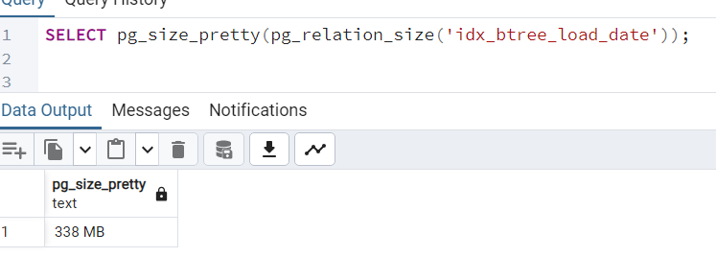

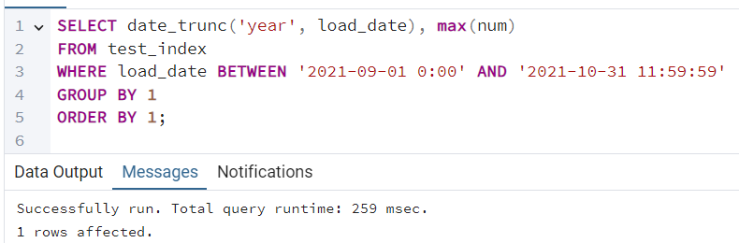
Almost twice faster than no index and the index size is almost twice smaller.
--------------------------------------------
CREATE INDEX idx_brin_load_date
ON test_index USING brin(load_date);

Query returned successfully in 1 secs 560 msec.
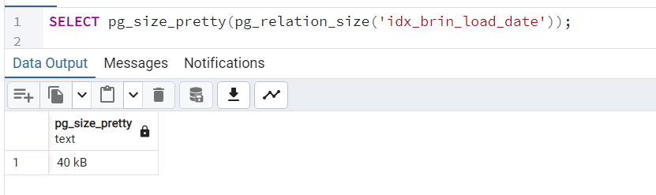

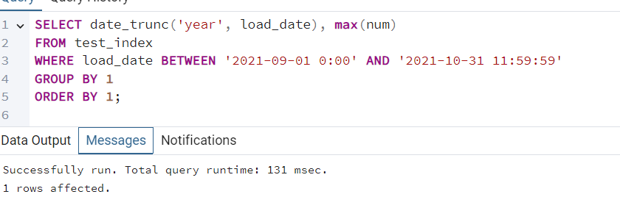

Brin index is very small in size and very fast.

TASK 4 - GIN VS GIST

Table size - 652 MB

SELECT * FROM test_index WHERE t_hash LIKE '%ceea167a5a%';
Successfully run. Total query runtime: 741 msec.
-----------
create gist index
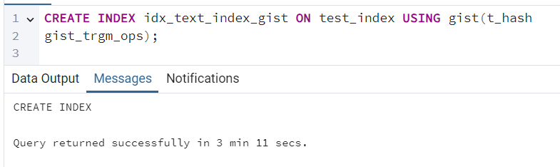

Index size - "1771 MB"

SELECT * FROM test_index WHERE t_hash LIKE '%ceea167a5a%';

Successfully run. Total query runtime: 805 msec.

Gist index didn’t help in this case.

----------------
GIN
CREATE INDEX
Query returned successfully in 1 min 20 secs.
---
Index size - "613 MB"
---
SELECT * FROM test_index WHERE t_hash LIKE '%ceea167a5a%';
Successfully run. Total query runtime: 110 msec. 1 rows affected.

Gin index worked about 7 times faster than no index when performing this select.

TASK 5 – CSV FILE AS A TABLE

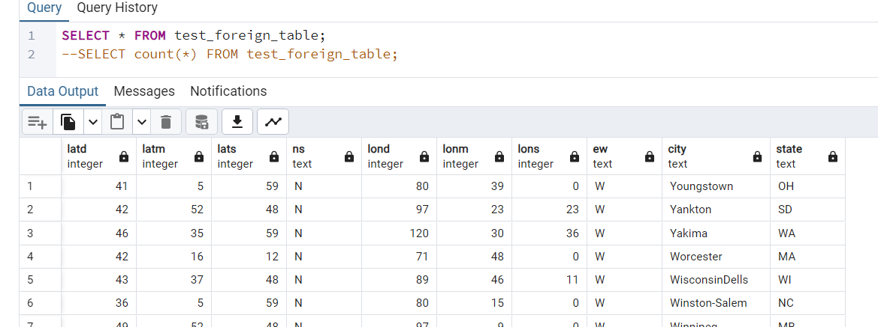
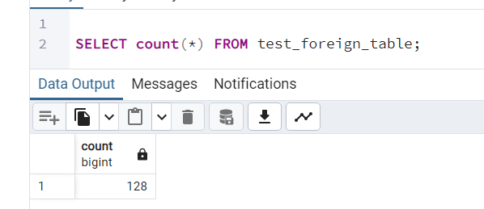
View created

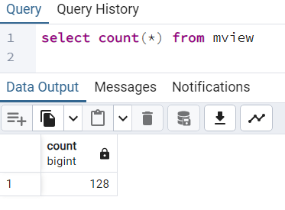

rows deleted

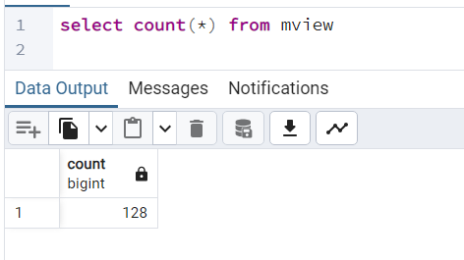

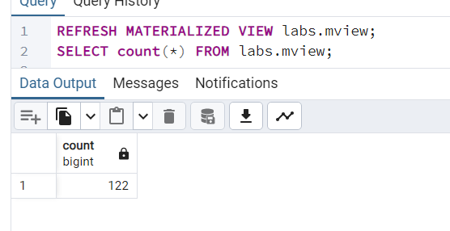

Materialized view is a snapshot of the table so it doesn’t show the updates as is. You need to refresh the materialized view to see the changes.

Foreign table reads from the csv and shows any changes immediately as they occur.

