TASK 2
Transaction 1:
read 1 (session 2 doesn’t see the table contents until session 1 commits)
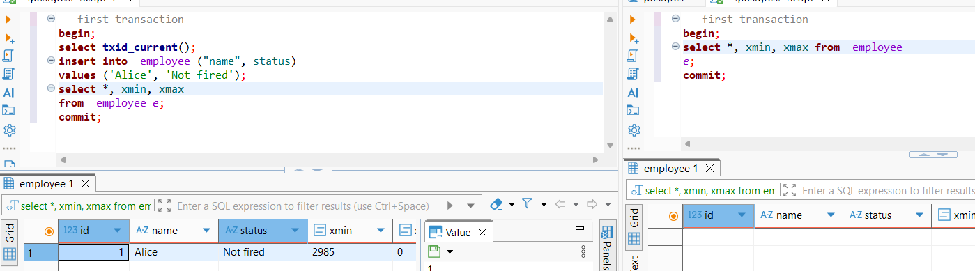
read 2 (after commit in the left window)

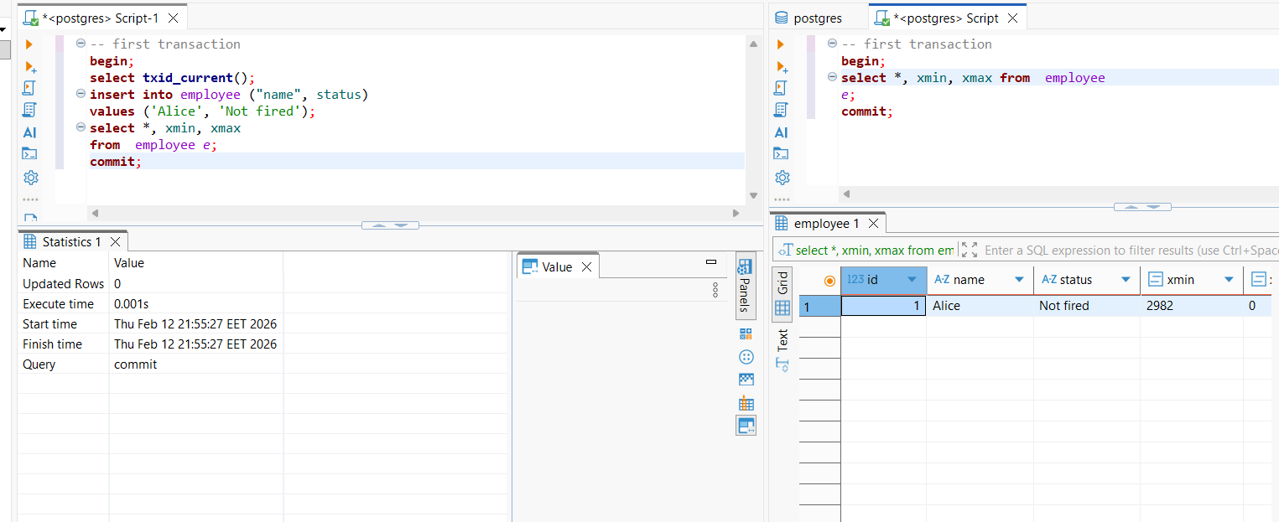
Non-repeatable read happened.

Transaction 2:
session 1 sees the number of the transaction that deleted the row (xmax) even though the delete operation wasn’t commited yet
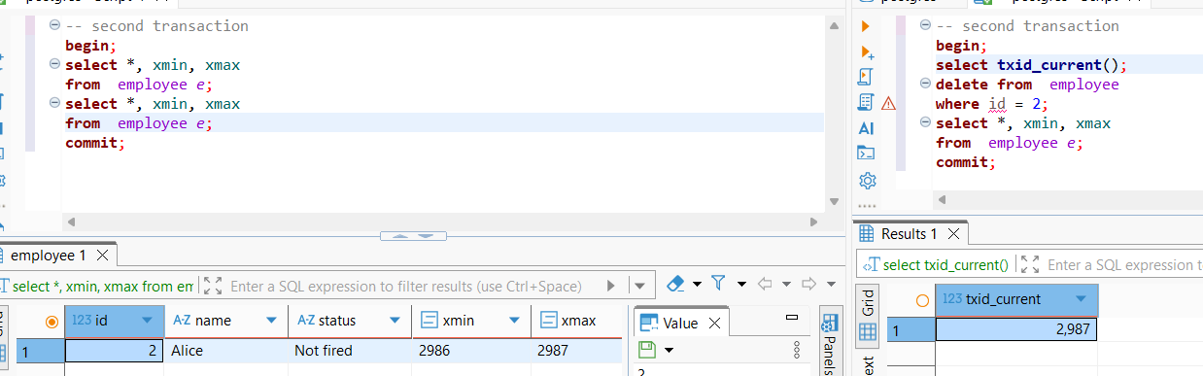
After the delete action was committed there is no such row in the table

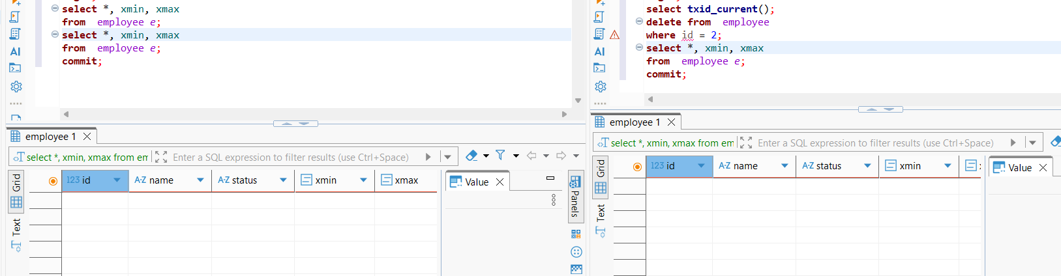
Transaction 3

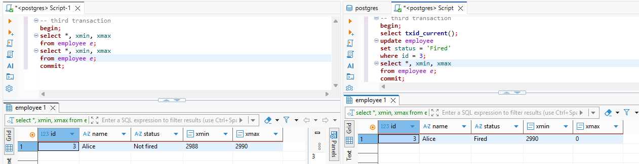
Update actually marks a row as deleted and creates a new row with the updated value.

TASK 3
Transaction 1
transaction isolation level is set.

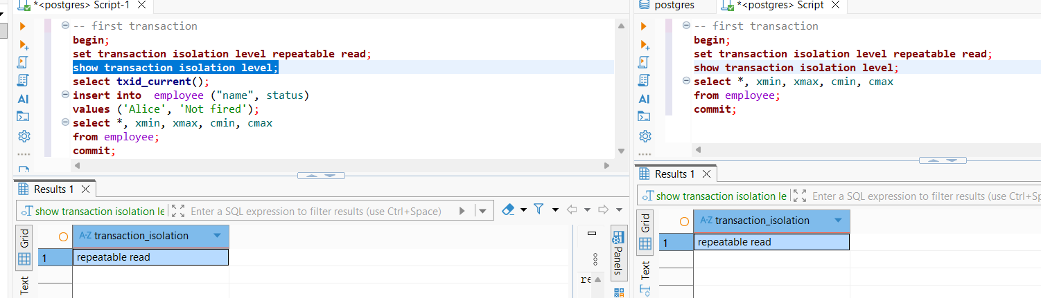
Read before commit
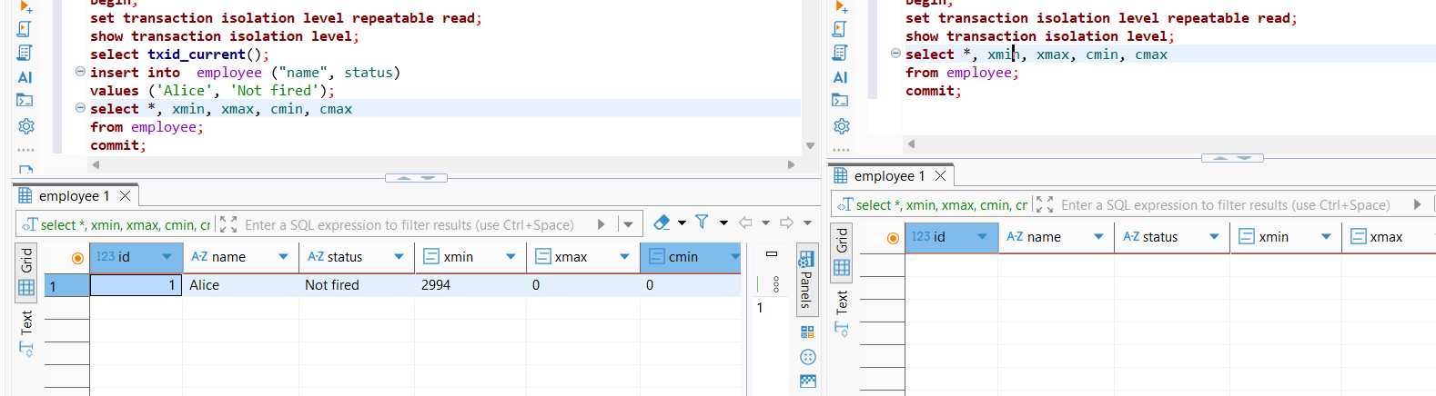
Read after commit
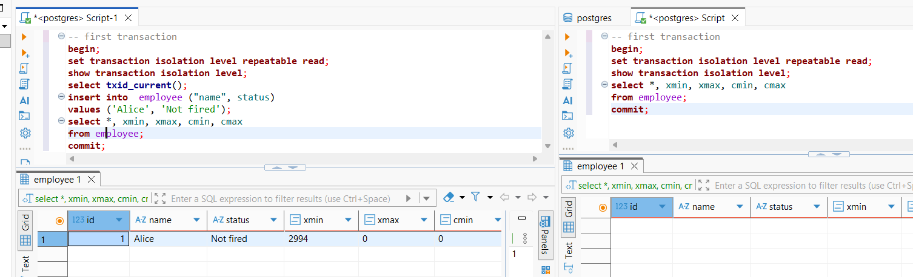
The session uses a snapshot of the db on the moment of transaction start. Select returns the same result inside one transaction.

Transaction 2

before commit
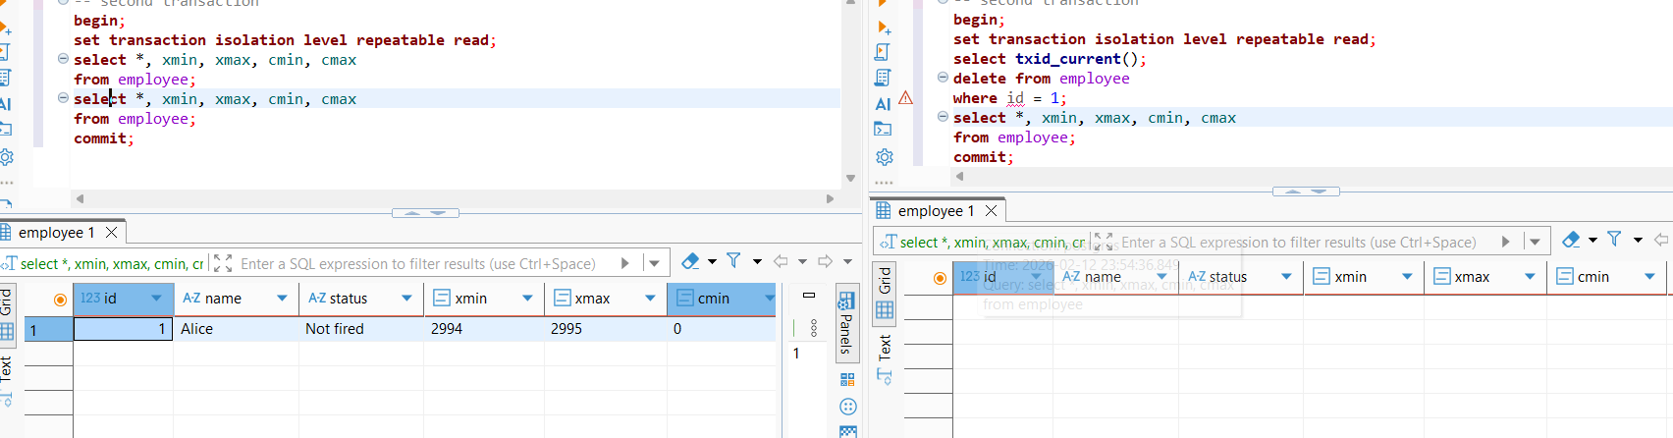

After commit
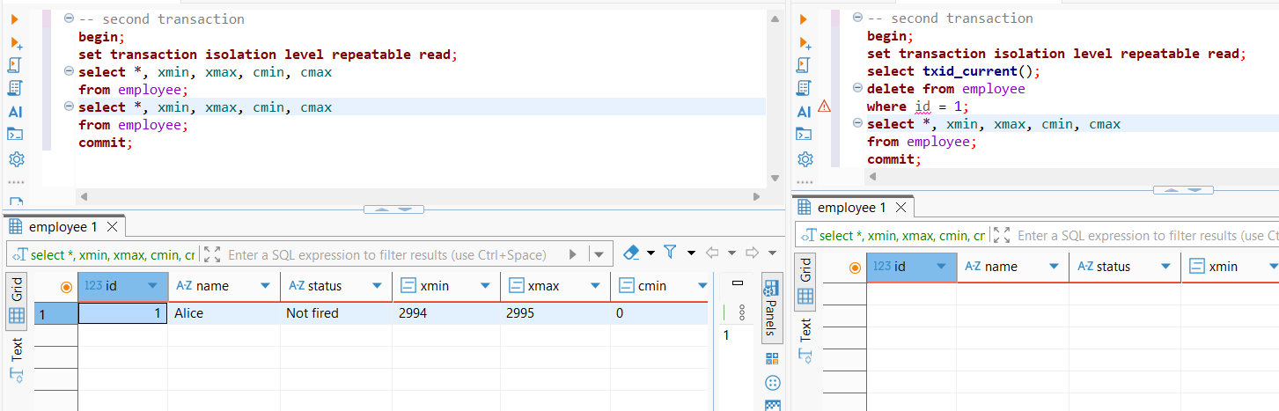
Same as transaction 1

Transaction 3

before commit
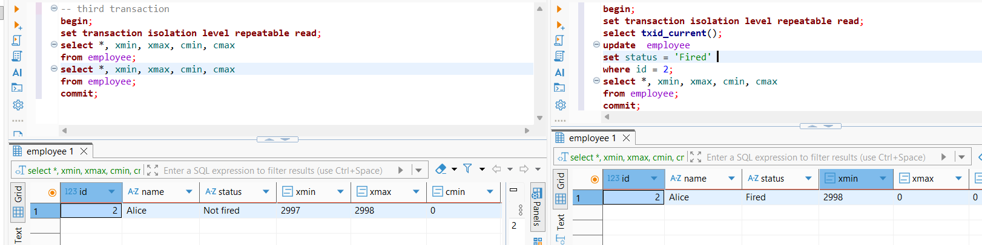
xmax still appears when the row is updated.

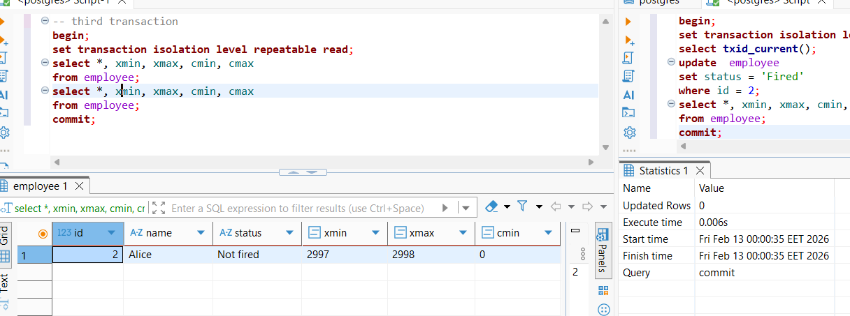
Same result after commit.
The result of the select statement is the same before and after the update operation was commited, but not the same as before the update operation was run.

TASK 5

Transaction 1

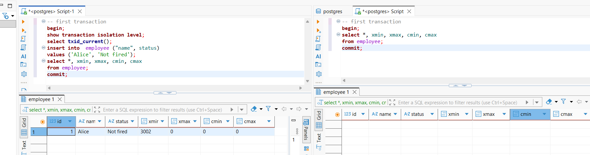
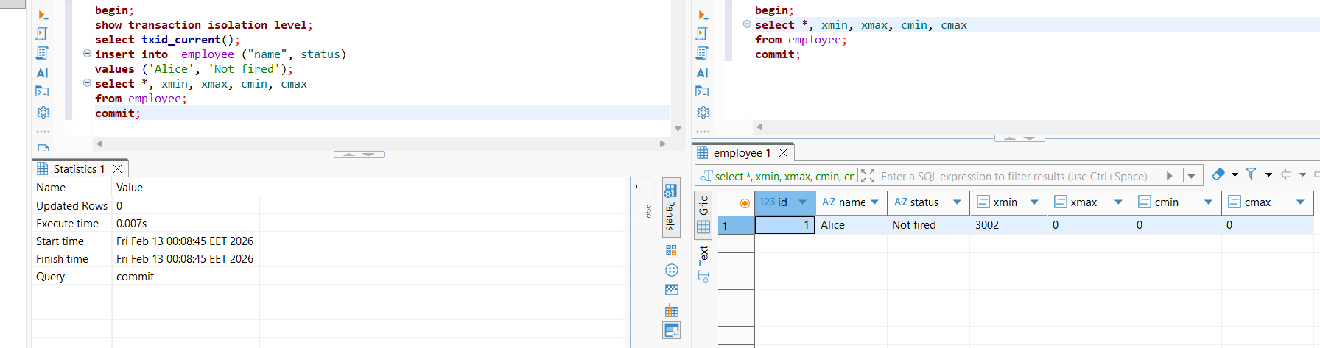
cmax xmin are 0. observations are the same as in Task 2

Transaction 2

cmax xmin are 0. observations are the same as in Task 2

Transaction 3

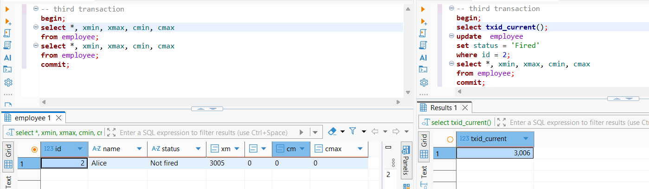

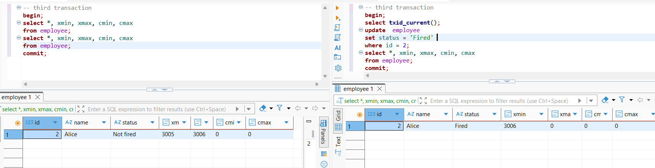
cmax xmin are 0. observations are the same as in Task 2.
----------------------
Task 6
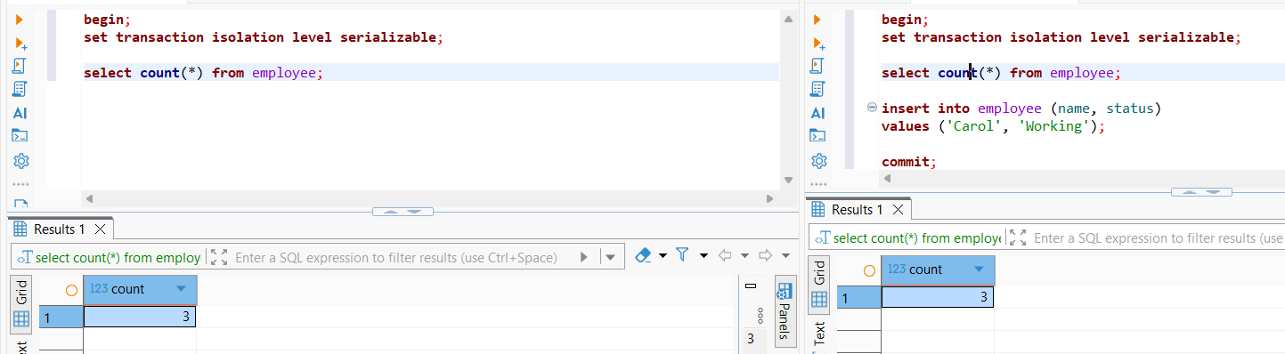
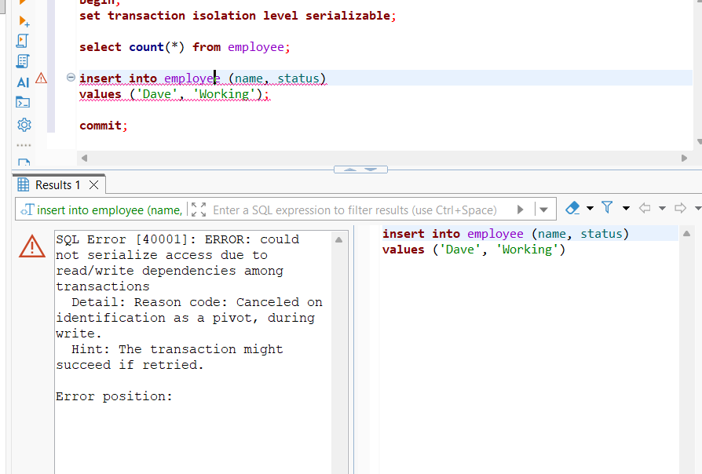

Under serializable isolation PostgreSQL detects conflicting concurrent transactions and aborts one with a serialization error.

Task 7

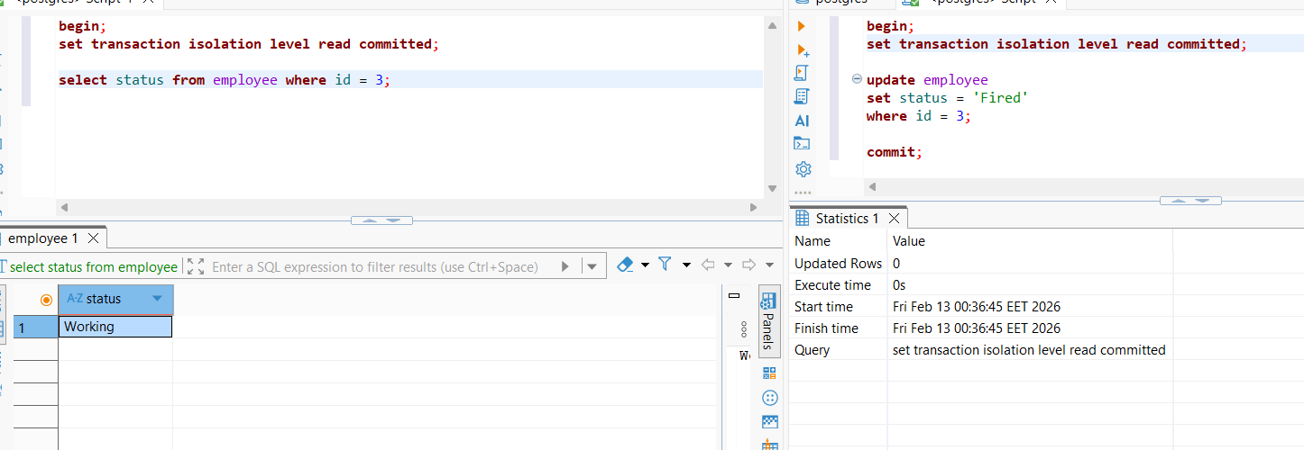

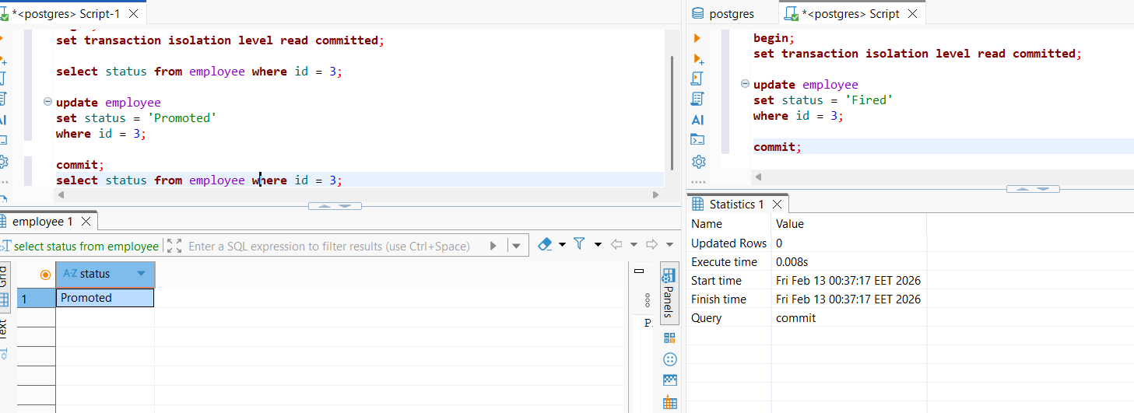

Session B’s change is overwritten. The update is lost

6

