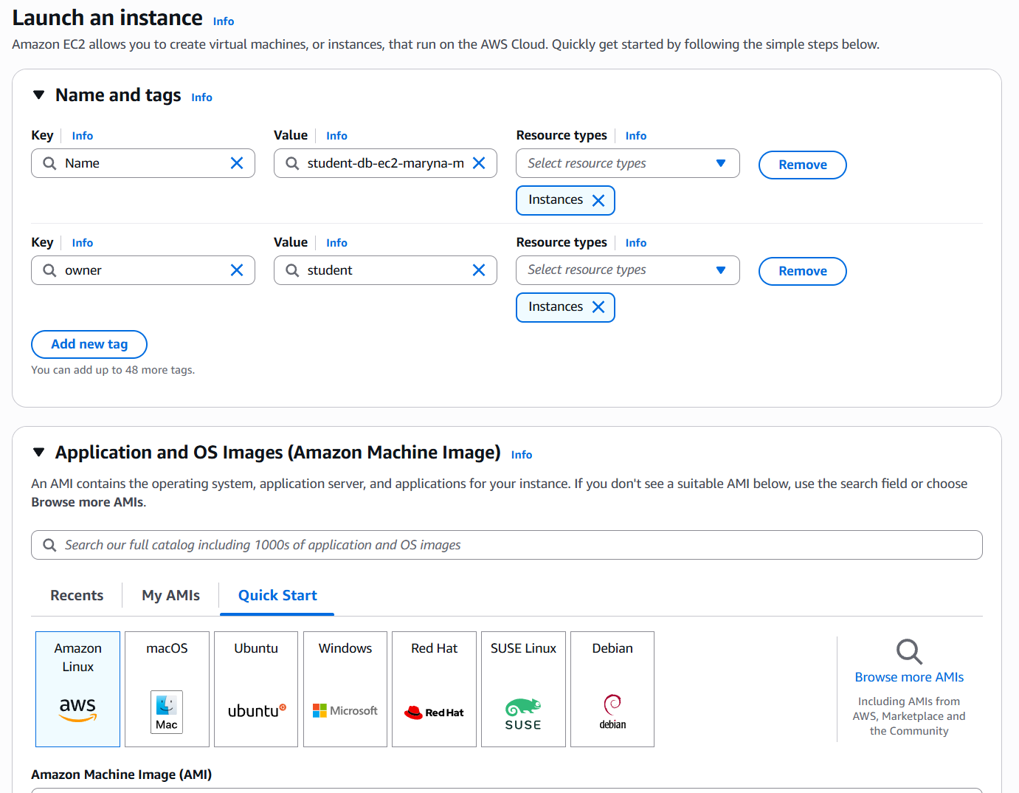
|Set the tags in the instance creation menu and chose the OS.

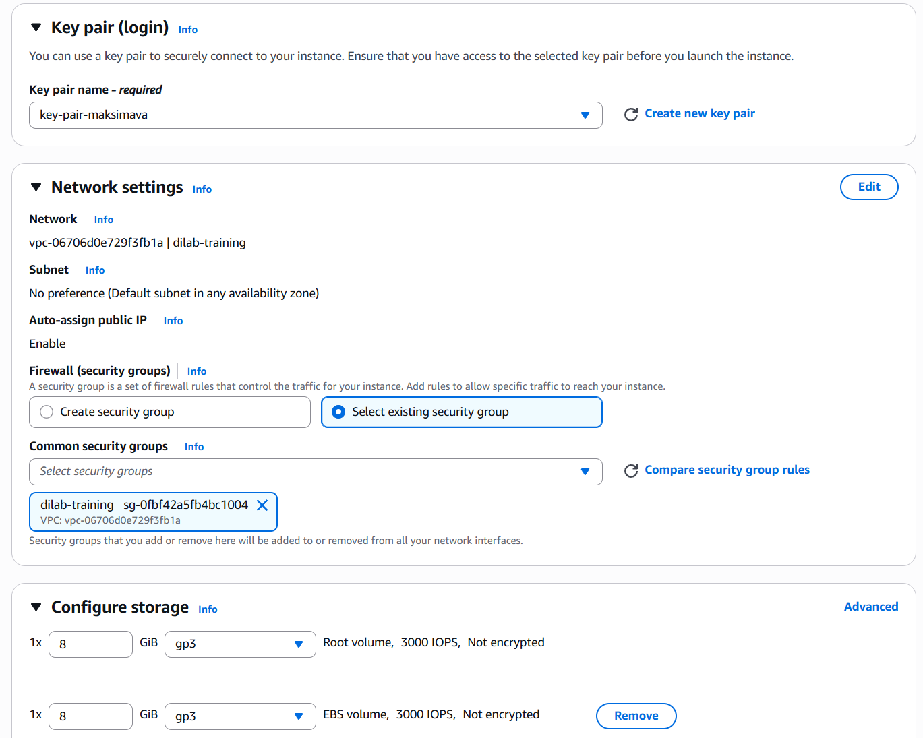
Configured key pair, security group and storage.

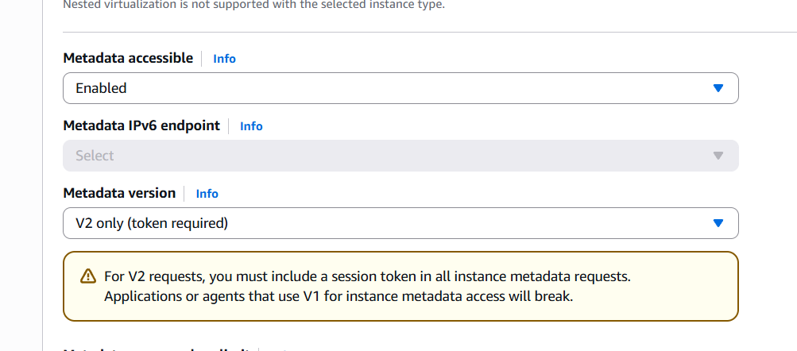
Enabled metadata service.

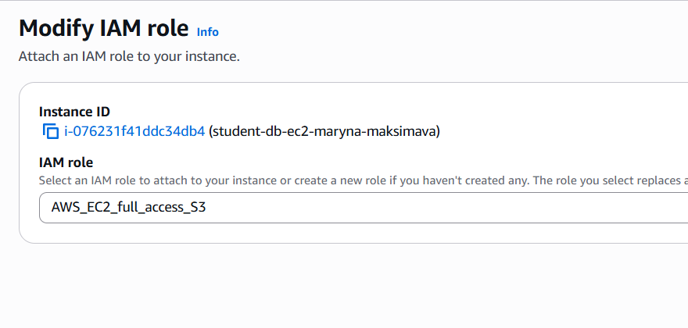

Attached the role.
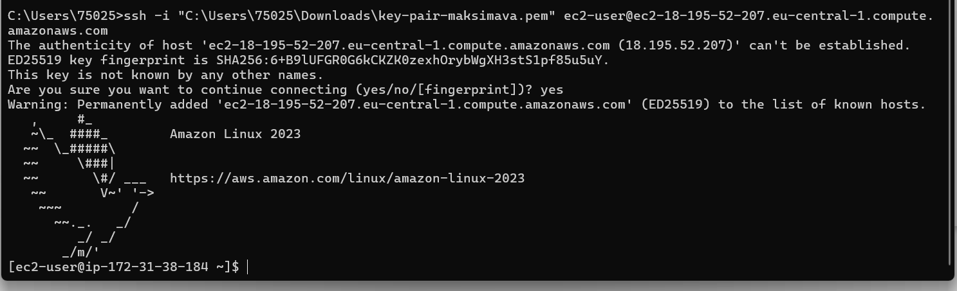

Connected to the instance.
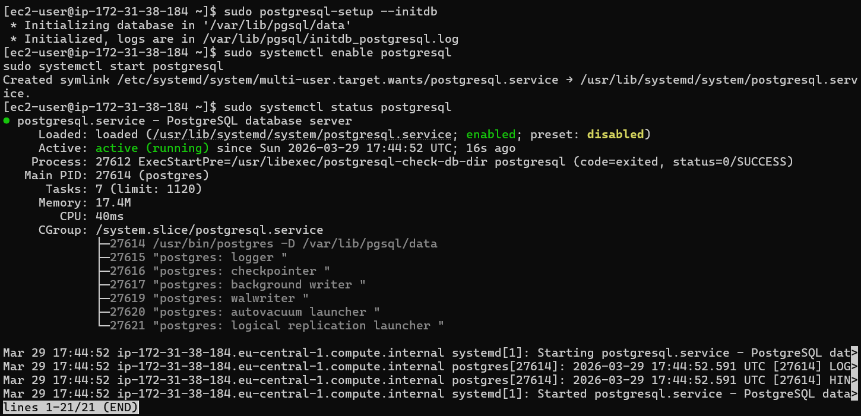

Set up postgres.

Created db and the user.

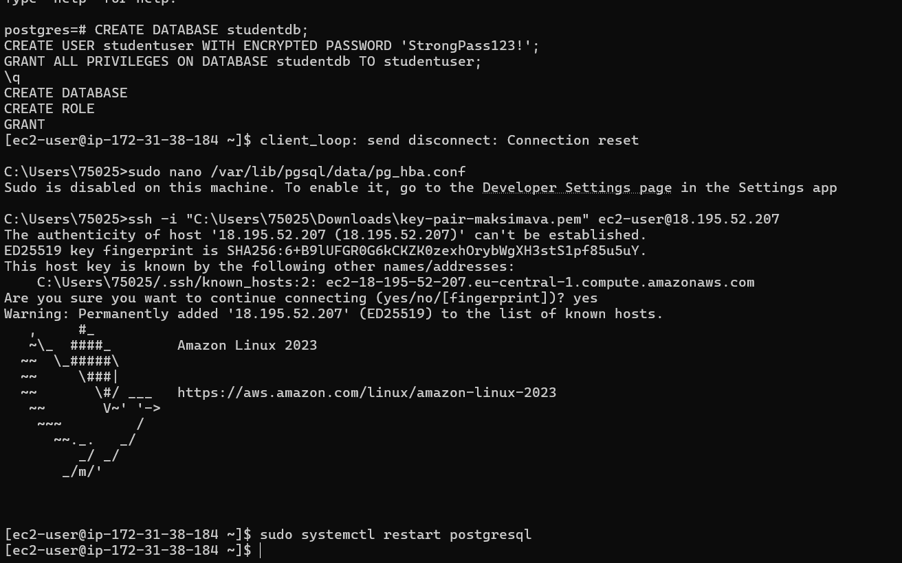

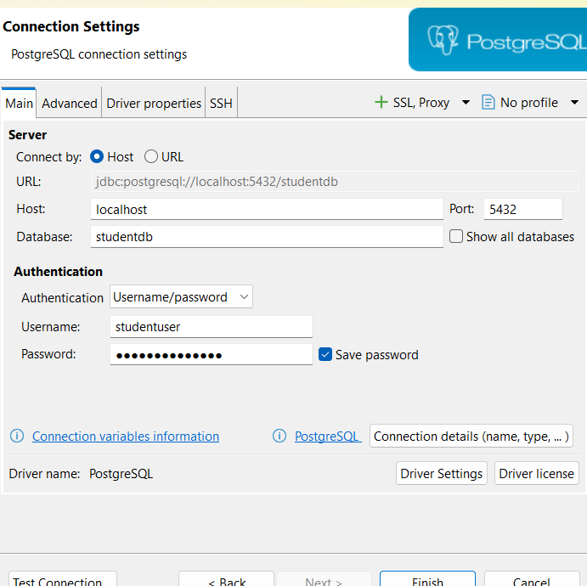
Set up connection info.
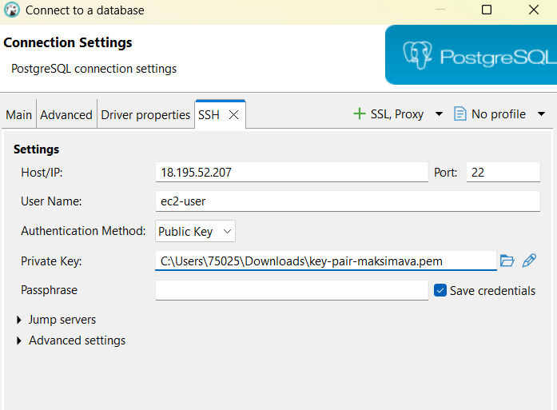
Connected to the database.

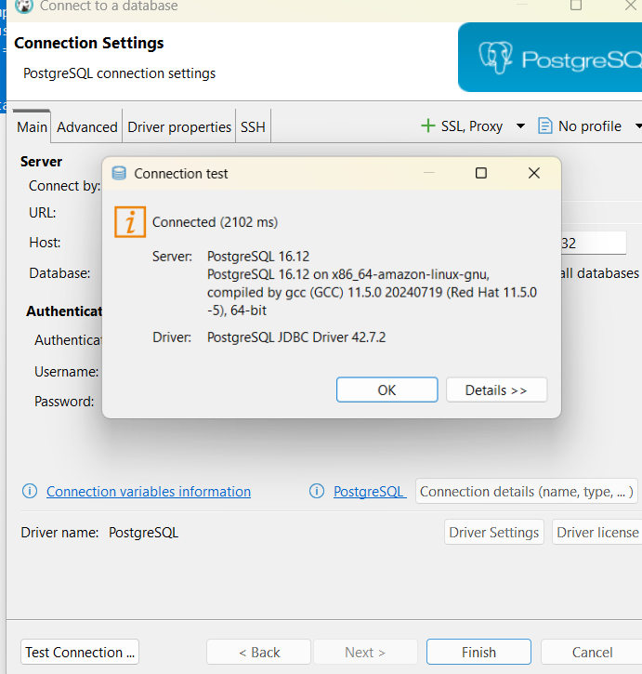

Host: localhost Port: 5432 Database: studentdb Username: studentuser Password: StrongPass123!

CREATE TABLE employees (
id SERIAL PRIMARY KEY,
first_name VARCHAR(50),
last_name VARCHAR(50),
department VARCHAR(100),
salary NUMERIC(10,2),
hire_date DATE DEFAULT CURRENT_DATE
);

INSERT INTO employees (first_name, last_name, department, salary)
VALUES
('Alice', 'Johnson', 'Engineering', 85000),
('Bob', 'Smith', 'Marketing', 72000),
('Carol', 'White', 'Engineering', 91000);

CREATE VIEW active_employees AS
SELECT id, first_name || ' ' || last_name AS full_name, department, salary
FROM employees;

CREATE OR REPLACE PROCEDURE give_raise(p_dept VARCHAR, p_percent NUMERIC)
LANGUAGE plpgsql AS $$
BEGIN
UPDATE employees SET salary = salary * (1 + p_percent/100)
WHERE department = p_dept;
END;
$$;

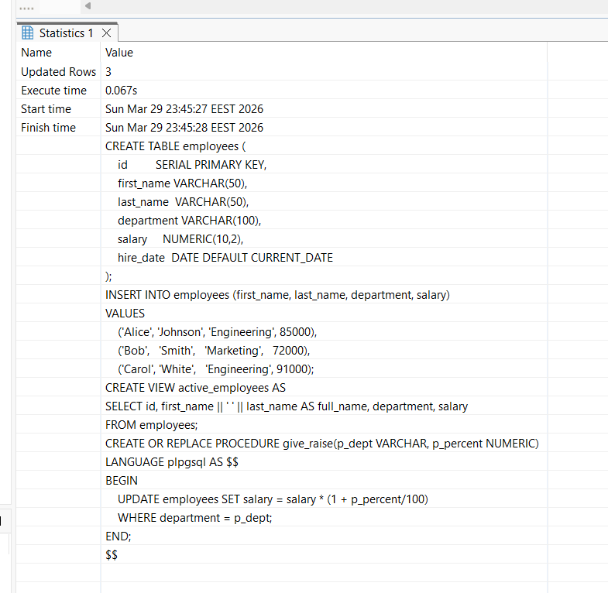
Created a table, a view, a procedure.

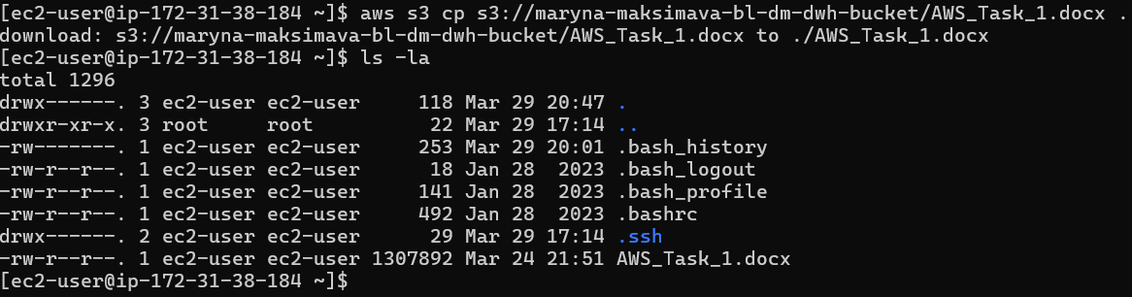
Copied a file from S3 to EC2.

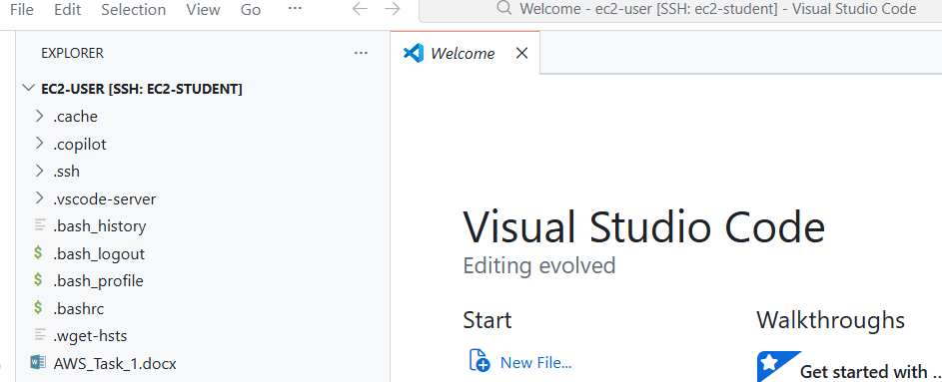

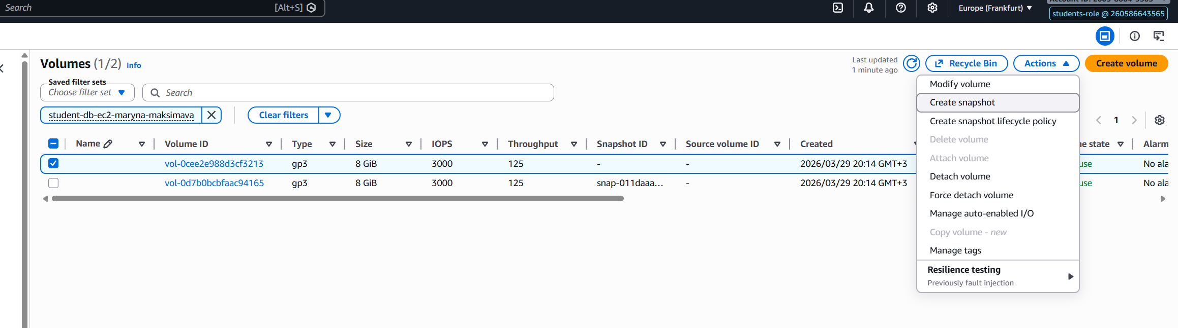
Opened the file explorer in VSCode to look at the files on the instance.
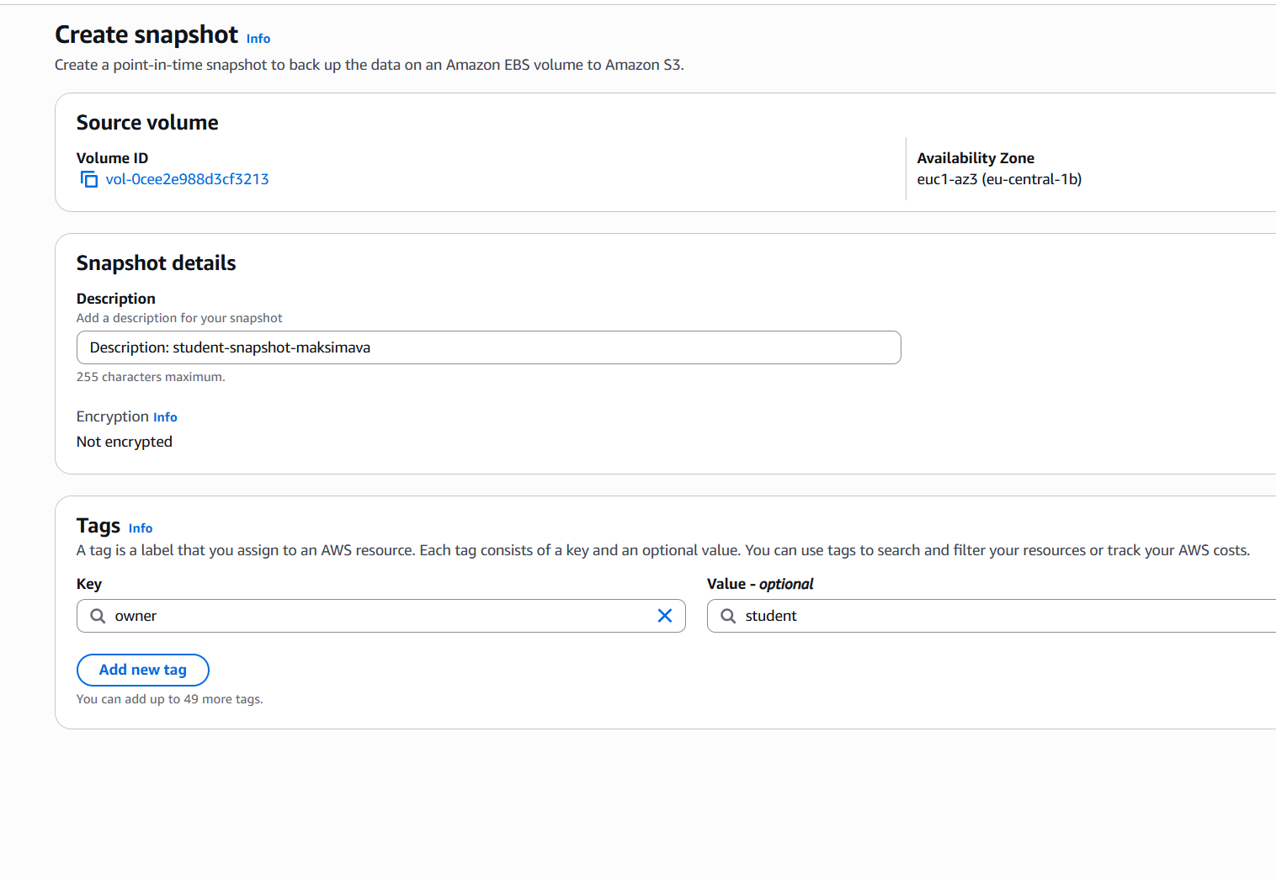
Created a snapshot.

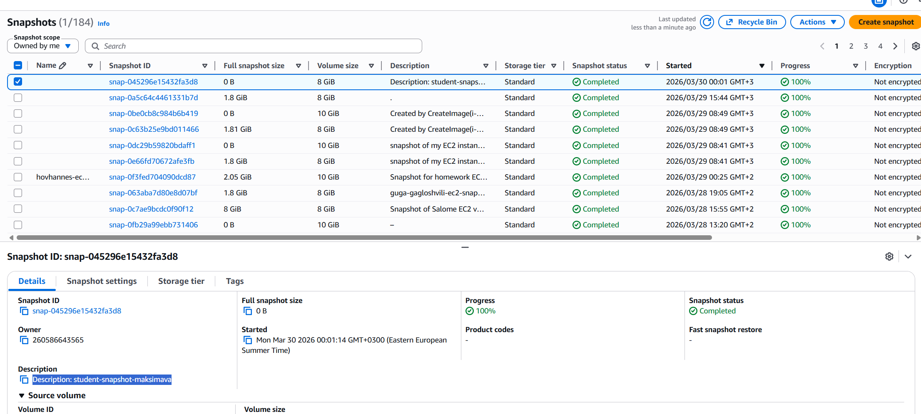
AMI was created through actions button on snapshot ribbon.

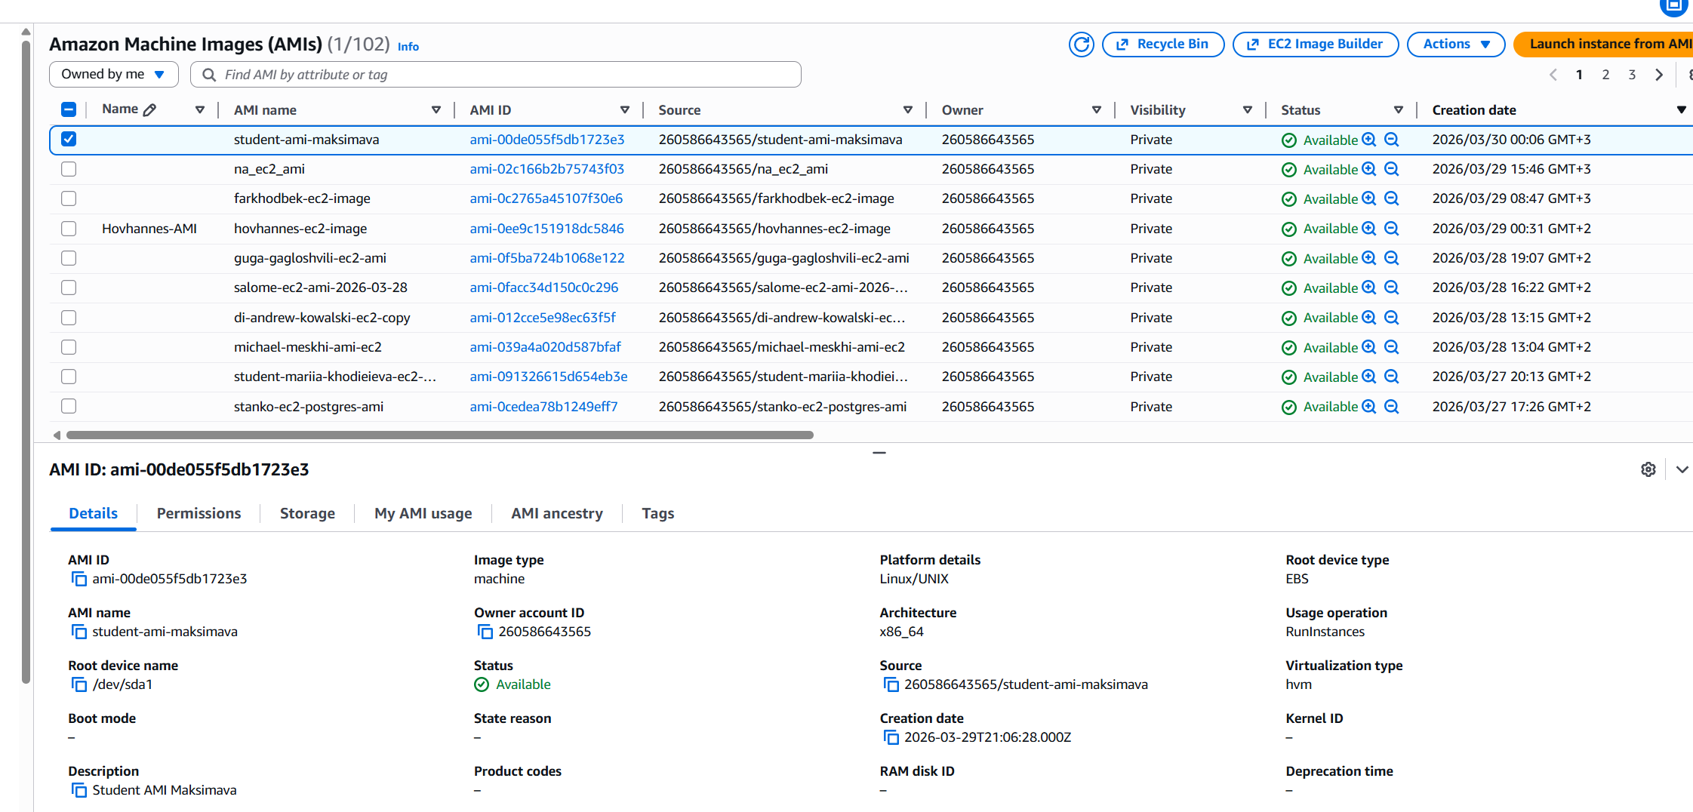

AMI created.

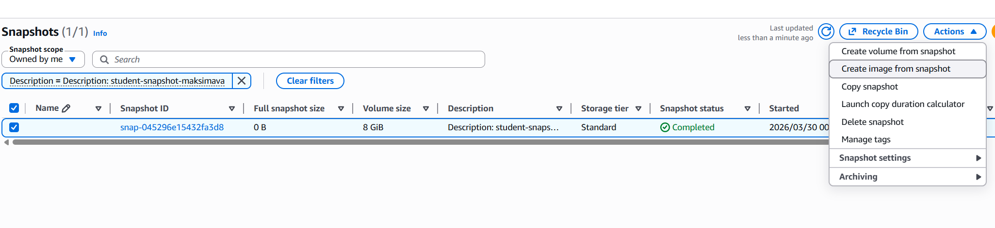

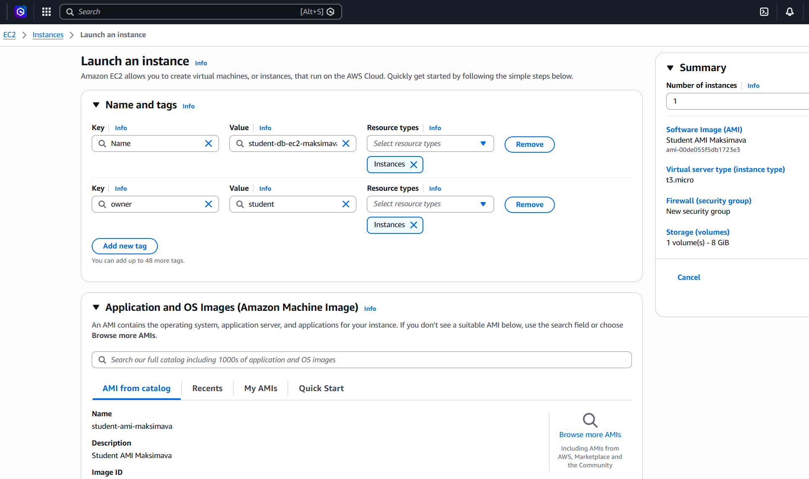

Created an instance from AMI.

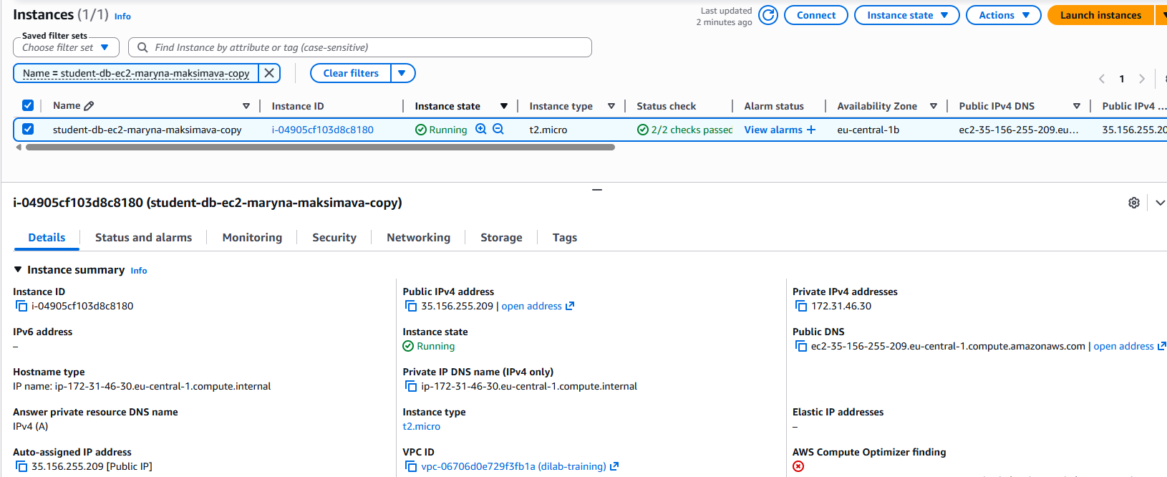
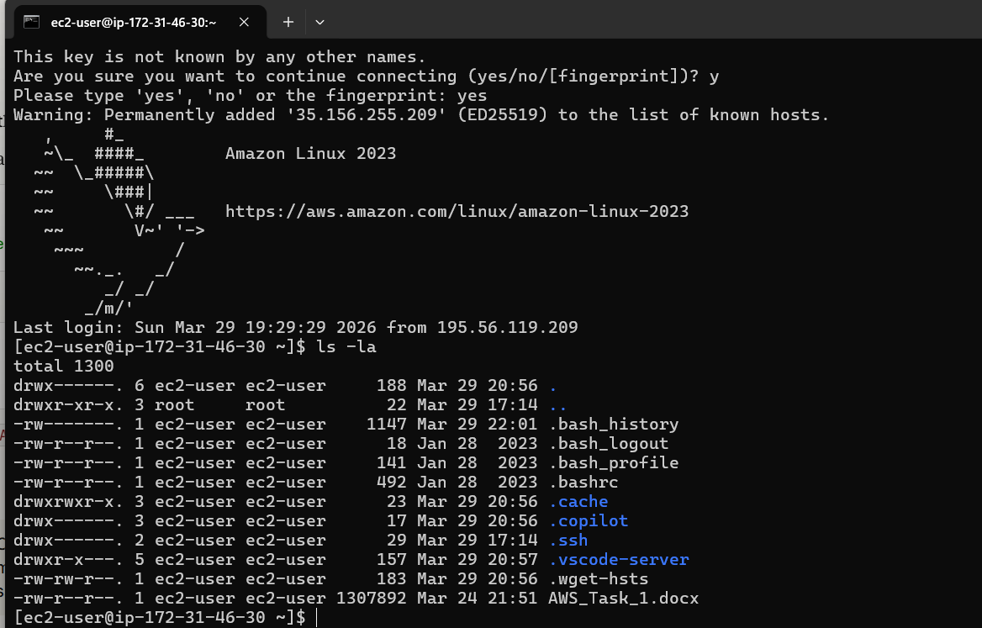
New instance contains all the files.

Installed apache.
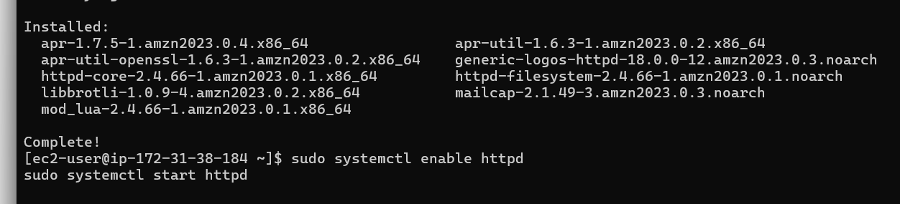

<!DOCTYPE html>
<html>
<head>
<title>Maryna Maksimava - AWS Training</title>
</head>
<body>
<h1>Hello from EC2!</h1>
<p>This is my first web page hosted on AWS EC2.</p>
<p>Student: Maryna Maksimava</p>
</body>
</html>

Created the website.
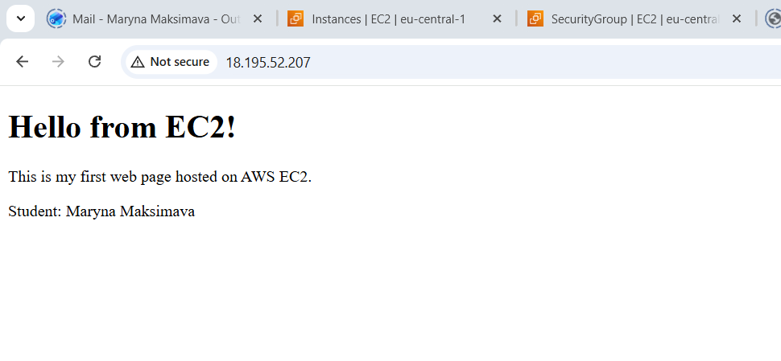

http://18.195.52.207
--

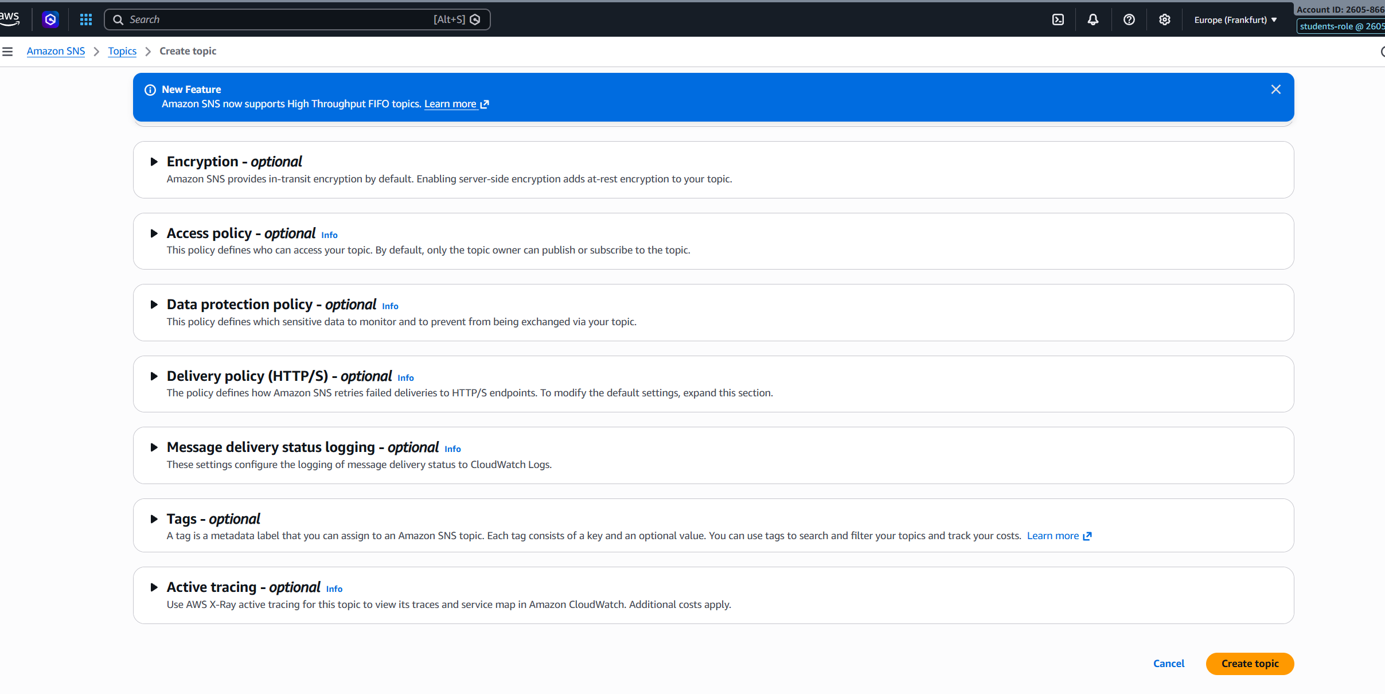
Created SNS topic.
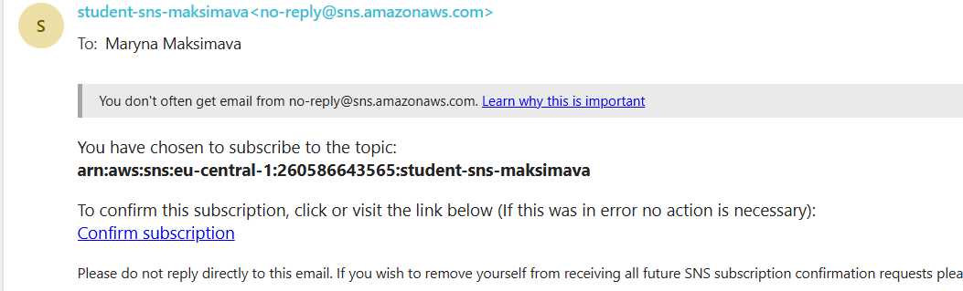
Created the email subscription.
--

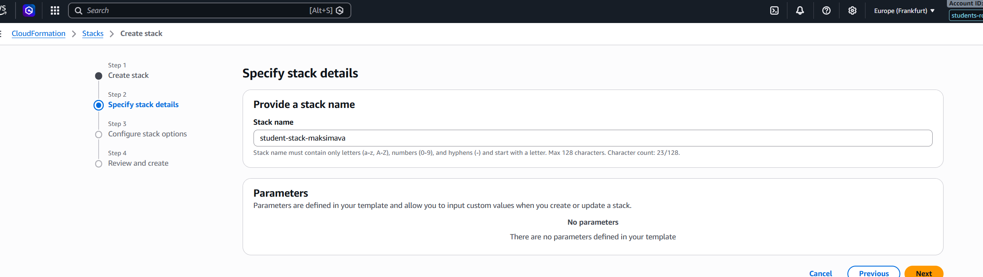

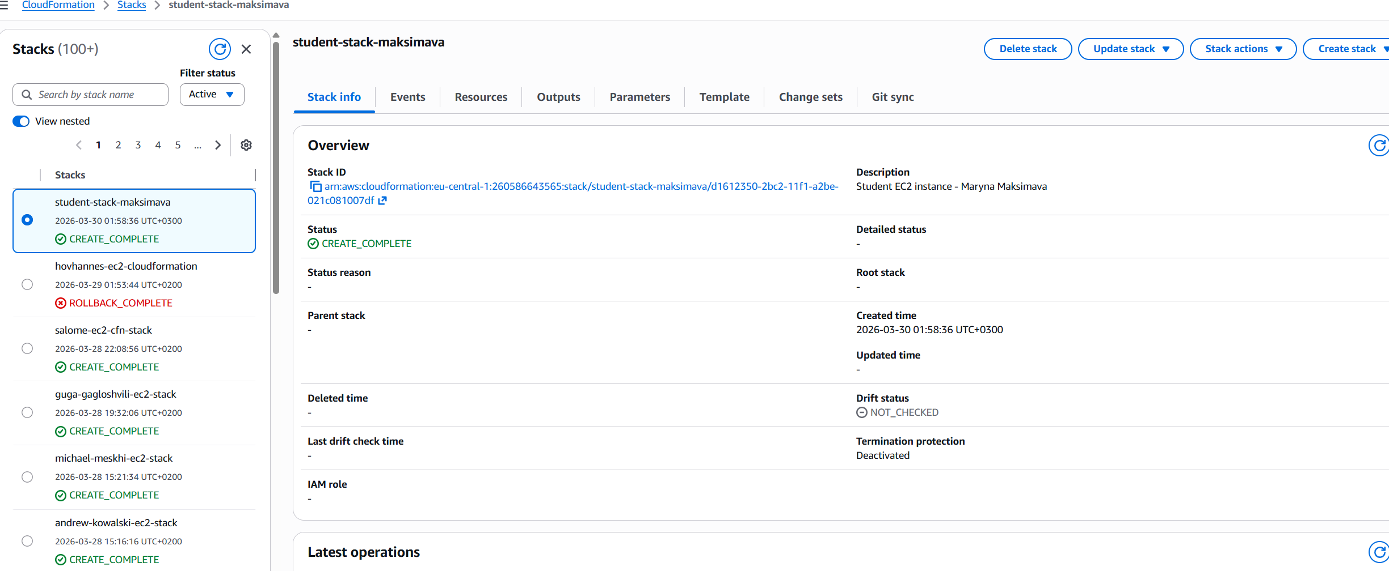
Created a stack from yaml.

AWSTemplateFormatVersion: '2010-09-09'
Description: Student EC2 instance - Maryna Maksimava

Resources:
StudentEC2Instance:
Type: AWS::EC2::Instance
Properties:
InstanceType: t2.micro
ImageId: ami-0ca87746397636a8b
SecurityGroupIds:
- sg-0fbf42a5fb4bc1004
MetadataOptions:
HttpTokens: required
HttpEndpoint: enabled
Tags:
- Key: owner
Value: student
- Key: Name
Value: student-db-ec2-maksimava-cfn

