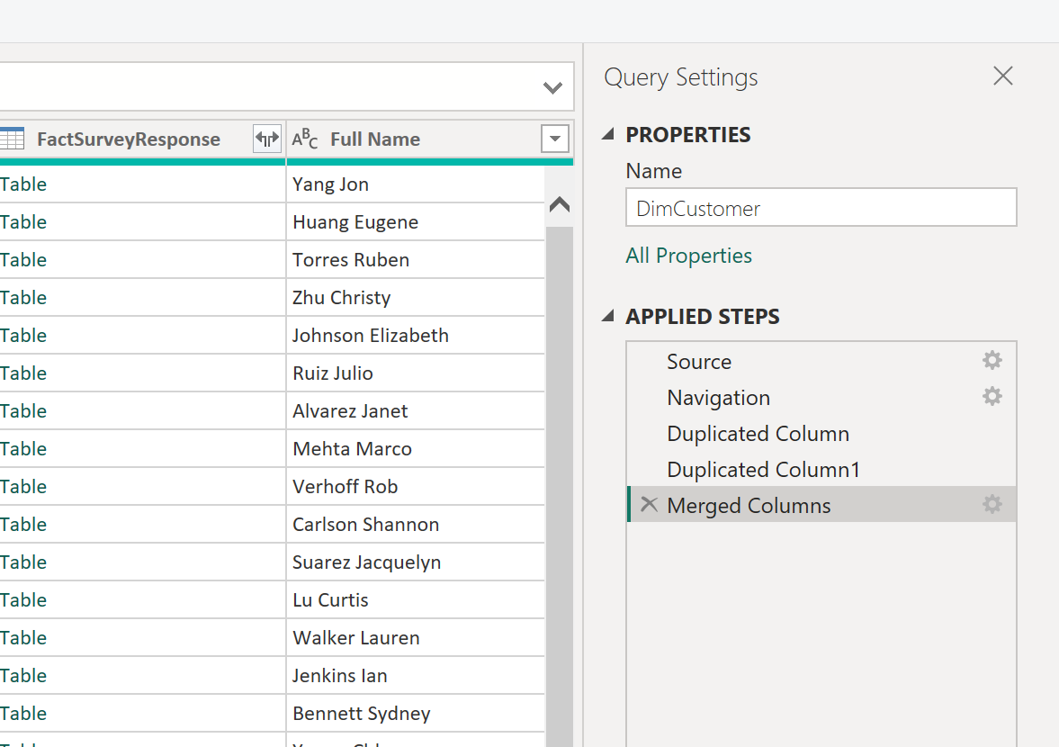
Full name created
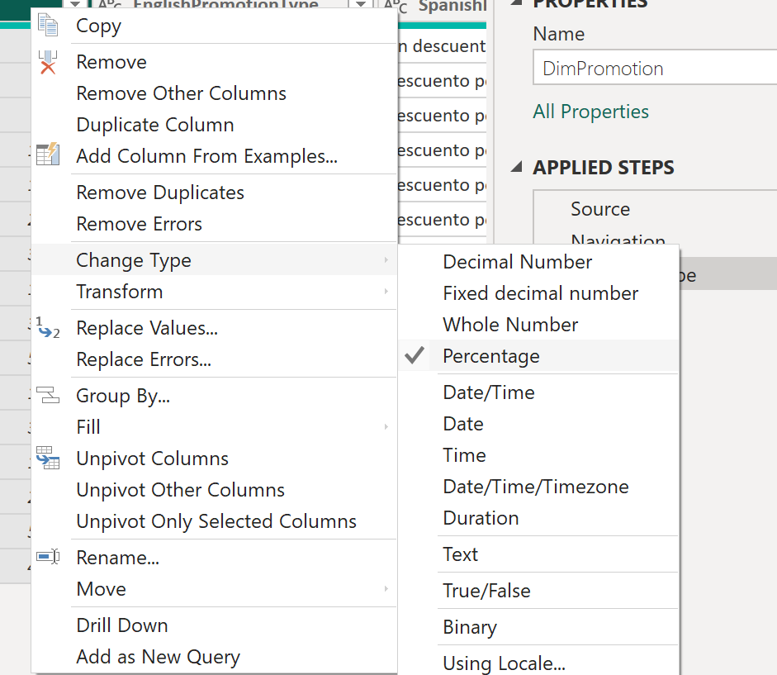

Type changed.

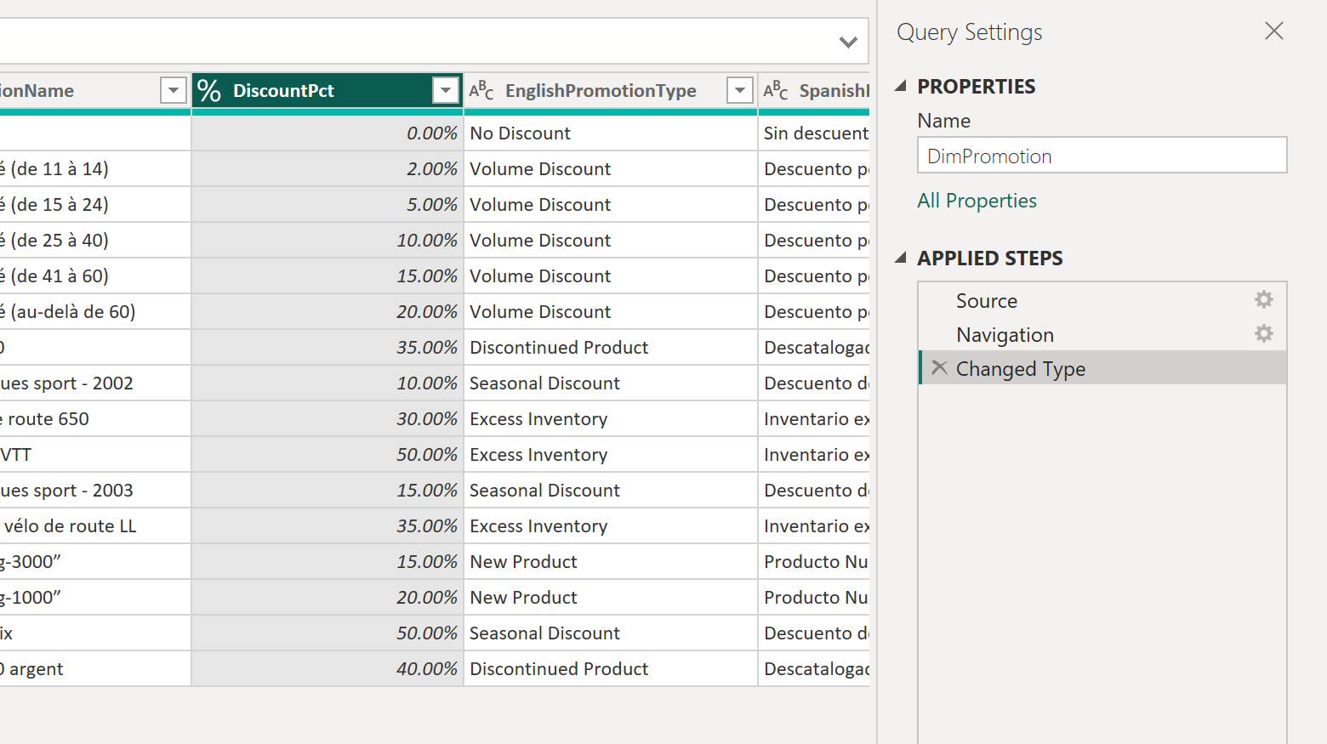

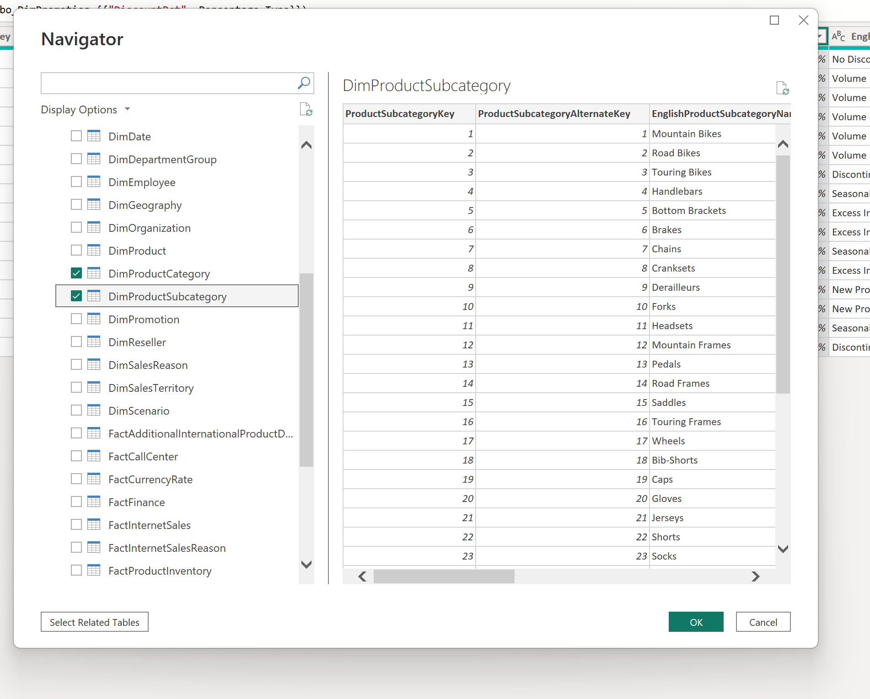
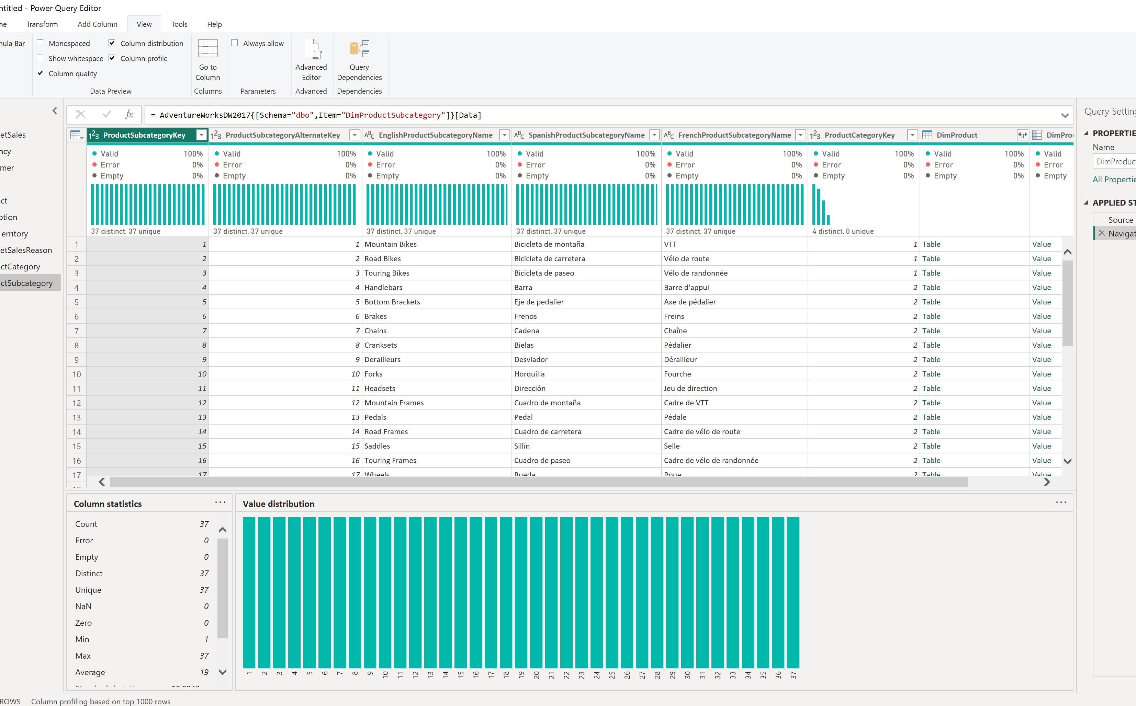
Tables were loaded and this view shows some kind of distribution of values.

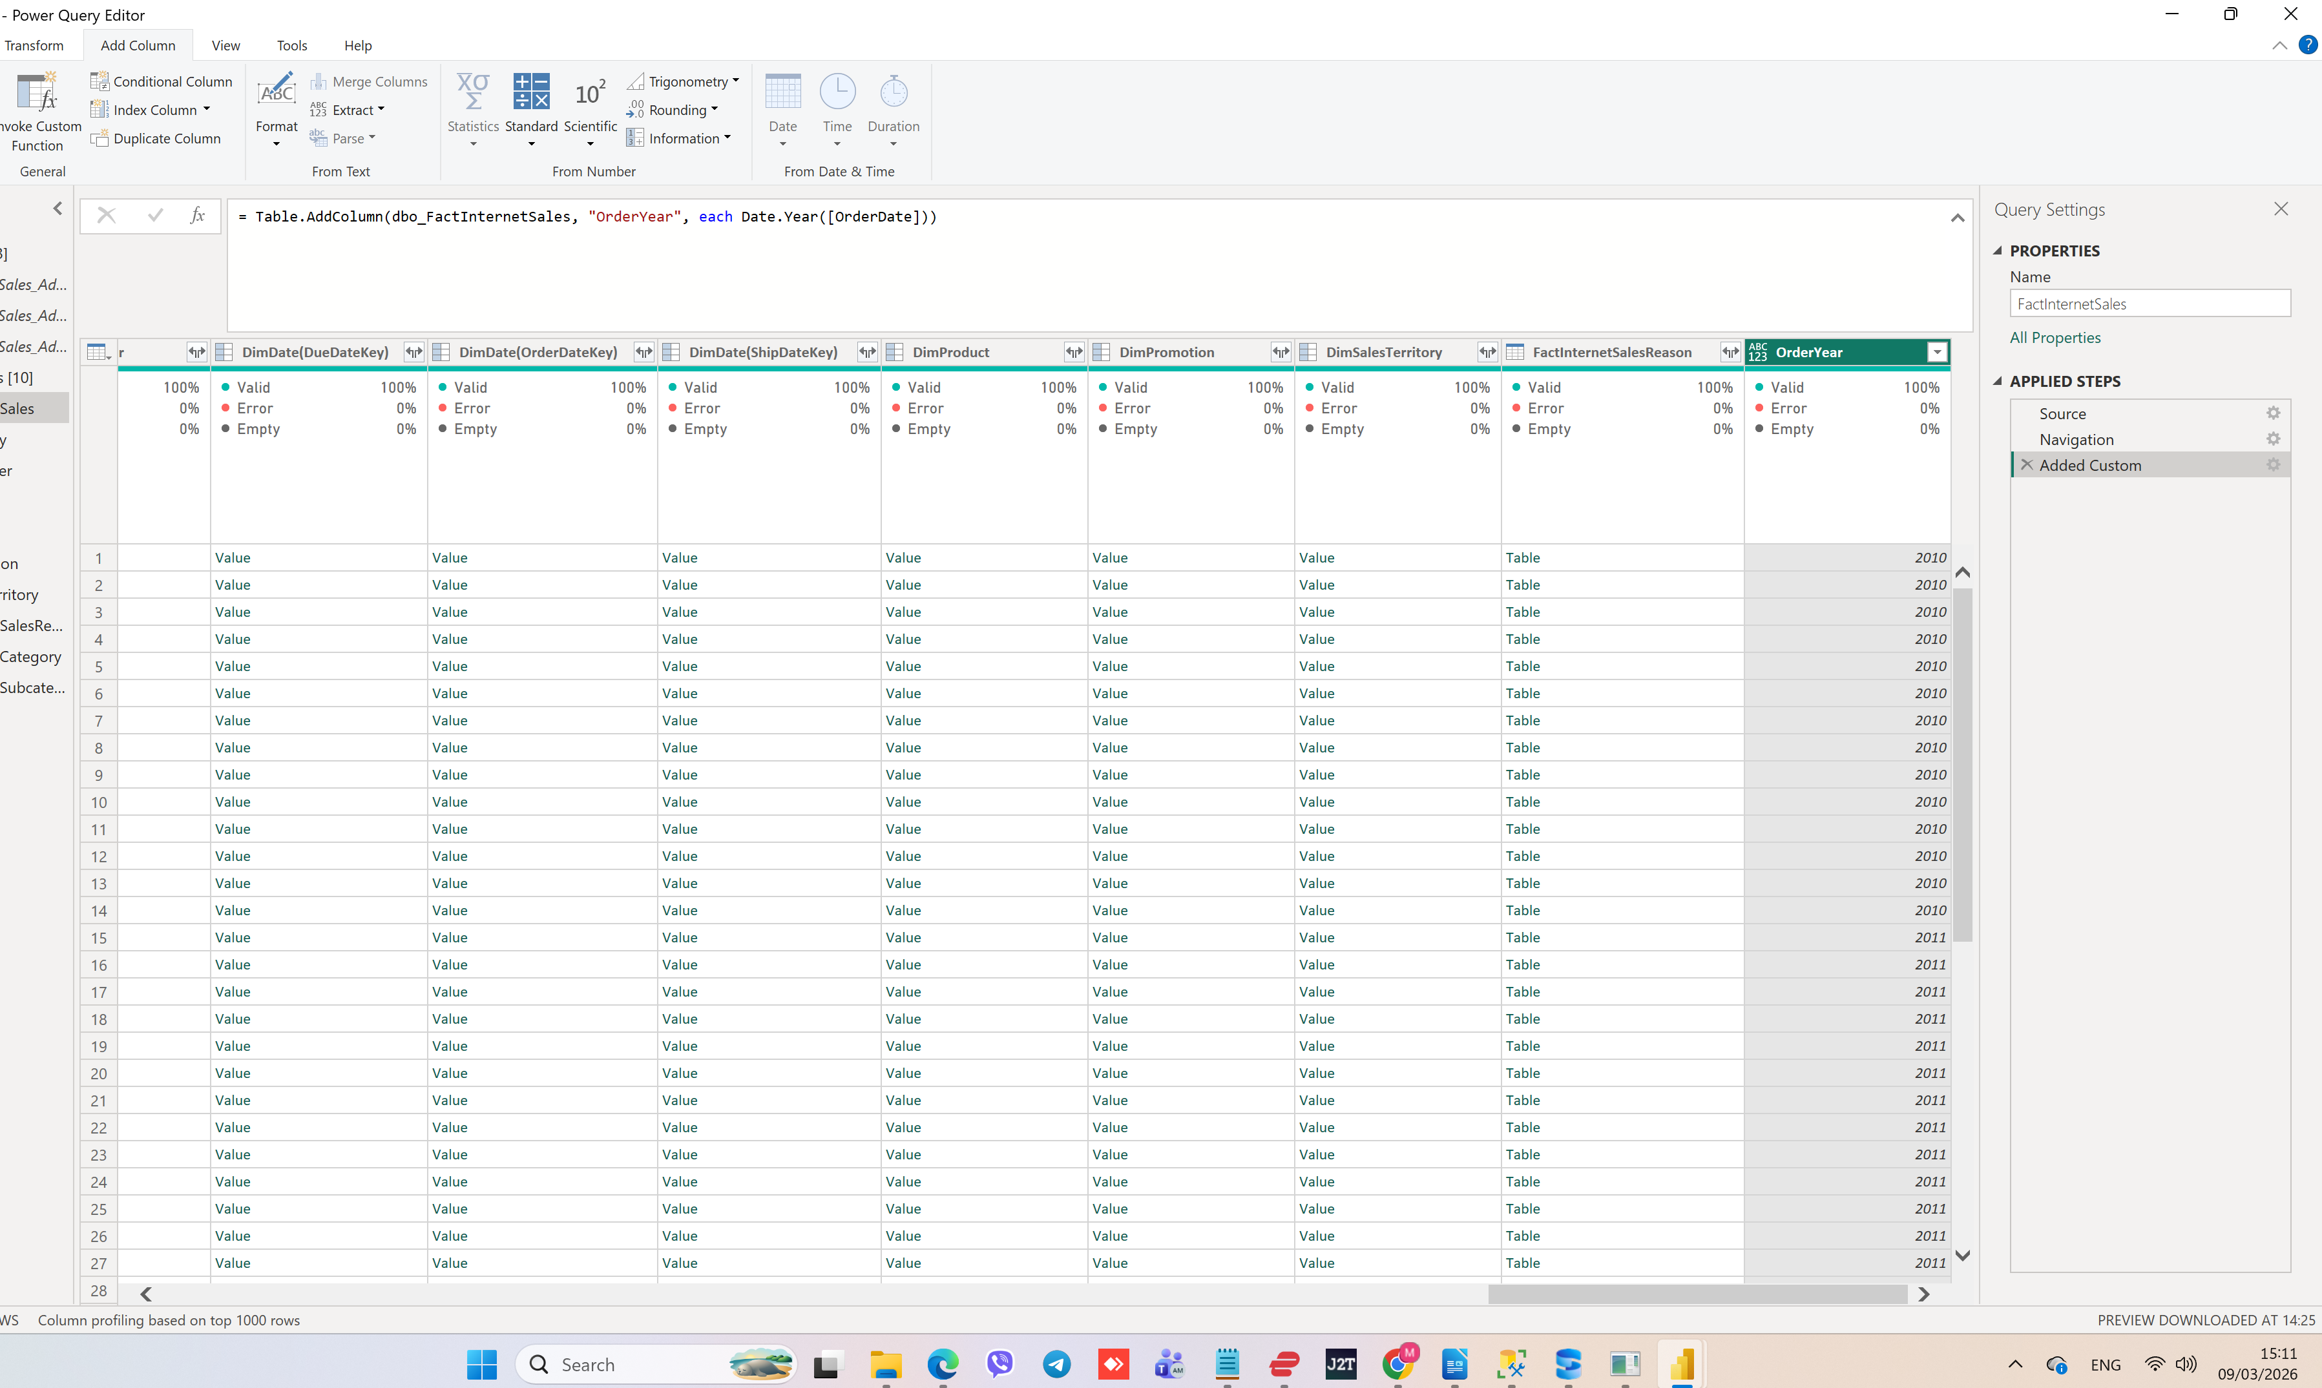

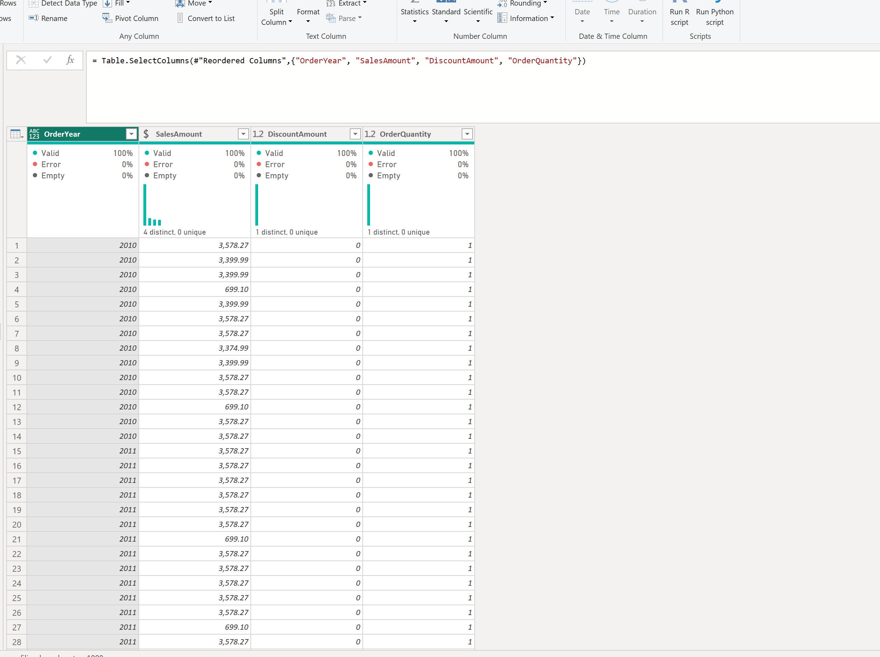

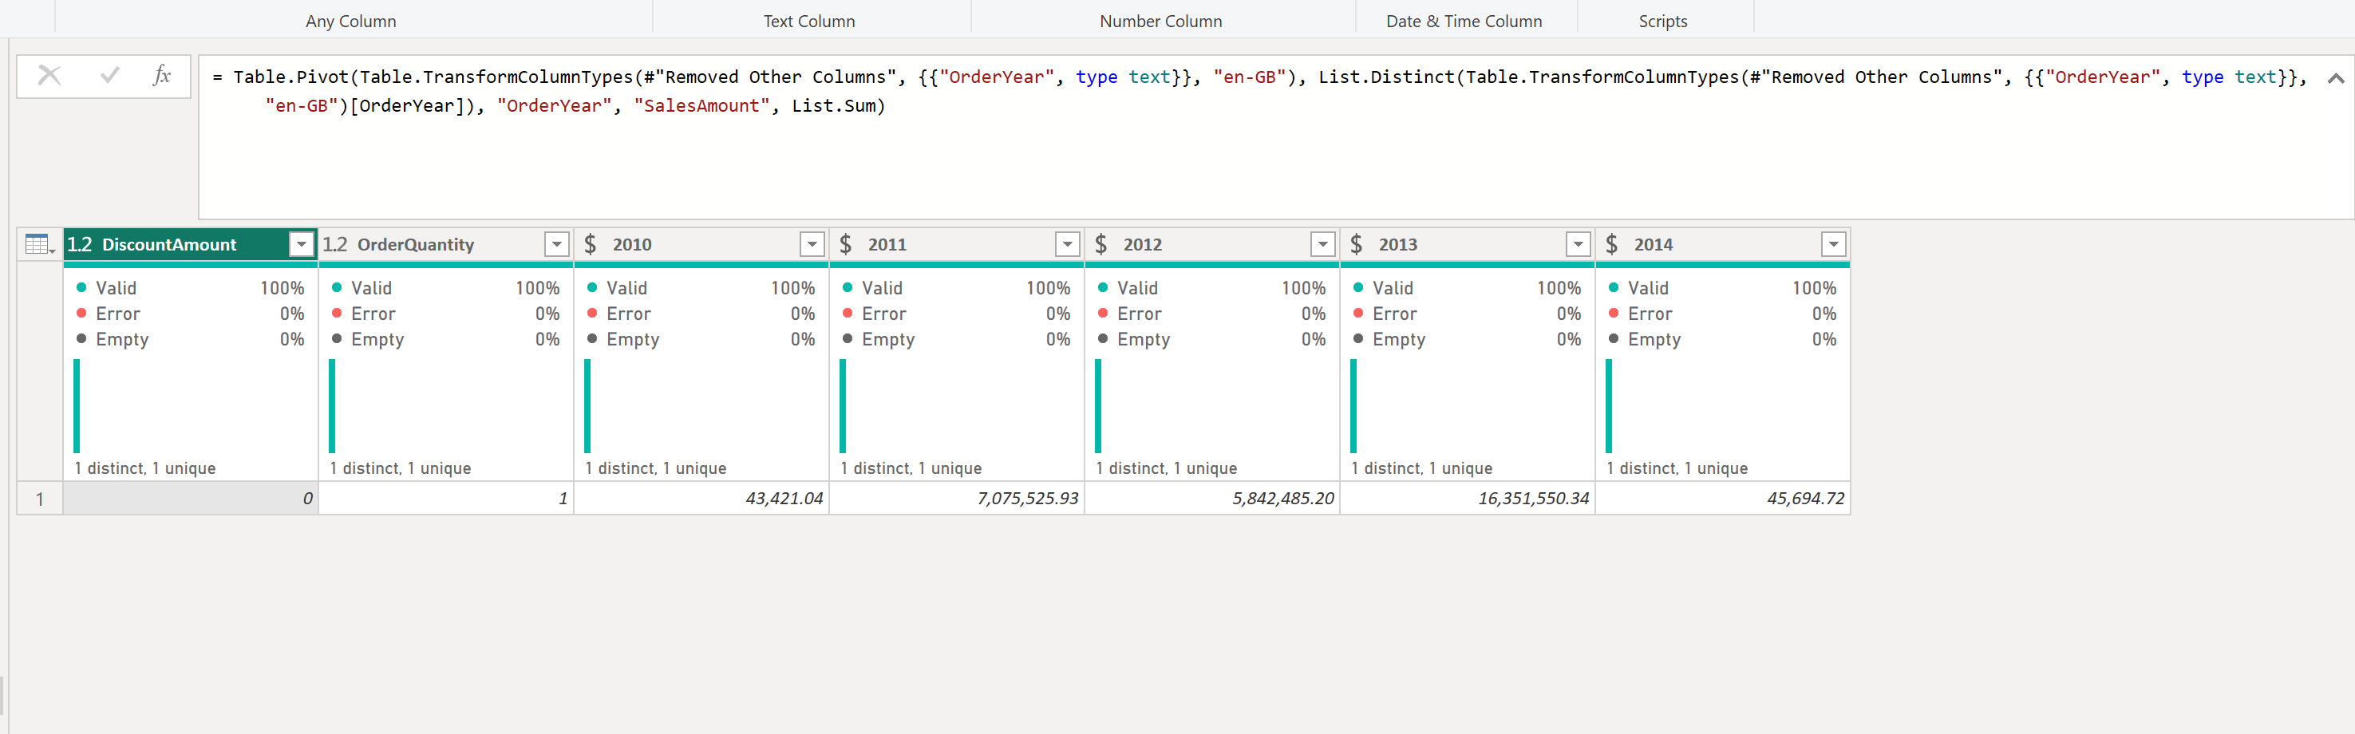

Sales by year.

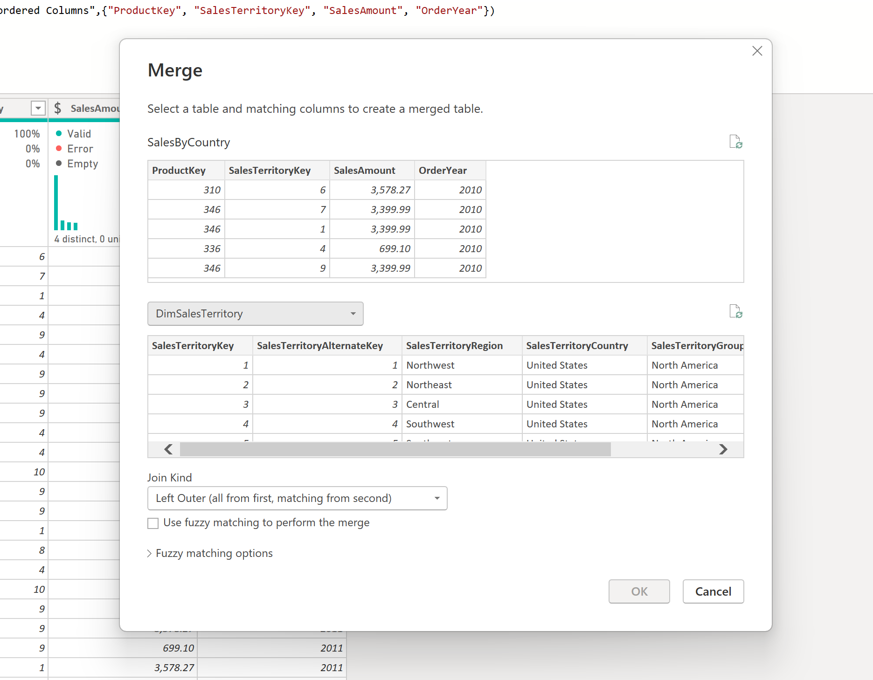
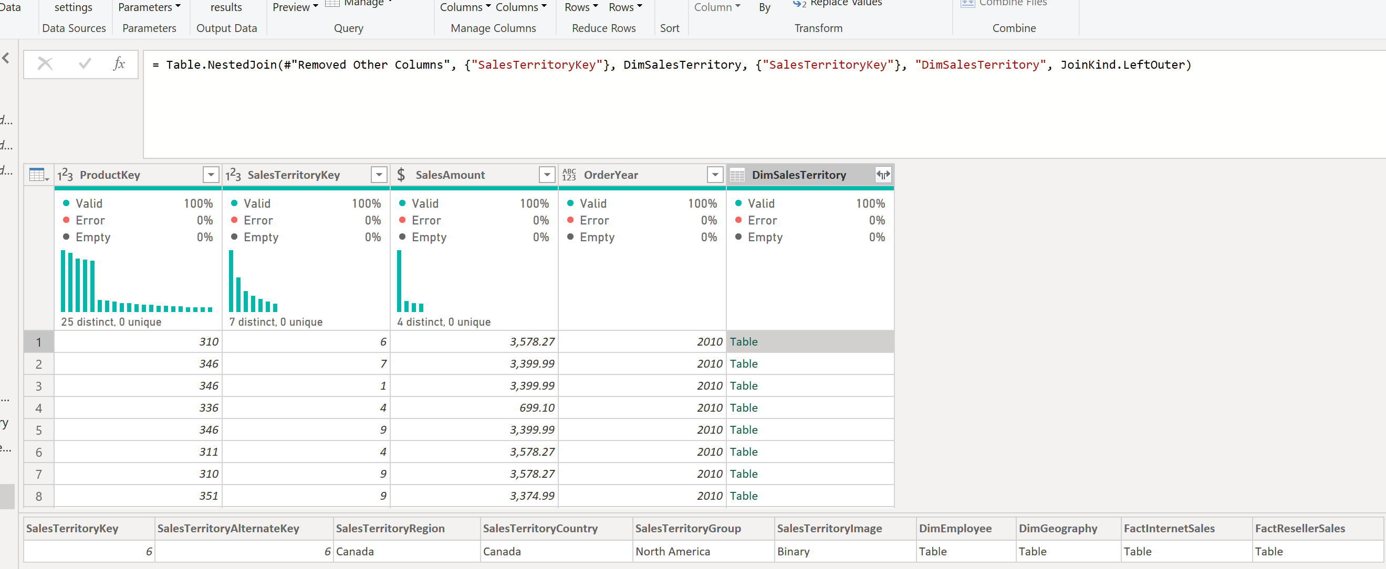
I chose the same values in both tables to connect them (like “SalesTerritoryKey”). To get product category name I needed to connect the Fact table to Product, ProductSubcategory and ProductCategory.

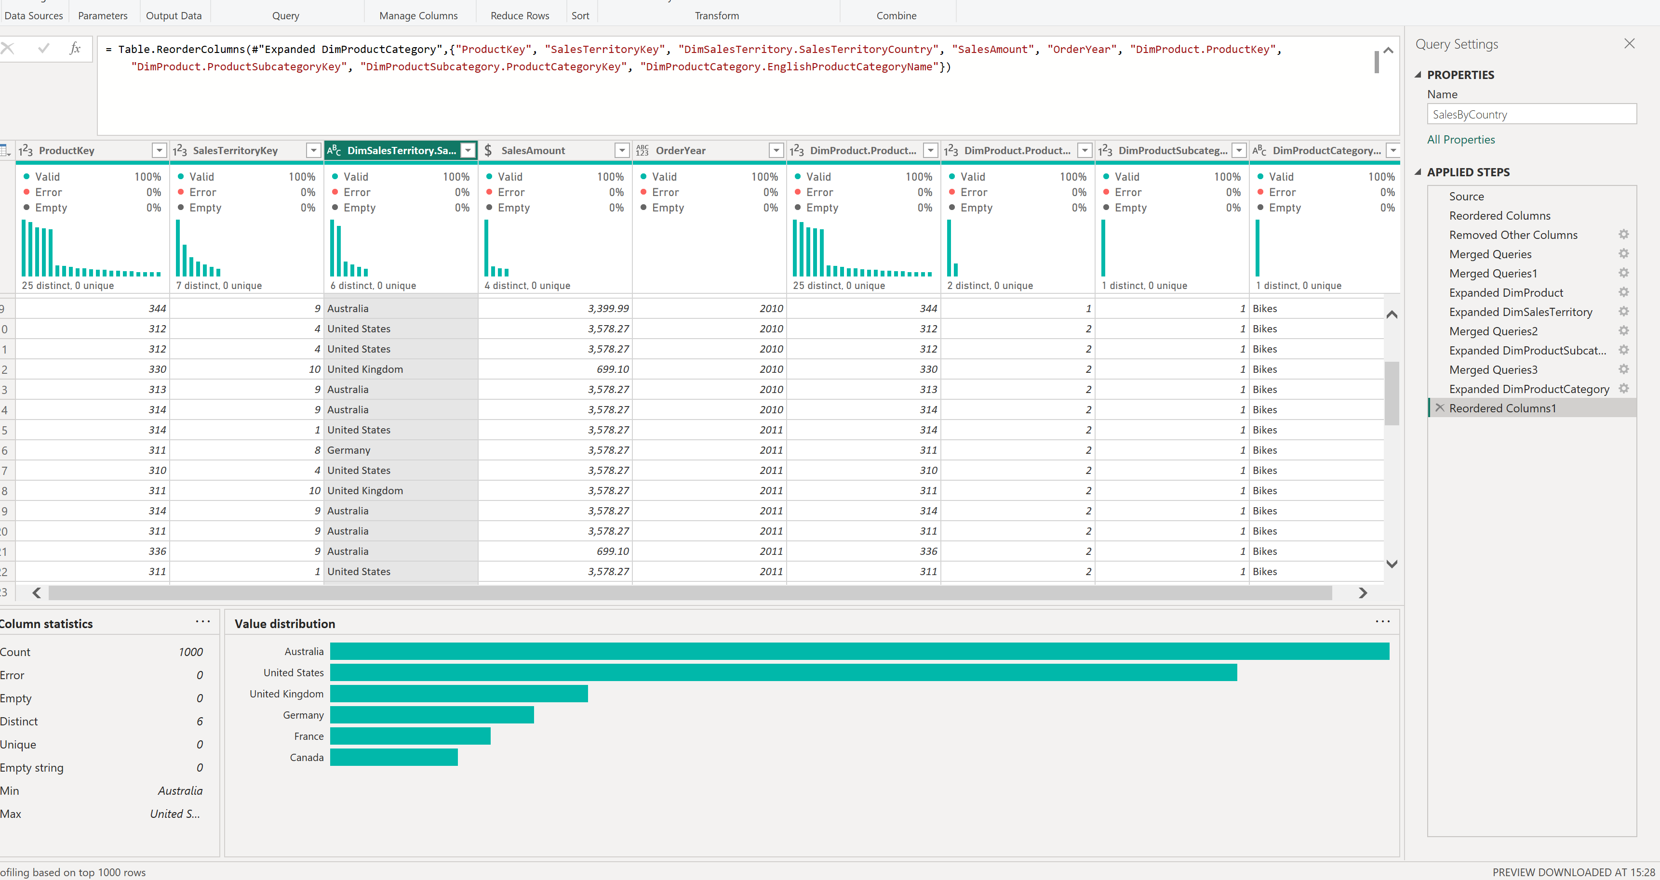

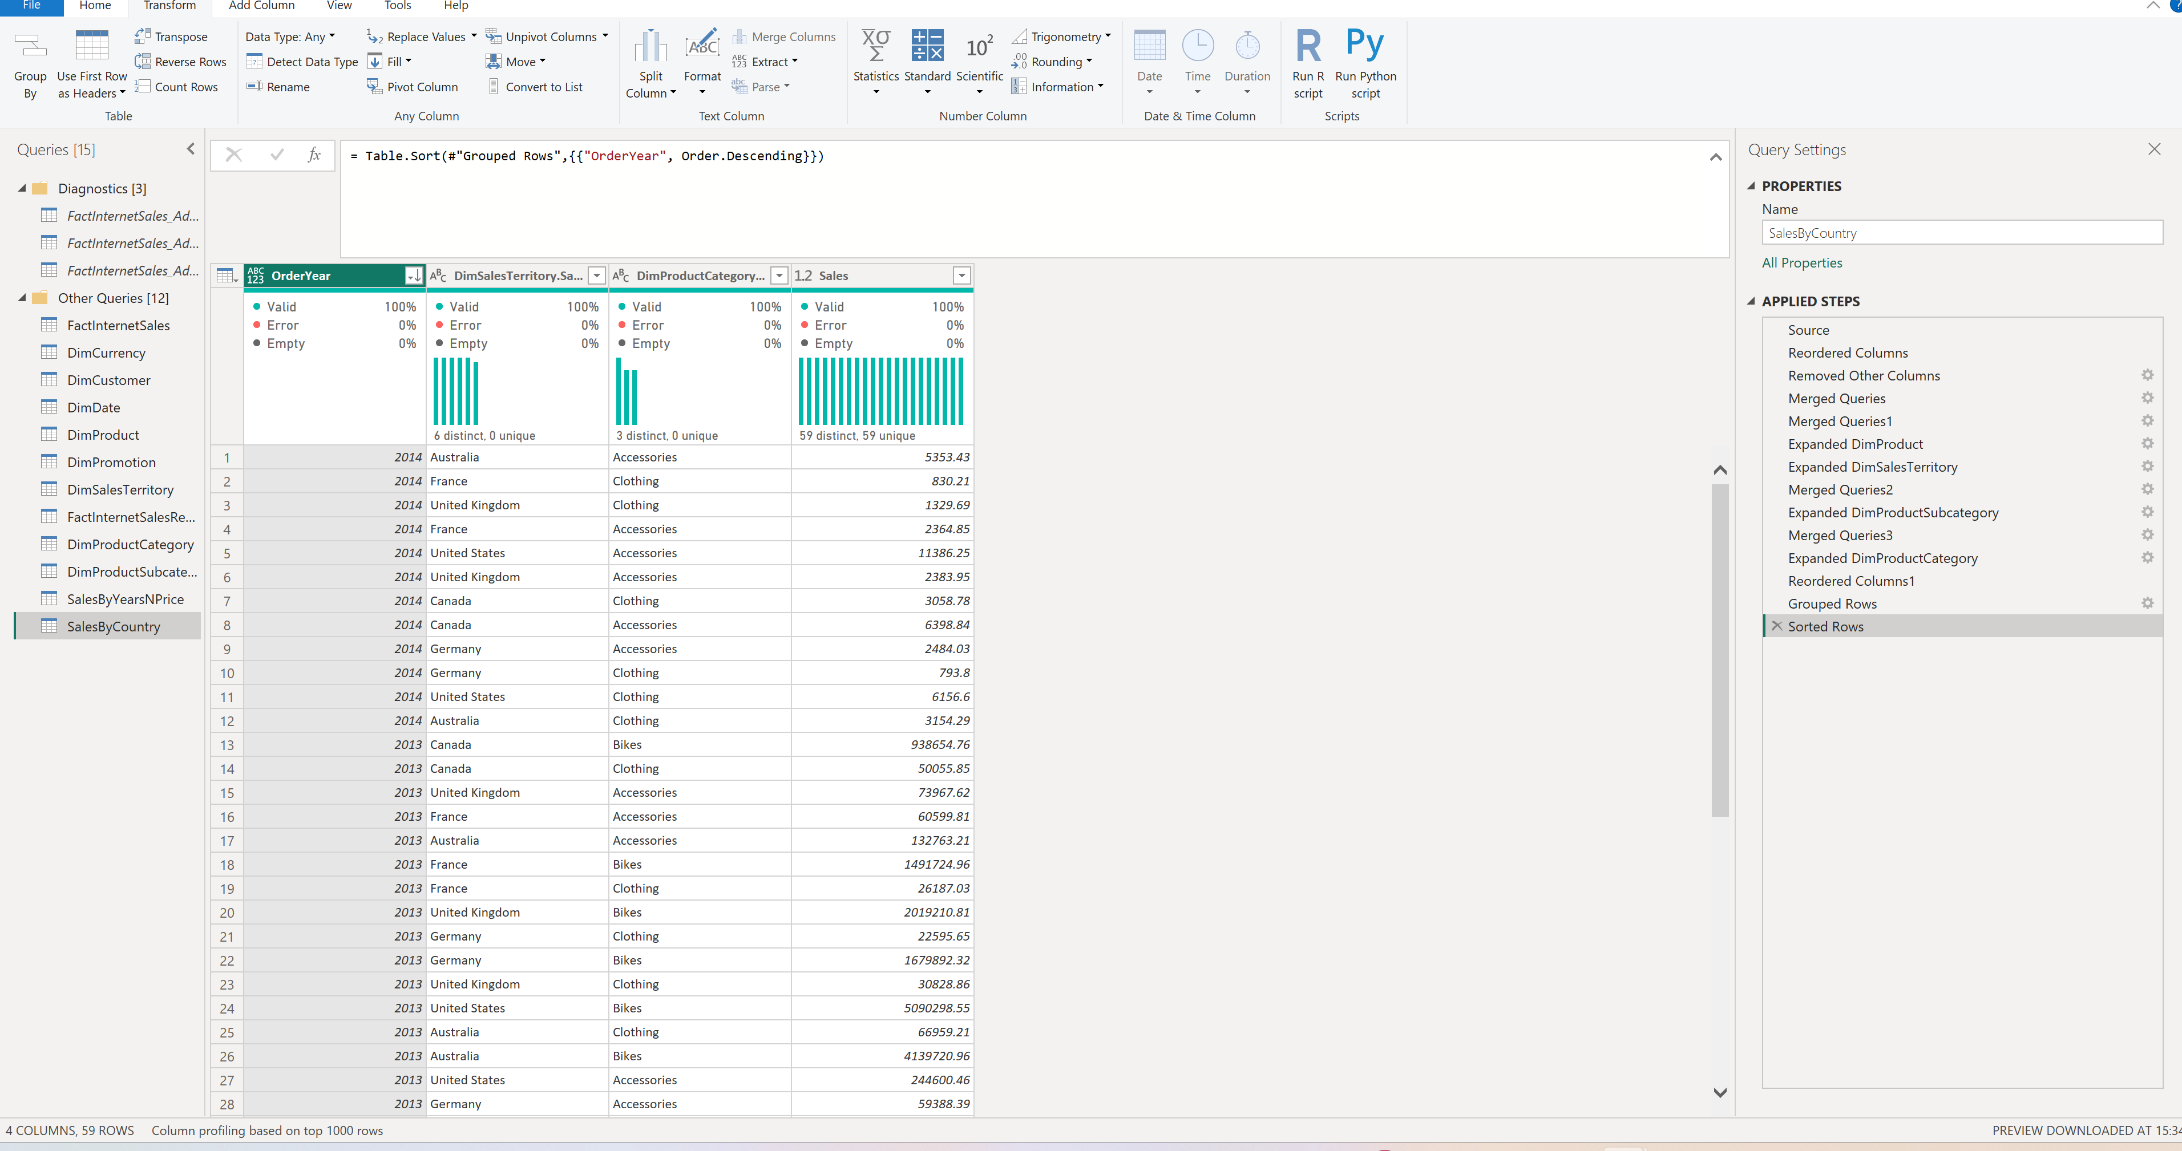
Grouping aalowed me to see the overall amount of money earned through sales of a product category in a country for a year.

--------------
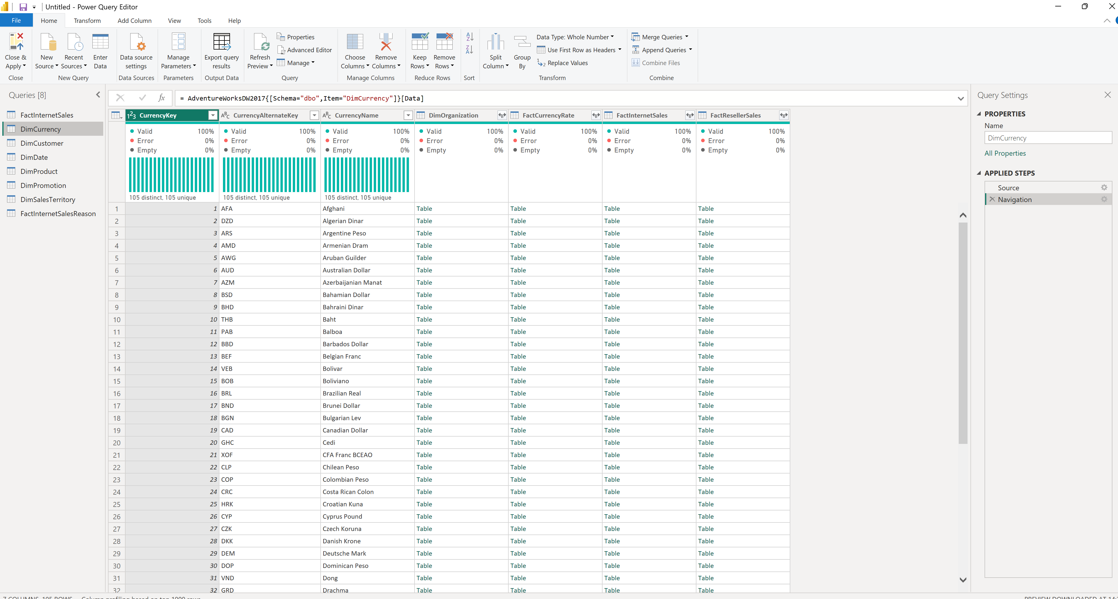
Opened the same tables through direct query and then I chose transform, I don’t see any difference. Internet says that import loads the data to memory which allows to make queries faster, while direct query connects directly to the database and the performance of queries is slower.
-------------------

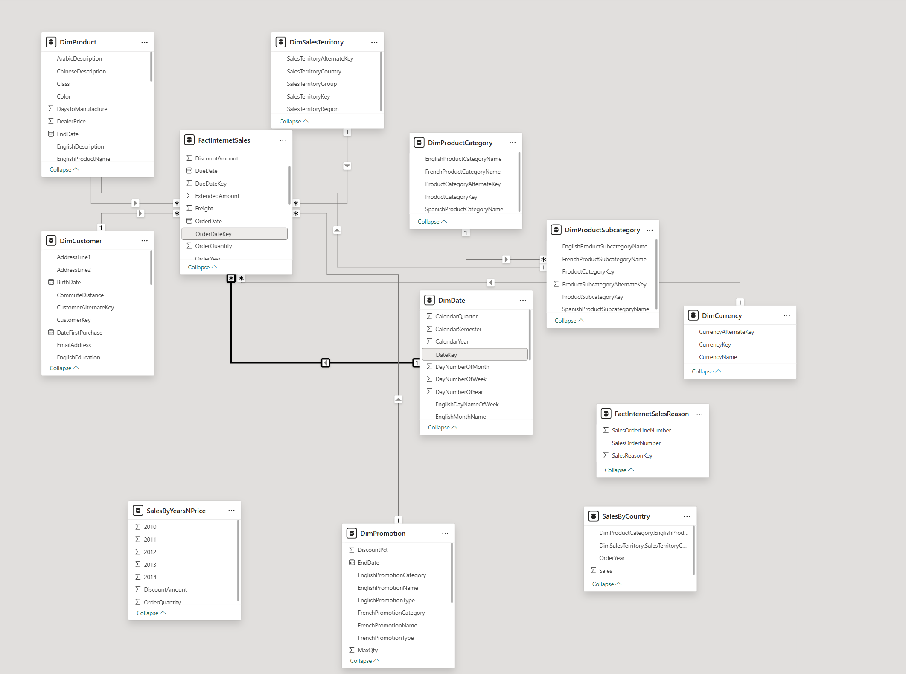
All the relationships here are one-to-many, Dimensions are connected to the Fact.

