# Museum Information System – Data Model Documentation

## 1. Business Description

The modeled system represents a Museum information Database that supports daily operational needs and basic analytics. The goal is to keep track of:

- **Physical structure of the museum** (types of locations and concrete locations such as galleries, storage rooms, offices, etc.).
- **Museum collection items** (their type, period, and current physical location).
- **Exhibitions** (temporary or ongoing events where items are displayed).
- **Visitors and their visits** (who visited which exhibition and when).
- **Staff (employees)** and where they work inside the museum.

The system focuses on operations that are realistic for a mid‑sized museum:
- Curators and managers can see which items are in which locations.
- Management can see which exhibitions attract more visitors over time.
- Staff assignments and museum locations are stored to support internal organization.
- Historical visits can be used to derive basic analytics.

The main “transaction” in the system is a visit: a visitor attending one exhibition on a given date. This is what later powers reporting and analytics (for example, visits per exhibition per quarter).

## 2. Overview of the Final Logical Model

Main entities (tables):

- **LocationType** – classification of locations (Gallery, Storage, Office, etc.).
- **Location** – specific museum locations (Main Gallery, East Storage, etc.).
- **ItemType** – classification of collection items (Painting, Sculpture, Weapon, Textile, …).
- **MuseumItem** – individual collection objects.
- **Visitor** – individual people who visit exhibitions.
- **Employee** – museum staff working at a specific location.
- **Exhibition** – events where items are displayed to the public.
- **Visit** – a visitor attending an exhibition on a certain date (transaction).
- **ExhibitionItem** – junction table between Exhibition and MuseumItem (an item being displayed in a particular exhibition, with a spot number).

Key relationships:
- One **LocationType** has many **Locations**.
- One **Location** can have many **MuseumItems**, many **Employees**, and many **Exhibitions**.
- One **ItemType** can have many **MuseumItems**.
- One **Exhibition** can have many **Visits**, and one **Visitor** can have many **Visits**.
- **Exhibition** and **MuseumItem** are in a many‑to‑many relationship via **ExhibitionItem**.

The model is designed in **3rd Normal Form (3NF)**: each attribute depends only on the key of its table, non‑key attributes are not redundant, and repeating groups are removed.

## 3. Step‑by‑Step Modeling Approach

### 3.1 Step 1 – Understand the Domain and Business Requirements

I started by clarifying what a museum typically needs to track:

1. **What does the museum own?**
→ Museum items (objects), their types, periods, and locations.

2. **Where are things located?**
→ Locations within the museum and high‑level location types (gallery vs. storage, etc.) or displayed abroad at some other museum.

3. **What events are organized?**
→ Exhibitions with start and end dates, descriptions, and assigned locations.

4. **Who interacts with the museum?**
→ External visitors and internal employees.

5. **What are the key transactions?**
→ Visits: a visitor attending an exhibition on a certain date.

From this, I extracted candidate entities: *LocationType, Location, ItemType, MuseumItem, Exhibition, Visitor, Employee, Visit, ExhibitionItem*.

### 3.2 Step 2 – Conceptual Model (High‑Level ERD)
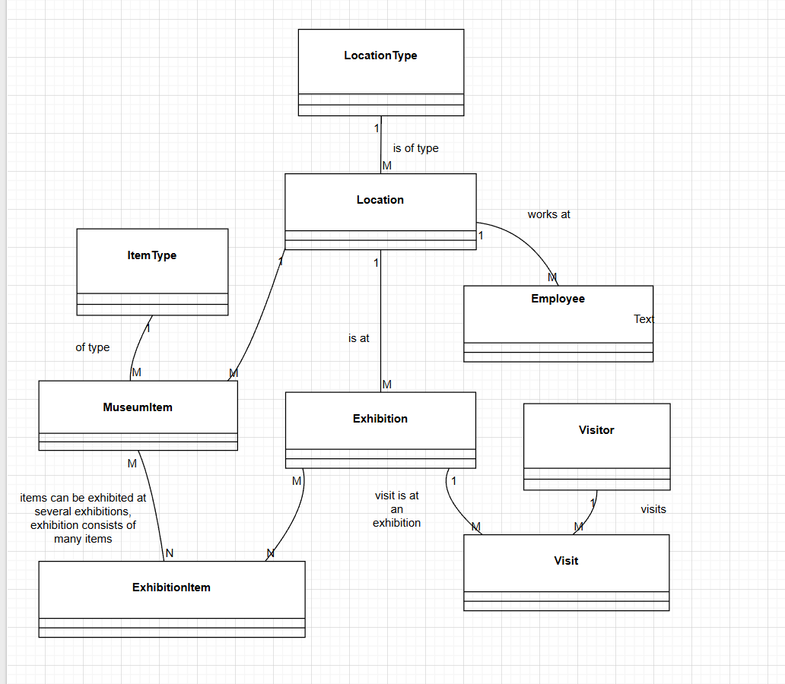
At the conceptual level, I defined:

- **Entities**: MuseumItem, Exhibition, Visitor, Employee, Location, etc.
- **Relationships**:
- MuseumItem *is of* one ItemType.
- MuseumItem *is currently stored at* one Location.
- Exhibition *takes place at* one Location.
- Visitor *attends* Exhibition via Visit.
- MuseumItem *is displayed at* Exhibition via ExhibitionItem (many‑to‑many).
- Employee *works at* one Location.

### 3.3 Step 3 – Logical Model and Normalization (3NF)
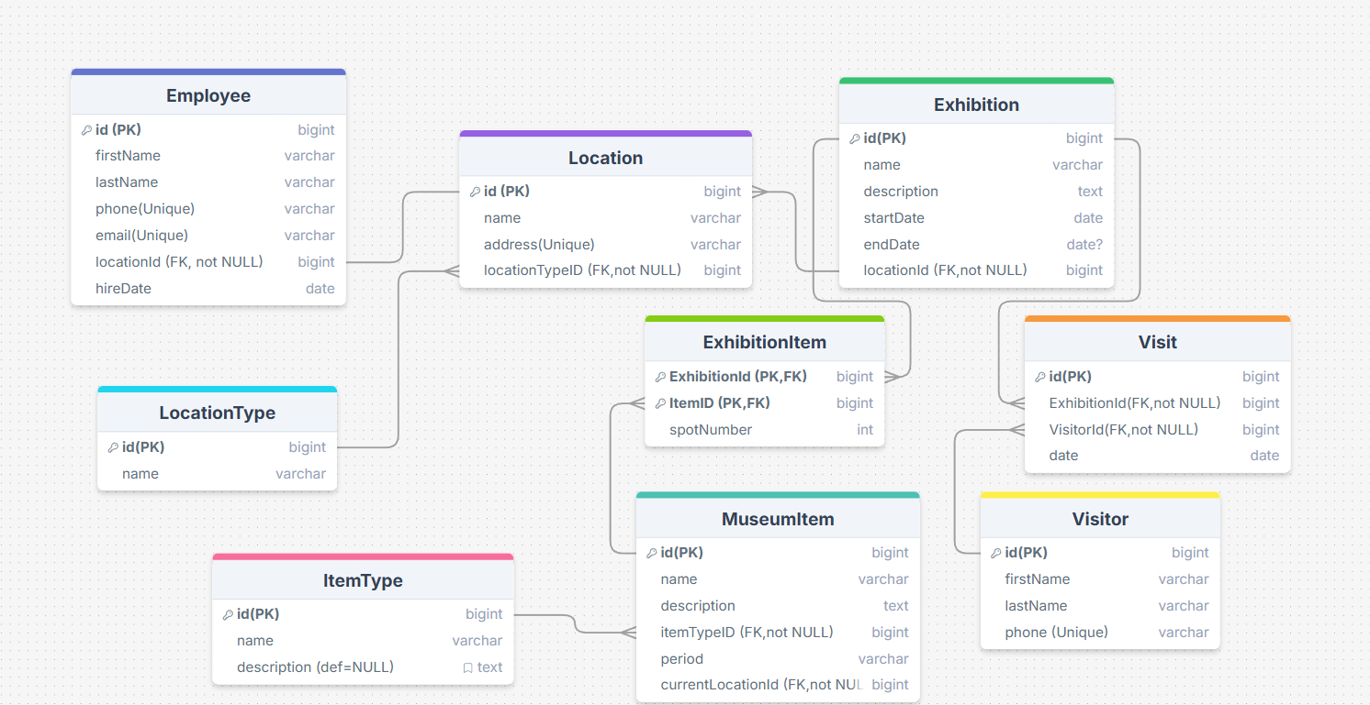
Next, I transformed the conceptual model into a logical relational model and checked normalization rules:

1. **Identify primary keys**
- Surrogate numeric keys (id) for each table (LocationType, Location, ItemType, …).
- Composite primary key for the junction table **ExhibitionItem(exhibitionId, itemId)**.

2. **Separate repeating and descriptive attributes**
- LocationType as a separate table instead of repeating strings in Location.
- ItemType as a separate table instead of repeating “Painting”, “Sculpture”, etc.
- ExhibitionItem split out from both Exhibition and MuseumItem to handle the many‑to‑many relationship cleanly.

3. **Check for 3NF**
- Non‑key columns depend on the primary key and not on other non‑key attributes.
- Example: In MuseumItem, `name`, `description`, `period`, `itemTypeId`, and `currentLocationId` all depend only on `id`, and not on each other.
- In Exhibition, `name`, `description`, `startDate`, `endDate`, and `locationId` all depend on `id` and are not derivable from each other.

At this point I also refined column names to be clear and consistent (e.g., `itemTypeId`, `currentLocationId`, `locationTypeId`).

### 3.4 Step 4 – Physical Model (DDL Design)

Once the logical structure was stable, I designed the **physical implementation in PostgreSQL**:

- Chose a dedicated database schema: `museum`.
- Used **BIGINT** with `GENERATED ALWAYS AS IDENTITY` for surrogate keys.
- Used appropriate data types:
- `VARCHAR` for names, `TEXT` for longer descriptions.
- `DATE` for dates such as `startDate`, `endDate`, `hireDate`, and `date` in Visit.
- `INT` for numeric but small data such as `spotNumber`.

- Defined primary and foreign keys in `CREATE TABLE` statements:
- Example: `FOREIGN KEY (locationId) REFERENCES museum.Location(id)`.

The table creation order respected dependencies:

1. LocationType
2. Location
3. ItemType
4. Visitor
5. Employee
6. Exhibition
7. MuseumItem
8. Visit
9. ExhibitionItem

### 3.5 Step 5 – Business Rules as Constraints (CHECK, NOT NULL, UNIQUE)

To enforce business rules and assignment requirements, I implemented constraints, mainly via `ALTER TABLE`:

- **NOT NULL** on mandatory columns (names, dates, foreign keys).
- **UNIQUE** on some natural keys (e.g., Location.address, ItemType.name).
- **CHECK constraints** such as:
- `hireDate >= DATE '2020-01-01'` for Employee.
- `startDate >= DATE '2020-01-01'` and `endDate >= startDate` for Exhibition.
- `date <= CURRENT_DATE` for Visit (no visits in the future).
- `spotNumber > 0` for ExhibitionItem (physical ordering in an exhibition must be positive).
- Optionally, limiting `period` to a set of allowed values.

This step translates real-world business rules into database‑level validation.

### 3.6 Step 6 – Data Population (Sample Data for the Last 3 Months)

I then populated the tables with **sample data** using `INSERT` statements:

- At least 6 rows in every table (LocationType, Location, ItemType, Visitor, Employee, Exhibition, MuseumItem, Visit, ExhibitionItem).
- No surrogate keys were explicitly inserted; they were generated by the database.
- Foreign keys were resolved using subqueries on natural keys (e.g., using names to get IDs).
- All Visit dates were chosen within the last three months, satisfying the “recent data” requirement and the CHECK constraint `date <= CURRENT_DATE`.
- Exhibitions had start/end dates within a realistic time frame and respected `endDate >= startDate`.

### 3.7 Step 7 – Functions (DML Encapsulation)

To demonstrate database programmability and safe data modifications, I created two functions:

1. **`update_museum_item_column(id, column, new_value)`**
- Allows updating selected, whitelisted columns of MuseumItem (e.g., name, description, period).
- Uses dynamic SQL but validates the column name to prevent SQL injection.
- Updates a single row based on the primary key.

2. **`add_visit_transaction(visitor_first, visitor_last, exhibition_name, visit_date)`**
- Encapsulates the logic for inserting a new Visit (transaction).
- Resolves `visitorId` and `exhibitionId` using natural keys (names).
- Ensures the requested visitor and exhibition exist; otherwise raises an exception.
- Inserts into Visit respecting CHECK constraints on date.

### 3.8 Step 8 – Analytics View

Next, I built a **read‑only analytic view** focusing on the **most recent quarter (last 3 months)**:

- View: `visit_analytics_last_quarter`.
- Aggregates visits per exhibition in the last 3 months:
- Exhibition name, start and end dates.
- Total number of visits.
- Number of distinct visitors.
- Earliest and latest visit dates in that period.
- Excludes surrogate keys and shows only meaningful business attributes.

This view is intended for management reporting without exposing low‑level technical columns.

### 3.9 Step 9 – Security: Read‑Only Manager Role

Finally, I implemented a **read‑only role** for a museum manager:

- Role: `museum_manager`.
- Can log in (`LOGIN`).
- Has `USAGE` on schema `museum`.
- Has `SELECT` on all existing tables in `museum`.
- Is granted default `SELECT` on all future tables in the schema via `ALTER DEFAULT PRIVILEGES`.
- Does **not** have permissions to insert, update, delete, or change schema definitions.

This follows best practices by separating roles for reading data (analytics, management) from roles that perform DML changes.

