YearMonthLabel = FORMAT('DimDate'[FullDateAlternateKey], "YYYY - MMM")

YearMonthSort = 'DimDate'[CalendarYear] * 100 + 'DimDate'[MonthNumberOfYear]

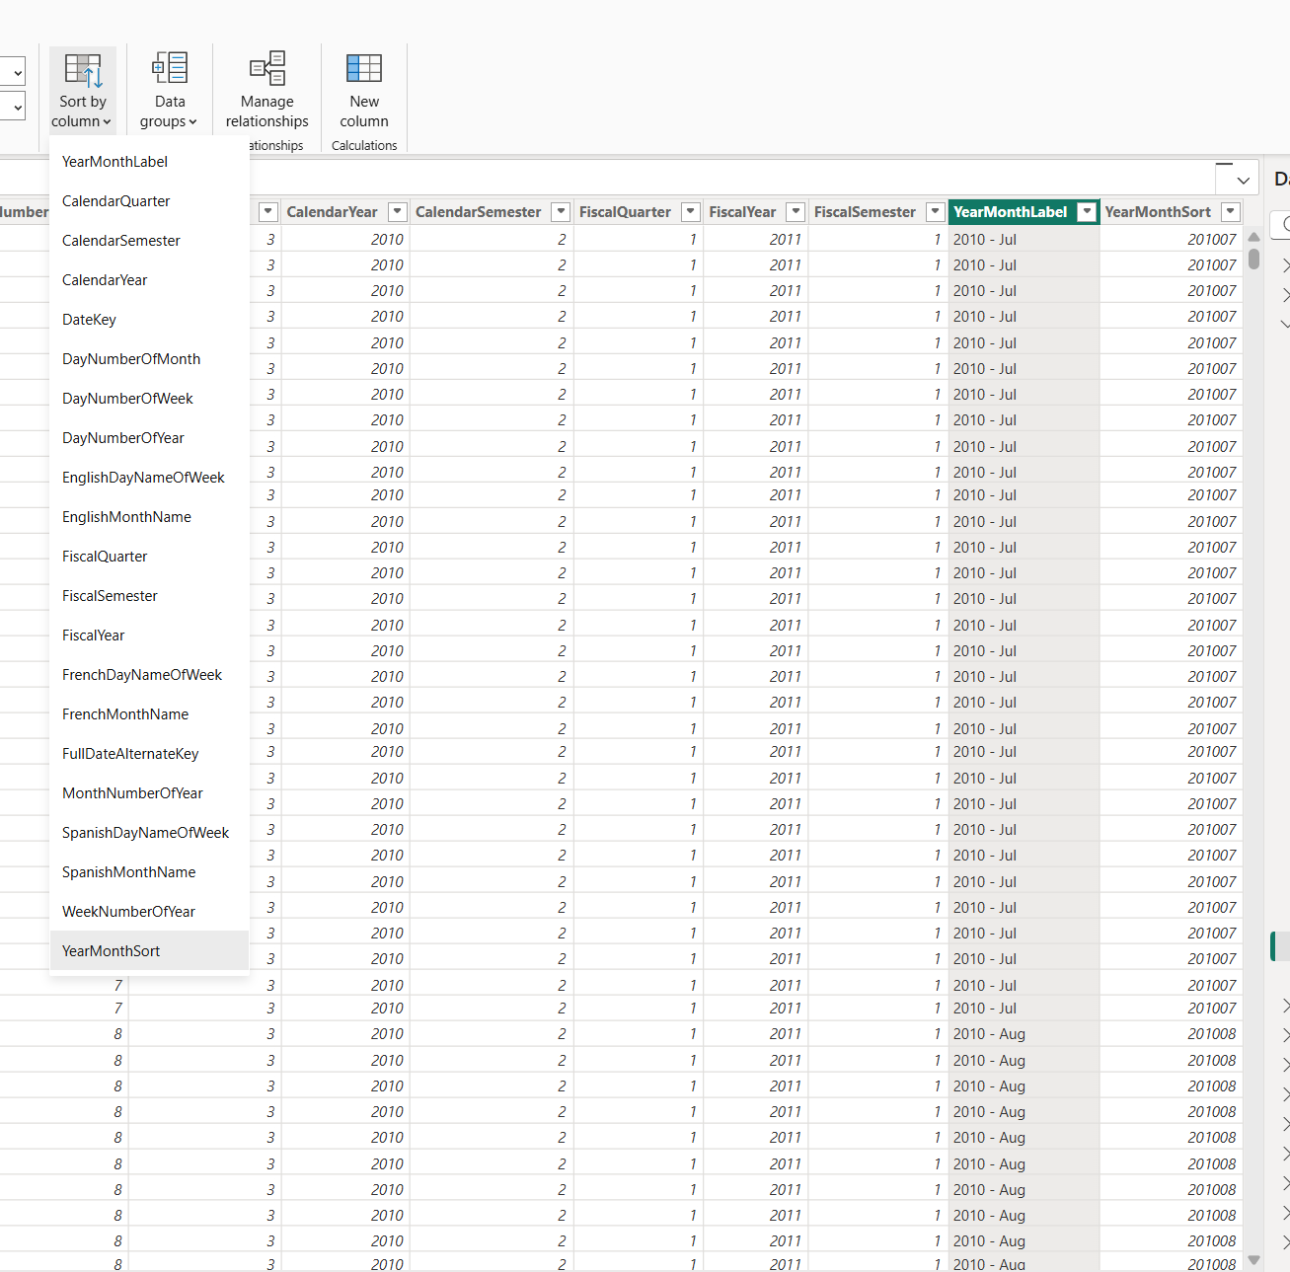
Fixed the sorting.

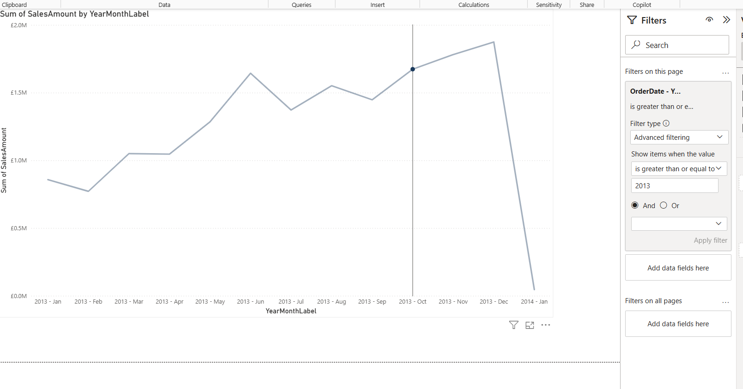
Filter.

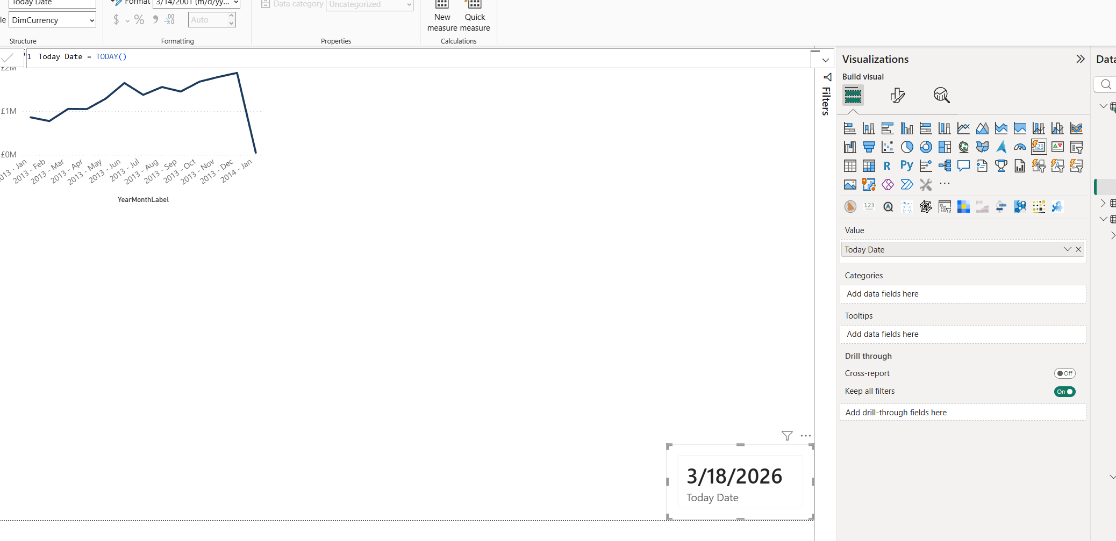
Measure:
-------
Order Quantity = SUM('FactInternetSales'[OrderQuantity])

Order Quantity YTD = CALCULATE([Order Quantity], DATESYTD('DimDate'[FullDateAlternateKey]))
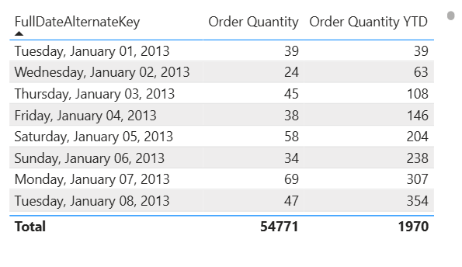

---

Order Quantity = SUM('FactInternetSales'[OrderQuantity])
Order Quantity YTD = CALCULATE([Order Quantity], DATESYTD('DimDate'[FullDateAlternateKey]))
Order Quantity YTD PY =
CALCULATE(
SUM('FactInternetSales'[OrderQuantity]),
DATESBETWEEN(
'DimDate'[FullDateAlternateKey],
DATE(YEAR(MAX('DimDate'[FullDateAlternateKey]))-1, 1, 1),
EDATE(MAX('DimDate'[FullDateAlternateKey]), -12)
)
)
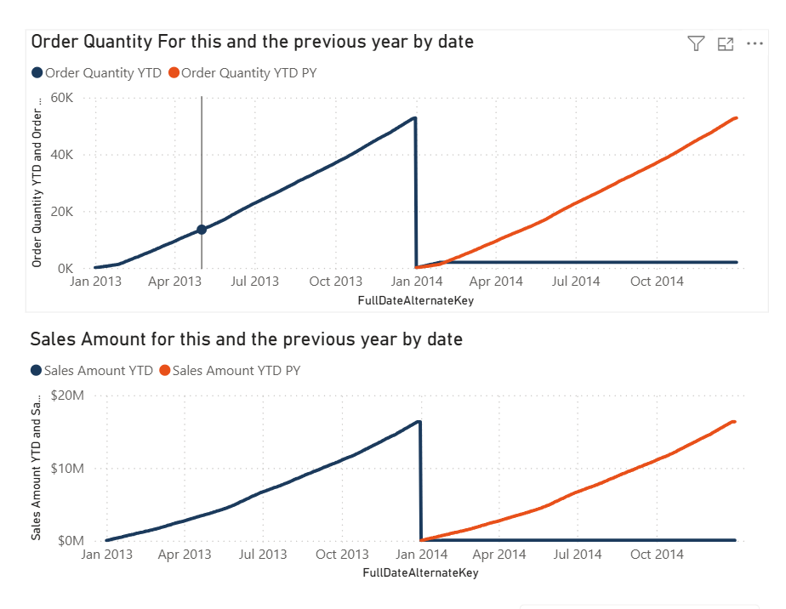

Sales Amount = SUM('FactInternetSales'[SalesAmount])
Sales Amount YTD = CALCULATE([Sales Amount], DATESYTD('DimDate'[FullDateAlternateKey]))
Sales Amount YTD PY = CALCULATE([Sales Amount YTD], SAMEPERIODLASTYEAR('DimDate'[FullDateAlternateKey]))

-------------

Welcome Message = "Welcome, " & USERPRINCIPALNAME() & " | Current Date is: " & FORMAT(TODAY(), "MM/DD/YYYY")

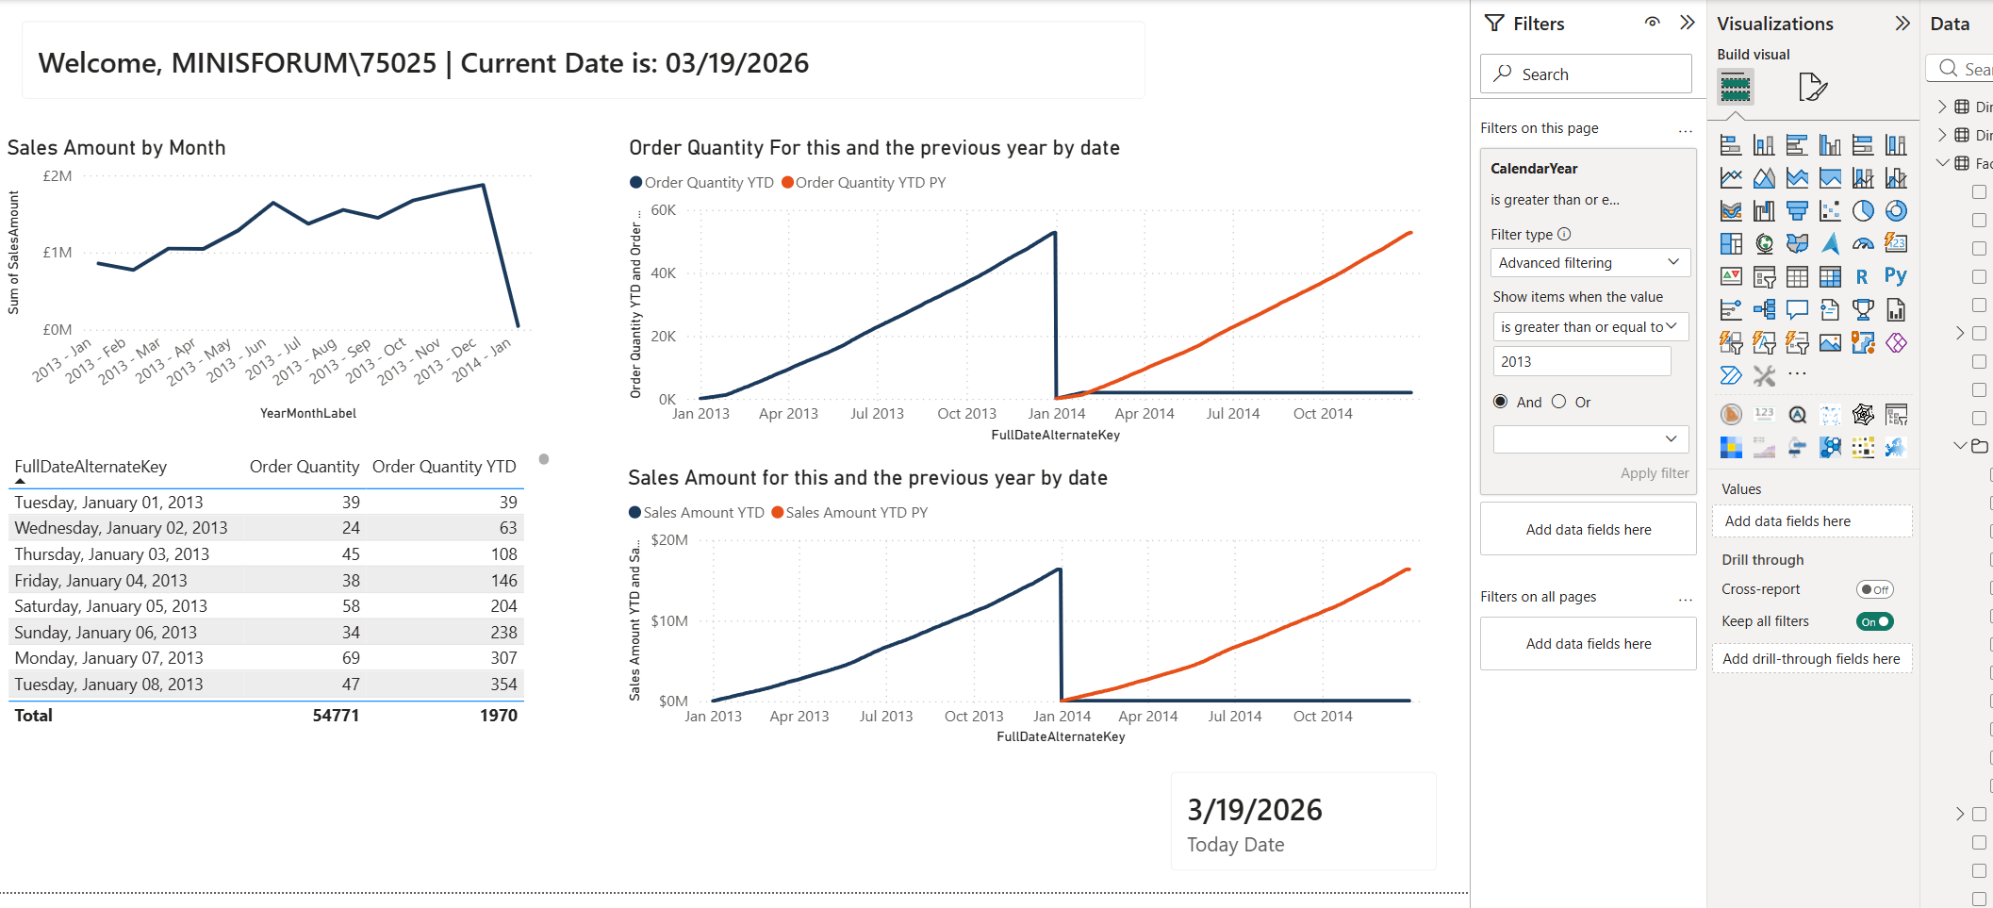
-----------
Percent =
DIVIDE(
[Order Quantity],
CALCULATE(
[Order Quantity],
ALLEXCEPT(FactInternetSales, DimProduct[EnglishProductName], DimProduct[Color])
)
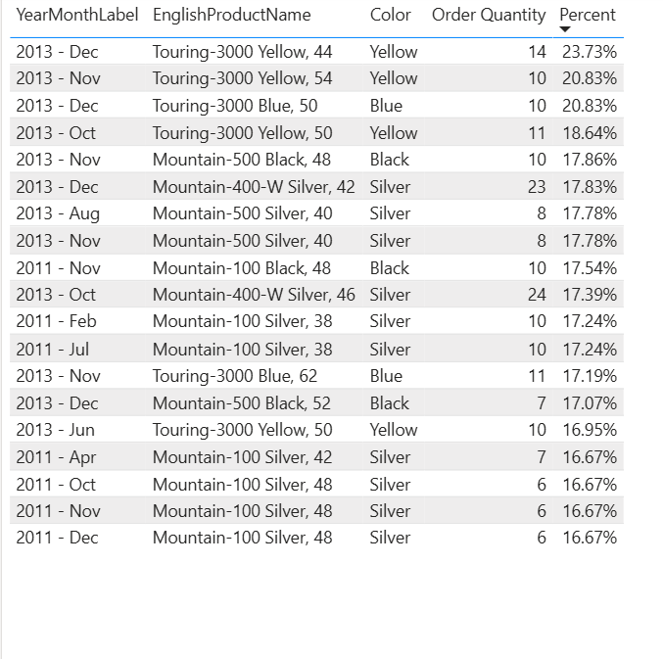
)

Max Date Sales = CALCULATE(
SUM('FactInternetSales'[SalesAmount]),
FILTER(
ALL('FactInternetSales'[OrderDate]),
'FactInternetSales'[OrderDate] = MAXX(ALL('FactInternetSales'), 'FactInternetSales'[OrderDate])
)
)

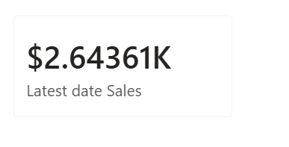

I chose the card visual because I need to display a single value.

------------------
Top Country =
MAXX(
TOPN(
1,
ALL('DimSalesTerritory'[SalesTerritoryCountry]),
CALCULATE(SUM('FactInternetSales'[SalesAmount]))
),
'DimSalesTerritory'[SalesTerritoryCountry]
)


I chose the card visual because I need to display a single value.
------------------------------

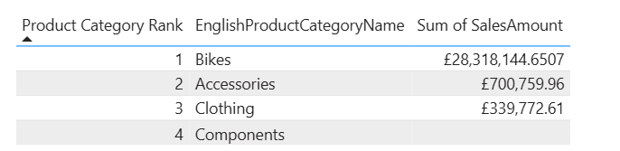

Product Category Rank =
RANKX(
ALL('DimProductCategory'[EnglishProductCategoryName]),
CALCULATE(SUM('FactInternetSales'[SalesAmount])),
,
DESC,
DENSE
)

I chose the table visual because it allowed me to display the rank values (1-4), it is about the only way to show the result of the rank function.
If I were to display it in any way I would choose the Bar Chart because it communicates ranking information visually and intuitively

