1.1. TASK 1: NESTED LOOP JOIN

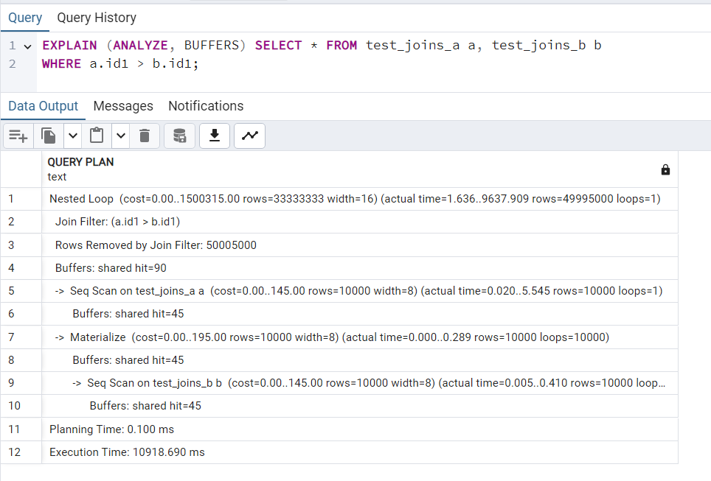

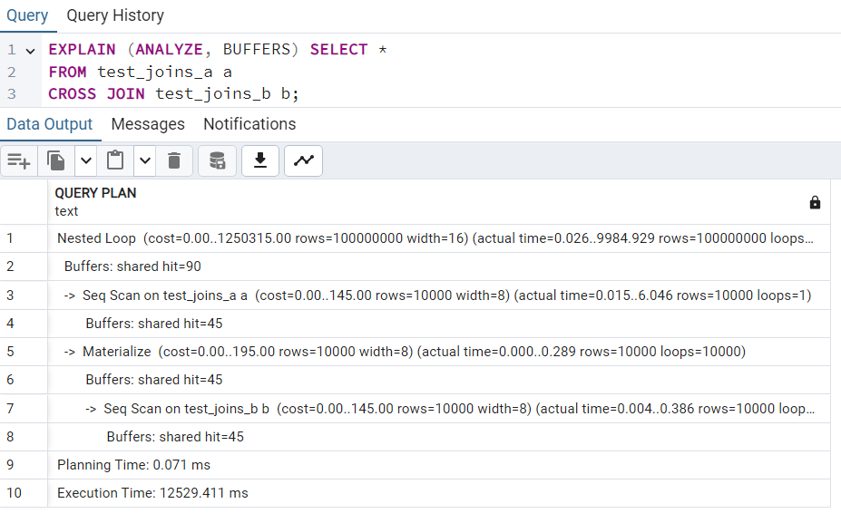

The nested loop is used for both queries because the result set is very big and these joins are not suitable for the hash join.
Hash join is good at finding equal values and query 1 joins unequal values, query 2 cross joins every row from table a to every row of table b.
Both hash join and merge join require a join condition and in cross join there is non.
Merge join won’t save much work in query 1 because it would also require sorting.
--------------------------------------------------------------------------------------

1.2 TASK 2: HASH JOIN

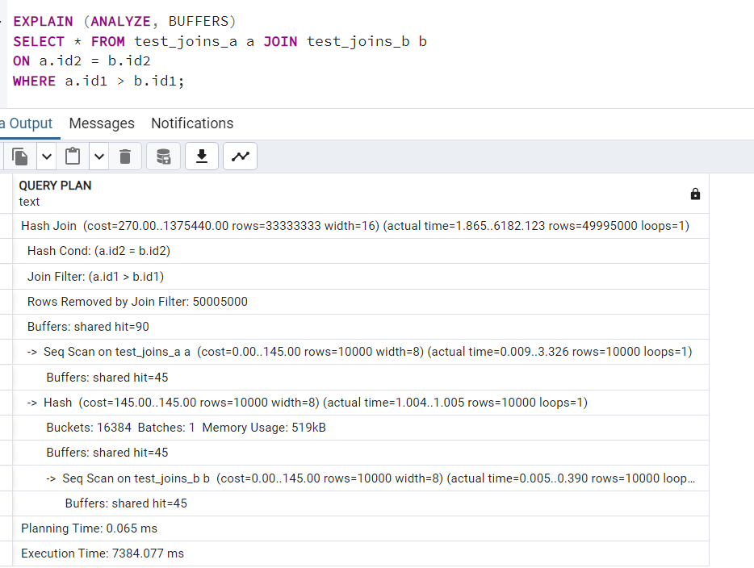

Hash join need an equality condition so we can join it by id2. It worked even faster than the nested loop.
----
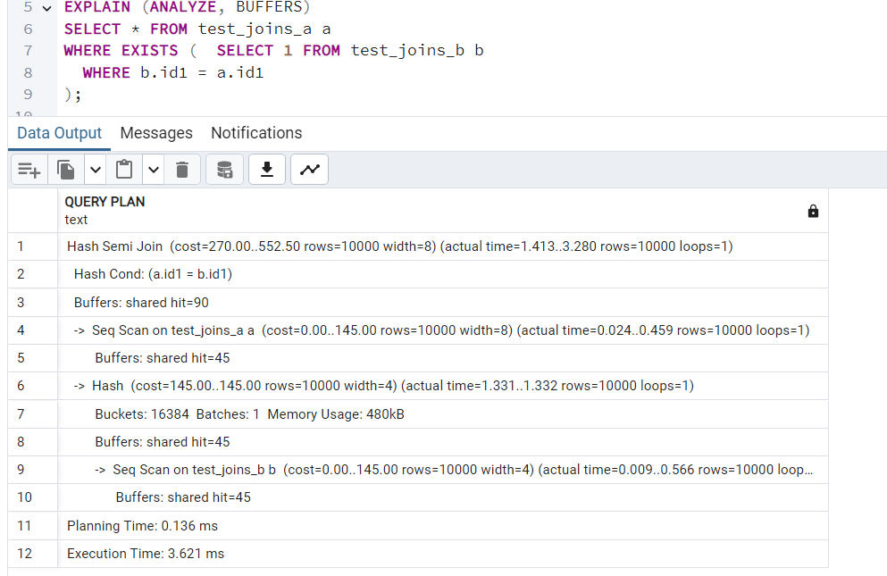
Using exists allows to make a semi-join.
---
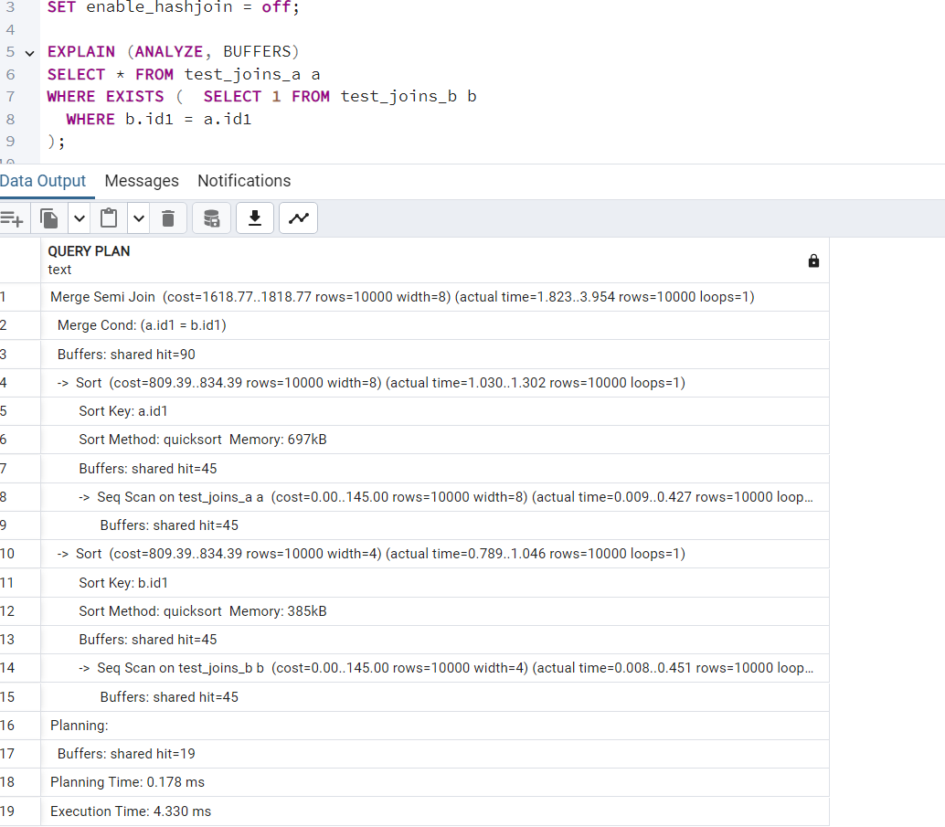

Merge semi join was used when hash join is switched off. It was a little slower and it needed to sort the values.
---------------------------------------------------------
1.3 TASK 3: MERGE JOIN
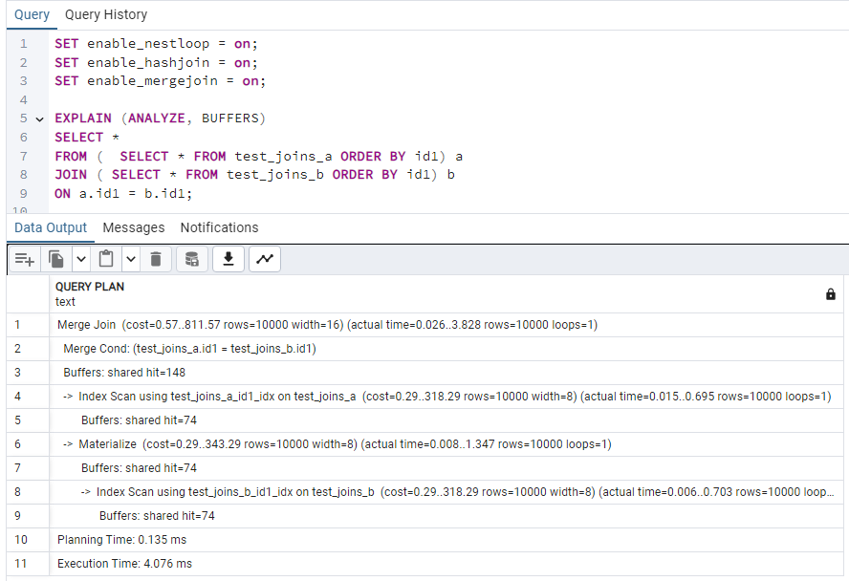

Selecting from sorted tables urged postgresql to choose merge join.
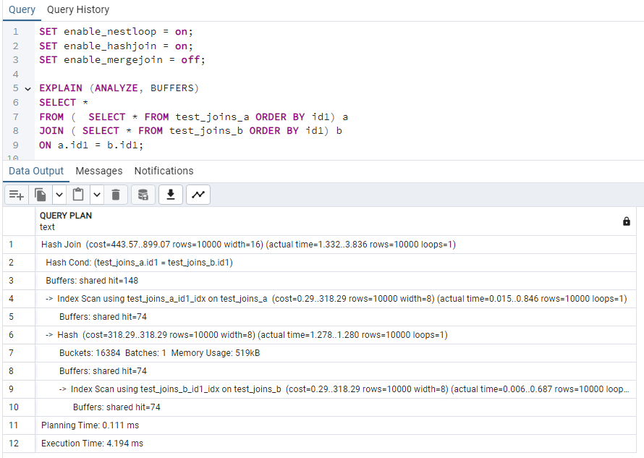

With merge join switched off Hash join occurred because it’s an equality join.

2.1 TASK 4: CHANGING JOIN ORDER
------------------------------------------------------

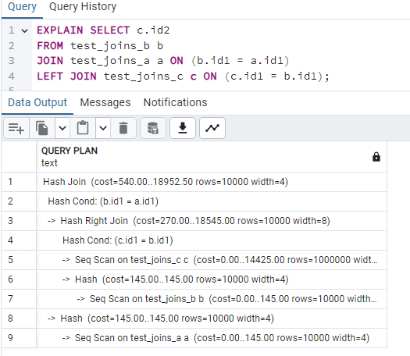

The planner reordered joins to optimize the query.
----
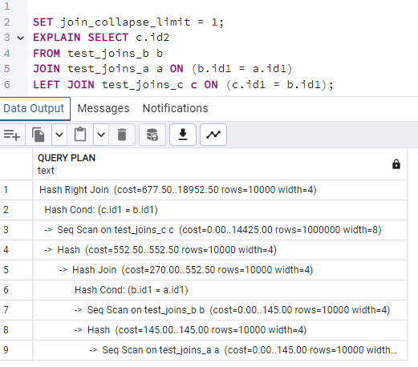

Now the planner follows the order of the joins in the query.
-----------------------------------------------------------------------------------
TASK 5: LATERAL JOIN
code used:

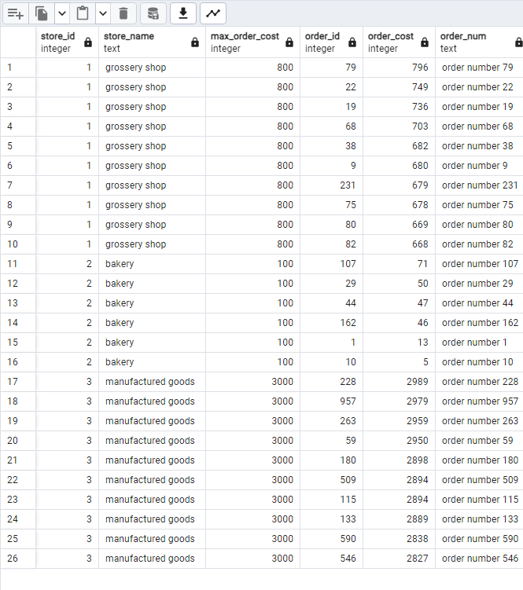
SELECT s.store_id, s.store_name, s.max_order_cost, o.order_id, o.order_cost, o.order_num
FROM stores s JOIN LATERAL (
SELECT order_id, order_cost, order_num FROM orders
WHERE order_cost < s.max_order_cost
ORDER BY order_cost DESC LIMIT 10
) o ON TRUE
ORDER BY s.store_id, o.order_cost DESC;

Found 26 orders.

----------------------------------------------------------------------------------------------
3.1 TASK 6: RECURSIVE CTE

WITH RECURSIVE org AS (
SELECT empno, ename, mgr,
1 AS level
FROM labs.emp
WHERE mgr IS NULL
UNION ALL
SELECT e.empno, e.ename, e.mgr, o.level + 1
FROM labs.emp e
JOIN org o ON e.mgr = o.empno
)
SELECT o.empno, o.ename AS employee, m.ename AS manager, o.level
FROM org o
LEFT JOIN labs.emp m ON o.mgr = m.empno
ORDER BY o.level, o.empno;
-------------------------------------------------------------------------------------------------------
3.2 TASK 7: CHANGING DATA CTE
WITH
updated_rows AS (
UPDATE orders
SET order_cost = (order_cost / 2)
WHERE order_cost BETWEEN 100 AND 1000
RETURNING order_id, order_cost, order_num
),
logged_updated AS (
INSERT INTO order_log (order_id, order_cost, order_num, action_type)
SELECT order_id, order_cost, order_num, 'U'
FROM updated_rows
RETURNING log_id
),
deleted_rows AS (
DELETE FROM orders
WHERE order_cost < 50
RETURNING order_id, order_cost, order_num
),
logged_deleted AS (
INSERT INTO order_log (order_id, order_cost, order_num, action_type)
SELECT order_id, order_cost, order_num, 'D'
FROM deleted_rows
RETURNING log_id
)

