Plan execution:

1. oracle developer – create_ddl_exit.sql
2. talend – execute job Exit_task_load_Maryna
3. talend – execute job Exit_task_dim_Maryna
4. talend – execute job Exit_task_fct_Maryna
5. oracle developer - drop_ddl_exit.sql

***************************************************************************

Firstly you need execute script for creating all necessary objects - create_ddl_exit.sql. It creates all tables with primary key and foreign keys, and sequences.

Secondly you need execute three jobs Exit_task_load_Maryna, job Exit_task_dim_Maryna and execute job Exit_task_fct_Maryna consequentially.

**Exit_task_load_Maryna** loads data from csv files into tables stage level - stage_customers, stage_products and stage_payments. In this process, all incorrect entries are recorded in the xls files: error_customers_null, error_products_null and error_payments_null. For instance, all products without campany name is written into error_products_null.

Features:

1. all tables are truncated before new loading.
2. all files payments that corresponding to the mask Payments*.csv are loaded in turn
3. to load payments is used table stage_pay_list: before loading the file name is compared with information into this table, after loading – the file name is written to it.

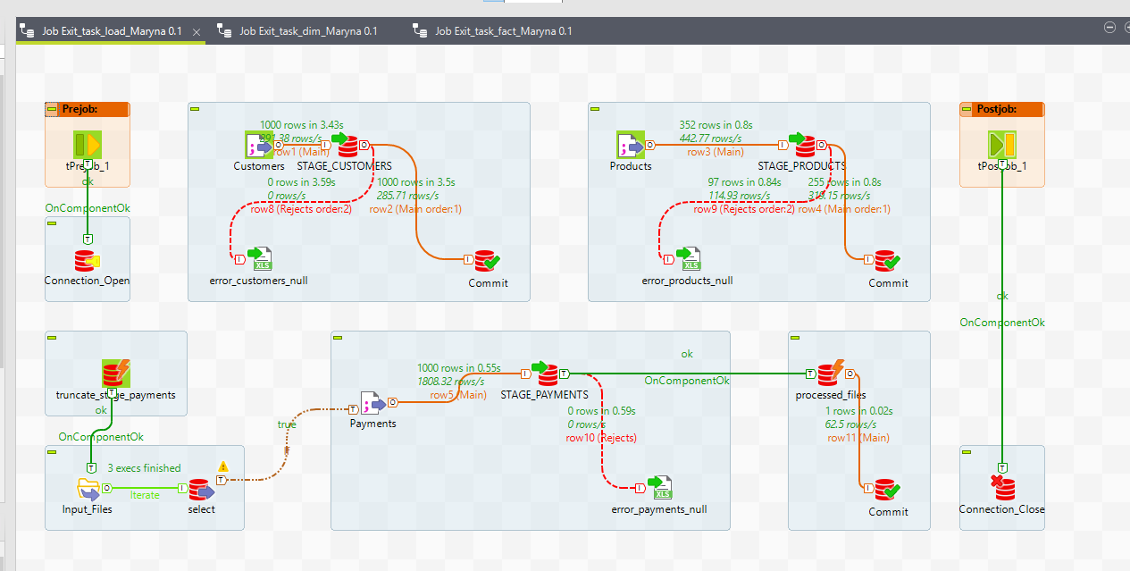

Loading stage_customers:

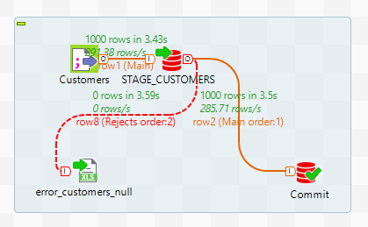

Loading stage_products:

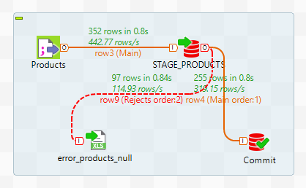

Loading stage_payments:

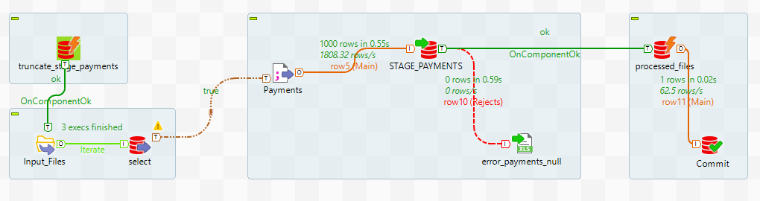

**Exit_task_dim_Maryna** loads data from tables’ stage level into dimensions dwh dwh_customers and dwh_products. These tables have primary surrogate keys which generated with help of sequences sqn_dwh_customers and sqn_dwh_products.

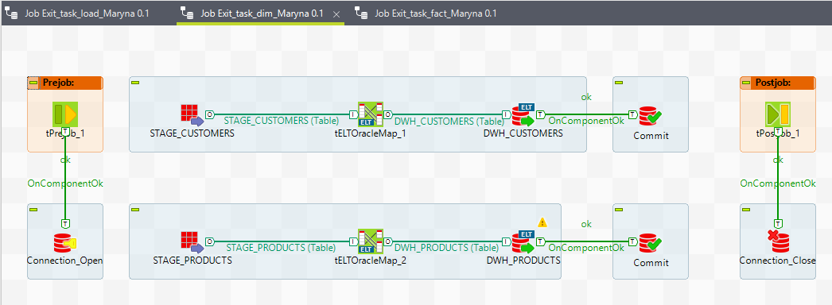

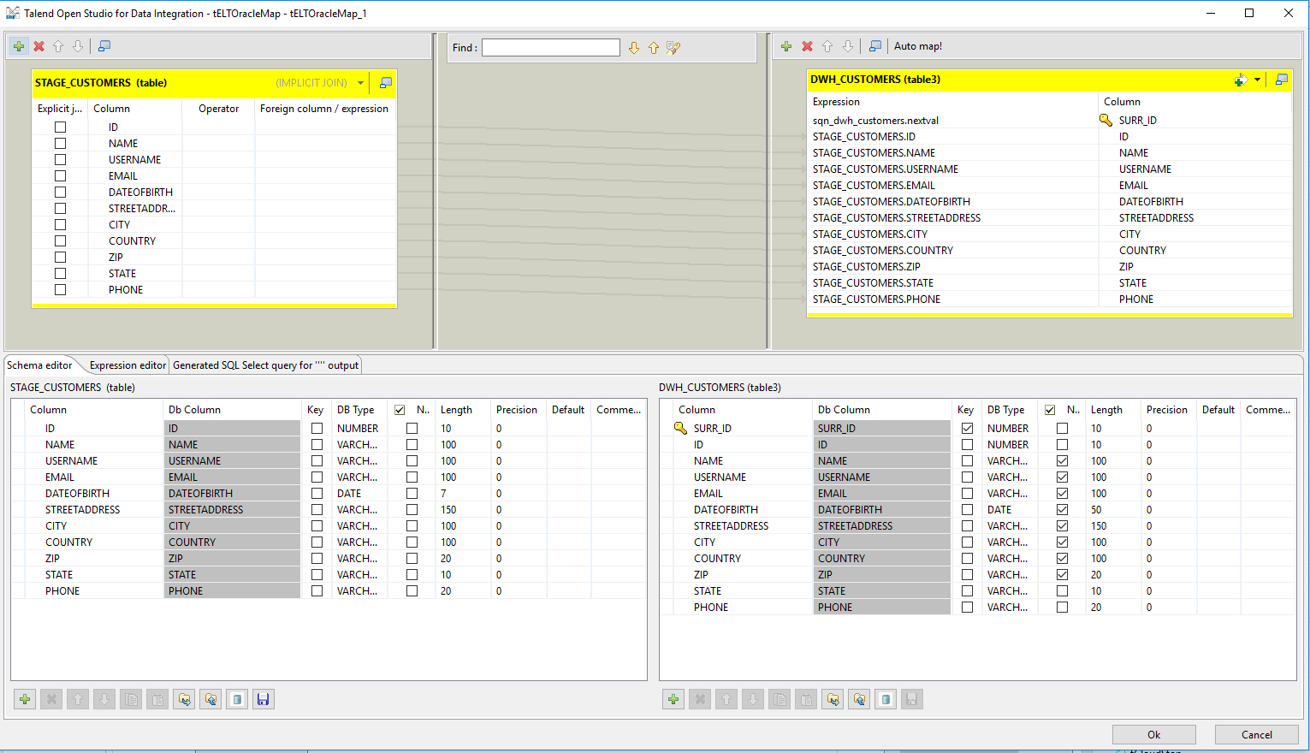

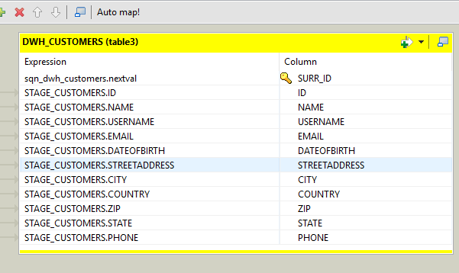

**Exit_task_fct_Maryna** loads data from tables’ stage level into fact table sqn_dwh_payments. This table has primary and foreign keys which connected with tables dwh_customers and dwh_products. All entries that have ID in these tables and a filled price are recorded in this table. All other entries are loaded into the table dwh_error_payments as mistaken. These tables have primary surrogate keys which generated with help of sequences sqn_dwh_payments and sqn_dwh_error_payments.

Also added an additional column KPI IsInterState calculated by the formula:

case when (trim(prod.WAREHOUSELOCATIONSTATE) = trim(cust.STATE)) then 1 else 0 end KPI

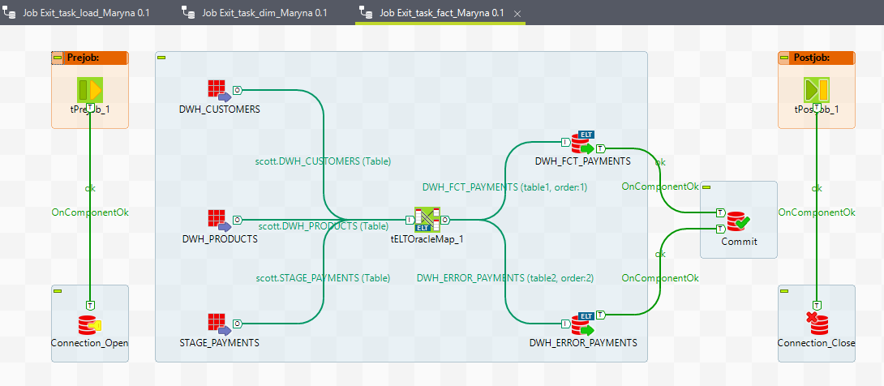

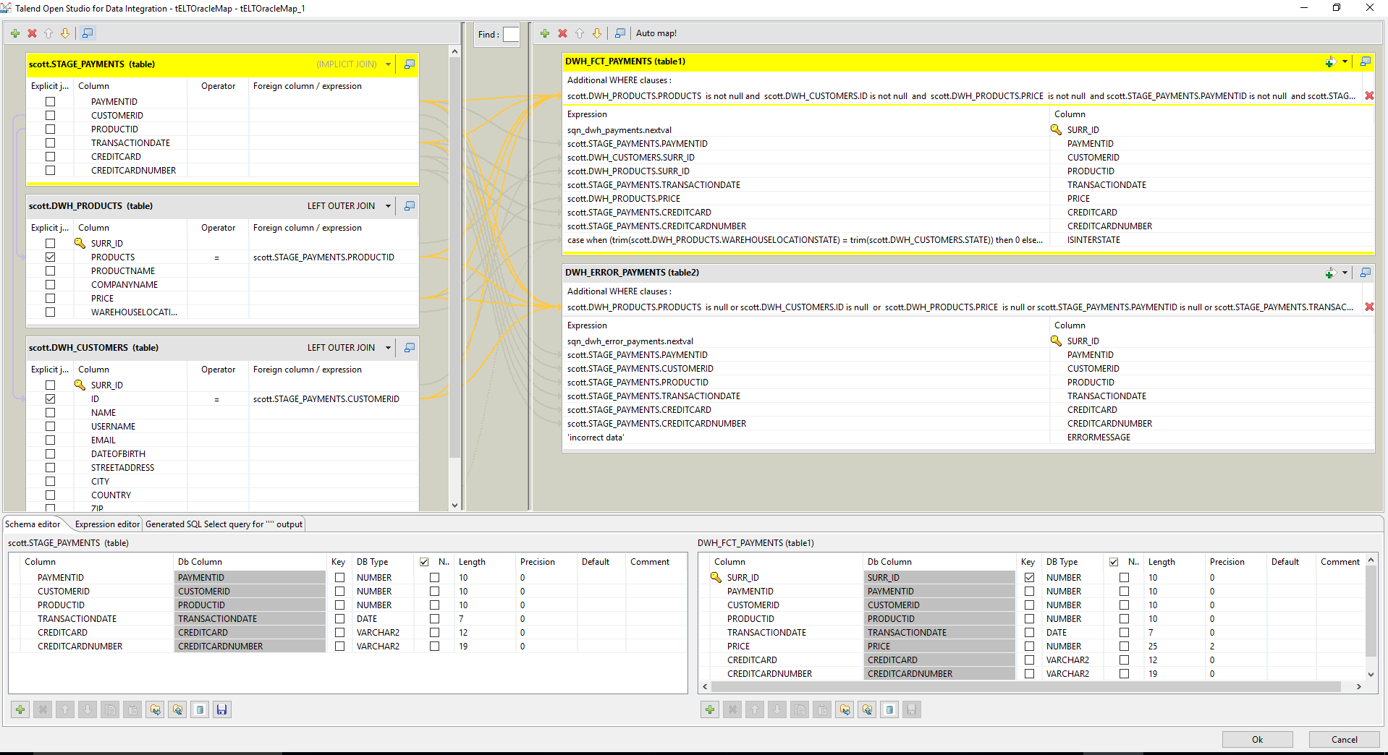

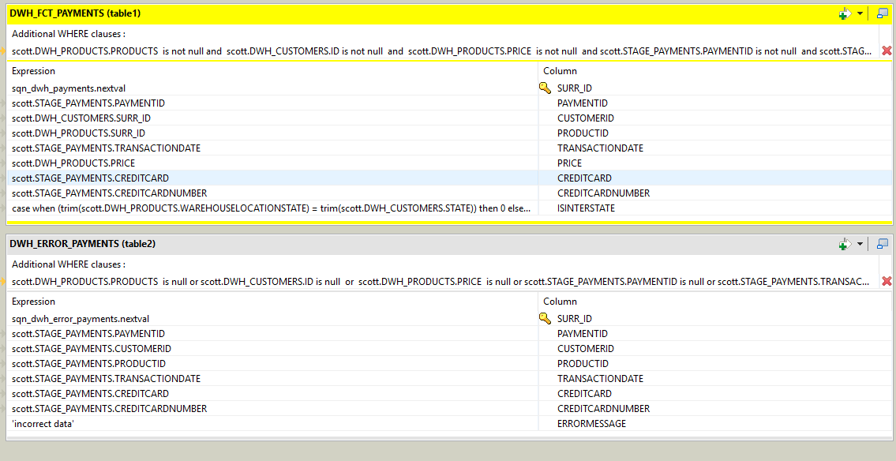

Finally you need execute script for dropping all created objects - drop_ddl_exit.sql