1. Activate PERSONAL project in Epam Cloud  
   2. Download maestro-cli  
   3. Execute describe regions command and choose region to run instance in it
2. 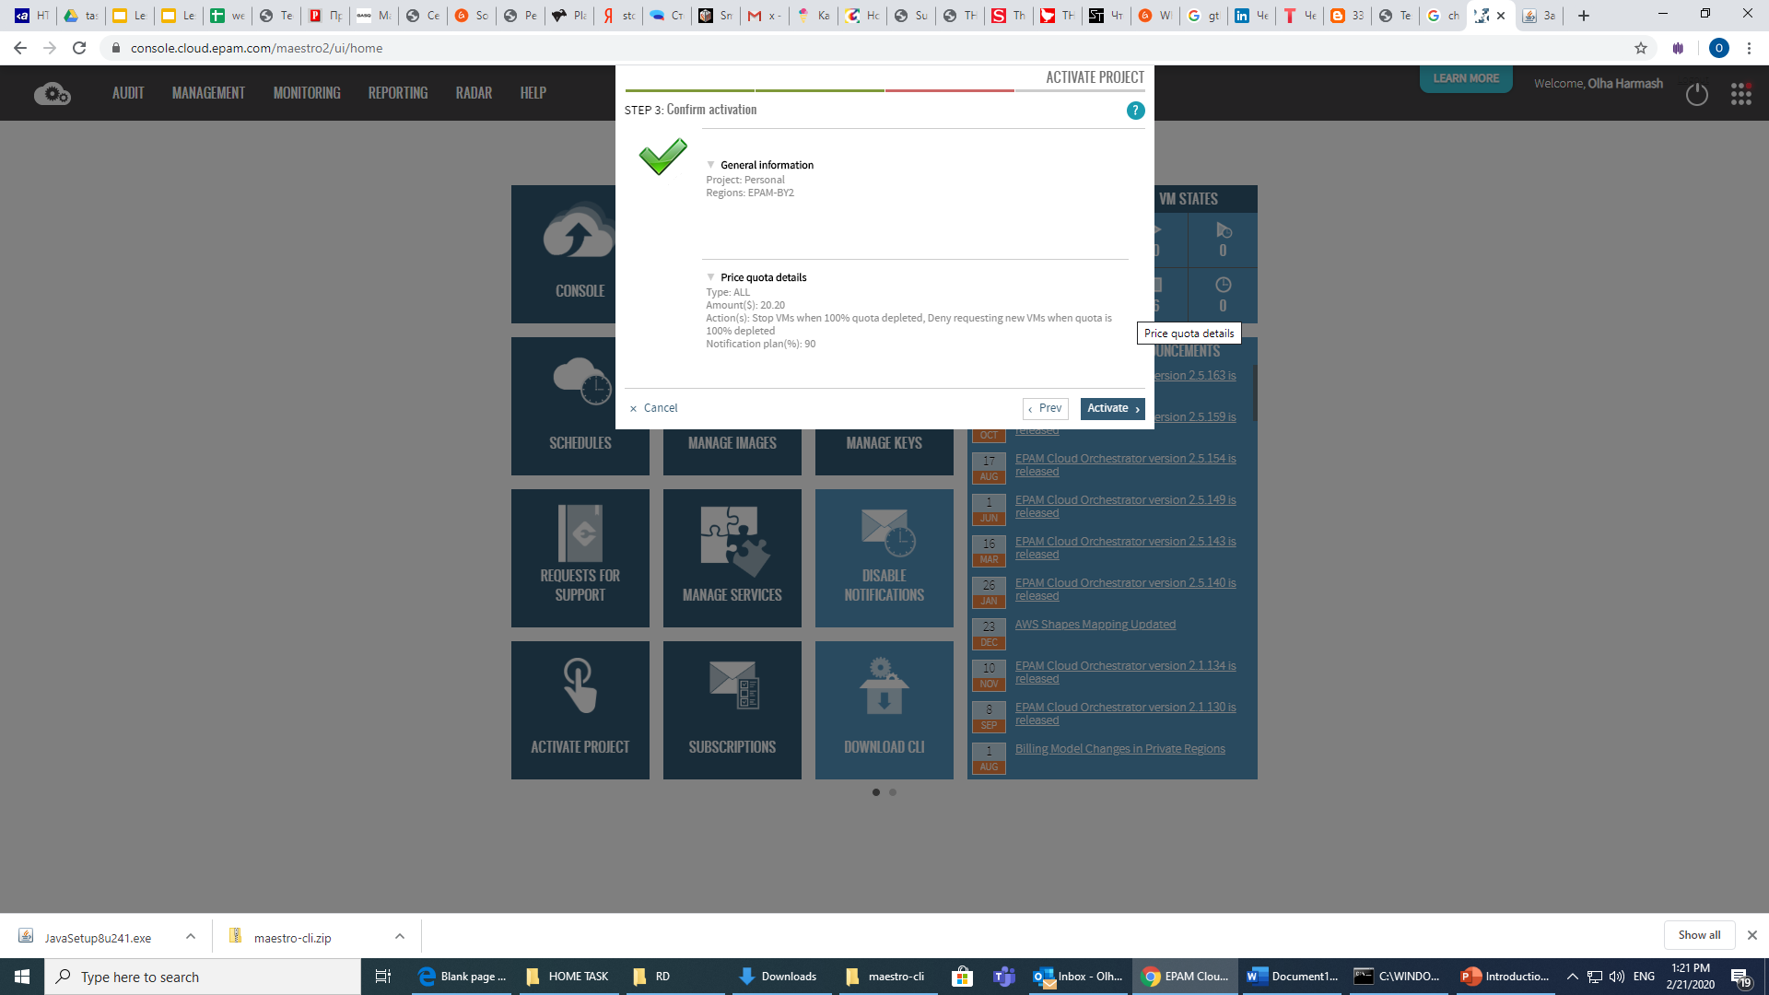  
   4. Run Linux instance and Windows instances in it

LINUX

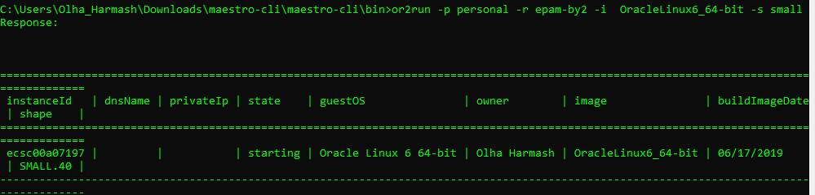

WINDOWS

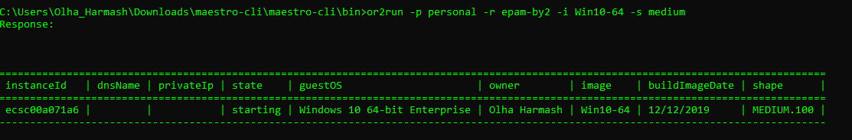  
5. Execute describe instance command

windows

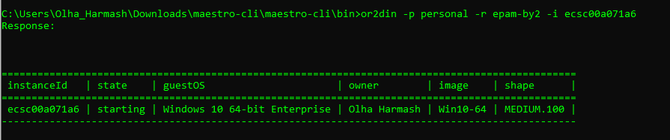

Linux

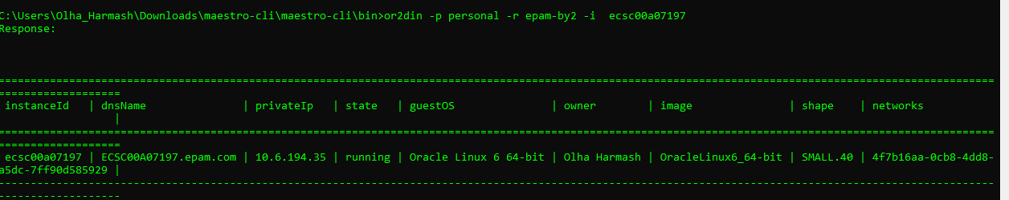

6. Login to Windows instance

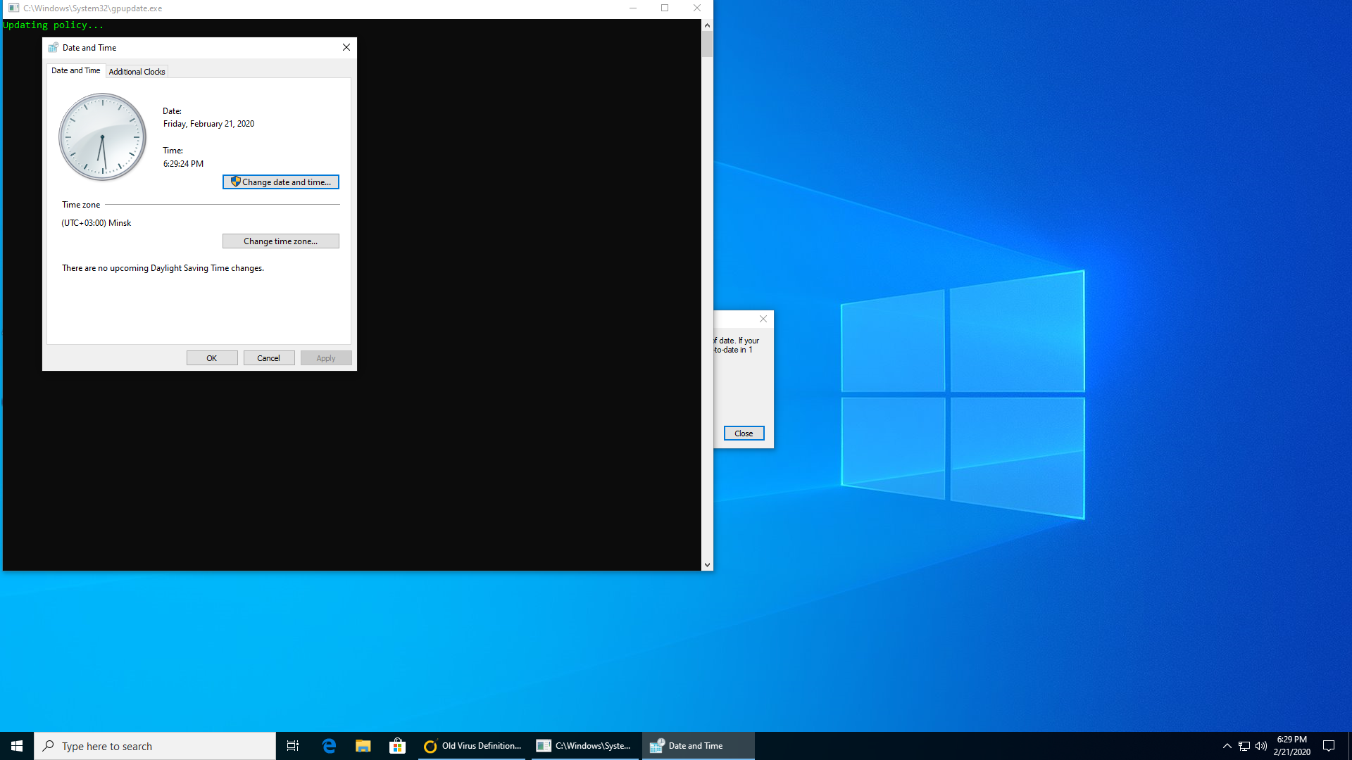

7. Login to Linux instance

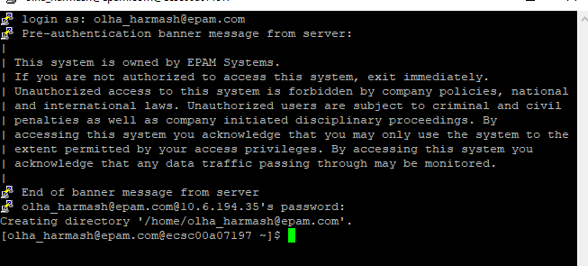

8. Reboot/suspend/stop instance

LINUX

stop

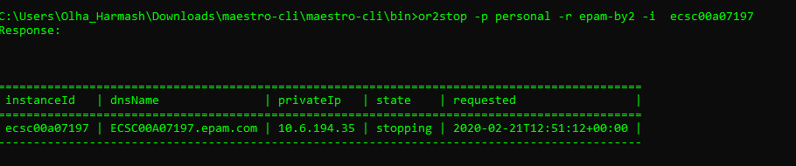

Start

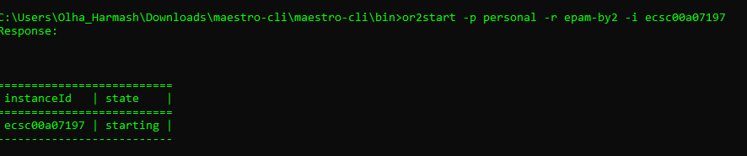

Reboot

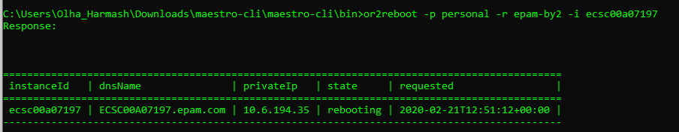

Suspend



Windows

Reboot

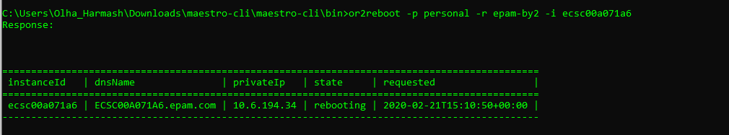

Suspend



Stop

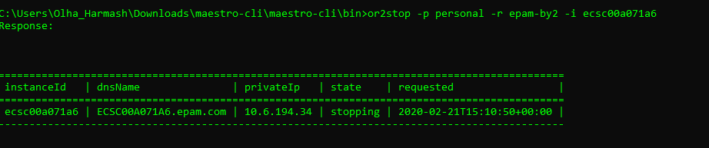

9. Change shape for instance

Linux

  
 Windows

For windows it is impossiable

10. Create and attach volume. Write any information on attached volume (e.g. .doc file, .txt file, .jpg file, create any folder). Attach volume/detach volume

Linux

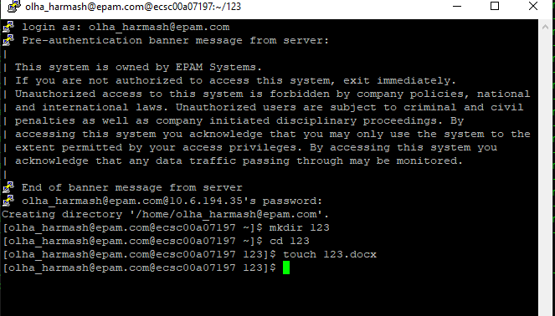

Windows

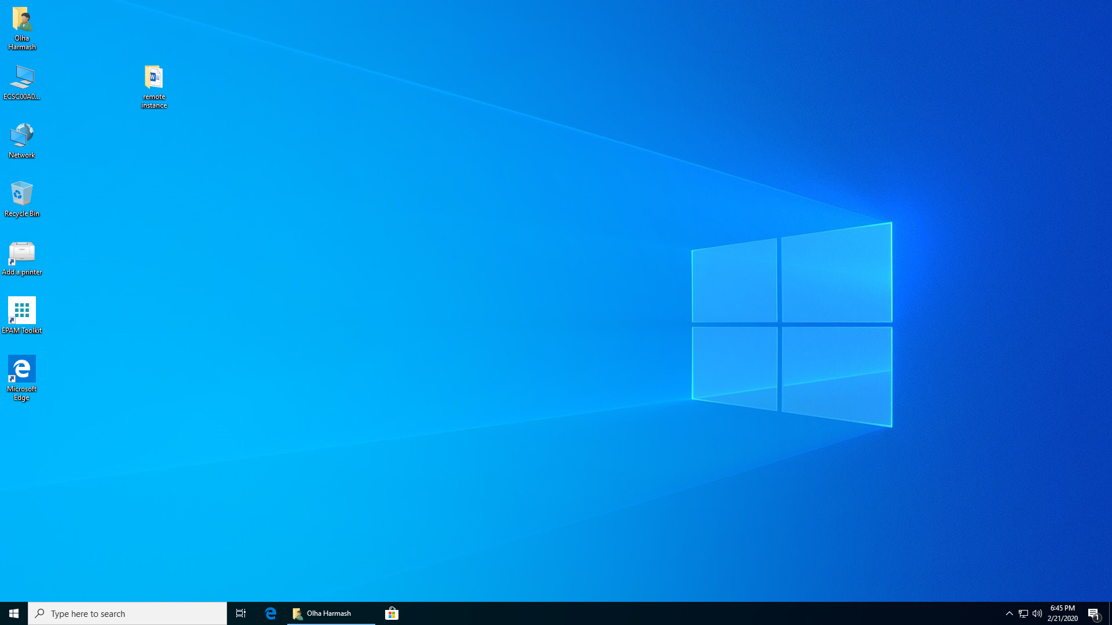

11. Create schedule for instance and check that it works

Linux

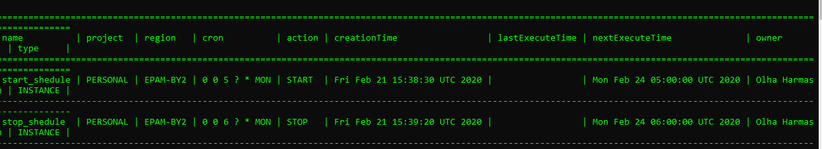

12. Add instance to schedule/remove instance from schedule

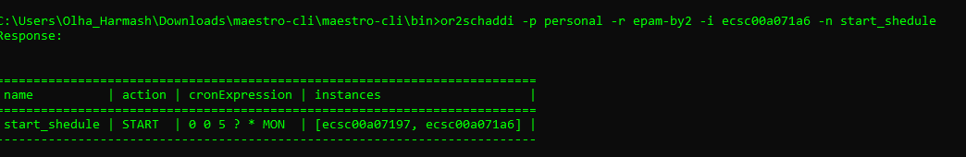

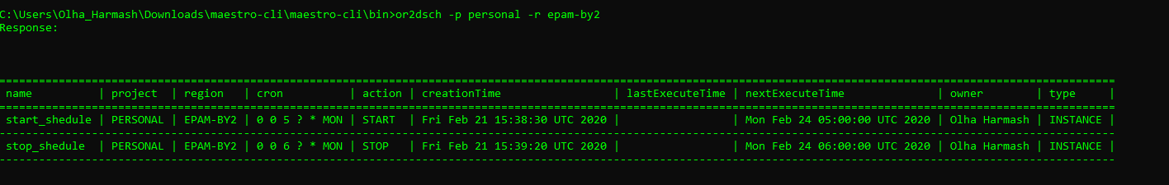

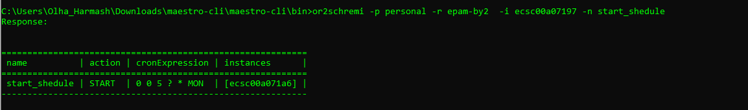

13. Create/describe/delete keypairs

Create

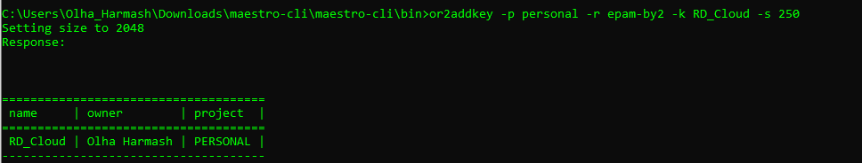  
Describe

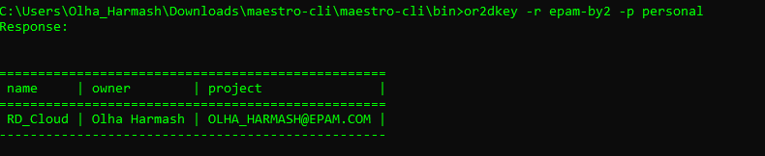

Delete

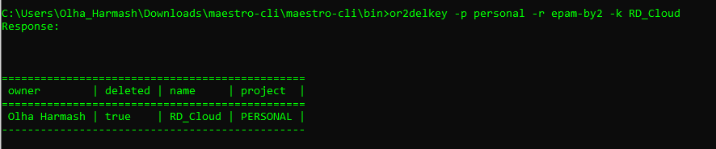

14. Set/describe tag for instance

Windows set

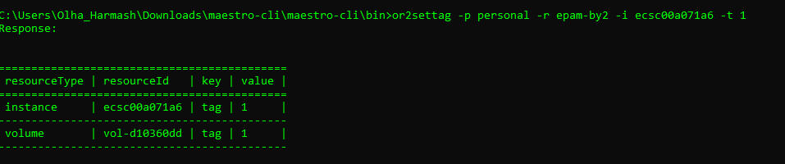

Linux

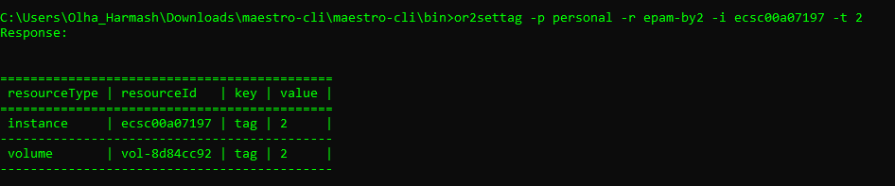  
15. Set/describe instance property

Windows

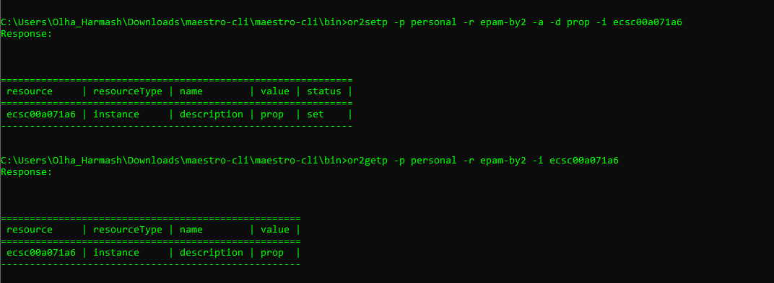  
Linux

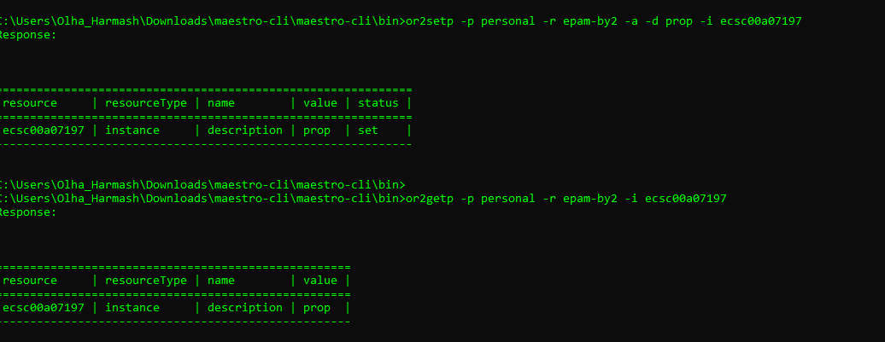

16. Retrieve instance/project audit

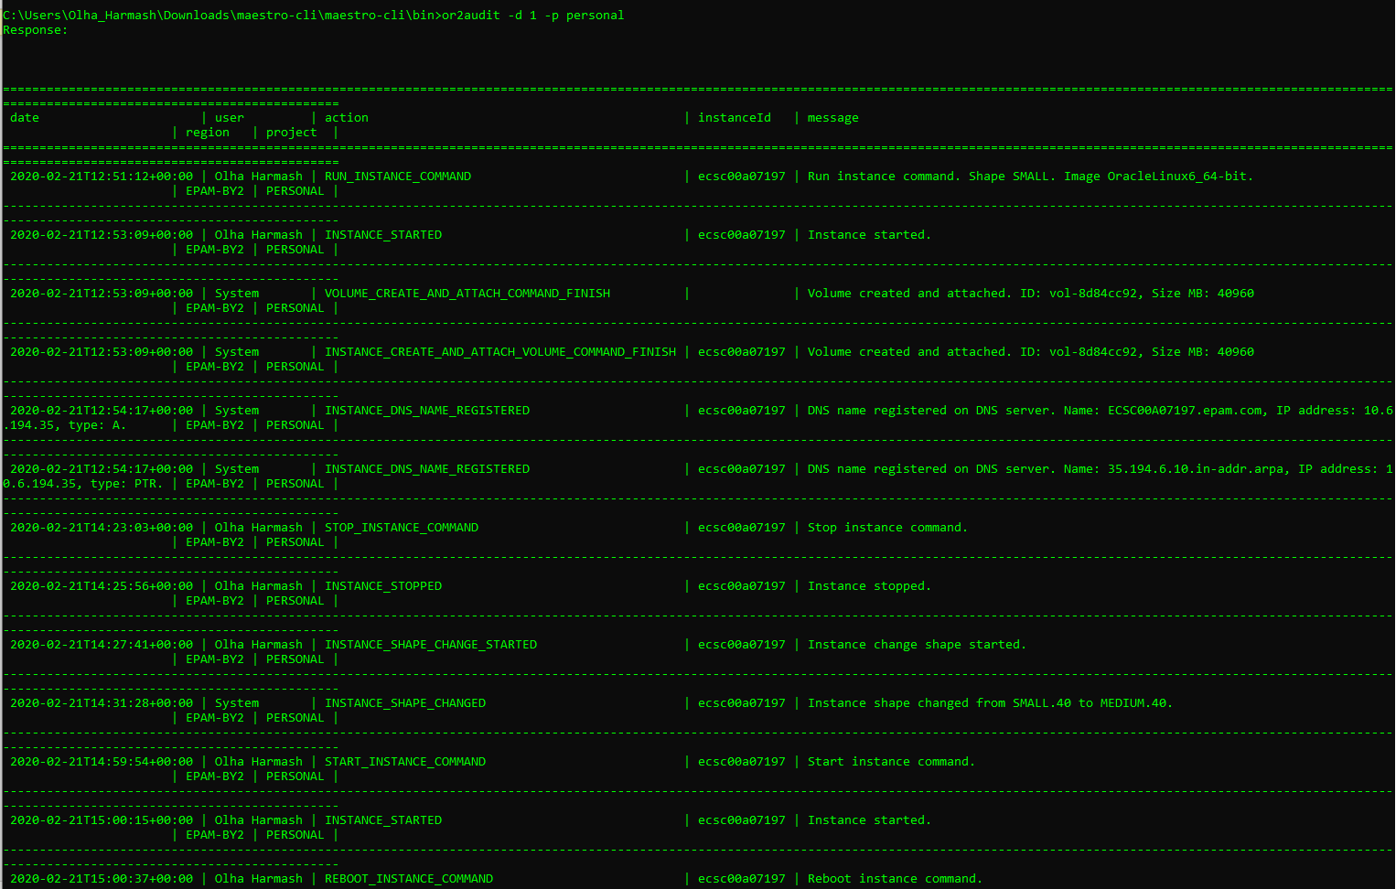

17. Generate different types of utilization report



18. Analyze EPAM Cloud changes over the past six months. What of the  features you are getting interested that were published to EPAM. Cloud during last 6 months?