1)Get weather in the city by city name

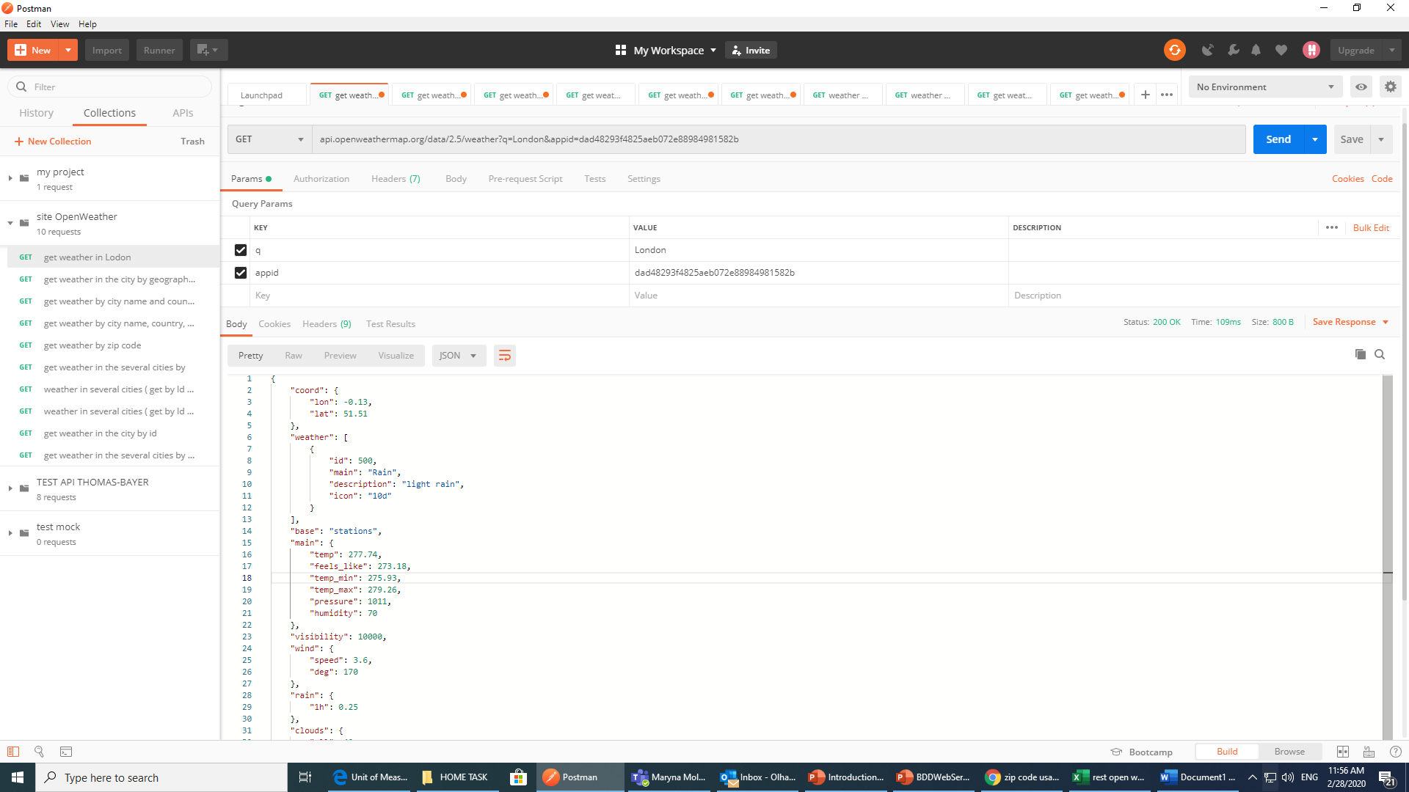

2)Get weather in the city by geographic coordinates

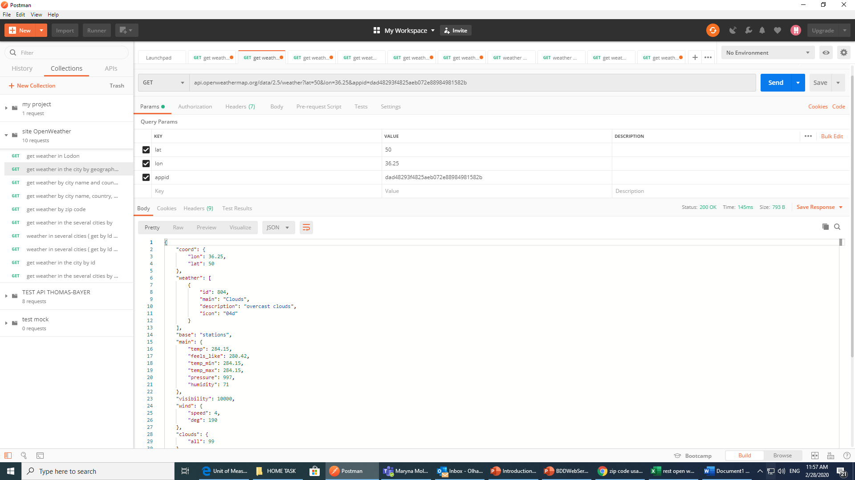

3)Get weather in the city by country and city name

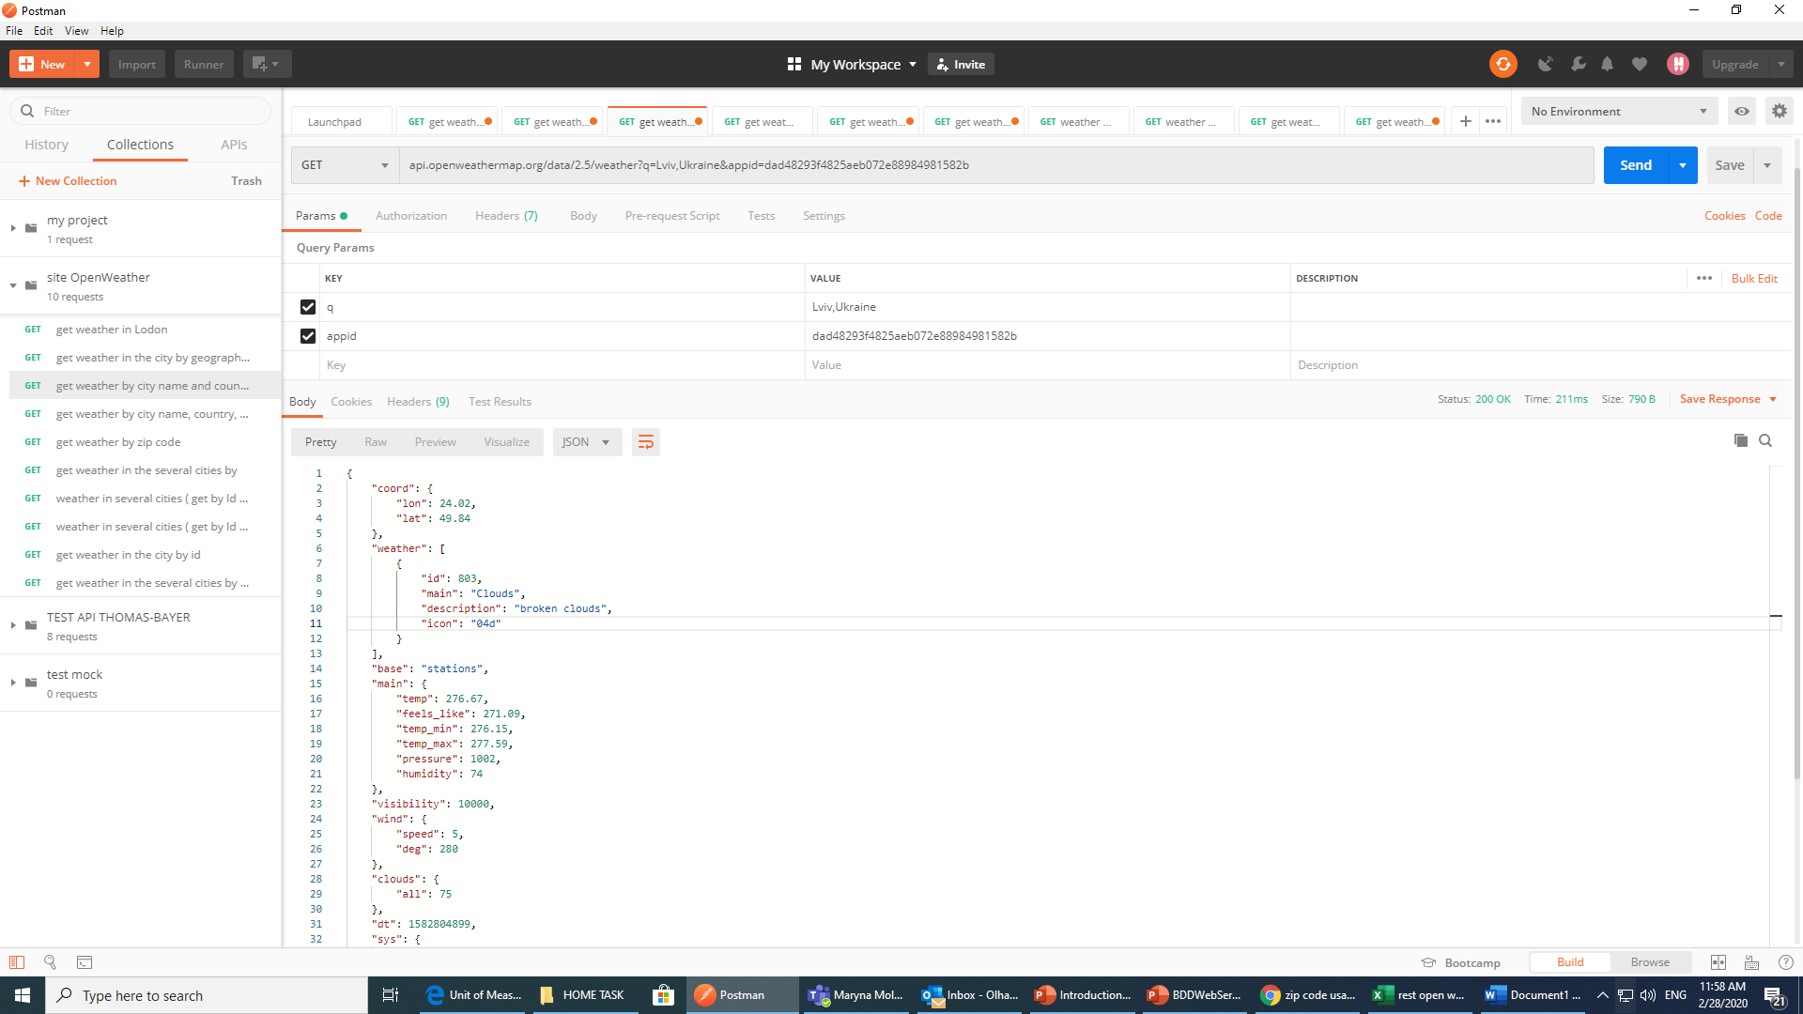

4)Get weather in the city by zip code, country and city name

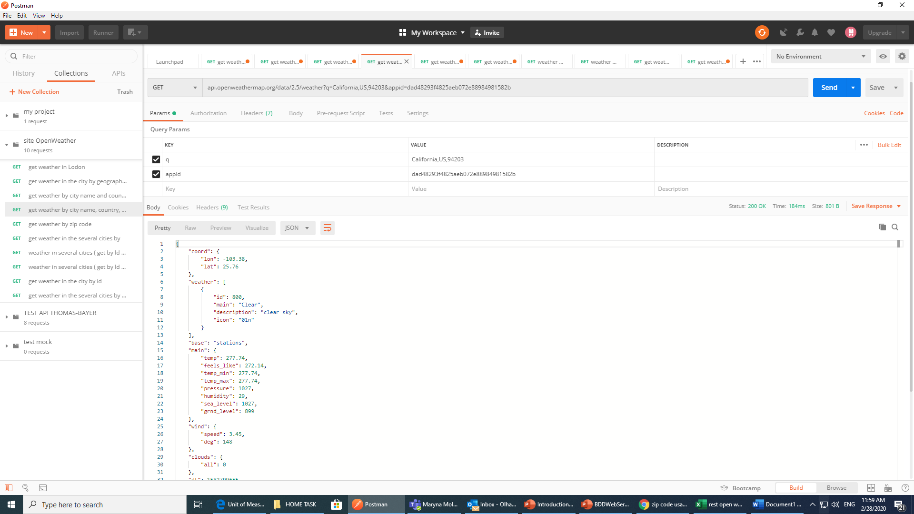

5)Get weather in the city by zip code

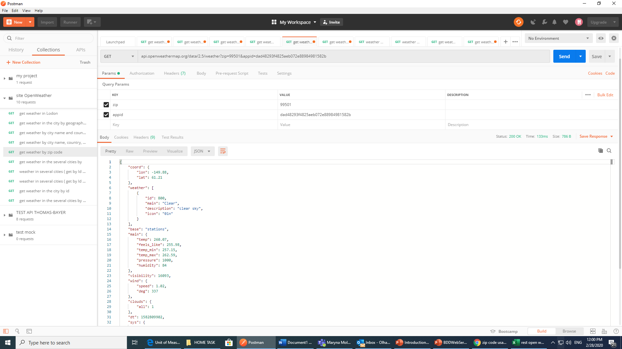

6)Get weather in cities in cycle 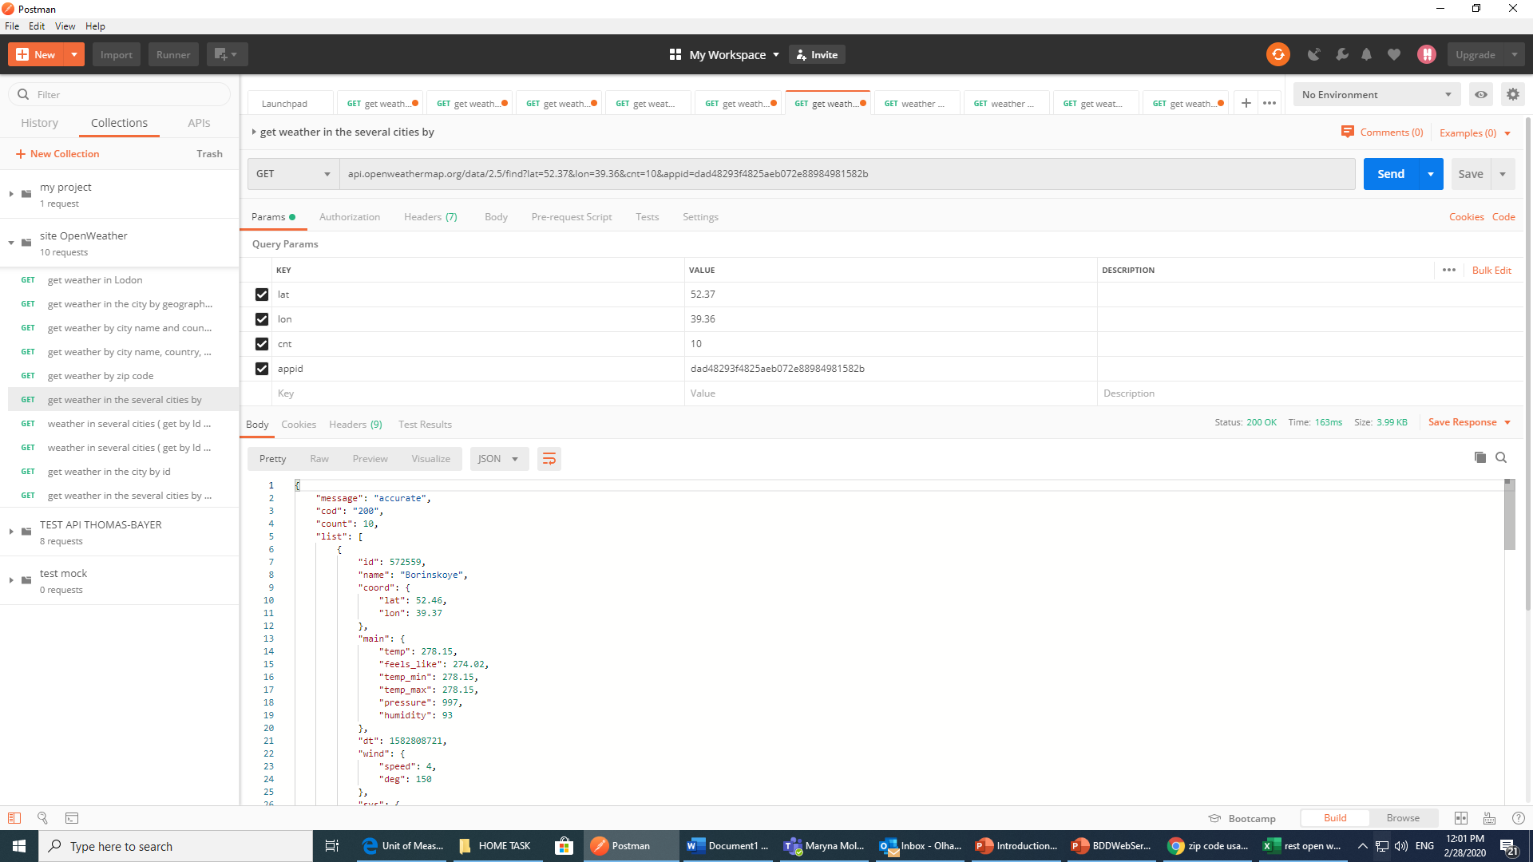

7)Get weather in several cities by ID

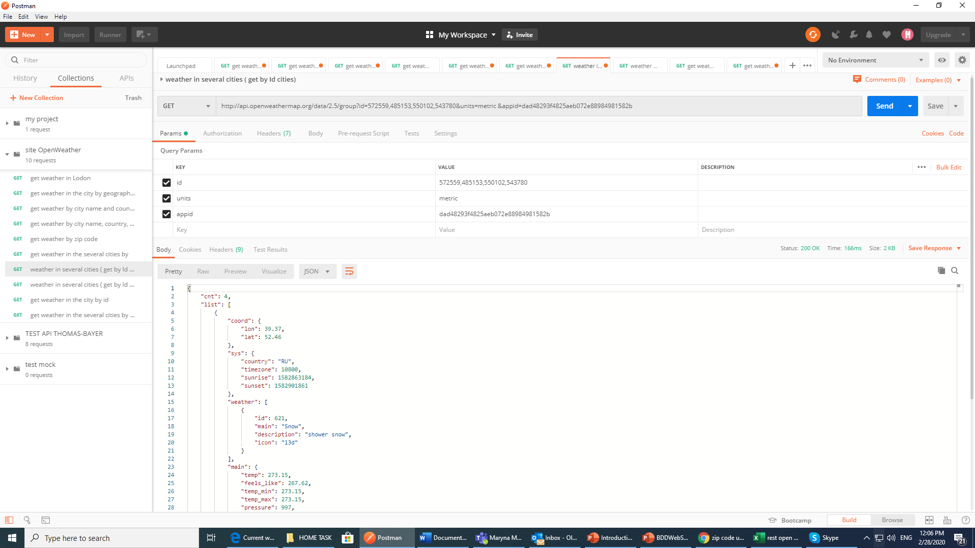

8)Get weather in several cities by ID (more than 20)

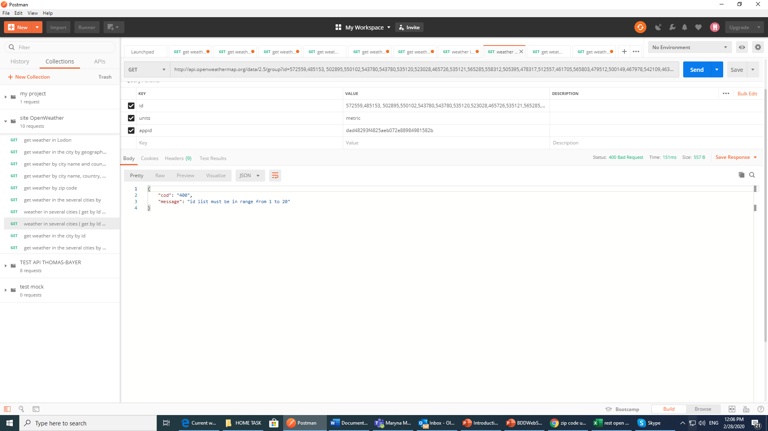

9)Get weather in the city by ID

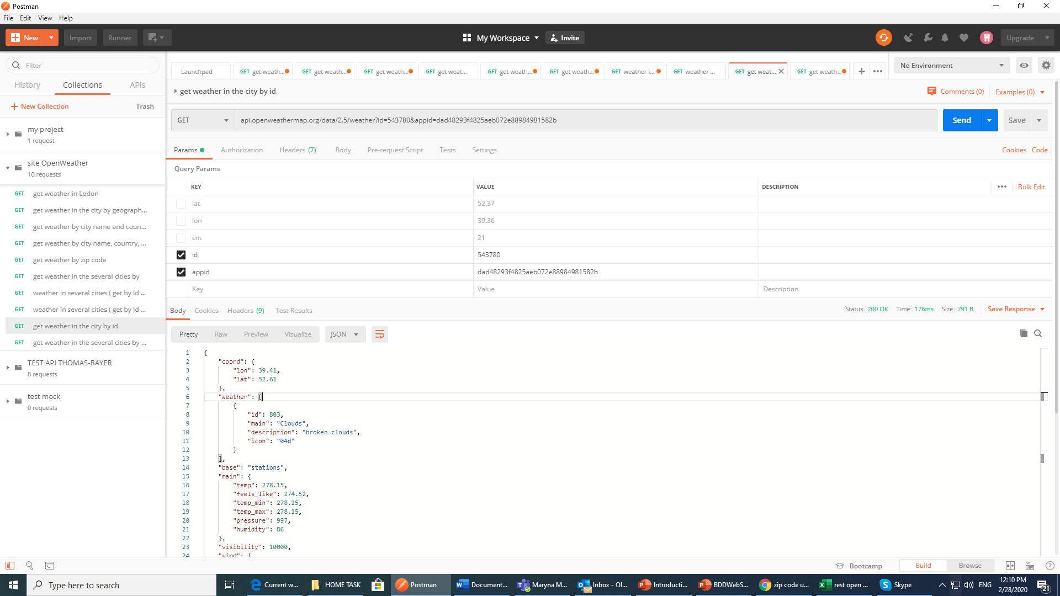

10)Get weather in several cities in cycle (value=0)

