Tutorial: Setting permissions for K2Application

*In this tutorial described how to configure segregated access of K2 user roles to K2 Applications*

This tutorial has several sub-steps. Step-by-step guidance to complete this tutorial:

1. Create two simple K2 applications with SmartForms, Views and Forms
2. Specify Active Directory groups for each Application and organize that to K2 Roles
3. Configure permissions of K2 Designeer, SmartObjects and base Categories
4. Configure permissions of Demo K2 Applications
5. Test results of permission settings.
6. Review of tools from Bytezoom.

**1. Create two simple K2 applications with SmartForms, Views and Forms**

**In K2 Designer create Categories structure and two simple K2 Application: App A and App B (similar)**

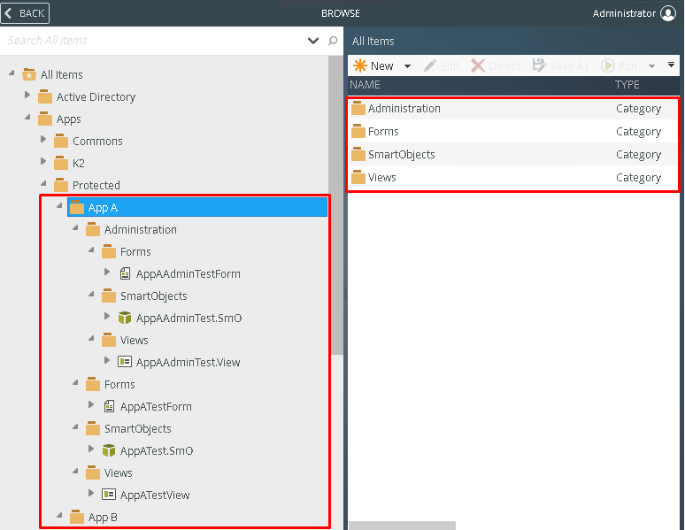

***detailed how to create K2 SmartForm Application by link*:**

<https://help.k2.com/onlinetraining/k2fivecore/default.htm#Tutorials/Build/LeaveRequestBasic/05BuildLeaveRequestForm.htm%3FTocPath%3DSmartForms%2520Fundamentals%7C_____3>

**2. Specify Active Directory groups for each Application and organize that to K2 Roles**

**In Active Directory Server Console create groups of users for App A and App B: Admins, Developers, Users.**

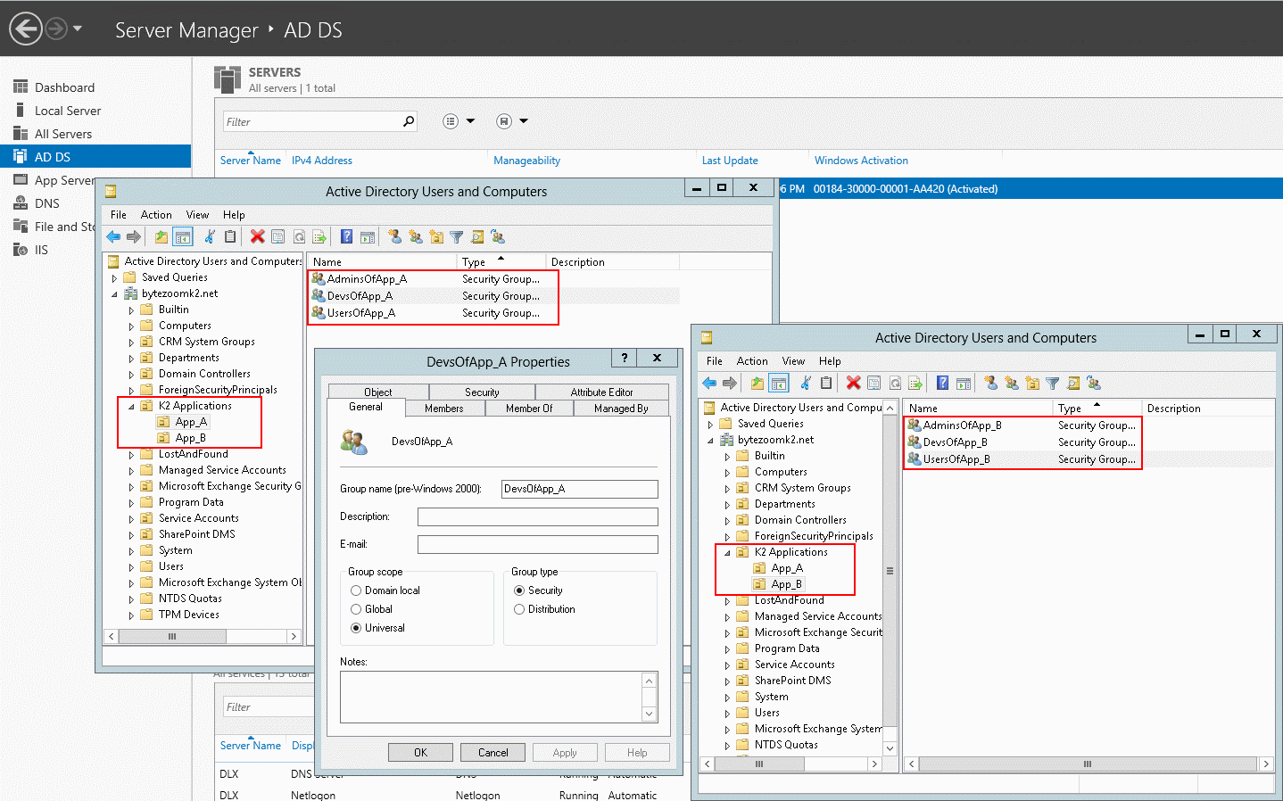

* **Open Server Manager Dashboard -> Tools -> Active Directory Users and Computers**
* **Select Domain Name, in mouse right button menu, New -> Organizational Unit**
* **Create “K2 Application” Unit, and select it**
* **Create Units “App_A” and “App_B” in “K2 Application”**
* **Create Groups “AdminsOfApp_A”, “DevdOfApp_A”, “UsersOfApp_A” in “App_A” Unit**
* **Create Groups “AdminsOfApp_B”, “DevdOfApp_B”, “UsersOfApp_B” in “App_B” Unit**
* **Add Member Users to each created Groups in “Members” Tab of Group Item Properties:**

AdminsOfApp_A - **Bob Maggio**;DevsOfApp_A - **Rick Cowan**; UsersOfApp_A - **Anthony Petro**; AdminsOfApp_B - **Bob Maggio**;DevsOfApp_B - **Mark Green**;UsersOfApp_B - **Blake Carrigan**.

**Organize Roles with AD groups in K2 Management panel, Menu Users->Roles.**

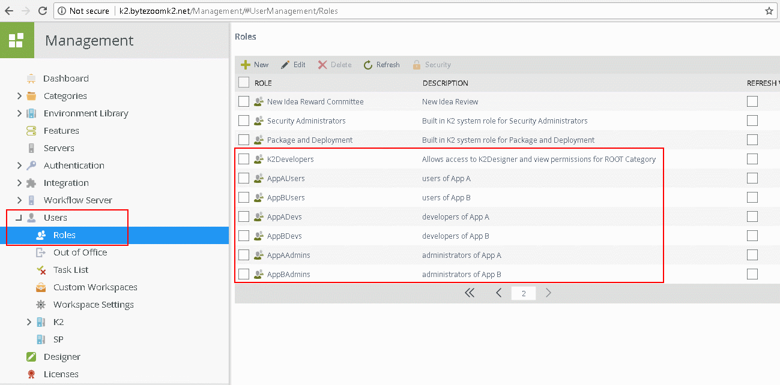

* **Open K2 Management Panel, in the Left Panel Menu select Users -> Roles**
* **In ToolBar panel Click to “New” Button**
* **Set Name and Description for new Role “K2Developers”, In Find Users, Search Drop down list set as “Groups” and Input “Devs” near “Search” Button, then click the Button. In Results list select rows with developer groups and click to “Add” Toolbar button for add groups to the members of Role.**

**Click to “OK” button for save and create Role.**

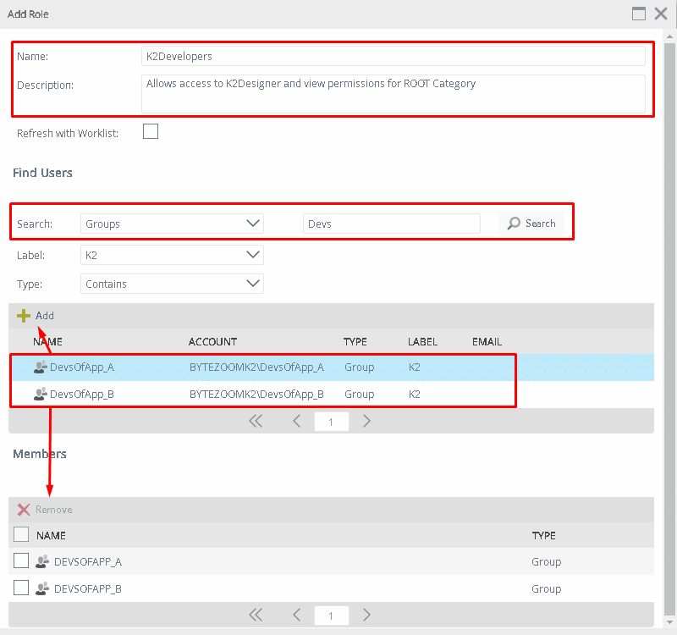

* Create Roles for each AD groups of K2 applications: “AppAUsers”, “AppADevs”, “AppAAdmins”, “AppBUsers”, “AppBDevs”, “AppBAdmins”.

**3. Configure permissions of K2 Designeer, SmartObjects and base Categories**

**Allow access to K2 Designer panel for K2Developers Role only**

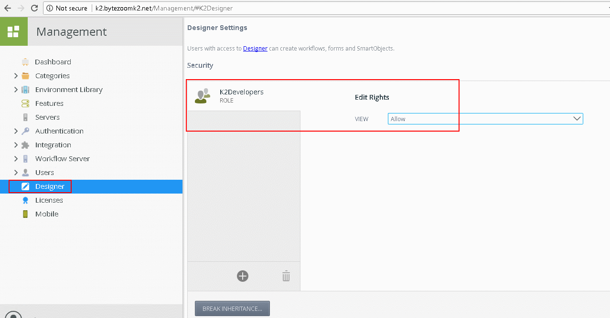

* **Open K2 Management Panel, in the Left Panel Menu select Designer**
* **From Security of Designer Settings remove “Everyone” Role with Permission Rights. Use** 
* **Add “K2Developers” Role and set “Allow” Rights for it. Use** 

**Set SmartBox Security permissions for AD groups of developers**

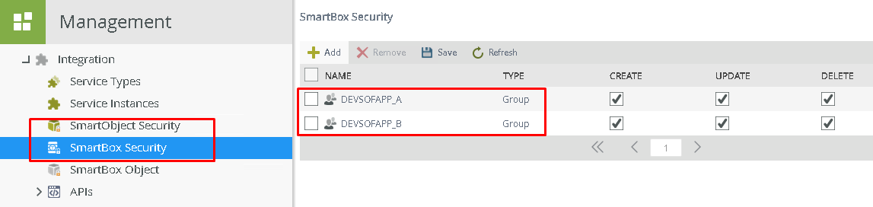

* **Open K2 Management Panel, in the Left Panel Menu select Integration -> SmartBox Security**
* **Use “Add”** **button on ToolBar panel for add AD Developer groups, and set permissions of Create, Update and Delete actions.**
* **Use “Save” button on ToolBar panel for save changes.**

**Configure base permissions of Categories**

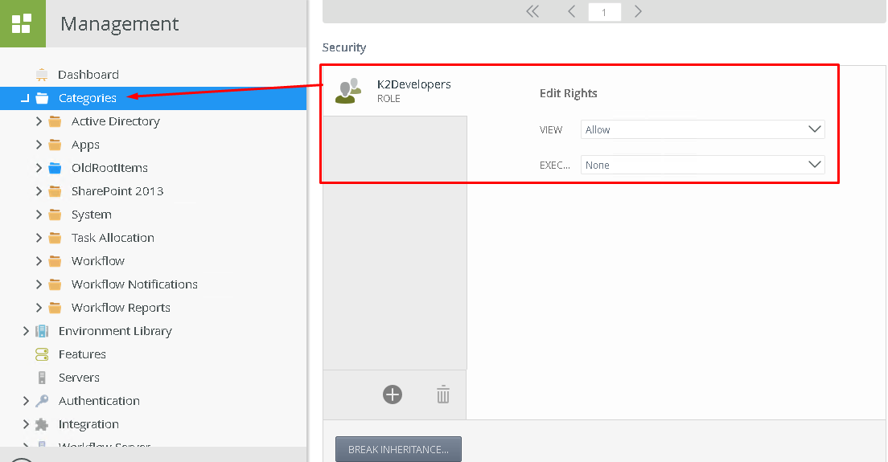

* **Open K2 Management Panel, in the Left Panel Menu select Categories**
* **From Security part remove “Everyone” Role with Permission Rights.**
* **Add “K2Developers” Role and set “Allow” Rights for “VIEW”, set “None” Rights for “EXECUTE”**

***Note:*** *View – access from designer to objects; Execute – access from Runtime to run forms.*

Allow to Execute System and K2 Framework forms for Everyone to keep K2 working for other users.

* **Select Categories by one: System, Workflow, Workflow Reports,** **Apps\K2\SmartStarters, Apps\K2\Workdesk; And add “Everyone” Role and set “Allow” Rights for “EXECUTE” Action**

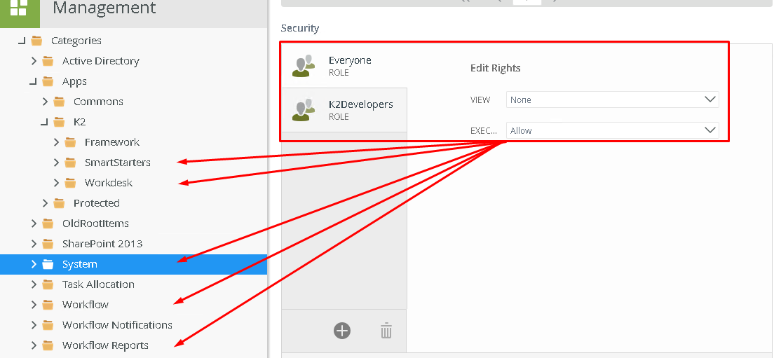

***Note:*** *The list of categories is not complete. probably on your server you will want to set the necessary rights to other categories. Detailed in K2 Documentation:*

[*https://help.k2.com/onlinehelp/k2five/userguide/5.0/default.htm#AuthorizationFramework/Authorization-Framework-Overview.htm*](https://help.k2.com/onlinehelp/k2five/userguide/5.0/default.htm#AuthorizationFramework/Authorization-Framework-Overview.htm)

BREAK INHERITANCE for Demo Apps Categories and Management Category. Remove Access Rights for those

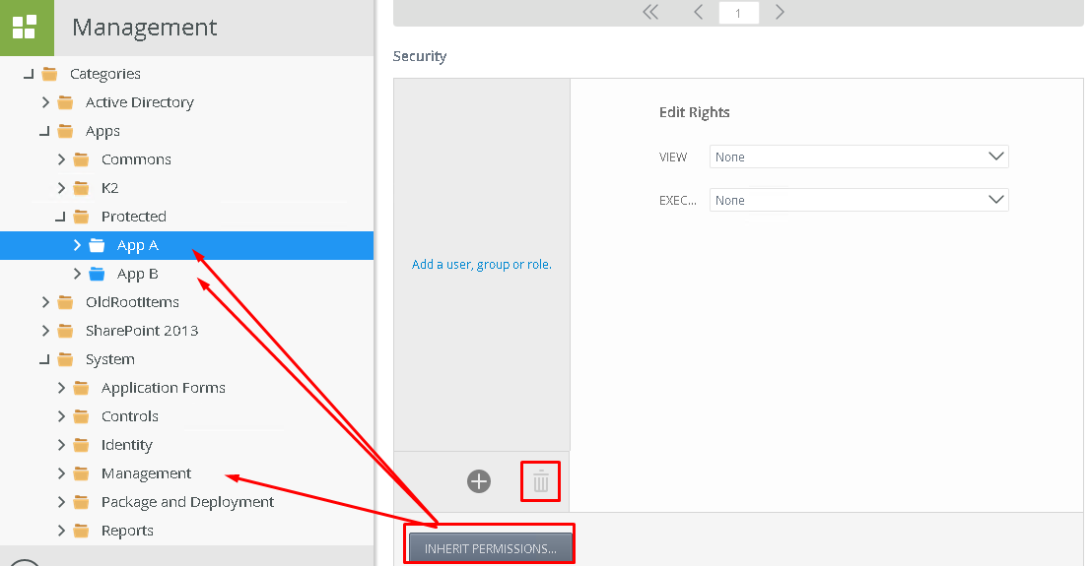

* **Select Categories by one: System\Management, Apps\Protected\App A, Apps\Protected\App B; And use Button “**BREAK INHERITANCE**” for disable categories permissions rights inheritance.**

**Also remove all Users, Group and Roles from selected categories Security rights.**

**4. Configure permissions of Demo K2 Applications Categories**

Add “AppADevs” Role to “Apps\Protected\App A” Category Security and “AppBDevs” Role to “Apps\Protected\App B” Category Security and set “Allow” Rights for “VIEW” and “EXECUTE” Actions.

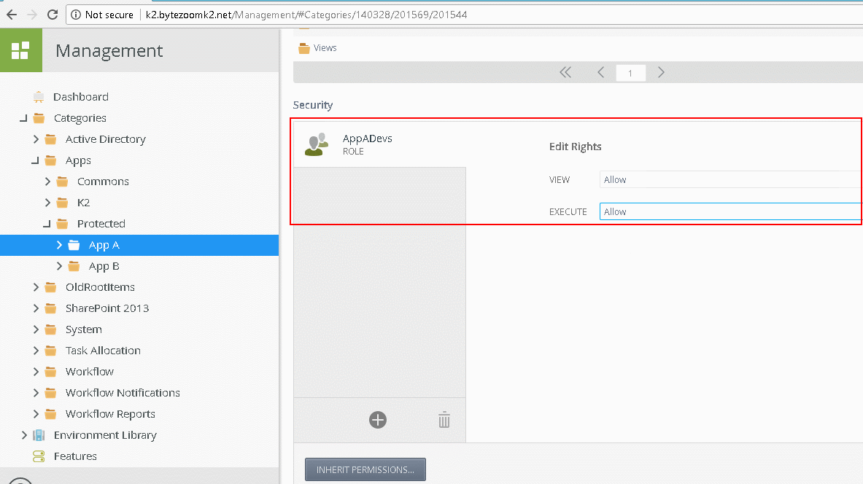

Add “AppAUsers” Role to “Apps\Protected\App A\Forms” Category Security and “AppBUsers” Role to “Apps\Protected\App B\Forms” Category Security and set “Allow” Rights for “EXECUTE” Action.

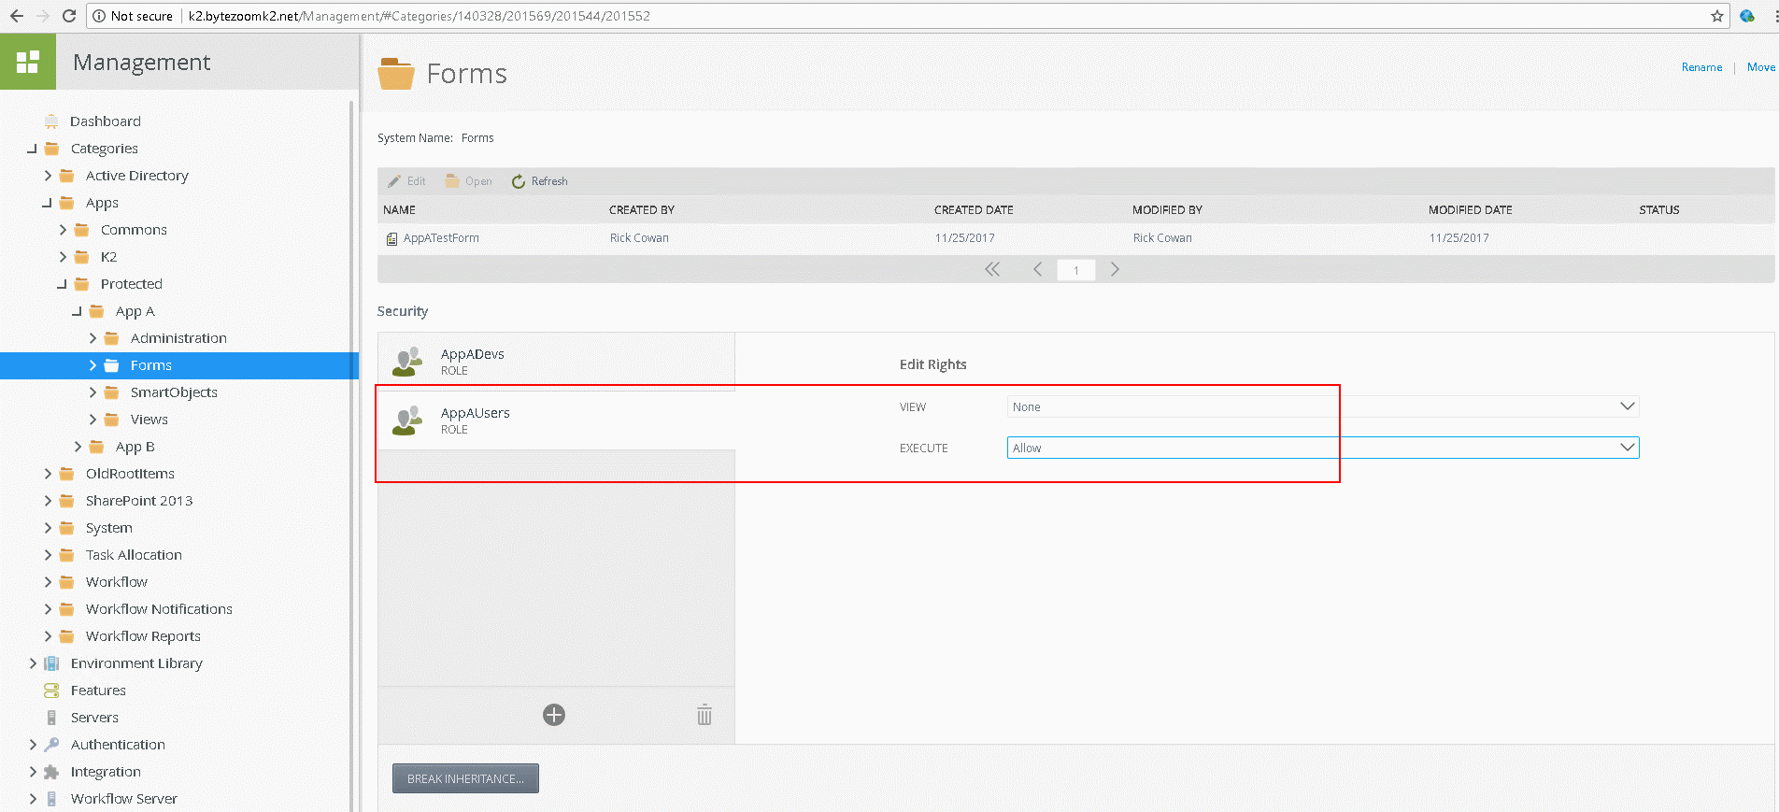

Add “AppAAdmins” Role to “Apps\Protected\App A\Administration\Forms” Category Security and “AppBAdmins” Role to “Apps\Protected\App B\Administration\Forms” Category Security and set “Allow” Rights for “EXECUTE” Action.

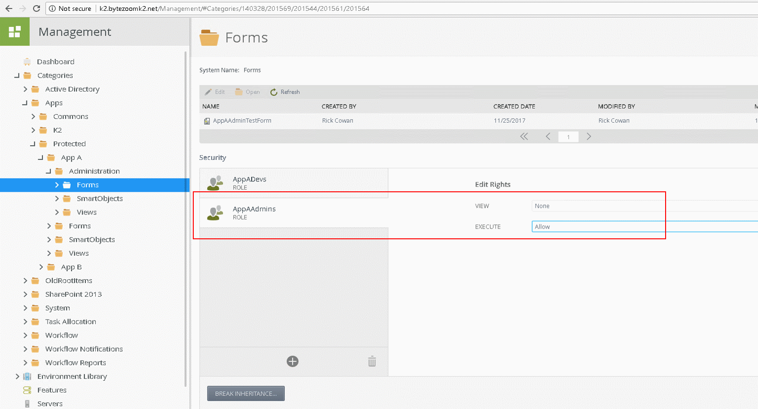

If you have Application forms for Demo Applications in “System\Application Forms” Category, so check permission rights for this objects. Users and Admins need to have “Allow” Rights to “EXECUTE” Action.

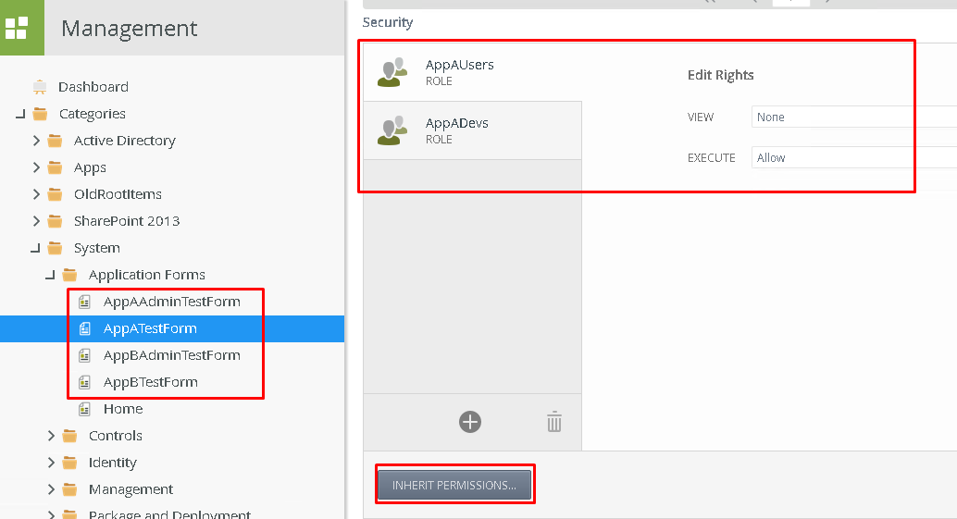

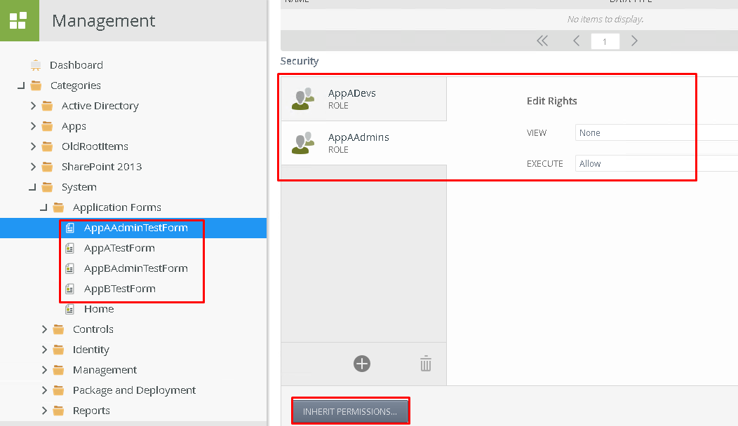

**5. Test results of permission settings.**

For check permissions settings of App Categories authorize in K2 with users from different roles.

**Anthony Petro** is member of **UsersOfApp_A** AD group (AppAUsers Role). And he does not have access to K2 Designer.

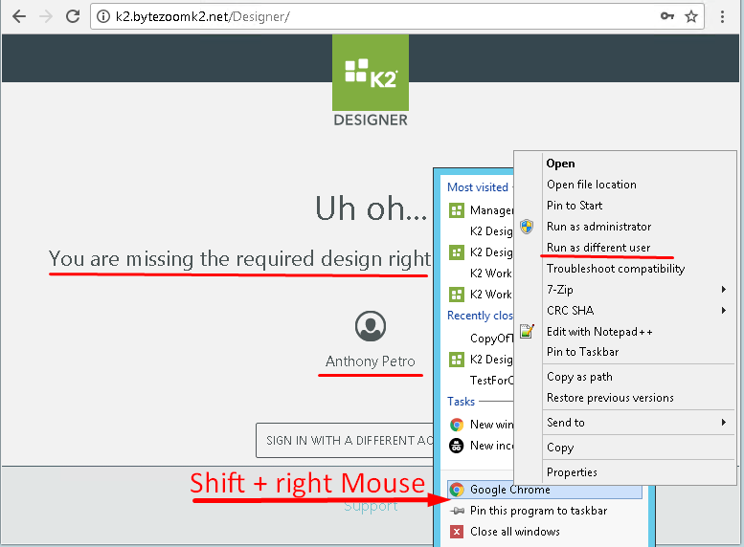

***Note:*** *For open Browser window with different users use right Button click of mouse with pressed Shift Key and select “Run as different user” item in context menu. Than Authorize with user credentials.*

**Anthony Petro** also does not have access to App Admin Forms or Management forms.

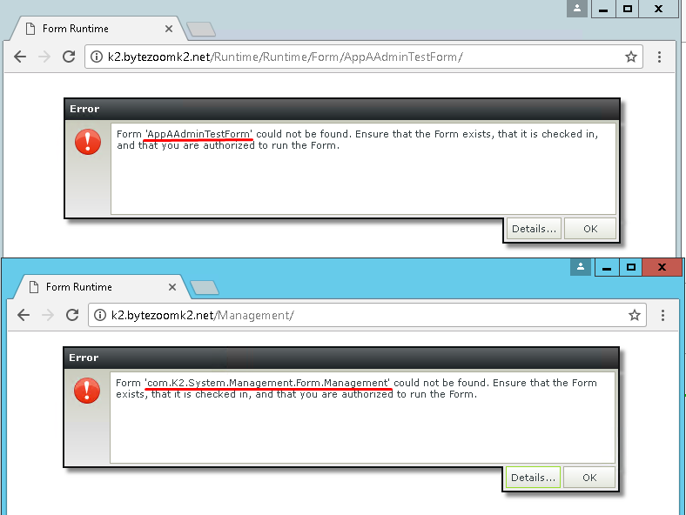

But **Anthony Petro** has access to “App A” Form And can see it in the Workspace.

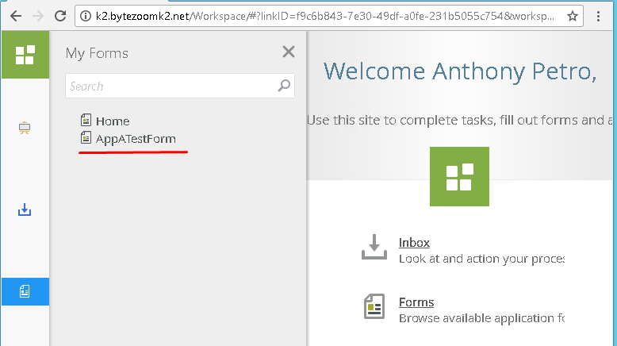

Another user **Rick Cowan** is member of DevsOfApp_A AD group (AppADevs Role). And he has access to K2 Designer and has access to “App A” Category. But can’t see “App B” Category.

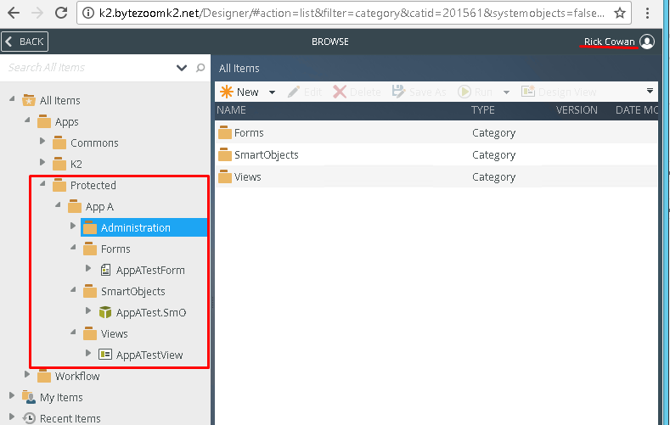

He can`t see “App B” Category in SmartObjects Services Tester utility also.

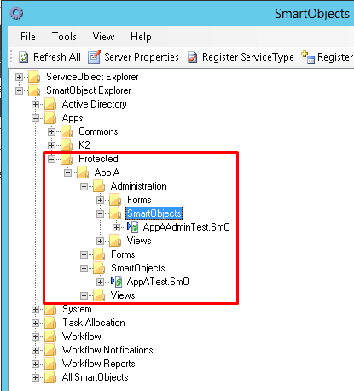

***Note:*** *check other rights yourself.*

**6. Review of tools from Bytezoom.**

**K2ResetIdentity** force refresh the K2 Identity cache for all Identity items (Roles, Groups, Users) or for specified Item. ServiceInstance has one required parameter "LabelName" and filled with default value. One Service instance used for refresh Identity Users and Groups Item filtered by LabelName and all Role items.

K2ResetIdentity has one ServiceObject "K2IdentityCache" with one Execute Method "SetExpireDate"

Method has 4 input properties ("AllItems", "Users", "Groups", "Roles") and one Return property "RowsAffected"

If first property equals to (true/yes) other input properties ignored, it will refresh and resolve all Identity Items.

"Users", "Groups", "Roles" properties used for specify which items need to refresh, names separated with ";"

if some groups specified it will also initiate to refresh and resolve all roles which include the group

For use it, copy **Bytezoom.Services.K2ResetIdentity.dll** to “Service Broker” in K2 Server program folder. Then Register via SmartObjects Services Tester utility and create Service instance and SmartObject.

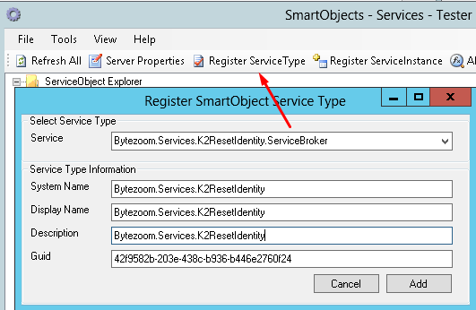 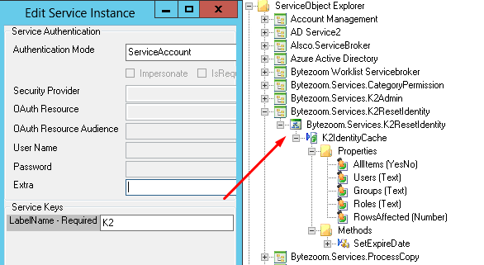

[<https://www.dropbox.com/s/kzpafvxr3nxqryp/Bytezoom.Services.K2ResetIdentity.dll?dl=0>]

It can be helpful when you add new members to AD groups but this groups already resolved and cached in K2.

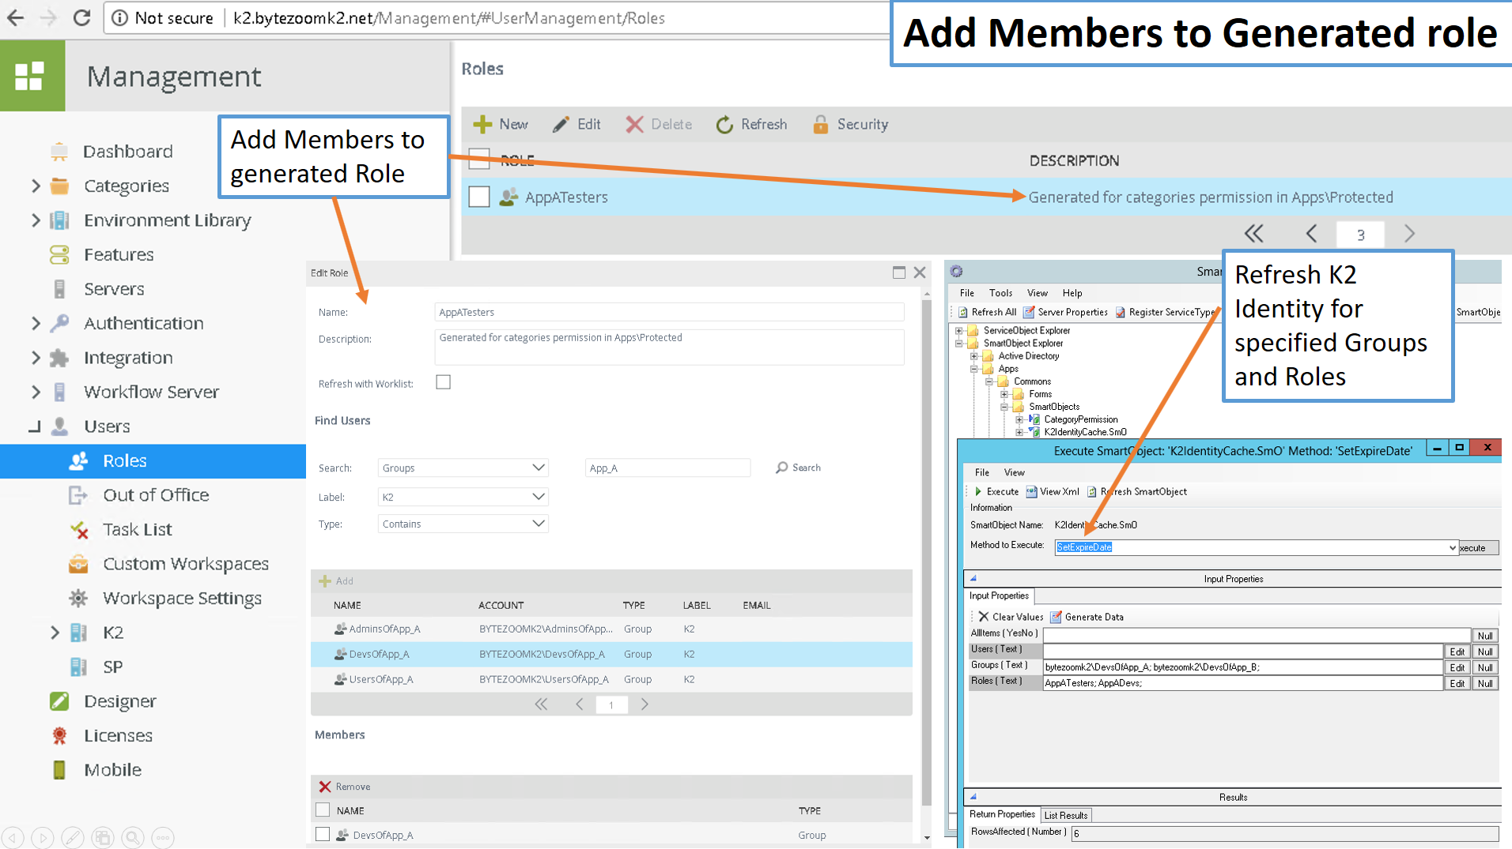

**Export/Import Category permissions** allows to move configured parameters to another server with same structures of categories. When Application moved to another server settings of permission will not deploy on destination Environment, because destination server can have different roles and AD users and groups. In this case the service broker allows export permission rights to JSON dump and import it to destination server. New roles will create automatically. Service broker has one ServiceObject “CategoryPermission” with methods “Export” and “Import”. Export Method required one input property “CategoryFullPath” and return “SerializedPermissions” memo with JSON. Import Method required one parameter “SerializedPermissions” and return list of new created roles “NewRoleFQN”. JSON dump looks easy and it can be modified manually.

For use it, copy **Bytezoom.Services.CategoryPermission.dll** to “Service Broker” in K2 Server program folder. Then Register via SmartObjects Services Tester utility and create Service instance and SmartObject.

[<https://www.dropbox.com/s/uqhhj32c7qx1r3f/Bytezoom.Services.CategoryPermission.dll?dl=0>]

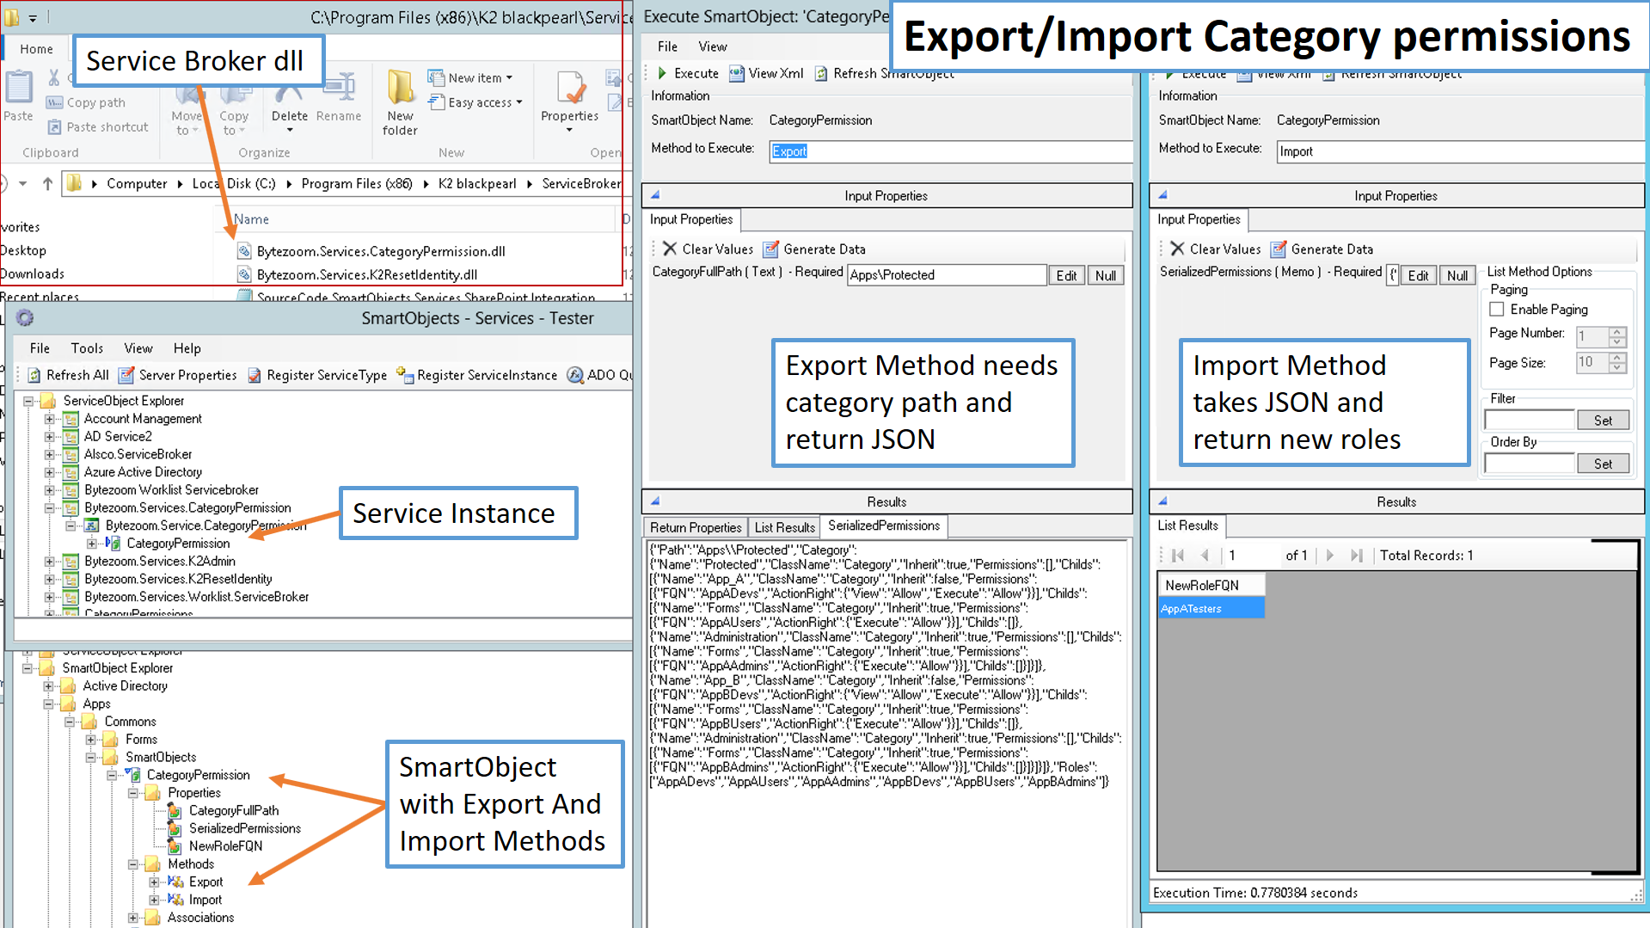

**CopyWorkflowProcess** allows to make copy of existing process with different name and project and save this copy to another Category on the server. K2Five Designer does not provide way to save copy of process same as save copy of form. In previous version it was easy deploy from renamed project of K2 studio or Visual Studio.

For Processes with SmartForm Integration after deploy new process needs to have SmartForm integration reconfigure. After copy process also needs to configure rights permissions.

Service broker has one ServiceObject “ProcessCopy” with method “DeployProcessAs”. The Method required 4 input properties “OriginFullName”, “ProjectName”, “ProcessName”, “CategoryPath” and return “Result” property. First input parameter for input full name of existing process, next input parameters are information for deploy new process.

For use it, copy **Bytezoom.Services.ProcessCopy.dll** to “Service Broker” in K2 Server program folder. Then Register via SmartObjects Services Tester utility and create Service instance and SmartObject.

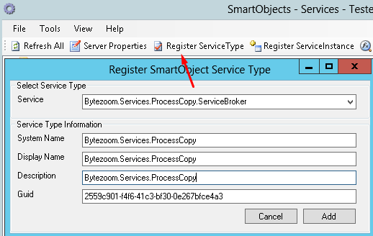 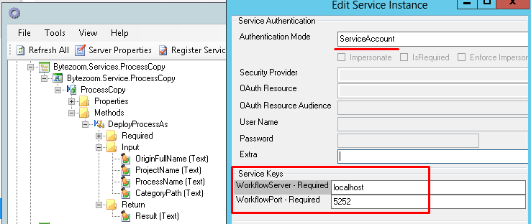

[<https://www.dropbox.com/s/tre6q21u6sglt3x/Bytezoom.Services.ProcessCopy.dll?dl=0>]

