 

 WORKDESK

ADMIN MANUAL

|  |  |  |  |
| --- | --- | --- | --- |
| Date | Version | Changed By | Changes |
| April 26, 2022 | Version 1.0 | Maryna Nikolaienko | Original Version |

Table of Contents

Review 4

Navigation menu 4

WORKDESK SETTINGS 4

Workdesk Settings 4

ADMINISTRATION MENU 8

User 8

Role Model 8

Landing List Visibility 9

Process Messages 10

Email Notifications 10

Component Versions 10

Process Info 11

Dictionaries 11

# Review

This document contains an admin guide for configuring and working with Workdesk (administration panel) for a Protocol process that uses the K2 Five application platform.

Workdesk is a tool, which helps to manage and configure applications.

The main window consists of three parts: the header, the navigation menu, and the main workspace window.

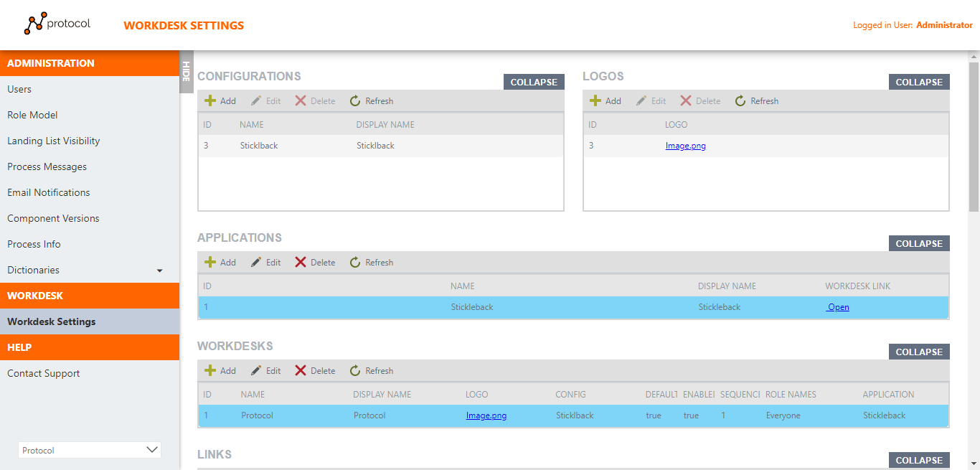

The Header displays the Process Logo, the currently selected menu name, and the current user’s name.

The navigation menu consists of the main menu and its sub-menu, as well as a drop-down list at the bottom, to go to another workdesk (if any).

The main window of the workspace displays the contents of the selected navigation menu

# Navigation menu

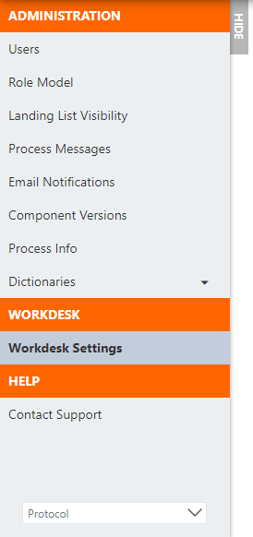

This menu consists of the main menu Administration, Workdesk, Help, and sub-menus, as well as a drop-down list with the ability to switch to another workdesk and a Hide button that allows you to collapse this menu.

## WORKDESK SETTINGS

This menu allows you to configure both a new workdesk and edit an existing one. To do this, go to the Workdesk Settings link and fill in the proposed data tables in the main working window.

### Workdesk Settings

On the Workdesk Settings tab, you can add applications, logos, menu links, users and determine their roles, also manage the appearance by changing colors and fonts. There are seven configuration view available in this submenu: Configurations, Logos, Applications, Workdesks, Links, Roles, Role Members. Also, for each table, there is a toolbar with functional buttons and a button that allows you to Collapse / Expand the table for more convenient work.

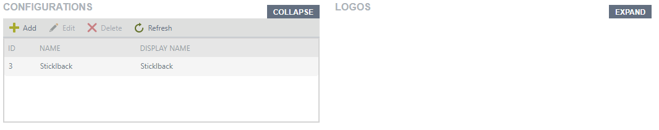

The Add button opens a pop-up window in which configuration data is entered.

The Edit button allows you to edit an existing setting in a pop-up window

The Delete button deletes the selected entry

The Refresh button refreshes the table

A button that allows you to Collapse / Expand the table

* Configuration

In the pop-up window of this view, the required fields Name, Display Name, as well as the color configuration of the entire system of fonts, backgrounds, and buttons are filled. If desired, you can edit the current styling for each control.

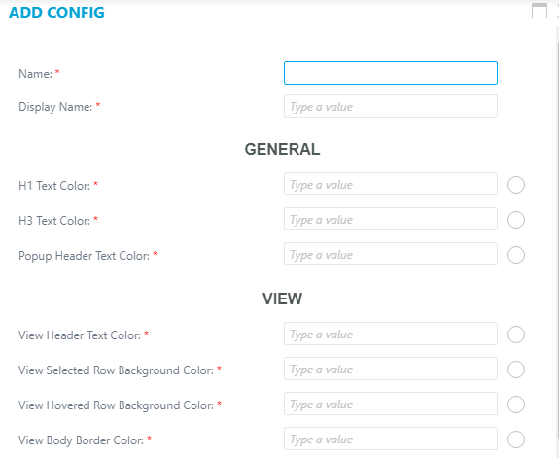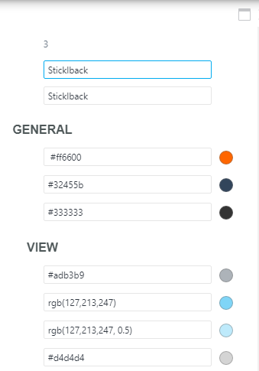

To customize the appearance of the application, enter the color numbers and you will immediately see how the color in the circle for the corresponding entry will look. After filling in all the required fields, click the Save button.

*\* Note. The "Cancel" button will cancel all changes made.*

* Logos

This view is intended for loading/changing the logo.

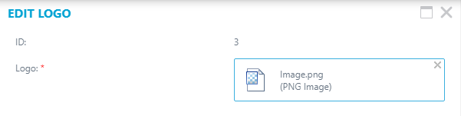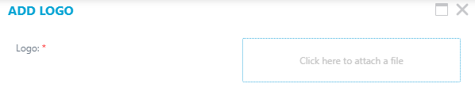

The Add button opens a panel where you want to attach a file. After you have attached the file, click on the Save button.

To change the logo, select the desired line and click the "Edit" button. In the panel that opens, delete the previous logo and attach a new logo file. After changing the logo, click the Save button.

*\*Note, that the Cancel button cancels the changes.*

* Applications

Applications view helps to configure applications.

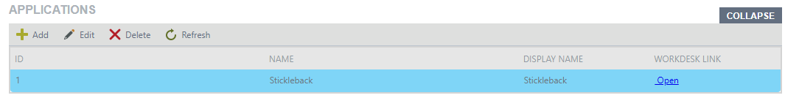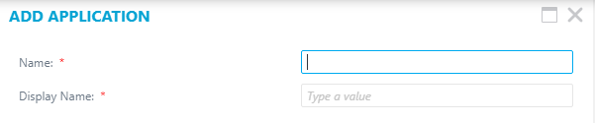

After you enter the name of the application, click on the Save button.

*\*Note. The Cancel button cancels the changes.*

The app link will be generated, you can see it in the Workdesk Link.

* Workdesks

This view helps you add and customize the desktops that will be in your application. For this it is necessary for the window that opens, to enter a name and a display name for the desktop. Select a logo and configuration from those you add to the Logos and Configurations views, respectively. Enter the desktop sequence where the desktops will be displayed. After that, select the roles of users who can see this menu on navigation panel (there can be several roles).

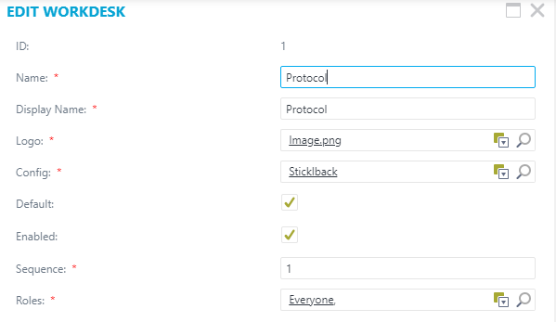

If you check the "Default" checkbox, this desktop will be open when you launch the Workdesk tool. If you select the Enabled checkbox, this desktop will be viewable.

After adding, click the Save button.

*\* Note that the Cancel button cancels the changes.*

* Links

The "Links" view is designed to populate the navigation menu located on the left Navigation menu.

*\*Note, to configure links you should at the first select application from the Applications view and workdesk from the Workdesk view, where you will use links.*

*\*If you create the first link for workdesk, the default would be the Header link.*

To add a new link, click the Add button, then in the window that opens enter:

Enter Name and Display name. Fill in the Description field if you need it. Choose the Type from the drop-down list, it could be a Link or Header.

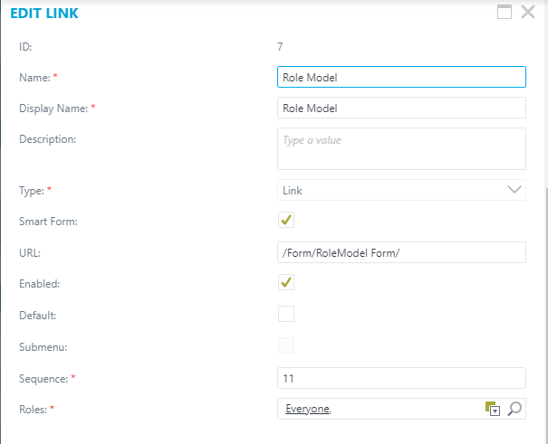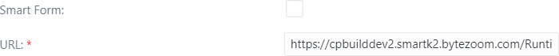

If you do not choose the Smart Form checkbox, you should enter the whole URL address, otherwise, you need to enter only part of it, for example:

Filling example: /Form/ Form name

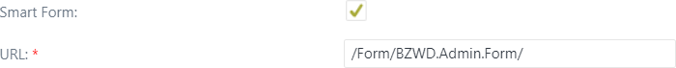

If you check the Default checkbox, this link will be open, when you open the Wokdesk. If you check the Enabled checkbox, this link will be available to see.

Check in Submenu checkbox if you want this link to be in the submenu of the other links. Then you should choose the Sequence of links on the left sidebar. This value determines the order in which menus are placed in the navigation bar and makes it easy to add a new entry in the right place. After, choosing the roles of users, who can see this menu on navigation panel (there can be several roles). After adding, click on the Save button.

*\*Note, the cancel button will cancel changes.*

* Roles

This view is used for assigning roles.

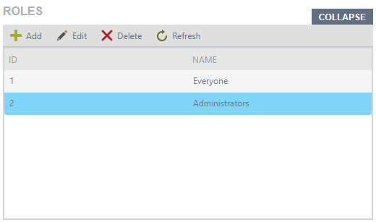

Add button opens a panel, where you should enter the name of the role. After you enter the name, click on the Save button.

*\* Note, that the Cancel button will cancel changes.*

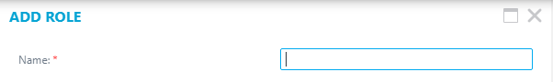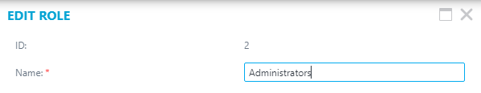

* Role Members

This view for assigning members to the role.

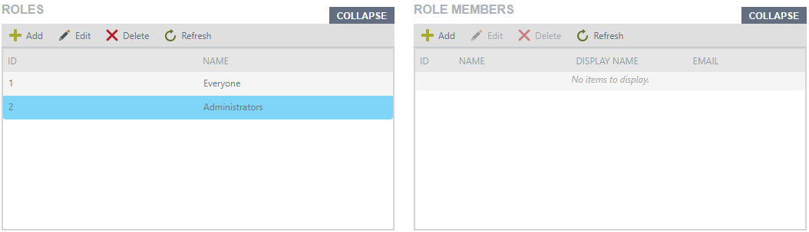

To add a New Role Member, first, Select the role from the Roles view and click on the Add button in the Role Members view.

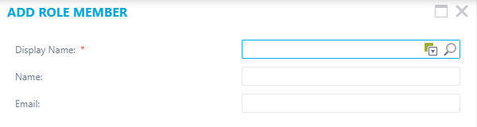

Add button opens a panel, where you should fill in fields. After you add a role member, click on the Save button.

*\* Note, that users cannot edit or delete themselves.*

*\* Note, that the Cancel button will cancel changes.*

## ADMINISTRATION MENU

### User

In this view, users are configured who will have access to the system and its role in this system, respectively.

When adding a new record, you must select the DISPLAY NAME in the picker, after which most of the fields from Active Directory will be automatically filled with data. Required fields include EMPLOYEE ID, TYPE, and INITIALS.

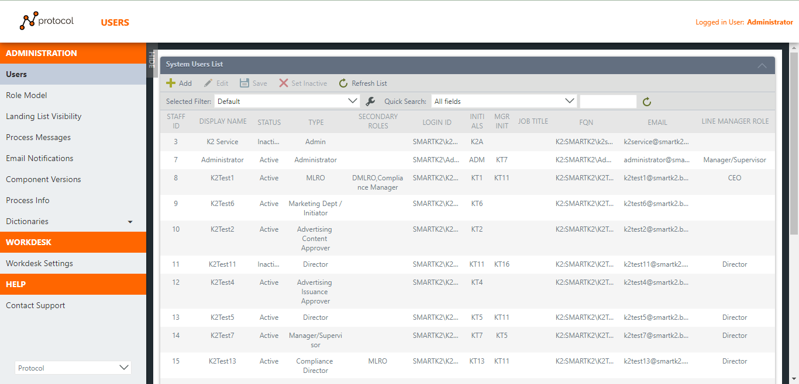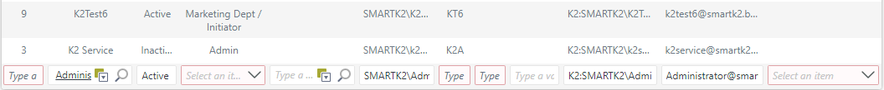

The Add button adds a new entry.

The Edit button allows you to modify an existing selected entry.

The Save button saves the new or updated entry.

The Set Inactive/Set Active button puts any user in the corresponding status

The Delete button deletes the selected entry

The Refresh button refreshes the table.

### Role Model

This view has a setting for each role component and a specification of which Main Hamburger Menu items will be available for use There are two Component Versions:

* The Custom version shows for each role set menu access rights for selected Custom component
* Master version shows all settings for all roles and all components

To display any of the Hamburger menu items, when adding or changing an entry, select the component of interest, the role, and set the checkboxes in accordance with the desired visualization

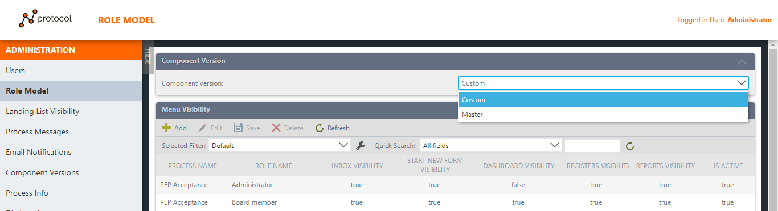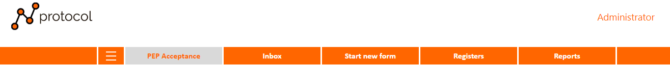

An example of visualizing the current setting of the Hamburger menu of the PEP Acceptance component of the Administrator role

### Landing List Visibility

For each component and role, the property of displaying processes in the Landing List is set. There are four types of access:

* All – all processes will be available for viewing in the landing list
* Process Involvement - only those processes in which the current user of this component participated will be available for viewing
* Subordinate involvement - processes in which the current user's subordinates participated for this component will be available for viewing (for this, subordination is applied according to the principle of a line manager)
* Client entity involvement - processes in which the current user's client participated for this component will be available for viewing

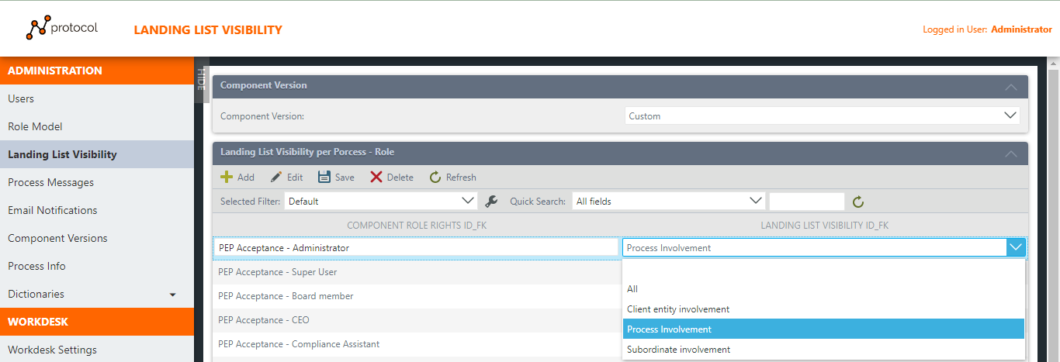

*\* The exception is the SuperUser role which has the ability to see all processes*

*\* SAR Component user has the ability to see the process if he is in the role of MLRO / DMLRO, this is configured programmatically.*

### Process Messages

In this menu, you can configure the Title and Messages of all message boxes that will be shown for each Component at a specific Step with a determined Action selected after the form is submitted.

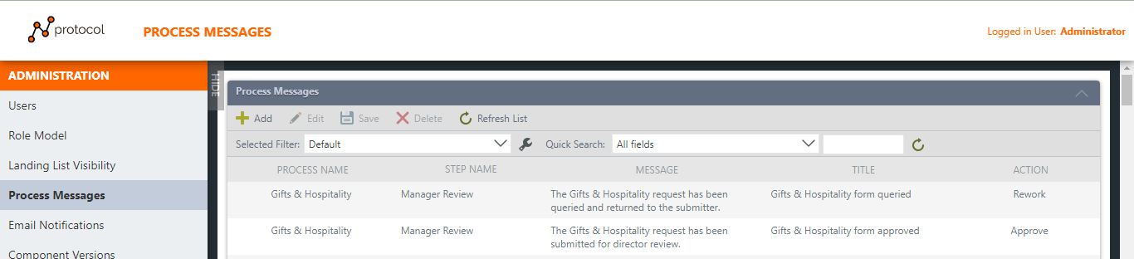

An example of what the Message box will look like when displayed after submitting for the Gifts & Hospitality Process on the Manager Review Step with the Approve Action selected.

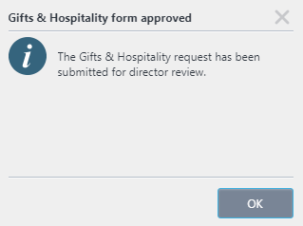

### Email Notifications

In this menu, you can configure the Subject and Body Email Notifications that will be sent for each Component at a specific Step with a determined Action selected.

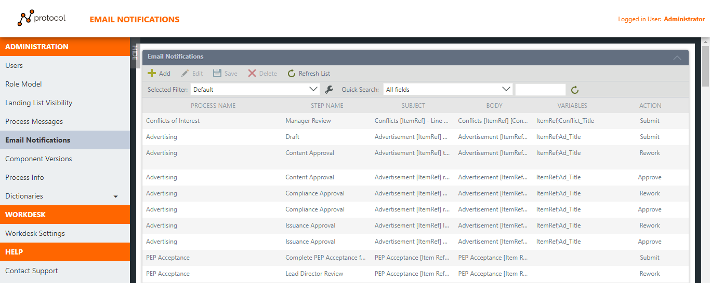

The Variables column contains a specific value (field name from the Database), the value of which is configured to display in the Subject or Body of the Email notification. In specified email, these Variables will be automatically replaced by the system with the corresponding values specified in the process instance

### Component Versions

This view displays all Component names, their ITEM REF CONST, and START NEW FORM LINK. Provided that the component has versioning, you can switch in this table by selecting the required version of the selected component by clicking on the Set Default Version button from the drop-down list, and then be sure to click the Save button. After saving the changes, the specified version of the component will be used when starting a new process of the selected component

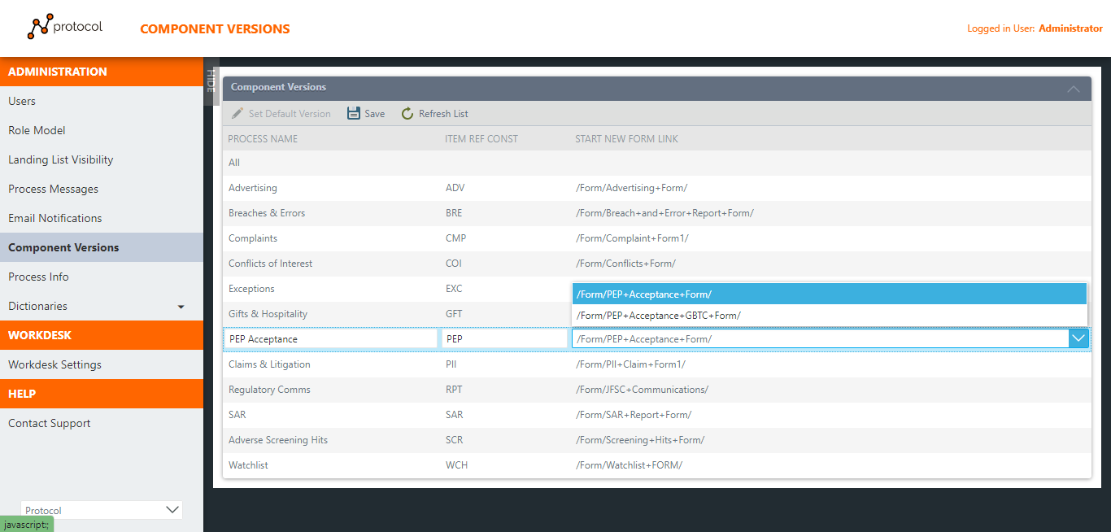

### Process Info

This view provides the ability to edit links to the Start New Form, link to the Worklist form, Power BI URL, and Register URL.

At the same time, the Component Version menu is also available in which Master will display a complete list of all components and links, and in the Custom version, only those components that have several versions.

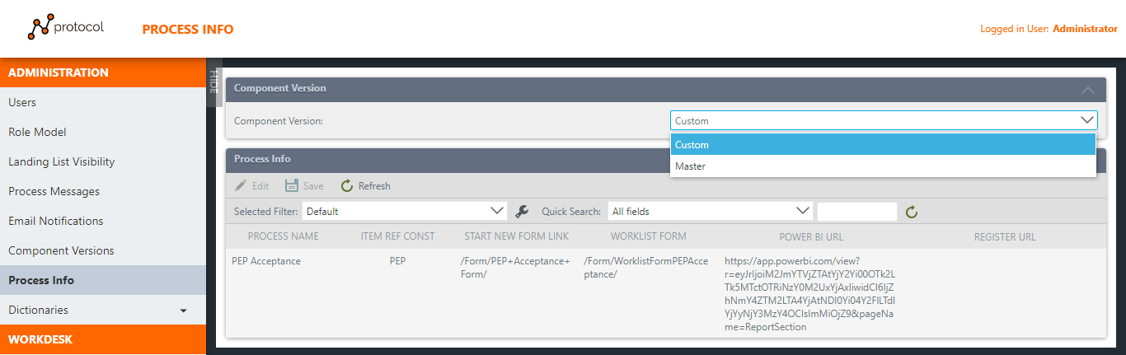

### Dictionaries

This is a group of links that has the type of directories. And filled in manually or directly through the database. For the convenience of filling in any of the directories, a toolbar and a filter is located in the upper part of the view.

