## Links

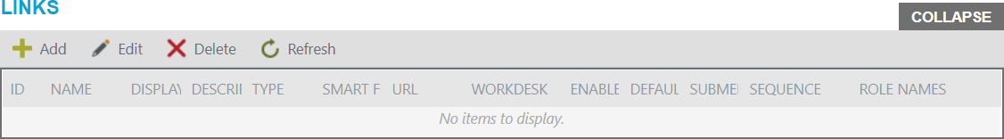Links view helps to confing links on your workdesk.

*Note, to configure links you should at first select application from the Applications view and workdesk from the Workdesk view, where you will use links.*

To add new link, select application and workdesk, then click Add button on the Links view.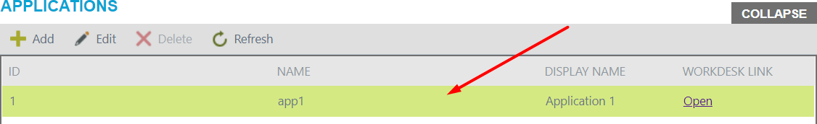

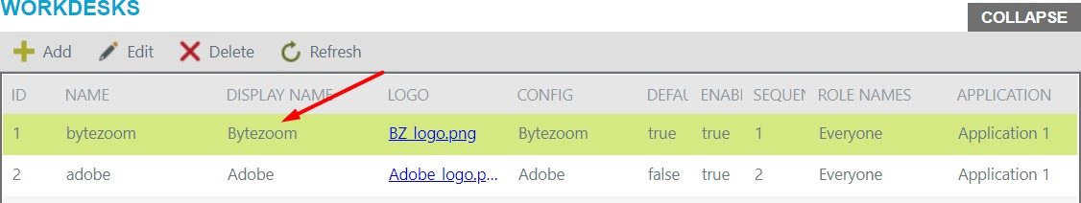

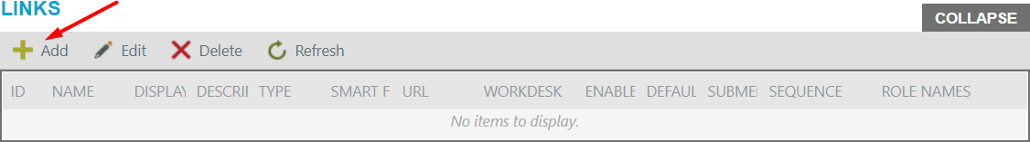

Add button opens a panel.

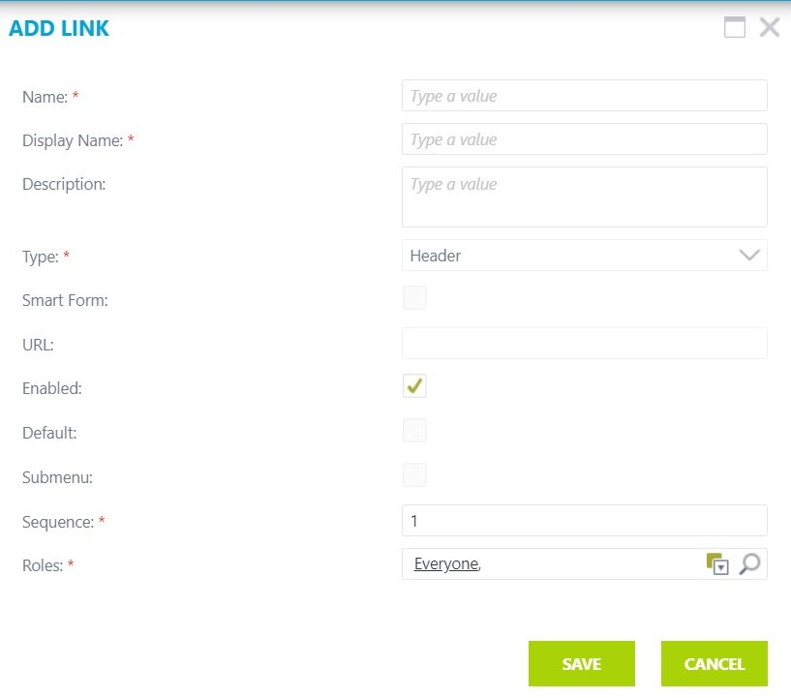If you create first link for workdesk, default it would be header link.

Enter name and display name. Fill in the Description field if you need. Choose the type from the drop-down list, it could be link or header. If you do not choose the Smart Form checkbox, you should enter the whole URL address, otherwise you need to enter only part of it, for example:

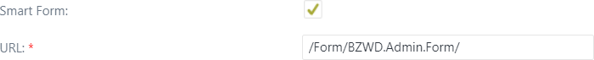

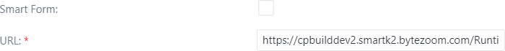If you check Default checkbox, this link will be open, when you open the Wokdesk. If you check Enabled checkbox, this link will be available to see. Check in Submenu checkbox if you want this link to be in submenu of other link. Then you should choose the sequence of link on left side bar. After, choose roles of users, who can see the link, there are could be several roles.

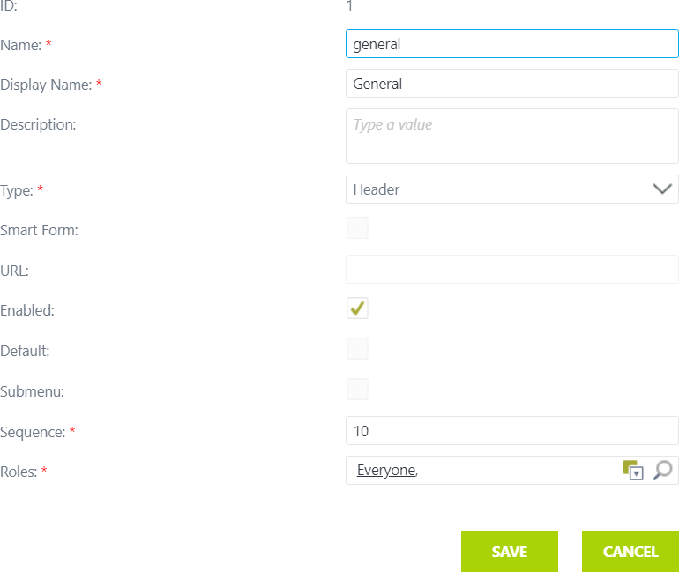

After adding, click on the Save button.

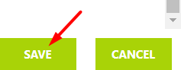

*Note, cancel button will cancel changes.*

### Edit

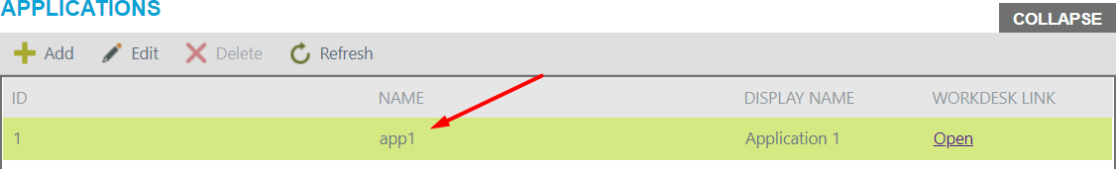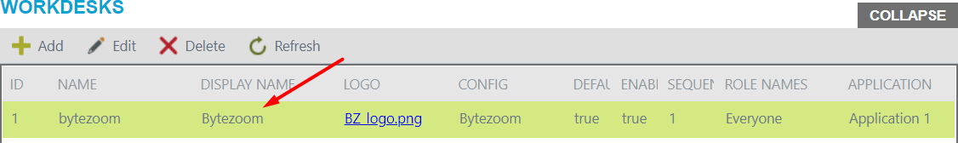To modify the link, select application and workdesk, then click on the link row you interested in and click Edit button.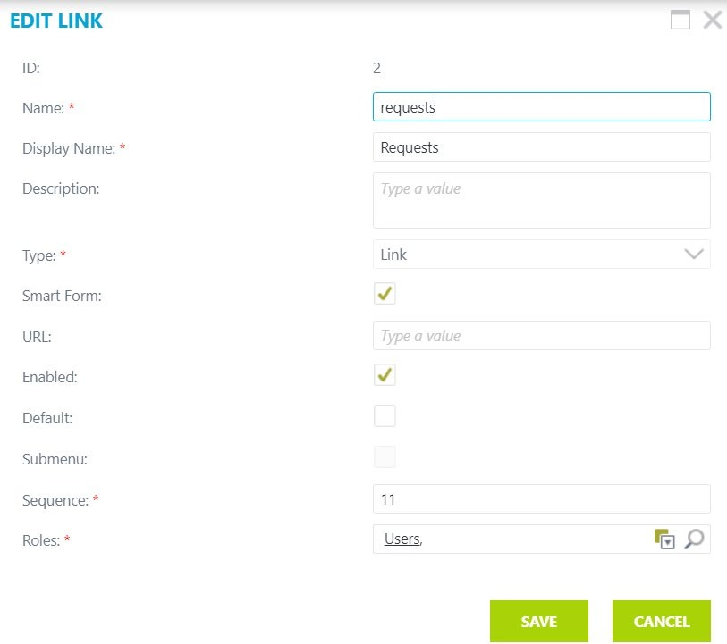Edit button opens a panel, where you should make changes.

After editing the link, click on the Save button.



*Note, cancel button will cancel changes.*

### Delete

To delete the link, select application and workdesk, click on the link row on the Links view and click the Delete button.

### Refresh

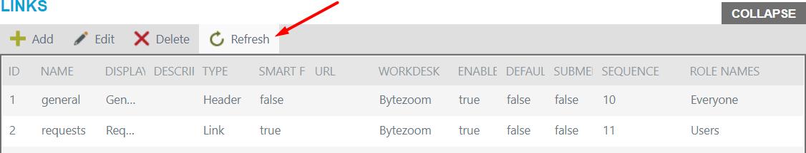To refresh the list, click Refresh.

## Roles

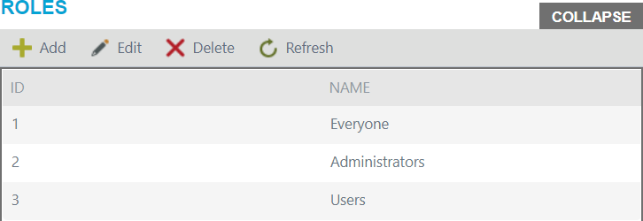This view used for assigning roles.

Buttons:

* + Add
  + Edit
  + Delete
  + Refresh

### Add

To add new role, click on the Add button.

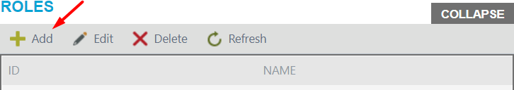

Add button opens a panel, where you should enter the name of the role.

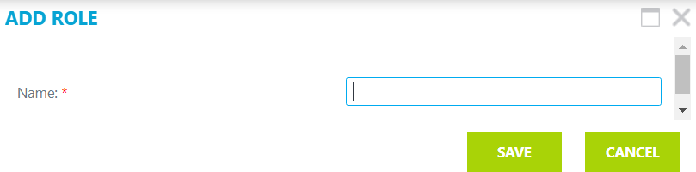

After you enter the name, click on the Save button.

*Note, cancel button will cancel changes.*

### Edit

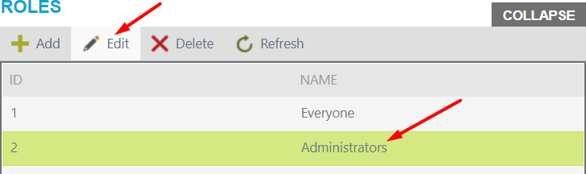To modify role, click on the row you interested in and click Edit button.

Edit button opens a panel, where you should rename the role.

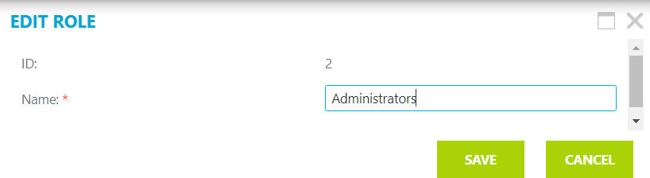

After making changes, click on the Save button.

*Note, cancel button will cancel changes.*

### Delete

To delete the role, select required row and click on the Delete button.

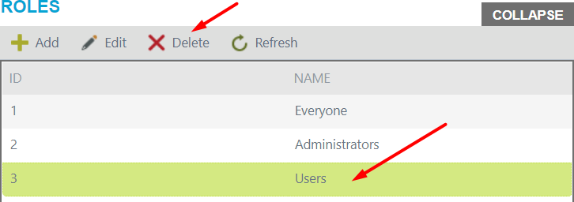

*Note, users cannot edit or delete the same role they are.*

### Refresh

To refresh the list, click Refresh.

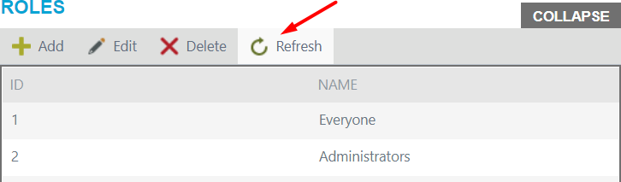

## Roles members

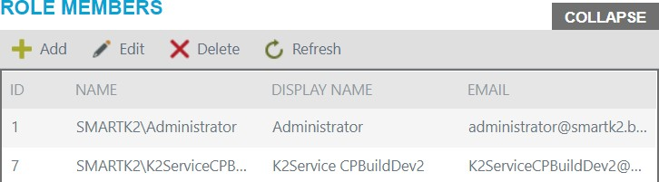This view for assigning members to the role.

Buttons:

* + Add
  + Edit
  + Delete
  + Refresh

### Add

To add new role member, first select the role from the Roles view and click on the Add button the Role Members view.

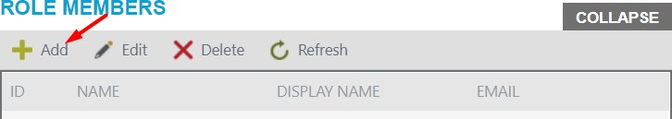

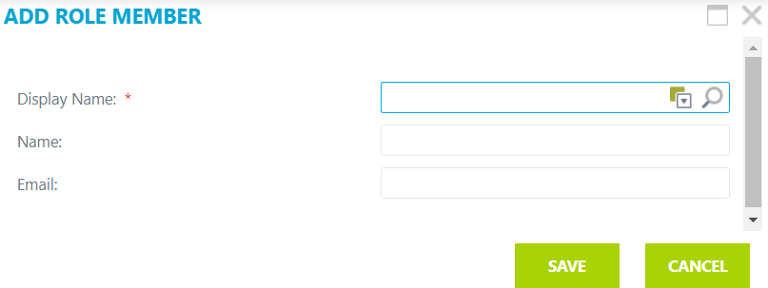Add button opens a panel, where you should fill in fields.

After you add a role member, click on the Save button.



*Note, cancel button will cancel changes.*

### Edit

To modify role member information, select role from Roles view, then select role member you interested in and click Edit button.

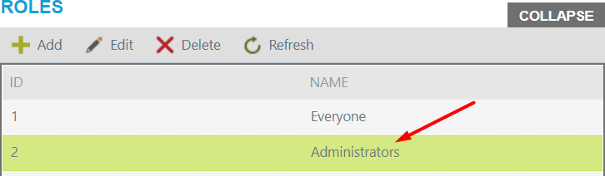

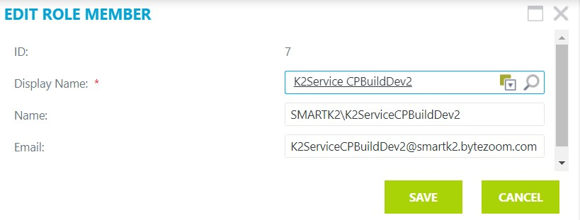Edit button opens a panel, where you should make changes.

After making changes, click on the Save button.



*Note, cancel button will cancel changes.*

### Delete

To delete, click on the role you are interested in and click the Delete button.

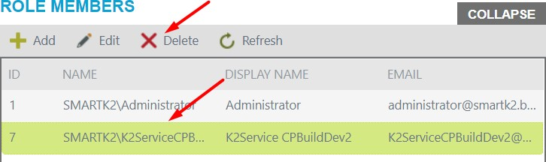

### Refresh

To refresh the list, click Refresh.

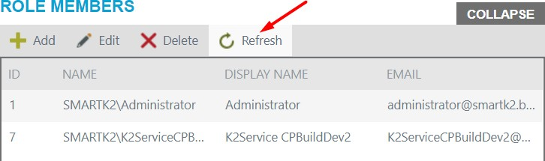

*Note, users cannot edit or delete themselves.*