# Whitewater Rafting Site Branding & Style Guide

## Logo:

File name: whitewater_rafting_logo.png

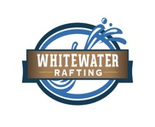

## Color Palette

Primary Color: #005f73

Secondary Color: #0a9396

Accent1 Color: #94d2bd

Accent2 Color: #e9d8a6

Color Palette URL: https://coolors.co/005f73-0a9396-94d2bd-e9d8a6

## Typography

Heading Font: Bebas Neue

Text Font: Open Sans