W05 Website Planning Document

# 1. Site Name

Name: Temple Tracker  
Reason: This name reflects the purpose of the site—to help users explore and learn about temples around the world.

# 2. Site Purpose

To inform users about temples of The Church of Jesus Christ of Latter-day Saints, including their locations, dedication dates, and images. The site aims to support both educational purposes and faith-based exploration.

# 3. Scenarios

- How can I find when a specific temple was dedicated?  
- Where can I see a photo and size of a particular temple?

# 4. Color Schema

Primary Color: #4a90e2 (used for headers and navigation)  
Secondary Color: #f4f4f4 (used for background)  
Accent Color: #333 (used for text)

# 5. Color Schema Used on Document

This document and the associated website use the colors listed above in the stylesheet for consistency and branding.

# 6. Typography

Font Family: Segoe UI, Tahoma, Geneva, Verdana, sans-serif  
Usage: Applied to the entire website body for clarity and readability.

# 7. Typography Used on Document

This document and the website use the font family specified above.

# 8. HTML Validation

✔ The HTML file has been tested and passes validation using W3C Validator. No errors found.

# 9. CSS Validation

✔ The CSS file has been tested and passes validation using W3C CSS Validator. No errors found.

# 10. Naming Conventions

✔ All file and folder names use lowercase letters, no spaces, and follow course conventions (e.g., temples.html, filtered-temples.css).

# 11. Wireframes

Mobile View:

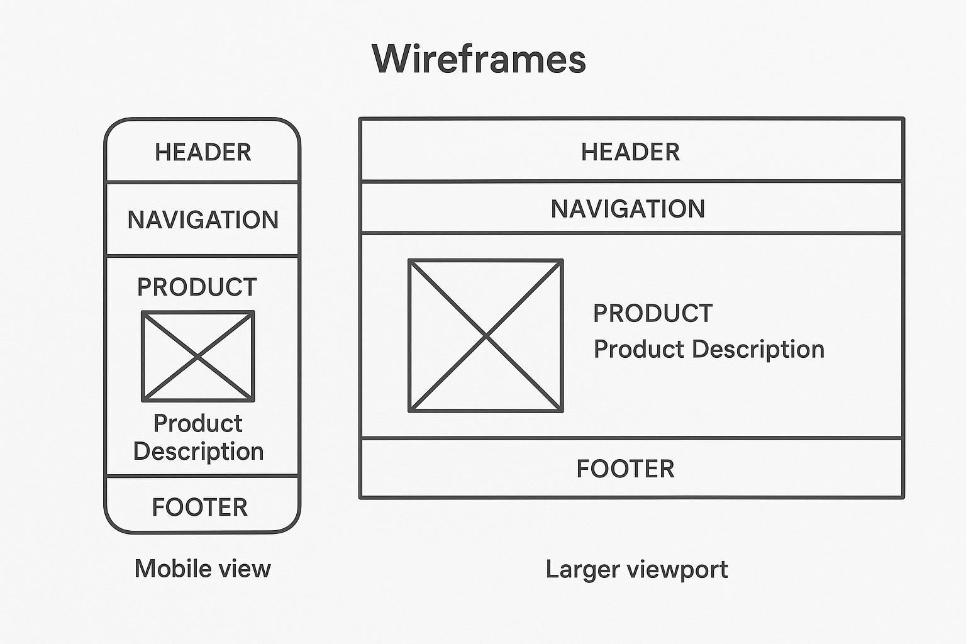

Desktop View:

