**Instructions :**

* ***Reference: Lectures In Snowflake & SQL folder (AWA - APP+WEBSITE)***
* ***Due Date : 15th-Nov-2023 11:59 PM(Midnight)***
* ***Late submissions will not be evaluated***
* ***Its mandatory to do all questions***
* ***Use SNOWFLAKE for the task submission while for practice one can execute in MySQL Workbench too.***
* ***Proper comments should be given for the code explanation wherever required.***
* ***Proper snippets should be attached of the output(mandatory) and write the code too.***
* ***Don’t do plagiarism***
* ***Kindly don’t USE JOINS or WINDOWS functions in any of the problems.***
* ***Kindly upload the assignment by uploading it in the below GOOGLE DRIVE FOLDER as per the mentioned format(only pdf) as fullname_assignment_name_ yyyy_mm_dd.pdf(anandjha_sql_assignment5_2023_09_20.pdf) :***
* ***If possible , create a ppt and video and share across linkedin and tag ANALYTICSWITHANAND & Me(Anand Jha) in order to reach visibility***

LINK for Upload: <https://drive.google.com/drive/folders/1f6374BbUE07FOUPp-TpMY7M6OG7yg5cE?usp=sharing>

**Part 1: Getting Started**

SQL seed file provided for a vehicle owner database. From the provided seed data, create queries to:

* Join the two tables so that every column and record appears, regardless of if there is not an owner_id.
* Count the number of cars for each owner. Display the owners first_name, last_name and count of vehicles.
* Count the number of cars for each owner and display the average price for each of the cars as integers. Display the owners first_name, last_name, average price and count of vehicles.

**CREATE OR REPLACE DATABASE** initials_joins_exercise_assignment_6;

**CREATE OR REPLACE TABLE** *owners*

**(id PRIMARY KEY,**

**first_name VARCHAR(20),**

**last_name VARCHAR(20));**

**CREATE TABLE** *vehicles*

**(id PRIMARY KEY,**

**make VARCHAR(20),**

**model VARCHAR(20),**

**year INTEGER,**

**price REAL,**

**owner_id INTEGER REFERENCES owners (id));**

INSERT INTO owners (first_name, last_name) VALUES ('Bob', 'Hope');

INSERT INTO owners (first_name, last_name) VALUES ('Jane', 'Smith');

INSERT INTO owners (first_name, last_name) VALUES ('Melody', 'Jones');

INSERT INTO owners (first_name, last_name) VALUES ('Sarah', 'Palmer');

INSERT INTO owners (first_name, last_name) VALUES ('Alex', 'Miller');

INSERT INTO owners (first_name, last_name) VALUES ('Shana', 'Smith');

INSERT INTO owners (first_name, last_name) VALUES ('Maya', 'Malarkin');

INSERT INTO vehicles (make, model, year, price, owner_id) VALUES ('Toyota', 'Corolla', 2002, 2999.99, 1);

INSERT INTO vehicles (make, model, year, price, owner_id) VALUES ('Honda', 'Civic', 2012, 12999.99, 1);

INSERT INTO vehicles (make, model, year, price, owner_id) VALUES ('Nissan', 'Altima', 2016, 23999.99, 2);

INSERT INTO vehicles (make, model, year, price, owner_id) VALUES ('Subaru', 'Legacy', 2006, 5999.99, 2);

INSERT INTO vehicles (make, model, year, price, owner_id) VALUES ('Ford', 'F150', 2012, 2599.99, 3);

INSERT INTO vehicles (make, model, year, price, owner_id) VALUES ('GMC', 'Yukon', 2016, 12999.99, 3);

INSERT INTO vehicles (make, model, year, price, owner_id) VALUES ('GMC', 'Yukon', 2014, 22999.99, 4);

INSERT INTO vehicles (make, model, year, price, owner_id) VALUES ('Toyota', 'Avalon', 2009, 12999.99, 4);

INSERT INTO vehicles (make, model, year, price, owner_id) VALUES ('Toyota', 'Camry', 2013, 12999.99, 4);

INSERT INTO vehicles (make, model, year, price, owner_id) VALUES ('Honda', 'Civic', 2001, 7999.99, 5);

INSERT INTO vehicles (make, model, year, price, owner_id) VALUES ('Nissan', 'Altima', 1999, 1899.99, 6);

INSERT INTO vehicles (make, model, year, price, owner_id) VALUES ('Lexus', 'ES350', 1998, 1599.99, 6);

INSERT INTO vehicles (make, model, year, price, owner_id) VALUES ('BMW', '300', 2012, 22999.99, 6);

INSERT INTO vehicles (make, model, year, price, owner_id) VALUES ('BMW', '700', 2015, 52999.99, 6);

**Part 2: Getting Started : UEFA EURO 2012 Football Championship**

The tables contain all matches and goals from **UEFA EURO 2012 Football Championship** in Poland and Ukraine.

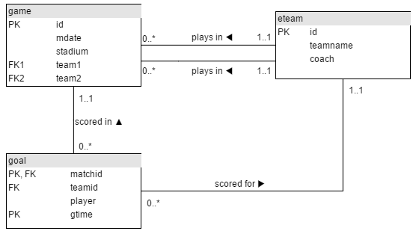

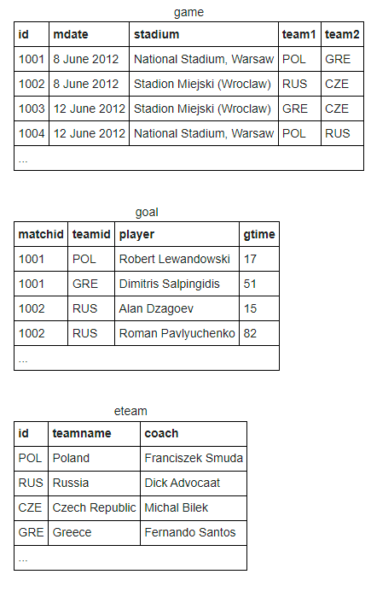

**Implement the above database design in Snowflake/MySQL Workbench and answer the below question**

**SET FOREIGN_KEY_CHECKS = 0;**

**-- Table structure for eteam**

**-- ----------------------------**

**DROP TABLE IF EXISTS `eteam`;**

**CREATE TABLE `eteam` (**

**`id` varchar(3) DEFAULT NULL,**

**`teamname` varchar(50) DEFAULT NULL,**

**`coach` varchar(50) DEFAULT NULL**

**)**

**-- ----------------------------**

**-- Records of eteam**

**-- ----------------------------**

**INSERT INTO `eteam` VALUES ('POL', 'Poland', 'Franciszek Smuda');**

**INSERT INTO `eteam` VALUES ('RUS', 'Russia', 'Dick Advocaat');**

**INSERT INTO `eteam` VALUES ('CZE', 'Czech Republic', 'Michal Bílek');**

**INSERT INTO `eteam` VALUES ('GRE', 'Greece', 'Fernando Santos');**

**INSERT INTO `eteam` VALUES ('NED', 'Netherlands', 'Bert van Marwijk');**

**INSERT INTO `eteam` VALUES ('DEN', 'Denmark', 'Morten Olsen');**

**INSERT INTO `eteam` VALUES ('GER', 'Germany', 'Joachim Löw');**

**INSERT INTO `eteam` VALUES ('POR', 'Portugal', 'Paulo Bento');**

**INSERT INTO `eteam` VALUES ('ESP', 'Spain', 'Vicente del Bosque');**

**INSERT INTO `eteam` VALUES ('ITA', 'Italy', 'Cesare Prandelli');**

**INSERT INTO `eteam` VALUES ('IRL', 'Republic of Ireland', 'Giovanni Trapattoni');**

**INSERT INTO `eteam` VALUES ('CRO', 'Croatia', 'Slaven Bilic');**

**INSERT INTO `eteam` VALUES ('UKR', 'Ukraine', 'Oleh Blokhin');**

**INSERT INTO `eteam` VALUES ('SWE', 'Sweden', 'Erik Hamrén');**

**INSERT INTO `eteam` VALUES ('ENG', 'England', 'Roy Hodgson');**

**INSERT INTO `eteam` VALUES ('FRA', 'France', 'Laurent Blanc');**

**COMMIT;**

**-- ----------------------------**

**-- Table structure for game**

**-- ----------------------------**

**DROP TABLE IF EXISTS `game`;**

**CREATE TABLE `game` (**

**`id` int NOT NULL,**

**`mdate` varchar(12) DEFAULT NULL,**

**`stadium` varchar(100) DEFAULT NULL,**

**`team1` varchar(100) DEFAULT NULL,**

**`team2` varchar(100) DEFAULT NULL,**

**PRIMARY KEY (`id`)**

**)**

**-- ----------------------------**

**-- Records of game**

**-- ----------------------------**

**INSERT INTO `game` VALUES (1001, '8 June 2012', 'National Stadium, Warsaw', 'POL', 'GRE');**

**INSERT INTO `game` VALUES (1002, '8 June 2012', 'Stadion Miejski (Wroclaw)', 'RUS', 'CZE');**

**INSERT INTO `game` VALUES (1003, '12 June 2012', 'Stadion Miejski (Wroclaw)', 'GRE', 'CZE');**

**INSERT INTO `game` VALUES (1004, '12 June 2012', 'National Stadium, Warsaw', 'POL', 'RUS');**

**INSERT INTO `game` VALUES (1005, '16 June 2012', 'Stadion Miejski (Wroclaw)', 'CZE', 'POL');**

**INSERT INTO `game` VALUES (1006, '16 June 2012', 'National Stadium, Warsaw', 'GRE', 'RUS');**

**INSERT INTO `game` VALUES (1007, '9 June 2012', 'Metalist Stadium', 'NED', 'DEN');**

**INSERT INTO `game` VALUES (1008, '9 June 2012', 'Arena Lviv', 'GER', 'POR');**

**INSERT INTO `game` VALUES (1009, '13 June 2012', 'Arena Lviv', 'DEN', 'POR');**

**INSERT INTO `game` VALUES (1010, '13 June 2012', 'Metalist Stadium', 'NED', 'GER');**

**INSERT INTO `game` VALUES (1011, '17 June 2012', 'Metalist Stadium', 'POR', 'NED');**

**INSERT INTO `game` VALUES (1012, '17 June 2012', 'Arena Lviv', 'DEN', 'GER');**

**INSERT INTO `game` VALUES (1013, '10 June 2012', 'PGE Arena Gdansk', 'ESP', 'ITA');**

**INSERT INTO `game` VALUES (1014, '10 June 2012', 'Stadion Miejski (Poznan)', 'IRL', 'CRO');**

**INSERT INTO `game` VALUES (1015, '14 June 2012', 'Stadion Miejski (Poznan)', 'ITA', 'CRO');**

**INSERT INTO `game` VALUES (1016, '14 June 2012', 'PGE Arena Gdansk', 'ESP', 'IRL');**

**INSERT INTO `game` VALUES (1017, '18 June 2012', 'PGE Arena Gdansk', 'CRO', 'ESP');**

**INSERT INTO `game` VALUES (1018, '18 June 2012', 'Stadion Miejski (Poznan)', 'ITA', 'IRL');**

**INSERT INTO `game` VALUES (1019, '11 June 2012', 'Donbass Arena', 'FRA', 'ENG');**

**INSERT INTO `game` VALUES (1020, '11 June 2012', 'Olimpiyskiy National Sports Complex', 'UKR', 'SWE');**

**INSERT INTO `game` VALUES (1021, '15 June 2012', 'Donbass Arena', 'UKR', 'FRA');**

**INSERT INTO `game` VALUES (1022, '15 June 2012', 'Olimpiyskiy National Sports Complex', 'SWE', 'ENG');**

**INSERT INTO `game` VALUES (1023, '19 June 2012', 'Donbass Arena', 'ENG', 'UKR');**

**INSERT INTO `game` VALUES (1024, '19 June 2012', 'Olimpiyskiy National Sports Complex', 'SWE', 'FRA');**

**INSERT INTO `game` VALUES (1025, '21 June 2012', 'National Stadium, Warsaw', 'CZE', 'POR');**

**INSERT INTO `game` VALUES (1026, '22 June 2012', 'PGE Arena Gdansk', 'GER', 'GRE');**

**INSERT INTO `game` VALUES (1027, '23 June 2012', 'Donbass Arena', 'ESP', 'FRA');**

**INSERT INTO `game` VALUES (1028, '24 June 2012', 'Olimpiyskiy National Sports Complex', 'ENG', 'ITA');**

**INSERT INTO `game` VALUES (1029, '27 June 2012', 'Donbass Arena', 'POR', 'ESP');**

**INSERT INTO `game` VALUES (1030, '28 June 2012', 'National Stadium, Warsaw', 'GER', 'ITA');**

**INSERT INTO `game` VALUES (1031, '1 July 2012', 'Olimpiyskiy National Sports Complex', 'ESP', 'ITA ');**

**COMMIT;**

**-- ----------------------------**

**-- Table structure for goal**

**-- ----------------------------**

**DROP TABLE IF EXISTS `goal`;**

**CREATE TABLE `goal` (**

**`matchid` int NOT NULL DEFAULT '0',**

**`teamid` varchar(3) DEFAULT NULL,**

**`player` varchar(100) DEFAULT NULL,**

**`gtime` int NOT NULL DEFAULT '0',**

**PRIMARY KEY (`matchid`,`gtime`)**

**) ENGINE=MyISAM DEFAULT CHARSET=utf8;**

**-- ----------------------------**

**-- Records of goal**

**-- ----------------------------**

**INSERT INTO `goal` VALUES (1001, 'POL', 'Robert Lewandowski', 17);**

**INSERT INTO `goal` VALUES (1001, 'GRE', 'Dimitris Salpingidis', 51);**

**INSERT INTO `goal` VALUES (1002, 'RUS', 'Alan Dzagoev', 15);**

**INSERT INTO `goal` VALUES (1002, 'RUS', 'Alan Dzagoev', 79);**

**INSERT INTO `goal` VALUES (1002, 'RUS', 'Roman Shirokov', 24);**

**INSERT INTO `goal` VALUES (1002, 'RUS', 'Roman Pavlyuchenko', 82);**

**INSERT INTO `goal` VALUES (1002, 'CZE', 'Václav Pilar', 52);**

**INSERT INTO `goal` VALUES (1003, 'GRE', 'Theofanis Gekas', 53);**

**INSERT INTO `goal` VALUES (1003, 'CZE', 'Petr Jirácek', 3);**

**INSERT INTO `goal` VALUES (1003, 'CZE', 'Václav Pilar', 6);**

**INSERT INTO `goal` VALUES (1004, 'POL', 'Jakub Blaszczykowski', 57);**

**INSERT INTO `goal` VALUES (1004, 'RUS', 'Alan Dzagoev', 37);**

**INSERT INTO `goal` VALUES (1005, 'CZE', 'Petr Jirácek', 72);**

**INSERT INTO `goal` VALUES (1006, 'GRE', 'Giorgos Karagounis', 45);**

**INSERT INTO `goal` VALUES (1007, 'DEN', 'Michael Krohn-Dehli', 24);**

**INSERT INTO `goal` VALUES (1008, 'GER', 'Mario Gómez', 72);**

**INSERT INTO `goal` VALUES (1009, 'DEN', 'Nicklas Bendtner', 41);**

**INSERT INTO `goal` VALUES (1009, 'DEN', 'Nicklas Bendtner', 80);**

**INSERT INTO `goal` VALUES (1009, 'POR', 'Pepe (footballer born 1983)', 24);**

**INSERT INTO `goal` VALUES (1009, 'POR', 'Hélder Postiga', 36);**

**INSERT INTO `goal` VALUES (1009, 'POR', 'Silvestre Varela', 87);**

**INSERT INTO `goal` VALUES (1010, 'NED', 'Robin van Persie', 73);**

**INSERT INTO `goal` VALUES (1010, 'GER', 'Mario Gómez', 24);**

**INSERT INTO `goal` VALUES (1010, 'GER', 'Mario Gómez', 38);**

**INSERT INTO `goal` VALUES (1011, 'POR', 'Cristiano Ronaldo', 28);**

**INSERT INTO `goal` VALUES (1011, 'POR', 'Cristiano Ronaldo', 74);**

**INSERT INTO `goal` VALUES (1011, 'NED', 'Rafael van der Vaart', 11);**

**INSERT INTO `goal` VALUES (1012, 'DEN', 'Michael Krohn-Dehli', 24);**

**INSERT INTO `goal` VALUES (1012, 'GER', 'Lukas Podolski', 19);**

**INSERT INTO `goal` VALUES (1012, 'GER', 'Lars Bender', 80);**

**INSERT INTO `goal` VALUES (1013, 'ESP', 'Cesc Fàbregas', 64);**

**INSERT INTO `goal` VALUES (1013, 'ITA', 'Antonio Di Natale', 61);**

**INSERT INTO `goal` VALUES (1014, 'IRL', 'Sean St Ledger', 19);**

**INSERT INTO `goal` VALUES (1014, 'CRO', 'Mario Mandžukic', 3);**

**INSERT INTO `goal` VALUES (1014, 'CRO', 'Mario Mandžukic', 49);**

**INSERT INTO `goal` VALUES (1014, 'CRO', 'Nikica Jelavic', 43);**

**INSERT INTO `goal` VALUES (1015, 'ITA', 'Andrea Pirlo', 39);**

**INSERT INTO `goal` VALUES (1015, 'CRO', 'Mario Mandžukic', 72);**

**INSERT INTO `goal` VALUES (1016, 'ESP', 'Fernando Torres', 4);**

**INSERT INTO `goal` VALUES (1016, 'ESP', 'Fernando Torres', 70);**

**INSERT INTO `goal` VALUES (1016, 'ESP', 'David Silva', 49);**

**INSERT INTO `goal` VALUES (1016, 'ESP', 'Cesc Fàbregas', 83);**

**INSERT INTO `goal` VALUES (1017, 'ESP', 'Jesús Navas', 88);**

**INSERT INTO `goal` VALUES (1018, 'ITA', 'Antonio Cassano', 35);**

**INSERT INTO `goal` VALUES (1018, 'ITA', 'Mario Balotelli', 90);**

**INSERT INTO `goal` VALUES (1019, 'FRA', 'Samir Nasri', 39);**

**INSERT INTO `goal` VALUES (1019, 'ENG', 'Joleon Lescott', 30);**

**INSERT INTO `goal` VALUES (1020, 'UKR', 'Andriy Shevchenko', 55);**

**INSERT INTO `goal` VALUES (1020, 'UKR', 'Andriy Shevchenko', 62);**

**INSERT INTO `goal` VALUES (1020, 'SWE', 'Zlatan Ibrahimovic', 52);**

**INSERT INTO `goal` VALUES (1021, 'FRA', 'Jérémy Ménez', 53);**

**INSERT INTO `goal` VALUES (1021, 'FRA', 'Yohan Cabaye', 56);**

**INSERT INTO `goal` VALUES (1022, 'SWE', 'Glen Johnson (English footballer)', 49);**

**INSERT INTO `goal` VALUES (1022, 'SWE', 'Olof Mellberg', 59);**

**INSERT INTO `goal` VALUES (1022, 'ENG', 'Andy Carroll', 23);**

**INSERT INTO `goal` VALUES (1022, 'ENG', 'Theo Walcott', 64);**

**INSERT INTO `goal` VALUES (1022, 'ENG', 'Danny Welbeck', 78);**

**INSERT INTO `goal` VALUES (1023, 'ENG', 'Wayne Rooney', 48);**

**INSERT INTO `goal` VALUES (1024, 'SWE', 'Zlatan Ibrahimovic', 54);**

**INSERT INTO `goal` VALUES (1024, 'SWE', 'Sebastian Larsson', 90);**

**INSERT INTO `goal` VALUES (1025, 'POR', 'Cristiano Ronaldo', 79);**

**INSERT INTO `goal` VALUES (1026, 'GER', 'Philipp Lahm', 39);**

**INSERT INTO `goal` VALUES (1026, 'GER', 'Sami Khedira', 61);**

**INSERT INTO `goal` VALUES (1026, 'GER', 'Miroslav Klose', 68);**

**INSERT INTO `goal` VALUES (1026, 'GER', 'Marco Reus', 74);**

**INSERT INTO `goal` VALUES (1026, 'GRE', 'Georgios Samaras', 55);**

**INSERT INTO `goal` VALUES (1026, 'GRE', 'Dimitris Salpingidis', 89);**

**INSERT INTO `goal` VALUES (1027, 'ESP', 'Xabi Alonso', 19);**

**INSERT INTO `goal` VALUES (1027, 'ESP', 'Xabi Alonso', 90);**

**INSERT INTO `goal` VALUES (1030, 'GER', 'Mesut Özil', 90);**

**INSERT INTO `goal` VALUES (1030, 'ITA', 'Mario Balotelli', 20);**

**INSERT INTO `goal` VALUES (1030, 'ITA', 'Mario Balotelli', 36);**

**INSERT INTO `goal` VALUES (1031, 'ESP', 'David Silva', 14);**

**INSERT INTO `goal` VALUES (1031, 'ESP', 'Jordi Alba', 41);**

**INSERT INTO `goal` VALUES (1031, 'ESP', 'Fernando Torres', 84);**

**INSERT INTO `goal` VALUES (1031, 'ESP', 'Juan Mata', 88);**

**COMMIT;**

**SET FOREIGN_KEY_CHECKS = 1;**

1. The first example shows the goal scored by a player with the last name 'Bender'. The * says to list all the columns in the table - a shorter way of saying matchid, teamid, player, gtime

**Modify it to show the *matchid* and *player* name for all goals scored by Germany. To identify German players, check for: teamid = 'GER'**

**SELECT * FROM goal**

**WHERE player LIKE '%Bender'**

1. From the previous query you can see that Lars Bender's scored a goal in game 1012. Now we want to know what teams were playing in that match.

Notice in the that the column matchid in the goal table corresponds to the id column in the game table. We can look up information about game 1012 by finding that row in the **game** table.

**Show id, stadium, team1, team2 for just game 1012**

1. You can combine the two steps into a single query with a JOIN.

SELECT *

FROM game JOIN goal ON (id=matchid)

The **FROM** clause says to merge data from the goal table with that from the game table. The **ON** says how to figure out which rows in **game** go with which rows in **goal** - the **matchid** from **goal** must match **id** from **game**. (If we wanted to be more clear/specific we could say  
ON (game.id=goal.matchid)

The code below shows the player (from the goal) and stadium name (from the game table) for every goal scored.

**Modify it to show the player, teamid, stadium and mdate for every German goal.**

1. Use the same JOIN as in the previous question.

**Show the team1, team2 and player for every goal scored by a player called Mario player LIKE 'Mario%'**

**5.** The table eteam gives details of every national team including the coach. You can JOIN goal to eteam using the phrase goal JOIN eteam on teamid=id

**Show player, teamid, coach, gtime for all goals scored in the first 10 minutes gtime<=10**

**6.** To JOIN game with eteam you could use either  
game JOIN eteam ON (team1=eteam.id) or game JOIN eteam ON (team2=eteam.id)

Notice that because id is a column name in both game and eteam you must specify eteam.id instead of just id

**List the dates of the matches and the name of the team in which 'Fernando Santos' was the team1 coach**

**7.** **List the player for every goal scored in a game where the stadium was 'National Stadium, Warsaw'**

**8.** The example query shows all goals scored in the Germany-Greece quarterfinal.

**Instead show the name of all players who scored a goal against Germany.**

***HINT :*** SELECT player, gtime

FROM game JOIN goal ON matchid = id

WHERE (team1='GER' AND team2='GRE')

9. **Show teamname and the total number of goals scored.**

10. **Show the stadium and the number of goals scored in each stadium.**

11. **For every match involving 'POL', show the matchid, date and the number of goals**

**scored.**

**12. For every match where 'GER' scored, show matchid, match date and the number of goals scored by 'GER'**

**13. List every match with the goals scored by each team as shown.**

|  |  |  |  |  |
| --- | --- | --- | --- | --- |
| **mdate** | **team1** | **score1** | **team2** | **score2** |
| 1 July 2012 | ESP | 4 | ITA | 0 |
| 10 June 2012 | ESP | 1 | ITA | 1 |
| 10 June 2012 | IRL | 1 | CRO | 3 |
| ... | | | | |

If it was a team1 goal then a 1 appears in score1, otherwise there is a 0.

You could SUM this column to get a count of the goals scored by team1.

**Sort your result by mdate, matchid, team1 and team2.**

**\*\*\*\*\*\*\*\*\*\*\*\*\*\*\*\*\*\*\*\*\*\*\*\*\*\*\*\*\*\*lets move to 2nd task \*\*\*\*\*\*\*\*\*\*\*\*\*\*\*\*\*\*\*\*\*\*\*\*\*\*\*\*\*\*\*\*\*\*\*\*\*\*\*\***

**Implement the following database design in MySQL**

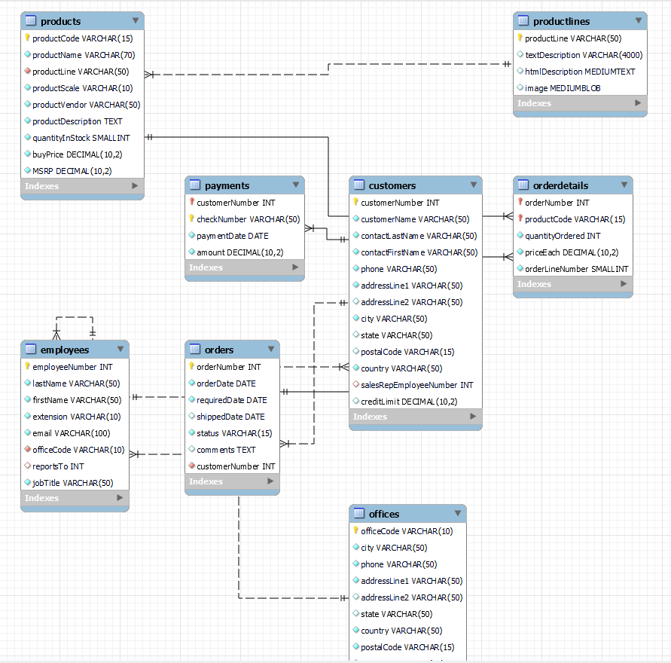



**Do the complete EDA of the datasets and come up with the important business key KPI along with questions and findings if any (atleast 10 KPIs) and share on linkedin in the form of video/PPTs**

**Let me see your creativity how you analyze all the above tables data and what descriptive/presctive analytics you can bring into picture.**