### **Secured and monitored web infrastructure**

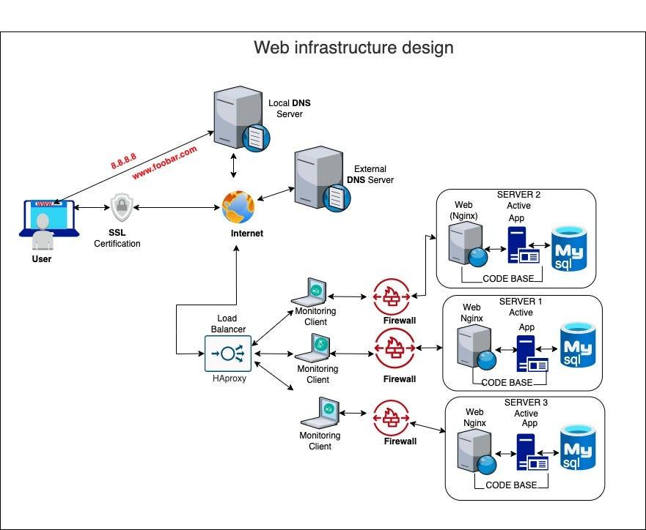

For every additional element, why you are adding it

Now, Because of the challenges faced by the above-Distributed Web Infrastructure, We now introduce the SSL certification, Monitoring client, and firewall.

**SSL certification**: The SSL certificate’s job is to initiate secure sessions with the user’s browser via the secure sockets layer (SSL) protocol.

**Infrastructure Monitoring** is used to collect health and performance data from servers, virtual machines, containers, databases, and other backend components in a tech stack. Engineers can use an infrastructure monitoring tool to visualize, analyze, and alert on metrics and understand whether a backend issue is impacting users.

**Firewalls** are software or hardware that work as a filtration system for the data attempting to enter your computer or network. They scan packets for malicious code or attack vectors that have already been identified as established threats.

What are firewalls for

Firewalls are software or hardware that work as a filtration system for the data attempting to enter your computer or network. They scan packets for malicious code or attack vectors that have already been identified as established threats.

Why is the traffic served over HTTPS

HTTPS uses the SSL/TLS protocol to encrypt communications so that attackers can't steal data. SSL/TLS also confirms that a website server is who it says it is, preventing impersonations. This stops multiple kinds of cyber attacks (just like food safety prevents illness).

What monitoring is used for

The purpose of monitoring is to provide regular, timely feedback on the implementation of a program or project, identify areas that require improvement, and make adjustments to ensure that the intended outcomes are achieved.

How the monitoring tool is collecting data

They are usually collected through standard techniques such as surveys, interviews and secondary sources. By asking about the existence and nature of relationships between actors, a very different picture emerges of what the system looks like.

Explain what to do if you want to monitor your web server QPS

When it comes to monitoring a web server, there are a few best practices that you should always keep in mind. First and foremost, you should always make sure that your server is properly backed up. If something does happen to your server, you can always restore it to its previous state. Secondly, you should also have some sort of monitoring system in place so that you can keep an eye on your server's performance and uptime. This way, if anything does go wrong, you'll be able to quickly identify the problem and take steps to fix it. Finally, it's also a good idea to stay up-to-date on security patches and updates for your web server software.