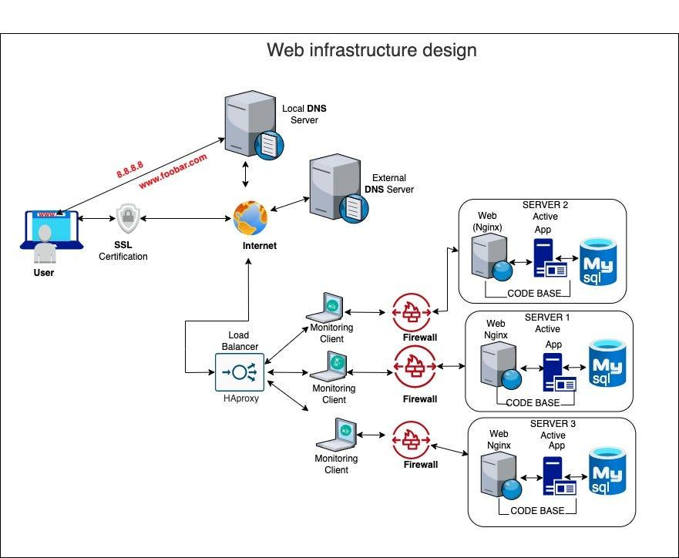

For every additional element, why you are adding it

**- load balancer:** Distributes traffic using round robin technique thus eliminating single

point of failure.

- **the new server** allows us to separate each component (web server; Nginx, Application

server; code base and Database; MySQL) in their own server. We still have one extra

server with all the components to serve as a backup if any of the components or server

fails.

- **Firewall** - each server is being monitored and has a firewall. We have also added an

extra load balancer that will assist in handling more traffic across the whole infrastructure