|  |  |  |
| --- | --- | --- |
| Защищено:  Гапанюк Ю.Е.    "__"_____________2017 г. |  | Демонстрация:  Гапанюк Ю.Е.    "__"_____________2017 г. |

**Отчет по лабораторной работе № 3 по курсу**

**Разработка интернет приложений**

5

(количество листов)

|  |  |
| --- | --- |
| ИСПОЛНИТЕЛЬ: |  |
| студент группы ИУ5Ц-71 | _____________________ |
|  | (подпись) |
| Зайцева М.А | "__"_____________2017 г. |

Москва, МГТУ - 2017

_____________________________________________________________________________________________

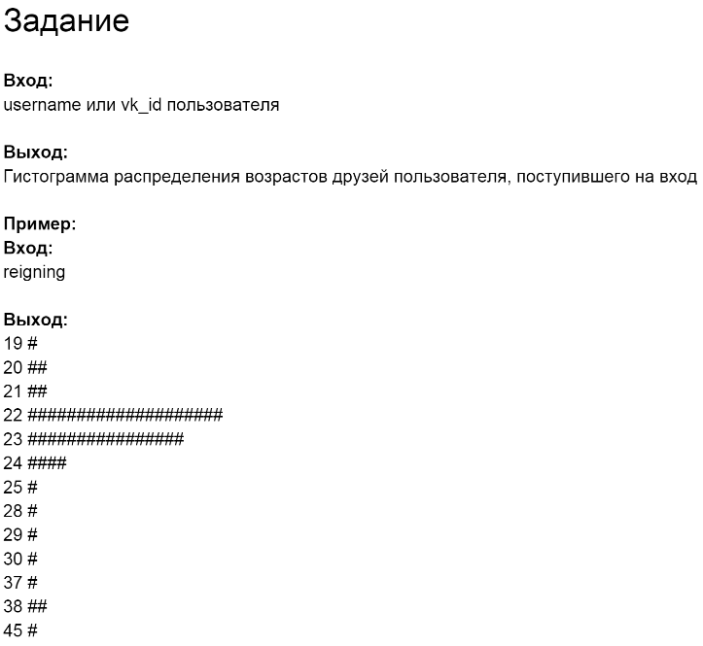

**base.py**

**import** requests  
  
  
**class** BaseClient:  
 *# URL vk api* BASE_URL = **None** *# метод vk api* method = **None** *# GET, POST, ...* http_method = **None  
  
 def** __init__(self, url, m, h):  
 self.BASE_URL = url  
 self.method = m  
 self.http_method = h  
  
 *# Получение GET параметров запроса* **def** get_params(self):  
 **return None** *# Получение данных POST запроса* **def** get_json(self):  
 **return None** *# Получение HTTP заголовков* **def** get_headers(self):  
 **return None** *# Склейка url* **def** generate_url(self, method):  
 **return '{0}{1}'**.format(self.BASE_URL, method)  
  
 *# Отправка запроса к VK API* **def** _get_data(self, method, http_method):  
 response = **None** print(**'base'**)  
  
 **return** self.response_handler(response)  
  
 *# Обработка ответа от VK API* **def** response_handler(self, response):  
 **return** response  
  
 *# Запуск клиента* **def** execute(self):  
 **return** self._get_data(  
 self.method,  
 self.http_method  
 )

**vk_clients.py**

**from** base **import** *  
**from** exceptions **import** *  
**from** datetime **import** datetime  
**import** requests  
  
  
**class** GettingID(BaseClient):  
 v = 5.58  
 user_id = **None  
  
 def** __init__(self, username):  
 super().__init__(**'https://api.vk.com/method/'**, **'users.get'**, **'GET'**)  
 self.user_id = username  
  
 **def** get_params(self):  
 **return** {**'user_ids'**: self.user_id, **'v'**: self.v}  
  
 **def** _get_data(self, method, http_method):  
 r = requests.get(self.generate_url(method), self.get_params())  
 **return** self.response_handler(r)  
   
 **def** response_handler(self, response):  
 res_dic = response.json()  
 **if not** res_dic.get(**'error'**) **is None**:  
 err = res_dic.get(**'error'**)  
 err_msg = err.get(**'error_msg'**)  
 **raise** API_Exception(err_msg)   
 **else**:   
 **return** res_dic.get(**'response'**)[0]  
  
  
  
  
**class** GettingFriends(BaseClient):  
 user_id = **None** fields = **'bdate'** v = 5.68  
   
 **def** __init__(self, user_id):  
 super().__init__(**'https://api.vk.com/method/'**, **'friends.get'**, **'GET'**)  
 self.user_id = user_id  
   
 **def** get_params(self):  
 **return** {**'user_id'**: self.user_id, **'v'**: self.v, **'fields'**: self.fields}  
  
 **def** _get_data(self, method, http_method):  
 r = requests.get(self.generate_url(method), self.get_params())   
 **return** self.response_handler(r)  
   
 **def** response_handler(self, response):  
 res_dic = response.json()  
 **if not** res_dic.get(**'error'**) **is None**:  
 err = res_dic.get(**'error'**)  
 err_msg = err.get(**'error_msg'**)  
 **raise** API_Exception(err_msg)   
 **else**:  
 **return** res_dic.get(**'response'**).get(**'items'**)  
  
  
 **def** execute(self):  
 ages = []  
 today = datetime.now()  
 **for** i **in** super().execute():  
 bdate_str = i.get(**'bdate'**)  
 **try**:  
 bdate = datetime.strptime(bdate_str, **'%d.%m.%Y'**)  
 days = (today - bdate).days  
 ages.append(days // 365)  
 **except**:  
 **pass  
 return** ages

**diagram_friends.py**

**from** vk_clients **import** *  
  
get_user = GettingID(**'id146403916'**)  
user = get_user.execute()  
user_id = user.get(**'id'**)  
  
get_friends = GettingFriends(user_id)  
friends = get_friends.execute()  
  
age_list = [0 **for** i **in** range(120)]  
today = datetime.now()  
  
print(user.get(**'last_name'**)+**" "**+user.get(**'first_name'**))  
  
**for** f **in** friends:  
 age_list[f] += 1  
  
**for** i **in** range(120):  
 **if** age_list[i]>0:  
 print(i,**': '**,**'#'**\*age_list[i])

**exceptions.py**

**class** API_Exception(Exception):  
 **pass**

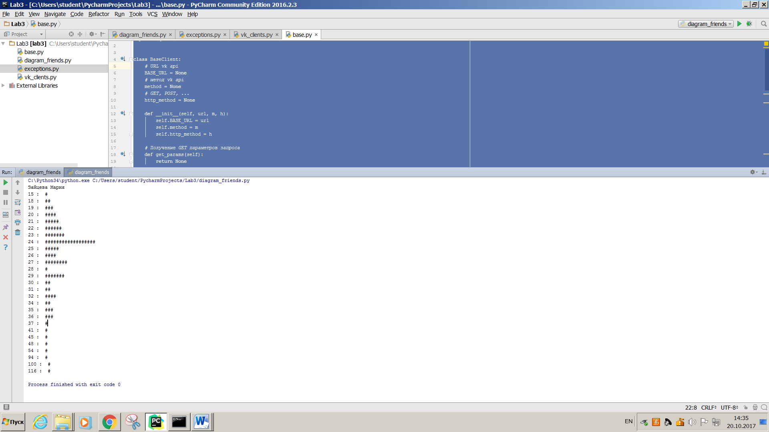**Результат**