Introduction to R - class 5 Plotting: base R and ggplot2

Tomasz Gaczorek, Wiesław Babik & Mateusz ChechetkinMarzena Marszałek [marzena.marszalek@doctoral.uj.edu.pl](mailto:marzena.marszalek@doctoral.uj.edu.pl)

2024-10-31

Table of Contents

**Data visualization** is a vital tool for statistics and research. Plots, graphs, and other visual representations of data not only make complex datasets **more accessible** but also reveal **patterns, trends, and outliers** we might not notice otherwise. Base R provides all necessary functions for creating quick plots that you can use for your own information, e.g. in accessing **the distribution of data**. To make plots more aesthetically pleasing, readable, and publication ready, we will use ggplot2 package.

## Basic plotting

During this class, we will be working on the internal dataset iris, which describes various dimensions of flowers. You can access the description of the dataset by typing a question mark before its name. Here is a botanical visual of the flower structure.

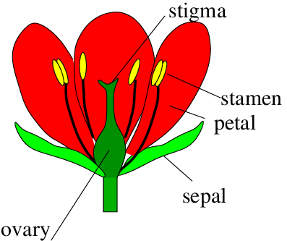

### **Exercise 1**

**Assign the internal data set iris to an object called my_data. View the dataset and create its short summary.**

Expected result (first 10 rows):

## Sepal.Length Sepal.Width Petal.Length Petal.Width Species  
## 1 5.1 3.5 1.4 0.2 setosa  
## 2 4.9 3.0 1.4 0.2 setosa  
## 3 4.7 3.2 1.3 0.2 setosa  
## 4 4.6 3.1 1.5 0.2 setosa  
## 5 5.0 3.6 1.4 0.2 setosa  
## 6 5.4 3.9 1.7 0.4 setosa  
## 7 4.6 3.4 1.4 0.3 setosa  
## 8 5.0 3.4 1.5 0.2 setosa  
## 9 4.4 2.9 1.4 0.2 setosa  
## 10 4.9 3.1 1.5 0.1 setosa

## Sepal.Length Sepal.Width Petal.Length Petal.Width   
## Min. :4.300 Min. :2.000 Min. :1.000 Min. :0.100   
## 1st Qu.:5.100 1st Qu.:2.800 1st Qu.:1.600 1st Qu.:0.300   
## Median :5.800 Median :3.000 Median :4.350 Median :1.300   
## Mean :5.843 Mean :3.057 Mean :3.758 Mean :1.199   
## 3rd Qu.:6.400 3rd Qu.:3.300 3rd Qu.:5.100 3rd Qu.:1.800   
## Max. :7.900 Max. :4.400 Max. :6.900 Max. :2.500   
## Species   
## setosa :50   
## versicolor:50   
## virginica :50   
##   
##   
##

The two most common types of plots are **scatterplots** and **histograms**.

* **Scatterplots** display individual observations of two variables measured existing on a **continuous scale**. They are usually used to demonstrate a **relationship** (or lack thereof) between two traits or measures.
* **Histograms**, on the other hand, display **frequencies** of observations (shown on the y axis of a graph) per category of observations (shown on the x axis).

Histograms are usually used to demonstrate differences between groups or their central tendencies (e.g. means).

### Scatterplot

We’ll start with a scatterplot.  
The basic R function to create any kind of plot is, simply, plot(). To set it up, provide arguments for data (the data frame it will use), x axis, and y axis: plot(x = x_axis_data_, y = y_axis_data), where x and y specify variables that define x and y axes values respectively.

#### **Exercise 2**

**Create a simple plot using the my_data data frame. Provide the Sepal.length column as x, and Sepal.width as y arguments of the plot() function.**

Expected result:

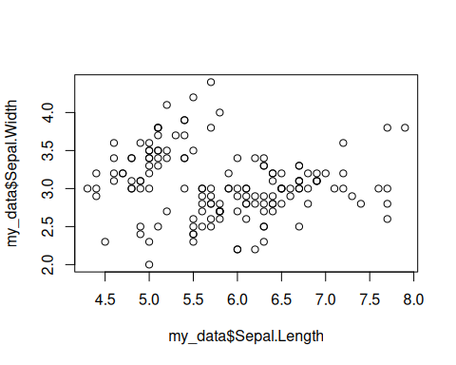

Alternatively, the same command can be given using the **tilde** ~ sign. In coding language, this can be read as “depends on”, and is used not only in plots, but also in e.g. statistical functions.

#### **Exercise 3**

**Create a plot using the same function but writing the arguments down as Sepal.width depending on Sepal.length. Provide the name of the data frame as data argument. Remember that, on a standard plot, the y axis shows the dependent variable, and x shows the independent variable.**

The only difference in the results should be the displayed titles for the axes.

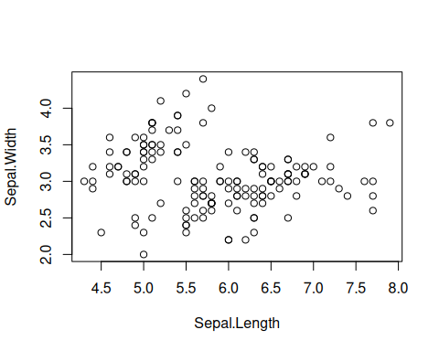

The basic plot() function allows us to somewhat customize the plots. For example, we can change the name of the axes, as well as the title of the plot.

#### **Exercise 4**

**Copy and modify the code from exercise 3. Add axis titles using the arguments xlab and ylab. Add the title of the plot using the main argument.**

Remember that, for any function, you can always access its manual by typing its name with a question mark at the beginning into the R console.

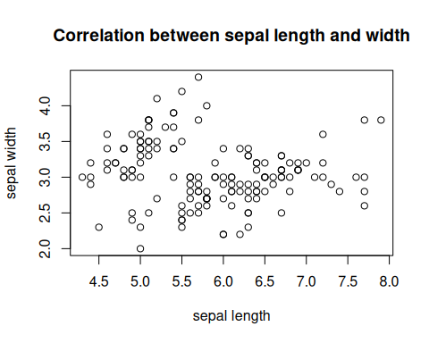

**Curiosity** You can use the par() function to further customize the plot. Inspecting the manual will show you the various options you have.

What if we want to add **grouping** to the scatterplot? We can add another argument to the function too, for example, color the individual observations according to group.

#### **Exercise 5**

**Modify the plot function to color the observations by Species. Do this by adding a col argument and setting the Species column as its value.**

Expected result:

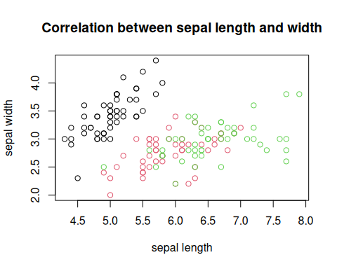

**Curiosity** The basic plot function allows further modification, such as, e.g., addition of a legend to the plot. We will not focus on this as making the plots more readable is easier in ggplot2.

### Histogram

Now let’s try to make a histogram.

The base R function for making a histogram is hist(). The only argument you need to provide is the column of the data you want to work on. The group of the observations will be shown on the x axis, and the frequency of occurrences of observations in that group will be shown on the y axis.

#### **Exercise 6**

**Create a histogram plot of the sepal length using my_data.**

Expected outcome:

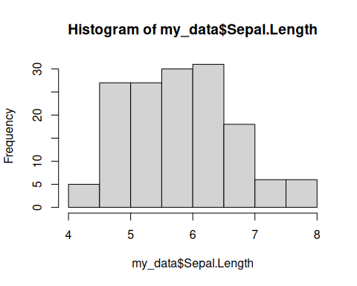

You can customize this plot using the same arguments as in the plot() function to add axes labels and a title. Additionally, we can adjust some other things about this plot, for example changing the grouping on the x axis using the breaks argument. The breaks argument can take a single number (which will correspond to the number of bins) or a numeric vector (which will correspond to the boundaries of the bins).

#### **Exercise 7**

**Update the histogram code by adding axes names, title, and setting it to display 4 bins.**

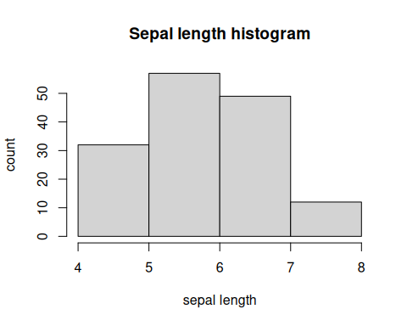

## ggplot2

### Installation

From now on, we are going to use the ggplot2 package.

Install and load the package:

install.packages("ggplot2")  
library(ggplot2)

### Syntax

The syntax to generate a plot includes three groups of functions:

* **the base** - ggplot() - starts a new plot
* **the body** - e.g.geom_point() - displays the data
* **the layout** - e.g. theme() - changes the appearance of a plot

You can use many functions that will contribute to a given plot but each of them should be connected by the plus symbol (+) e.g. ggplot(…) + geom_point() + geom_line() + theme(…).

Both the ggplot() and the body functions share two crucial arguments:

* data - data frame based on which plotting should be performed
* mapping - the value needs to be in a form of aes() (aesthetic) function with following arguments:
  + x - name of the column with values for the x (horizontal) axis (without quotation marks)
  + y - name of the column with values for the y (vertical) axis (without quotation marks)

Note that the arguments passed to the ggplot() function are “parental”. It means they would be used if no arguments are provided for the body functions. It is called inheritance in the programming (because every subsequent function in the line “inherits” the arguments of the parent function).

To create the plotting area we supply the name of the dataset and map two variables to x and y aesthetics.

ggplot(data = iris, mapping = aes(x = Petal.Length, y = Petal.Width))

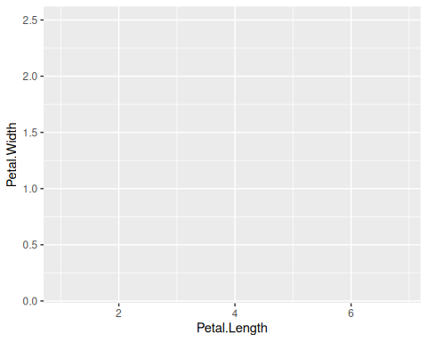

### Scatterplot

We see the plot, with both axes scaled according to the ranges of the two variables to be plotted, but there’s nothing else on the plot. It’s because we have to add the visual layer(s) representing the data, which are called **geoms**. Not every geom is appropriate for displaying every type of data, you can find the complete list of geoms [here](https://ggplot2.tidyverse.org/reference/index.html). For scatterplot we’ll use geom_point(). Also, we can omit data = and mapping = when we keep the order of the arguments.

ggplot(data = iris, mapping = aes(x = Sepal.Length, y = Sepal.Width)) + geom_point()

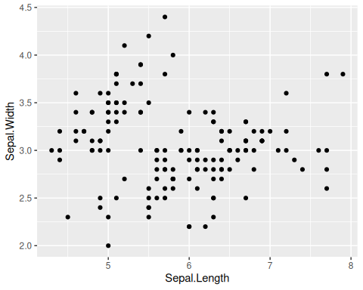

You can also move mapping from the base of ggplot to the body - here, to geom_point(). Both options will give the same result.

ggplot(data = iris) + geom_point(mapping = aes(x = Sepal.Length, y = Sepal.Width))

Now let’s mark each species with a distinct color. It’s very simple and natural in ggplot2() - we just add color aesthetics and map the variable Species to it. The results of both formulas below will be the same.

ggplot(data = iris, mapping = aes(x = Sepal.Length, y = Sepal.Width, color = Species)) + geom_point()

ggplot(data = iris) + geom_point(mapping = aes(x = Sepal.Length, y = Sepal.Width, color = Species))

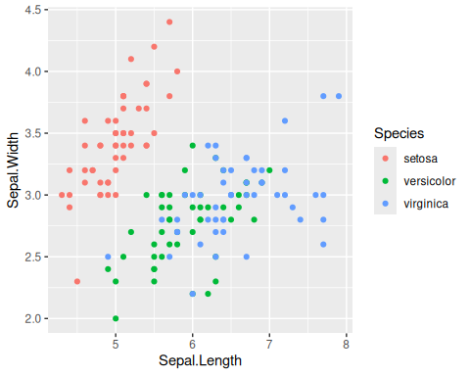

#### **Exercise 8**

**Create a scatterplot presenting the relationship between sepals’ length and width. Use geom_point() function.**

Expected result:



Now, let’s make it pretty!

1. Decide on the general appearance by the choice of a given theme…() function. For example, it is often usefl to apply theme_bw() as it **removes unnecessary background**. To check all built-in possibilities follow the [link](https://ggplot2.tidyverse.org/reference/ggtheme.html). Be aware that the choice of any specific theme…() function reduces adjustment flexibility. The other option is to use plain theme() function and adjust all characteristics on your own.
2. Set proper labels by using labs() function with arguments: title for the title of plot, x for x-axis label and y for y-axis label.

#### **Exercise 9**

**Modify previous scatterplot by setting theme_bw() function. Also, set a main title and axis labels according to the plot below.**

*Tip: By default plot title is left-aligned. To center the title you can use the theme() function: theme(plot.title = element_text(hjust = 0.5)). The hjust argument controls horizontal justification, with 0.5 centering the title.*

Expected result:

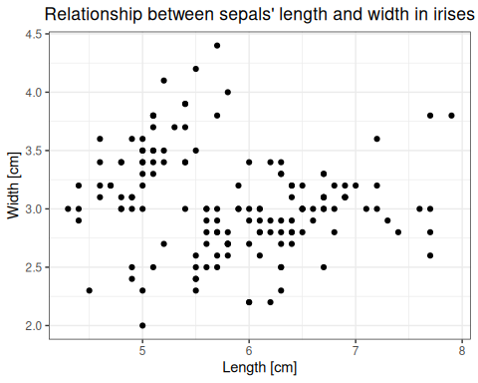

As you have seen in the dataset description, the observations were collected for the three species of irises. To display them in different colors add color argument to geom_point() aesthetic and set it as the name of column with species description for each observation. Notice that the legend will be automatically added.

#### **Exercise 10**

**Modify previous scatterplot by displaying the observations from different species with distinct colors.**

Expected result:

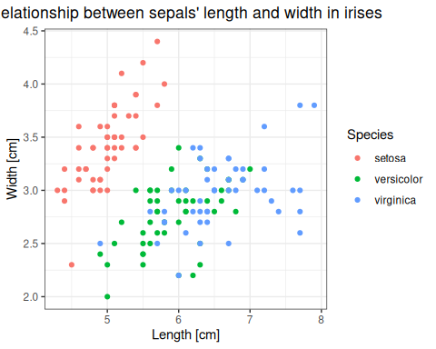

**Curiosity**  
There is an entire family of the scale…() functions that personalize the way observations are displayed e.g.:  
1. scale_x_discrete() (for groups), scale_x_continuous() (for gradient) - modify x axis functionalities (e.g. its range)  
2. scale_y_discrete() (for groups), scale_y_continuous() (for gradient) - modify y axis functionalities (e.g. its range)  
3. scale_color_manual() - to set personalized colors and legend labels

Points alone are often not enough to see a trend. To get a better idea we need a **regression line**. You can draw it by adding geom_smooth() function to the plot’s body. Remember about required arguments (either assigned or inherited). Also, to obtain the linear regression, set geom_smooth() method to "lm".

#### **Exercise 11**

**Draw a linear regression line for the scatterplot from exercise 10.**

Expected result:  
Regression line in blue, gray area represents confidence intervals generated by default.

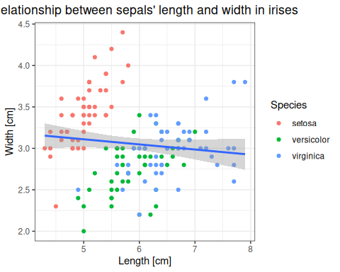

It seems that there is **no relationship** when you consider **all points together** but what about **relationships within species**? Do it by adding color argument to the geom_smooth() aesthetics and setting it as the name of column with species description for each observation.

#### **Exercise 12**

**Modify a scatterplot from exercise 11 to obtain separate regression lines for each species.**

Expected result:

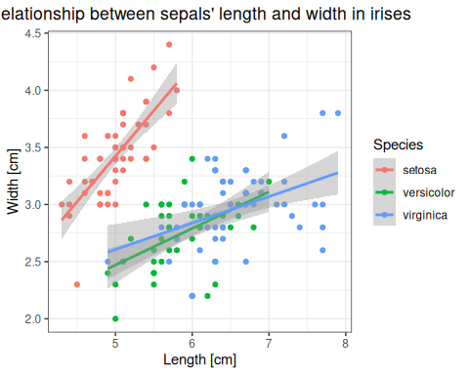

**Curiosity** Using group argument instead of color will also generate separate lines but all will be of the same color.

### Boxplot

Until now, we were working on plots with **continuous values on x and y axes**. What if we want to plot sepal width alone over all species? As **species are on discrete scale** we should consider a **boxplot**. Generate it in the similar way with the use of geom_boxplot() function. Note, that **discrete variables can be of character**, logical or factor type.  
If you have named groups it is highly recommended to encode them as **factors**, because factor levels can be ordered manually, which allows you to control the order in which groups appear on the plot.

#### **Exercise 13**

**Generate a boxplot representing the sepal’s length across different iris species.**

Expected result:

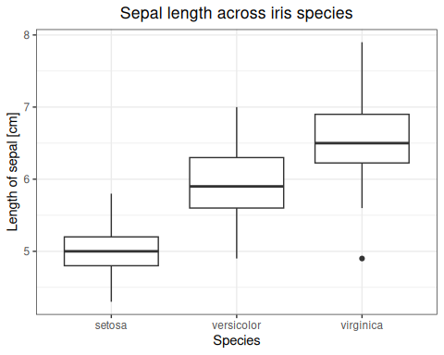

*An advice: If you do not know how to interpret the boxplot, follow the* [*link*](https://wellbeingatschool.org.nz/information-sheet/understanding-and-interpreting-box-plots)*.*

To set a common color for all boxes, use fill and color argument of geom_boxplot() function and provide it with a color name. It would set the color of filling and contours respectively. To color the boxes or its contours according to a variable e.g., Species you have to place fill or color argument in aes().

#### **Exercise 14**

**Modify plot from exercise 13. by setting the color of boxes’ contours according to Species.**

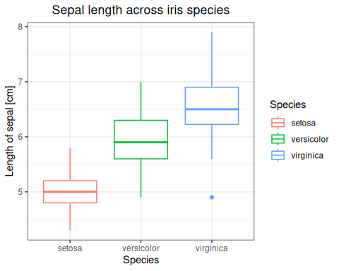

If you have tens, or perhaps a hundred data points, it may be useful to show them all together with boxplot. To avoid points overlapping each other, use geom_jitter().

#### **Exercise 15**

**Modify plot from exercise 14. by setting adding data points. Use geom_jitter() function**

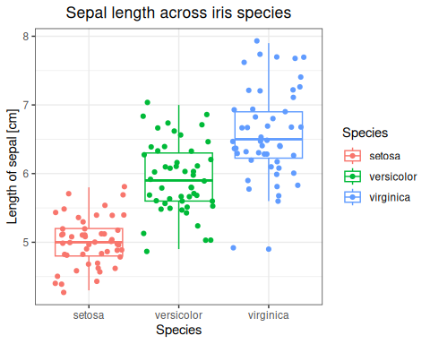

### Histogram

Another commonly used type of a plot is **histogram**. It depicts the **number of observations within given ranges of values**. Generate it with the geom_histogram() function. Specify the aesthetics for x-axis only as y-values are computed by R.  
To set a common color for all bars, use fill and color argument of geom_histogram() function and provide it with a color name. It would set the color of filling and contours respectively.

#### **Exercise 16**

**Generate a histogram of sepal length. Set bars and contours color.**

Expected result:

## `stat_bin()` using `bins = 30`. Pick better value with `binwidth`.

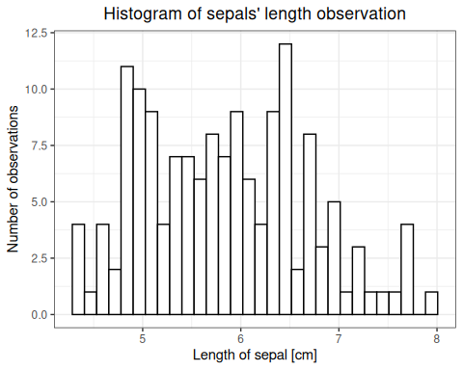

It looks like there are too many bins (the default is 30), let’s reduce their number to 10. It’d also be nice to to show each species with different colour.

#### **Exercise 17**

**Generate a histogram of sepal length. Set bars’ color according to Species. Add bins = 10 argument to geom_histogram() function to decrease the number of bins.**

Expected result:

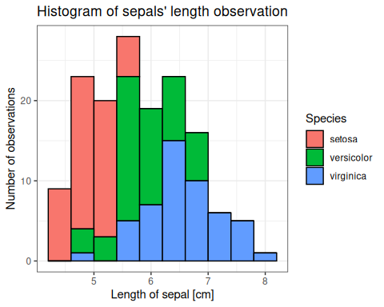

Still not great. The bars from different species overlap each other. To show the bars for each species next to each other we adjust their position with position = "dodge" in geom_histogram() function.

#### **Exercise 18**

**Modify histogram from exercise 17 to show the bars for each species next to each other.**

Expected result:

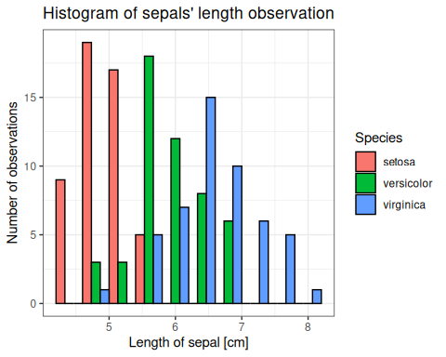

You can also think about histograms as **calculating the frequency** rather than the number of observations. To do this set the y argument of geom_histogram() aesthetics to (after_stat(count))/(sum(after_stat(count))). Note that after_stat(count)) is a function that allows you to access computed statistics while creating a plot.

#### **Exercise 19**

**Generate a histogram of sepal length with the relative frequencies on the y axis.**

Expected result:

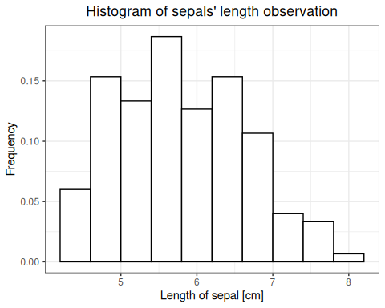

Note that the histograms looks almost identical but the **y-axis values were changed**.

Using histograms, you can also generate a **density distribution**. Think about it as the graphical visualization of **relative probabilities** that a **randomly sampled observations come from a given interval**. Note that sampling based on density function would generate the histogram similar to the one from the real-data. It can be used to **roughly assess the normality of data**. Do it by changing y argument of geom_histogram() function to after_stat(density). Additionally, use geom_density() function. Remember about aesthetics’ argument x and note you can use alpha argument to set distribution transparency.

#### **Exercise 20**

**Modify the histogram from exercise 16th to display density on y axis. Add also density distribution using geom_density().**

Expected result:

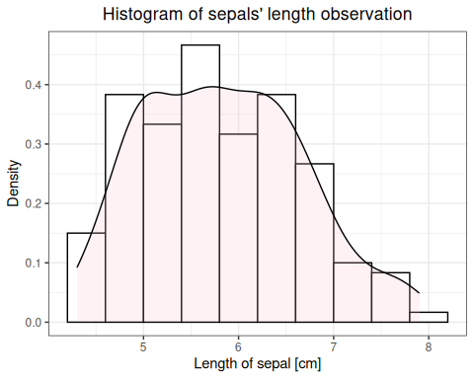

#### **Exercise 21**

**Modify the histogram above and display density distributions for each species separately on a single plot. Take advantage of color argument inside aesthetics.**

Expected result:

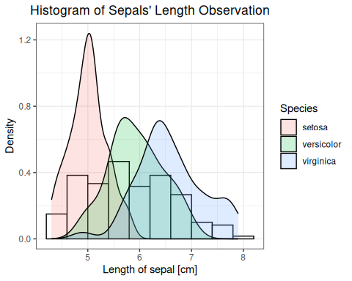

### Saving your images

When R generates plots based on our commands, they are treated like any other object – meaning that **they are not automatically stored in the app memory unless we save the code that generates them or export the images out of R studio**. There are 2 main ways to do this:

* through user interface, using export >> save as an image file or copying the image directly into the clipboard and pasting it into a word document or an image editor such as MS Paint; for reference, see [this guide](http://www.sthda.com/english/wiki/creating-and-saving-graphs-r-base-graphs).
* using lines of code

If you only need to save one image, both options are equally convenient. If, however, you are generating multiple plots per script, it can be faster to include code that saves them after every line that generates the image.

In base R, to save a plot you need first initialize an appropriate graphic device with a file name, than use plotting commands, and finally close the device. It looks like this:

png("name.png")  
plot(arguments)  
dev.off()

Other than .png, you can save it in .jpg, .bmp, and .tiff formats, using graphic devices. Remember that **by default, R will save the image to your working directory**.

In ggplot, we can use the function ggsave(). **By default, it saves the last plot generated in the code**. It takes the name of a file to be generated (with a format extension) as the main argument, and it can be adjusted using many other arguments. For example: ggsave("scatterplot_1.pdf", width = 20, height = 20, units = "cm")

#### **Exercise 22**

**Save one of the plots we generated today using your preferred method.**

## Homework

Use the built in mtcars data set for all exercises. As a reminder, you can pull up a description of the inbuilt data set by typing a question mark before its name into the R console. 1. Using base R, generate a scatterplot to demonstrate a relationship between any 2 continuous variables. Add a grouping by color to the plot, descriptions of axes, and a title. 2. Using base R, generate a histogram for any appropriate variable. Set the number of bins on it to 5, add axes descriptions, and plot title. 3. Load the ggplot2 library and use it for all subsequent tasks. Draw a scatterplot of cars’ horsepower against weight. Include a regression line to check the relationship. 4. Group values in the above scatterplot based on the number of cylinders. Does it change the relationship 5. Plot a relationship between the number of forward gears and rate of combustion (miles/per gallon).

**Save all the graphs with your preferred method. Upload your R script (including commands for saving graphs) on the *Pegaz* platform. Do not upload graph files itself.**