Introduction to R - class 1 variables, functions, vectors
Tomasz Gaczorek, Wiesław Babik & Mateusz Chechetkin Marzena Marszałek marzena.marszalek@doctoral.uj.edu.pl
2025-08-04
knitr::opts_chunk$set(echo = T)

What is R?
R is an extremely powerful programming language, broadly used in the science for:
- data processing
- statistical analysis
- production of highly-customizable, publication quality graphs
- computer simulations
- … and much more

R installation
To install R for Windows follow the link and then click on “Download R – version_number – for Windows”.
To install R for OS X (Macs) follow the link and then click on “Download R for (Mac) OS X”
To install R for Linux type the lines below in the terminal.
sudo apt-get update
sudo apt-get install r-base
Run R. You should see a window similar to the one below.
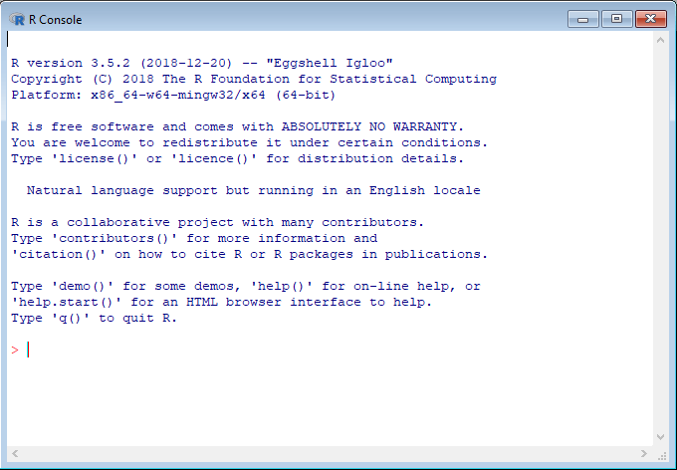
It is so called R console. Anything written and executed within a console will be interpreted (calculated) by R and a result or message will be printed out in the console.

Note on Programming Vocabulary
- console: the window in which you type lines of code and receive the result of the code running
- input: what you give to R to work on, such as commands, values, or files
- output: what R displays back to you, typically the result of an operation
- call: run the code or prompt the computer to produce output
- function: instruction given by us to R about what to do with our input
- object: the thing you work on in R
Descriptions of exercises are in green.
Homeworks are in orange

R as a typical calculator
R understands standard mathematical operators: + (addition), - (subtraction), * (multiplication), / (division) and ^ (power). We can perform mathematical operations on single values – numbers, as well as other objects made up of numbers.

Exercise 1
Sum up all numbers from 1 to 10 using the + operator.
Expected result:
1+2+3+4+5+6+7+8+9+10
## [1] 55

Exercise 2
Raise the result of exercise 1 to the power of 5.
Expected result:
55^5
## [1] 503284375
R also provides 2 additional operators:
%% - modulo - returns the rest from the division
%/% - integer division - returns how many times one number fits into another

Exercise 3
For numbers 10, 156, 557, 777 and 1055, check which are divisible by 7.
Expected result:
10 %% 7
## [1] 3
156 %% 7
## [1] 2
557 %% 7
## [1] 4
777 %% 7
## [1] 0
1055 %% 7
## [1] 5

Exercise 4
Calculate the area of a circle if the radius equals 40 meters.
Tip: Due to its unique role in science π value can be obtained just by typing ‘pi’.
Expected result:
pi*(40^2)
## [1] 5026.548
An advice: R uses the standard order of mathematical operations. However, it is usually a good practice to use parentheses.
Apart from that, there are also commonly used mathematical functions as:
log() - natural logarithm
log10() - logarithm base 10
exp() - exponent, Euler number raised to a given power
sin(), cos(), tan() - trigonometric functions
abs() - absolute value
You can use them by including the desired number inside the parentheses e.g. exponent of e for exp() or an angle in radians for any of trigonometric functions.

Exercise 5
Using the equation for Shannon - Wiener index and species frequencies shown below, calculate diversity for both populations separately. Which is more diverse (higher values reflect more diverse populations)?
$$H_{SW}=\sum_{i=1}^{S}{p_{i}}⋅ln\left(\frac{1}{p_{i}}\right)$$
Where:
- $H_{SW}$ is the Shannon-Wiener diversity index,
- $S$ is the total number of species,
- $p_{i}$ is the frequency of given species,
- $ln$ is the natural logarithm.
Species | Population 1 | Population 2
species 1 | 0.8 | 0.2
species 2 | 0.1 | 0.2
species 3 | 0.1 | 0.6
Expected result:
#population 1
(0.8*log(1/0.8))+(0.1*log(1/0.1))+(0.1*log(1/0.1))
## [1] 0.6390319
#population 2
(0.2*log(1/0.2))+(0.2*log(1/0.2))+(0.6*log(1/0.6))
## [1] 0.9502705

Variables
Until you name something it does not exist in a computer memory! Any outcome of the execution of a command within the console perishes when the calculation is finished, unless it is assigned to a given name. Named objects within the computer memory are called variables. You can create one by using arrows (assignement symbol) in the following manner:
chosen_name <- object_to_be_saved
You can easily recall the value of the variable later on by typing its name.

Exercise 6
Try to save 5 as variable. Choose a variable name on your own. Then, type your variable’s name and press Enter.
Expected result:
x <- 5
x
## [1] 5
An advice: The variable name is case sensitive and cannot contain blank spaces or start with a digit. When you want to combine several words into one name use the underscore (_). By convention dots are used for function names and should be used with caution.
Since the variable is saved, its name can replace the actual value in any R commands e.g. if 2 is assigned to x, both 2+3 and x+3 would result in 5.

Exercise 7
Using the table from exercise 5, calculate the range of species frequencies for both populations and save them as separate variables. Then using chosen names, calculate the absolute difference between ranges. Save it to a variable called range_diff and call it.
Expected result:
range1 <- 0.8-0.1
range2 <- 0.6-0.2
range_diff <- abs(range2-range1)
range_diff
## [1] 0.3
Variables can also be overwritten. It is done by assigning a new object to the already used variable’s name. Remember, however, that once you overwrite the variable the old value disappears for good.

Exercise 8
Change variable range_diff by increasing its value by 20%. Call it.
Expected result:
range_diff <- range_diff + (range_diff*0.20)
range_diff
## [1] 0.36
Variables can store not only numbers. The other very popular type of data is string. It is a text which behaves as a single object regardless of its length. To distinguish strings from variable names R requires usage of quotation marks ("") around them.

Exercise 9
Save your name to the variable my_name. Call it.
Expected result:
my_name <- "Your_Name"
my_name
## [1] "Your_Name"

Functions
One of the usual ways to deal with your data in R is to use functions. They are simply lines of code saved in a computer memory that perform desired operations and often return a result. Some functions are built into R, and some require additional tools called packages to be installed. Think apps pre-loaded on your phone like a calculator or a calendar vs apps for specific uses you need to download separately. We will talk about packages in the next class.
Functions we used before take only a single argument e.g. log() takes a number. However, it is rarely the case. List of function’s arguments and the way of usage can be found in function’s manual. It can be reached by typing question mark (?) followed by the function’s name.

Exercise 10
Open the manual for paste() function.
Usually the manual consists of 7 sections:
- DESCRIPTION - the aim of the function
- USAGE - the syntax
- ARGUMENTS - arguments passed to the function and their meaning
- DETAILS - detailed description of the function behaviour
- VALUE - outcome of the function
- REFERENCES - often the scientific article function is based on
- EXAMPLES

Exercise 11
Use paste() function to stick the following words together: ’I’m’, ‘using’ and ‘R’. Don’t forget about quotation marks ("").
Expected result:
paste("I’m", "using", "R")
## [1] "I’m using R"
Arguments passed to functions often have their own names. Distinctive names are crucial because many functions take multiple arguments that need to be distinguished. Such named arguments are passed in the following pattern: argument_name = argument_value.

Exercise 12
Use the same function as above but set another argument called sep (separator) to ’_’.
Expected result:
paste("I’m", "using", "R", sep = "_")
## [1] "I’m_using_R"
Note that the blank space was replaced with an underscore. However, where did the blank spaces in the Exercise 11 result come from? The answer is that some arguments have their default values that would be taken if no value is put into function. In the above case, the default value for sep argument is a blank space (” “).
An advice: It is a good practice to use argument names while calling a function. Although, R can “guess” the argument name by the order in which arguments are typed, it can work improperly when the number of arguments is not strictly defined (“…” sign in function description).

Vectors
Vector is a series of numbers (or strings) that are saved as a single variable. A new vector can be created with c() function in the following manner: c(value_1,value_2,value_3,…).

Exercise 13
Create a vector containing integers from 5 to 10 and save it to a variable. Call it.
Expected result:
v1 <- c(5:10)
v1
## [1] 5 6 7 8 9 10
Tip: To create a vector of consecutive integers you can type the limits of the range separated by the colon.

Exercise 14
Create a vector containing integers from 1 to 100 and save it to a variable one_to_hundred. Call it.
Expected result:
one_to_hundred <- c(1:100)
one_to_hundred
## [1] 1 2 3 4 5 6 7 8 9 10 11 12 13 14 15 16 17 18
## [19] 19 20 21 22 23 24 25 26 27 28 29 30 31 32 33 34 35 36
## [37] 37 38 39 40 41 42 43 44 45 46 47 48 49 50 51 52 53 54
## [55] 55 56 57 58 59 60 61 62 63 64 65 66 67 68 69 70 71 72
## [73] 73 74 75 76 77 78 79 80 81 82 83 84 85 86 87 88 89 90
## [91] 91 92 93 94 95 96 97 98 99 100
An advice: Note that concerning ranges, R is fully inclusive which means that both limits of the range will be included in the final outcome.
To create a vector of consecutive numbers which differ by a given value, use seq() function. Note that the function will return a vector so there is no need to use c().

Exercise 15
Access seq() manual. Using seq() function, create a vector of numbers between 0 and 1 that differ by 0.1.
Expected result:
v2 <- seq(from = 0, to = 1, by = 0.1)
v2
## [1] 0.0 0.1 0.2 0.3 0.4 0.5 0.6 0.7 0.8 0.9 1.0
To create a vector of repeated values, use rep() function.

Exercise 16
Access rep() manual by typing ?rep in console. Using rep() function, create a vector consisting of 1,2 and 3 repeated 20 times. Save it as a variable repeated. Call it.
repeated <- rep(x = c(1:3), times = 20)
repeated
## [1] 1 2 3 1 2 3 1 2 3 1 2 3 1 2 3 1 2 3 1 2 3 1 2 3 1 2 3 1 2 3 1 2 3 1 2 3 1 2
## [39] 3 1 2 3 1 2 3 1 2 3 1 2 3 1 2 3 1 2 3 1 2 3

Exercise 17
Create a vector from 1 to 4 with odd numbers typed as digits and even numbers typed as words. What is the outcome? Vector of integers or vector of strings?
Expected result:
v4 <- c(1, "two", 3, "four")
v4
## [1] "1" "two" "3" "four"

Vector machinations
Useful functions:
min() - minimum value
max()- maximum value
sum() - sum up all numbers in a vector
prod() - multiply all numbers in a vector
mean() - average value
median() - central value
length() - number of elements in a vector
sort() - sort values (default is ascending order, use decreasing argument to sort in descending order)
unique() - return unique values
round() - round numbers (to integers by default)

Exercise 18
Having a vector one_to_hundred calculate its mean and median.
Expected results:
mean(one_to_hundred)
## [1] 50.5
median(one_to_hundred)
## [1] 50.5

Exercise 19
Having a vector repeated sort it and return unique values.
Expected results:
sort(repeated)
## [1] 1 1 1 1 1 1 1 1 1 1 1 1 1 1 1 1 1 1 1 1 2 2 2 2 2 2 2 2 2 2 2 2 2 2 2 2 2 2
## [39] 2 2 3 3 3 3 3 3 3 3 3 3 3 3 3 3 3 3 3 3 3 3
unique(repeated)
## [1] 1 2 3
Vectors can be also used in typical mathematical operations. However there is one important rule: shorter vector will be repeated until it reaches length of longer one (single number is treated as vector of length 1).
Examples:
c(1,2,3,4) + 5 # 5 is added to each element, the same as c(1,2,3,4) + c(5,5,5,5)
c(1,2,3,4) + 5
## [1] 6 7 8 9
c(1,2,3,4) + c(1,2) # the same as c(1,2,3,4) + c(1,2,1,2)
c(1,2,3,4) + c(1,2)
## [1] 2 4 4 6
paste("text", seq(1:10)) # Similarly here - the shorter vector including 1 element ("text") is repeated 10 times to reach the length of the longer vector.
paste("text", seq(1:10))
## [1] "text 1" "text 2" "text 3" "text 4" "text 5" "text 6" "text 7"
## [8] "text 8" "text 9" "text 10"
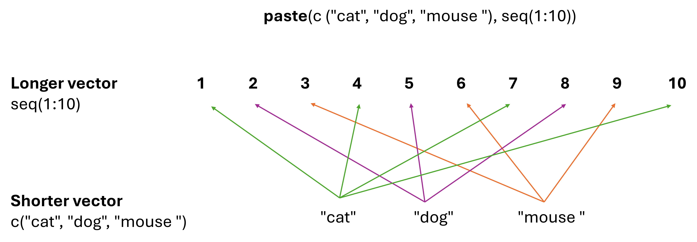
The result:
paste(c("cat", "dog", "mouse"), seq(1:10))
## [1] "cat 1" "dog 2" "mouse 3" "cat 4" "dog 5" "mouse 6" "cat 7"
## [8] "dog 8" "mouse 9" "cat 10"

Exercise 20
Having a vector one_to_hundred, raise each element to the power of 3. Save it to a variable called power_3.
Expected result:
power_3 <- one_to_hundred^3
power_3
## [1] 1 8 27 64 125 216 343 512 729
## [10] 1000 1331 1728 2197 2744 3375 4096 4913 5832
## [19] 6859 8000 9261 10648 12167 13824 15625 17576 19683
## [28] 21952 24389 27000 29791 32768 35937 39304 42875 46656
## [37] 50653 54872 59319 64000 68921 74088 79507 85184 91125
## [46] 97336 103823 110592 117649 125000 132651 140608 148877 157464
## [55] 166375 175616 185193 195112 205379 216000 226981 238328 250047
## [64] 262144 274625 287496 300763 314432 328509 343000 357911 373248
## [73] 389017 405224 421875 438976 456533 474552 493039 512000 531441
## [82] 551368 571787 592704 614125 636056 658503 681472 704969 729000
## [91] 753571 778688 804357 830584 857375 884736 912673 941192 970299
## [100] 1000000

Accessing elements of a vector
Vector can be subsetted (=accessed or displayed at a specific point) in the following manner: vector_name[element_index]. Index is the position of the value in the vector, e.g. 1st, 3rd, 25th, etc.

Exercise 21
Return 15th element of the vector power_3.
Expected result:
power_3[15]
## [1] 3375

Exercise 22
Return 2nd to 20th element of the vector power_3.
Tip: Colon can be used for ranges just as for vector creation.
Expected result:
power_3[2:20]
## [1] 8 27 64 125 216 343 512 729 1000 1331 1728 2197 2744 3375 4096
## [16] 4913 5832 6859 8000

Exercise 23
Return 15th, 30th and 45th element of the vector power_3.
Tip: To obtain multiple values, put a vector instead single position index.
Expected result:
power_3[c(15,30,45)]
## [1] 3375 27000 91125

Exercise 24
Create a vector including numbers from 1 to 10, 40 and 55. Save it to a variable. Return corresponding elements of the vector power_3 with the use of previously saved variable.
Tip : While creating a vector you can combine both ranges and single indexes with c() function.
Expected result:
numbers <- c(1:10, 40, 55)
power_3[numbers]
## [1] 1 8 27 64 125 216 343 512 729 1000
## [11] 64000 166375

Before leaving
If you want to save your code written during the class, type the commands below to save the R history.
savehistory(file = "my_history.txt") # saves your R history to the file "my_history.txt"
getwd() # displays where the file was saved

Homework
Please save all your R commands in a plain text file and call it “class_1_homework_Your_Name.txt” (replace “Your_Name” with your actual name). Then, upload the file to the Class 1 tab on the Pegaz platform.
1. Create a vector of the number of days in each month called days. The vector should have 12 elements and contain only numbers. Assume it is not a leap-year.
2. Using vector days find the median number of days in a month and save it to a new variable called median_days.
3. Using vector days find the difference (in days) between the longest and shortest month and save it to a new variable called difference_days.
4. Using vector days get a vector of unique month lengths and call a new vector month_length.
5. Overwrite the days vector by replacing it with the number of minutes in each month .

