## Description:

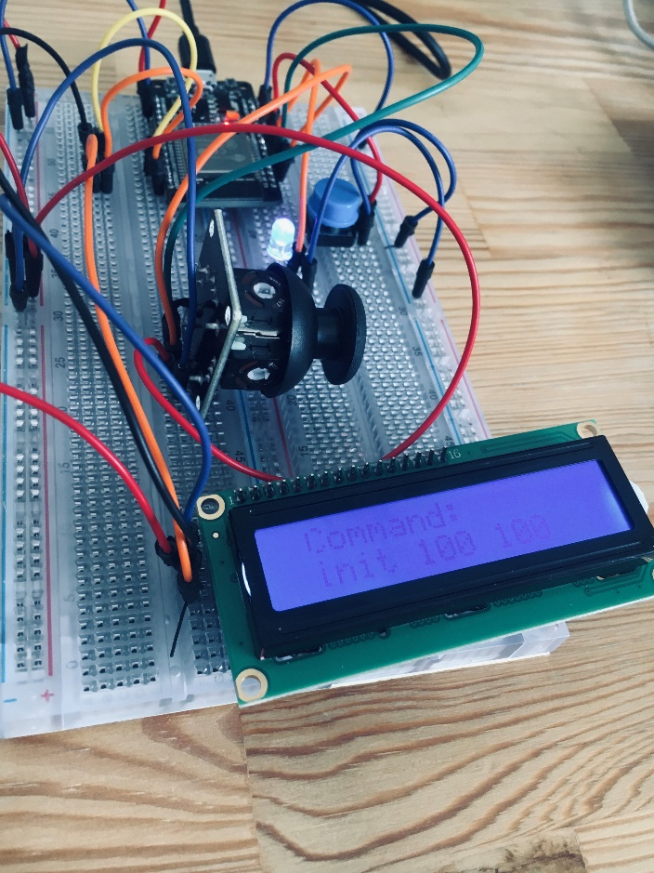This project is about to make a controller for a drone. In our project we use an ESP32 development board, a breadboard with a LED light, a button, an LCD screen, and a joystick. We setup button and joystick as inputs and LED light and LCD screen as output in our project. The ESP32 have Wi-Fi and when the Wi-Fi is connected it is waiting for button pressed. If the button is pressed, it will initiate the drone by commands and in real drone testing, the drone start to take off and the LED will turn on, also commands which are send to drone will display by LCD screen.

By moving the joystick, values x and y are detected and based on values, moving to left or right commands are sent to drone. LCD screen also are showing the sent commands.

When the button is pressed again, the landing command will send to drone and LED will turn off.

We test our program with pxlserver as an emulator and codes for real drone also in the included in program but commented.

In our code we have used Object-Oriented Programming concepts, we define five classes for drone and each of output and input named “Drone”, “Joystick”, “Button”, “Lcd” and “Led”. Button class is responsible to determining pressing status and Led class will do turn on or off the led and led class also showing self status, it will use in drone to determine whether drone is on or off. The LCD class will demonstrate the receiving message, and Joystick class will receive the values of x and y positions in addition determine the moving condition.

We design our drone board base on this diagram:

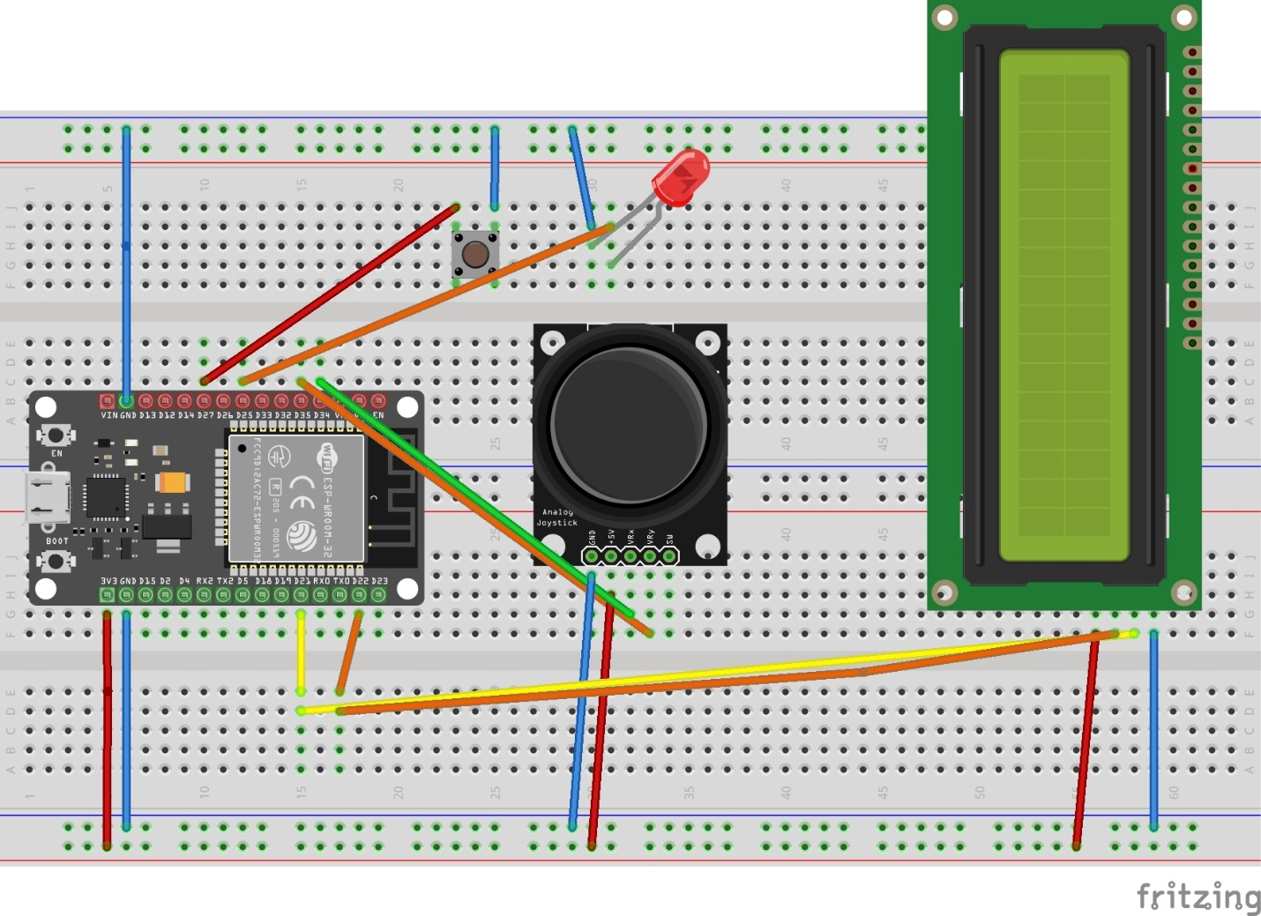

Github code repository:

<https://github.com/MarziehJ/IDS_ESP32_Drone_1>