BLE-BASED PROXIMITY ATTENDANCE SYSTEM WITH BIOMETRIC VERIFICATION
[COURSE CODE] / SHORT RANGE WIRELESS COMMUNICATION
Submitted by
ADITYA KUMAR NATH (RA2411003020203)
ABHISHEK S (RA2411003020208)
GOVIND GOEL (RA2411003020215)
Under the guidance of
[GUIDE NAME] ([Designation])
([Designation], Department of [Department])
V SEMESTER / III YEAR
COMPUTER SCIENCE AND ENGINEERING FACULTY OF
ENGINEERING AND TECHNOLOGY

SRM INSTITUTE OF SCIENCE AND TECHNOLOGY RAMAPURAM, CHENNAI
OCTOBER 2026
SRM INSTITUTE OF SCIENCE AND TECHNOLOGY
(Deemed to be University U/S 3 of UGC Act, 1956)
BONAFIDE CERTIFICATE
Certified that this project report titled BLE-BASED PROXIMITY ATTENDANCE SYSTEM WITH BIOMETRIC VERIFICATION is the bonafide work of ADITYA KUMAR NATH (RA2411003020203), ABHISHEK S (RA2411003020208), GOVIND GOEL (RA2411003020215), who carried out the project work under my supervision. This project work conforms to [Course code] / Short Range Wireless Communication, V Semester, III Year, 2026.
SIGNATURE

[Guide Name] ([Designation])
Department of [Department]
SRM Institute of Science and Technology
Ramapuram, Chennai.

S.No | INDEX | Page. No
1 | ABSTRACT | 2
2 | PROBLEM DESCRIPTION | 3
3 | METHODOLOGY | 4
4 | RESULT AND DISCUSSIONS | 6
5 | CONCLUSION | 9
ABSTRACT
This project builds a classroom attendance system that marks students present over Bluetooth Low Energy (BLE), a short-range wireless technology built into every modern smartphone. No extra hardware is needed: the teacher's phone and each student's phone run the same Android app, developed in Flutter, in two different modes.
The teacher's phone broadcasts a random session code that changes every class. A student's phone scans for this broadcast, verifies the student with the phone's fingerprint or face unlock, and then broadcasts the student's roll number, a per-install phone ID and the session code. The teacher's phone scans these broadcasts and accepts only those carrying the current session code. It also filters out signals weaker than an adjustable Received Signal Strength Indicator (RSSI) cutoff, so a phone outside the classroom is not counted. The teacher then broadcasts an acknowledgement, and the student's phone shows "Present marked".
To reduce proxy attendance, the system combines four checks: biometric verification on the student's phone, a session code that defeats replayed broadcasts, an RSSI threshold that limits range, and binding of each roll number to the phone that first used it. The teacher can load a class list, see absent students, approve flagged phones and mark students manually, then export the attendance as a CSV file.
The app was tested on a real Android phone in student mode, with a laptop's built-in Bluetooth adapter acting as the teacher through a Python script that uses the same packet format. Attendance was marked and acknowledged successfully. The project demonstrates BLE advertising and scanning, connectionless data transfer within a 31-byte advertisement, and the use of RSSI for proximity estimation.
PROBLEM DESCRIPTION
Manual roll call wastes several minutes of every class and is easy to cheat. A student can answer for an absent friend, and signing a sheet allows the same proxy. QR-code attendance is faster, but a photo of the code can be forwarded to someone outside the room. The problem is to mark only students who are physically present, quickly, without buying extra hardware.
Short-range wireless communication fits this problem because its limited range is the feature we need. BLE has a practical indoor range of roughly 10 to 30 m, and its signal weakens with distance, so the received signal strength gives an estimate of how near a phone is. Every smartphone already has a BLE radio, so the solution needs only software.
Using BLE alone is not enough, however. A broadcast can be recorded and replayed, a friend can carry another student's phone, and someone in the corridor may still be within radio range. The system must therefore answer three questions for each student: is this phone in the room, is it this class session, and is the right person holding the phone.
The objectives of this project are:
- Build one Android app with a teacher mode and a student mode that exchange attendance data over BLE advertisements, without pairing.
- Verify the student with the phone's biometric lock before attendance is sent.
- Reject replayed broadcasts with a per-session random code, and distant phones with an RSSI cutoff the teacher can adjust.
- Bind each roll number to one phone, and let the teacher load a class list, approve flagged phones and mark students manually.
- Confirm attendance back to the student, and export the result as CSV.
METHODOLOGY ( ALGORITHM )
The system uses BLE advertising only: every message is a broadcast that any nearby phone can scan, so no pairing or connection is set up. This keeps the exchange fast and lets one teacher phone hear a whole class at once. The app is written in Flutter (Dart) for Android, using flutter_blue_plus for scanning, flutter_ble_peripheral for advertising and local_auth for the fingerprint or face check.
Packet format
A legacy BLE advertisement carries 31 bytes. The flags field takes 3 bytes and the manufacturer-specific data header takes 4 (length, type 0xFF and company ID 0xFFFF, the ID the Bluetooth SIG reserves for testing). That leaves 24 bytes for the application payload.
Packet | Tag | Session code | Phone ID | Text
Teacher broadcast | 'T' | 4 bytes | none | Roll number being acknowledged, 0 to 10 bytes
Student broadcast | 'S' | 4 bytes | 4 bytes | "roll|name", up to 15 bytes, name cut to fit
Teacher algorithm
- Generate a random 32-bit session code and start advertising the teacher packet.
- Scan continuously for advertisements with company ID 0xFFFF.
- For each student packet, discard it if the session code differs (an old or replayed broadcast).
- If a class list is loaded and the roll number is not on it, flag it as "Not in class list".
- If the roll number is bound to a different phone ID, flag it as "Registered on a different phone".
- If the RSSI is at or above the cutoff, mark the student present and bind the roll number to this phone ID if it was unbound.
- Every second, rotate the acknowledgement field through the students still broadcasting, so each one receives its own roll number back.
- On request, mark or unmark a student by hand, approve a flagged phone, or export the list as CSV.
Student algorithm
- On first use, register the roll number and name and generate a random phone ID; these cannot be edited later.
- Scan for a teacher packet for up to 20 seconds and read its session code.
- Ask for the fingerprint or face unlock; stop if it fails.
- Advertise the student packet with the session code, phone ID, roll number and name.
- Keep scanning for up to 60 seconds for a teacher packet whose acknowledgement field equals this roll number.
- On a match, stop advertising and show "Present marked"; otherwise ask the student to move closer and try again.
Proximity estimation with RSSI
Received signal strength falls with distance according to the log-distance path-loss model, where RSSI(d₀) is the strength at a reference distance d₀ (usually 1 m) and n is the path-loss exponent (about 2 in free space, 2.7 to 4 indoors):
RSSI(d) = RSSI(d₀) − 10 · n · log₁₀(d / d₀)
Instead of converting RSSI to metres, which is unreliable indoors because of walls, bodies and reflections, the teacher sets a cutoff in dBm. The default is −75 dBm and the slider ranges from −100 to −40 dBm, so the cutoff can be tuned to the size of each classroom.
RESULT AND DISCUSSIONS
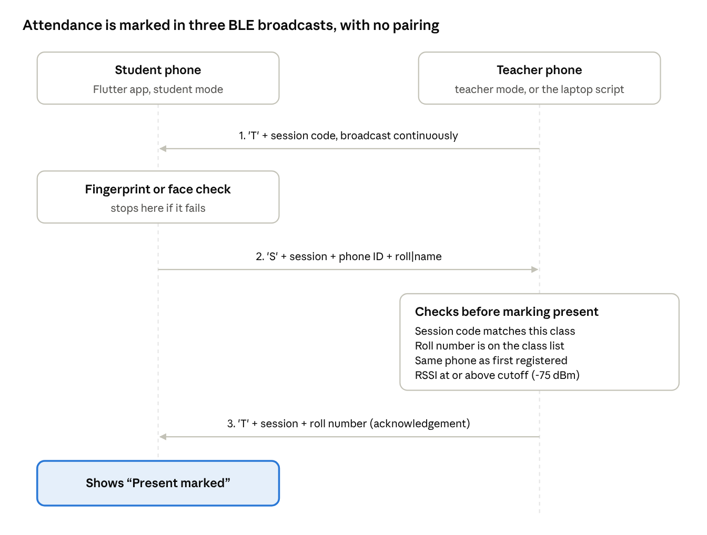
Fig 1 : Message Exchange Between the Student and Teacher Phones
Fig 1 shows the complete exchange. The teacher's phone broadcasts the session code; the student's phone verifies the student, then answers with the session code, its phone ID and the roll number. The teacher's phone runs four checks before marking the student present, then sends the roll number back as an acknowledgement. No pairing or connection is set up at any point, so one teacher phone can serve a whole class at once.
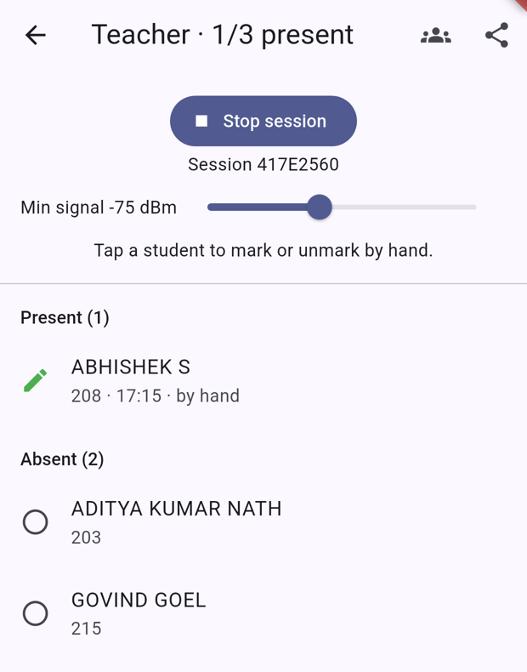
Fig 2 : Teacher Screen with the Class List and Manual Marking
Fig 2 shows the teacher mode during a live session. The class list holds the three team members, so the screen shows the count as 1/3 present and splits the class into Present and Absent. ABHISHEK S was marked by tapping his name, and the entry is labelled "by hand" so it can be told apart from Bluetooth marking. The slider sets the RSSI cutoff, here the default −75 dBm.
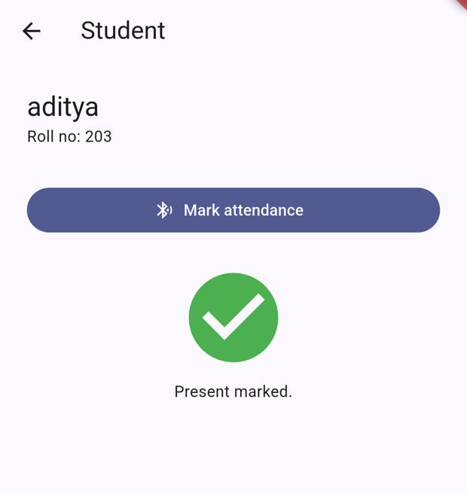
Fig 3 : Student Screen after the Teacher's Acknowledgement
Fig 3 shows the student's phone after a successful run. The student tapped Mark attendance, passed the fingerprint check, and the phone received its own roll number back in the teacher's broadcast. It then stopped advertising and showed "Present marked" with a green tick.
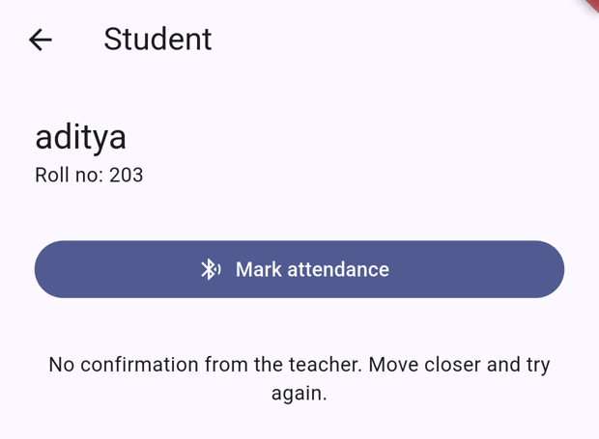
Fig 4 : Student Screen when the Signal was Too Weak
Fig 4 shows the same phone when its signal was below the teacher's cutoff. The teacher ignored the broadcast, so no acknowledgement came back and the phone asked the student to move closer.
Test observations
The test used one Android phone (OnePlus CPH2487) in student mode and a Windows laptop's built-in Intel Bluetooth adapter as the teacher, running a Python script with the same packet format. The phone and laptop stayed in the same positions for both runs; only the cutoff was changed.
Run | Cutoff | Measured RSSI | Laptop (teacher) | Phone (student)
1 | −75 dBm | −81 dBm | Ignored, too weak | No confirmation (Fig 4)
2 | −90 dBm | −84 dBm | Marked present | Present marked (Fig 3)
Laptop console output for the two runs:
Session A2762173 started. Min signal -75 dBm. Ctrl+C to stop.
ignored 203 aditya -81 dBm (too weak)

Session F40E376B started. Min signal -90 dBm. Ctrl+C to stop.
PRESENT 203 aditya -84 dBm
The two runs show the RSSI cutoff working as a range filter: the same phone at the same place was rejected at −75 dBm and accepted at −90 dBm. The readings also varied by 3 dB between runs without anything being moved, which confirms that RSSI is noisy and that the cutoff should be set from measurements in the actual classroom, with some margin.
Limitations
- A legacy advertisement leaves only 24 bytes, so roll numbers are limited to 10 characters and long names are shortened; the full register number (15 characters) does not fit, so the last digits are used.
- RSSI depends on walls, people and how the phone is held, so the cutoff separates inside from outside only approximately.
- The phone ID is sent openly and could be copied by a modified app; biometric checks prove only that someone enrolled on that phone unlocked it.
- iPhones restrict custom BLE advertisements, so the app runs on Android only.
CONCLUSION
In this work, a BLE-based proximity attendance system was designed, built and tested using only smartphones and a laptop, with no additional hardware. The teacher and student exchange attendance entirely through BLE advertisements, without pairing, and the whole message fits within the 24 bytes of payload a legacy advertisement allows.
The system combines short-range wireless communication with several checks against proxy attendance: a per-session random code rejects replayed broadcasts, an adjustable RSSI cutoff limits marking to nearby phones, the phone's biometric lock confirms who is holding it, and each roll number is bound to one phone. The teacher can load a class list, see absent students, approve flagged phones, mark students by hand and export the result as CSV, while each student receives a clear "Present marked" confirmation.
Testing with a real Android phone and a laptop acting as the teacher confirmed that attendance was marked and acknowledged correctly. The project also shows the practical limits of BLE: RSSI varies with walls, bodies and phone orientation, and an advertised phone ID can be copied by a modified app, so the system discourages proxies rather than making them impossible.
Future work could add signed or encrypted packets to stop ID copying, a server to share class lists and history across devices, multi-receiver positioning to locate students within the room, and iOS support where the platform allows custom advertisements.

