Overview – Instructions determine the behavior of the various part of the computer. For a MIPS computer, more specifically the first 6 bits (bits 31-26) determine the computer's control state.
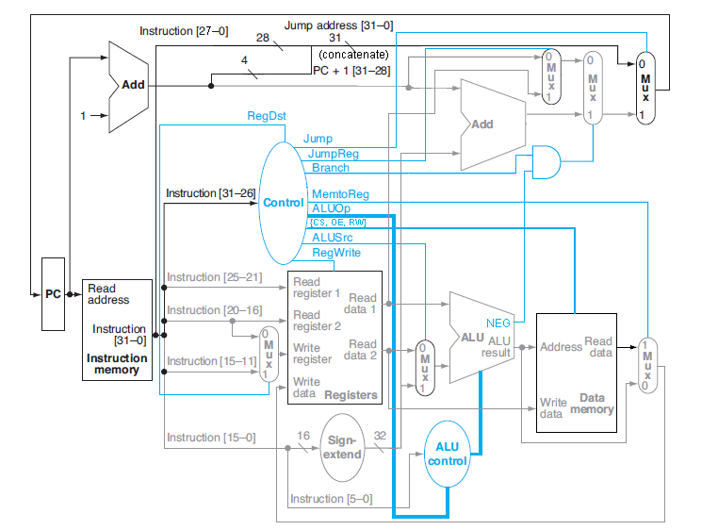
Figure 1: Computer Data and Control Flow

Figure 1 will be the diagram we use for determining all of our signal connections. There may be some discrepancies or errors that we will need to address later, but for now it looks to be what we need.
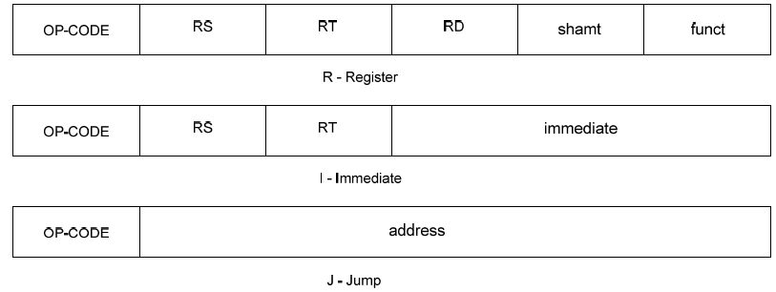
Figure 2: Types of Instructions
The format for the 3 types of instructions we care about is shown in Figure 2. The notation for the parts of the Instruction in the figure are below (Shamt is not used by us):
- OP-CODE – operation
- RS – First register source operand
- RT – Second register source operand
- RD – Register destination operand
- Shamt – Shift amount
- Funct – Specifies variant on operation given in opcode
The 32 bit instruction can be broken down into the following parts:
- Most fields are 5 bits
- Funct – 6 bits
- Op-Code – 6 bits
- Immediate – 16 bits
- Address – 26 bits
As mentioned, the first 6 bits (the OP-CODE) drive the controls of the rest for the computer. To do this the instruction is used to determine the state of several smaller 'micro-instructions' that can be put together to form a 'control word'. We'll use Figure 1's naming conventions for each signal for now. The OP-CODES we are interested in are below:

OP-CODE | Mode
0 | Register
2 | Jump
7 | Immediate (Branch Greater Than [BGT])
8 | Immediate (Add [ADD])
10 | Immediate (Set Less Than [SLT])
12 | Immediate (And [AND])
13 | Immediate (Or [OR])
14 | Immediate (Xor [XOR])
35 | Immediate (Load Word [LW])
43 | Immediate (Store Word [SW])
Table 1: OP-CODES

For register mode (OP-Code = 0) there are additionally several ALU operations that can be specified by the Funct field:

Funct | ALU Operation
0 | No Operation [NOP]
4 | Shift Left Logical [SLLV]
32 | Add [ADD]
34 | Subtract [SUB]
36 | And [AND]
37 | Or [OR]
38 | Xor [XOR]
42 | Set Less Than [SLT]
Table 2: ALU Functions

Below are the designations for each of the registers in the reg file. For the register operations, we will primarily use the temporary registers (T or TR) (the '$' sign is a convention for the file register).

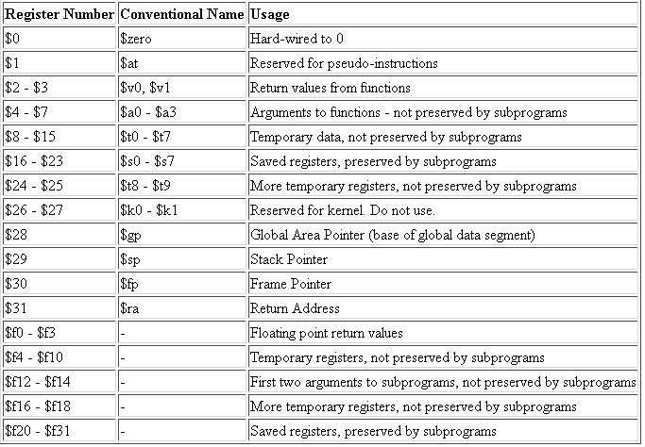
Table 3: File Register Designations

Below is the logic for most of the control signals shown in Figure 1:

OP-CODE | 0* | 2 | 7** | 8 | 10 | 12 | 13 | 14 | 35*** | 43****
RegDst | 1 | X | X | 0 | 0 | 0 | 0 | 0 | 0 | X
Jump | 0^ | 1 | 1 | 0 | 0 | 0 | 0 | 0 | 0 | 0
Jump Reg | X^ | 0 | X | X | X | X | X | X | X | X
Branch | X^ | 0 | 1 | X | X | X | X | X | X | X
{CS,OE,RW} | '1XX | '1XX | '1XX | '1XX | '1XX | '1XX | '1XX | '1XX | '010 | '001
MemtoReg | 0 | X | X | 0 | 0 | 0 | 0 | 0 | 1 | 0
ALUop | funct^ | X | SUB | ADD | SLT | AND | OR | XOR | ADD | ADD
ALUSrc | 0 | X | 0 | 1 | 1 | 1 | 1 | 1 | 1 | 1
RegWrite | 1# | 0 | 0 | 1 | 1 | 1 | 1 | 1 | 1 | 0
Table 4: Control Signal Logic

For Immediate Arithmetic Operations, RT is the destination register for the result: so RT = RS + Immed. Value
# For Funct = NOP, and Funct = JR – special cases
^ JR instruction has unique properties:
Jump = 1, JR = 1, Branch = 0, ALUop = NOP
* ALUop for Register-type is a mask for the ALU funct: ALU control = ALUop & funct (for ALUop = 6'b111111)
** Uses the Negative Flag to determine branch: Branches if RT > RS
*** Writes to RT from memory address at RS + Immed. Value: RT = mem@(RS + Immed. Value)
**** Writes value in RT to memory address at RS + Immed. Value: mem@(RS + Immed. Value) = RT

