Statistical Inference Course Project: Basic inferential data analysis

MY

Sunday, October 25, 2015

### Assignment Description

In this assignment we perform basic inferential analyses using the ToothGrowth data in the R datasets package.

As per the help file of this dataset, the response is the length of odontoblasts (teeth) in each of 10 guinea pigs at each of three dose levels of Vitamin C (0.5, 1, and 2 mg) with each of two delivery methods (orange juice or ascorbic acid).

##### 1. Load the ToothGrowth data and perform some basic exploratory data analyses

library(datasets)  
library(ggplot2)  
data(ToothGrowth)  
# look at the dataset variables  
str(ToothGrowth)

## 'data.frame': 60 obs. of 3 variables:  
## $ len : num 4.2 11.5 7.3 5.8 6.4 10 11.2 11.2 5.2 7 ...  
## $ supp: Factor w/ 2 levels "OJ","VC": 2 2 2 2 2 2 2 2 2 2 ...  
## $ dose: num 0.5 0.5 0.5 0.5 0.5 0.5 0.5 0.5 0.5 0.5 ...

# convert variable dose from numeric to factor  
ToothGrowth$dose <- as.factor(ToothGrowth$dose)  
str(ToothGrowth)

## 'data.frame': 60 obs. of 3 variables:  
## $ len : num 4.2 11.5 7.3 5.8 6.4 10 11.2 11.2 5.2 7 ...  
## $ supp: Factor w/ 2 levels "OJ","VC": 2 2 2 2 2 2 2 2 2 2 ...  
## $ dose: Factor w/ 3 levels "0.5","1","2": 1 1 1 1 1 1 1 1 1 1 ...

##### 2. Provide a basic summary of the data

summary(ToothGrowth)

## len supp dose   
## Min. : 4.20 OJ:30 0.5:20   
## 1st Qu.:13.07 VC:30 1 :20   
## Median :19.25 2 :20   
## Mean :18.81   
## 3rd Qu.:25.27   
## Max. :33.90

# split of cases between different dose levels and delivery methods  
table(ToothGrowth$dose, ToothGrowth$supp)

ggplot(aes(x=dose, y=len), data=ToothGrowth) + geom_boxplot(aes(fill=dose))

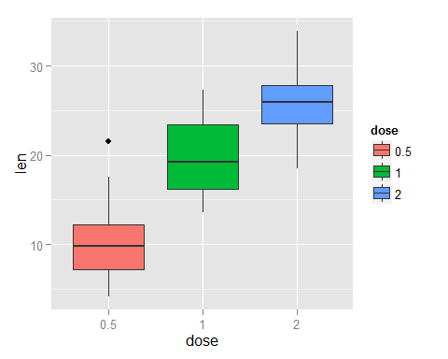

# visualization of tooth growth as function of supplement type  
ggplot(aes(x=supp, y=len), data=ToothGrowth) + geom_boxplot(aes(fill=supp))

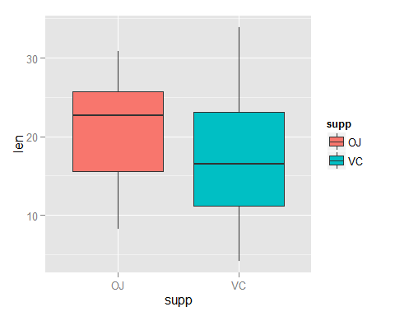

##### 3. Use confidence intervals and hypothesis tests to compare tooth growth by supp and dose

# check for group differences due to different supplement type   
# assuming unequal variances between the two groups  
t.test(len ~ supp, data = ToothGrowth)

The p-value is 0.06, and the confidence interval contains zero. This indicates that we can not reject the null hypothesis that the different supplement types have no effect on tooth length.

# first create three sub-groups as per dose level pairs  
ToothGrowth.doses_0.5_1.0 <- subset (ToothGrowth, dose %in% c(0.5, 1.0))   
ToothGrowth.doses_0.5_2.0 <- subset (ToothGrowth, dose %in% c(0.5, 2.0))   
ToothGrowth.doses_1.0_2.0 <- subset (ToothGrowth, dose %in% c(1.0, 2.0))   
  
# Check for group differences due to different dose levels (0.5, 1.0)  
t.test(len ~ dose, data = ToothGrowth.doses_0.5_1.0)

# Check for group differences due to different dose levels (0.5, 2.0)  
t.test(len ~ dose, data = ToothGrowth.doses_0.5_2.0)

# Check for group differences due to different dose levels (1.0, 2.0)  
t.test(len ~ dose, data = ToothGrowth.doses_1.0_2.0)

For all three dose level pairs, the p-value is less than 0.05, and the confidence interval does not contain zero. The mean tooth length increases on raising the dose level. This indicates that we can reject the null hypothesis, and establish that increasing the dose level leads to an increase in tooth length.

##### 4. State your conclusions and the assumptions needed for your conclusions

*Conclusions*  
* Supplement type has no effect on tooth growth.  
* Inreasing the dose level leads to increased tooth growth.

*Assumptions*  
1. The experiment was done with random assignment of guinea pigs to different dose level categories and supplement type to control for confounders that might affect the outcome.  
2. Members of the sample population, i.e. the 60 guinea pigs, are representative of the entire population of guinea pigs. This assumption allows us to generalize the results.